**WAIHI NORTH PROJECT - PROPOSED WILDLIFE ACT APPROVAL CONDITIONS**

**Wildlife Act Approval for wildlife located on public conservation land**

**SCHEDULE 1**

|  |  |  |
| --- | --- | --- |
| 1 | **Authorised activity (including the species, any approved quantities and collection methods)**  (Schedule 2, clause 2) | 1. Activity: 2. To catch, salvage and relocate native frog and lizard species listed in Schedule 4 prior to vegetation clearance at mineral exploration and mining operation sites (see list of sites, in next section) 3. To catch and hold native frogs for the purpose of long-term monitoring 4. To take or destroy the eggs of the following wildlife species when unavoidable: 5. Pīwakawaka / New Zealand fantail (*Rhipidura fuliginosa);* 6. Kāhu / Australasian harrier (*Circus approximans);* 7. Korimako / Bellbird (*Anthornis melanura);* 8. Riroriro / Grey warbler (*Gerygone igata);* 9. Keruru / NZ pigeon (*Hemiphaga novaeseelandiae);* 10. Kotare / Kingfisher (*Todiramphus sanctus)*; 11. Tauhou / Silvereye (*Todiramphus sanctus);* 12. Miromiro /Tomtit (*Petroica macrocephala);* 13. Tūī (*Prosthemadera novaeseelandiae);* 14. Warou /Welcome swallow (*Hirundo neoxena);* 15. Pōpokotea / Whitehead (*Mohoua albicilla);* 16. Kākāriki/ Yellow-crowned parakeet (*Cyanoramphus auriceps);* 17. Ruru / Morepork (*Ninox novaeseelandiae);* 18. Kākā (*Nestor meridionalis);* 19. Pīpīwharauroa / Shining cuckoo (*Chrysococcyx lucidus); and* 20. Stag beetle (*Geodorcus auriculatus* sp). 21. To kill the wildlife species listed in A(c)(i – xv) above, and / or long-tailed bats (*Chalinolobus tuberculatus*) when unavoidable 22. Any accidental / unintentional harm to wildlife that could arise from any of the activities undertaken in relation to the Waihi North Project. 23. Methodology: 24. Within the Coromandel Forest Park: Except when instructed otherwise by the Grantor, the methods set out in:     1. The Terrestrial Ecology Management Plan as included in the Wharekirauponga Underground Mine Ecology and Landscape Management Plan and included in Part H of the application documents; and     2. Native Frog Monitoring Plan. 25. Outside the Coromandel Forest Park: Methods set out in the Willows Site section of the Wharekirauponga Underground Mine Ecology and Landscape Management Plan and included in Part H of the application documents, and the Lizard Management Plan section of the Waihi Area Ecology and Landscape Management Plan and included in Part H of the application documents. |
| 2 | **The** **Land**  (Schedule 2, clause 2) | Areas marked Area 1 – Area 7 on Map 1 in Schedule 5, except that monitoring of native frogs may take place anywhere in the areas shown on Map1 and Map 2. |
| 3 | **Personnel authorised to undertake the Authorised Activity**  (Schedule 2, clause 3) | 1. Katherine Muchna 2. Liam Ireland 3. Jenna Powell 4. Cassie McArthur 5. Matthew Turner 6. Bella Burgess 7. Brittany Pearce 8. Michaela Scarrott 9. Additional personnel as may be approved in writing by the Grantor. |
| 4 | **Term**  (Schedule 2, clause 4) | [insert date of approval] to [insert date 30 years from date of approval] |
| 5 | **Approval Holder’s address for notices**  (Schedule 2, clause 8) | The Approval Holder’s address in New Zealand is:  Physical: 22 Maclaggan Street, Dunedin 9016, New Zealand  Postal: PO Box 5442 Dunedin 9054  Phone: 03 479 4736  Email: [NZ.Legal@oceanagold.com](mailto:NZ.Legal@oceanagold.com) |
| 6 | **Grantor’s address for notices** | The Grantor’s address for all correspondence is:  [Hauraki District Office, 3/366 Ngati Maru Highway (SH25)  Thames 3500 (physical);  PO Box 343, Thames 3540 (postal);  Phone: [0800 275 362](tel:0800%20275%20362);  Email: thames@doc.govt.nz] |

**SCHEDULE 2**

**STANDARD TERMS AND CONDITIONS OF THE APPROVAL**

1. **Interpretation**
   1. The Approval Holder is responsible for the acts and omissions of its employees, contractors or agents. The Approval Holder is liable under this Approval for any breach of the terms of the Approval by its employees, contractors or agents as if the breach had been committed by the Approval Holder.
   2. Where obligations bind more than one person, those obligations bind those persons jointly and separately.
2. **What is being authorised?** 
   1. The Approval Holder is only allowed to carry out the Authorised Activity on the Land described in Schedule 1, Item 2.
   2. Any arrangements necessary for access over private land or leased land are the responsibility of the Approval Holder. In granting this approval the Grantor does not warrant that such access can be obtained.
   3. The Approval Holder must advise the Department of Conservation’s local Operations Manager(s) (“Manager”) prior to carrying out the Authorised Activity (where possible, one week prior).
   4. The Approval Holder and Authorised Personnel must carry a copy of this Approval with them at all times while carrying out the Authorised Activity.
   5. The Approval Holder must comply with any reasonable request from the Grantor for access to any wildlife.
   6. The Approval Holder may publish authorised research results.
   7. The Approval Holder must immediately notify the Grantor of any taxa found which are new to science. In addition, the Approval Holder must lodge holotype specimens and a voucher specimen of any new taxa with a recognised national collection.
3. **Who is authorised?**
   1. Only the Approval Holder, its employees, contractors and agents and the Authorised Personnel described in Schedule 1, Item 3 are authorised to carry out the Authorised Activity, unless otherwise agreed in writing by the Grantor, such agreement is not to be unreasonably delayed or withheld.
4. **How long is the** Approval **for - the Term?**
   1. This Approval commences and ends on the dates set out in Schedule 1, Item 4.
5. **What are the liabilities?**
   1. The Approval Holder agrees to exercise the Approval at the Approval Holder’s own risk and releases to the full extent permitted by law the Grantor and the Grantor's employees and agents from all claims and demands of any kind and from all liability which may arise in respect of any accident, damage or injury occurring to any person or property arising from the Approval Holder’s exercise of the Authorised Activity.
   2. The Approval Holder must indemnify the Grantor against all claims, actions, losses and expenses of any nature which the Grantor may suffer or incur or for which the Grantor may become liable arising from the Approval Holder’s exercise of the Authorised Activity.
   3. This indemnity is to continue after the expiry or termination of this Approval in respect of any acts or omissions occurring or arising before its expiry or termination.
6. **What about compliance with legislation and Grantor’s notices and directions?**
   1. The Approval Holder must comply with all statutes, bylaws and regulations, and all notices, directions and requisitions of the Grantor and any competent authority relating to the conduct of the Authorised Activity. Without limitation, this includes the Conservation Act 1987 and the Acts listed in the First Schedule of that Act and all applicable health and safety legislation and regulation.
7. **Are there limitations on public access and closure?**
   1. The Approval Holder acknowledges that the public conservation land being part of the Land is open to the public for access and that the Grantor may close public access to that public conservation land during periods of high fire hazard or for reasons of public safety or emergency.
8. **When can the** Approval **be terminated?**
   1. The Grantor may terminate this Approval at any time in respect of the whole or any part of the Land, and/or the whole or any part of the Authorised Activity if:
9. the Approval Holder breaches any of the conditions of this Approval; or
10. in the Grantor’s opinion, the carrying out of the Authorised Activity causes or is likely to cause any unforeseen or unacceptable effects in relation to protected wildlife.
    1. If the Grantor intends to terminate this Approval in whole or in part, the Grantor must give the Approval Holder such prior notice as, in the sole opinion of the Grantor, appears reasonable and necessary in the circumstances.
11. **How are notices sent and when are they received?**
    1. Any notice to be given under this Approval by the Grantor is to be in writing and made by personal delivery or email to the Approval Holder at the physical or email address specified in Schedule 1, Item 5. Any such notice is to be deemed to have been received:
12. in the case of personal delivery, on the date of delivery;
13. in the case of email, on the date receipt of the email is acknowledged by the addressee by return email or otherwise in writing.
    1. If the Approval Holder’s details specified in Schedule 1, Item 5 change then the Approval Holder must notify the Grantor within 5 working days of such change.
14. **What about the payment of costs?**
    1. The Approval Holder must pay the standard Department of Conservation charge-out rates for any staff time and mileage required to monitor compliance with this Approval and to investigate any alleged breaches of the terms and conditions of it.
15. **Biosecurity**
    1. The Approval Holder must take all precautions to ensure weeds and non-target species are not introduced to the Land; this includes ensuring that all tyres, footwear, gaiters, packs and equipment used by the Approval Holder, its staff and clients are cleaned and checked for pests before entering the Land.
16. **Are there any Special Conditions?**
    1. Special conditions are specified in Schedule 3. If there is a conflict between this Schedule 2 and the Special Conditions in Schedule 3, the Special Conditions will prevail.
17. **Can the Approval be varied?**
    1. The Approval Holder may apply to the Grantor for variations to this Approval in line with clause 7(2) of Schedule 7 of the Fast-track Approvals Act 2024.

**SCHEDULE 3**

**SPECIAL CONDITIONS**

**Compatibility with Access Arrangement and Concession Documents**

1. The Special Conditions in the following documents apply within their respective areas of effect:
   1. Wharekirauponga Access Arrangement [reference number]
   2. Favona Access Arrangement [reference number]
   3. Northern Concession [reference number]
   4. Willows Area Concession [reference number]

**Management and Monitoring Plans**

1. All Activities authorised by this Wildlife Act Approval must be undertaken in accordance with the following management and monitoring plans included in Part H of the application documents, or any amended versions that may be made under Condition 3:
   1. Within the Coromandel Forest Park:
      1. The Terrestrial Ecology Management Plan as included in the Wharekirauponga Underground Mine Ecology and Landscape Management Plan;
      2. The Native Frog Monitoring Plan;
      3. The Native Frog Salvage Release Plan as included in the Wharekirauponga Underground Mine Ecology and Landscape Management Plan.
   2. Outside the Coromandel Forest Park:
      1. The Willows Site section of the Wharekirauponga Underground Mine Ecology and Landscape Management Plan;
      2. The Lizard Management Plan as included in the Waihi Area Ecology and Landscape Management Plan.
2. In accordance with Conditions C8A – C8C of Resource Consent [to link in the consent number of the Combined HDC and WRC Conditions] the Approval holder may make amendments to any of the management plans referred to in Condition 2 at any time, provided that:
   1. The Approval holder must invite the Manager to participate in a collaborative workshop with the Approval holder to discuss the proposed amendments.

*Advice Note: The collaborative workshop may occur as a standalone workshop, or it may be combined with other collaborative workshops required by this Authority if practical.*

* 1. If the Manager agrees to participate in a workshop:
     1. The Approval holder must provide a copy of the amended management plan to the Manager at least 15 working days before the workshop;
     2. The Approval holder must circulate a record of the workshop discussions to the Manager within 5 days of the completion of the workshop; and
     3. The Manager must be given an opportunity to provide written feedback to the Approval holder on the management plan amendments within 15 working days of the completion of the workshop.
  2. If the Manager declines the opportunity to participate in a collaborative workshop, the Approval holder must provide a copy of the amended management or monitoring plan to the Manager and give the Manager 15 working days to provide written feedback to the Approval holder on the proposed amendments.
  3. If the Manager has not, within 15 Working Days of receipt of the amendment, advised the Approval holder that Condition 3(e) applies, any Works associated with the amendment may proceed.
  4. Except where Condition 3(b) applies, until an amendment is approved, any work must be conducted in accordance with the existing management or monitoring plan.

***Terrestrial Ecology Management Plan as included in the Wharekirauponga Underground Mine Ecology and Landscape Management Plan***

1. The objective of the Terrestrial Ecology Management Plan is to describe (and outline actions) the ecological management actions to appropriately minimises and mitigates the potential terrestrial ecological effects associated with vegetation and habitat clearance for the WUG.
2. Any current version of the Terrestrial Ecology Management Plan must as a minimum:
   1. Remain consistent with the objective of the Terrestrial Ecology Management Plan (as set out in Condition 4);
   2. Include maps for visual tools which identify the location and extent of any proposed management and mitigation measures, including identification of which specific Areas within which these measures will occur;
   3. Include details of monitoring and reporting to the Management prior to, during and post-construction and operation to determine if the Terrestrial Ecology Management Plan objective is met; and
   4. Include details of the roles and responsibilities of key staff responsible for implementing the Terrestrial Ecology Management Plan and procedures for training of contractors and other Project staff regarding the Terrestrial Ecology Management Plan.
3. By 30 June each year the Approval holder must engage a suitably qualified and experienced ecologist to prepare an annual Terrestrial Ecology Monitoring Report that covers activities addressed in the Terrestrial Ecology Management Plan for the previous year.

*Advice Note: The Terrestrial Ecology Monitoring Report may be provided as a standalone report, or it may be integrated into a combined report with any of the other annual reports required by this Authority.*

1. The Terrestrial Ecology Monitoring Report required by Condition 6 above must include:
   1. A description of any works and other actions envisaged by the Terrestrial Ecology Management Plan completed by the Approval holder in the previous twelve months;
   2. Where aspects of the Terrestrial Ecology Management Plan have not been implemented, the reasons why, and the measures that have been taken by the Approval holder to address this;
   3. An assessment of the effectiveness of the actions taken to implement the Terrestrial Ecology Management Plan in achieving its objective. Where the report identifies that the objective has not been met, the Report must include:
      1. The reasons why the objective has not been met;
      2. Specific measures that have already been implemented, or are required to be implemented to achieve performance indicators; and
   4. Details of any amendments needed to the Terrestrial Ecology Management Plan or any other of the other management plans identified in Condition 2 to better ensure that the objective will be met.
2. If the Department of Conservation is not satisfied that the actions taken by the Approval holder are achieving the objective of the Terrestrial Ecology Management Plan, the Approval holder and the Department of Conservation shall participate in a collaborative workshop to discuss the levels of achievement, and to identify any measures that are required to be implemented to address any agreed failure to achieve the objective.

In the instance that there is disagreement between the Approval holder and the Department of Conservation at the conclusion of the collaborative workshop, the process in Conditions 47 and 48 (Dispute Resolution) is to be implemented.

*Advice Note: The collaborative workshop may occur as a standalone workshop, or it may be combined with other collaborative workshops required by this Authority if practical.*

***Native Frog Monitoring Plan***

1. The objective of the Native Frog Monitoring Plan is to outline the frog monitoring undertaken with incorporation of success indicators.
2. Any current version of the Native Frog Monitoring Plan must as a minimum:
   1. Remain consistent with the objective of the Native Frog Monitoring Plan (as set out in Condition 9);
   2. Include maps for visual tools which identify the location and extent of any proposed management and mitigation measures, including identification of which specific Areas within which these measures will occur;
   3. Include details of monitoring and reporting to the Management prior to, during and post-construction and operation to determine if the Native Frog Monitoring Plan objective is being met; and
   4. Include details of the roles and responsibilities of key staff responsible for implementing the Native Frog Monitoring Plan and procedures for training of contractors and other Project staff regarding the Native Frog Monitoring Plan.
3. By 30 June each year the Approval holder must engage a suitably qualified and experienced herpetologist to prepare an Annual Leiopelmatid Frog Monitoring Report that covers activities addressed in the Native Frog Monitoring Plan for the previous year.

*Advice Note: The Annual Leiopelmatid Frog Monitoring Report may be prepared in conjunction with the Annual Leiopelmatid Frog Monitoring Report prepared in accordance with the requirements applying to the ‘Waihi North Project – Wharekirauponga Access Arrangement’. The Annual Leiopelmatid Frog Monitoring Report may be provided as a standalone report, or it may be integrated into a combined report with any of the other annual reports required by this Authority.*

1. The Annual Leiopelmatid Frog Monitoring Report required by Condition 11 above must include:
   1. A description of any works and other actions envisaged by the Native Frog Monitoring Plan completed by the Approval holder in the previous twelve months, including;
      1. the number and biometric data (snout vent length, SVL) of any Archey’s or Hochstetter’s frogs;
      2. the release pen (for Archey’s frogs), or stream location (for Hochstetter’s frogs) that they were released into; and
      3. a clear dorsal photograph for photographic identification; and all survey details (climatic conditions, time and date, and search effort).
   2. Where aspects of the Native Frog Monitoring Plan have not been implemented, the reasons why, and the measures that have been taken by the Approval holder to address this;
   3. An assessment of the effectiveness of the actions taken to implement the Native Frog Monitoring Plan in achieving its objective. Where the report identifies that the objective has not been met, the Report must include:
      1. The reasons why the objective has not been achieved;
      2. Specific measures that have already been implemented, or are required to be implemented to meet the objective; and
   4. Details of any amendments needed to the Native Frog Monitoring Plan or any other of the other management plans identified in Condition 2 to better ensure that the objective will be met.
2. If the Department of Conservation is not satisfied that the actions taken by the Approval holder are achieving the objective of the Native Frog Monitoring Plan, the Approval holder and the Department of Conservation shall participate in a collaborative workshop to discuss the levels of achievement, and to identify any measures that are required to be implemented to address any agreed failure to achieve the objective.

In the instance that there is disagreement between the Approval holder and the Department of Conservation at the conclusion of the collaborative workshop, the process in Conditions 47 and 48 (Dispute Resolution) is to be implemented.

*Advice Note: The collaborative workshop may occur as a standalone workshop, or it may be combined with other collaborative workshops required by this Authority if practical.*

***Native Frog Salvage Release Plan as included in the Wharekirauponga Underground Mine Ecology and Landscape Management Plan***

1. The objective of the Native Frog Salvage Release Plan is to detail the process and methods to be undertaken when salvaging and translocating native frogs.
2. Any current version of the Native Frog Salvage Release Plan must as a minimum:
   1. Remain consistent with the objective of the Native Frog Salvage Release Plan (as set out in Condition 14);
   2. Identify where any frogs are to be released (“the release site”);
   3. Provide data which confirms the resident frog population at the release site;
   4. Explain how the release site is to operate (i.e. multiple release pens and types of pens);
   5. Outline frog salvage methods including transportation methods, transportation timings / durations, frog handling protocols, and release process;
   6. Identify what monitoring is to occur at the release site following the release of frogs at the site, and how this monitoring is to be implemented;
   7. Provide details of how / when the operation and monitoring of the release site is to conclude;
   8. Include details of monitoring and reporting to the Manager prior to, during and post-construction and operation to determine if the Native Frog Salvage Release Plan objective is being met; and
   9. Include details of the roles and responsibilities of key staff responsible for implementing the Native Frog Salvage Release Plan and procedures for training of contractors and other Project staff regarding the Native Frog Salvage Release Plan.
3. By 30 June each year the Approval holder must engage a suitably qualified and experienced herpetologist to prepare an Annual Native Frog Salvage Release Report that covers activities addressed in the Native Frog Salvage Release Plan for the previous year.

*Advice Note: The Annual Native Frog Salvage Release Report may be provided as a standalone report, or it may be integrated into a combined report with any of the other annual reports required by this Authority.*

1. The Annual Native Frog Salvage Release Report required by Condition 16 above must include:
   1. A description of any works and other actions envisaged by the Native Frog Salvage Release Plan completed by the Approval holder in the previous twelve months;
   2. Where aspects of the Native Frog Salvage Release Plan have not been implemented, the reasons why, and the measures that have been taken by the Approval holder to address this;
   3. An assessment of the effectiveness of the actions taken to implement the Native Frog Salvage Release Plan in achieving its objective. Where the report identifies that the objective has not been met, the Report must include:
      1. The reasons why the objective has not been achieved;
      2. Specific measures that have already been implemented, or are required to be implemented to meet the objective; and
   4. Details of any amendments needed to the Native Frog Salvage Release Plan or any other of the other management plans identified in Condition 2 to better ensure that the objective will be met.

*Advice Note: The collaborative workshop may occur as a standalone workshop, or it may be combined with other collaborative workshops required by this Authority if practical.*

1. If the Department of Conservation is not satisfied that the actions taken by the Approval holder are achieving the objective of the Native Frog Salvage Release Plan, the Approval holder and the Department of Conservation shall participate in a collaborative workshop to discuss the levels of achievement, and to identify any measures that are required to be implemented to address any agreed failure to achieve the objective.

In the instance that there is disagreement between the Approval holder and the Department of Conservation at the conclusion of the collaborative workshop, the process in Conditions 47 and 48 (Dispute Resolution) is to be implemented.

***Willows Site section of the Wharekirauponga Underground Mine Ecology and Landscape Management Plan***

1. The objective of the Willows Site section of the Wharekirauponga Underground Mine Ecology and Landscape Management Plan is to outline the ecological values of the Willows Site, the activities to be undertaken and outline how vegetation and fauna will be managed as vegetation and habitat clearance is undertaken.
2. Any current version of the Willows Site section of the Wharekirauponga Underground Mine Ecology and Landscape Management Plan must as a minimum:
   1. Remain consistent with the objective of the Willows Site section of the Wharekirauponga Underground Mine Ecology and Landscape Management Plan (as set out in Condition 19);
   2. Include maps for visual tools which identify the location and extent of any proposed management and mitigation measures, including identification of which specific Areas within which these measures will occur;
   3. Include details of monitoring and reporting to the Management prior to, during and post-construction and operation to determine if the Wharekirauponga Underground Mine Ecology and Landscape Management Plan objective is being met; and
   4. Include details of the roles and responsibilities of key staff responsible for implementing the Wharekirauponga Underground Mine Ecology and Landscape Management Plan and procedures for training of contractors and other Project staff regarding the Wharekirauponga Underground Mine Ecology and Landscape Management Plan.
3. If the Department of Conservation is not satisfied that the actions taken by the Approval holder are achieving the objective of the Willows Site section of the Wharekirauponga Underground Mine Ecology and Landscape Management Plan, the Approval holder and the Department of Conservation shall participate in a collaborative workshop to discuss the levels of achievement, and to identify any measures that are required to be implemented to address any agreed failure to achieve the objective.

In the instance that there is disagreement between the Approval holder and the Department of Conservation at the conclusion of the collaborative workshop, the process in Conditions 47 and 48 (Dispute Resolution) is to be implemented.

*Advice Note: The collaborative workshop may occur as a standalone workshop, or it may be combined with other collaborative workshops required by this Authority if practical.*

***The Lizard Management Plan as included in the Waihi Area Ecology and Landscape Management Plan***

1. The objective of the Lizard Management Plan is to minimise potential adverse effects on native lizards within the proposed footprints.
2. Any current version of the Lizard Management Plan must as a minimum:
   1. Remain consistent with the objectives of the Lizard Management Plan (as set out in Condition 22);
   2. Include maps for visual tools which identify the location and extent of any proposed management and mitigation measures, including identification of which specific Areas within which these measures will occur;
   3. Include details of monitoring and reporting to the Management prior to, during and post-construction and operation to determine if the Lizard Management Plan objective is met; and
   4. Include details of the roles and responsibilities of key staff responsible for implementing the Lizard Management Plan and procedures for training of contractors and other Project staff regarding the Lizard Management Plan.
3. By 30 June each year the Approval holder must engage a suitably qualified and experienced ecologist to prepare an annual Lizard Monitoring Report that covers activities addressed in the Lizard Management Plan for the previous year.

*Advice Note: The* Lizard Monitoring Report *may be provided as a standalone report, or it may be integrated into a combined report with any of the other annual reports required by this Authority.*

1. The Lizard Monitoring Report required by Condition 24 above must include:
   1. A description of any works and other actions envisaged by the Lizard Management Plan completed by the Approval holder in the previous twelve months;
   2. Where aspects of the Lizard Management Plan have not been implemented, the reasons why, and the measures that have been taken by the Approval holder to address this;
   3. An assessment of the effectiveness of the actions taken to implement the Lizard Management Plan in achieving its objective. Where the report identifies that the objective has not been met, the Report must include:
      1. The reasons why the objective has not been met;
      2. Specific measures that have already been implemented, or are required to be implemented to achieve the objective; and
   4. Details of any amendments needed to the Lizard Management Plan or any other of the other management plans identified in Condition 2 to better ensure that the objective will be met.

If the Department of Conservation is not satisfied that the actions taken by the Approval holder are achieving the objectives and performance indicators of the Lizard Management Plan, the Approval holder and the Department of Conservation shall participate in a collaborative workshop to discuss the levels of achievement, and to identify any measures that are required to be implemented to address any agreed failure to meet the objective.

In the instance that there is disagreement between the Approval holder and the Department of Conservation at the conclusion of the collaborative workshop, the process in Conditions 47 and 48 (Dispute Resolution) is to be implemented.

*Advice Note: The collaborative workshop may occur as a standalone workshop, or it may be combined with other collaborative workshops required by this Authority if practical.*

**Lizard Capture and Handling**

1. Lizards must only be handled by Authorised Personnel named in Schedule 1, or under the direct supervision of the Authorised Personnel in accordance with Schedule 2, clause 3.1.
2. Lizard capture and relocation must be undertaken between the 1st October and 30 April when lizards are most active.
3. Capture and handling of lizards must involve only techniques that minimise the risk of infection or injury to the animal.
4. Capture and handling methods shall follow those described in the Herpetofauna inventory and monitoring toolbox [http://www.doc.govt.nz/our-work/biodiversity-inventory-and-monitoring/herpetofauna/](https://urldefense.proofpoint.com/v2/url?u=http-3A__www.doc.govt.nz_our-2Dwork_biodiversity-2Dinventory-2Dand-2Dmonitoring_herpetofauna_&d=DwMFAg&c=euGZstcaTDllvimEN8b7jXrwqOf-v5A_CdpgnVfiiMM&r=o4a8kz2nRJ81B9SJhsRmmAkQWF4-iMuXKHMoOl-ziFk&m=sNr6hD_89kpWyJtwjavz8TmTD8Yg20ldaEjgU3zyolVTZcS_L1E_JX6GVA1fowZI&s=WGcYgX7qgH53E9GrP0gpwcLV512a-tJz8d350vfFv5g&e=)
5. The Approval Holder must ensure all live capture traps are covered to protect lizards from exposure and minimise stress. Damp leaf litter or other material must be provided to reduce desiccation risk and the bottom of the pit-fall trap must be perforated to allow drainage of water.
6. The Approval Holder must ensure all live capture traps, (e.g. pitfall traps and G-minnow traps), are checked daily within 12 hours of sunrise.
7. The Approval Holder must sterilise any instruments that come in contact with the lizards and/or are used to collect or measure lizards between each location.  A separate holding bag must be used for each animal. All gear should be thoroughly cleaned and dried between sites.
8. The Approval Holder must ensure lizards are temporarily held individually in a suitable container (e.g. breathable cloth bag) and held out of direct sunlight to minimise the risk of overheating, stress, and death.

**Frog Capture and Handling**

1. The Approval Holder must adhere to the current national Frog Hygiene Protocol to minimise the possible spread of chytrid fungus and other pathogens to, within and between the sites.
2. The Approval Holder must ensure that personnel undertaking frog handling and capture activities are accompanied by a suitably qualified herpetologist or staff trained by a suitably qualified herpetologist. Suitably qualified means a herpetologist who:
   1. Demonstrates expertise and experience in frog survey, capture, handling, and release, including extended periods of experience undertaking frog surveys. They will understand and demonstrate competency in survey methods and searching techniques (including where, when and in what conditions it is best to survey to maximise detection), frog identification, and safe capture, handling and release of frogs to the satisfaction of the Manager (who will consult with the Native Frog Recovery Group).
3. Frog capture and handling methods shall follow those described in the Herpetofauna inventory and monitoring toolbox [http://www.doc.govt.nz/our-work/biodiversity-inventory-and-monitoring/herpetofauna/](https://urldefense.proofpoint.com/v2/url?u=http-3A__www.doc.govt.nz_our-2Dwork_biodiversity-2Dinventory-2Dand-2Dmonitoring_herpetofauna_&d=DwMFAg&c=euGZstcaTDllvimEN8b7jXrwqOf-v5A_CdpgnVfiiMM&r=o4a8kz2nRJ81B9SJhsRmmAkQWF4-iMuXKHMoOl-ziFk&m=sNr6hD_89kpWyJtwjavz8TmTD8Yg20ldaEjgU3zyolVTZcS_L1E_JX6GVA1fowZI&s=WGcYgX7qgH53E9GrP0gpwcLV512a-tJz8d350vfFv5g&e=), the Frog Hygiene Protocol.
4. The Approval Holder must take all practicable steps to minimise trampling and disturbance of frogs and their habitat by:
   1. Using the same marked access routes for access to the site.
   2. Avoiding survey of habitat that may result in crushing or collapse of delicate refugia, e.g. stream seepages with small, stacked pebbles that could collapse entirely if searching is attempted.
   3. Returning all captured and handled frogs to their original capture point (unless the frog is being relocated) using a system of release that avoids the risk of liberated frogs being disturbed or trampled.

**Ownership and holding of Absolutely Protected Wildlife**

1. This Approval gives the Approval Holder the right to hold absolutely protected wildlife for no longer than 12 hours in accordance with the terms and conditions of the Approval, but the wildlife remains the property of the Crown. This includes any dead wildlife, live wildlife, any parts thereof, any eggs or progeny of the wildlife, genetic material and any replicated genetic material.
2. Unless expressly authorised by the Grantor in writing, the Approval Holder must not donate, sell or otherwise transfer to any third party any wildlife, material, including any genetic material, or any material propagated or cloned from such material, collected under this Approval.

**Death of wildlife associated with activities covered by the** approval

1. If, in the course of undertaking the Activities, all reasonable effort has been made to meet all of the conditions expressed and implied in this approval; and wildlife is killed by the Approval Holder, then that will be permitted under this approval.
2. If any protected wildlife is found dead; the Approval Holder must contact the Grantor’s Hauraki Office on 07 867 9180, with known details of the animal’s history. Then, if the Grantor requests it, the body must be sent to Massey University Wildlife Post Mortem Service for necropsy.
3. In that eventuality; the Approval Holder must, if requested by the Grantor:
   1. Ensure that the body is to be chilled if it can be delivered within 24 hours, or frozen if it will take longer than 24 hours to delivery.
   2. Ensure appropriate measures are taken to minimise further deaths.
   3. Discuss with the Grantor’s Hauraki office, whether it is necessary to halt all further handling until full investigations of death(s) occur.
   4. Pay for any costs incurred in investigation of the death

**Euthanasia**

1. The Approval Holder must not euthanize any wildlife unless the Approval Holder:
   1. Obtains the recommendation of a veterinarian where euthanasia is on animal welfare grounds; or
   2. Carries out the euthanasia under direction from the Grantor and in consultation with a veterinarian (as applicable).

**Records**

1. All survey, salvage and release records must be made available for inspection at reasonable times by officers of the Grantor.

**Lizard and Frog Salvage Reporting**

1. Independent of any reporting required under the conditions of any Access Arrangement or Concession; a report is to be submitted in writing to the Manager by 1 October each year for the life of this Approval (covering the proceeding 1 July – 30 June period); summarising outcomes, and mentioning approval number [insert this WAA reference number]. Each report must include:
   1. the species and number of any animals collected and released;
   2. the GPS location (or a detailed map) of the collection point(s) and release point(s);
   3. results of all surveys, monitoring or research.
2. Completed Amphibian and Reptile Distribution System (ARDS) cards for all herpetofauna sightings and captures must be sent to the Herpetofauna Database Administrator, PO Box 10420 Wellington 6143, or via email to [herpetofauna@doc.govt.nz](mailto:herpetofauna@doc.govt.nz) (A copy of the ARDS card is included as Attachment 1 to this Approval).

**Dispute Resolution**

1. The parties agree to negotiate in good faith to resolve any differences which arise in connection with this Approval.
2. Failing resolution in accordance with Condition 47, any differences and disputes between the parties concerning this Approval, its interpretation, effect or implementation or any act or thing to be done in pursuant thereof (except as otherwise expressly provided) is to be referred to arbitration in New Zealand by a single arbitrator who is to be mutually agreed upon and, failing agreement, is to be appointed by the President of the New Zealand Law Society. In all other respects the provisions of the Arbitration Act 1996 shall apply.

**SCHEDULE 4**

|  |  |  |
| --- | --- | --- |
| **Common Name** | **Scientific Name** | **NZ Threat Classification** |
| Northern striped gecko | Toropuku inexpectatus | Threatened-Nationally Endangered |
| Pacific gecko | Dactylocnemis pacificus | Not Threatened |
| Elegant gecko | Naultinus elegans | At Risk-Declining |
| Forest gecko | Mokopirirakau granulatus | At Risk-Declining |
| Striped skink | Oligosoma striatum | At Risk-Declining |
| Ornate skink | Oligosoma ornatum | At Risk-Declining |
| Common skink | Oligosoma polychroma | Not threatened |
| Copper skink | Oligosoma aeneum | At Risk - Declining |
| Moko skink | Oligosoma moco | At Risk-Relict |
| Archey's frog | Leiopelma archeyii | At Risk- Declining |
| Hochstetter's frog | Leiopelma hochstetteri | At Risk-Declining |

**SCHEDULE 5:**

**Map 1**

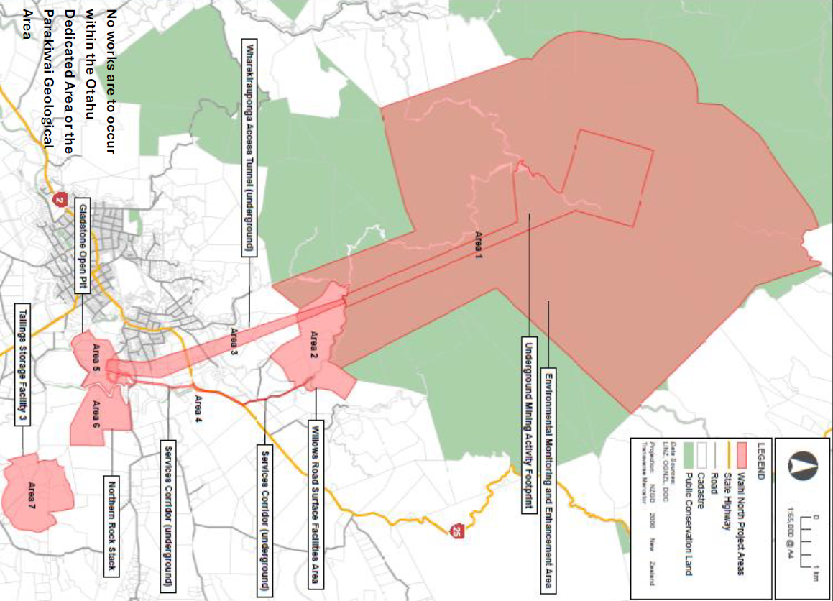

**SCHEDULE 5:**

**Map 2**

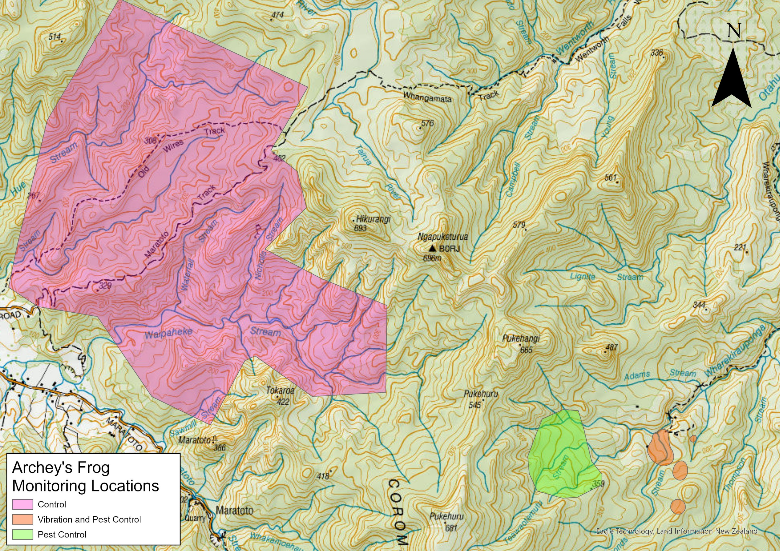

**Attachment 1: Amphibian and Reptile Distribution System (ARDS) card**

|  |  |  |  |  |  |  |  |  |  |  |  |  |  |  |  |  |  |  |  |  |  |  |  |  |  |  |  |  |  |  |  |  |  |  |  |  |  |  |  |
| --- | --- | --- | --- | --- | --- | --- | --- | --- | --- | --- | --- | --- | --- | --- | --- | --- | --- | --- | --- | --- | --- | --- | --- | --- | --- | --- | --- | --- | --- | --- | --- | --- | --- | --- | --- | --- | --- | --- | --- |
| ARDS CARD | **New Zealand Amphibian/Reptile Distribution Scheme** Herpetofauna Administrator, RD&I, Department of Conservation, P.O. Box 10420, Wellington. | | | | | | | | | | | | | | | | | | | | | | | | | | | | | | Card No: | | | | | | | | |
| Observer: |  |  |  | | | | | | | |  | | Date: | | | | | | | | | | Locality Name: | | | | | | | | | | | | | | | | |
| Initials |  | Surname | | | | |  | | |  | | Alt (m): | | | | | | | | | |
| Address: |  | | | | | | |  | | | | | | | | Easting | | | | | | | | | | | | Northing | | | | | | | | | | | |
|  |  | | | | | | |  | GPS | | | | | | |  | |  |  |  | |  | |  |  | |  |  |  | |  | |  | |  |  |  |  | |
|  | | | | | | | Series | | | | | | | Map No. | | | | | | Easting | | | | | | | | | | Northing | | | | | | | | |
|  | | | | | | |  |  |  | |  | |  | |  | |  |  |  | |  | |  |  | |  |  |  | |  | |  | |  |  |  |  |  | |
|  |  | | | | | | |  | | | | | | | | | | | | | | | | | | | | |  | | |  | | | | | | | |
| Affiliation: |  | | | | | | | Area Office: | | | | | | | | | | | Conservancy: | | | | | | | | | | | Ecol. District: | | | | | | | | | |
|  |  | |  | | | | |  | | | | | | | | | | | | | | | | | | | | | | | | | | | | | | | |
| Species name | | **No.** | | | **Time** | | Habitat | | | | Weather | | | | | | Weather Light   1. Fine/Sunny 2. Part Cloudy 3. Overcast 4. Showers 5. Rain 6. Night 7. 0-½ Moonlit 8. ½-1 Moonlit   Temperature   1. Hot 2. Warm 3. Moderate 4. Cool 5. Cold   Wind   1. Calm 2. Light breeze 3. Mod breeze 4. Gusty 5. Strong winds | | | | | | | | | Major Habitat Types  1. Beech Forest 2. Podocarp forest 3. Broadleaf forest 4. Exotic forest 5. Scrub 6. Sub-alpine 7. Alpine 8. Undeveloped tussock land 9. Developed farmland 10. River terrace 11. Fresh water | | | | | | | | | | | | | |
| e.g. *Hoplodactylus maculatus* | | 6 | | | 18:00 | | 16, D, E | | | | 6,2,1 | | | | | |
|  | |  | | |  | |  | | | |  | | | | | |
|  | |  | | |  | |  | | | |  | | | | | |
|  | |  | | |  | |  | | | |  | | | | | |
|  | |  | | |  | |  | | | |  | | | | | |
|  | |  | | |  | |  | | | |  | | | | | |
| Voucher specimen(s) | | | | Yes/No | | Specify: | | | | | | | | | | |
| Photograph(s) | | | | Yes/No | |  | | | | | | | | | | |
| Extra notes on reverse side | | | | Yes/No | |  | | | | | | | | | | | 1. Wet land 2. Coastal 3. Scree 4. Bare rocks 5. Beach 6. Urban | | | | | | | | Micro habitats  A Foliage  B Trunk  C Branches  D Under stones  E Under wood  F Open ground  G Crevices  H | | | | | |
| Notes: | | | | | | | | | | | | | | | | |
| Identified by:  Authority used: | | | | | | | | | | | | | | | | |