DECISION MADE BY THE PANEL: WAITAHA HYDRO SCHEME
TE WHAKATAUNGA A TE PAEWHIRI WHAKAWĀ WAITAHA HIKO-Ā-AWA
APPENDIX B: resource consent conditions | ĀPITIHANGA B: NGĀ herenga o ngā WHAKAAETANGA-ā-rawa
[Note to parties providing comment]

Structure
These conditions following a similar structure to those provided with the Application:
- Definitions
- Schedule 1: These are conditions that are common to WCRC and WDC. The number of the conditions contain a “CC” at the start to indicate that they are “Common Conditions” (for example, CC1, CC2, etc.)
- Schedule 2: These are conditions for WCRC consents. The number of the conditions contain a “RC” at the start to indicate that they are “Regional Conditions” (for example, RC1, RC2, etc.)
- Schedule 3: These are conditions for WDC consents. The number of the conditions contain a “DC” at the start to indicate that they are “District Conditions” (for example, DC1, DC2, etc.)
- Appendices. The number of the appendices also includes “CC” “RC” or “DC” at the start.
Reading notes
- These should be read alongside the Draft Decision, which provides an explanation for changes
- Defined terms are highlighted in bold
- Condition references highlighted in grey
- Cells where key changes have been made to conditions (outside of changes made for enforceability, readability, clarity, etc.) are shaded in green
- The original sections that demarcated specific regional conditions have been retained
- The Management Plan conditions have been restructured, which has necessitated consequential changes to the individual management plan requirements as originally set out.

Definitions
This table below defines the acronyms and terms used in the conditions.
Acronym/Term | Definition
AMP | Avifauna Management Plan
Application | The document titled “Westpower Limited Waitaha Hydro Project: An Application made under the Fast-track Approvals Act (2024)” dated 8 August 2025, including all technical assessments and supporting reports, as listed in Appendix A to this consent.
Bank | Means the land on either side of a river which confines the natural flow of the water whether the normal flow, or flood flows.  (source: Te Tai o Poutini Plan (Operative in Part)
BMP | Bat Management Plan
Bulk Earthworks | Large scale soil / rock disturbances associated with any Project Construction Works (excludes earthworks associated with Enabling Works).
CEMP | Construction Environmental Management Plan
Cleanfill Material | is material that when buried will have no adverse effect on people or the environment. Cleanfill material includes virgin natural materials such as clay, soil and rock, and other inert materials such as concrete or brick that are free of:  - combustible, putrescible, degradable or leachable components  - hazardous substances  - products or materials derived from hazardous waste treatment, hazardous waste stabilisation or hazardous waste disposal practices  - materials that may present a risk to human or animal health such as medical and veterinary waste, asbestos or radioactive substances  - liquid waste  - protruding reinforcing - any reinforcing must be cut off from the concrete face.  (source: Operative Regional Land and Water Plan)
Commencement Date / Commencement of this Consent | Means the date on which the decision is served under section 116 of the Resource Management Act 1991.
Commencement of Construction | The time when any Project Construction Work Component (excluding Enabling Works) first starts.
Completion of Construction | The time when the Waitaha Hydro Project has been built and commissioned and is available to generate electricity for customer supply.
Commencement of Generation | The date when the Project first transmits electricity onto the local network for customer supply.
Commissioning | Means the period commencing when water is first introduced to any part of the Waitaha Hydro Scheme for the purpose of testing, calibration, and initial operation of the intake, conveyance structures, Power Station, and associated infrastructure, and ending when the Scheme is ready for the Commencement of Generation.
Consents | Any resource consents granted under the FTAA that would otherwise have been granted under the RMA.
Concessions | Any concessions granted under the FTAA that would otherwise have been granted under the Conservation Act.
Concession Area | Area of the Project located on land administered by the Department of Conservation.
Consent Area | The total area of land covered by the Consents – equivalent to the total area of land used for the construction and operation of the Project. The area is shown in Appendix CC1.
Consent Holder | Westpower Limited
Construction | All activities related to constructing the Project excluding Enabling Works and Pre-Construction activities.
CNMP | Construction Noise Management Plan.
Consent Authority | Westland District Council, in respect of land use consents administered by Westland District Council; or  West Coast Regional Council, in respect of resource consents administered by West Coast Regional Council.
Conservation Act | Conservation Act 1987
Construction Staging Areas | Areas developed prior to or during Construction and used for plant and equipment laydown, construction contractor and staff offices and amenities, staff parking, helicopter landings and take-offs and other general construction-related activities. Construction Staging Areas within the Project Construction Site include:  - Construction Staging Area 1 (Headworks);  - Construction Staging Area 2 (Power Station Site); and  - Construction Staging Area 3 (McLean’s Farm).  These are shown in Appendix CC2.
CTMP | Construction Traffic Management Plan
DOC | Department of Conservation
DOC Liaison Officer | The designated Department of Conservation employee or external contractor who will act as a liaison contact between the Consent Holder and the Department of Conservation’s local Area Office during Construction.
DMP | Dust Management Plan
Enabling Works | Construction related activities (or any part thereof) NOT requiring removal of indigenous vegetation AND occurring outside the following locations:  - Any land within 10m of any stream; and  - Any land within 20m of any natural wetland.  Enabling Works may include, but are not necessarily limited to:  - Geophysical investigations or other non-invasive surveys or monitoring;  - Works necessary to implement sediment or erosion controls required in accordance with the certified ESCP;  - Establishment of Construction Staging Area 3 (McLean’s Farm);  - Re-grassing (spraying, sowing);  - Formation or upgrading of vehicle access roads within the Waitaha and Anderson Road Reserves and within the McLean Farm;  - Establishment of site entrances and fencing;  - Construction of surface water take infrastructure for construction activities;  - Construction of temporary structures;  - Any other construction related activity ordinarily permitted under any West Coast Regional Plan, the Westland District Plan, any National Environmental Standard, or any National Policy Statement.  Except for formation or upgrading of roads in a road reserve, Enabling Works can be undertaken without a certified CEMP and without a Pre-Construction Meeting.
EPA | the Environmental Protection Authority
ESCP | Erosion and Sediment Control Management Plan
FEMP | Freshwater Ecology Management Plan
FlushMP | Morgan Gorge Flushing Management Plan
FMP | Flight Management Plan
FTAA | Fast-track Approvals Act 2024
Headworks | The physical structures within the Scheme situated above Morgan Gorge comprising a low-profile weir and intake structure together with an access tunnel portal and access road.
LMP | Landscape Management Plan
LizMP | Lizard Management Plan
McLean Farm | Land within the Consent Area located north of, and adjacent to, the true right bank of Macgregor Creek described as Rural Section 933 and Rural Section 4047, Section 1-4 Survey Office Plan 11859 and Lot 2 Deposited Plan 376096, LOT 1 DP 339 LOT 2 DP 376096 SECS 1-4 SO 11859 RSEC 1 SO 481569 URAL SECS 933 4047 4023.
Operation / Operational | Means when Commissioning is complete and the Scheme is ready for the Commencement of Generation
Power Station | The physical structures within the Scheme situated immediately adjacent to, and in the vicinity of, the Waitaha River and the lower end of the Tunnels generally comprising the:  - Powerhouse;  - Tailbay;  - Tailrace;  - Switchyard; and  - all ancillary structures.
Power Station Site | The area comprising the Power Station
Power Station Access Road | The vehicle access road between the Anderson Road vehicle crossing and the Power Station Site.
Pre-Construction activities | Any activity associated with investigative drilling or geophysical investigations.
Project | Includes all physical resources and activities associated with constructing, operating and maintaining the Scheme and all ancillary structures and activities.
Project Construction Site | All land required to be used for the construction of the Project.
Project Site | All land required to be used for the operation and maintenance of the Project.
Project Construction Work Component | Specified components or phases associated with constructing the Project (including all associated activities (excluding Enabling Works)). Project Construction Work Components include:  - Construction Staging Area 3 (McLean’s Farm)and adjacent land-based gravel extraction / spoil disposal;  - Waitaha River gravel extraction;  - Construction of temporary access road and bridge to and over Granite Creek;  - Road formation and road upgrade works occurring in road reserve;  - Construction of new transmission lines and upgrades to existing transmission lines and access road north of the true right bank of Macgregor Creek;  - Construction of new access road and transmission lines south of the true left bank of Macgregor Creek and associated structures;  - Streamworks;  - Power Station Site and/or Tunnels including Construction Staging Area 2 (Power Station Site);  - Headworks including Construction Staging Area 1 (Headworks);  - Waitaha Substation re-build; and  - Rehabilitation works.
PRSRR | Public River Safety Risk Report
RMA | Resource Management Act 1991
Road Controlling Authority | In relation to a road,—  (a) means the authority, body, or person having control of the road; and  (b) includes a person acting under and within the terms of a delegation or authorisation given by the controlling authority  (source: Land Transport Act 1998)
Scheme | The Waitaha Hydro Scheme.
SMP | Stormwater Management Plan
SOMP | Site Operations and Maintenance Plan
SSSHA | Site Specific Seismic Hazard Assessment
SQEP | Means a suitably qualified and experienced person or persons, who  individually or collectively hold the professional qualifications, training,  and experience relevant to the particular task or subject matter. .
Stable Trib | Refers to the Stable Tributary (shown Appendix RC2 and DC2)
Streamworks | All physical works undertaken within, and involving the disturbance of, any stream or riverbed excluding riverbed gravel extraction.
Tunnels | All physical structures associated with the water tunnel and the access tunnel included in the Scheme.
Transmission Line | The physical structures comprising the electricity transmission infrastructure between the Power Station Site and the existing Waitaha Substation.
VMP | Vegetation Management Plan
Water body | means fresh water or geothermal water in a river, lake, stream, pond, wetland, or aquifer, or any part thereof, that is not located within the coastal marine area  (source: RMA s.2)
WCRC | West Coast Regional Council
WDC | Westland District Council
Wildlife Permits | Any Wildlife Permits granted under the Fast-track Approvals Act 2024 that would otherwise be granted under the Wildlife Act.
WWNZ | Whitewater NZ Incorporated

Schedule One: Conditions Common to WCRC and WDC Consents
 | General
CC1 | The activities authorised by this consent must be undertaken in general accordance with the information contained in the Application.  Advice Note: The Consent Area is shown in Appendix CC1.
 | Inconsistency
CC2 | Where there is inconsistency between:  - the information identified in Condition CC1 above and these conditions, these conditions shall prevail;  - the information and plans lodged with the Application and further information provided post lodgment, the most recent information and plans shall prevail; and  - the conditions of these resource consents and the provisions of a certified version of a management plan, monitoring plan or any other document submitted to the relevant Consent Authority for certification, the conditions of these resource consents shall prevail.
 | Costs
CC3 | The Consent Holder must meet all reasonable and invoiced costs associated with monitoring procedures undertaken by the relevant Consent Authority, or its authorised agents, to establish compliance with the conditions of these consents.
 | Project Website / Virtual Information Source
CC4 | The consent holder must establish a project website, or equivalent virtual information source, within six (6) months following the Commencement Date and must maintain it for the life of the Project. The website or virtual information source shall include a copy of these conditions and shall provide information on:  - the status of the Project;  - anticipated construction timeframes;  - certified management plans;  - contact details for enquiries and recreational track access during construction;  - how to file complaints  - a subscription service to enable receipt of project updates by email;  - annual reports;  - recreational track status (open / closed);  - maintenance activities at the Headworks;  - no-take days; and  - the following water flow data (as required by Condition RC126)  - Station Inflow  - Waitaha River Flow;  - Residual Flow to abstraction reach; and  - Water tunnel diversion flow.
CC5 | The website, or equivalent virtual information source will be updated (as a minimum):  - at the start of any Project Construction Work Component;  - when any management plan or amendment to a management plan is certified;  - where any Construction or Operational activity may impact public safety; and  - when there is any change to no-take days.
CC6 | The Consent Holder must give written notice to the parties identified in Schedule Four as soon as reasonably practicable once the website, or equivalent virtual information source has been established.  Advice Note: The Consent Holder should also consider providing details to recreational groups that exist at the Commencement of Construction.
 | Management Plans
 | Certification by Consent Authority and Submission Dates
CC7 | - The following documents must be submitted to WCRC for certification by the submission date specified in Table 1 below:  Table 1: Documents to be certified by WCRC and submission dates  - The following documents must be submitted to WDC for certification by the submission date specified in Table 2 below:  Table 2: Documents to be certified by WDC and submission dates  Advice Note: Refer to Condition CC11 for the plans required under each Project Construction Work Component, and Condition CC12 for plans required for Operation of the Scheme. To assist the Councils with certification, the Consent Holder should give as much notice as possible of intent to submit a management plan for certification.
  Document | Submission Date
  - Erosion and Sediment Control Management Plan | At least ten (10) working days prior to the commencement of a Project Construction Work Component
  - Dust Management Plan | At least thirty (30) working days prior to the commencement of a Project Construction Work Component
  - Freshwater Ecology Management Plan | At least ten (10) working days prior to the commencement of a Project Construction Work Component
  - Morgan Gorge Flushing Management Plan | At least twelve (12) months following the Commencement of Generation
  - Site Operations and Maintenance Plan | At least sixty (60) working days prior to the Commencement of Generation
  - Stormwater Management Plan | At least sixty (60) working days prior to the Commencement of Generation
  - Monitoring Plan | At least sixty (60) working days prior to the Commencement of Generation
  Document | Submission Date
  - Construction Environmental Management Plan | At least ten (10) working days prior to the commencement of a Project Construction Work Component
  - Construction Traffic Management Plan | At least thirty (30) working days prior to the commencement of a Project Construction Work Component
  - Construction Noise Management Plan | At least thirty (30) working days prior to the commencement of a Project Construction Work Component
  - Flight Management Plan | At least thirty (30) working days prior to the commencement of a Project Construction Work Component
  - Lizard Management Plan | At least fifteen (15) working days prior to the commencement of a Project Construction Work Component
  - Vegetation Management Plan | At least fifteen (15) working days prior to the commencement of a Project Construction Work Component
  - Avifauna Management Plan | At least fifteen (15) working days prior to the commencement of a Project Construction Work Component
  - Bat Management Plan | At least fifteen (15) working days prior to the commencement of a Project Construction Work Component
  - Landscape Management Plan | At least fifteen (15) working days prior to the commencement of a Project Construction Work Component
CC8 | The management plans submitted to the relevant council for certification must be in general accordance with the draft management plans that formed part of the Consent Holder’s FTAA Application (where applicable), except as amended to:  - to provide a more stringent management approach;  - align the management plans with consent conditions; or  - incorporate comments made by the councils, or the Department of Conservation (where relevant) on the draft management plans.  Advice Note: the following draft management plans formed part of the Application: the Lizard Management Plan, Freshwater Ecology Management Plan, Vegetation Management Plan, Avifauna Management Plan, Bat Management Plan, Erosion and Sediment Control Mangement Plan and Landscape Management Plan.
CC9 | All management plans must:  - be prepared and implemented in accordance with the relevant management plan condition(s);  - be prepared by a SQEP having regard to the subject matter of the management plan;  - if relevant, include commentary in accordance with Condition CC10(e) where Department of Conservation consultation is required;  - include sufficient detail relating to the management of effects associated with the relevant activities and/or Project Construction Work Component to which it relates; and  - once certified, be uploaded to the Project website or equivalent virtual information source as required by Condition CC4 and CC5.
 | Comments by Department of Conservation on Selected Management Plans
CC10 | - Prior to submitting the management plans for the following Project Construction Work Components for certification, the Consent Holder must invite the Department of Conservation to review the management plans and provide comments, suggest amendments or additions to each plan within 20 working days of the management plan being provided to the Department:  - Construction of a new access road and transmission lines across and south of the true left bank of Macgregor Creek  - Streamworks  - Headworks including Construction Staging Area 1  - Power Station Site and/or Tunnels including Construction Staging Area 2  - The Consent Holder must take into account all comments and suggested amendments and additions to each plan received from the Department of Conservation.  - The Consent Holder must prepare a document (or documents) outlining what if any amendments or additions have been made to each plan in response to comments and suggestions made by the Department of Conservation and provide that document to the Westland District Council or West Coast Regional Council contemporaneously with each plan when it is submitted for certification or recertification.  - The document required under (c) must include an explanation of where any comment or suggestion made by the Department of Conservation has not been incorporated into the plan and the reasons why.  - A copy of each plan that is submitted for certification must be provided to the Department of Conservation for their information, together with the document required under Condition CC10(c).  - The Consent Holder must meet all of the Department of Conservation’s actual and reasonable costs associated with reviewing and providing feedback on the management plans listed in Condition CC10(a).  Advice Note: The management plans noted in this condition relate to works or activities on, over, or under land administered by the Department of Conservation.
 | Plans required for each Project Construction Work Component
CC11 | - Construction must not commence for a Project Construction Work Component until the management plans for that Project Construction Work Component as listed in Table 5 are certified:  Table 3: Management Plans required for each Project Construction Work Component  - Management plans submitted for certification may address one or more Project Construction Work Components.
  Project Construction Work Component | Management Plans required to be certified before Commencement of Construction
  Construction Staging Area 3 and adjacent land-based gravel extraction / spoil disposal. | - Erosion and Sediment Control Management Plan  - Dust Management Plan  - Construction Traffic Management Plan  - Construction Noise Management Plan
  Waitaha River gravel extraction. | - Dust Management Plan  - Construction Traffic Management Plan  - Construction Noise Management Plan
  Road formation and road upgrade works occurring in road reserve. | - Erosion and Sediment Control Management Plan  - Dust Management Plan  - Construction Traffic Management Plan  - Construction Noise Management Plan  - Lizard Management Plan
  Construction of new transmission lines and upgrades to existing transmission lines and access road north of the true right bank of Macgregor Creek | - Construction Environmental Management Plan  - Flight Management Plan (if helicopters are used)  - Construction Noise Management Plan
  Construction of new access road and transmission lines across and south of the true left bank of Macgregor Creek | - Construction Environmental Management Plan  - Erosion and Sediment Control Management Plan  - Dust Management Plan  - Construction Traffic Management Plan  - Construction Noise Management Plan  - Freshwater Ecology Management Plan  - Vegetation Management Plan  - Avifauna Management Plan  - Bat Management Plan  - Lizard Management Plan  - Landscape Management Plan
  Streamworks | - Construction Environmental Management Plan  - Flight Management Plan (if helicopters are used)  - Erosion and Sediment Control Management Plan  - Construction Noise Management Plan  - Freshwater Ecology Management Plan
  Headworks including Construction Staging Area 1 | - Construction Environmental Management Plan  - Erosion and Sediment Control Management Plan  - Dust Management Plan  - Construction Traffic Management Plan  - Flight Management Plan (if helicopters are used)  - Construction Noise Management Plan  - Freshwater Ecology Management Plan  - Vegetation Management Plan  - Avifauna Management Plan  - Bat Management Plan  - Lizard Management Plan  - Landscape Management Plan
  Power Station Site and/or Tunnels including Construction Staging Area 2 | - Construction Environmental Management Plan  - Erosion and Sediment Control Management Plan  - Dust Management Plan  - Construction Traffic Management Plan  - Flight Management Plan (if helicopters are used)  - Construction Noise Management Plan  - Freshwater Ecology Management Plan  - Vegetation Management Plan  - Avifauna Management Plan  - Bat Management Plan  - Lizard Management Plan  - Landscape Management Plan
  Waitaha Substation works | - Construction Environmental Management Plan  - Erosion and Sediment Control Management Plan  - Construction Traffic Management Plan  - Construction Noise Management Plan
  Rehabilitation Works | - Vegetation Management Plan  - Landscape Management Plan
 | Plans required for Operation
CC12 | The following Operational management plans must be certified before the Commencement of Generation:  - Site Operations and Maintenance Plan;  - Monitoring Plan; and  - Stormwater Management Plan.  Advice Note: It is noted that the Monitoring Plan required under Condition RC126 is to be included within the SOMP.
 | Consent Holder must implement the Management Plans
CC13 | The Consent Holder must implement and comply with all management plans (including  amendments to those plans) for the duration of the relevant activity, or as otherwise specified in  the relevant management plan condition(s).
CC14 | The Consent Holder must undertake all activities authorised by these Consents in accordance with the relevant Management Plans referred to in Conditions CC11 and CC12.
 | Amendments to Plans
CC15 | The Consent Holder may make amendments to any of the management plans referred to in Condition CC11 and Condition CC12 at any time.
CC16 | A certified management plan may be amended to reflect minor changes in design, construction methods, or management of effects, without requiring recertification, provided that the amendment does not result in a materially different outcome to that described in the certified plan. Minor amendments must be discussed with the relevant Council and submitted for written confirmation that the changes are minor prior to implementation.
CC17 | Any amendment to a certified Management Plan that would result in a materially different outcome must be prepared in accordance with the requirements of Condition CC8 to CC10 and submitted to the relevant Consent Authority for recertification prior to implementation.
CC18 | Any works associated with a material amendment must not commence until the amendment has been certified in accordance with the relevant certification condition.
 | Copies of Management Plans
CC19 | Until Completion of Construction, copies of all current and certified management plans for a Project Construction Work Component(s) referred to in Condition CC11 must always be kept at Construction Staging Area 3 (McLean’s Farm).
CC20 | From the Commencement of Generation, and to the extent of their respective tenures, copies of all current, certified Management Plans referred to in Condition CC12 must always be kept at the Power Station Site.
 | Pre-commencement meeting – Project Construction Work Components
CC21 | Not less than 10 days prior to the anticipated commencement of any Project Construction Work Component(s), the Consent Holder must schedule and attend a pre-construction meeting on the Project Site with the Consent Authorities and the contractor(s) who will manage or undertake the works associated with the relevant Project Construction Work Component(s).  Advice Note: The purpose of this meeting is so that all parties in attendance are aware of the scale and scope of works to be undertaken and are familiar with relevant consent conditions and Management Plan requirements that apply.
CC22 | The following information must be made available at the pre-construction meeting by the Consent Holder:  - scheduling and staging of the works, including the proposed start date;  - relevant consent conditions;  - contact details for all relevant parties;  - site visit / inspection requirements; and  - copies of any Management Plans required for the Project Construction Work Component(s) as set out in Condition CC11.
 | Enabling Works
CC23 | Except for formation or upgrading of roads in a road reserve, the Consent Holder may undertake Enabling Works without a certified CEMP and without a Pre-commencement meeting.
 | Hours of Construction
CC24 | The Consent Holder must limit hours of construction for specific activities in accordance with the following table:  Table 4: Hours of Construction
  Construction Activity | Hours of Construction
  Underground tunnel construction and associated activities | Any time
  Construction of tunnel portals and the Headworks | Any time, provided that works undertaken between 7 PM and 7 AM are avoided whenever practicable
  All other construction activities | Between the hours of 7 AM and 7 PM Monday to Sunday inclusive
 | Disturbance Area and Project Footprint Limits
 | Construction Disturbance Area Limits
CC25 | The total land area disturbed or used during construction activities authorised by these Consents must not exceed the following:  Table 5: Construction Disturbance Area Limits  Advice Note: For the avoidance of doubt, the maximum areas set out in this condition exclude construction disturbances located between the northern boundary of the McLean Farm and the Waitaha substation – being minor disturbances associated with the construction of the new transmission line along Waitaha Road, upgrades and creation of vehicle passing bays on Waitaha Road, and upgrades to existing transmission line between the Waitaha Rd / SH6 intersection and Waitaha substation.
  Project Construction Site | Maximum Area (ha)
  Headworks | 1.2
  Power Station Site and access road / transmission line south of Macgregor Creek, alternative walking track | 6.2
  McLean Farm including Construction Staging Area 3, Spoil Disposal Areas, access road, transmission lines and gravel screening | 28
  Overall Total | 35.4
 | Indigenous Vegetation Disturbance Area Limits
CC26 | The total area of indigenous vegetation permanently removed as a result of activities authorised by these Consents must be not exceed the following:  Table 6: Indigenous Vegetation Disturbance Area Limits
  Project Construction Site / Project Site Areas | Maximum Area (ha)
  Headworks | 0.13
  Power Station Site including tailrace and alternative walking track | 0.73
  Access Road / transmission line south of Macgregor Creek | 3.46
  McLean Farm including Construction Staging Area 3, Spoil Disposal Areas, access road, transmission lines and gravel screening | 0.21
  Overall Total | 4.45
 | Permanent Scheme Footprint
CC27 | The maximum operational footprint of the Project Site must not exceed the following:  Table 7: Project Site Area Limits  Advice Note: For the avoidance of doubt, the maximum areas set out in this condition exclude transmission lines located between the northern boundary of the McLean Farm and the Waitaha substation.
  Project Site Area | Maximum Area (ha)
  Headworks | 0.3
  Power Station Site and access road / transmission line corridor south of Macgregor Creek | 4.7
  McLean Farm including, access road, transmission lines | 6.5
  Overall Total | 11.5
 | Accidental Discovery Protocols
CC28 | If, at any time during any authorised earthworks, Streamworks or gravel extraction activities, any archaeological features (including human remains, archaeology and artefacts) are uncovered, works in the immediate site must cease, the area immediately surrounding the discovery must be appropriately protected and Poutini Ngāi Tahu, WCRC, WDC, Heritage New Zealand Pouhere Taonga must be notified immediately. If any archaeological features are uncovered in the Concession Area, DOC must also be notified; and if any human remains are uncovered, the New Zealand Police, must be notified immediately.  In all cases, the following protocols must be followed:  Wait for and enable inspection of the site  - Stop work and wait for the site to be inspected by the relevant authority or agency:  - The New Zealand Police are required to investigate the human remains to determine whether they are those of a missing person or are a crime scene. The remainder of this process will not apply until the New Zealand Police confirm that they have no further interest in the discovery.  - A site inspection for the purpose of initial assessment and response will be arranged by the Consent Authorities in consultation with Heritage New Zealand Pouhere Taonga and appropriate Poutini Ngāi Tahu representatives.  - Following site inspection and consultation with all relevant parties (including the Consent Holder), the Consent Authorities will determine the area of the site within which work must cease, until the requirements of this condition have been satisfied.  Recommencement of work  - Work within the area determined by the Consent Authorities must not recommence until all of the following requirements, so far as relevant to the discovery, have been met:  - Heritage New Zealand Pouhere Taonga has confirmed that an archaeological authority has been approved for the work or that none is required;  - Any required notification under section 11(3) of the Protected Objects Act 1975 ;  - Any material of scientific or educational importance has been recorded and if appropriate recovered and preserved; and  - Where the site is of Māori origin and an authority from Heritage New Zealand Pouhere Taonga is not required, the Council will confirm, in consultation with Poutini Ngāi Tahu, that:  - Any kōiwi have either been retained where discovered or removed in accordance with the appropriate tikanga; and  - Any agreed revisions to the planned works to be/have been made to address adverse effects on Māori cultural values.
 | Pounamu Accidental Discovery Protocol
CC29 | If, at any time during any earthworks, Streamworks or gravel extraction activities authorised by these consents, any pounamu (greenstone) is discovered, the Consent Holder must implement the following Pounamu Accidental Discovery Protocol:  - Any pounamu (greenstone) accidentally discovered should be reported to the Pounamu Management Officer of Te Rūnanga o Ngāi Tahu as soon as is practicable.  - Any artefact made of pounamu discovered or found within the Ngāi Tahu takiwā should be left untouched and notified immediately to the local regional museum who will in turn notify Ngāi Tahu. If the artefact happens to be collected it should be handed directly to the appropriate regional museum along with all information about the find.  - In the event that the finder considers the pounamu is at immediate risk of loss such as erosion, animal damage to the site or theft, the pounamu/greenstone should be carefully covered over and/or relocated to the nearest safe ground. The find should then be notified immediately to the Pounamu Management Officer.  - All pounamu discovered, other than through authorised collection, regardless of size is the property of Te Rūnanga o Ngāi Tahu and cannot be removed without consultation with Te Rūnanga o Ngāi Tahu and authorisation from the appropriate Kaitiaki Rūnanga.  - Fossicking for pounamu by the public is only allowed on beaches along the West Coast and is limited to what an individual can carry by hand or bag/backpack and is limited to one such take per 24 hour period.  Advice Note: Pursuant to the Ngāi Tahu (Pounamu Vesting) Act 1997, all natural state pounamu/greenstone in the Ngāi Tahu tribal area is owned by Te Rūnanga o Ngāi Tahu. The Ngāi Tahu Pounamu Resource Management Plan provides for the above measures. Other policies include: Kaupapa 20 & 21 – Customary and Cultural Collection Policies (p.92) Kaupapa 25 Extraction Policy for Te Rūnaka o Kāti Waewae Takiwā (p.99) Kaupapa 26 Extraction Policy for Te Rūnanga o Makaawhio Takiwā (p.99) Refer map (p.141) for Rūnanga rohe boundaries.
 | Emergency sirens
CC30 | Emergency sirens must:  - be designed so that they are audible in the vicinity of the Headworks and Power Station where staff and recreational users / the public need to be alerted of sudden river level changes; and  - be designed in consultation with a suitably qualified and experienced ecologist to limit noise exposure to wildlife as far as practicable.
 | Pre-Commissioning Notification
CC31 | The Consent Holder must notify the Consent Authority in writing at least one (1) week prior to the start of Commissioning.
 | Consent Compliance
CC32 | The Consent Holder must supply a copy of these Consents, including conditions and relevant Management Plans, to any agent or contractor undertaking any activities authorised by these Consents.
 | Annual Report
CC33 | By 30 September each year following the Commencement of Generation, the Consent Holder must provide an Annual Report to the WCRC, WDC and DOC covering the period from 1 July of the preceding year to 30 June of the reporting year that contains the following information:  - A general description of operations including any major maintenance and/or operational or compliance issues including frequency, duration, and spatial extent of in-stream sediment excavation works required above the Headworks;  - All Monitoring Plan data collected during the reporting period;  - Within the first five years following the Commencement of Generation, a description of all restoration planting areas including monitoring and maintenance records as set out in the VMP;  - Results of ongoing ecological monitoring undertaken in accordance with the FEMP along with a critical analysis of any trends identified, any recommended adaptive management responses along with any associated recommended amendments to the SOMP, Monitoring Plan, and FEMP;  - Confirmation of all recreation and WWNZ compensation payments required to be made within the annual reporting period in accordance with Conditions RC132 to RC134, along with the details of all no-take days agreed with WWNZ and any cancelled no-take days including details of when compensation payments were made, the amounts of any payments and the contact details of a person acting on behalf of WWNZ who is able to confirm the payment’s receipt;  - Confirmation of all ecological compensation payments required to be made within the annual reporting period in accordance with Conditions DC59 to DC65, including details of when compensation payments were made, what entities received the payments, the amounts of payments and contact details of a person acting on behalf of each entity who is able to confirm the payment’s receipt;  - Results of any other operational information required in accordance with the SOMP;  - Details associated with any complaints received and any associated corrective actions undertaken; and  - Details of any future significant changes to the Scheme or its operations.
 | Review
CC34 | Pursuant to Section 128 of the Resource Management Act 1991, the Consent Authority may review the conditions of these Consents by serving notice within a period of three months commencing each anniversary of the commencement of the consent for any of the following purposes:  - To deal with any adverse effect on the environment which may arise from the exercise of these Consents and which it is appropriate to deal with at a later stage.  - To require the Consent Holder to adopt the best practicable option to remove or reduce any adverse effect on the environment.  - To address in-stream effects associated with continued exceedance of in-stream excavation works as identified in the In-Stream Works Review Report (Condition RC111).  Advice Note: Any review must, in addition to addressing the requirements of the RMA, have particular regard to the purpose of the FTAA.

Schedule Two: WCRC Conditions
These conditions apply to regional consents held by Westpower Limited in relation to:
- Undertaking of earthworks and vegetation disturbance within riparian margins, Erosion Prone Area One (including land-based gravel extraction activities) and Erosion Prone Area Two.
- Gravel extraction from the beds of the Waitaha River and Macgregor Creek.
- The take of water from the Waitaha River for tunnel drilling, concrete batching plant operations, dust suppression and other ancillary construction activities.
- The temporary diversion of Waitaha River flows for the construction of the Headworks, the Power Station tailrace and for the construction of crossing structures for flowing tributary water bodies.
- Discharge of contaminants to air from a concrete batching plant.
- Discharge of concrete batching plant and concrete equipment wash water to land.
- Discharge of spoil material to land.
- Placement, use, maintenance and removal of structures in, on or over the beds of rivers and streams associated with the Waitaha Hydro Scheme including, but not limited to:
  - All Headworks structures located on the bed of the Waitaha River including the diversion weir and intake structure;
  - Box culvert structures in the beds of Alpha Creek, Allen Creek and an unnamed tributary of the Waitaha River;
  - The drift deck structure for the Macgregor Creek crossing;
  - The temporary and permanent Granite Creek Bridges;
  - The Alpha Creek and Macgregor Creek flow training structures / bunds;
  - Parts of the Power Station tailrace and flood protection structures located on the bed of the Waitaha River;
  - Parts of the permanent accessway between the Headworks access tunnel portal and the Waitaha River edge located on the bed of the Waitaha River;
  - Water level and river flow recording devices; and
  - all works, including Streamworks, associated with construction, maintenance and removal of all structures listed above.
- The take, use and diversion of water from the Waitaha River for hydro-electric power generation purposes.
- The take, use and diversion of groundwater into the pressurized water and access tunnels.
- The use of water diverted into the pressurized water tunnel for Power Station equipment cooling, staff potable supply and other general Power Station Site operations and maintenance.
- The diversion of Waitaha River flows over the Headworks diversion weir including the kōaro passage structure, through the Headworks residual flow gate and channel and through the sluice gate and chamber.
- Incidental discharges of contaminants to water resulting from the maintenance of in-stream structures including any associated adjacent, upstream or downstream Streamworks.
- Discharges to air associated with intermittent operation of an emergency diesel fired generator at the Power Station Site.

General (applicable to all WCRC consents)
 | General
RC1 | The activities authorised by this consent must be undertaken in general accordance with the information contained in the Application.
 | Common Conditions
RC2 | The Consent Holder must comply with the conditions common to WCRC and WDC Consents set out in Schedule One.
 | Lapse and Expiry
RC3 | Pursuant to Section 87(b) of the FTAA, these consents shall lapse if not given effect to within 10 years of the Commencement Date.
RC4 | Pursuant to Section 96 of the FTAA, the following consent shall expire fifteen (15) years from the Commencement Date unless they have been surrendered or cancelled at an earlier date:  - XXXXXX  - XXXXXX
RC5 | Pursuant to Section 96 of the FTAA, the following consent shall expire thirty-five (35) years from the Commencement Date unless they have been surrendered or cancelled at an earlier date:  - XXXXXX  - XXXXXX
RC6 | At least twenty (20) working days prior to the first exercise of any one or more of these consents, the Consent Holder must advise WCRC in writing of the date upon which the exercising of any one or more of these will commence.
 | Notification of Non-Compliance and Fuel Spill
RC7 | Unless otherwise stated in these Consents, in the event of any breach of compliance with the conditions of these Consents and in the event of any fuel spillage in excess of 20 litres that occurs onto the land surface or into water, the Consent Holder must notify the Consent Authority immediately after becoming aware of the breach.
RC8 | Within 7 working days of becoming aware of the breach, the Consent Holder must provide written notification to the Consent Authority, which explains the cause of the breach, and steps which were taken to remedy the breach and steps which will be taken to prevent any further occurrence of the breach.  Advice Note: “immediately after” reporting required by this condition can be undertaken at any time via the WCRC’s pollution hotline (0508 800 118)
 | Sediment losses
RC9 | The Consent Holder must manage construction, operational, and maintenance activities authorised by these consents so as to avoid sediment discharges to natural water bodies where practicable and otherwise minimise sediment discharges.
 | Didymo
RC10 | To prevent the spread of Didymo or any other aquatic pests, all Project activities must be undertaken in accordance with the Biosecurity New Zealand's hygiene procedures.  Advice note: You can access the most current version of these procedures from the Biosecurity New Zealand website http://www.biosecurity.govt.nz

(C2) Specific Conditions: Section 9 - Land Use Consent: Earthworks and Vegetation Clearance
 | Recreation Access Track
RC11 | Prior to Construction, the consent holder must:  - in consultation with Department of Conservation, design the alternative track access in accordance with the Tramping Track Standard described in the New Zealand Handbook Tracks and Outdoor Visitor Structures SNZ HB8630:2004.  - construct the alternative track access on the true right bank of the Waitaha River, in general accordance with the location shown in Appendix RC0.  Advice Note: The alternative access track is provided to minimise visitor views of the new access road, transmission line corridor and Power Station Site construction areas and activities.
 | Dust Management Plan
RC12 | - The objective of the DMP is to set out the practices and procedures to be adopted to manage and minimise the generation of dust emissions from construction activities so that they do not cause an objectionable or offensive effect beyond the boundary of the Project Site.  - The DMP must include (as a minimum):  - Confirmation of the parties responsible for dust management during Construction;  - Identification of sensitive receivers to potential dust effects and specific works methodologies for undertaking works in proximity to these parties;  - Proposed dust control methods including concrete batching plant dust management methods and confirmation of an adequate water supply with sufficient capacity so that damp ground conditions can be maintained within the site during high dust risk periods; and  - Protocols for responding to and addressing any complaints received.
RC13 | All construction activities must be undertaken so that there is no discharge of particulate matter that causes an objectional effect beyond the Project Site.
 | Erosion and Sediment Control Management Plan
RC14 | - The objective of the ESCP is to manage and minimise erosion and sediment discharges from construction work areas.  - The ESCP must be prepared in accordance with the principles of the Environment Canterbury document “Erosion and Sediment Control Toolbox for Canterbury” (ECAN ESC Toolbox) and must include (as a minimum):  - Methods for minimising erosion and mobilisation of sediment during all earthwork activities, and in particular, specific sediment discharge protection measures for the “Stable Trib” shown in Appendix RC2 of this consent and in accordance with Condition RC20;  - Methods for controlling mobilised sediment during construction related earthworks including locations, dimensions and capacities of all controls to achieve the discharge quality standard set out in Condition RC22 of this consent;  - Methods for minimising mobilisation of sediment and release of cementitious contaminants to water during all Streamworks activities;  - Methods for monitoring and treating any high-pH water generated during the application of shotcrete in tunnels to achieve the discharge quality standard set out in Condition RC22; and  - Erosion and sediment control device monitoring and maintenance or replacement requirements including maintaining levels of accumulated sediment within any sediment retention pond of no more than 20% of the pond’s volume.
 | Pre-Commencement Notification
RC15 | The Consent Authority must be notified at least five (5) working days prior to Bulk Earthworks and vegetation clearance activities commencing on the Project Site.
 | Land-based Gravel Extraction
RC16 | The Consent Authority must be notified at least five (5) working days prior to Bulk Earthworks and vegetation clearance activities commencing on the Project Site.
RC17 | All land-based gravel extraction activities must be confined to the Consent Area denoted in Appendix RC1 of this consent.
RC18 | The Consent Holder must not take more than a total volume of 100,000m³ of gravel material from the Consent Area denoted in Appendix RC1.
RC19 | All land-based gravel extraction areas must be backfilled and rehabilitated in accordance with the ESCP and LMP.
 | Access road between Macgregor Creek and the Power Station
RC20 | Prior to finalising the alignment of the access road between Macgregor Creek and the Power Station, the Consent Holder must:  - accurately determine and mark the location of the banks of the Stable Tributary (‘Stable Trib’) by way of a ground survey; and  - design the alignment of the access road so that all parts of the access road, including the road formation, batters, cut and fill areas, drainage structures, and any associated earthworks, are located 20 metres away from the bank of the Stable Tributary, as identified by the ground survey.
 | During Earthworks
RC21 | The Project Site must be progressively stabilised against erosion at all stages of the earthwork activity and must be sequenced to minimise the discharge of contaminants to groundwater and/or surface water in accordance with any certified ESCP.
RC22 | Any discharge to surface water from any construction phase water treatment device must comply with the following quality standards:  - Clarity of no less than 100mm; and  - pH of between 6.7 and 8.2;
RC23 | The erosion and sediment control measures must be maintained throughout the duration of the earthwork activity at that site, or until the site is permanently stabilised against erosion. A record of any maintenance work to the erosion and sediment control measures must be kept by the Consent Holder and be supplied to WCRC on request.
RC24 | All earthworks must be managed so that they do not lead to any instability or collapse either adversely affecting the site, neighbouring properties or water courses. If such collapse or instability does occur and results in one or more of these adverse effects, it must be reported to the WCRC immediately following the Consent Holder becoming aware of the instability or collapse and must be repaired by the Consent Holder as soon as practicable.  Advice Note: “immediately following” reporting required by this condition can be undertaken at any time via the WCRC’s pollution hotline (0508 800 118)
RC25 | All imported fill used within the Project Site must:  - comply with the definition for Cleanfill Material;  - be solid material of a stable, inert nature; and  - not contain hazardous substances or contaminants above recorded natural background levels of the receiving site.
RC26 | All machinery must be maintained and operated in a manner that reduces risks of spillages of hazardous substances such as fuel, oil, grout, concrete products and any other contaminants are avoided or otherwise minimised.
RC27 | The maximum area of any unstabilised parts of the spoil disposal areas located on the McLean’s Farm (Construction Staging Area 3) must not exceed 1 hectare at any one time.

(C3) Specific Conditions: Section 13 - Land Use Consent: River Gravel Extraction
 | Gravel Extraction Limits
RC28 | River gravel extraction is limited to the area shown in Appendix RC3.
RC29 | The Consent Holder must not take more than a total volume of 23,000m³ of gravel from the area shown in Appendix RC3.
RC30 | Notwithstanding Condition RC29, if the Consent Holder is advised in writing by the Consent Authority that the Consent Authority reasonably considers that the available gravel resource has become depleted, the Consent Holder must cease or reduce its gravel extraction to the extent directed by the Consent Authority.
 | Pre-Gravel Extraction Activities
RC31 | Prior to any gravel extraction works being undertaken, the Consent Holder must engage a qualified and experienced ecologist (Supervising Ecologist) to visually inspect the riverbed to determine if nesting At Risk and/or Threatened avifauna are present.
RC32 | If nesting At Risk and/or Threatened avifauna are present:  - a 50 metre setback from each nest must be demarcated by the Supervising Ecologist;  - Works in the vicinity of nesting birds must be monitored by the Supervising Ecologist; and  - Works must cease if the Supervising Ecologist determines that the birds have become distressed, and must not recommence until the nest has fledged or failed.
 | Gravel Extraction Operations
RC33 | Gravel extraction activities within the bed of the Waitaha River authorised by this consent must not occur simultaneously with stone removal activities authorised by Resource Consent RC-2019-0037.
RC34 | The Consent Holder must notify the Consent Authority in writing at least one working day prior to the commencement of any period of gravel extraction operations. The written notice required by this condition must include;  - the estimated duration of gravel extraction operations;  - the name of the agent(s) or contractor(s) undertaking the gravel removal and whether or not the equipment they propose to use has been used previously in water bodies containing Didymosphenia geminata (Didymo); and  - the anticipated quantity of gravel for each period of extraction.
RC35 | The bed disturbance and excavation and gravel removal must be undertaken:  - only in the dry bed of the river when the bed is not submerged by high river flows;  - at least 6 metres from the bank of any water body;  - by excavating in strips that are parallel to the flow of the river and not by excavating holes;  - to a depth no greater than 0.1 metres above the current water level in the flowing channel at the time of extraction; and  - by working back from, and no closer than, 4 metres from the closest water edge.
RC36 | Gravel extraction must not occur within:  - any area of indigenous vegetation; or  - 50 metres of any bridge in the riverbed; or  - 20 metres of any other structure.
RC37 | Within five (5) working days of the completion of the period of gravel extraction operations notified to WCRC in accordance with Condition RC34(a), the Consent Holder must restore the gravel extraction site. Restoration required by this condition must, as a minimum, include the following:  - reject, surplus or unused gravel must be spread out evenly over the beach or adjacent dry bed areas;  - stripping areas must be left with battered slopes of a gentle contour;  - removing all equipment and signs associated with the operation; and  - all gravel heaped up during the process of removal must be spread out as per Condition RC37(a) above.
RC38 | The site must be left tidy with all machinery removed from the riverbed at the completion of each day’s activities.
RC39 | River gravel extraction and screening activities must be undertaken so that there is no discharge of particulate matter that causes an objectional effect beyond the area shown in Appendix RC3.
 | River Gravel Extraction Reporting
RC40 | The Consent Holder must on an annual basis, and no later than 31 January each year, provide the Consent Authority records of gravel volumes removed during the previous calendar year (i.e. the period from 1 January to 31 December).  Advice note: “Gravel Extraction Record Forms” can be requested from a Regional Council Compliance Officer, or downloaded from www.wcrc.govt.nz.

(C4) Specific Conditions: Section 14 – Water Permit: Take (Construction Phase)
 | Take Limit, Cessation and Fish Screen
RC41 | The maximum combined rate of take from all consented take locations must not exceed 1,728 m³ per day.
RC42 | If requested by the Consent Authority the Consent Holder must cease water takes for a period of up to 48 hours to allow for the calculation of the instantaneous flow rate of any flowing water body.
RC43 | A fish screen with a mesh aperture no greater than 3 mm (or no greater than 5 mm if combined with the pump head being submerged in a ballast-filled well pit or ballast-filled permeable vessel) must be installed and maintained on the intake structure to minimise fish passing through the intake or being trapped against the screen.

(C5) Specific Conditions: Section 14 – Water Permit: Diversions (Construction Phase)
 | General
RC44 | All temporary surface water diversions must be undertaken in accordance with relevant requirements set out in the CEMP, ESCP and FEMP.
 | Pre-diversion Fish Survey
RC45 | Prior to commencing any temporary diversions associated with the construction or installation of any structures in or on the bed of any river or stream, the Consent Holder must engage a suitably qualified and experienced person to undertake a fish survey of the surface water bodies within the site to identify the fish species present or expected to be present.
 | Fish Screen / Passage
RC46 | A fish screen with a mesh aperture no greater than 3 mm (or no greater than 5 mm if combined with the pump head being submerged in a ballast-filled well pit or ballast-filled permeable vessel) must be installed and maintained on the diversion pump intake to minimise fish passing through the intake or being trapped against the screen.
RC47 | The design for all culvert and culverted ford structures must be informed by the New Zealand Fish Passage Guidelines, Version 2.0: June 2024) and must reflect the local water body conditions and fish species present or expected to be present as identified in the survey required under Condition RC45 of this consent.
 | Temporary Diversion Activities
RC48 | The Consent Holder must notify the WCRC no less than five (5) working days prior to undertaking any temporary diversions of the Waitaha River above the Headworks.
RC49 | Any diversion pumping activities during construction must be undertaken under supervision of an appropriately qualified and experienced ecologist.
RC50 | During temporary diversion of the Waitaha River above the Headworks, the Consent Holder must maintain natural fish passage at that location, including continued upstream and downstream passage of kōaro, while continuing to exclude upstream salmonid passage.
RC51 | Any diversion of surface water must be designed and managed so that, outside the immediate area of the works, it does not result in a material reduction in natural surface water flows, or cause or exacerbate flooding of another person’s property, erosion, land instability, sedimentation, or property damage.
RC52 | Except for temporary diversions of the Waitaha River above the Headworks (which are separately addressed in Condition RC50), during all other temporary diversions, fish passage must be maintained at all times except where pumping over or around culvert structure locations is required for construction purposes and undertaken in accordance with Condition RC46 and RC49.

(C7) Specific Conditions: Section 15 – Discharge Permit: Concrete Batching Plant (Construction Phase)
 | Discharges to Land
RC53 | The temporary concrete batching plant must be located within Construction Staging Area 3 (McLean’s Farm).
RC54 | There must be no direct discharge of any contaminants to surface waters as a result of the operation of the concrete batching plant and/or washing equipment used to transport or apply concrete.
RC55 | All concrete batching plant and concrete equipment washwater must be directed or discharged to retention ponds or ground soakage facilities appropriately sized and designed to avoid any overland flow.
RC56 | All concrete batching plant and concrete equipment washwater discharges to land must be located at least ten (10) metres from the bank of any water body.
 | Retention Pond / Ground Soakage Facilities
RC57 | Prior to any concrete batching plant washwater being discharged to land within Construction Staging Area 3 (McLean’s Farm), the Consent Holder must submit final design plans for the washwater retention ponds or ground soakage facilities to the Consent Authority for certification that the design is appropriately sized and configured to achieve compliance with Condition RC55.
 | Discharges to air
RC58 | The Consent Holder must undertake regular cleaning of site surfaces, use dust suppression techniques, and maintain all equipment to minimise dust emissions.
RC59 | The operation of the concrete batching plant must be undertaken so that there is no discharge of particulate matter that causes an objectionable effect beyond the boundary of Construction Staging Area 3 (McLean’s Farm).

(C8) Specific Conditions: Section 15 – Discharge of Spoil Material to Land (Construction Phase)
 | General
RC60 | Spoil disposal activities must be located in the Spoil Disposal Areas denoted in Appendix RC5.
RC61 | All spoil materials discharged to land must be located at least ten (10) metres away from the bank of any water body.
RC62 | All material placed in the Spoil Disposal Areas must be limited to:  - Rock cuttings from tunnel excavation activities that comply with the definition for Cleanfill Material;  - Excess fill generated from Construction related earthworks or stream works that comply with the definition for Cleanfill Material; and  - Excess vegetation cleared from the Project footprint.
 | Spoil Disposal Management
RC63 | There must be no disposal of soil to any water body.
RC64 | All areas of spoil disposed to land must be managed to ensure land stability and erosion control, and be progressively rehabilitated to pasture, in accordance with the ESCP, VMP, and LMP.
RC65 | The placement and compaction of fill material must be supervised by a suitably qualified engineering professional.

(C9) Specific Conditions: Section 13, 14, 15 – Main Hydro Scheme Consents (Construction and Operation Phase)
 | Site Specific Seismic Hazard Assessment
RC66 | Prior to the submission of the Weir and Intake Structure Design Report required by Condition RC71 the Consent Holder shall provide to WCRC for information a SSSHA prepared by a suitably qualified and experienced Chartered Professional Engineer (CPEng) with demonstrable expertise in engineering seismology and geotechnical earthquake engineering.  The SSSHA must:  - Be undertaken in general accordance with the principles of NZS 1170.5:2004 Structural Design Actions – Part 5: Earthquake Actions – New Zealand;  - Characterise the site-specific seismic hazard, including but not limited to fault proximity effects, local site amplification, liquefaction potential, and ground shaking parameters;  - Provide recommended design ground motion parameters for use in structural and geotechnical design; and  - Identify any seismic-related geotechnical constraints relevant to the structures.
 | Weir and Intake Structure Design
RC67 | The Final Weir and Intake Structure Design Report must be in general accordance with preliminary plan drawing titled “Concept Design – Preferred Arrangement Headworks General Arrangement Channel and Intake” Revision E, and preliminary cross-section drawing titled “Preliminary Design – Headworks General Arrangement Section and Details” Revision D, provided in Appendix 42 of the Application.
RC68 | The design of the Weir and Intake Structure for the Headworks must be finalised in consultation with the following:  - a suitably qualified and experienced engineer to provide advice on how the design may reduce anticipated effects on river morphology and effects associated with sediment transport;  - a suitably qualified freshwater ecologist and suitably qualified terrestrial expert familiar with whio to provide advice on how the design may reduce anticipated effects on kōaro and whio (respectively);  - the Department of Conservation in respect to the design of the physical structures associated with the weir and intake as it relates to kōaro and who; and  - WWNZ in respect to portage access structures.
RC69 | The Consent Holder must pay the reasonable and agreed costs of an expert to advise WWNZ and DOC in relation to the portage design.
RC70 | A Weir and Intake Structure Consultation Summary Report must be prepared following the completion of the consultation activities required in Condition RC68 and included in the Final Weir and Intake Structure Design Report. The Weir and Intake Structure Consultation Summary Report must include (as a minimum):  - A summary of the recommendations from each entity listed in Condition RC68 and an explanation of how these have been considered by the Consent Holder; and  - A summary of any other relevant commentary and how it has been taken into account.
 | Final Weir and Intake Structures Design Report
RC71 | - At least twenty (20) working days prior to commencement of any Streamworks associated with Headworks, the Consent Holder must submit a Final Weir and Intake Structure Design Report to WCRC for certification that the design does not exceed the conditions of this consent and that the Report meets the requirements of (b) below.  - The Final Weir and Intake Structure Design Report must include:  - Details on how Condition RC67 is met;  - Final detailed drawings of all Weir and Intake structures;  - Final location details of the structures;  - Detail on how the findings and recommendations of the SSSHA (Condition RC66) shall be incorporated into the final design;  - Details of consultation undertaken in accordance with Condition RC68, and an explanation about how the recommendations have been incorporated to the final design and if not, why not;  - Confirmation of design features to:  - maintain the minimum residual flow required by Condition RC106 and RC107;  - manage and pass bedload sediment;  - maintain existing natural fish passage including the continued provision for upstream and downstream passage of kōaro and the continued exclusion of upstream salmonid passage as required by Condition RC80;  - if possible, without compromising the weir structure’s ability to achieve part (d) (iii) of this condition, provide for the passage of whio;  - provide for safe downstream portage of recreational kayakers; and  - minimise adverse landscape, natural character, visual and amenity impacts;  - Erosion and scour protection features;  - Any proposed rehabilitation; and  - Identification of any changes between the detailed engineering designs and the conceptual Scheme design submitted with the Application.
RC72 | Once certified, the Consent Holder must construct the Weir and Intake structures in accordance with the certified Final Weir and Intake Structure Design Report.
RC73 | Within three (3) months of completing the Weir and Intake structures work required under Condition RC73, the Consent Holder must provide as-built plans for information to WCRC and the parties consulted on the design listed in Condition RC68.
 | Alternations to Weir and Intake Structures
RC74 | - During Operation of the Scheme and in response to a need to revisit the design of the Weir and Intake Structures, the Consent Holder may submit a Revised Weir and Intake Structure Design Report to WCRC for certification that the results, and any recommended changes to the design do not exceed the conditions of this consent.  - The Report must (as a minimum):  - Identify the reasons for changing the design (e.g. monitoring results of kōaro recruitment into Kiwi Flat);  - Be prepared in consultation with the parties identified in Condition RC69;  - Include a summary of the consultation and provide an explanation about how any recommendations have been incorporated to the amended design and if not, why not;  - Include revised detailed drawings of all Weir and Intake structures;  - Identify any revised location details of the structures; and  - Confirmation of any changes to the design features set out in Condition RC71(b)(v) to RC71(b)(vii).
RC75 | Once certified, the recommended changes as set out in the Revised Weir and Intake Structure Design Report may be relied upon to alter the Weir and Intake structures.
RC76 | Within three (3) months of completing any alterations to the Weir and Intake structures in accordance with Condition RC75, the Consent Holder must provide as-built plans for information to WCRC and the parties consulted on the design listed in Condition RC69.
 | Fish Passage
RC77 | Prior to commencing the construction or installation of any structures in or on the bed of any river or stream, the Consent Holder must engage a suitably qualified and experienced person to undertake a fish survey of the surface water bodies within the site to identify the fish species present or expected to be present.
RC78 | The design for all culvert and culverted ford structures must be informed by the New Zealand Fish Passage Guidelines, Version 2.0: June 2024, and must reflect the local water body conditions and fish species present or expected to be present as identified in the survey required under Condition RC77 of this consent.
RC79 | The Headworks diversion weir must be operated and maintained to maintain existing natural fish passage at this location, including the continued provision for upstream and downstream passage of kōaro and the continued exclusion of upstream salmonid passage.
RC80 | During temporary diversion of the Waitaha River above the Headworks, the Consent Holder must maintain natural fish passage at that location, including continued upstream and downstream passage of kōaro, while continuing to exclude upstream salmonid passage.
RC81 | Except for temporary diversions of the Waitaha River above the Headworks (which are separately addressed in Condition RC50), during all other temporary diversions, fish passage must be maintained at all times except where pumping over or around culvert structure locations is required for construction purposes and undertaken in accordance with Condition RC46 and RC49.
RC82 | Any diversion pumping activities must be undertaken using a fish screen with a mesh aperture size no greater than 3 mm (or no greater than 5 mm if combined with the pump head being submerged in a ballast-filled well pit or ballast-filled permeable vessel) must be installed and maintained on the diversion pump intake to minimise fish passing through the intake or being trapped against the screen.
 | Streamworks
RC83 | Streamworks associated with the construction of structures authorised by these Consents must be undertaken in accordance with relevant requirements set out in the CEMP, ESCP and FEMP.
RC84 | Streamworks associated with the maintenance of structures must be undertaken in accordance with the SOMP.
RC85 | Any diversion pumping activities during construction or maintenance must be undertaken under the supervision of an appropriately qualified and experienced ecologist.
RC86 | Any diversion of surface water must be designed and managed so that, outside the immediate area of the works, it does not result in a material reduction in natural surface water flows, or cause or exacerbate flooding of another person’s property, erosion, land instability, sedimentation, or property damage.
RC87 | Wet concrete must not be placed in any water body.
RC88 | All machinery must be cleaned prior to its arrival on site so that it is free of weeds, seeds and plant material and upon request, provide proof to the Consent Authority that this has occurred.
RC89 | No cleaning of any machinery or vehicles may occur within twenty (20) metres of a water body.
RC90 | The Consent Holder must not leave machinery unattended on the bed of a water body at any time during the exercise of these Consents.  Advice Note: For the avoidance of doubt, the intent of this condition is to avoid machinery being exposed to flood events and becoming washed downstream. To this extent, “unattended” in the context of this condition excludes periods of time a worker might leave an item of machinery as part of their normal work.
 | National Environmental Standard – Freshwater Conditions
RC91 | The information specified in this condition must be collected and provided to the Consent Authority within twenty (20) working days after the works associated with each instream structure have finished. The information includes:  - The time and date of the collection of the information;  - The type of structure;  - The geographical co-ordinates of the structure;  - The flow of the river or connected area (whether none, low, normal, or high);  - Whether the water is tidal at the structure’s location;  - At the structure’s location,—  - The width of the river or connected area at the water’s surface; and  - The width of the bed of the river or connected area.  - Whether there are improvements to the structure to mitigate any effects the structure may have on the passage of fish;  - Whether the structure protects particular species, or prevents access by particular species to protect other species;  - The likelihood that the structure will impede the passage of fish; and  - Visual evidence (for example, photographs) that shows both ends of the structure, viewed upstream and downstream.  - The culvert’s asset identification number, if known;  - Whether the culvert’s ownership is—  - Held by the Crown (for example, the Department of Conservation), a regional council, a territorial authority, the New Zealand Transport Agency, or KiwiRail Holdings Limited; or  - Held publicly by another person or organisation; or  - Held privately; or  - Unknown.  - The number of barrels that make up the culvert;  - The culvert’s shape;  - The culvert’s length;  - The culvert’s diameter or its width and height;  - The height of the drop (if any) from the culvert’s outlet;  - The length of the undercut or erosion (if any) from the culvert’s outlet;  - The material from which the culvert is made;  - The mean depth of the water through the culvert;  - The mean water velocity in the culvert;  - Whether there are low-velocity zones downstream of the culvert;  - The type of bed substrate that is in most of the culvert;  - Whether there are any remediation features (for example, baffles or spat rope) in the culvert;  - Whether the culvert has wetted margins;  - The slope of the culvert;  - The alignment of the culvert;  - The numbers of each other type of structure to which this subpart applies, or of wingwalls or screens, on the culvert; and  - If there is any apron or ramp on the culvert, the information required by regulation 68 of the Resource Management (National Environmental Standards for Freshwater) Regulations 2020 for each structure.  Advice note: The information as required by this condition is also required to be submitted for non-consented culverts installed under permitted activity rules as per part 3 Regulations 62 and 63 of the Resource Management (National Environmental Standards for Freshwater) Regulations 2020.
 | Freshwater Ecology Management Plan
RC92 | - The objective of the FEMP is to specify the construction and operational procedures to be applied for the management of potential adverse impacts on aquatic habitat and aquatic ecology from the Scheme.  - The FEMP must include (as a minimum):  - Results of surveys undertaken to identify all freshwater species present;  - Methods for fish capture and relocation within flowing stream or riverbeds (e.g. for water body crossings) prior to associated Steamworks;  - Methodologies for monitoring and reporting kōaro recruitment into Kiwi Flat that follows a Before-After-Control-Impact (BACI) design including no less than two kōaro surveys prior to commencing construction of the diversion weir;  - Methodologies for monitoring for any other fish species in Kiwi Flat water bodies;  - For the purpose of informing the FlushMP, abstraction reach periphyton monitoring and triggers for undertaking flushing flows to reduce growth build-up;  - Design criteria and operational and maintenance management methods for the weir and tailrace to minimise effects on fish, and in particular, maintain compliance with Conditions RC78, RC79, and RC80; and  - Compliance monitoring and reporting processes.
 | Hydro Scheme diverted water management
RC93 | The maximum rate of water taken and diverted from the Waitaha River at the Headworks must not exceed 23 m³/sec.
RC94 | Except for any water taken and used for domestic purposes at the site as a permitted activity, all water diverted under Condition RC93 and used for electricity generation must be done so non-consumptively and returned to the Waitaha River via the Power Station tailrace and/or the bypass valve in a “run-of-river” fashion.  Advice note: For the avoidance of doubt, any water left within the water tunnel following a shut-down of the Power Station is excluded from this run-of-river operation requirement.
RC95 | During any controlled power station start-up, the ramp-up rate for discharges to the tailrace must not exceed those set out in Table 10.
RC96 | During any controlled power station shut-down, the ramp-down requirements for discharges to the tailrace must not exceed those set out in Table 10 of this consent.  Table 10: Power Station Ramping Requirements
  River flow above intake (m³/s) | Maximum ramp-up and ramp-down rates
  < 8.5 | "(X m³/s - 3.5 m³/s ) / 10 minutes  (where “X” = River Flow)
  8.5 – 40 | 0.5 m³/s/minute
  40 – 180 | X m³/s/minute  (where “X” = 1.3% of the river flow)
  180 or more | No restriction
RC97 | Deviations from the ramping requirements set out in Conditions RC95 and RC96 may only occur when one or more of the following circumstances apply:  - When undertaking trials to establish the appropriateness of the Power Station ramping requirements set out in Conditions RC95 and RC96 in terms of potential fish stranding and public safety effects;  - When ramping up at “night”, being the time between the end of evening civil twilight and the beginning of morning civil twilight;  - When undertaking an Emergency Black Start;  - When there is a threat to the structural integrity of the structures of the Waitaha Hydro Scheme;  - When otherwise lawfully directed in writing by the WCRC for flood management or Civil Defence purposes;  - When requested by the police, army, fire or other emergency service provider;  - When necessary to respond to the uncontrolled release and spread of contaminants; and  - Any force majeure event.  Advice Note: An Emergency Black Start is defined as starting the Power Station when there is no supply from the electricity grid. In this rare situation (anticipated to occur approximately once every 5 years when there is a total loss of supply from the grid), the Power Station may need to increase flow at higher ramping rates to accept blocks of electrical load while maintaining a stable electricity network frequency.
RC98 | Whenever a deviation from the defined ramping rate regime occurs due to any of the circumstances described in Conditions RC97(c) to RC97(h) of this consent, the Consent Holder must return to the normal operating regime as soon as practicably possible.
RC99 | To avoid bank erosion, all diverted water returned to the Waitaha River via the bypass valve must be directed downstream and not towards the true left river bank.
RC100 | All groundwater diverted into the access tunnel must be:  - controlled to be no more than 200 L/s; and  - directed to the Waitaha River either via a dedicated drain or pipe that directs flow to the Power Station tailrace or via a dedicated drain or pipe that directs flow to Kiwi Flat.
RC101 | Any groundwater diverted into the access tunnel and subsequently discharged to the Waitaha River must comply with the following quality standards:  - Clarity of no less than 100mm;  - pH of between 6.7 and 8.2;
 | Ramping Rate Effects
RC102 | The Consent Holder must engage a suitably qualified and experienced freshwater ecologist to design and implement a trial methodology and monitoring programme to assess the effectiveness of the Power Station ramp up and ramp down requirements set out in Conditions RC95 and RC96 in minimising downstream fish displacement or stranding. Details of the trial methodology and monitoring programme must be included in the SOMP required under Condition RC108.
RC103 | For the purpose of confirming the extent, magnitude and timing of flow changes downstream of the Power Station and the diversion weir associated with its operations, the Consent Holder must engage a suitably qualified and experienced freshwater ecologist and a recreational river safety expert to undertake trials, including monitoring downstream river levels and fish to establish the appropriateness of the Power Station ramp-up and ramp-down requirements set out in Conditions RC95 and RC96 in terms of appropriately minimising public river safety risks and minimising fish displacement or stranding effects. These trials must be undertaken for a period of no less than twelve (12) months following Commencement of Generation and the details of the trial methods and monitoring must be included in the SOMP required under Condition RC108.
 | Ramping Rate Adaptive Management Report
RC104 | - The Consent Holder must engage suitably qualified and experienced freshwater ecologist and a recreational river safety expert to jointly prepare a Ramping Rate Adaptive Management Report based on the monitoring information collected in accordance with Conditions RC102 and RC103.  - Unless authorised by the Consent Authority following a request by the Consent Holder to extend the timeframe due to unfavourable flows for conducting the monitoring, the Ramping Rate Adaptive Management Report must be submitted to WCRC for information within eighteen (18) months following the Commencement of Generation and it must, as a minimum, include the following information:  - In relation to confirming ramping rate impacts on public safety;  - Results of downstream river water level monitoring and Power Station ramp-up and/or ramp-down flow curves and any corresponding bypass flows; and  - Observational details of any downstream safety issues associated with controlled Power Station ramp-up and/or ramp-down.  - In relation to confirming ramping rate impacts on downstream fish displacement or stranding;  - Details of downstream fish monitoring undertaken including: monitoring dates, times, ambient river flows and Power Station ramp-up and/or ramp-down flow curves;  - Observational details of any downstream fish displacement or stranding during, or associated with, controlled Power Station ramp-up and/or ramp-down; and  - Any recommended changes to the Power Station ramp-up and ramp-down requirements set out in Conditions RC95 and RC96 and any likely corresponding changes to renewable electricity generation.
RC105 | Pursuant to Section 128 of the RMA, the conditions of this consent (<insert permit number>) may be reviewed by the Consent Authority at the Consent Holder’s cost, within sixty (60) working days of receiving the Ramping Rate Adaptive Management Report required under Condition RC104 of this consent in order to vary the Power Station ramp-up and ramp-down rates set out in Conditions RC95 and 96.
 | Hydro Scheme Residual Flow
RC106 | A residual flow of at least 3.5 m³/s must be maintained in the Waitaha River immediately downstream of the intake weir.
RC107 | Where natural flows at the intake are less than 3.5 m³/s, all water must be passed downstream to Morgan Gorge and no water may be abstracted for hydro-generation.
 | Site Operations Management Plan
RC108 | - The objective of the SOMP is to set out the operational practices and procedures to be adopted so that all operational conditions of the Consents are complied with and adverse effects on neighbours and their property, the wider community including recreational users of the Waitaha Valley and the receiving environment resulting from operational and maintenance activities within the Project Site are minimised and appropriately avoided, remedied or mitigated.  - The SOMP must include (as a minimum):  - General site operations, monitoring, and maintenance procedures for the Project Site including standard operating and maintenance procedures for:  - Controlled (planned) Power Station ramp-up and ramp-down (Condition RC95 and 96);  - Unplanned Power Station trip events;  - Ensuring ongoing downstream passage of sediment past the Headworks and ensuring the occurrence of “clogging” events at or near the Headworks requiring in-stream sediment excavation works is minimised;  - Monitoring of the frequency, duration, and spatial extent of in-stream sediment excavation works required above the Headworks (Condition RC110 and RC111);  - Discharging sediment through the desander sluicing pipe at the tailrace of the Power Station including the timing and duration of such discharges;  - Establishing no-take days in accordance with Condition RC130, including processes used to communicate and co-ordinate the use of them to/with relevant recreational users; and  - Other routine in-stream maintenance works;  - Measures and actions to respond to warnings of heavy rain;  - Trial methodologies and associated monitoring details to confirm the appropriateness of maximum ramping rates set out in Conditions RC102 to RC104 in respect of fish stranding (during planned Power Station shut down) and public safety (during planned Power Station start-up and shut down);  - Methods for providing for the health and safety of the general public;  - Procedures for the refuelling and maintenance of plant and equipment to avoid discharges of fuels or lubricants to watercourses;  - Methods for managing sewage, solid wastes and refuse generated from the Project Site;  - Procedures for incident management including natural hazard events;  - Procedures for monitoring and maintaining the structural integrity of in-stream structures, including the Headworks, culverts and culverted ford river crossing structures and associated Streamworks;  - the management and maintenance steps taken on other in-stream structure(s) within the Scheme to minimise adverse effects on the passage of fish and whio;  - Procedures for desander flushing in accordance with Condition RC122 and RC123, once they have been developed following any desander flushing trials undertaken under Condition RC119 to RC121, procedures for desander flushing including minimum river flows for desander flushing events;  - The Monitoring Plan required under Condition RC126 including detailed information on all monitoring locations and methods;  - When available, procedures for flushing Morgan Gorge in accordance with the Morgan Gorge Flushing Management Plan required under Condition RC116 and RC117;  - Indigenous tree trimming protocols;  - Annual reporting procedures; and  - Public complaint procedures; and a record of any complaints received about the Construction Works. The record shall be made available to WDC upon request, and shall include:  - the date, time and nature of the complaint;  - the name, phone number and address of the complainant (unless the complainant wishes to remain anonymous);  - measures taken to respond to the complaint (including a record of the response provided to the complainant) or confirmation of no action if deemed appropriate;  - the outcome of the investigation into the complaint; and  - any other activities in the area, unrelated to the Project that may have contributed to the complaint, such as non-project construction, fires, traffic accidents or unusually dusty conditions generally.
RC109 | The Consent Holder must review the SOMP at least once every five (5) years following the Commencement of Generation. Minor amendments may be made in accordance with Condition CC15 and CC16. Amendments made to the SOMP that would result in a materially different outcome must be certified in accordance with Condition CC17.
 | In-stream Works
 | In-stream Works and no-take days
RC110 | In-stream sediment excavation works must not be undertaken on any no-take day required by Conditions RC130.
 | In-stream Works Review Report
RC111 | - If, for any consecutive five (5) year period following the Commencement of Generation, the average annual frequency of in-stream sediment excavation work events undertaken above the Headworks exceeds fifteen (15) the Consent Holder must prepare an In-stream Works Review Report. The purpose of the In-stream Works Review Report is to identify practicable measures for minimising the frequency of in-stream sediment excavation work events.  - The In-stream Works Review Report must (as a minimum):  - Be prepared by a suitably qualified and experienced professional;  - Include a detailed analysis of the likely root causes for all in-stream sediment excavation events recorded within the five (5) year period;  - If the root causes are not considered "unique" to the preceding five (5) year period, include a detailed review of the Headworks operating procedures set out in the SOMP to identify potential operational and/or set-point changes that could reduce the average frequency of in-stream sediment excavation events;  - Include a summary of other options considered to reduce the average frequency of in-stream sediment excavation events; and  - Identify any recommended changes to the operating procedures set out in the SOMP and/or any recommended physical changes to the headworks structure including any technical information to support any recommendations made.
RC112 | If an In-stream Works Review Report is required to be prepared under Condition CC111, the Consent Holder must provide the Report to WCRC and WDC for their information no later than three months following the end of the relevant five (5) year review period.
 | Morgan Gorge flushing for removing accumulated fine sediment
 | Flushing Trials
RC113 | Within the first 12 months following the Commencement of Generation the Consent Holder must complete flushing trials and monitoring to establish a reference state of fine sediment cover and thickness under natural low-flow conditions in Morgan Gorge, and inform the development of the FlushMP. The flushing trials and monitoring must:  - be designed by a suitably qualified and experienced geomorphologist; and  - include visual bankside assessment of fine sediment cover to assess the width of any fine sediment depositional zone and sampling the sediment thickness within that zone by direct measurement.
RC114 | The Consent Holder must give written notice to WCRC at least one (1) week prior to the commencement of the flushing trials. This information must include the trial start date and duration.
 | Morgan Gorge Flushing Trial Report
RC115 | Following completion of flushing trials undertaken in accordance with Condition RC113, the Consent Holder must submit a Morgan Gorge Flushing Trial Report to the WCRC for information. The Report must, as a minimum:  - be prepared by a suitably qualified and experienced geomorphologist;  - confirm the trial methodologies used;  - confirm the results of all monitoring undertaken during the trials; and  - any recommendations concerning flushing parameters.
 | Morgan Gorge Flushing Management Plan
RC116 | - The objective of the FlushMP is to minimise adverse impacts on the quality of habitat for biota in the abstraction reach associated with accumulated fine sediment that may occur following extended low-flow periods within Morgan Gorge.  - To achieve this objective, the FlushMP must include (as a minimum) methodologies and procedures applicable for a five (5) year period, commencing from the date the FlushMP is certified (or recertified), including:  - Methodology details and results of the trials undertaken in accordance with Condition RC113;  - A critical analysis of the trial results (Condition RC115) to be prepared by an appropriately qualified and experienced geomorphologist and freshwater ecologist to inform flushing methodologies for the relevant five (5) year period;  - The location of the nearest slow run habitats within the abstraction reach where the accumulated sediment reference state will be monitored during the five (5) year period;  - Monitoring details for fine sediment cover at the monitoring site including timing, frequency and methodology to be applied over the five (5) year period;  - Confirmation of the fine sediment cover trigger (i.e. as compared with the reference states established for these parameters during the trials) along with any other pre-requisite conditions (e.g. no forecasted rainfall) that require a manually controlled flush of water through Morgan Gorge during the five (5) year period; and  - Morgan Gorge flushing procedures including minimum flush rates, duration, and any operational constraints, applicable for the five (5) year period.
RC117 | The Consent Holder must review the FlushMP at least once every five (5) years following the Commencement of Generation. Minor amendments may be made in accordance with Condition CC15 and CC16. Amendments made to the FlushMP that would result in a materially different outcome must be certified in accordance with Condition CC17.
 | Desander Flushing
 | Desander flushing restriction
RC118 | Except where undertaken in accordance with Conditions RC119, desander flushing must only occur when the Waitaha River flow, as measured at the Headworks diversion weir, is 75 m³/s or greater.
 | Desander Flushing Trials
RC119 | Following the Commencement of Generation, the Consent Holder may undertake a series of desander flushing trials at the Power Station Site during river flows below 75 m³/s for the purpose of determining whether desander flushing is acceptable at lower flows.
RC120 | Any low-flow desander flushing trials undertaken under Condition RC119 must, as a minimum:  - be designed by a suitably qualified and experienced person;  - include desander flushing events across a range of Waitaha River flow rates below 75 m³/s;  - record Waitaha River flow rates during each flushing event;  - record the duration of each flushing event;  - where practicable, monitor riverbed sediment cover upstream and downstream of the tailrace before and after flushing; and  - monitor river turbidity or water clarity upstream and downstream of the tailrace during flushing.
RC121 | The Consent Holder must give written notice to WCRC at least one week prior to the commencement of any desander flushing trials. This information must include:  - the trial start date and duration;  - the range of river flows to be tested; and  - a summary of the proposed trial methodology.
 | Low-Flow Desander Flushing Trials Report
RC122 | - Following completion of any low‑flow desander flushing trials undertaken in accordance with Condition RC119, the Consent Holder must submit a Low‑Flow Desander Flushing Trials Report to the WCRC for certification that the results, and any recommended lower river flow thresholds do not exceed the Conditions of this consent.  - The Report must include (as a minimum):  - be prepared by a suitably qualified and experienced person;  - confirm the trial methodologies used;  - confirm the results of all monitoring undertaken during the trials; and  - recommend any lower river flow thresholds under which desander flushing can be undertaken.
RC123 | Once certified, the recommended lower river flow thresholds set out in the Low‑Flow Desander Flushing Trials Report may be relied upon for the purpose of undertaking desander flushing.
 | Site Stormwater Management Plan
RC124 | - The objective of the SMP is to manage and reduce risks associated with potential spills and to avoid, or otherwise minimise, the release of other contaminants into the environment via stormwater generated within the Project Site, and in particular, within the Power Station Site.  - To achieve the objective, the SMP must include (as a minimum):  - Identification of the specific activities conducted on the site;  - Identification of potential contaminants associated with these activities;  - Descriptions of the methods to be used to prevent identified contaminants being discharged into stormwater and manage environmental risks from site activities;  - An up-to-date and accurate site drainage plan showing the location of all site catchpits, treatment devices and the discharge point(s) of the site stormwater system;  - Operation and maintenance plan for any oil detection and/or any other interceptor systems installed on site; and  - Copies of relevant Material Safety Data Sheets.
RC125 | The Consent Holder must review the SMP at least once every five (5) years following the Commencement of Generation. Minor amendments may be made in accordance with Condition CC15 and CC16. Amendments made to the SMP that would result in a materially different outcome must be certified in accordance with Condition CC17.
 | Monitoring Plan
RC126 | The Consent Holder must prepare and implement an Operations phase Monitoring Plan for the Project Site to be included in the SOMP. As a minimum, the Monitoring Plan must include the monitoring activities set out in the table below:  Table 11: Monitoring Plan Activities
  Monitoring Parameter | Monitoring location(s) |  | Units |  | Measurement Accuracy | Measurement Frequency
  WATER FLOWS
  Station Inflow | Power Station Site |  | m³/sec |  | ± 5% | 15 minute moving average
  Water tunnel diversion flow | Power Station Site |  | m³/sec |  | ± 5% | 15 minute moving average
  Residual flow to abstraction reach | Immediately downstream of diversion weir |  | m³/sec |  | ± 5% | 15 minute moving average
  Waitaha River Flow | Immediately upstream of the diversion weir and intake (calculated as the sum of measured station inflow and residual flow) |  | m³/sec |  | ± 5% | 15 minute moving average
  Monitoring parameter |  | Monitoring location(s) |  | Units |  |  | Measurement Frequency
  ECOLOGY
  All fish  (presence/absence) |  | In tributaries above the intake in the Kiwi Flat area, |  | Fish presence (for eDNA samples a detection must also meet the minimum eDNA signal strength requirements), as set out in the FEMP. |  |  | Yearly monitoring for a prescribed number of years after completion of the Scheme, as set out in the FEMP.
  Kōaro recruitment |  | In tributaries above the intake in the Kiwi Flat area and in tributaries below the intake, as set out in the FEMP |  | number caught/100m²; length frequency histograms; proportion of juveniles vs adults – all as set out in the FEMP |  |  | Following a BACI design with yearly monitoring for a prescribed number of years before and after completion of the Scheme, as set out in the FEMP
  Periphyton |  | Abstraction reach and as set out in the FEMP |  | % cover of filamentous algae as set out in the FEMP |  |  | Following any prolonged period of residual flow, as well as during the first twelve (12) months of the Scheme’s operation if this prolonged residual flow period is not exceeded, as set out in the FEMP
  Accumulated fine sediment reference state |  | Abstraction reach and as set out in the FlushMP |  | Extent and thickness of fine sediment, as s set out in the FlushMP |  |  | As set out in the FlushMP
  RIVER MORPHOLOGY
  Kiwi Flat river bed morphology |  | Between the bottom of Waitaha Gorge to the Headworks |  | Lidar or similar |  |  | Annual for the first five years following Commencement of Generation then ten (10) yearly
RC127 | The Consent Holder must install and operate a monitoring device or system to demonstrate compliance with the flow rate(s) specified in Condition RC93 and RC106 based on a fifteen (15) minute moving average. The monitoring device or system must:  - Measure and record flow rate at the locations and with the accuracy specified in the table above;  - Be connected to a system which collects and stores the data continuously; and  - Record the flow rate at each location specified in the table below at a frequency not greater than every five minutes.
RC128 | As part of the SOMP, the Consent Holder must include a monitoring and maintenance plan for all in-stream structures authorised by these Consents including information on activities to ensure ongoing compliance with Conditions RC78, RC78 and RC79. As a minimum, the monitoring and maintenance plans must include the following information:  - What monitoring and maintenance will be done;  - The frequency and/or duration of monitoring and maintenance that will be done;  - The steps to be taken to ensure that the structure’s provision for the passage of kōaro required under Condition RC79of this consent does not reduce over its lifetime;  - Any other steps taken to minimise any adverse effects on the passage of fish (including maintaining the exclusion of salmonids from Kiwi Flat) and whio.
RC129 | The Consent Holder must provide an updated version of the information required by Condition RC91 of this consent in an electronic format to the Consent Authority as follows:  - Each time any maintenance is done that materially alters any structure; and  - Each time a significant natural hazard affects the structural integrity of any structure to an extent requiring amendments to the monitoring and maintenance plans.
 | Kayaking and No-take days
RC130 | Within three months of the Commencement of Generation, and annually thereafter for the duration of these consents, the Consent Holder must offer WWNZ four no‑take days along the abstraction reach of the Waitaha River for the forthcoming twelve (12) month period. One no‑take day must occur in each month between November and February (inclusive), unless otherwise agreed by WWNZ.
RC131 | The Consent Holder may only cancel a no-take day under this condition if either:  - There is a requirement to generate electricity to maintain supply to electricity customers on the Westcoast and/or under a grid emergency notice from Transpower;  - It is required to comply with any statutory requirements or with the conditions of the consents; or  - There is mechanical or system failure requiring urgent repair or maintenance.
RC132 | If a no-take day is cancelled under Condition RC131 (above) the Consent Holder must:  - consult with WWNZ to arrange another no-take day during the same twelve (12) month period; or  - pay WWNZ $5,000 (excluding GST) per no-take day cancelled up to a maximum of $20,000 (excluding GST) if rescheduling of no-take days is not practicable during the same twelve (12) month period.
RC133 | If WWNZ informs the Consent Holder that it does not wish to use a no-take day the Consent Holder must pay WWNZ $5,000 (excluding GST) per no-take day declined for each November to February period (inclusive).
RC134 | The Consent Holder must pay WWNZ $15,000 (excluding GST) per annum and make publicly available through its website, or equivalent virtual information source in consultation with WWNZ:  - information regarding access to and the kayaking opportunities on the Waitaha River; and  - information on risks and safety requirements due to the Scheme.
RC135 | During each no-take day exercised under Condition RC130, the Consent Holder must operate the Hydro Scheme (including the Power Station and bypass valve) so as to provide a stable and continuous river flow suitable for recreational kayaking, except where operational or public health and safety constraints make this impracticable.
 | Maintenance Earthworks
RC136 | Physical disturbance of earth associated with maintenance of the access road between Macgregor Creek and the Power Station must not occur within twenty (20) metres of any part of the Stable Trib shown in Appendix RC6.
 | Air discharges from emergency diesel fired generator.
RC137 | The Consent Holder must maintain and test the emergency generator at the Power Station Site in accordance with the manufacturer’s instructions. Records of the tests within the last two years must be retained and provided to the Consent Authority on request.
 | Public River Safety Risk Report
RC138 | - No less than six (6) months prior to the Commencement of Generation, the Consent Holder must engage a suitably qualified and experienced person to prepare a Public River Safety Risk Report (PRSRR). The purpose of the PRSRR is to identify any public river safety risks that may arise from the exercise of these Consents and recommend methods to appropriately minimise these risks.  - The PRSRR must consider and address, as a minimum:  - any potential hazards that may arise from rapid changes in water flows and levels;  - the use of the bypass valve;  - the need for signage and audible siren at the Power Station and Headworks; and  - the suggested public safety measures set out in the Public Safety Report provided as Appendix 32 to the Application.  - The Consent Holder must provide a copy of the PRSRR to WCRC, WDC and DOC.
139 | Pursuant to Section 128 of the RMA, the conditions of this consent (<insert permit number>) may be reviewed by the WCRC at the Consent Holder’s cost, within sixty (60) working days of receiving the PRSRR required under Condition RC138 of this consent in order to vary the conditions to align with the recommendations of the Report.

Schedule Three: WDC Conditions
These conditions apply to regional consents held by Westpower Limited in relation to Land use consent authorising the construction, operation and maintenance of the Waitaha Hydro Scheme including temporary vegetation clearance, investigative drilling, use of helipads and aggregate mining, and permanent flood protection works, signs and water level and river flow recording devices.

General (applicable to all WDC consents)
 | General
DC1 | The activities authorised by this consent must be undertaken in general accordance with the information contained in the Application.
 | Common Conditions
DC2 | The Consent Holder must comply with the conditions common to WCRC and WDC Consents set out in Schedule One.
 | Lapse and Expiry
DC3 | Pursuant to Section 87(b) of the FTAA, these consents shall lapse if not given effect to within ten (10) years of the Commencement Date.
DC4 | Pursuant to Section 96 of the FTAA, these consents are for an unlimited period.
DC5 | At least twenty (20) working days prior to the first exercise of these consents, the Consent Holder must advise WDC in writing of the date upon which the exercising of this consent will commence.
 | Notification of Non-compliance
DC6 | Unless otherwise stated in these Conditions, in the event of any breach of the Conditions of this Consent, the Consent Holder must notify the Consent Authority by no later than 24 hours after becoming aware of the breach or, if the Consent Holder became aware of the breach on a non-working day, no later than midday of the next working day.
DC7 | Within seven (7) working days of becoming aware of the breach, the Consent Holder must provide written notification to the Consent Authority, which explains the cause of the breach, the steps taken to remedy the breach and the steps which will be taken to prevent any further occurrence of the breach.
 | State Highway 6 – Waitaha Road Intersection
DC8 | Prior to the Commencement of Construction, the Consent Holder must upgrade the northern (inside) radius of the left‑turn approach from State Highway 6 into Waitaha Road to accommodate construction traffic and achieve safe turning movements in accordance with the New Zealand Transport Authority’s requirements.
DC9 | Prior to the Commencement of Construction, and for the duration of Construction activities, roadside vegetation adjacent to the State Highway 6 / Waitaha Road intersection must be maintained to ensure that safe sight distances are achieved in accordance with the relevant Road Controlling Authority’s standards.
DC10 | At the Commencement of Construction, the Consent Holder must provide the Consent Authority with confirmation that the intersection works required by Condition DC8 and the initial vegetation maintenance required by Condition DC9 have been completed in accordance with the requirements of the Road Controlling Authority.
DC11 | Prior to the Commencement of Construction, the Consent Holder must consult with the Road Controlling Authority regarding temporary traffic signage at the State Highway 6 / Waitaha Road intersection and must install and maintain any agreed signage for the duration of construction activities.
 | Local Road Works
DC12 | No less than three (3) months prior to undertaking any upgrade works on any existing parts of Waitaha Road or Anderson Road the Consent Holder must submit design/construction plans for all parts of the road works to the Consent Authority for certification. The submitted plans must include, but are not limited to:  - Pavement design;  - Longitudinal sections;  - Disposal of stormwater including all structures and erosion control;  - Common services trench; and  - Surface treatment.
DC13 | All road construction and upgrade works must be designed to the acceptance of the Road Controlling Authority at the Consent Holder’s expense.
DC14 | Prior to using Waitaha Road and Anderson Road for Construction activities, the Consent Holder must undertake the road construction and upgrade works in accordance with the certified design/construction plans submitted under Condition DC12 of this consent.  Advice Note: The Consent Holder must submit a Corridor Access Request to WDC’s District Assets Department prior to undertaking works in the legal road reserve.
DC15 | Within three (3) months of completing the road construction or upgrade works required under Condition DC14, the Consent Holder must:  - Submit Quality Assurance Certificates prepared by a suitably qualified and experienced expert must be completed, signed and submitted to the Road Controlling Authority for information; and  - provide as-built plans of the road upgrades and any associated structures located within the road reserve to the Road Controlling Authority for information.
 | Site Access
DC16 | Where not already achieved, the site entrance from Anderson Road must be upgraded, formed, and thereafter maintained for the term of this consent in accordance with the Westland District Council Code of Practice for Engineering Works. All costs of works shall be met by the Consent Holder.
 | Construction Environmental Management Plan
DC17 | - The objective of the CEMP is to set out the management procedures and construction methods to be implemented by the Consent Holder to avoid, remedy, or mitigate adverse effects associated with construction works so that construction works are undertaken in accordance with the limits, standards, and requirements of these consents.  - To achieve this objective, the CEMP must include (as a minimum):  - copies of any Management Plans applicable to the scope of Project Construction Work Component(s) being to which the CEMP relates;  - The roles and responsibilities of staff and contractors including their contact details (phone and email address);  - A summary description of the existing site(s) to be used for Construction;  - A detailed description of the scope of construction activities, including a list of all Project Construction Work Components and all land to be used;  - Construction work programmes and any staging details;  - Hours of Construction work in accordance with Condition CC24;  - Construction Site layout details including Construction Staging Areas, locations of refuelling activities and construction lighting (Condition DC56 to DC57);  - Measures and actions to respond to warnings of heavy rain;  - Methods for providing for the health and safety of the general public during construction;  - Methods for ensuring the public are informed of general construction activities and construction programme, including the general potential for temporary recreation track closures, and for complying with the requirements regarding track closures in accordance with Condition DC66;  - Procedures, including spill prevention and response measures, for the refuelling and maintenance of plant and equipment to avoid discharges of fuels or lubricants to watercourses;  - Methods for managing sewage, solid wastes and refuse generated from Construction works;  - Procedures for incident management including natural hazard events; and  - a record of any complaints received about the Construction Works. The record shall be made available to WDC upon request, and shall include:  - the date, time and nature of the complaint;  - the name, phone number and address of the complainant (unless the complainant wishes to remain anonymous);  - measures taken to respond to the complaint (including a record of the response provided to the complainant) or confirmation of no action if deemed appropriate;  - the outcome of the investigation into the complaint; and  - any other activities in the area, unrelated to the Project that may have contributed to the complaint, such as non-project construction, fires, traffic accidents or unusually dusty conditions generally.
 | Construction Traffic Management Plan
DC18 | - The objective of the CTMP is to set out how the Consent Holder will manage road traffic to and from the Project Site to appropriately protect public safety, minimise delays to road users and address any road pavement damage caused by the consented construction activities.  - To achieve this objective, the CTMP must include (as a minimum):  - The measures to be adopted to minimise, to the extent practicable, the effects of the Project on the existing roading network;  - Construction dates and hours of operation including any specific non-working hours for traffic;  - Diagrams of all truck routes to be used within the Project Construction Site;  - Methods to ensure any damage to Waitaha Road (including its intersection with State Highway 6), caused as a result of project construction traffic, is identified and remedied in accordance with Conditions DC19 to DC21 of this consent;  - Measures to ensure vegetation located adjacent to the SH6 – Waitaha Road intersection is maintained to achieve appropriate sight distances for construction traffic turning into State Highway 6 from Waitaha Road;  - Temporary traffic management details to manage the interaction of road users with heavy construction traffic including details and locations of temporary road signage required by Condition DC11 of this consent;  - Waitaha Road passing bay details including design drawings and confirmation of design standards used;  - Driver protocols and measures to meet speed restrictions required by Condition DC71;  - Communication protocols with Waitaha Road residents; and  - Details of site access/egress to and from the local roading network over the entire construction period and any limitations on truck movements.  Advice Note: The Consent Holder is reminded that the CTMP should be included as part of any Corridor Access Request application
 | Road pavement maintenance surveys
DC19 | Prior to the Start of Construction, a walkover survey and video survey of all parts of Waitaha Road and Anderson Road that are to be used for construction traffic must be undertaken by the Consent Holder, and a representative from WDC. Details of any existing defects must be submitted to WDC prior to works commencing for information and must including a description and photographs of the defects and identification of their location.  Advice Note: The surveys undertaken in accordance with this condition must also consider effects on road conditions that may have been caused by other users of Waitaha Road and Anderson Road, including any potential future consented activities (such as a quarry) that use these roads.
DC20 | The Consent Holder must repair damage cause by the consented activities along Waitaha Road and Anderson Road that are to be used for construction traffic to a safe and comfortable driving surface (at least equivalent to the road surface condition identified by the pre-construction road survey undertaken under Condition DC19 and to the reasonable satisfaction of the Consent Authority) for the duration of the construction period.
DC21 | The road carriageways used must be made good for any damage cause by the consented activities by the consent holder during and/or at the end of the construction period and must be returned to the Road Controlling Authority in a condition no worse than that prior to the commencement of Construction.
DC22 | Construction activities must be managed to avoid the deposition of earth, mud, dirt, gravel, cement or any other construction material onto SH6 or any local road. In the event that such deposition does occur, it must immediately be removed when safe to do so.
 | Power Station parking and manoeuvring
DC23 | All permanent vehicle manoeuvring areas and parking spaces at the Power Station must be:  - formed and drained with a permanent all weather surface such as concrete, cobblestone, chip seal, asphalt or similar; and  - maintained so that the surface remains in a good and serviceable condition.
 | Helicopter Movements
 | Helicopter Flight Management Plan
DC24 | - The objective of the FMP is to minimise adverse effects of helicopter use on recreational users of the Waitaha Valley and high value ecological areas that support wildlife.  - To achieve this objective, the FMP must include (as a minimum):  - Pilot briefing notes which include:  - The maximum number of helicopter flights as set out in Condition DC25;  - Relevant information that alerts pilots of high value ecological areas near the Site that support wildlife that can be adversely affected by helicopter noise; and  - Any other helicopter operator instructions required by the Consent Holder including pre-flight communications to ensure Consent requirements, on-site health and safety or operational procedures or requirements are met;  - Protocols to manage noise impacts on local residents when flying helicopters to and from the Project Site and when flying within the Project Site;  - Protocols to ensure that all new operators are informed of the certified FMP, including information on relevant consent conditions, approved helipad locations, flight paths, flight exclusion areas and protocols; and  - FMP review procedures, and compliance monitoring and reporting processes.
 | Helicopter / Flight Restrictions
DC25 | During Construction, helipads authorised for use by these Consents are limited to one helipad each at the following locations:  - Within Construction Staging Area 1 (Headworks);  - Within Construction Staging Area 2 (Power Station Site); and  - Within Construction Staging Area 3 (McLeans Farm).
DC26 | There must be no more than 30 helicopter movements during any one day during Construction.  Advice note: For the avoidance of doubt, a helicopter movement comprises a take-off from any helipad on the Project Site and a landing at any helipad on the Project Site. i.e. One helicopter taking off and landing within the Project Site constitutes one helicopter movement.
DC27 | There must be no helicopter movements at night, other than in emergency situations.  Advice note: The Civil Aviation Authority defines “night” as the time between the end of evening civil twilight and the beginning of morning civil twilight.
DC28 | The Consent Holder must maintain a complete and accurate log of all helicopter movements to and from the site during Construction. The log must be made available to Council officers within ten (10) working days upon request, and must include (as a minimum) the following information:  - The date and time of each movement;  - Records of the helicopter owner, operator or helicopter transit company undertaking the helicopter flight; and  - The helicopter model type or Civil Aviation Authority registration number.
DC29 | Flight paths for all helicopter trips during Construction and Operations must avoid, as far as practicable, the airspace directly above, and 30 metres either side of, Morgan Gorge, and the airspace directly above, and 30 metres either side of, the Waitaha River and tributaries in locations upstream of Construction staging Area 1 (Headworks) to minimise impacts on whio.
DC30 | No aircraft is authorised to sit and idle on the ground for longer than ten (10) minutes, except for the periods required for construction and operational purposes immediately prior to take off and after landing.
DC31 | Helipads are not to be used for engine testing unless required for safety or emergency reasons.
DC32 | Helicopters flights must be flown in accordance with noise abatement techniques provided in The Helicopter Association International's 'I Fly Neighborly' programme.
 | Construction Noise
 | Construction Noise Management Plan
DC33 | - The objective of the CNMP is to identify and enable the implementation of the best practicable option to avoid, remedy or mitigate adverse construction noise effects, and identify the noise control protocols required to achieve the noise limits set out in these Consents.  - To achieve this objective, the CNMP must include (as a minimum):  - Brief descriptions of construction work;  - Noise criteria to apply to general construction activities, blasting and helicopter movements as set out in Conditions DC35, DC36 and DC37;  - Details of general noise management and contingency measures to be implemented during general construction activities, helicopter movements and open-air blasting;  - Specific details on noise management measures to minimise noise effects on local residents, recreational users, wildlife and livestock including methods for achieving compliance with Condition DC34 of this consent;  - Methods and frequency for monitoring and reporting on construction noise;  - Construction worker training; and  - Noise complaint review, and if required, corrective action procedures.
 | Open-air blasting
DC34 | Prior to a period of work involving open-air blasting, the Consent Holder must:  - notify residents within a five-kilometer radius of the proposed blast site(s) of the nature and duration of the activity at least forty-eight (48) hours prior to the commencement of open-air blasting;  - update the project website, or equivalent virtual information source with information relating to open-air blasting activities;  - temporarily close public access to any part of a walking track located within 500 metres from a blasting site or sites; and  - must make arrangements to ensure any livestock are no closer than 500 metres from a blasting site or sites.
DC35 | Construction blasting must be controlled to achieve the following limits set out in Appendix J of AS 2187.2-2006 “Explosives-Storage and use, Part 2: Use of explosives” (specifically Appendix J) at the notional boundary of any rural dwelling:  - A maximum air blast overpressure of 115 dB L_{peak}; and  - The level of 115 dB L_{peak} may be exceeded on up to 5% of the total number of blasts over a period of 12 months, however, the level should not exceed 120 dB L_{peak} at any time.
 | Construction Noise Limits
DC36 | Construction noise (excluding blasting and helicopter movements within the site) must be controlled to achieve the following limits set out in Table 2 of NZS 6803:1999 at the notional boundary of any rural dwelling:  Table 12: Construction Noise Limits
  Time of week | Time period | Long-term duration (dBA)
   |  | L_{eq} | L_{max}
  Weekdays | 0630-0730 | 55 | 75
  Weekdays | 0730-1800 | 70 | 85
  Weekdays | 1800-2000 | 65 | 80
  Weekdays | 2000-0630 | 45 | 75
  Saturdays | 0630-0730 | 45 | 75
  Saturdays | 0730-1800 | 70 | 85
  Saturdays | 1800-2000 | 45 | 75
  Saturdays | 2000-0630 | 45 | 75
  Sundays and public holidays | 0630-0730 | 45 | 75
  Sundays and public holidays | 0730-1800 | 55 | 85
  Sundays and public holidays | 1800-2000 | 45 | 75
  Sundays and public holidays | 2000-0630 | 45 | 75
DC37 | During construction at the Headworks, the Consent Holder must assume that Kiwi Flat Hut is occupied overnight unless there is clear evidence to the contrary. Where construction activities are undertaken between 2000 and 0630, those activities must be managed to comply with the night-time noise limits in NZS 6803:1999 when measured at the Kiwi Flat Hut.
 | Construction and Operational Helicopter Noise
DC38 | Construction and Operational helicopter noise within the Project Site must not exceed the following limits set out in NZS6807:1994 “Noise management and land use planning for helicopter landing areas” at the notional boundary of any rural dwelling:  - 50 dB Ldn (day-night average); and  - 70 dB LAFmax (between 10 pm and 7 am)
 | Operational Noise Limits
DC39 | Operational noise (excluding helicopter use and maintenance activities) must not exceed the limits specified in the table below:  Table 13: Operational Noise Limits
  Times |  | Noise from any activity must not exceed the following noise limits at any point at the notional boundary of any site within the GRUZ (General Rural Zone)
  Daytime | Monday to Friday 7:00am – 10:00pm | 55 dB L_{Aeq (15 min)}
  Daytime | Saturday, Sundays and Public Holidays 7:00 am –10:00pm | 50 dB LAeq
  Night-time | 10:00pm – 7:00am | 45 dB L_{Aeq (15 min)}
  Night-time | 10:00pm – 7:00am | 75 dB L_{AFmax}
 | Landscape Management Plan
DC40 | - The objective of the LMP is to detail the landscape, natural character and amenity measures to be implemented and managed through construction, Rehabilitation Works and establishment phases of the Scheme.  - To achieve this objective, the LMP must include (as a minimum):  - Areas to be rehabilitated;  - Landscape rehabilitation processes and/or options for the Headworks, Power Station Site, access road between the Power Station Site and Macgregor Creek and the Spoil Disposal Areas including the methods to be implemented to comply with Conditions DC41, DC43 and DC47;  - Contingency options for landscape management in the event of unforeseen events (e.g. slips); and  - Where practicable, all indigenous planting required as part of LMP must use eco-sourced plant material of West Coast provenance. Where eco-sourced plant material is not reasonably available, indigenous plant species sourced from within the wider West Coast region may be used.
 | Shotcrete
DC41 | Shotcrete must only be used if other more sensitive treatments methods are not practicable due to engineering, structural integrity or health and safety reasons. Should shotcrete be required, the Consent Holder must:  - Limit the application of shotcrete to the minimum amount required for the circumstance;  - Apply the shotcrete in a way to encourage rehabilitation techniques outlined in the LMP (Condition DC40); and  - Provide a memorandum to WDC for information detailing how (a) to (b) will be achieved. The memorandum must be submitted twenty (20) working days before shotcrete activities begin.
 | Headworks and Upper Access Tunnel Portal
DC42 | At least twenty (20) working days prior to Start of Construction of the Headworks and Upper Access Tunnel Portal, the Consent Holder shall:  - submit detailed engineering designs and drawings to WCRC for Certification that the design is in general accordance with the Application, in particular the conceptual Scheme design drawings contained in Appendix 42; and  - identify any changes between the detailed engineering designs and the conceptual Scheme design submitted with the Application.
DC43 | During Construction, the Consent Holder must maintain a buffer of existing vegetation between Construction Staging Area 1 (Headworks) and the Waitaha River in general accordance with Appendix DC3.
DC44 | The permanent access track surface between the top of the access tunnel portal and the true right edge of the Waitaha River must be formed using gravel materials (i.e. not concrete or any other artificial paved or sealed surface) and must be no wider than 5 metres.
DC45 | Any digger or excavator used in the riverbed at Kiwi Flat after the Completion of Construction:  - must be painted black, karaka green or a similarly recessive colour; and  - must be stored within the access tunnel at a location no closer than 100 metres from the top portal when not in use.
DC46 | At least twenty (20) working days prior to Start of Construction of the Power Station Site, the Consent Holder shall:  - submit detailed engineering designs and drawings to WDC for certification that the design is in general accordance with the Application; and  - identify any changes between the detailed engineering designs and the conceptual Scheme design submitted with the Application.
DC47 | During Construction, the Consent Holder must use all reasonable endeavours to retain a vegetative buffer within Construction Staging Area 2 (Power Station Site) between Power Station construction activities (excluding perimeter stormwater diversion bunding) and the true right side of Waitaha River at locations both upstream and downstream of the tailrace.
DC48 | The Power Station’s external cladding, including roof and trim must:  - be a dark, recessive colour within the natural grey, green or brown hue range; and  - have a maximum light reflectance value (LVR) of 12%.
 | Vegetation Management Plan
DC49 | - The objective of the VMP is to specify relevant vegetation removal and rehabilitation methods that will be applied during, and immediately following, the Construction of the Scheme to avoid, remedy, mitigate or minimise adverse environmental effects on vegetation and associated habitats for flora and fauna and to comply with all relevant conditions regarding the management and protection of terrestrial flora.  - To achieve this objective, the VMP must include (as a minimum):  - Confirmation of indigenous vegetation areas to be cleared;  - Methods, procedures or protocols for;  - Inducting employees and contractors in vegetation removal activities;  - Avoiding, minimising or mitigating adverse effects on vegetation and associated habitats for flora and fauna;  - Avoiding works in delineated natural inland wetlands shown in Map 9 of Appendix I of the Vegetation Report provided as Appendix 20 of The Application and the stable tributary shown in Appendix DC2 of this consent and avoiding, as far as practicable, removal of individual trees possessing significant ecological values; and  - Rehabilitating the temporary construction areas, including spoil disposal areas;  - A monitoring framework designed to confirm that the requirements of Condition CC26 (indigenous vegetation clearance area limits) has been adhered to;  - A weed monitoring and control plan; and  - Reporting of monitoring data, incidents and inspections.
 | Avifauna
 | Acoustic Recording Review
DC50 | Within thirty (30) days of the Commencement of Consent, the Consent Holder must engage an independent and suitably qualified and experienced avifauna expert to review the acoustic recordings. The purpose of this review is to confirm the bird species detected during these recordings.
DC51 | The results of this review must be provided to WDC and DOC within twenty (20) working days of the Consent Holder receiving them from the independent avifauna expert.  Advice Note: The acoustic recording referred to are those dated August 2024 and held by [who??]
DC52 | Pursuant to Section 128 of the RMA, if the independent avifauna expert identifies the presence of Kiwi in the review required under Condition DC50, the conditions of this consent (<insert permit number>) may be reviewed by the Consent Authority at the Consent Holder’s cost within thirty (30) working days of receiving the review in order to vary the Avifauna Management Plan requirements set out in Conditions DC53.
 | Avifauna Management Plan
DC53 | - The objective of the AMP is to specify the methods that will be applied to avoid, remedy, minimise or mitigate potential adverse effects on avifauna (including whio) associated with the construction of the Scheme and to comply with all relevant conditions regarding the management and protection of native avifauna.  - To achieve this objective, the AMP must include (as a minimum):  - methods, procedures or protocols for managing effects on indigenous avifauna including, to the extent practicable;  - undertaking Streamworks maintenance at the Headworks outside of the whio breeding season (September – December);  - minimising helicopter trips within the Site during the whio breeding season; and  - minimising construction activities and use of outdoor lighting between dusk and dawn.  - protocols during vegetation and other avifauna habitat removal;  - bird injury and mortality protocols;  - compensation details designed to address residual construction related effects on forest birds and whio in accordance with Conditions DC60, DC61 and DC62; and  - compliance monitoring and reporting processes.
 | Bat Management Plan
DC54 | - The objective of the BMP is to specify the procedures and methods to be applied during construction and operation of the Scheme to manage potential adverse effects on long-tailed bats (Chalinolobus tuberculatus).  - To achieve this objective, the BMP must include (as a minimum):  - Methods, procedures or protocols to avoid, remedy or mitigate effects on bats with the first priority being to avoid adverse effects given their threat status;  - the Protocols for minimising the risk of felling occupied bat roosts, Version 4: October 2024 (Bat Roost Protocols) and any other measures to be adopted prior to, during and after bat habitat removal;  - Compensation details designed to address residual construction related effects in accordance with Conditions DC59, DC61 and DC62;  - Compliance monitoring and reporting processes; and  - Clear roles, responsibilities, and minimum competency requirements for personnel implementing the BMP.
 | Lighting
DC55 | The Consent Holder must minimise light sources and light spill from any lighting used during Construction (excluding within the tunnels), Operations and maintenance activities to the greatest extent practicable.
DC56 | Any lighting used during Construction (excluding within the tunnels), Operations and maintenance activities must meet the following requirements:  - Light fittings that are white LED must have a maximum colour temperature of 2700K; and  - Security lighting must be controlled by motion sensors with a short-duration timers and must not be continuously illuminated or operate when the site is unmanned.
DC57 | During Operations, lighting is restricted to the Power Station and Headworks Areas only, and no artificial lighting is to be placed along access roads.
 | Lizard Management Plan
DC58 | - The objective of the LizMP is to specify the procedures to be applied for the management of potential adverse impacts on lizards associated with the construction of the Scheme.  - To achieve this objective, the LizMP must include (as a minimum):  - A description of methodology for survey, trapping and relocation of lizards rescued including but not limited to:  - salvage methods including timeframes;  - lizard handling and relocation protocols (including method used to identify suitable relocation site(s));  - data collection; and  - habitat clearance/transfer protocols;  - A description of the release site(s);  - Clear roles, responsibilities, and minimum competency requirements for personnel implementing the LizMP;  - Compensation details designed to address residual construction related effects in accordance with Conditions DC63 of this consent; and  - Compliance monitoring and reporting processes.
 | Ecological Compensation
DC59 | For ten years following the Commencement of Construction, and in consultation with the DOC, the Consent Holder must make an annual payment of $15,000 to an ecosystem programme in the region as a contribution to support the West Coast region’s bat population. The first of the ten payments required by this condition must be made no later than two months following the Commencement of Construction. Subsequent annual payments must be made on the same month as the first annual payment.
DC60 | For ten years following the Commencement of Construction, and in consultation with the DOC, the Consent Holder must make an annual payment of $35,000 to an ecosystem programme in the region as a contribution to support the West Coast region’s whio population. The first of the ten payments required by this condition must be made no later than two months following the Commencement of Construction. Subsequent annual payments must be made on the same month as the first annual payment.
DC61 | From and including the eleventh year following the Commencement of Construction, and then for the duration of the consents, and in consultation with the DOC, the Consent Holder must make an annual payment of $35,000 to an ecosystem programme in the region as a contribution to support the West Coast region’s wider ecosystem or locally in the Waitaha Valley.
DC62 | For any year during the Construction of the Scheme where indigenous vegetation clearance is undertaken south of Macgregor Creek, in consultation with the DOC, the Consent Holder must make a payment of $10,000 to an ecosystem programme in the region as a contribution to support the West Coast region’s wider ecosystem.
DC63 | For any year during the Construction of the Scheme where indigenous vegetation clearance is undertaken between 1 April and 30 September, the Consent Holder must make a payment of $5,000 to an ecosystem programme in the region, in consultation with the DOC, as a contribution to supporting lizard populations on the West Coast.
DC64 | If the ecosystem programmes being funded in accordance with Conditions DC59, DC60 and DC61 change or cease to exist within the period when payments are required, the Consent Holder must, following consultation with the DOC, make the annual payments to an alternative entity undertaking pest management works in the West Coast region or locally in the Waitaha Valley (as the case may be).  Advice Notes:  To assist the WDC in their role of monitoring and enforcing compliance, all information associated with any compensation payments made by the Consent Holder under Conditions DC59 to DC 63 of this consent is required to be included in the Annual Report prepared in accordance with Condition CC33 of these consents.
 | Consumer Price Index Adjustments
DC65 | The compensation amounts in Conditions DC59 to DC63 must be adjusted at the start of each calendar year from the Commencement Date year by the annual Consumer Price Index (CPI) published by Statistics New Zealand. The adjusted rates must thereafter be used as the compensation amount required to be paid in accordance with Conditions DC59 to DC63.
 | Recreation effects management
DC66 | During Construction the Consent Holder must:  - establish a reasonable method for track users to request an escort to safely guide them through any construction work areas;  - limit any walking track closure to periods when there is a health and safety risks to the public and when alternative methods to manage these risks are not practicable;  - for the Power Station access road construction, limit the initial one-off walking track closure to two consecutive days; and  - for open-air blasting activities, limit walking track closure to one (1) closure per day and a maximum duration of two (2) hours each time.
 | Works Supervision
DC67 | Construction of retaining structures, flood protection structures and Power Station building foundations and any associated placement and compaction of fill material must be supervised by a suitably qualified engineering professional.
 | Scheme Signage
DC68 | The Consent Holder must minimise the number and size of signs installed within the Project Site and any single sign must meet the following minimum requirements:  - They must not exceed 2 metres in height and 2 metres in width; and  - They must not be flashing, revolving or retro-reflective.
DC69 | At least 6 months prior to the Commencement of Generation the Consent Holder must provide a register of site signage (the “Sign Register”) to the Consent Authority for information. The Sign Register must include the location and sizes of all signs, and approved design and installation specifications.
DC70 | The Consent Holder must maintain all signs listed in the Sign Register in accordance with their approved design and installation specifications, and in a condition that ensures they remain legible and fit for purpose at all times. Any damage, vandalism, or deterioration must be remedied within fourteen (14) days of being identified by or brought to the Consent Holder’s attention.
 | Speed Limit
DC71 | During Construction and Operation of the Scheme, the speed limit on the access road is restricted to 50km/hr.
 | Electricity Network Management
DC72 | All electric or magnetic fields associated with the Project’s electricity network assets must be managed in accordance with recommendations from the World Health Organization monograph Environmental Health Criteria (No 238, Extremely low frequency fields) and International Commission on Non-Ionizing Radiation Protection ‘Guidelines for limiting exposure to time-varying electric and magnetic fields (1 Hz to 100 kHz)’ (Health Physics 99(6): 818–836; 2010) (ICNIRP Guidelines).

Schedule Four: Parties to notify
The Following parties should be notified once the website or equivalent virtual information source has been established:
- WCRC
- WDC
- DOC
- NZTA
- New Zealand Conservation Authority
- Poutini Ngāi Tahu
- WWNZ
- Westland Schist
- Premier Group
- All landowners and directly adjoining landowners where Project activities will be taking place.

Appendices

Appendix A: Application Documentation

Appendix CC1: Waitaha Hydro Project Consents Area
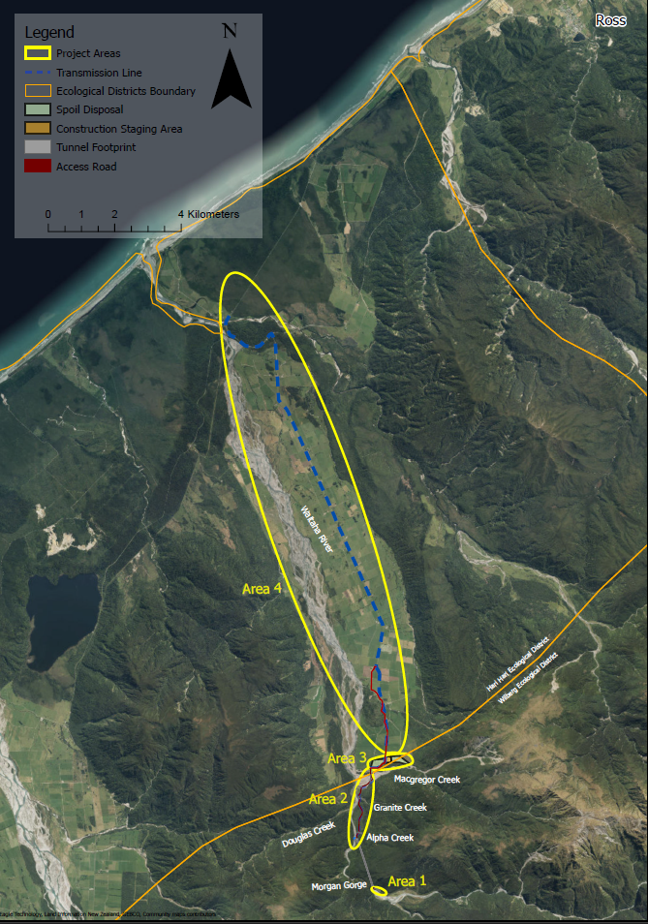

Appendix CC2: Waitaha Construction Staging Areas
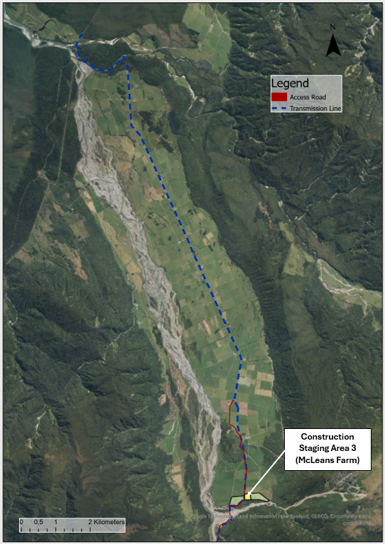
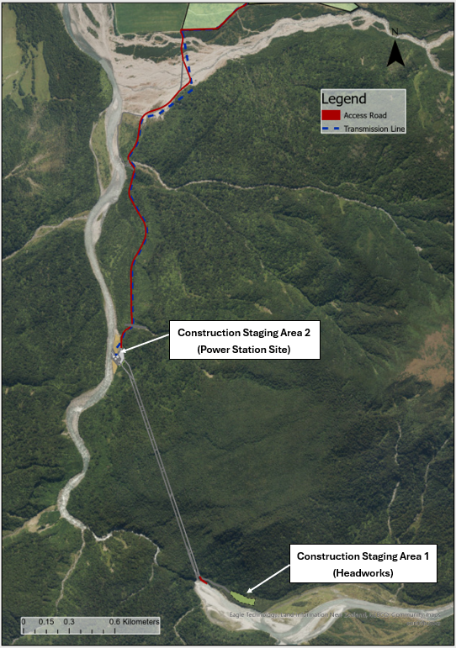

Appendix RC0: Indicative Location Alternative Access Track
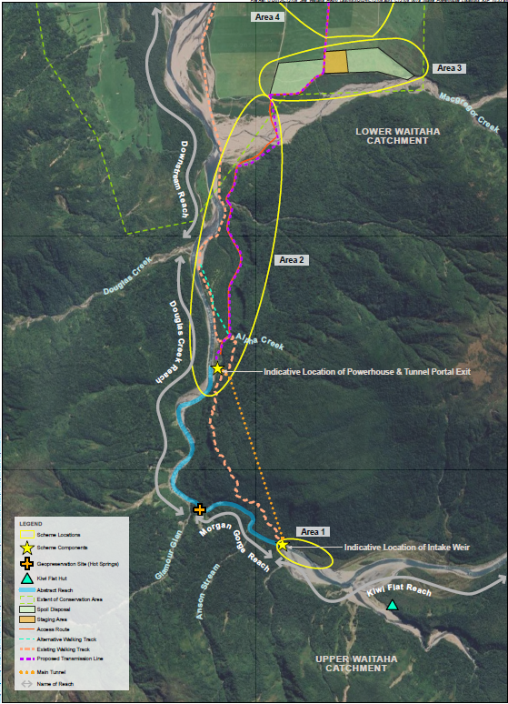
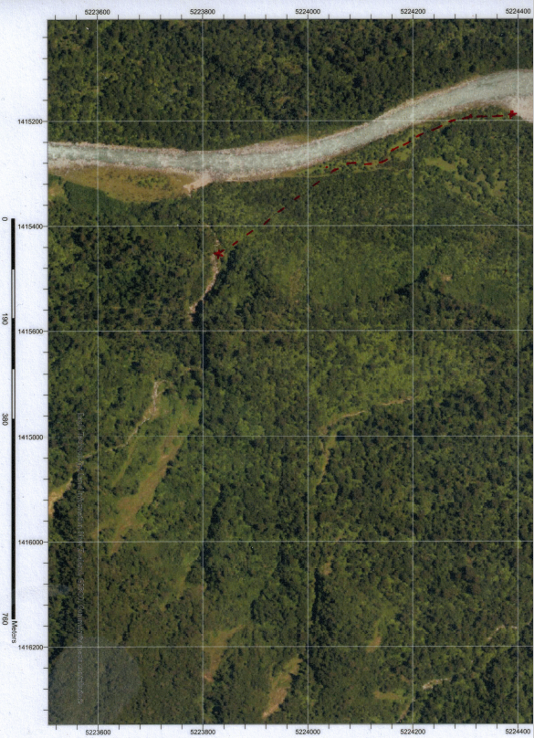

Appendix RC1: Land-based Gravel Extraction Area
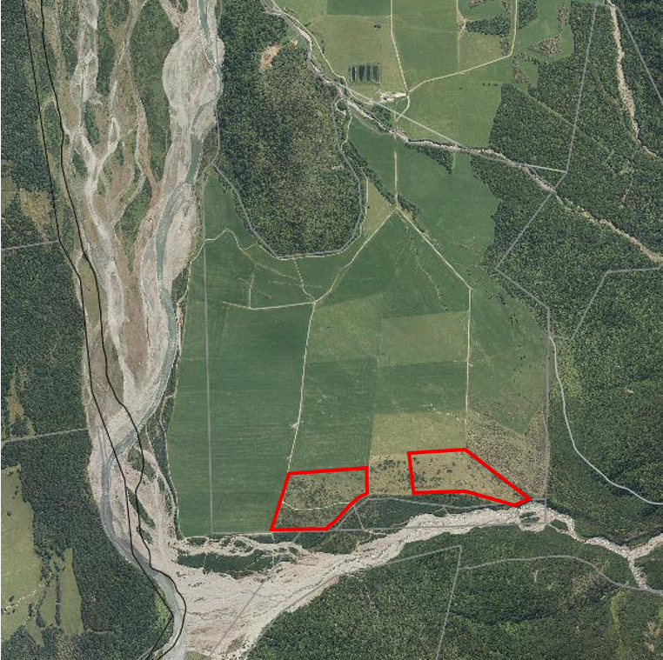

Appendix RC2: Stable Tributary
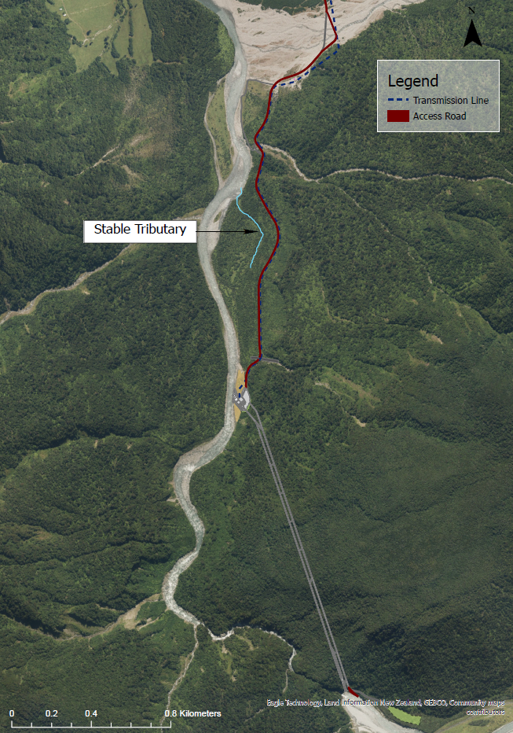

Appendix RC3: River Gravel Extraction Area (being the Waitaha River portion of the consent area for existing resource consent RC-2019-0037)
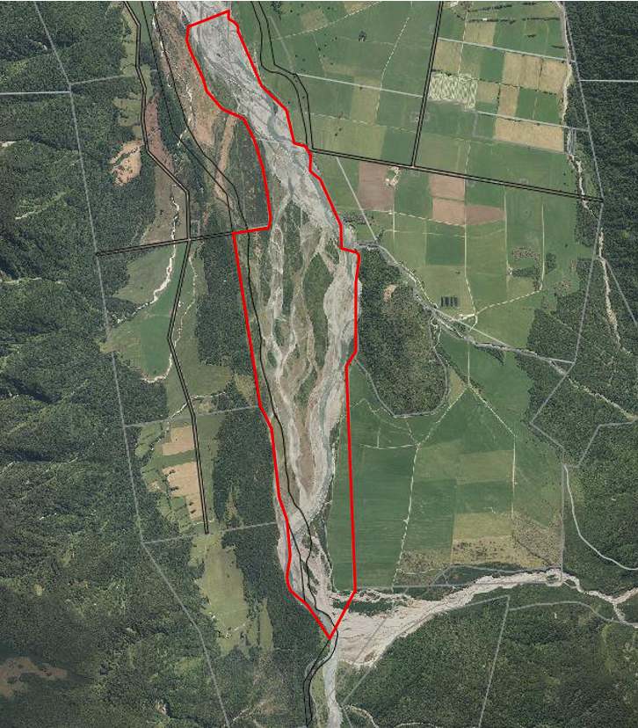

Appendix RC4: Map Showing Approximate Locations of Water Surface Takes
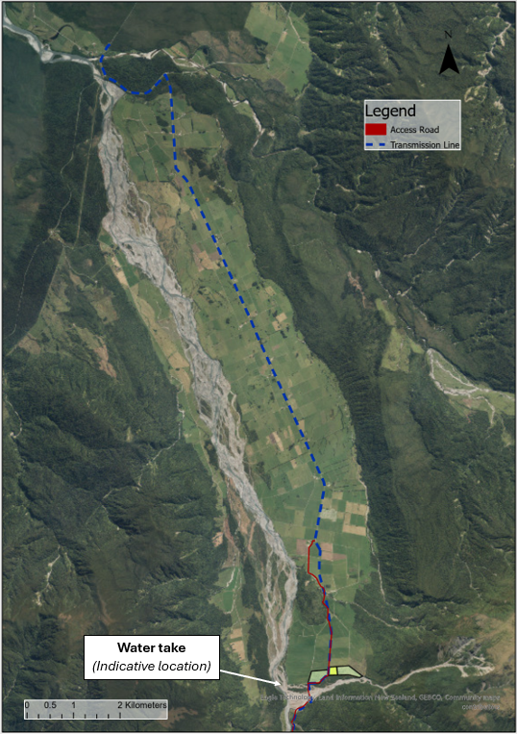
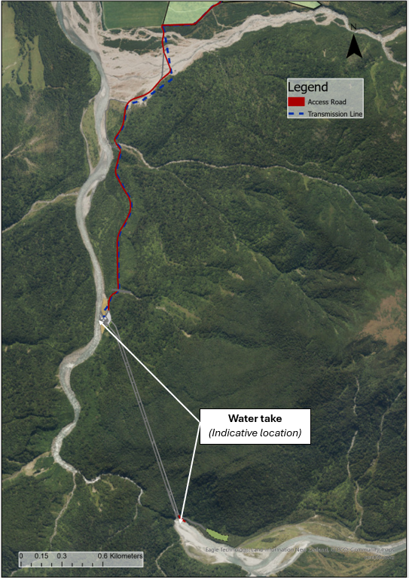

Appendix RC5: Spoil Disposal Areas (areas in red outline)
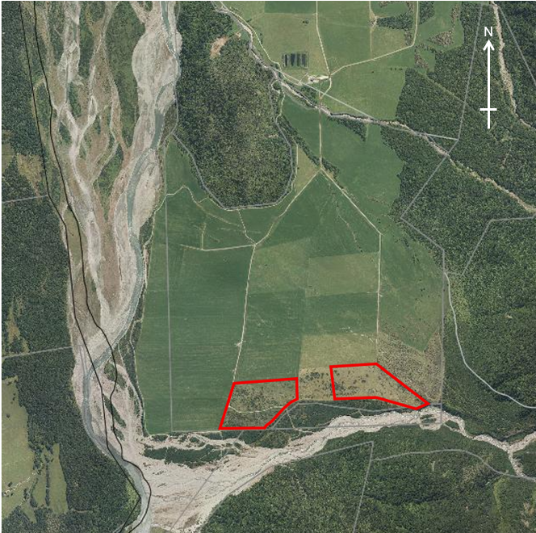

Appendix RC6: Stable Tributary

Appendix DC1: Aggregate Mining Areas (areas in red outline)

Appendix DC2: Stable Tributary

Appendix DC2: Construction Staging Area 1 Vegetation Buffer
