**WAIHI NORTH PROJECT - PROPOSED FRESHWATER FISHERIES DISPENSATION CONDITIONS**

**FTAA s42(4)(j) application - Dispensation that would otherwise be applied for under regulation 43 of the Freshwater Fisheries Regulations 1983 in respect of a complex freshwater fisheries activity.**

Regulation 43 of the Freshwater Fisheries Regulations 1983 states:

(1) The Director-General may require that a dam or diversion structure proposed to be built include a fish facility, except if the dam or diversion structure is subject to a water right issued before 1 January 1984 under the Water and Soil Conservation Act 1967.

(2) A person proposing to build a dam or diversion structure must—

(a) notify the Director-General; and

(b) forward a submission seeking the Director-General’s approval or dispensation from the requirements of these regulations; and

(c) supply to the Director-General any information that is reasonably required to assist the Director-General in deciding any requirements that may apply (including plans and specifications of the proposed structure and any proposed fish facility).

(3) If the Director-General considers that the information supplied under subclause (2)﻿(c) is inadequate, the Director-General may, within 28 days, advise the applicant as to what further information is required.

[…]

There are two diversion structures proposed as part of the Project, which engage Regulation 43. These are:

1. The “Northern Uphill Diversion Drain”; being a diversion of watercourse TB1 around the Northern Rock Stack (the **TB1 Diversion**); and
2. The “Southern Uphill Diversion Drain”; being a diversion of the Ruahorehore Stream around Tailings Storage Facility 3 (the **Ruahorehore Diversion**).

In both cases the diversions are designed and will be constructed to maintain fish passage (and habitats) to a similar standard as existing. Therefore, it is considered that there is no requirement for these diversion structures to include a fish facility, and a dispensation is sought accordingly.

All works are to be undertaken in accordance with the provisions of the Aquatic Fauna Salvage and Relocation Plan and the Stream Diversion and Development Plan included in the Waihi Area Ecology and Landscape Management Plan included in Part H of the application documents.

**Summary of Design and Effects**

The TB1 and Ruahorehore Diversions and their effects are considered in detail in the WNP Freshwater Ecological Assessment included in Part B of the application documents (Boffa Miskell), and summarised as follows.

***TB1 Diversion***

The TB1 Diversion will comprise a c.695 m length open channel, which will be designed according to the principles set out in Appendix 1.

TB1 has moderate ecological values, being itself an ecologically enhanced stream diversion. The design of the diversion channel is planned to replicate aquatic habitat attributes with a range of suitable stable microhabitats for fish and invertebrates, including the creation of stable pool habitats, the inclusion of gravel and cobble riffle habitats, and it will provide for the passage of climbing fish, especially eels. The stream gradient may be difficult to maintain fish passage for general fish species but allows the passage of fish with climbing abilities (eels, kōura), which have the ability to access the remaining upstream habitat. This mirrors the existing environment, in which the upper reaches of the stream are separated from the lower by a large natural waterfall that currently creates a significant natural fish barrier to swimming fish species. Surveys of the existing stream above this waterfall observed only the shortfin eel, for which access will be maintained by the new structure.

***Ruahorehore Stream Diversion***

The Ruahorehore Stream Diversion will comprise some 2,503 m of newly created open channel. Again, this will be designed according to the principles set out in Appendix 1.

The existing Ruahorehore Stream is of moderate to high ecological value. The Diversion will replicate existing aquatic habitat attributes with a range of suitable stable microhabitats for fish and invertebrates, including the creation of pools, the inclusion of gravel and cobble riffle habitats, and provision for the passage of climbing fish, especially eels. As with TB1, stream gradient may make it difficult to maintain (upstream and downstream) fish passage for general fish species, but will accommodate the passage of migrating eels, and other native fish with climbing abilities, allowing them to access the upstream habitat. Again, this mirrors the existing environment, in which the reaches of the existing stream to be replaced have a predominance of eels and kōura, and an existing waterfall impedes passage to the upper reaches, in which kōura are the predominant species.

***Summary***

The diversion structures are designed to maintain fish passage (and habitat) similar to the existing environment, in which the natural gradient impedes access for fish other than eels and kōura. As the natural condition is preserved, it is considered that there is no need for a fish facility at either diversion, and a dispensation is appropriate.

**Conditions**

|  |  |  |
| --- | --- | --- |
| ***Management Plan*** | | |
| FF1 | All works are to be undertaken in accordance with the provisions of the Aquatic Fauna Salvage and Relocation Plan and the Stream Diversion and Development Plan which are included in the Waihi Area Ecology and Landscape Management Plan (provided in Part H of the application documents). | The provisions of Section 7.1 of the Stream Diversion and Development Plan relate specifically to the ecological objectives of the diversion channel design. |
| ***Diversion Design*** | | |
| FF2 | The TB1 Diversion and Ruahorehore Stream Diversion must be designed in accordance with the principles set out in the Indicative Stream Channel Diversion Design provided in Appendix 1. |  |
|  | *Advice Note: The design of the TB1 Diversion and Ruahorehore Stream Diversion must be in accordance with the Diversion Design resource consent requirements applying to the “Waihi North Project – Conditions for the Waikato Regional Council”.* | Refer to Condition G22 of the Waihi North Project – Proposed Conditions for the Waikato Regional Council. |
| ***Exclusion Conditions*** | | |
| FF3 | The Dispensation holder will not undertake the following activities:   1. *Instream works during peak migration times;* 2. *The utilisation of wet concrete in flowing water.* |  |
| ***Biosecurity Management*** | | |
| FF4 | The Dispensation holder will ensure that all equipment to be used close to or within any surface waterbodies for the establishment of the TB1 Diversion and the Ruahorehore Diversion is clean and dry prior to use. |  |
| FF5 | The Dispensation holder will follow best practise biosecurity protocols throughout the establishment of the TB1 Diversion and the Ruahorehore Diversion. This is to include, but not be limited to, the cleaning down of equipment between use at differing sites to prevent the spread of freshwater and other pests. |  |
| FF6 | The Dispensation holder will undertake biosecurity risk assessments of any species which are to be translocated throughout the establishment of the TB1 Diversion and the Ruahorehore Diversion. |  |

**Appendix 1: Indicative Stream Channel Diversion Design**



Stream Diversion Type 1 – Lowland stream cross section

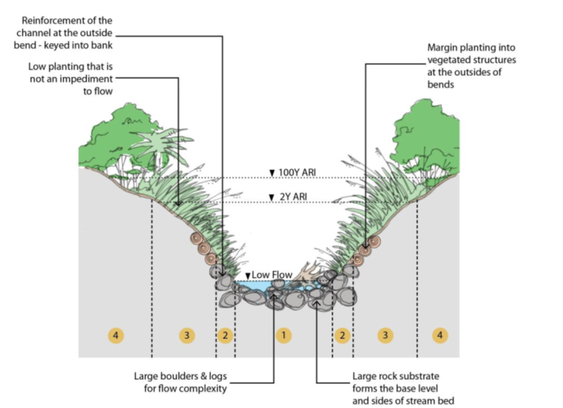

Stream Diversion Type 2 – Steep stream cross section