DECISION MADE BY THE PANEL: WAITAHA HYDRO SCHEME
TE WHAKATAUNGA A TE PAEWHIRI WHAKAWĀ WAITAHA HIKO-Ā-AWA

APPENDIX E : WILDLIFE ACT PERMITS | ĀPITIHANGA E: NGĀ WHAKAATANGA - -Ā-TURE KARAREHE kōwaO

[Note to parties providing comment]

Reading Notes
- These should be read alongside the Draft Decision, which provides an explanation for changes
- References to approval numbers, dates, etc. will be updated and have been highlighted for ease of reference
- Condition references highlighted in grey
- The conditions have been updated so that the wording now aligns with the revised resource consent conditions. References to “consent holder” and “consent” have been changed where necessary

WILDLIFE APPROVAL
THIS APPROVAL is made this [Date] day of [Month] 2026
PARTIES:
Waitaha Hydro [FTAA-2505-1069] Expert Panel under the Fast-track Approvals Act 2024 (the Grantor)
Westpower Limited (the Wildlife Approval Holder)
BACKGROUND
- The Wildlife Approval Holder proposes to construct the Waitaha Hydro Scheme (Scheme).
- The Wildlife Approval Holder has applied for a wildlife approval under the Fast-track Approvals Act 2024 in relation to the Scheme.
- A wildlife approval granted under the Fast-track Approvals Act 2024 has force and effect for its duration, and according to its terms and conditions, as a lawful authority for the purposes of Part 5 of the Wildlife Act 1953 for the act or omission for which the approval was granted and is treated as if it were granted under that Act.
- This wildlife approval under the Fast-track Approvals Act 2024 in relation to the Scheme was granted by an expert panel on [add date].
OPERATIVE PARTS
The Wildlife Approval Holder has been authorised by an expert panel under the Fast-track Approvals Act 2024 to undertake the activities specified in this approval, subject to the terms and conditions contained in this wildlife approval and its schedules.

Schedule 1: authorised activity
 | Approved activity (Schedule 2, clause 2) | The activities approved are:  - To catch, salvage and relocate native lizards listed in Schedule 4 from the Scheme footprint.  - To disturb whio / blue duck by gently guiding (without catching) them away from blasting and helicopter use areas.  - To disturb, catch and liberate whio / blue duck if required to protect their safety.  - In the unlikely event it is required, to capture and relocate avifauna and long-tailed bats listed in Schedule 5 in accordance with the Avifauna Management Plan (AMP) and Bat Management Plan (BMP).  - To incidentally harm or kill wildlife listed in Schedule 5 if the harm or death is not directly intended but is unavoidable and foreseeable.
 | The Land  (Schedule 2, clause 2) | The Waitaha Hydro Site, identified in the map included in Schedule 6.
 | Personnel approved to undertake the Approved Activity  (Schedule 2, clause 3) | For lizards:  - Dr Graham Ussher or others under his direct supervision, and/or  - a suitably qualified and experienced expert with subject matter expertise relevant to the protected wildlife species concerned, as authorised in writing by the Department, and others under the direct supervision of the suitably qualified and experienced expert.  For avifauna and long-tailed bats, a suitably qualified and experienced expert with subject matter expertise relevant to the protected wildlife species concerned, as authorised in writing by the Department, and others under the direct supervision of the suitably qualified and experienced expert.
 | Term  (Schedule 2, clause 4) | Commencing on [insert date of approval] and expiring on [insert date 15 years from date of approval]
 | Wildlife Approval Holder's address for notices  (Schedule 2, clause 8) | The Wildlife Approval Holder's address for notices is:  146 Tainui Street  PO Box 375  Greymouth
 | Department's address for notices | The Department's address for all correspondence is:  Permissions Team  Level 4  73 Rostrevor Street  Hamilton, 3204  Email: permissionshamilton@doc.govt.nz

schedule 2: standard terms and conditions of the approval

Interpretation

The Wildlife Approval Holder must provide a copy of these conditions to its employees, contractors or agents and explain the obligations under the conditions.

Where obligations bind more than one person, those obligations bind those persons jointly and separately.

What is being authorised?

The Wildlife Approval Holder is only allowed to carry out the Approved Activity on the Land described in Schedule 1, Item 2.

Any arrangements necessary for access over private land or leased land are the responsibility of the Wildlife Approval Holder.

The Wildlife Approval Holder must advise the Department’s local Operations Manager(s) prior to carrying out the Approved Activity in the District (where possible, one week prior), when the Wildlife Approval Holder intends to carry out the Approved Activity.

The Wildlife Approval Holder and Approved Personnel must carry a copy of this approval with them at all times while carrying out the Approved Activity.

The Wildlife Approval Holder must comply with any reasonable request from the Department for access to any wildlife.

The Wildlife Approval Holder may publish authorised research results.

The Wildlife Approval Holder must immediately notify the Department of any taxa found which are new to science.

The Wildlife Approval Holder must immediately notify the Department if any Threatened, At Risk or Data Deficient species not covered by this approval are incidentally discovered.

Who is approved?

Only the Wildlife Approval Holder and the Approved Personnel described in Schedule 1, Item 3 are approved to carry out the Approved Activity, unless otherwise agreed in writing by the Department.

How long is the approval for – the Term?

This approval commences and ends on the dates set out in Schedule 1, Item 4.

What are the liabilities?

The Wildlife Approval Holder agrees to exercise the approval at the Wildlife Approval Holder's own risk and releases to the full extent permitted by law the Department and the Department's employees and agents from all claims and demands of any kind and from all liability which may arise in respect of any accident, damage or injury occurring to any person or property arising from the Wildlife Approval Holder's exercise of the Approved Activity.

This indemnity is to continue after the expiry or termination of this approval in respect of any acts or omissions occurring or arising before its expiry or termination.

What about compliance with legislation and notices and directions?

The Wildlife Approval Holder must comply with all statutes, bylaws and regulations, and other statutory instruments associated with the Land. Without limitation, this includes the Conservation Act 1987 and the Acts listed in the First Schedule of that Act and all applicable health and safety legislation and regulation.

The Wildlife Approval Holder will comply with all notices, directions and requisitions of the Department and any competent authority relating to the conduct of the Approved Activity.

Are there limitations on public access and closure?

The Wildlife Approval Holder acknowledges that the public conservation land being part of the Land is open to the public for access and that the Department may close public access to that public conservation land during periods of high fire hazard or for reasons of public safety or emergency.

How are notices sent and when are they received?

Any notice to be given under this approval by the Department is to be in writing and made by personal delivery, by pre-paid post or email to the Wildlife Approval Holder at the address or email address specified in Schedule 1, Item 5. Any such notice is to be deemed to have been received:

in the case of personal delivery, on the date of delivery;

in the case of post, on the third working day after posting;

in the case of email, on the date receipt of the email is acknowledged by the addressee by return email or otherwise in writing, except that return emails generated automatically shall not constitute an acknowledgement of receipt of the email.

If the Wildlife Approval Holder's details specified in Schedule 1, Item 5 change then the Wildlife Approval Holder must notify the Department within five working days of such change.

What about the payment of costs?

The Wildlife Approval Holder must pay the standard Department charge-out rates for any staff time and mileage required to monitor compliance with this approval and to investigate any alleged breaches of the terms and conditions of it.

Biosecurity

The Wildlife Approval Holder must take all precautions to ensure weeds and non-target species are not introduced to the Land; this includes ensuring that all tyres, footwear, gaiters, packs and equipment used by the Wildlife Approval Holder, its staff and clients are cleaned and checked for pests before entering the Land.

Are there any Special Conditions?

Special conditions are specified in Schedule 3. In the event of inconsistency or conflict, the Special Conditions will prevail over this Schedule 2.

Can the approval be varied?

The Wildlife Approval Holder may apply to the Department for variations to this approval in accordance with clauses 7(2) and (3) of Schedule 7 of the Fast-track Approvals Act 2024.

schedule 3: Special conditions

General

The Special Conditions in the following documents apply within their respective areas of effect:

Lease and Licence Concession

Easement Concession

WDC Consents

WCRC Consents

Management and Monitoring Plans

All Activities authorised by this Approval must be undertaken in accordance with the relevant conditions of the Concessions and Consents listed in clause 1 and with the relevant management and monitoring plans:

Avifauna Mangement Plan that has been certified under Condition XX of Appendix / Schedule XX: Conditions Common the West Coast Regional Council and Westland District Council Resource Consents.

Bat Management Plan that has been certified under Condition XX of Appendix / Schedule XX: Conditions Common the West Coast Regional Council and Westland District Council Resource Consents.

Lizard Management Plan that has been certified under Condition XX of Appendix / Schedule XX: Conditions Common the West Coast Regional Council and Westland District Council Resource Consents.

NOTE: Any change to the Concessions, Consents and their conditions, and the relevant management and monitoring plans will not constitute a change to the conditions of this Approval, unless or until this Approval is varied in accordance with requirements of the conditions of this Approval and/or the Fast-track Approvals Act 2024 as appropriate.

Any references to wildlife in conditions of the Access Arrangements, Concessions, and Consents shall apply to this Approval as if they are references to all species of absolutely protected wildlife, with any necessary modifications.

Whio handling

Whio will only be handled (caught and liberated):

if required to protect their safety; and

a whio specialist or the project ecologist (as Approved by DOC in Schedule 1) following instructions of a whio specialist.

Lizard capture, salvage and relocation

The Approved personnel listed in Schedule 1 must undertake lizard capture, salvage and relocation as set out in the LizMP.

The Wildlife Approval Holder must sterilise any instruments that come in contact with the lizards and/or are used to collect or measure lizards between each location. A separate holding bag must be used for each animal. All equipment should be thoroughly cleaned and dried between sites.

The Approval Holder must ensure lizards are held temporarily in a suitable container (e.g. breathable cloth bag) and placed out of direct sunlight to minimise the risk of overheating, stress and death between capture and salvage, and relocation to the adjoining receiving site.

Incidental death of protected wildlife

If any Threatened, At Risk or Data Deficient species should be incidentally killed in the construction of the Scheme, the Wildlife Approval Holder must:

inform the Department within twenty-four (24) hours of the death;

chill the body if it can be delivered within seventy-two (72) hours of the death, or freeze the body if delivery will take longer than seventy-two (72) hours;

send the body to [add] for necropsy along with details of the animal's history;

pay all reasonable costs incurred in investigation of the death of any Threatened, At Risk or Data Deficient species; and

if required by the Department, cease the Approved Activity for a period determined by the Department.

Injured protected wildlife and euthanasia

If any protected wildlife is incidentally injured as part of the Approved Activity or in the course of undertaking activities associated with the Scheme, the Wildlife Approval Holder must contact a suitably qualified person to get advice on management of the protected wildlife, including how to best address the injury.

If protected wildlife is incidentally harmed by the Wildlife Approval Holder, the Wildlife Approval Holder will take all reasonable steps to rehabilitate protected wildlife, in line with the advice of a suitably qualified person.

The Wildlife Approval Holder is authorised to appoint a qualified veterinarian to euthanise injured animal(s) on the recommendation of the suitably qualified person. Once euthanised, the Wildlife Approval Holder will deal with the protected wildlife in accordance with condition 4.

The Wildlife Approval Holder must notify the Department's [West Coast Operations Manager(s)] within twelve (12) hours of euthanising protected wildlife. The notification will include details of the species of wildlife euthanised and personnel involved in the euthanasia of the wildlife.

Reporting

The Wildlife Approval Holder must undertake reporting as set out in the AMP, BMP and LizMP.

Ownership of protected wildlife

All wildlife remains the property of the Crown. This includes any dead wildlife, live wildlife, any parts thereof, any eggs or progeny of the wildlife, genetic material and any replicated genetic material.

Unless expressly authorised by the Department in writing, the Wildlife Approval Holder must not donate, sell or otherwise transfer to any third party any wildlife collected or otherwise obtained under this approval.

Cancellation

The Department may revoke this Approval in whole or any part at any time (pursuant to clause 7(4) of Schedule 7 of the Fast-track Approvals Act 2024) if:

The Wildlife Approval Holder breaches any of the conditions of this Approval.

In the Department's opinion, the exercise of this Approval has caused, or is likely to cause, any unforeseen adverse effects on wildlife.

If the Department intends to revoke this Approval in whole or in part, the Department must give the Wildlife Approval Holder at least thirty (30) days advance notice and either party may invoke the dispute resolution process in clause 9 below before the Department initiates the cancellation process.

How will disputes be resolved?

If a dispute arises between the parties in connection with this Approval the parties must, without prejudice to any other rights or entitlements they may have, attempt to resolve the dispute by agreement using informal dispute resolution techniques such as negotiation, mediation, independent expert appraisal or any other alternative dispute resolution technique. The rules governing any such technique adopted are to be agreed between the parties.

If the dispute cannot be resolved by agreement within 30 working days of written notice by one party to the other (or such further period as the parties may agree to in writing) either party may refer the dispute to mediation, where relevant, or to arbitration, which arbitration is to be carried out in accordance with the provisions of the Arbitration Act 1996.

If the parties do not agree on an arbitrator within 10 working days of a party giving written notice of the requirement to appoint an arbitrator the President of the New Zealand Law Society is to appoint the arbitrator. In either case the arbitrator must not be a person who has participated in an informal dispute resolution procedure in respect of the dispute.

The arbitrator must include in the arbitration award reasons for the determination.

Despite the existence of a dispute, each party must continue to perform its obligations under this Approval.

Bat Protocols

The Wildlife Approval Holder shall follow the Bat Roost Protocols, as attached at Schedule 7 of this Wildlife Approval when felling occupied bat roost trees during vegetation clearance.

schedule 4: LIZArds that the Wildlife Approval Holder is APPROVED to catch, salvage and relocate
Common name | Scientific name | NZ threat classification
Northern grass skink | Oligosoma polychroma | Not Threatened
Forest gecko | Mokopirirakau granulatus | At Risk – Declining
Newman's speckled skink | Oligosoma newmani | At Risk – Declining
West Coast green gecko | Naultinus tuberculatus | Threatened – Nationally Vulnerable

schedule 5: wildlife known or predicted to be in the scheme area
Common name | Scientific name | NZ threat classification
Long-tailed bat | Chalinolobus tuberculatus | Threatened – Nationally Critical
West Coast green gecko | Naultinus tuberculatus | Threatened – Nationally Vulnerable
Kea | Nestor notabilis | Threatened – Nationally Endangered
Blue duck / Whio | Hymenolaimus malacorhynchos | Threatened – Nationally Vulnerable
South Island kākā | Nestor m. meridionalis | Threatened – Nationally Vulnerable
Long-tailed cuckoo | Eudynamys taitensis | Threatened – Nationally Vulnerable
Bush falcon / Karearea | Falco novaeseelandiae | Threatened – Nationally Increasing
Grey duck | Anas superciliosa | Threatened – Nationally Vulnerable.
Yellow-crowned parakeet / Kākāriki | Cyanoramphus auriceps | At Risk – Declining
South Island pied oystercatcher | Haematopus finschi | At Risk – Declining
South Island robin | Petroica a. australis | At Risk – Declining
South Island fernbird | Bowdleria p. punctata | At Risk – Declining
New Zealand pipit | Anthus n. novaeseelandiae | At Risk – Declining
Black shag | Phalacrocorax carbo novaehollandiae | At Risk – Relict
Little shag | Phalacrocorax melanoleucos brevirostris | At Risk – Relict
Forest gecko | Mokopirirakau granulatus | At Risk – Declining
Newman's speckled skink | Oligosoma newmani | At Risk – Declining
Northern grass skink | Oligosoma polychroma | Not Threatened
Western weka | Gallirallus a. australis | Not Threatened
Welcome swallow | Hirundo n. neoxena | Not Threatened
South Island tomtit | Petroica m. macrocephala | Not Threatened
South Island fantail | Rhipidura f. fuliginosa | Not Threatened
Brown creeper | Mohoua novaeseelandiae | Not Threatened
Tui | Prosthemadera n. novaeseelandiae | Not Threatened
Bellbird | Anthornis m. melanura | Not Threatened
Grey warbler | Gerygone igata | Not Threatened
South Island rifleman | Acanthisitta chloris chloris | Not Threatened
New Zealand kingfisher | Todiramphus sanctus vagans | Not Threatened
Morepork | Ninox n. novaeseelandiae | Not Threatened
Shining cuckoo | Chrysococcyx l. lucidus | Not Threatened
New Zealand pigeon / Kererū | Hemiphaga novaeseelandiae | Not Threatened
White-faced heron | Egretta n. novaehollandiae | Not Threatened
Pied stilt | Himantopus himantopus leucocephalus | Not Threatened
Silvereye | Zosterops l. lateralis | Not Threatened
Little owl | Athene noctua | Introduced and naturalised
Pukeko | Porphyrio m. melanotus | Not Threatened
Swamp harrier | Circus approximans | Not Threatened
Paradise shelduck | Tadorna variegata | Not Threatened
Common redpoll | Carduelis flammea | Introduced and naturalised

schedule 6: map of the land covered by the approval
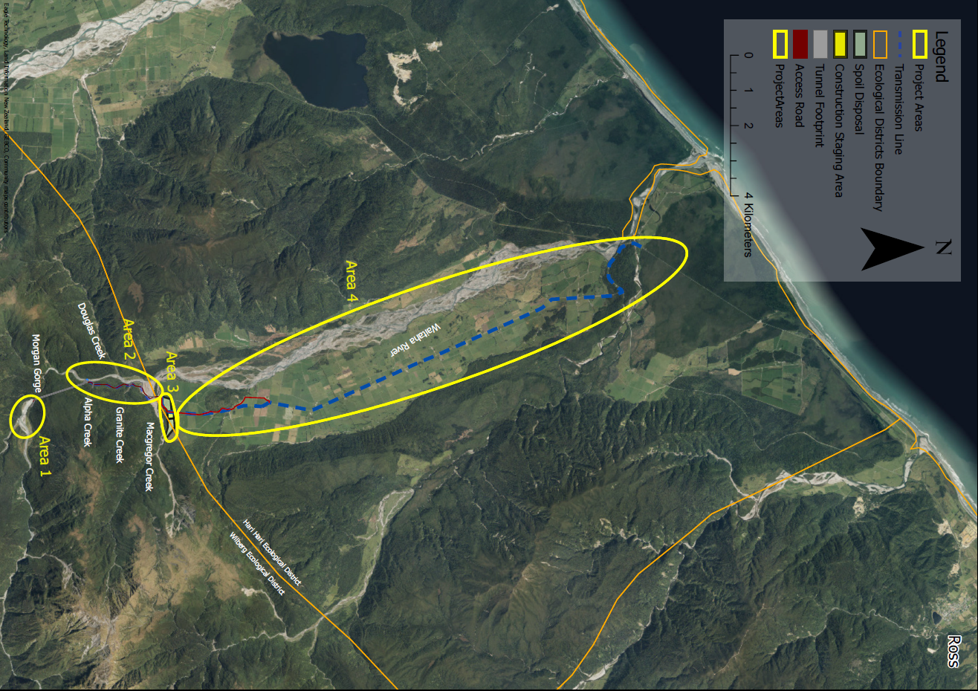

schedule 7: doc bat roost protocols
docCM - Bat roost protocol 2024

