APPENDIX B: POUND ROAD INDUSTRIAL DEVELOPMENT

CONDITIONS – CANTERBURY REGIONAL COUNCIL CONSENTS

UPDATED 16 MARCH 2026
Part 1: CRC s9 land use
Part 2: CRC s14 water permit
Part 4: CRC s15 stormwater discharge (construction phase)
Part 5: CRC s15 stormwater discharge (operation phase)
Applicant comments:
Green shade = agreement reached
Orange = minor amendments made as part of the s55 response, and in consultation with CRC.
Red text = changes made by NTP as part of s55 response.
Column 1: Applicant’s Proposed Conditions – Section 55 Response | Column 2: Summary of Section 53 Comments and Response to Changes Requested | Column 3 – Panel Comments
Note: Green cells indicate the condition wording is agreed between NTP and CRC with no changes from CRC’s Appendix 5 conditions.  Note: Orange cells indicate the condition wording has been changed (red text) from CRC’s Appendix X set and explains why the changes have been made in response to s53 comments. The proposed changes have subsequently been agreed with CRC on 5 December 2025. |  | Comments made in black text.  Suggested tracked changes shown in text in column 1 in blue text with new text underlined and removed text struck through.  New conditions are shown in new blue underlined text in a new row in the column.

Part 1: Canterbury Regional Council: CRC260879 s9 land use conditions
Duration sought: 7 years
 | Limits | Applicant comments and response to changes requested as part of Section 55 response | Panel Comments
1. | The works authorised by this resource consent are limited to the excavation of land associated with the development of an industrial subdivision at Pound Road Industrial Development at 2, 38, 64, 86, 94 Barters Road; 4, 22, 30, 40 and 48 Barters Road; 111 and 173 Pound Road and 570 and 578 Waterloo Road, legally described as: Lot 3 DP 33334, Lot 2 DP 33334, Lot 10 DP 23834, Lot 2 DP 23834, Lot 1DP 33334, Lot 2 DP 20738, Lot 1 DP 20738, Lot 2 DP 38418, Lot 7 DP 23834, Lot 6 DP 23834, Lot 2 DP 24156, Lot 1 DP 24156, Lot 1 DP 23834, Lot 1 DP 38418 and has a total area of approximately 60 hectares (ha). | Updated to include all property addresses.  Condition wording agreed between NTP and CRC.
2. | The works shall be undertaken within the area of the attached design plan, plan CRC260879 which forms a part of this consent. | Updated to reflect CRC new condition.  Condition wording agreed between NTP and CRC.
3. | The maximum depth of excavation for the works authorised by this resource consent must not exceed 5.5 metres below natural ground level.  Advice Note: It will be up to the Consent Holder to demonstrate compliance with the maximum excavation depth. This can be done, for example, via reference to a specified datum and reduced levels from that datum or via site specific survey points or other measurements. | Condition wording agreed between NTP and CRC.
 | Prior to Commencement
4. | Prior to any bulk earthworks occurring on the site (excluding Lots 400 and 401), further investigation of any outstanding areas of land not already investigated including the 94 Barters Road bund, shall be undertaken via a Preliminary Site Investigation (PSI) and/or a Detailed Site Investigation (DSI) with the results submitted to Canterbury Regional Council, Attention: Compliance Manager and Contaminated Land Team (via ECinfo@ecan.govt.nz). | Condition updated to include Lots 400 and 401 given that they still form a part of the site, and industrial use will be enabled on them through an approval. These properties should be included, however further investigation will be required to be undertaken on these lots at time they are developed.  Condition wording agreed between NTP and CRC. | We do not understand the reasons for the differences between conditions 4 and 5. As worded Lots 400 and 401 are be excluded in condition 4 but included in condition 5 yet the same requirements applying in both condition to both areas of land. Please clarify what is the basis for any distinction and revise accordingly to make that distinction.
5. | Prior to any bulk earthworks occurring within Lots 400 and Lot 401, further investigation of this land shall be undertaken via a Preliminary Site Investigation (PSI) and/or a Detailed Site Investigation (DSI) as required, with the results submitted to Canterbury Regional Council, Attention: Compliance Manager and Contaminated Land Team. | This condition is included as Lots 400 and 401 are a part of the application.  Condition wording agreed between NTP and CRC. | If condition 5 is to remain adding the email address in brackets to would be helpful and consistent with condition 4.
6. | A site validation report must be provided to Canterbury Regional Council for approval at least 10 working days prior to the commencement of bulk earthworks. The report must demonstrate that:  a. the remaining soils at the site within 20m of the surface water body (water area on the western boundary) meet ANZG GV-High criteria.;  b. All remaining areas of the site outside of the areas in (a) shall meet the commercial/industrial SGV standards.  Advice note: This condition does not apply to Lots 400 and 401, which will require separate remediation prior to any works commencing on these two balance lots. | Condition updated following further correspondence with CRC and NTP’s contaminated land experts.  Condition wording agreed between NTP and CRC. | Please amend the condition to make it clear (as is shown in condition 4) who at Canterbury Regional Council, including an email address if appropriate, the site validation report is to be provided (or submitted) to.  The condition should also refer to certification, rather than approval. Please amend conditions to ensure consistency in certification requirements and terminology across all report submission and management plan conditions. The format of Condition 12 is more consistent with what we would expect to see in conditions of this nature.  The references to ANZG GV- High criteria and commercial/industrial SGV standards should be written in full in the first instance and then abbreviated and referred to consistently throughout all conditions.  The Advice note imposes a requirement on the consent holder that would be more appropriately addressed as a consent condition. Please revise.
7. | Any contaminated land identified on Lots 400 and 401 through the investigations required under Condition 5 of this resource consent shall be remediated prior to earthworks occurring within either of those Lots. | Updated as NTP consider this condition should remain, as Lots 400 and 401 are a part of the application.  Condition wording agreed between NTP and CRC.
8. | Prior to commencement of the works described in Condition (1), all personnel working on the site must be made aware of, and have access to, the following:  a. The contents of this resource consent document and all associated documents, including the Earthworks Management Plan (EMP) prepared by Davie Lovell Smith and attached as Appendix 13; and  b. Resource Consents and all associated documents, including the Erosion and Sediment Control Plan (ESCP) as set out in Condition (11). | Condition wording agreed between NTP and CRC. | The Earthworks Management Plan reference needs to be clearer. The reference requires a date or document number or it needs to be attached to the resource consent.  It is not clear what, or where, Appendix 13 is. Please revise.
9. | At least 15 working days prior to the commencement of works to remediate contaminated land, the consent holder must submit a Remedial Action Plan (RAP) to Canterbury Regional Council, Attention: Compliance Manager (via ECinfo@ecan.govt.nz) for certification that it complies with the conditions of this consent.  The RAP must:  a. Outline the proposed soil sampling procedure to identify the extent of contamination, including guidelines used to analyse samples;  b. Detail a procedure for managing any discovery of contaminated soil or material;  c. Describe the methodology for soil removal and how soil will be prevented from being entrained in stormwater;  - Including but not limited to an ESCP  d. Outline where the contaminated soil will be displaced of; and  e. Describe any validation sampling that will be undertaken. | Condition wording agreed between NTP and CRC. | Subclause 9 c. i. does not make sense as drafted. Please clarify.
10. | The RAP may be amended at any time. Any amendments must be:  a. Only for the purpose of improving the efficacy of the management of contaminated soil and must not result in an increase of sediment being discharged from the site; and  b. Consistent with the conditions of this resource consent; and  c. Submitted in writing to the Canterbury Regional Council, Attention: Compliance Manager (via ECinfo@ecan.govt.nz), prior to any amendment being implemented. | Condition wording agreed between NTP and CRC.
11. | The ESCP must:  a. include a map showing the location of all works;  b. Detailed plans showing the location of sediment control measures, on-site catchment boundaries, and sources of run-off;  c. Detail how best practicable measures are taken to minimize discharges of sediment-laden stormwater run-off beyond the boundaries of the site;  - Include drawings and specifications of designated sediment control measures, if these are not designed and installed in accordance with the ESCT;  - Detail the methodology for stabilizing the site entrance and exit points and any measures employed to prevent off-site tracking of sediment and other materials from the site.  d. Include a confirmation that the erosion and sediment control devices have been sized appropriately in accordance with the ESCT;  e. Include a programme of works, including a proposed timeframe for each stage of the works and the earthworks methodology;  f. Detail the management of any stockpiled material;  g. Detail inspection and maintenance of the sediment control measures.  h. Detail sampling procedures and protocols;  i. Define the discharge points where stormwater is discharged onto land / infiltrates into land;  j. Include a description of dust mitigation to be used and details of best practicable options to be applied to mitigate dust and sediment discharge beyond the site boundary;  k. Detail the methodology for stabilizing the site if works are paused for more than five working days or abandoned;  l. detail the methodology for stabilizing the site and appropriate decommissioning of all erosion and sediment control measures after works have been completed; and | Condition wording agreed between NTP and CRC. | The conditions covering ESCP in this consent should be consistent, to the extent practicable, with those in consent Part 2 s15 discharge consent construction phase below.  Conditions 8-12 of Part 2 s15 discharge consent construction phase provide a more suitable starting point than those here.  The conditions must commence with a requirement for the consent holder to prepare an ESCP and what the purpose of that Plan is.  The condition must require the ESCPs (including the Dust Management Plan) to be prepared by an appropriately qualified person, reviewed by the Canterbury Regional Council, implemented by an experienced contractor and monitored throughout the site development phase.
12. | a. The ESCP must be submitted to the Canterbury Regional Council, Attention: Compliance Manager (via ECinfo@ecan.govt.nz), at least 10 working days prior to works commencing, for certification that it complies with the ESCT and the conditions of this resource consent;  b. The discharge must not commence until certification has been received from the Canterbury Regional Council that the ESCP is consistent with the ESCT or equivalent industry guideline; and  c. Notwithstanding Condition (9(a)), if the ESCP has not been reviewed and/or certified within ten working days of the Compliance Manager receiving the ESCP, the discharge may commence. | NTP accepts the updates made by CRC.  Condition wording agreed between NTP and CRC. | Condition reference in 12.c. appears to require correction.
13. | The ESCP may be amended at any time. Any amendments must be:  a. Only for the purpose of improving the efficacy of the erosion and sediment control measures and must not result in reduced discharge quality; and  b. For the purpose of applying best practicable measures to mitigate [dust and] sediment transport off-site;  c. Consistent with the conditions of this resource consent; and  d. Submitted in writing to the Canterbury Regional Council, Attention: Compliance Manager, prior to any amendment being implemented. | Condition wording agreed between NTP and CRC.
14. | Erosion and sediment control measures must be inspected at least once per day, as well as following any rainfall event that results in more than five millimeters of rainfall at the site. Any accumulated sediment must be removed, and repairs made, as necessary, to ensure effective functioning of measures and devices. Records of any inspections must be kept and provided to the Canterbury Regional Council on request. | Condition wording agreed between NTP and CRC. | Should the 5mm rain event have a prescribed time period? Please revise if required
15. | If the consent holder abandons work on-site, or pauses works for more than five working days, adequate preventative and remedial measures must be taken to control sediment discharged from exposed or unconsolidated surfaces. These measures must be maintained for so long as necessary to prevent sediment discharges from the earth worked areas. | Condition wording agreed between NTP and CRC. | This condition is not clear or specific. What are “adequate preventative and remedial measures?” How is sediment to be controlled? It could be read to mean that the consent holder must prevent all/any sediment discharge from these areas. Is this realistic? Please revise.
16. | At least 10 working days prior to the commencement of works on site, the Canterbury Regional Council, Attention: Compliance Manager (via ECinfo@ecan.govt.nz) must be informed of the commencement of works. |  | Conditions 16 and 17 would sit better prior to condition 13.
17. | At least 10 working days prior to commencement of works on site, the consent holder must request a pre-construction site meeting with the Canterbury Regional Council, Attention: Compliance Manager (via ECInfo@ECan.govt.nz), and all relevant parties, including the primary contractor. At a minimum, the following must be covered at the meeting:  a. Scheduling and staging of the works;  b. Responsibilities of all relevant parties, including confirmation that the person (or persons) implementing the ESCP on the site is (are) suitably trained and/or experienced;  c. Contact details for all relevant parties;  d. Expectations regarding communication between all relevant parties;  e. Procedures for implementing any amendments;  f. Site Inspection; and  g. Confirmation that all relevant parties have copies of the consents of this resource consent document and all associated erosion and sediment control plans and any other discharge treatment methodologies employed. | Condition wording agreed between NTP and CRC.
 | During works
18. | All practicable measures must be taken to:  a. Minimise soil disturbance to that necessary to carry out the works described under Condition 1;  b. Prevent soil erosion;  c. Avoid placing excavated material in a position where it may enter:  - any neighbouring site;  - a surface water body; and/or  - the Christchurch City Council reticulated stormwater network, or any other private or public stormwater devices. | Condition wording agreed between NTP and CRC.
19. | All earthworks shall be managed to avoid the potential for cross-contamination of materials to occur, in particular movement of contaminated soil around the site and/or deposition of contaminated soil on other parts of the site shall be avoided. | Condition wording agreed between NTP and CRC.
20. | - Tracking of material off-site during the works must be avoided at all times.  - In the event that material is tracked off-site, the tracked material must be removed as soon as practicable. | Condition wording agreed between NTP and CRC.
21. | Excess soil or waste materials removed from the application site shall be taken to a consented site whose waste acceptance criteria would be met. Evidence of waste disposal such as weighbridge receipt shall be provided upon remediation or upon request to account for accidental discovery. | Condition wording agreed between NTP and CRC. | Is reference to “application site” different from reference to “site” used elsewhere. Please clarify and ensure consistent use of terms throughout conditions.  The second sentence of the condition does not make sense in the context of the first sentence. What remediation or accidental discovery is being referred to? Should this part of the condition be elsewhere?
 | Installation of Culverts- Fish Protection
22. | The consent holder shall ensure that all practicable measures are undertaken to ensure that there is no stranding of fish in pools or channels up and downstream of the works.
23. | Prior to works commencing in any waterways, Aa Fish Management Plan (FMP) shall be prepared by a suitably qualified freshwater ecologist. The objective of the plan is to avoid harm to fish when undertaking instream works. The plan must beand submitted to the Canterbury Regional Council (via ECinfo@ecan.govt.nz) for certification that it complies with the conditions of this consent and will achieve the objective of avoiding harm to fish when undertaking instream works. prior to any works in waterways.  The Plan should include the following information as a minimum:  a. Locations where the Plan will be implemented;  b. Methods to ensure fish cannot access works areas  c. Protocols to be followed including methods to rescue and relocate fish;  d. Person/s responsible for ensuring the plan is implemented;  e. Protocols if pest fish are encountered;  f. Protocols to ensure fish are not entrained in pumps during pumping (water pumping shouldmust have fish screens with a maximum mesh width and height size of three millimeters). | Condition wording agreed between NTP and CRC. | We generally prefer the wording proposed by the Director General of Conservation for this condition and have amended it, with some modifications.
24. | In the event that fish or freshwater mussels are required to be salvaged and relocated to an appropriate waterway. The fish salvage must include the following measures;  a. Be conducted by or under supervision of a certified, suitably qualified and experienced freshwater ecologist;  b. Be in general accordance with Canterbury Regional Council and Christchurch City Council’s “Fish Salvage Guidance for Works in Waterways” (12 October 2017) attached as Appendix CRC260879 and the Ministry for the Environment’s “National works in waterways guideline.” (2021);  c. The fish must be relocated to a habitat deemed suitable by the certified, suitably qualified and experienced freshwater ecologist;  d. The certified, suitably qualified and experienced freshwater ecologist must hold any necessary permits and approvals required by the Ministry for Primary Industries, Department of Conservation and Fish and Game to conduct fish salvage. | Reference to ‘freshwater mussels’ included per the advice of NTP’s freshwater expert, Ms Drummond.  Condition wording agreed between NTP and CRC. | We generally prefer the wording proposed by the Director General of Conservation for this condition and have amended it with some modifications.  We do not consider that consultation with experts from the Director General of Conservation and Fish and Game is required if the relocation habitat is deemed suitable by a suitably qualified and experienced freshwater ecologist.  Do the guidelines referred to need to be attached?
25. | Within 10 working days completion of works, the consent holder shall provide a record to the Canterbury Regional Council, Attention Compliance Manager (via ECinfo@ecan.govt.nz) of any fish captured and relocated. This record shall include:  a. The location where fish were captured;  b. The species and number of fish captured; and  c. The location where fish were relocated | Condition wording agreed between NTP and CRC.
 | Discovery of Contaminated Soil or Materials
26. | In the event that any contaminated soil or material is uncovered by the works, a contamination discovery protocol must be implemented, including but not limited to the following steps:  a. Earthworks within ten metres of discovered contaminant soil or material must cease immediately;  b. All practicable steps must be taken to prevent the contaminated material becoming entrained in stormwater. Immediate steps must include, where practicable:  - Diverting any stormwater runoff from surrounding areas away from the contaminated material; and ii. Minimizing the exposure of the contaminated material, including covering the contaminants with an impervious cover;  c. Notification of the Canterbury Regional Council, Attention: Contaminated Sites Manager, within 24 hours of the discovery;  d. Earthworks within ten metres of discovered contaminant soil or material must not recommence until a suitably qualified and experienced contaminated land practitioner (SQEP) confirms to Canterbury Regional Council, Attention: Compliance Manager, that continuing works does not represent a significant risk to the environment;  e. All records and documentation associated with the discovery must be kept and copies must be provided to the Canterbury Regional Council upon request. | Condition wording agreed between NTP and CRC. | Please fix the formatting in b. i. b i and b ii run together  Clauses d and e would seem to be a second limb to the condition rather than part of the list of steps to be taken in the event of discover of contaminated soil. Please revise.
27. | a. Any material removed from the site during the works that is potentially or confirmed as contaminated, must be disposed of at a facility authorised to receive such material.  b. Disposal dockets shall be retained and provided to Canterbury Regional Council upon request, Attention: Compliance Manager (via ECinfo@ecan.govt.nz). | Condition wording agreed between NTP and CRC. | How does this condition relate to “waste materials” disposed of offsite under condition 21 above? Please clarify and revise condition if necessary.
 | Spills
28. | All practicable measures must be taken to avoid spills of fuel or any other hazardous substances within the site. These measures must include:  a. Refuelling of machinery and vehicles must not occur within 20 metres of:  - open excavations;  - exposed groundwater; and  - stormwater devices.  b. A spill kit must be kept on site that is capable of absorbing the quantity of oil and petroleum products that may be spilt on site at any one time, remains on site at all times.  c. In the event of a spill of fuel or any other hazardous substance, the spill must be cleaned up as soon as practicable, the stormwater system must be inspected and cleaned, and measures taken to prevent a recurrence;  d. The Canterbury Regional Council, Attention: Compliance Manager, must be informed within 24 hours of a spill event exceeding five litres and the following information provided:  - The date, time, location and estimated volume of the spill;  - The cause of the spill;  - The type of hazardous substance(s) spilled;  - Clean up procedures undertaken;  - Details of the steps taken to control and remediate the effects of the spill on the receiving environment;  - An assessment of any potential effect of the spill; and  - Measures to be undertaken to prevent a recurrence. | Condition wording agreed between NTP and CRC. | Revise a. as follows:  - Refuelling or maintenance of machinery and vehicles must not occur within 20 metres of:  Revise b. as follows:  - A spill kit must be kept on site that is capable of absorbing the quantity of oil and petroleum products that may be spilt on site at any one time, and must remainremains on site at all times.
 | Artesian Aquifer Interception
29. | In the event of an interception of unanticipated levels of artesian flows, all practicable measures must be undertaken to remedy or mitigate any change in aquifer pressure water quality or temperature. This must include:  a. The contractor must immediately cease all works within the immediate area of excavation that caused the interception of the artesian flows;  b. The contractor must determine and document whether the flow is constant or increasing, if the turbidity is constant or increasing and if the flow is confined to the excavation.  c. The contractor must notify the site engineer and/or other appropriate personnel to determine the emergency measures required to arrest the artesian flow. Emergency measures must include, but not be limited to:  - The installation of a layer of impermeable material to the extent required to reform a capping layer over the aquifer to prevent the upward movement of groundwater through the confining layer; or  - Inserting a vertical pipe in the aquifer interception point (if practicable) and provide for a secure seal against the pipe to enable the stabilisation of the artesian flow in the pipe, and to determine the above ground water level to assess any further measures.  d. The temporary artesian flow beyond the excavation must be controlled and mitigated with appropriate erosion and sediment control measures;  e. The Canterbury Regional Council, Attention: Compliance Manager must be notified as soon as practicable but no later than two working days after the interception; and Upon remediation and arresting of flow from the aquifer interception, the construction methodology must be reconsidered and, if required, revised to avoid future interceptions of the aquifer. | Condition wording agreed between NTP and CRC.
 | Accidental Discovery of Archaeological Material
30. | a. Any activity which may modify, damage or destroy a pre-1900 archaeological site or material must follow the archaeological authority process under the Heritage New Zealand Pouhere Taonga Act 2014. An archaeological authority is required from Heritage New Zealand to modify, damage or destroy any archaeological site, whether recorded or not in the New Zealand Heritage List/Rārangi Kōrero.  b. In the event of accidental discovery of any archaeological material, all works must cease immediately in the part of the site known, or suspected, to be an archaeological site.  c. The Canterbury Regional Council, Heritage New Zealand Pouhere Taonga and Papatipu Rūnanga, as well as the New Zealand Police in the case of discovery of kōiwi/human bones, must be informed immediately of the disturbance, and the archaeological authority process under the Heritage New Zealand Pouhere Taonga Act 2014 must be followed.  d. In the event of the accidental discovery of Māori archaeological sites or material, the attached accidental discovery protocol for Māori archaeology must be followed in addition to the process under the Heritage New Zealand Pouhere Taonga Act 2014.  e. To ensure that all statutory and cultural requirements have been met, any works in the part of the site subject to the archaeological discovery must not recommence until authorised by the Canterbury Regional Council and:  i. Upon completion of the archaeological authority process referred to under (c); and  ii. In the event of the accidental discovery of Māori archaeological sites or material , and in addition to (c) upon completion of the process referred to under (d); and  iii. In the event of the discovery of kōiwi/human bones, immediately advise the New Zealand police. | Condition wording agreed between NTP and CRC.
 | After Completion of Works
31. | Within 10 working days of the completion of each stage of works authorised by this resource consent:  a. All disturbed areas must be stabilized and/or revegetated; and  b. All spoil and other waste materials from the works must be removed from site. | Condition wording agreed between NTP and CRC.
 | Administration
32. | The Canterbury Regional Council may annually, on the last working day of May or November, serve notice of its intention to review the conditions of this resource consent for the purposes of:  a. Dealing with adverse effect on the environment which may arise from the exercise of this resource consent, and which is not appropriate to deal with at a later stage; or  b. Requiring the adoption of the best practicable option to remove or reduce any adverse effect on the environment. | Condition wording agreed between NTP and CRC.
33. | If this resource consent is not exercised before [31 June 2031], it lapses in accordance with Section 125 of the Resource Management Act 1991.  Advice note: Exercised is defined as implementing any requirements to operate this consent and undertaking the activity as described in these conditions and/or application documents. | Condition wording agreed between NTP and CRC – date updated to reflect anticipated decision date of FTA.

Plan CRC260879

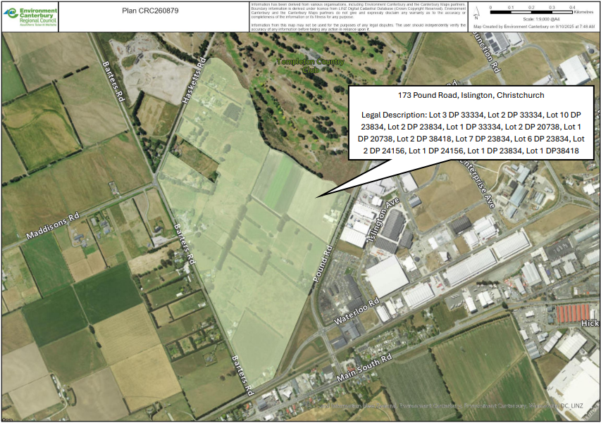
Appendix CRC260879

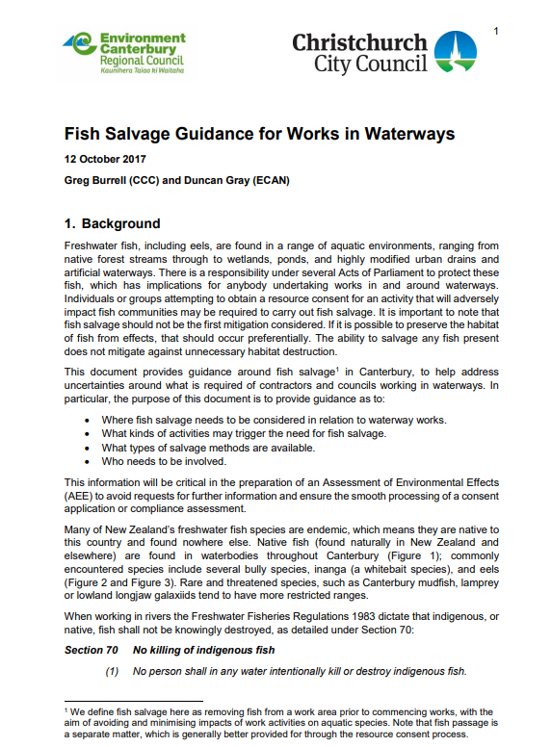
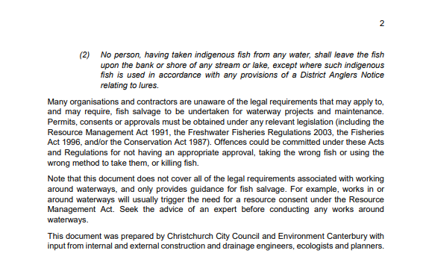
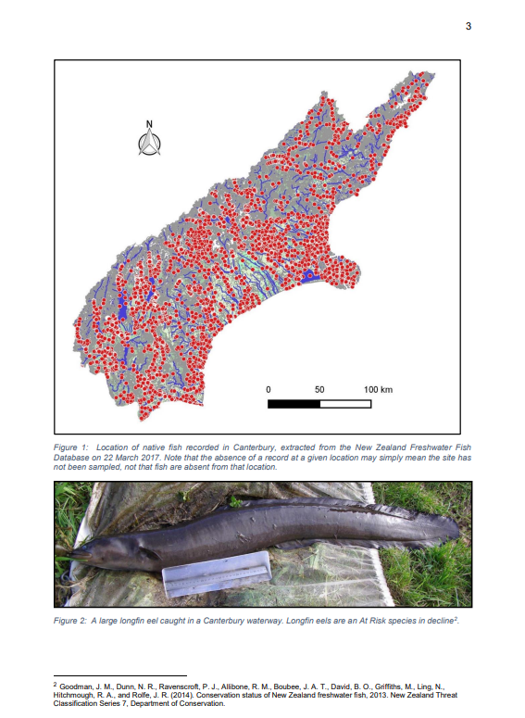
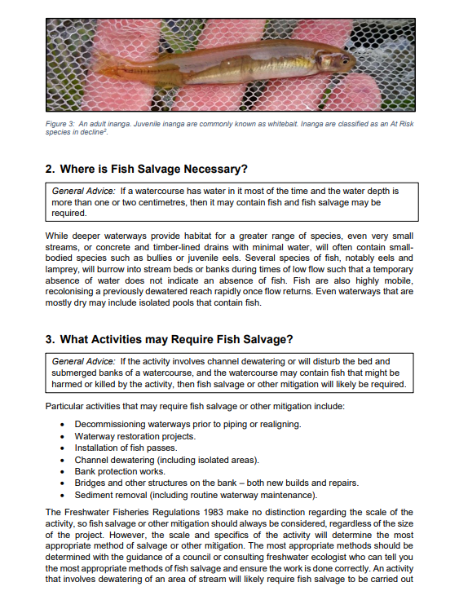
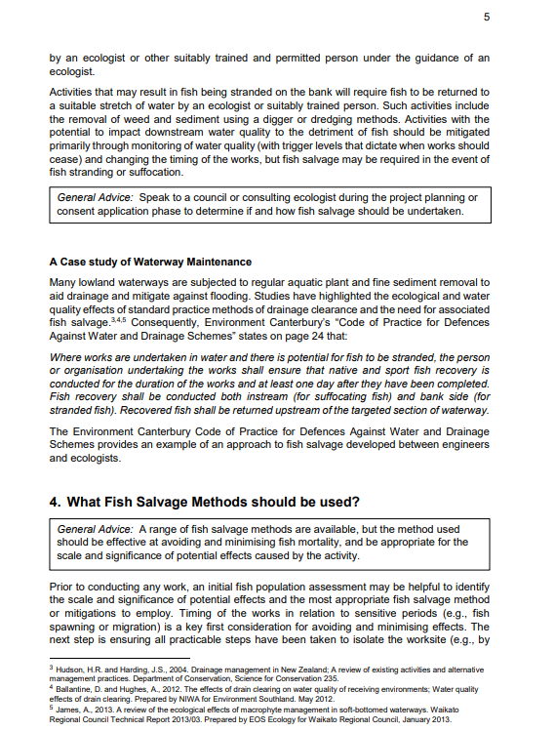
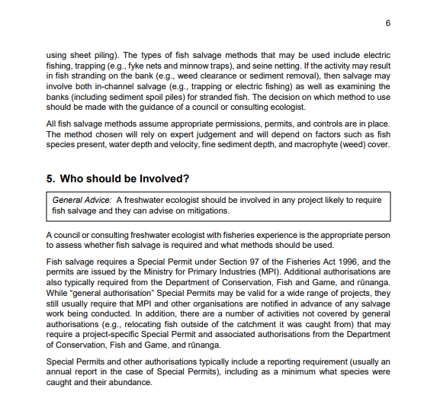
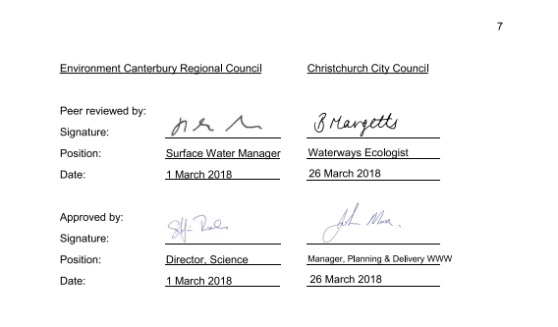

Part 2: Canterbury Regional Council: s14 water permit conditions
Duration sought: 5 years
 | Limits | Applicant comments and response to changes requested as part of Section 55 response | Panel Comments
1. | The activities authorised by this consent shall be limited to:  a. The temporary instream damming of the Paparua Water Race Network at 2, 38, 64, 86, 94 Barters Road; 4, 22, 30, 40 and 48 Barters Road; 111 and 173 Pound Road and 570 and 578 Waterloo Road , legally described as: Lot 3 DP 33334, Lot 2 DP 33334, Lot 10 DP 23834, Lot 2 DP 23834, Lot 1DP 33334, Lot 2 DP 20738, Lot 1 DP 20738, Lot 2 DP 38418, Lot 7 DP 23834, Lot 6 DP 23834, Lot 2 DP24156, Lot 1 DP 24156, Lot 1 DP 23834, Lot 1 DP 38418 to facilitate the take and use of water for non-consumptive purposes; and  b. The temporary non-consumptive take and use of water from the Paparua Water Race Network at 173 Pound Road, legally described as: Lot 3 DP 33334, Lot 2 DP 33334, Lot 10 DP 23834, Lot 2 DP 23834, Lot 1DP 33334, Lot 2 DP 20738, Lot 1 DP 20738, Lot 2 DP 38418, Lot 7 DP 23834, Lot 6 DP 23834, Lot 2 DP 24156, Lot 1 DP 24156, Lot 1 DP 23834, Lot 1 DP 38418 for the purpose of bypassing flows around the locations of the culvert installation. | Updated to include all property addresses.  Condition wording agreed between NTP and CRC. | Paparua Water Race Network and PWRN appear to be used interchangeably throughout conditions. Please ensure consistent use of terms. We prefer the term to be written in full at first occurrence with an abbreviation in brackets immediately afterwards, then the abbreviation to be used thereafter.
2. | The works shall be undertaken in accordance with the attached design plan, plan CRC260878 which forms a part of this consent. | Condition wording agreed between NTP and CRC.
3. | Water may only be taken under Condition (1) for no longer than 12 weeks as an overall total, with no longer than 2 weeks continuous. | Condition wording agreed between NTP and CRC.
4. | All water taken in accordance with this consent must be discharged back into the lateral channel of the PWNR. | Condition wording agreed between NTP and CRC.
 | Water Take
5. | Over pumping of the Paparua Water Race Network must be carried out at a rate that maintains existing water levels at the time of pumping. Over-pumping must not result in a reduction of water levels in the upstream reach. | Condition wording agreed between NTP and CRC.
6. | Water taken from over-pumping the Paparua Water Race Network and removing water from the culvert installation sites shall be returned to the Paparua Water Race Network, immediately downstream of the culvert installation sites. | Condition wording agreed between NTP and CRC.
 | Fish Protection
7. | Any pump used to take water in Condition (1) must be fitted with fish screens in general accordance with the Christchurch City Council’s “Standards for Temporary Fish Screens on Christchurch City Council Projects” (2023) attached as Appendix CRC260878. | Condition wording agreed between NTP and CRC. | This reference is the same as that used in Condition 2. However, text within conditions 2 and 7 indicate the documents are different. Please clarify or correct references.
 | Administration
8. | b. Requiring the adoption of the best practicable option to remove or reduce any adverse effect on the environment. | Condition wording agreed between NTP and CRC.
  The Canterbury Regional Council may, once per year, on any of the last five working days of May or November, serve notice of its intention to review the conditions of this consent for the purposes of:
  a. Dealing with any adverse effect on the environment that may arise from the exercise of the consent or
9. | If this resource consent is not exercised before [31 June 2031], it lapses in accordance with Section 125 of the Resource Management Act 1991.  Advice note: ‘Exercised’ is defined as implementing any requirements to operate this consent and undertaking the activity as described in these conditions and/or application documents. | Date updated to reflect anticipated timeframe of decision.  Condition wording agreed between NTP and CRC. | Check to ensure date correlates with final FTAA decision date.

Plan CRC260878
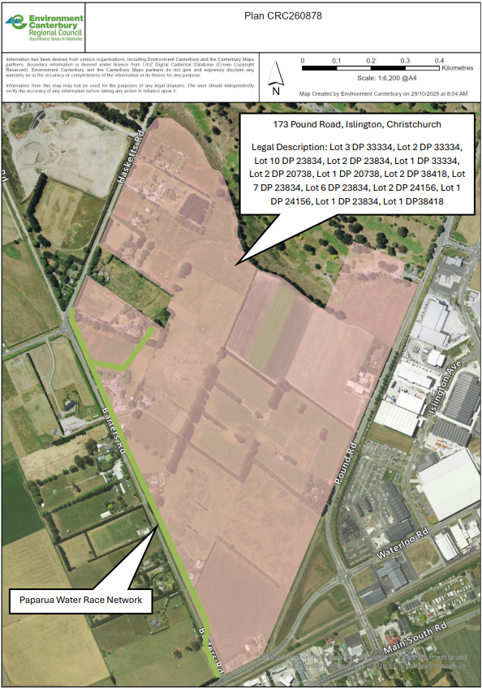
Appendix CRC260878
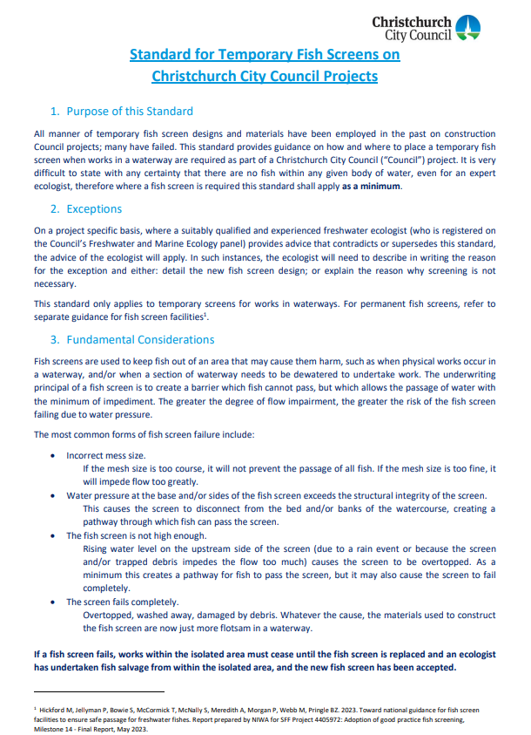
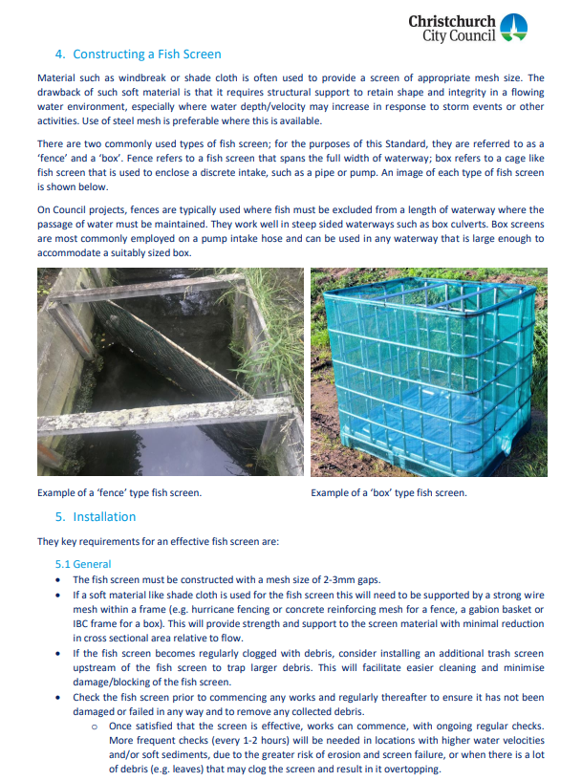
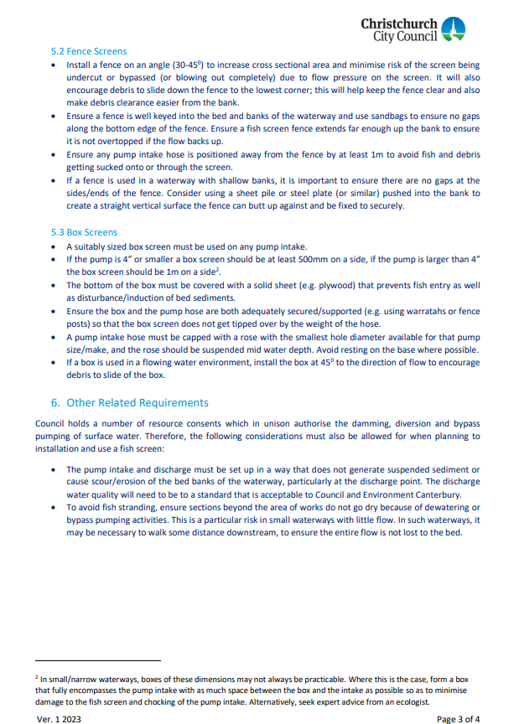
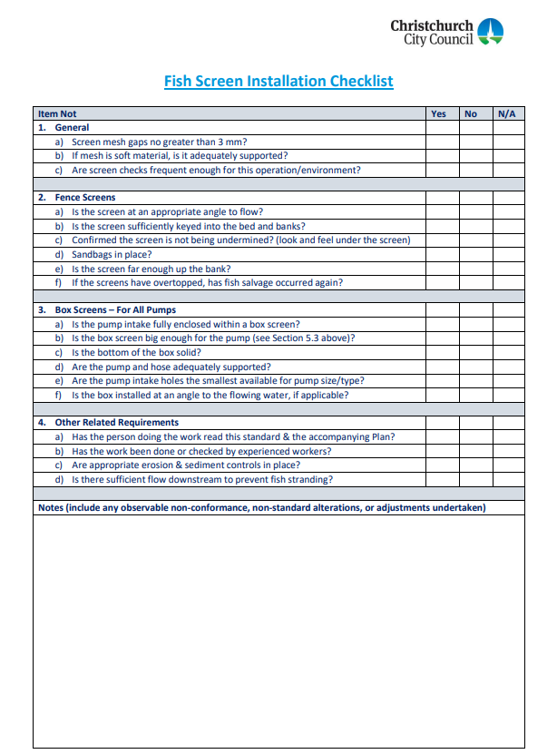
Part 2: Canterbury Regional Council: s15 discharge permit -construction phase
Duration sought: 7 years
 | Limits | Applicant comments and response to changes requested as part of Section 55 response | Panel Comments
1. | The discharges authorised under this resource consent is limited to:  a. The discharge of surface water to the lateral channel of the Paparua Water Race Network at Pound Road, being 2, 38, 64, 86, 94 Barters Road; 4, 22, 30, 40 and 48 Barters Road; 111 and 173 Pound Road and 570 and 578 Waterloo Road, legally described as: Lot 3 DP 33334, Lot 2 DP 33334, Lot 10 DP 23834, Lot 2 DP 23834, Lot 1DP 33334, Lot 2 DP 20738, Lot 1 DP 20738, Lot 2 DP 38418, Lot 7 DP 23834, Lot 6 DP 23834, Lot 2 DP24156, Lot 1 DP 24156, Lot 1 DP 23834, Lot 1 DP 38418) associated with the non-consumptive take and use authorised by resource consent CRC260878 as shown in Plan CRC260876A.  b. Sediment-laden stormwater from exposed areas during earthworks to land via temporary soak pits within the site at Pound Road (173 Pound Road, legally described as: Lot 3 DP 33334, Lot 2 DP 33334, Lot 10 DP 23834, Lot 2 DP 23834, Lot 1DP 33334, Lot 2 DP 20738, Lot 1 DP 20738, Lot 2 DP 38418, Lot 7 DP 23834, Lot 6 DP 23834, Lot 2 DP24156, Lot 1 DP 24156, Lot 1 DP 23834, Lot 1 DP 38418) as authorised by resource consent CRC260879 as shown in Plan CRC260876B. | Updated to include all property addresses.  Condition wording agreed between NTP and CRC.
2. | Sediment laden stormwater must be discharged:  a. In accordance with the Erosion and Sediment Control Plan (ESCP) required by Condition (8) of this resource consent;  b. Onto and/or into land via temporary soak pits. | Condition wording agreed between NTP and CRC.
 | Prior to Commencement of Works
3. | Prior to commencement of the works described in Condition (1) all personnel working on the site must be made aware of, and have access to, the following:  a. The contents of this resource consent document and all associated erosion and sediment control plans and other discharge treatment methodologies;  b. Resource Consents CRC260878 and CRC260879, and any subsequent variations, and all associated documents. | Condition wording agreed between NTP and CRC.
4. | All erosion and sediment control measures detailed in the ESCP required by Condition (8) of this resource consent must be installed prior to the commencement of any earthworks or stripping of vegetation and topsoil occurring on the site. | Condition wording agreed between NTP and CRC.
5. | At least 10 working days prior to the commencement of works on site, the Canterbury Regional Council, Attention: Compliance Manager (via ECinfo@ecan.govt.nz) must be informed of the commencement of works. | Condition wording agreed between NTP and CRC.
6. | Any remaining soils in areas where temporary construction-phase soakpits and stormwater basins are proposed, must be tested and confirmed to be below WasteMINZ Table C-3 criteria prior to use. | Changes to the conditions have occurred in correspondence with CRC post s53 comments.  Condition wording agreed between NTP and CRC. | The reference to “WasteMINZ Table C-3” needs to be clearer. A document reference and date is required.
7. | All remaining areas of the site, outside of those described in condition (6) must meet the commercial/industrial SGV standards. | New condition agreed with CRC post s53 comments.  Condition wording agreed between NTP and CRC. | The reference to “commercial/industrial SGV standards” should be written/referenced in full in the first instance and then abbreviated and referred to consistently throughout all conditions.
 | Erosion and Sediment Control
8. | The discharges authorised under this resource consent must occur in accordance with an ESCP. The ESCP must:  a. Detail best practicable sediment control measures that will be implemented to ensure compliance with the conditions of this resource consent;  b. Be prepared by a suitably qualified person with experience in erosion and sediment control in accordance with:  - Canterbury Regional Council’s Erosion and Sediment Control Toolbox for the Canterbury Region (ESCT); or  - An equivalent industry guideline. If an alternative guideline is used, the ESCP must provide details of the relevant alternative methods used and an explanation of why they are more appropriate than the ESCT; and  c. Be signed by an engineer or suitably qualified person with experience in erosion and sediment control, confirming that the erosion and sediment control measures for the site are appropriately sized and located in accordance with the ESCT or alternative guideline. | Condition wording agreed between NTP and CRC. | The conditions covering ESC in this consent should be consistent, to the extent practicable, with those in consent CRC260879.  Conditions 8-12 here seem to provide a more suitable starting point than those in CRC260879.  The conditions must commence with a requirement for the consent holder to prepare an Erosion and Sediment Control Plan and what the purpose of that Plan is.
9. | The ESCP must:  a. Include a map showing the location of all works;  b. Detailed plans showing the location of sediment control measures, on-site catchment boundaries, and sources of run-off;  c. Detail how best practicable measures are taken to minimize discharges of sediment-laden stormwater run-off beyond the boundaries of the site;  - include drawings and specifications of designated sediment control measures, if these are not designed and installed in accordance with the ESCT;  - Detail the methodology for stabilizing the site entrance and exit points and any measures employed to prevent off-site tracking od sediment and other materials from the site;  d. Include a confirmation that the erosion and sediment control devices have been sized appropriately in accordance with the ESCT;  e. Include a programme of works, including a proposed timeframe for each stage of the works and the earthworks methodology;  f. Detail the management of any stockpiled material;  g. Detail inspection and maintenance of the sediment control measures;  h. Detail sampling procedures and protocols;  i. Define the discharge points where stormwater is discharged onto land / infiltrates into land;  j. Include a description of dust mitigation to be used and details of best practicable options to be applied to mitigate dust and sediment discharge beyond the site boundary;  k. Detail the methodology for stabilizing the site if works are paused for more than five working days or abandoned;  l. detail the methodology for stabilizing the site and appropriate decommissioning of all erosion and sediment control measures after works have been completed.; and  m. include measures such as Chemical Treatment Plan should the use of water treatment chemicals be required. | Condition wording agreed between NTP and CRC.
10. | The ESCP must be submitted to the Canterbury Regional Council Attention: Compliance Manager (via ECinfo@ecan.govt.nz), after the commencement of the resource consent and at least 10 working days prior to works commencing. | Condition wording agreed between NTP and CRC. | A certification step is required. Please amend.
11. | The ESCP may be amended at any time. Any amendments must be:  a. Only for the purpose of improving the efficacy of the erosion and sediment control measures and must not result in reduced discharge quality; and  b. For the purpose of applying best practicable measures to mitigate sediment transport off-site; and  c. Consistent with the conditions of this resource consent; and  d. Submitted in writing to the Canterbury Regional Council, Attention: Compliance Manager (via ECinfo@ecan.govt.nz), prior to any amendment being implemented. | Condition wording agreed between NTP and CRC.
12. | Erosion and Sediment Control measures must be inspected at least once per day, as well as following any rainfall event that results in more than five millimetres of rainfall at the site. Any accumulated sediment must be removed, and repairs made, as necessary, to ensure effective functioning of measures and devices. Records of any inspections must be kept and provided to the Canterbury Regional Council on request. | Condition wording agreed between NTP and CRC. | Please identify who at Canterbury Regional Council is to be provided with records of inspections.
 | During the works
13. | The discharge to surface water described in Condition 1(a) must not at any time:  a. Have a concentration of Total Suspended Solids (TSS) exceeding 50 milligrams per litre; and  b. Result in within the receiving waterbodies:  - the production of any oil or grease films;  - the production of any floatable or suspended materials;  - the production any sludge or emulsion deposited on the bed. | Condition wording agreed between NTP and CRC.
14. | a. Prior to the discharge of water in accordance with Conditions (1)(a) of this resource consent, a set of laboratory calibrated samples must be made up in clear bottles containing the following concentrations of TSS:  - 0 milligrams per litre;  - 50 milligrams per litre;  - 100 milligrams per litre;  b. The calibrated samples must be:  - prepared using representative soil samples from the site and then calibrated by a suitable laboratory to the unique combination of soil types at the site and the TSS concentrations detailed under (a); and  - be replaced by a newly prepared sample every six months.  c. The set of calibrated samples must be held on site.  d. Records of the laboratory calibration, including records of replacement samples prepared must be kept and provided to Canterbury Regional Council on request. | Condition wording agreed between NTP and CRC. | The reference to “of this resource consent” is not made elsewhere is conditions. In our view it is self evident and not required.  Please identify who at Canterbury Regional Council is to be provided with records.
15. | During the discharge to surface water described in Condition (1)(a), samples of discharge water must be:  a. Taken by a suitably qualified person and in accordance with best practicable sampling methodology;  b. Collected in clean containers at the end of the sediment treatment system prior to the discharge to land or water;  c. Collected one, two, four, and 24 hours after the discharge has commenced, and once per day thereafter if discharge exceeds one working day; and  d. Visually compared to the calibrated samples prepared in accordance with Condition (12). | Condition wording agreed between NTP and CRC.
16. | If it becomes apparent at any stage during water quality monitoring detailed in Conditions (11) and/or (13) that a maximum TSS concentration of 50 milligrams per litre in the discharge will not, or is unlikely to be achieved, or if the visual assessment and observations undertaken in accordance with Condition (X) indicate a sheen of oil or grease or discoloration, or any sludge or emulsion below the water surface, then:  a. the discharge must cease immediately;  b. the discharge can only recommence once amendments have been made to the treatment process such that:  - a TSS concentration of 50 milligrams per litre in the treated discharged is achieved;  - the source of the sheen of oil or grease, discoloration, or any sludge or emulsion below the water surface, has been removed. | Condition wording agreed between NTP and CRC. | Are the condition references correct. Condition 11 addressed changed to the Erosion and Sediment Control Plan.  Is condition X supposed to be condition 15 d.
17. | All practicable measures must be taken to:  a. minimise soil disturbance to that necessary to minimise the potential for sediment-laden stormwater runoff to be generated;  b. Prevent soil erosion as a result of stormwater runoff generated from the works area;  c. Avoid placing excavated material in a position where it may become entrained in stormwater runoff and discharged to:  - Any surface water body;  - Any neighbouring site; and/or  - The Christchurch City Council reticulated stormwater network. | Condition wording agreed between NTP and CRC.
18. | a. Tracking of material off-site during the works must be avoided at all times.  b. In the event that material is tracked off-site, the tracked material must be removed as soon as practicable. | Condition wording agreed between NTP and CRC.
 | Stockpiling of Contaminated Material/Soil
19. | Stockpiling of contaminated material or soils must be avoided where possible. In the event that temporary stockpiling of suspected contaminated or contaminated material is required, then the contaminated material stockpiles must be managed as below:  a. Stockpiled contaminated material or soils must be kept separate from uncontaminated excavated soils stockpiles and any virgin aggregate or other material also stockpiled on-site; and  b. Stockpiled contaminated material must be placed on polythene sheeting or similar impervious material to prevent contamination of underlying material; and  c. Stockpiled contaminated material must include a perimeter bund or berm installed to prevent runoff leaving the area and stormwater from other areas entering the stockpile area; and  d. Stockpiled material must be covered or dampened during dry and windy conditions so as to prevent wind erosion; and  e. If any rainfall is forecasted that has the potential to cause runoff from the stockpiles, or if the stockpiles are left overnight, over the weekend or over public holidays, the stockpiled material must be covered with plastic sheeting or a suitable material such as clean topsoil, or otherwise stabilised, to prevent stormwater runoff coming into contact with contaminated material.  Advice note: For the purpose of this condition, temporary stockpiling means material being stockpiled for no longer than the overall construction period or the stage of construction if construction occurs in stages, whichever is the shorter period, and only for as long as reasonably necessary. The overall requirement to avoid, where possible, the stockpiling of contaminated material or soils prevails. | Condition wording agreed between NTP and CRC. | Please ensure this condition is consistent with those dealing with the same matters in other consents. See condition 26 of the Canterbury Regional Council landuse consent.
 | Spills
20. | All practicable measures must be taken to avoid spills of fuel or any other hazardous substances within the site. These measures must include:  a. Refueling of machinery and vehicles must not occur within 20 metres of:  - open excavations;  - exposed groundwater; and  - stormwater devices.  b. A spill kit must be kept on site that is capable of absorbing the quantity of oil and petroleum products that may be spilt on site at any one time, remains on site at all times.  c. In the event of a spill of fuel or any other hazardous substance, the spill must be cleaned up as soon as practicable, the stormwater system must be inspected and cleaned, and measures taken to prevent a recurrence;  d. The Canterbury Regional Council, Attention: Compliance Manager, must be informed within 24 hours of a spill event exceeding five litres and the following information provided:  - The date, time, location and estimated volume of the spill;  - The cause of the spill;  - The type of hazardous substance(s) spilled;  - Clean up procedures undertaken;  - Details of the steps taken to control and remediate the effects of the spill on the receiving environment;  - An assessment of any potential effect of the spill; and  - Measures to be undertaken to prevent a recurrence. | Condition wording agreed between NTP and CRC. | Please ensure this condition is consistent with those dealing with the same matters in other consents.
 | Upon Completion of Works
21. | Erosion and sediment control measures must not be decommissioned until the site is stabilised and the stormwater system for the developed site is functioning. The following decommissioning measures must be undertaken:  a. All disturbed areas must be stabilised and re-vegetated within 10 working days of the completion of the works;  b. Any visible debris, litter, sediment and hydrocarbons must be removed from all sediment control measures and disposed at a suitable facility; and  c. Erosion and sediment control measures must be removed. | Condition wording agreed between NTP and CRC.
22. | Upon completion of works and the removal of erosion and sediment control measures, any visible sediment accumulated on impervious surfaces within or immediately adjacent to the works site must be removed to minimise the risk of sediment becoming entrained in stormwater. All sediment removed must be disposed of at a suitable facility. | Condition wording agreed between NTP and CRC.
 | Administration
23. | The Canterbury Regional Council may, once per year, on any of the last five working days of May or November, serve notice of its intention to review the conditions of this consent for the purposes of:  a. Dealing with any adverse effect on the environment that may arise from the exercise of the consent or  b. Requiring the adoption of the best practicable option to remove or reduce any adverse effect on the environment. | Condition wording agreed between NTP and CRC.
24. | If this resource consent is not exercised by 31 June 2031, it lapses in accordance with Section 125 of the Resource Management Act 1991.  Advice note: ‘Exercised’ is defined as implementing any requirements to operate this consent and undertaking the activity as described in these conditions and/or application documents. | Condition wording agreed between NTP and CRC – date updated to reflect anticipated timeframe of FTA decision.

Plan CRC260876A
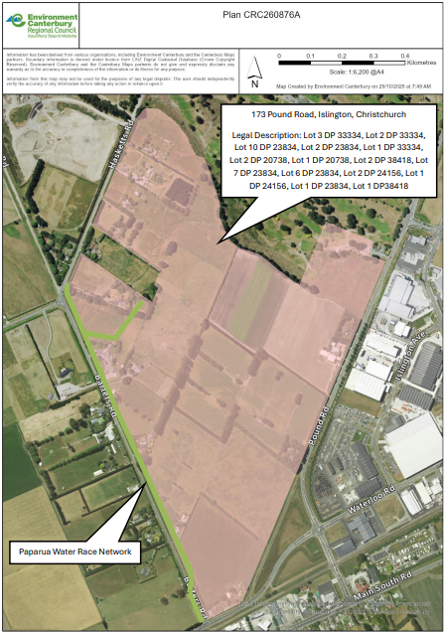
Plan CRC260876B
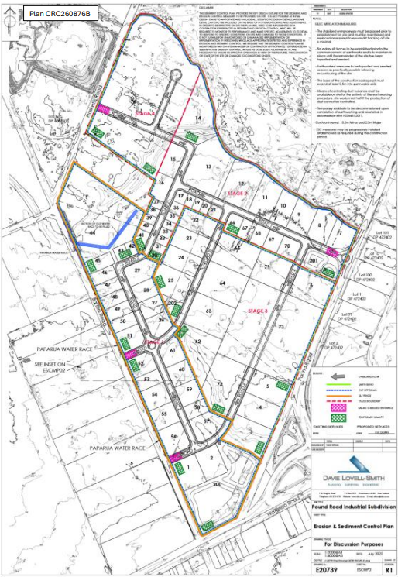

Part 2: Canterbury Regional Council: s15 discharge permit – operation phase
Duration sought: 35 years
 | Limits | Applicant comments and response to changes requested as part of Section 55 response | Panel Comments
1. | The activity authorised under this resource consent is limited to the discharge of stormwater generated from:  a. Roofs  b. Roads  c. Berms  d. Footpaths  e. Hardstand and impervious surface areas  associated with the proposed industrial subdivision ‘Pound Road Industrial Development’ labelled, as ‘Lots 1 to 72, 400 and 401’ on Plan CRC260877A attached to and forming part of this consent. | Condition wording updated to reflect the correct lots.  Condition wording agreed between NTP and CRC.
2. | Stormwater must only be discharged onto and into land within the boundary of the site in accordance with Conditions (4) to (14) of this resource consent. | Condition wording agreed between NTP and CRC.
3. | Unless treatment is provided, the discharge of roof stormwater must not arise from:  a. Copper building materials; or  b. Unpainted galvanized sheet materials. | Condition wording agreed between NTP and CRC.
 | Individual Lot Stormwater Systems
4. | Stormwater must be discharged into land via the following stormwater system:  a. Stormwater from roofs shall be discharged via a sealed system that excludes all other stormwater to soakage pits;  b. A minimum of one infiltration test at the location of each of the proposed soakage pits;  c. The soakpits and associated detention shall have a minimum capacity to attenuate and dispose all rainfall events up to and including the 24 hour duration two percent annual exceedance probability event from the contributing catchment;  d. Stormwater in excess of the specified event in Condition 4 (c) must be directed towards the roading reserve.  Advice Note: The intent of clause (d) of this condition is to avoid flooding of properties. | Condition wording agreed between NTP and CRC.
5. | The individual lot soak pits must:  a. Along with its associated detention, store and dispose of all stormwater from the contributing catchment for up to and including the 24 hour duration two percent annual exceedance probability event from the contributing catchment;  b. Have a base that extends into free draining soil strata; and  c. Have a factor of safety of three incorporated into the soak pit design to account for reduction of infiltration performance over time (clogging).  d. Be sized and designed based on infiltration tests completed at the proposed soakpit location and target depth;  e. Have a maximum depth to the base of 5.5 metres below natural ground level or a minimum separation distance of 1 metre to groundwater. | Condition wording agreed between NTP and CRC. | It is unclear what “factor of safety of three” in condition 5 c. means or equates to. Please clarify and amend condition to be clear.
6. | Stormwater generated within each individual site must only be discharged onto and into land within the boundary of each individual site except where specified in Condition (9). | Condition wording agreed between NTP and CRC. | Is the second reference to “site” supposed to be “lot?”
7. | The discharges must not arise from a site where any of the activities or industries listed in Schedule 3 of the Land and Water Regional Plan attached as Appendix CRC260877, which forms part of this consent, are conducted or operated. | Updated to refer to the correct Schedule.  Condition wording agreed between NTP and CRC. | Schedule 3 does not appear to be attached.
8. | For the avoidance of doubt, Conditions (9) to (14) do not apply to the individual lot discharges from roof surfaces covered by Conditions (4) to (8).
 | Overall Subdivision Stormwater System
9. | Stormwater from roads, footpaths, berms, hardstand areas, impervious surfaces, and excess stormwater run-off from industrial lots must be conveyed via kerb and channel to submerged outlet sumps and treated via a first flush infiltration basin and/or soakpits system. | Condition wording updated post s53 comments removing reference to the previously referenced schedules of the LWRP. Updates have occurred in consultation with CRC.  Condition wording agreed between NTP and CRC.
10. | The infiltration basin and/or soakpits shall:  a. Along with its associated detention, store and dispose of all rainfall events up to and including the 24 hour duration two percent annual exceedance probability event from the contributing catchment;  b. Have a base that extends into free draining soil strata; and  c. Have a factor of safety of [three] incorporated into the soak pit design to account for reduction of infiltration performance over time (clogging);  d. Be sized and designed based on infiltration tests completed at the proposed soakpit location and target depth.  e. Have a maximum depth to the base of 5.5 meters below natural ground level or a minimum separation distance of 1 metre to groundwater. | Condition wording agreed between NTP and CRC. | It is unclear what “factor of safety of three” in condition 10 c. means or equates to. Please clarify and amend condition to be clear.
11. | Where the capacity of the primary stormwater system is exceeded, stormwater must be directed towards the internal roading network and to the Christchurch City Council stormwater network in Pound Road or Waterloo Road. | Condition wording agreed between NTP and CRC.
12. | All sumps must be fitted with submerged outlets capable of trapping at least 60 litres of hydrocarbons. | Condition wording agreed between NTP and CRC.
13. | Stormwater shall not pond in any open detention area for longer than 48 hours after the cessation of any storm event. | Condition wording agreed between NTP and CRC.
14. | Stormwater shall only be discharged onto and into land via the stormwater system detailed under Condition (109) of this resource consent. | Condition wording agreed between NTP and CRC.
 | Design Plans
15. | At least 20 working days prior to the installation of the stormwater system the consent holder or lot owner shall submit to the Canterbury Regional Council, Attention Compliance Manager:  a. Final detailed design plans for the stormwater system/component.  b. A certificate signed by a Chartered Professional Engineer (CPEng) with stormwater system design and construction experience confirming that:  - The stormwater system has been designed in accordance with the Conditions of this resource consent; and  c. A statement signed by the CPEng confirming that they are competent to certify the engineering work. | Condition wording agreed between NTP and CRC. | Is condition 15 c. supposed to be numbered b. ii., rather than c.
16. | Within 10 working days of the installation of the stormwater system, the consent holder or lot owner shall submit to the Canterbury Regional Council, Attention: Compliance Manager (via ECinfo@ecan.govt.nz):  a. All as built design plans of the stormwater system installed;  b. A certificate signed by a CPEng with stormwater system design and construction experience confirming that confirming that the installed stormwater system complies with the conditions of this resource consent; and  c. A statement signed by the CPEng confirming that they are competent to certify the engineering work. | Condition wording agreed between NTP and CRC.
 | Inspection and Maintenance
17. | The soakage pits must be inspected at least once every six months, and the following maintenance carried out if necessary, unless otherwise agreed with Canterbury Regional Council:  a. Inspecting the proprietary treatment device or other chosen treatment system, trapped sumps, outlet manholes and soakage pit inlets at least once every six months depending on which first flush treatment solution has been designed for the individual site.  b. Removing any visible hydrocarbons, debris or litter within ten working days of the inspection.  c. Removing any accumulated sediment in the infiltration basin forebay and main infiltration bed within five working days of the inspection.  d. Removing any accumulated sediment in the sumps and [manholes] when the sediment occupies more than one quarter of the depth below the invert of the outlet pipe.  e. Repairing any scour or erosion within ten working days of the inspection. | Condition wording updated to include the correct treatment devices.  Condition wording agreed between NTP and CRC. | Please include reference to the position title of the person at Canterbury Regional Council with whom agreement is to be made.
18. | Any material, including sediment, hydrocarbons and other contaminants removed in accordance with condition 17 of this consent shall be disposed of at a location or facility authorised to receive such material. | Condition wording agreed between NTP and CRC.
19. | Records of the inspection and maintenance of the stormwater system must be kept. The records must include, but not be limited to, information that demonstrates compliance with conditions 17 and 18 of this consent. Copies of these records must be provided to the Canterbury Regional Council on request. These records must include, but not be limited to:  a. Date and details of inspections of the stormwater system;  b. Date and details of any maintenance work, repairs and upgrades to the stormwater system, including removal of material and its disposal;  c. Any complaints received about the stormwater discharge. | Condition wording agreed between NTP and CRC. | Please include reference to the position title of the person at Canterbury Regional Council to whom copies of records are to be provided.
 | Spills
20. | All practicable measures shall be taken to avoid spills of fuel or any other hazardous substances within the site. In the event of a spill of fuel or any other hazardous substance:  - The spill shall be cleaned up as soon as practicable, the stormwater system shall be inspected and cleaned, and measures shall be taken to prevent a recurrence;  - The Canterbury Regional Council, Compliance Manager shall be informed within 24 hours of a spill event exceeding five litres and the following information provided:  - The date, time, location and estimated volume of the spill;  - The cause of the spill;  - The type of hazardous substance(s) spilled;  - Clean up procedures undertaken;  - Details of the steps taken to control and remediate the effects of the spill on the receiving environment;  - An assessment of any potential effects of the spill; and  - Measures to be undertaken to prevent a recurrence. | Condition wording agreed between NTP and CRC.
21. | All best practicable options shall be used to contain spills or leaks of any hazardous substance from being discharged via the stormwater system. These shall include, but not be limited to the following:  a. Using a tank filling procedure to minimise spills during any fuel delivery;  b. Making spill kits available to contain or absorb any hazardous substances used or stored on the site;  c. Maintaining signs to identify the location of the spill kits; and  d. Maintaining written procedures in clearly visible locations that are to be undertaken to contain, remove and dispose of any spilled hazardous substance. | Condition wording agreed between NTP and CRC.
 | Administration
22. | The Canterbury Regional Council may, once per year, on any of the last five working days of May or November, serve notice of its intention to review the conditions of this consent for the purposes of:  a. Dealing with any adverse effect on the environment that may arise from the exercise of the consent or  b. Requiring the adoption of the best practicable option to remove or reduce any adverse effect on the environment. | Condition wording agreed between NTP and CRC.
23. | If this resource consent is not exercised before [31 June 2031], it lapses in accordance with Section 125 of the Resource Management Act 1991.  Advice note: ‘Exercised’ is defined as implementing any requirements to operate this consent and undertaking the activity as described in these conditions and/or application documents. | Condition wording agreed between NTP and CRC, date updated to reflect anticipated decision date of FTA. | Check to ensure date correlates with final FTAA decision date.

