**WAIHI NORTH PROJECT - PROPOSED FAVONA ACCESS ARRANGEMENT VARIED CONDITIONS**

*The proposed changes to 62342-AA are provided in* redline *and* ~~strikethrough~~ *below.*

**ACCESS ARRANGEMENT**

THIS AGREEMENT for an Access Arrangement pursuant to section 61 of the Crown Minerals Act 1991 dated 17 January 2018, and as varied on [date], between His Majesty the King ~~Her Majesty the Queen~~ in Right of New Zealand ("Crown") acting by and through the Minister of Conservation and the Minister of Resources (hereinafter referred to as "the Ministers") and **OCEANA GOLD (NEW ZEALAND) LIMITED** (hereinafter referred to as the "Permit holder'').

WHEREAS

1. The Land described in the First Schedule is administered by the Department of Conservation pursuant to section 25 of the Conservation Act 1987 and Section 23 of the Reserves Act 1977; and the Minister of Conservation is responsible for that Department.

1. The Minister of ~~Energy and~~ Resources, through the Ministry of Business, Innovation and Employment, administers the Crown Minerals Act 1991. The purpose of the Act is to promote prospecting for, exploration for, and mining of Crown-owned minerals for the benefit of New Zealand.
2. The Permit holder has been granted a minerals permit **(Minerals Mining Permit 41808)** by the Minister of Resources pursuant to section 25 of the Act to undertake Mining operations in and on the Land.

1. Minerals Mining Permit 41808 is classified as a Tier 1 permit pursuant to section 2B of the Crown Minerals Act 1991.

1. The Permit holder has applied under the Fast-track Approvals Act 2024 for approvals to conduct Mining operations, including a request for an Access Arrangement under section 59 of the Crown Minerals Act 1991 in respect of the Land described in the First Schedule. Pursuant to section 96 of the Fast-track Approvals Act an Access Arrangement granted under that Act has the same force and effect for its duration, and according to its terms and conditions, as if it were granted, issued or entered into under the Crown Minerals Act 1991.
2. Pursuant to section 61(1)(c)~~(1AA)~~ of the Crown Minerals Act 1991 the decision of whether or not to enter into ~~an initial~~ a variation to an existing access arrangement in relation to a Tier 1 permit is with the ~~Ministers.~~ Minister of Conservation, except if the variation is to allow for the purpose of significant exploration or mining activities.

1. Pursuant to section 61(1AAB) of the Crown Minerals Act 1991 the Minister of Conservation has determined that the activities are not significant exploration or mining activities.

1. Although this Access Arrangement is entered into by the Ministers, on behalf of His Majesty the King ~~Her Majesty the Queen~~, the administration of the Access Arrangement together with matters relating to the Permit Holder's access to, and use of the Land is the responsibility of the Department. The Ministry of Business, Innovation and Employment is responsible for matters relating to the minerals permit.

IT IS AGREED between the Ministers of the first part and the Permit holder of the second part that the Permit holder may enter the Land described in the First Schedule subject to the terms and conditions set out below and in the Second Schedule hereto:

# INTERPRETATION

* 1. "Access Arrangement" means this agreement for an access arrangement.

"Act" means the Crown Minerals Act 1991.

"Work Programme" means the Work Programme referred to in Condition 7(b). "Department" means the Department of Conservation.

"Mining" and "Mining operations" have the same meanings as defined in section 2 of the Crown Minerals Act 1991.

"Mining operations" means operations in connection with Mining for any Crown owned mineral and authorised under this Access Arrangement.

"Mining permit" means a mining permit granted under the Crown Minerals Act 1991.

"Land" means the land described in the First Schedule.

"Manager'' means the person for the time being holding the office of Operations Manager, Tauranga District, Central North Island Region of the Department of Conservation and includes any person authorised by the Manager to act on his or her behalf in respect of this agreement.

"Ministers" means the Minister of Conservation and the Minister of Energy and Resources.

"Parties" means the Minister of Conservation, the Minister of Energy and Resources and the Permit holder.

"Permit holder" has the meaning as defined in section 2 of the Crown Minerals Act 1991 and includes its servants, agents, contractors and assignees.

# ASSIGNMENT

* 1. The Permit holder will not assign, transfer or sublet any rights herein granted or any part thereof without the prior written consent of the Ministers, and such consent will not be· unreasonably withheld. Any change in the Permit holder's shareholding altering the effective control of the Permit holder shall be deemed to be a proposed assignment requiring the consent of the Ministers.

# COMPENSATION

* 1. Pursuant to section 76 of the Act, the Permit holder will pay the Minister of Conservation the following compensation:
     1. $6,000.00 + GST per annum in arrears.

Compensation may be annually reviewed for changes in the Consumer Price Index (CPI) and adjusted accordingly. Compensation is payable into Department of Conservation administered bank account to be used by the Department for conservation purposes in the Central North Island Region.

# COMPENSATION FOR ANY UNAUTHORISED DISTURBANCE

* 1. The Minister of Conservation may require the Permit holder to pay additional compensation for any breaches of this Access arrangement and/or Mining operations carried out by the Permit holder on the Land or on other adjoining or proximate land administered by the Department outside of the Land **NOT** authorised by this Access arrangement. Such additional compensation will be for an amount solely determined by the Minister of Conservation and should be paid by the Permit holder upon receiving an invoice.

# ADMINISTRATION COSTS

* 1. Pursuant to section 76 of the Act the Permit holder will also pay to the Minister of Conservation, upon receiving an invoice, all actual and reasonable costs to cover the administrative costs of processing this Access arrangement.
  2. Pursuant to section 76 of the Act the Permit holder will also pay to the Minister:
     1. The actual and reasonable costs of administering this Access arrangement; and
     2. The actual and reasonable costs of monitoring compliance of the conditions in this Access Arrangement including all associated inspections of the Land by the Department.

# PRECONDITIONS BEFORE ENTRY TO LAND

* 1. The Permit holder will not enter in or on to the Land for the purpose of commencing Mining operations until:
     1. The documents referred to in Condition 9 have been supplied to the Manager; and
     2. The Permit holder has submitted to the Manager a Work Programme in accordance with Condition 62 in the Second Schedule; and
     3. Any payments referred to in Conditions 3, 4, 5, 6 and 17 which are due and owing have been paid; and
     4. The bond required by Condition 21 has been provided to the Manager; and
     5. The Manager has approved the plans required to be submitted by Condition 7(b) and has issued the Permit holder with an Authority to Enter and Operate as provided by Condition 10.
  2. The Manager may require the Permit holder to vary the proposed Work Programme to ensure the Mining operations are not inconsistent with the conditions of this Access Arrangement. Where required by the Manager the Permit holder will amend the proposed Work Programme accordingly.
  3. The Permit holder will seek an Authority to Enter and Operate from the Manager. At the time of seeking an Authority to Enter and Operate, the Permit holder will submit to the Manager:
     1. A copy of the insurance policies and the premium payment receipts and guarantees or bonds as required in Conditions 20 and 21; and
     2. A copy of the Mining permit granted pursuant to section 25 of the Act; and
     3. A copy of all resource consents granted under the ·Resource Management Act 1991, and a copy of any reports that the Permit holder has been required to submit to the consent authority as a requirement of any resource consent relating to the mining permit, as defined in clause (c).
     4. If new resource consents are granted and/or varied a copy will be submitted to the Manager before exercise of that consent.
  4. Upon the Manager being satisfied that the requirements of Conditions 7, 8 and 9 have been met, the Manager will issue the Permit holder with a written "Authority to Enter and Operate" permitting the Permit holder to enter in or on to the Land to commence Mining operations for the term of the Access Arrangement provided the Mining Permit continues in force for the term, or longer, of any Authority to Enter and Operate issued.
  5. A breach or failure to comply with the requirements of the documents referred to in Condition 7(e), as approved by the Manager, shall be deemed to be a breach of this Access Arrangement, and shall entitle the Ministers to exercise any rights or powers which arise from a breach of or failure to comply with the terms of this Access arrangement.
  6. Prior to the expiry of the first Authority to Enter and Operate, and each subsequent Authority to Enter and Operate thereafter, the Permit holder will submit to the Manager for approval a further Work Programme and any other plans or amended plans as required by Condition 7(b) and any other requirements of Conditions 7, 8 upon request of the Manager all or parts of Condition 9, for the remainder of the Access Arrangement term identified in Condition 33 (or a lesser period *if* considered appropriate by the Permit holder).
  7. Except as permitted by the Manager, the Permit holder will not after the expiry of an Authority to Enter and Operate, undertake any work prior to each subsequent Authority to Enter and Operate has been issued by the Manager pursuant to Condition 10.
  8. The Manager will not unreasonably fail to grant a subsequent Authority to Enter and Operate where the Permit holder has supplied all the required documentation and made all the payments required by Condition 12, and the further Work Programme is consistent with the project description contained in the application for this Access Arrangement or any variation(s) to this Access Arrangement and the conditions of this Access Arrangement or any authorised variations to this Access Arrangement.
  9. Pending the granting of a subsequent Authority to Enter and Operate the Manager may in his or her discretion, issue an interim Authority to Enter and Operate providing the documents and payments required by Condition 12 have been submitted.

# INDEMNITIES

* 1. The Permit holder will indemnify and keep indemnified the Ministers against all claims by any person in respect of any injury, loss or damage (including fire damage) caused or suffered as a result of or arising out of any act or omission of the Permit holder or otherwise caused as a result of the Mining operations on the Land.
  2. If due to the Permit holder's Mining operations the Land or any part of it is assessed as rateable land under the Local Government (Rating) Act 2002, or any amendment to that Act, or the introduction of a new Act in substitution for it, the Permit holder is to pay any of the rates which may be struck in respect of the Land and/or the Mining operations; but the Permit holder and the Minister of Conservation expressly agree that such payment is not to constitute an acknowledgement of exclusive possession by the Permit holder of the Land.
  3. The Ministers will not be liable for and do not accept any responsibility for damage or interference to the Mining operations, equipment, buildings or structures, held or erected on the Land due to any cause whatsoever including (without restriction) any acts or omissions by the Ministers, their servants, agents, or contractors (other than acts or omissions arising from the willful misconduct of the Ministers, their servants, agents or contractors), natural disaster, vandalism, sabotage, fire, exposure to the elements or any other cause whatsoever.
  4. The Permit holder will take all reasonable steps to protect the safety of persons present on the Land during Mining operations and between work periods and will, when required by the Minister of Conservation, erect protective fencing or erect signposts warning the public of any dangers that may be encountered as a result of the Mining operations. The Permit holder will take all reasonable steps to mitigate any dangers to the public and will clearly mark any that remain.
     1. Where the Permit holder, to ensure the safety of the public, employees, plant and equipment, requests the Manager (acting under delegated authority from the Minister of Conservation) to close public access to the Land the Manager may do so if he or she considers it appropriate.
     2. The Permit holder will give the Manager reasonable notice of its request so that the Manager can ensure that all reasonable steps are taken to ensure members of the public are made aware of the closure and the reasons for it.
     3. The Permit holder will be responsible for the costs of ensuring that the public is made aware of the closure.

# INSURANCE

* 1. Prior to commencing Mining Operations, the Permit holder will effect and maintain, during the term of this Access Arrangement, insurance cover for an amount of **$1,000,000.00** for public liability and **$500,000.00** for third party motor vehicle. The Manager may from time to time require the cover of any insurance to be increased to such an amount as considered reasonably necessary.

# BONDS

* 1. Prior to commencing Mining operations, the Permit holder will provide a bond to ensure compliance by the Permit holder with the conditions of this agreement. The bond will be in a form of a surety or bank bond as approved by the Manager and the initial amount of the bond will not be less than **$5,000.00.**
  2. Notwithstanding Condition 21 the Manager may during consideration of any Work Programme or variation to any Work Programme require the bond amount to be increased or decreased.
  3. The bond will not be released and will remain effective until such time as all conditions of this agreement have been complied with, notwithstanding the completion of Mining operations. In the event that there is an adverse effect to the Land and its natural resources whether during or after the completion of the Mining operations which is not permitted by this agreement and could not have reasonably been foreseen, the Permit holder will take all action necessary to mitigate or remedy those adverse effects. If the Permit holder fails to mitigate or remedy those adverse effects to the Manager's satisfaction, the Manager may undertake any necessary action to do so and recover the costs associated with undertaking the work by calling on the bond.
  4. If the Permit holder breaches any condition of this arrangement the Manager may revoke the Authority to Enter and Operate and call on the bond, or any portion thereof to ensure compliance with the conditions of this Access Arrangement. If the Manager calls on the bond, or any portion thereof, the Permit holder must submit a new Work Programme or amended Work Programme for approval by the Manager before re commencing any further Mining operations.

# FIRE PRECAUTIONS

* 1. The Permit holder will:
     1. Take all reasonable precautions to ensure no fire hazard arises from the Mining operations;
     2. Not light any fire except by permit issued by the Manager;
     3. Not store or permit to be stored fuels or other combustible materials on the Land without the prior written permission of the Manager; The Manager acknowledges that fuel will need to be stored for the Mining operations.

# PROTECTION OF THE ENVIRONMENT

* 1. The Permit holder will ensure that in respect of all Mining operations under this Access Arrangement:
     1. Environmental disturbance is minimised and land affected by Mining operations is kept stable.
     2. There is no land disturbance other than that authorised under this Access arrangement.
     3. All indigenous flora and fauna are protected except for disturbance authorised under this Access Arrangement. •
     4. No debris, rubbish or other dangerous or unsightly matter will be deposited in or on the Land, or any pollution will occur of any water body, except as permitted by this Access Arrangement and any resource consent granted under the Resource Management Act 1991.
     5. There will be no destruction, damage or modification to any archaeological site in the area (as defined by the Heritage New Zealand Pouhere Taonga Act 2014) without the authority of Heritage New Zealand Pouhere Taonga obtained under section 44 of that Act. The Permit holder will produce such authority to the Manager.
     6. Any *protected New Zealand object, or taonga taturu* (as defined by the Protected Objects Act 1975), or object of historic significance found in the area or on the Land will be left *in situ,* and the ~~Manager and Secretary of Internal Affairs~~ Chief Executive of the Ministry for Culture and Heritage notified as soon as reasonably practicable.
     7. Every person under the Permit holder's control entering on to the Land complies with the provisions of this Condition (Condition 26).

# SUPPLY OF INFORMATION

* 1. The Permit holder will lodge with the Manager copies of the renewal of or substitution for any insurance policies including receipts for payment of premiums, any variations to bonds and evidence that the bonds are in force.
  2. The Permit holder will provide to the Minister of Conservation all information required from time to time by the Minister of Conservation in respect of the use of the Land and any buildings or equipment thereon including any details concerning the Mining operations and details concerning the numbers of people employed by the Permit holder or permitted or allowed by the Permit holder to come onto the Land provided that, subject to the requirements of the Official Information Act 1982, the Minister of Conservation will not release that information to any third party.
  3. The Permit holder will submit to the Minister of Conservation a copy of any application lodged with the Minister of Energy and Resources to vary and/or extend the term of the Mining permit covering the Land including any application to transfer the Mining permit to another person provided that, subject to the requirements of the Official Information Act 1982, the Minister of Conservation will not release that information to any third party.

# MONITORING

* 1. The Permit holder will allow the Manager or any other person authorised by the Manager to enter in or on to the Land at any time:
     1. To inspect the Land or to consider approval of any Work Programme or other plans, or to monitor compliance with the conditions of this Access Arrangement.
     2. To undertake any work necessary for the exercise of the Minister's functions and powers in respect of the Land provided that such work will not unnecessarily interfere with the Permit holder's rights under this Access Arrangement.
  2. Monitoring may include but is not limited to, the taking of soil and water samples, and the taking of a photographic record of activities occurring on the Land subject to the Access Arrangement.

# BANKRUPTCY OR INSOLVENCY

* 1. If the Permit Holder becomes bankrupt, insolvent or has a receiving order made against it or is wound up or otherwise ceases to function or carries on its business under a receiver for the benefit of creditors the Ministers may either:
     1. Terminate this Access Arrangement forthwith by notice in writing to the Permit holder or to the receiver or liquidator or to any person in whom the Access arrangement may become vested; or
     2. Give such receiver or liquidator or other person the option of continuing the Access Arrangement subject to the provision of a guarantee by one or more guarantors of any bond given, on terms acceptable to the Ministers for the due and faithful performance of the Access Arrangement up to an amount to be determined by the Ministers.
     3. Any notice under Condition 39 does not release the Permit holder from liability in respect of any breach of this Access Arrangement prior to the termination of the Access Arrangement or which survive termination.TERM
  2. The term of this Access Arrangement will be from the date of execution of this Access Arrangement until expiry of Minerals Mining Permit 41808.

# TERMINATION

* 1. If the Permit holder is in breach or fails to observe any of the conditions contained herein or the requirements of any approved Work Programme or any other approved plan, the Ministers will give written notice to the Permit holder specifying the default and requiring it to be remedied within 21 consecutive days. If the Permit holder fails to comply with such notice, then the Ministers may by notice in writing terminate this Access Arrangement.
  2. Notwithstanding Condition 34, termination of this Access Arrangement will not release the Permit holder from liability in respect of any breach of this Access Arrangement.
  3. Upon termination or expiry of this Access Arrangement the Ministers will not be liable to pay any compensation to the Permit holder whatsoever for any buildings, structures or improvements erected by the Permit holder. If requested by the Manager and prior to the completion of Mining operations the Permit holder will remove all such buildings and structures and improvements. The Permit holder will repair at its own expense all damage which may have been done by such removal and will leave the Land in a clean and tidy condition for restoration as set out in the Second Schedule of this Access Arrangement. If the Permit holder fails to remove any buildings within a reasonable time of the request, the Minister of Conservation may undertake this work and recover the costs from the Permit holder or from the bond referred to in Condition 21.
  4. The Permit holder is responsible for the acts and omissions of its employees, contractors, agents, clients and invitees (excluding other members of the public accessing the Land). The Permit holder is liable under the Access Arrangement for any breaches of the terms of the Access Arrangement by its employees, contractors, agents, clients and invitees (excluding other members of the public accessing the Land), as if the breach had been committed by the Permit holder.

# MISCELLANEOUS

* 1. If the Permit holder has:
     1. Not paid any compensation payment as provided by Condition 3; or
     2. Not submitted a Work Programme to the Manager

Within two years of the date of execution of this Access Arrangement, this Access Arrangement will terminate and cease to have any effect.

* 1. Any notice required to be addressed by any of the parties will in the absence of proof to the contrary be sent by ordinary post, facsimile or email during normal business hours and will be deemed to have been received by the other parties;
     1. In the case of posting by ordinary mail, on the second working day following the date of posting to the address for service; and
     2. In the case of facsimile transmission, when sent to the facsimile number for service provided in this agreement; and
     3. In the case of email, when acknowledged by the party orally or by return email or otherwise in writing, except that return emails generated automatically shall not constitute an acknowledgement of receipt of the email.
  2. The Minister of Conservation's address, phone and fax number, and email for service will be [C/- The Manager, The Department of Conservation, Tauranga District Office, PO Box 343, Thames 3540; Phone: 0800 275 362; Email: thames@doc.govt.nz]
  3. The Minister of Energy and Resources' address, phone and fax number for service will be [C/- The National Manager Minerals, Energy & Resource Markets Branch, Ministry of Business, Innovation and Employment, 15 Stout Street, Wellington 6140, PO Box 1473; Ph. 0508 263 782]
  4. The Permit holder's phone number and address for service will be: 22 Maclaggan St Dunedin 9016 (physical), PO Box 5442 Dunedin 9054 (postal); Email: [NZ.Legal@oceanagold.com](mailto:NZ.Legal@oceanagold.com)

# DISPUTE RESOLUTION

* 1. The parties agree to negotiate in good faith to resolve any differences which arise in connection with this Access Arrangement.
  2. Failing resolution in accordance with Condition 43, any differences and disputes between the parties concerning this Access Arrangement, its interpretation, effect or implementation or any act or thing to be done in pursuant thereof{except as otherwise expressly provided) is to be referred to arbitration in New Zealand by a single arbitrator who is to be mutually agreed upon and, failing agreement, is to be appointed by the President of the New Zealand Law Society. In all other respects the provisions of the Arbitration Act 1996 shall apply.

**GENERAL**

* 1. Except where inconsistent with this Access Arrangement, the Permit holder will comply with the provisions of any conservation management strategy or conservation management plan pursuant to Part IIIA of the Conservation Act 1987, together with any amendment or review of any strategy or plan.
  2. The Permit holder will at all times comply with all statutes, ordinances, regulations, by-laws or other enactments affecting or relating to the Land or affecting or relating to the Mining operations including the Health and Safety at Work Act 2015, the Fire and Emergency New Zealand Act 2017, the Hazardous Substances and New Organisms Act 1996, the Crown Minerals Act 1991, the Resource Management Act 1991 and the Conservation Act 1987 and all Acts included in its First Schedule.
  3. The Permit holder will comply with all conditions contained in this Access Arrangement and within five working days of a request in writing by the Ministers supply the Ministers with evidence of such compliance.
  4. A breach or contravention by the Permit holder of any legislation affecting or relating to the Land or affecting or relating to the Mining operations will be deemed to be a breach of this Access Arrangement.
  5. The Permit holder will only operate within the boundaries of the Land. Any Mining operations carried out by the Permit holder outside the boundary of the Mining Permit is unlawful and constitutes an offence under the Act.
  6. The Permit holder will not use any Land subject to this Access Arrangement for any purposes other than those specified in this Access Arrangement. Unless otherwise authorised by this Access Arrangement, or otherwise approved by the Minister of Conservation, the Permit holder will not erect, install or operate anything on the Land other than that described in the approved Work Programme or any other approved plans submitted in accordance with Condition 7(b).
  7. Any transfer of the Land to a purchaser transfer to that purchaser this Access Arrangement provided it has not expired.
  8. The headings set out in this Access Arrangement have been inserted for convenience and will not in any way limit or govern the construction of this Access Arrangement.
  9. Nothing in this Access Arrangement including Special Conditions in the Second Schedule will prevent the Ministers from participating in any statutory process in respect of any matter relating to Mining operations in or on the Land defined in this Access Arrangement.
  10. If any conditions attached to any resource consent obtained by the Permit holder are in the opinion of the Minister of Conservation, or the Ministers, as the case may be, inconsistent with this Access Arrangement the Minister of Conservation or the Ministers, as the case may be, may review the provisions of this Access Arrangement and this Access Arrangement may be varied accordingly.
  11. If, in the opinion of the Ministers, the Mining operations of the Permit holder are having, or may have an adverse effect on the natural, historic or cultural values of the Land, which are not permitted by this Access Arrangement and could not have reasonably been foreseen, the Ministers may:
      1. Suspend the Mining operations or any part of the Mining operations, until the Permit holder remedies or mitigates such adverse effects to the extent satisfactory to the Minister of Conservation; and/or
      2. Review the conditions of this Access Arrangement and impose any further conditions necessary to avoid, remedy or mitigate such adverse effects; and/or
      3. Call on the Bond required under Condition 21 or any portion thereof to ensure such adverse effects which have occurred are remedied or mitigated.
  12. The Ministers may suspend the Mining operations or any part of the Mining operations while the Ministers or any other enforcement agency investigates any of the Mining operations authorised by this Access Arrangement. The Ministers may also suspend this Access Arrangement while the Ministers or any other enforcement agency investigates any:
      1. Potential breach of the terms and conditions of this Access Arrangement; or
      2. Possible offence by the Permit holder, its directors, employees, servants, agents, contractors or assignees under the Crown Minerals Act 1991; Conservation Act 1987, or any of the Acts listed in the First Schedule of that Act, or any other Act relevant to the Mining operations.
  13. Any temporary suspension may, at the sole option of the Ministers be either in whole or in part, and be either immediate or after such time as the Ministers allow. Notice of such suspension will be given to the Permit holder in writing.
  14. During any period of suspension all Mining operations on the Land will cease, other than activities necessary for the purposes of saving or protecting life or health, or preventing serious damage to property or avoiding an actual or likely adverse effect on the environment. The Permit holder will remain responsible for the health and safety, and environmental protection of the Land, and will continue to have access to the Land for these purposes during the term of any suspension, subject to any directions issued by the Ministers. The Permit holder will remain liable for all fees and payments required to be paid under this Access Arrangement during the term of any suspension.
  15. The Ministers will not be liable to the Permit holder for any loss sustained by the Permit holder by reason of the suspension of the Access Arrangement under Conditions 55 and 56 including loss of profits or consequential loss.
  16. The Permit holder must pay in full immediately on demand all costs and fees (including solicitor's costs and fees of debt collection agencies engaged by the Minister of Conservation) arising out of and associated with steps taken by the Minister of Conservation to enforce or attempt to enforce the Minister of Conservation's rights and powers under this Access Arrangement including the right to recover outstanding money owed to the Ministers.
  17. Any failure by the Ministers to exercise any right or power under this Access Arrangement does not operate as a waiver and the single or partial exercise of any right or power by the Ministers does not preclude any other or further exercise of that or any other right or power by the Ministers

# FIRST SCHEDULE

The Permit holder, subject to the conditions contained in this Access Arrangement, will have access to ~~the Land, that being 0.72 [insert] hectares (ha)~~ of Public Conservation Land within Mining Permit 41808, specifically:

1. Up to approximately 0.30 ha of Community Buildings - Waihi Scout Hall (2792298) (as shown on Figure 1); ~~and~~
2. Up to approximately 0.41 ha of Conservation Area - Mueller Street, Waihi (2792299) (as shown on Figure 1);
3. Up to approximately 4,147 m2 of Marginal Strip – Ohinemuri River (as shown on Figure 2);
4. Up to approximately 8,586 m2 of Marginal Strip – Ohinemuri River (as shown on Figure 3);
5. Up to approximately [X] ha of Marginal Strip – Baxter Road (as shown on Figure 4); and
6. Up to approximately [X] ha of Marginal Strip – Ohinemuri River Discharge Structure (as shown on Figure 5);

The location of the Land is shown in the attached Map / Plan.

~~The Conservation values associated with the Public Conservation Land within Mining Permit 41808 are as follows:~~

|  |  |  |
| --- | --- | --- |
| **~~Community Buildings~~** ~~-~~ **~~Waihi Scout Hall (2792298)~~** | | |
| ~~Indigenous Values Flora & Fauna~~ | **~~X~~** | ~~Highly modified site, values minimal, mixture of native and exotic plantings form a 'corridor' but no connectivity to a wider more significant area~~ |
| ~~Historic Values~~ | **~~X~~** | ~~No known historic sites~~ |
| ~~Amenity Values~~ | **~~X~~** | ~~Excellent recreational and industry scenic value~~ |
| ~~Aquatic Values~~ | **~~X~~** | ~~No known waterways or waterbodies~~ |
| ~~Cultural Values~~ | **~~X~~** | ~~No known cultural sites~~ |
| ~~Community Buildings~~ | **~~X~~** | ~~Scout Hall relocated away from the site~~ |
| **~~Conservation Area~~** ~~-~~ **~~Mueller Street, Waihi (2792299)~~** | | |
| ~~Indigenous Values Flora &Fauna~~ | **~~X~~** | ~~Highly modified site, values minimal, mixture of native 'scrub' and exotic plantings~~ |
| ~~Historic Values~~ | **~~X~~** | ~~No known historic sites~~ |
| ~~Amenity Values~~ | **~~X~~** | ~~Excellent recreational and industry scenic value~~ |
| ~~Aquatic Values~~ | **~~X~~** | ~~No known waterways or waterbodies~~ |
| ~~Cultural Values~~ | **~~X~~** | ~~No known cultural sites~~ |
|  |  |  |

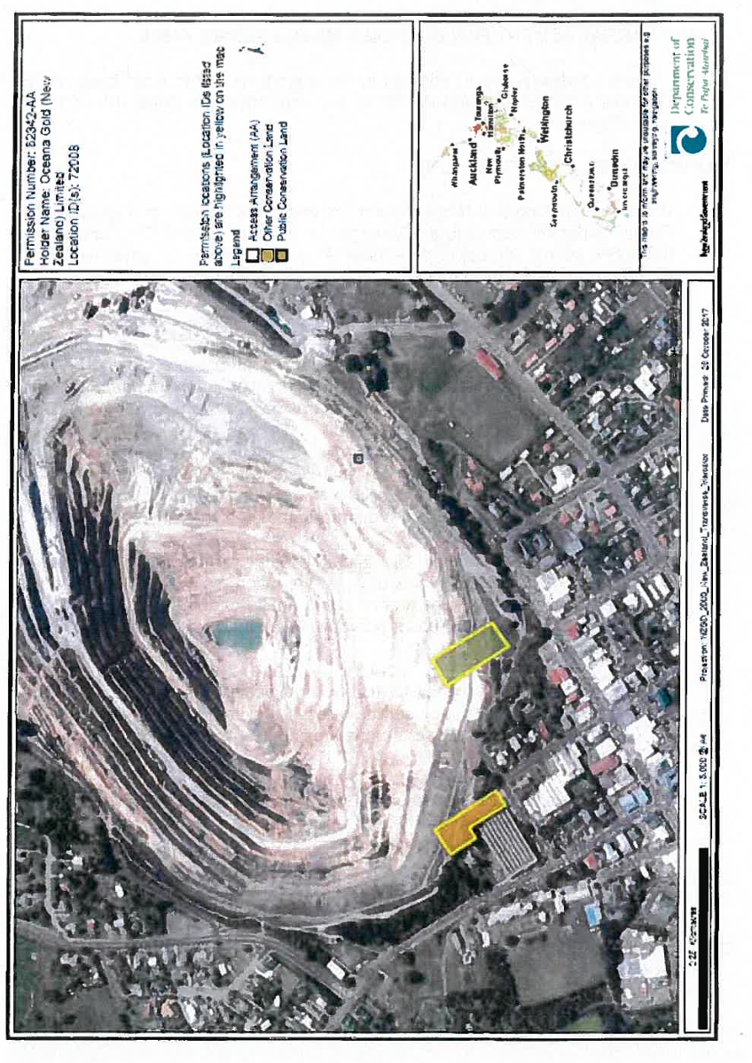

Figure 1: Access Arrangement Area – Martha

Figure 2: Access Arrangement Area (shown in pink), Marginal Strip - Ohinemuri River

Figure 3: Access Arrangement Area (shown in pink), Marginal Strip - Ohinemuri River

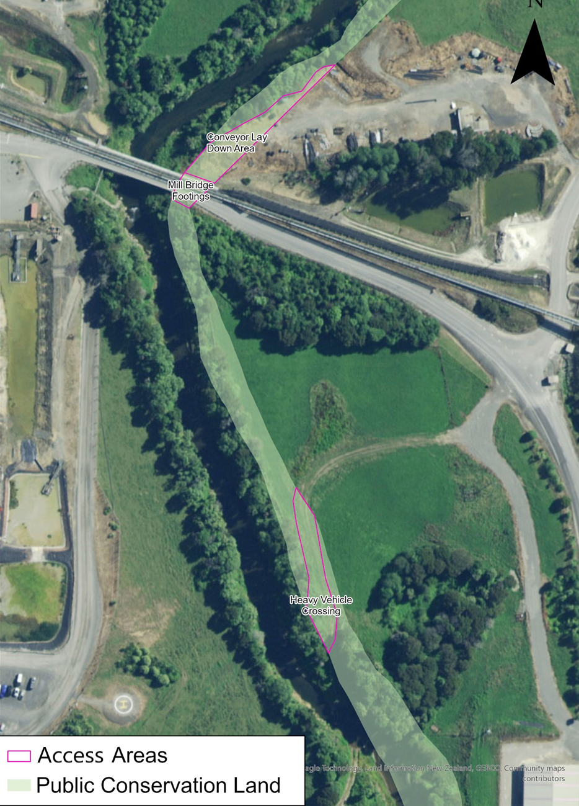

Figure 4: Access Arrangement Area (shown in pink), Marginal Strip - Ohinemuri River

Figure 5: Access Arrangement Area – Ohinemuri River Discharge Structures (red). within Marginal Strip - Ohinemuri River (in green).

The Activities authorised by this Access Arrangement are:

1A. In the areas marked on Figure 1:

1. The operation of part of the Martha Open Pit;
2. Operation and maintenance of the pit rim walkway, including but not limited to tree trimming, weed spraying, track maintenance;
3. Rehabilitation and closure activities;
4. The operation of a carpark for the Moresby Ave OceanaGold Offices and associated fencing and security cameras;
5. Conveyance and maintenance of fibre optic cable; and
6. A communications mast.

1B. In all areas marked on Figures 2 & 3:

1. Planting of native vegetation and maintenance of planted areas.
2. Pest control and monitoring.
3. Minimum impact activities, as defined in the Crown Minerals Act 1991, and also including ecological and other environmental monitoring.
4. Ongoing maintenance and replacement of any equipment as required.

1C. In the areas marked on Figure 4:

1. Establishment, use and maintenance of:
   1. Bridge footings for the Mill Bridge, including tailings, gas, water, electricity conveyance across the bridge.
   2. A lay down yard adjacent to Mill Bridge for storage of equipment relating to Waihi mining operations.
   3. A heavy vehicle crossing of the Ohinemuri River.

Noting that the Activities listed in 1C are existing and ongoing.

1D. In the areas marked on Figure 5:

1. The establishment, use and maintenance of a water line with a discharge manifold to convey treated wastewater (an existing activity); and
2. The upgrade of the water line, and associated infrastructure, to enable extra discharge capacity.

**SECOND SCHEDULE**

**SPECIAL CONDITIONS:**

**ACCESS ARRANGEMENT FOR MINERALS MINING PERMIT 41808**

NOTE: These conditions are in addition to the conditions in the main body of the Access Arrangement and do not in any way affect the generality of those conditions.

**ANNUAL WORK PROGRAMME CONDITIONS**

* 1. ~~Before undertaking any Mining operations under this Access Arrangement, the Permit holder will submit to the Manager for approval a Work Programme and thereafter submit for approval a new Work Programme or amended Work Programme if anything changes from the approved first Work Programme.~~ Before undertaking any Activities under this Access Arrangement, the Permit holder will provide to the Manager a first Annual Work Programme and thereafter annually the Permit Holder shall provide a new Work Programme for the succeeding 12-month period.

The Annual Work Programme will include:

* 1. A recent aerial photograph or plan at an appropriate scale showing the Mining permit boundary and the conservation land boundary and the location of all proposed Mining operations ~~for the term of the Access Arrangement, or any lesser period~~ for the forthcoming 12 months;
  2. A description of all Mining related activities including operations, mitigation measures, rehabilitation, access, monitoring and reporting carried out in the previous ~~Work programme period~~ 12 months.
  3. A detailed description of all Mining related activities including operations, mitigation measures, rehabilitation, access, monitoring and reporting intended to be carried out for ~~the term of the Access Arrangement, or any lesser period~~ the following 12 months, with an approximate timetable of events.
  4. A description and analysis of any unexpected adverse effect on the environment that has arisen as a result of activities within the ~~previous Work Programme periodprevious~~ previous 12 months and the steps taken to mitigate or remedy any effects that resulted.
  5. Any other Information required by other conditions of this agreement ~~or that is required by any resource consent held by the Permit holder relating to this Mining operation~~.

The Permit holder will submit to the Manager, for approval, an amended Work Programme if required by the Manager. For the avoidance of doubt, the Permit holder may combine the Work Programme required by this Access Arrangement, with that required by Access Arrangement XXX (in respect of the Wharekirauponga Access Arrangement) so that there is one Work Programme covering all of the Permit holder’s operations.

* 1. The Permit holder will undertake all work in accordance with the approved Work Programme.
  2. The Permit holder may, at any time, submit to the Manager for approval an amended Work Programme, provided that no work may occur under that amended Work Programme until it is approved in writing by the Manager.

# MINING OPERATIONS CONDITIONS

**Authorised Activities**

* 1. The Permit holder will undertake all Mining and Mining operations in accordance with the Access Arrangement application lodged by the Permit holder, the application to vary this Access Arrangement (dated X), this Access Arrangement approved by the Ministers, the Rehabilitation Management Plan approved by the Manager in accordance with Special Condition 67 and an Authority to Enter and Operate issued by the Manager in accordance with Condition 10. In the event of inconsistency, the Access Arrangement, the Rehabilitation Management Plan and Authority to Enter and Operate shall prevail over the application for Access Arrangement.

# Exclusion Conditions

* 1. The Permit holder **will not** undertake the following activities on the land:

1. Undertake any Mining operations within the areas marked on Figure 1 (Martha Pit) outside Weekdays between 07:00 am - 21:00 pm, Saturdays between 07:00 am - 12:00 pm and on Public Holidays excepting those activities required to maintain the security and safety of both sites and to control dust;
2. Undertake any Mining operations, excepting those activities provided for under the Authority to Enter and Operate on Public Conservation Land under Mining Permit 41808 and the Rehabilitation Management Plan approved by the Manager;
3. Disturb or hinder public use, access or enjoyment of the Land otherwise unaffected by the authorised Mining operations under this Access Arrangement except as required to maintain public safety;
4. Clear any native vegetation excepting where necessary to maintain the security and safety of both sites or where approved by the Manager in an Authority to Enter and Operate or the Reinstatement and Rehabilitation Management Plan approved by the Manager; and
5. ~~The Permit holder will not r~~ Remove or minimise in any way the car park, walking paths and Martha Mine Pit Rim Walkway, unless approved by the Manager in writing.

**Rehabilitation Management Plan (RMP)**

* 1. Within 12 months of the commencement of this Access Arrangement the Permit holder will submit a Rehabilitation Management Plan (RMP) to the Manager for approval. The RMP will apply to ~~all areas of Land~~ the areas of Land shown in Schedule 1. The purpose of the RMP is to describe in detail how the Land ~~described in Schedule 1~~ shown in Figure 1 of Schedule 1 will be rehabilitated to foster Recreation and Scenic values. The RMP will:

1. Be approved by the Manager prior to commencing rehabilitation; and
2. Address all aspects of Recreation and Scenery management post Mining and Mining operations; and specifically address the following aspects concerned with the Land:
   * 1. The mine pit/pit lake;
     2. The banks of the mine pit/pit lake and any planting plans;
     3. The car park;
     4. Walking paths; and
     5. Martha Mine Pit Rim Walkway.
   1. Approval of the RMP will be at the sole discretion of the Manager (such approval will not be unreasonably withheld).
   2. The Permit holder will implement and comply with the RMP approved by the Manager, at all times.
   3. The Manager may request a review and/or amendment of the RMP at any time. The Permit holder will implement and comply with any amendments to the RMP approved by the Manager.

**Vegetation clearance and site disturbance**

* 1. No vegetation will be cleared excepting where necessary to maintain the security and safety of both sites or where allowed by Condition 78 or where approved by the Manager in an Authority to Enter and Operate or the Rehabilitation Management Plan approved by the Manager.
  2. The Permit holder will preferentially use plants that are locally sourced native plants, except where rehabilitation purposes may be better achieved by non­ locally sourced native or non-native plants.

**Rehabilitation**

* 1. All rehabilitation shall be completed to the satisfaction of the Manager.
  2. Rehabilitation will be undertaken in accordance with the Rehabilitation Management Plan approved by the Manager.
  3. The Permit holder will not remove or minimise in any way the car park, walking paths and Martha Mine Pit Rim Walkway , unless approved by the Manager in writing.
  4. The open pit will constitute a lake and rehabilitation will accommodate the creation of the lake and/or recreational and/or scenic value of the lake.
  5. The Permit holder will revegetate the upper pit slopes as far as practicable. This will include planting and-landscaping of upper pit benches and the immediate pit surrounds. Plants used will be in accordance with Condition 72.

**Weed and Pest Control**

* 1. The Permit holder will control exotic weeds within the Land subject to this Access Arrangement in accordance with the pest animal management section of the Waihi Area Ecology and Landscape Management Plan (prepared in accordance with the resource consent requirements applying to the ‘Waihi North Project – Conditions Common to the Hauraki District Council and Waikato Regional Council Resource Consents’), or any amended version that may be made under Condition 83, and to the satisfaction of the Manager for a period of two years following completion of all Mining operations under this Access Arrangement.

**Storage and Structures**

* 1. The Permit holder will not erect/place on the Land any sheds, containers or similar structures not authorised by a Work Programme.

**Public Access**

* 1. ~~The Permit holder will not prevent public access to the Land or parts of the Land unless written approval to do so has been obtained from the Manager.~~ The Permit holder will not prevent public access to the Land or parts of the Land unless written approval to do so has been obtained from the Manager, except during emergency situations, or to meet immediate health and safety management requirements. Where approval is given the Permit holder is deemed to have been given delegated approval to trespass the public from the Land.

**Removal of Material**

* 1. Without changing the effect of Condition 36, at the completion of the Mining operations the Permit holder will remove from the site all materials including rubbish, pipelines, equipment and structures associated with the Mining operation, unless the Manager has given prior written approval for the item(s) to remain.

# Management Plan Conditions

* 1. All Activities within the areas shown in Figures 2 and 3 must be undertaken in accordance with the parts of the Waihi Area Ecology and Landscape Management Plan which are relevant to this Access Arrangement, or any amended version that may be made under Condition 83.
  2. The Permit holder may make amendments to the parts of the Waihi Area Ecology and Landscape Management Plan which are relevant to this Access Arrangement at any time, provided that:

1. The Permit holder must invite the Manager to participate in a collaborative workshop with the Permit holder to discuss the proposed amendments.
2. If the Manager agrees to participate in a workshop:
   1. The Permit holder must provide a copy of the amended management plan to the Manager at least 15 working days before the workshop;
   2. The Permit holder must circulate a record of the workshop discussions to the Manager within 5 days of the completion of the workshop; and
   3. The Manager must be given an opportunity to provide written feedback to the Permit holder on the management plan amendments within 15 working days of the completion of the workshop.
3. If the Manager declines the opportunity to participate in a collaborative workshop, the Permit holder must provide a copy of the amended management plan to the Manager, and give the Manager 15 working days to provide written feedback to the Permit holder on the proposed amendments.
4. If the Manager has not, within 15 Working Days of receipt of the amendments, advised the Permit holder that Condition 83 (e) applies, any Works associated with the amendment may proceed and the Management Plan will be deemed to be certified.
5. Except where Condition 83 (b) applies, until an amendment is approved, any work must be conducted in accordance with the existing management plan.

# Planting

* 1. All planting undertaken on the Land must only be for the purpose of ecological restoration, conservation or amenity planting and:

1. Comprise only indigenous species;
2. Use plants which are eco-sourced from the Coromandel or Bay of Plenty Ecological Regions; and
3. Use seed collected locally and germinated and raised at a New Zealand Plant Producers Incorporated (NZPPI)-accredited nursery or from a suitable alternative community-based nursery.
   1. All planting must be subject to annual maintenance, including regular releasing of plants from weeds and replacement of plants that do not survive for a period of at least five years following planting. Any species that consistently fails must be replaced with an alternative similar species.

# Minimum impact activities

* 1. The Permit holder will inform the Tauranga District Office of dates, duration and location of any minimum impact activities, prior to entering the Land to undertake said activities.
  2. All rock samples undertaken as part of a minimum impact activity will be obtained through hand-held, non-mechanical methods only and must be under 5 km in weight.
  3. There will be no track cutting or vegetation clearance as part of any minimum impact activity.
  4. The Permit holder will ensure that no minimum impact activity which disturbs the land is conducted at the sides of formed tracks and all disturbed land is restored to a condition consistent with the surrounding environment (so as not to leave an obvious mark on the land).
  5. Prior to undertaking any minimum impact activities that require repeated access, the Permit holder must designate access routes which are to be used for repeat access. Access to such sites shall only be via the designated routes.
  6. The Permit holder must avoid the following when conducting minimum impact activities:
  7. Tramping and disturbing rocks and logs in wet areas beside water channels; and
  8. Sampling from banks where seepages/side streams adjoin a main stream or within stream headwaters or side seepages (breeding habitat).