ARCHAEOLOGICAL AUTHORITY

AUTHORITY DETAILS
Authority Number:

Determination Date: Expiry Date: 6 years duration

Authority Holder: Precinct Properties New Zealand Limited

Postal Address:

Archaeological Sites: R11/3458 and potential subsurface archaeological sites

Location: Lot 9 DP 60151, Lot 7 DP 77037, Lot 1 DP 78340, Lot 5 DP 63972, Lot 1 DP
183125 and the road reserves of Customs Street West, Lower Hobson Street, Sturdee Street and Fanshawe Street (shown in Schedule A)
Section 45 Approved Person: Ellen Cameron

Landowner Consent: To be provided

DETERMINATION
The FTAA Expert Consenting Panel grants an archaeological authority pursuant to section 81 of the Fast Track Approvals Act 2024 and section 48 of the Heritage New Zealand Pouhere Taonga Act 2014 in respect of the archaeological sites described above, within the areas specified in the location above, to Precinct Properties New Zealand Limited for enabling works, including land disturbance and excavation of approximately 100,000m³ over 6,442m² (archaeological works), subject to the following conditions:

CONDITIONS OF AUTHORITY

No. | Condition
Before Works
1 | Start Work Notification  The Authority Holder must advise Heritage New Zealand Pouhere Taonga (HNZPT) of the date when archaeological works will begin at least two working days before archaeological works start.
2 | Archaeological Management Plan  The Authority must be exercised in accordance with the Archaeological Management Plan, (Cameron E, October 2025. Archaeological Management Plan: Downtown Carpark Site Development, Auckland Fast Track. Prepared for Precinct Properties New Zealand Limited). (AMP)

 | The Authority Holder may update the AMP by submitting the amended AMP in writing to HNZPT for its written approval.
3 | Landowner Consent  The Authority Holder must provide HNZPT with the written consent of all landowners of the land subject to this Authority prior to any archaeological works commencing.
4 | Site Briefing  The Authority Holder must ensure that all contractors working on the project are briefed on site by the section 45 approved person (who may appoint a person to carry out the briefing on their behalf) prior to any archaeological works commencing. The briefing must include the possibility of encountering archaeological evidence, how to identify possible archaeological sites, the archaeological work required by the conditions of this Authority, and contractors’ responsibilities with regard to discovering archaeological evidence.
During Works
5 | Tikanga  In addition to tikanga Māori protocols agreed between the Authority Holder and Ngāti Whātua Ōrākei, Te Ākitai Waiohua and Ngaati te Ata, the following shall apply:  - access for Ngāti Whātua Ōrākei, Te Ākitai Waiohua and Ngāti te Ata to any archaeological site encountered in order to undertake tikanga subject to any health and safety requirements.  - If any possible taonga or Māori artefacts are encountered, Ngāti Whātua Ōrākei, Te Ākitai Waiohua and Ngāti te Ata shall be informed to enable appropriate tikanga to be undertaken, so long as all statutory requirements under the Heritage New Zealand Pouhere Taonga Act 2014 and the Protected Objects Act 1975 are met.  - If any archaeological site is encountered and works modifying or destroying the archaeological site are undertaken, Ngāti Whātua Ōrākei, Te Ākitai Waiohua and Ngāti te Ata shall be provided with a copy of any reports completed and be given an opportunity to discuss it with the Project Archaeologist if required.
6 | Kōiwi Discovery  If any kōiwi (human remains) are encountered, all works must cease within 20 metres of the discovery. HNZPT, New Zealand Police, and Ngāti Whātua Ōrākei, Te Ākitai Waiohua and Ngaati te Ata must be advised immediately. Any steps following must be undertaken in accordance with Guidelines for Kōiwi Tangata/Human Remains (AGS8 2014) and no further work in the area may take place until future actions have been agreed by all parties.
7 | Monitoring  Any earthworks that may affect an archaeological site must be monitored by the section 45 approved person, who may appoint a person to carry out the monitoring on their behalf in accordance with accepted archaeological practice and the AMP.
8 | Investigation

 | Any archaeological evidence encountered during the exercise of this Authority must be investigated, recorded and analysed in accordance with accepted archaeological practice
After Works
9 | Work Completion Notification  The Authority Holder shall advise HNZPT of the completion of archaeological works within five working days of completion.
10 | Completion of Archaeological Siteworks  Within 20 working days of the completion of on-site archaeological work associated with this Authority, the Authority Holder shall ensure that:  - An interim report, to the satisfaction of HNZPT, following the Archaeological Report Guideline (AGS12 2023) is submitted to HNZPT for inclusion in the HNZPT Archaeological Reports Digital Library.  - Site records are updated or submitted to the NZAA Site Recording Scheme.
11 | Archaeological Records  Within 12 months of the completion of the on-site archaeological work, the Authority Holder shall ensure that a final report, completed following the Archaeological Report Guideline (AGS12 2023), is emailed to HNZPT for inclusion in HNZPT’s Archaeological Reports Digital Library, and to Ngāti Whātua Ōrākei, Te Ākitai Waiohua and Ngaati te Ata. A copy must also be provided to the NZAA Central Filekeeper.

Schedule A

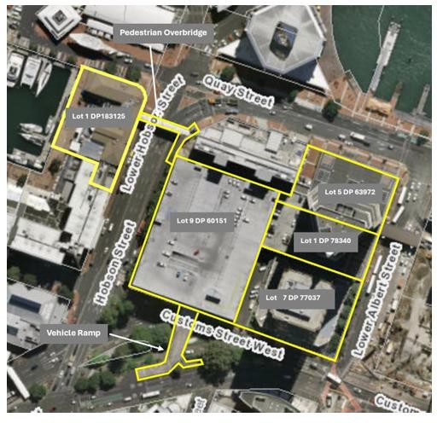

Diagram showing the detail of the properties in the Project Area and pedestrian overbridge and vehicle ramp which are subject to this Authority.

