BENDIGO-OPHIR GOLD PROJECT
PROPOSED WILDLIFE ACT APPROVAL AND CONDITIONS
Updated 28 August 2026 to reflect MGL’s response to RFI 11
Note: The following is subject to feedback from DOC on 7 September 2026

SCHEDULE 1
1 | Authorised activity (including the species, any approved quantities and collection methods)  (Schedule 2, clause 2) | - Activity:  - Catch, salvage and relocate native lizard species listed in Schedule 4 prior to disturbance and vegetation clearance within the Direct Disturbance Footprint (“DDF”) / Project Site, any other areas disturbed within the BOGP Consent Area (including the area of the Bendigo Conservation Covenant to be uplifted) and the areas subject to the approved concessions associated with the Bendigo-Ophir Gold Project (see Map 1 in Schedule 6).  - Hold wildlife for the purpose of relocation after salvage at timeframes advised by a Suitably Experienced and Qualified Ecologist (“SEQE”) approved by the Department of Conservation as part of the certification of the Lizard Management Plan and the Avifauna Management Plan certified in accordance with Common Condition NEW (or as amended in accordance with relevant conditions) that apply to Central Otago District Council and Otago Regional Council in Schedule One.  - Undertake biodiversity monitoring of native lizards and avifauna.  - To undertake works affecting the habitat of wildlife listed in Schedule 4 and Schedule 5.  - To disturb, injure or kill the wildlife species listed in Schedule 4 and Schedule 5 when unavoidable.  - Any accidental / unintentional harm to wildlife that could arise from any of the activities undertaken in relation to the Bendigo-Ophir Gold Project.  - Methodology:  - Methods set out in the following management plans:  - Habitat Impact Management Plan;  - Avifauna Management Plan;  - Lizard Management Plan;  - Landscape and Ecological Rehabilitation Management Plan;  - Ardgour Restoration Area Management Plan;  - Matakanui Sanctuary Management Plan;  - Mammalian Pest Management Plan;  - Biosecurity Plant Pest Management Plan; and  - Biodiversity Outcomes Monitoring Plan.  - This includes but is not limited to:  - For lizards:  - Catch alive using artificial cover objects;  - Catch alive using funnel traps and pitfall traps;  - Timed manual searches;  - Manual search of artificially created habitat;  - Handle to take measurements;  - Pre-habitat clearance manual searching;  - Construction-assisted salvaging; and  - Habitat destruction.  - For birds:  - Pre-habitat clearance surveys to demarcate nests; and  - Habitat destruction.
2 | The Land  (Schedule 2, clause 2) | Areas marked on Map 1 and Map 2 in Schedule 6.
3 | Personnel authorised to undertake the Authorised Activity  (Schedule 2, clause 3) | Matt Baber, Graham Ussher and Keith Barber in accordance with Schedule 2, clause 3.  Additional personnel as may be approved in writing by the Department of Conservation in accordance with Schedule 2, clause 3.1.
4 | Term  (Schedule 2, clause 4) | 35 years from date of approval.
5 | Approval Holder’s address for notices  (Schedule 2, clause 8) | Physical: 2 Cemetery Road, Cromwell  Postal: PO Box 316, Cromwell  Phone: [REDACTED]  Email: [REDACTED]
6 | Grantor’s address for notices | The Grantor’s address for all correspondence is:  Permissions Team  Level 4  73 Rostrevor Street  Hamilton, 3204  Email: AskPermissions@doc.govt.nz  Unless otherwise specified in this Authority.

SCHEDULE 2

STANDARD TERMS AND CONDITIONS OF THE APPROVAL
- Interpretation
  - The Approval Holder is responsible for the acts and omissions of its employees, contractors or agents. The Approval Holder is liable under this Approval for any breach of the terms of the Approval by its employees, contractors or agents as if the breach had been committed by the Approval Holder.
  - Where obligations bind more than one person, those obligations bind those persons jointly and separately.
- What is being authorised?
  - The Approval Holder is only allowed to carry out the Authorised Activity on the Land described in Schedule 1, Item 2.
  - The Approval Holder must advise the Department of Conservation’s local Operations Manager(s) (“Manager”) prior to carrying out the Authorised Activity (where possible, one week prior).
  - The Approval Holder and Authorised Personnel must carry a copy of this Approval with them at all times while carrying out the Authorised Activity.
  - The Approval Holder must comply with any reasonable request from the Grantor for access to any wildlife.
  - The Approval Holder may publish authorised monitoring or research results.
  - The Approval Holder must immediately notify the Grantor of any taxa found which are new to science. In addition, the Approval Holder must lodge holotype specimens and a voucher specimen of any new taxa with a recognised national collection.
- Who is authorised?
  - Only the Authority Holder and the Authorised Personnel described in Schedule 1, Item 3 are authorised to carry out the Authorised Activity, unless otherwise agreed in writing by DOC to advise on person at the Department. Such agreement is not to be unreasonably delayed or withheld.
- How long is the Approval for - the Term?
  - This Approval commences and ends on the dates set out in Schedule 1, Item 4.
- What are the liabilities?
  - The Approval Holder agrees to exercise the Approval at the Approval Holder’s own risk and releases to the full extent permitted by law the Grantor and the Grantor's employees and agents from all claims and demands of any kind and from all liability which may arise in respect of any accident, damage or injury occurring to any person or property arising from the Approval Holder’s exercise of the Authorised Activity.
  - The Approval Holder must indemnify the Grantor against all claims, actions, losses and expenses of any nature which the Grantor may suffer or incur or for which the Grantor may become liable arising from the Approval Holder’s exercise of the Authorised Activity.
  - This indemnity is to continue after the expiry or termination of this Approval in respect of any acts or omissions occurring or arising before its expiry or termination.
- What about compliance with legislation and Grantor’s notices and directions?
  - The Approval Holder must comply with all statutes, bylaws and regulations, and all notices, directions and requisitions of the Grantor and any competent authority relating to the conduct of the Authorised Activity. Without limitation, this includes the Conservation Act 1987 and the Acts listed in the First Schedule of that Act and all applicable health and safety legislation and regulation.
- When can the Approval be terminated?
  - The Grantor may terminate this Approval at any time in respect of the whole or any part of the Land, and/or the whole or any part of the Authorised Activity if:
- the Approval Holder breaches any of the conditions of this Approval; or
- in the Grantor’s opinion, the carrying out of the Authorised Activity causes or is likely to cause any unforeseen or unacceptable effects in relation to protected wildlife.
  - If the Grantor intends to terminate this Approval in whole or in part, the Grantor must give the Approval Holder such prior notice as, in the sole opinion of the Grantor, appears reasonable and necessary in the circumstances.
- How are notices sent and when are they received?
  - Any notice to be given under this Approval by the Grantor is to be in writing and made by personal delivery or email to the Approval Holder at the physical or email address specified in Schedule 1, Item 5. Any such notice is to be deemed to have been received:
- in the case of personal delivery, on the date of delivery; or
- in the case of email, on the date receipt of the email is acknowledged by the addressee by return email or otherwise in writing.
  - If the Approval Holder’s details specified in Schedule 1, Item 5 change then the Approval Holder must notify the Grantor within 5 working days of such change.
- What about the payment of costs?
  - The Approval Holder must pay the standard Department of Conservation charge-out rates for any staff time and mileage required to monitor compliance with this Approval and to investigate any alleged breaches of the terms and conditions of it.
- Are there any Special Conditions?
  - Special conditions are specified in Schedule 3. If there is a conflict between this Schedule 2 and the Special Conditions in Schedule 3, the Special Conditions will prevail.
- Can the Approval be varied?
  - The Approval Holder may apply to the Grantor for variations to this Approval in line with clause 7(2) of Schedule 7 of the Fast-track Approvals Act 2024.

SCHEDULE 3
SPECIAL CONDITIONS
Management and Monitoring Plans
- All Activities authorised by this Wildlife Act Approval must be undertaken in accordance with the versions of the following management and monitoring plans included in Part G of the application documents certified by Otago Regional Council (ORC) and Central Otago District Council (CODC), or any amended versions that may be made under Condition 3:
- Habitat Impact Management Plan;
- Avifauna Management Plan;
- Lizard Management Plan;
- Landscape and Ecological Rehabilitation Management Plan;
- Ardgour Restoration Area Management Plan;
- Matakanui Sanctuary Management Plan;
- Mammalian Pest Management Plan; and
- Biodiversity Outcome Monitoring Plan.

- The Grantee must prepare and implement the following management plans which are to be certified by DOC (in addition to certification by ORC and CODC):
- Lizard Management Plan (LMP);
- Avifauna Management Plan (AMP); and
- Aspects of the other management plans listed in Condition 1 above which are relevant to the Lizard Management Plan and the Avifauna Management Plan (those sections of the management plans to be specified by the Grantee when seeking certification).
- The LMP and AMP are to have the following objectives respectively:
- The objective of the LMP is to detail the methods that will be used to avoid or minimise adverse ecological effects on native lizards during construction and operation of the BOGP.
- The objective of the AMP is to describe measures to avoid or minimise adverse ecological effects on indigenous avifauna species during construction and operation of the BOGP.
- In accordance with Condition C17 of the Common Conditions in Schedule 1 to the Resource Consents granted for the BOGP within the administrative jurisdiction of the Central Otago District Council and the Otago Regional Council, the Approval Holder may make amendments to any of the management plans referred to in Special Condition 1 at any time, provided that:
- The Approval holder must invite the Manager to participate in a collaborative workshop with the Approval holder to discuss the proposed amendments.
Advice Note: The collaborative workshop may occur as a standalone workshop, or it may be combined with other collaborative workshops required by this Authority if practical.
- If the Manager agrees to participate in a workshop:
- The Approval Holder must provide a copy of the amended management plan to the Manager at least 15 working days before the workshop;
- The Approval Holder must circulate a record of the workshop discussions to the Manager within 5 days of the completion of the workshop; and
- The Manager must be given an opportunity to provide written feedback to the Approval Holder on the management plan amendments within 15 working days of the completion of the workshop.
- If the Manager declines the opportunity to participate in a collaborative workshop, the Approval Holder must provide a copy of the amended management or monitoring plan to the Manager and give the Manager 15 working days to provide written feedback to the Approval holder on the proposed amendments.
- If the Manager has not, within 15 Working Days of receipt of the amendment, advised the Approval Holder that Condition 3(e) applies, any Works associated with the amendment may proceed.
- Except where Condition 3(b) applies, until an amendment is approved, any work must be conducted in accordance with the existing management or monitoring plan.
- In the instance that there is disagreement between the Approval Holder and the Department of Conservation at the conclusion of the collaborative workshop, the process in Conditions 19 and 20 (Dispute Resolution) is to be implemented.
Advice Note: The collaborative workshop may occur as a standalone workshop, or it may be combined with other collaborative workshops required by this Authority if practical.

Lizard Capture and Handling
- All lizard handling must be undertaken by Suitably Experienced and Qualified Ecologists directly supervised by Authorised Personnel (specified in Schedule 2, Clause 3.1) that are approved in writing by the Department of Conservation.
- Suitably Experienced and Qualified Ecologists may supervise trained field staff for non-invasive tasks. All handling must be undertaken by, or under the direct supervision of, the Suitably Experienced and Qualified Ecologist.
- No works that may disturb lizards may commence until Department of Conservation confirms in writing that the Lizard Management Plan is certified as giving effect to these conditions. Lizard capture and relocation must be undertaken between the 1st October and 30 April when lizards are most active, when temperatures are above 12 degrees Celsius.
- Capture and handling of lizards must involve only techniques that minimise the risk of infection or injury to the animal and are outlined in the applicable management plans (outlines in Special Condition 1).
- .
- The Approval Holder must sterilise any instruments that come in contact with the lizards and / or are used to collect or measure lizards between each location and must ensure all gear is thoroughly cleaned and dried between sites.
- The Authority must ensure lizards are temporarily held through either of the following options:
- Individually in a suitable container (e.g. breathable holding bag), and held out of direct sunlight to minimise the risk of overheating, stress and death; or
- Collectively in large containers (60 litres or larger with floor areas equal to or greater than the cubed proportion i.e. fish bins or similar) with natural refuge (e.g. grass, moss, crumpled paper etc.) covering the floor. These containers must not hold more than 50 individuals and must be kept out of direct sunlight for prolonged periods for the during of the holding period.
- All lizards are to only be held temporarily for an appropriate timeframe determined by the SEQE before being transferred to the release site. The Authority Holder’s SEQE must maintain awareness and assessment of any inter and intra-specific lizard aggression leading to injury (e.g. tail loss, injuries, death) and adapt the densities and / or cover and / or duration and / or species composition of holding to minimise impacts.
- Lizards must not be released into the Ardgour Restoration Area or any other area without:
- demonstrated habitat suitability for the target species; and
- a predator management regime.
- No release may proceed until Department of Conservation has certified the release site(s) against Condition 10 and the Lizard Management Plan specifies prerelease habitat preparation, carrying capacity, and post release monitoring.
- The Lizard Management Plan must include contingencies and adaptive management triggers where objectives are not met (e.g. release sites underperforming), with pre-agreed corrective actions and timelines for DOC approval.
- Should any lizard species other than those listed in Schedule 4 be identified within the Bendigo-Ophir Gold Project site, the Authority Holder must contact the Operations Manager of the Department’s Central Otago Office as soon as reasonably possible for further advice (xxxx@doc.govt.nz). A variation of this Approval or separate application will be required to capture, salvage, relocate or kill non-authorised species.
- Prior to any works commencing that would impact on avifauna Department of Conservation must certify the Avifauna Management Plan, and any changes or amendment to it.
- The Avifauna Management Plan shall specify measures to be applied to ensure falcon species are not electrocuted where there are power poles with a transformer (electrocution occurs when birds touch two different voltages).
- In the event a falcon nest is detected within the mining zone, vegetation clearance within 200 m of the nest shall be postponed until the young have fledged.
Ownership and holding of Absolutely Protected Wildlife
- This Approval gives the Approval Holder the right to hold absolutely protected wildlife for temporary periods as determined by the SEQE in accordance with the terms and conditions of the Approval, but the wildlife remains the property of the Crown. This includes any dead wildlife, live wildlife, any parts thereof, any eggs or progeny of the wildlife, genetic material and any replicated genetic material.
- Unless expressly authorised by the Grantor in writing, the Approval Holder must not donate, sell or otherwise transfer to any third party any wildlife, material, including any genetic material, or any material propagated or cloned from such material, collected under this Approval.
Death of wildlife associated with activities covered by the approval
- If, in the course of undertaking the Activities, all reasonable effort has been made to meet all of the conditions expressed and implied in this approval; and wildlife is killed by the Approval Holder, then that will be permitted under this approval.
Euthanasia
- The Approval Holder must not euthanize any wildlife unless the Approval Holder:
  - Obtains the recommendation of a veterinarian where euthanasia is on animal welfare grounds; or
  - Carries out the euthanasia under direction from the Grantor and in consultation with a veterinarian (as applicable).
Records
- All survey, salvage, and release records must be made available for inspection at reasonable times by officers of the Grantor.
Lizard Salvage Reporting
- The Approval holder must engage a Suitably Experienced and Qualified Ecologist to prepare an annual Lizard Compliance Monitoring Report which will sit within the overarching Ecology Annual Monitoring Report, which must include:
  - Confirmation that lizard effects avoidance and minimisation protocols were followed in accordance with the HIMP and LMP and associated proposed conditions, including:
- A description of methods and results relating to lizard salvaging operations;
- Confirmation that salvage targets were met for each species; and
- Maps illustrating where avoidance or minimisation measures were undertaken.
  - Confirmation that relocation site habitat restoration and enhancement measures were achieved prior to release of lizards for relocation.
  - Recommendations for potential changes to improve the effectiveness of lizard management in relation to the LMP scope.
  - Representative photos showing evidence of effects avoidance and minimisation measures being undertaken along with evidence of release and relocation site restoration and enhancement measures.
- Annual lizard monitoring reporting will cease once lizard salvage is complete, and all captured lizards have been relocated to the release site.
- The Approval holder must engage a Suitably Experienced and Qualified Ecologist to prepare an annual Avifauna Compliance Monitoring Report which will sit within the overarching Ecology Annual Monitoring Report, which must include:
  - X
  - X
  - X
- The Regulator/Grantor will be notified as soon as practicable but no more than five working days after an unscheduled event associated with habitat clearance. Such events include a notable compliance failure that results in adverse ecological effects, or an event that causes vegetation damage on a scale that requires an urgent remedy according to the SEQE to return to compliance with any section of the BOGP ecological management plans and planting programmes. A subsequent investigation report will be provided to the Regulator/Grantor within 30 working days and include the following information:
  - The causes of the incident, the emergency response measures (if applicable), and the response proposed to avoid a recurrence of the issue;
  - An assessment undertaken by a SEQE which details any adverse effects of the exceedance; and
  - Proposed measures to address effects.
- Lizard capture and relocation data will also be compiled, summarised and submitted to the Grantor’s national data repository for lizard records (the Bioweb Herpetofauna database) annually (in August each year). As a minimum, the report will include the following information:
  - DOC Wildlife Act Authority number and Project name and location;
  - A summary of the species, numbers and age/sex classes of lizards captured and relocated;
  - Locations of lizards captured and relocated; and
  - Summary of salvage methodologies, effort and success.
- Should any novel lizard species be recorded, the Suitably Experienced and Qualified Ecologist will be engaged to submit the record to the DOC Amphibian and Reptile Distribution Scheme (ARDS), to undertake a follow up survey and make recommendations (if any), and to review relevant aspects of this LMP accordingly.
Dispute Resolution
- The parties agree to negotiate in good faith to resolve any differences which arise in connection with this Approval.

SCHEDULE 4
Common Name | Scientific Name | NZ Threat Classification
Kawarau gecko | Woodworthia Cromwell | At Risk-Declining
Southern Grass Skink | Oligosoma chionochloescens | At Risk-Declining
McCann’s skink | Oligosoma maccanni | Not Threatened

SCHEDULE 5
Māori Name | Common Name | Scientific Name | NZ Threat Classification | Regional threat status
Kārearea* | New Zealand falcon – eastern form* | Falco novaeseelandiae | Threatened, nationally vulnerable | Threatened, regionally vulnerable
Mātātā/Kōtātā | South Island fernbird | Bowdleria punctata punctata | At Risk, declining | Regionally At Risk, declining
Pīhoihoi* | New Zealand pipit* | Anthus novaeseelandiae novaeseelandiae | At Risk, declining | Regionally not threatened
Māpunga* | Black shag* | Phalacrocorax carbo | At Risk, relict | Threatened, regionally endangered
Tauhou* | Silvereye* | Zosterops lateralis | Not threatened | Regionally At Risk, declining
Miromiro* | Tomtit* | Petroica macrocephala | Not threatened | Not threatened (but locally uncommon)
Tōrea* | South Island Pied Oystercatcher* | Haematopus finschi | At Risk, declining | Threatened, regionally vulnerable
Kawau paka | Little shag | Phalacrocorax sulcirostris | At Risk, relict | At Risk, relict
Tarapiroe | Black-fronted tern | Chlidonias albostriatus | Threatened, nationally endangered | Threatened, regionally endangered
Tarāpuka | Black-billed gull | Chroicocephalus bulleri | At Risk, declining | Threatened, regionally vulnerable
Kāhu | Australasian harrier* | Circus approximans | Not threatened | Not threatened
Kuruwhengi | Australasian shoveler | Anas rhynchotis | Not threatened | Not threatened
Korimako | Bellbird | Anthornis melanura | Not threatened | Not threatened
Kakīānau | Black swan | Cygnus atratus | Not threatened | Not threatened
Riroriro | Grey warbler | Gerygone igata | Not threatened | Not threatened
Tētē-moroiti | Grey teal | Anas gracilis | Not threatened | Not threatened
 | Mallard x grey duck hybrid* | Anas platyrhynchos x Anas superciliosa | Not threatened | Not threatened
Pīwakawaka | New Zealand fantail | Rhipidura fuliginosa | Not threatened | Not threatened
Kererū | New Zealand pigeon | Hemiphaga novaeseelandiae | Not threatened | Not threatened
Pāpango | New Zealand scaup | Aythya novaeseelandiae | Not threatened | Not threatened
Pūtangitangi | Paradise shelduck | Tadorna variegata | Not threatened | Not threatened
Poaka | Pied stilt | Himantopus leucocephalus | Not threatened | Not threatened
Pūkeko | Pukeko | Porphyrio melanotus | Not threatened | Not threatened
Kōtare | Kingfisher | Todiramphus sanctus vagans | Not threatened | Not threatened
Karoro | Southern black-backed gull | Larus dominicanus dominicanus | Not threatened | Not threatened
 | Spur-winged plover | Vanellus miles novaehollandiae | Not threatened | Not threatened
Warou | Welcome swallow | Hirundo neoxena | Not threatened | Not threatened
Matuku moana | White-faced heron | Egretta novaehollandiae | Not threatened | Not threatened
*Detected in the DDF in surveys

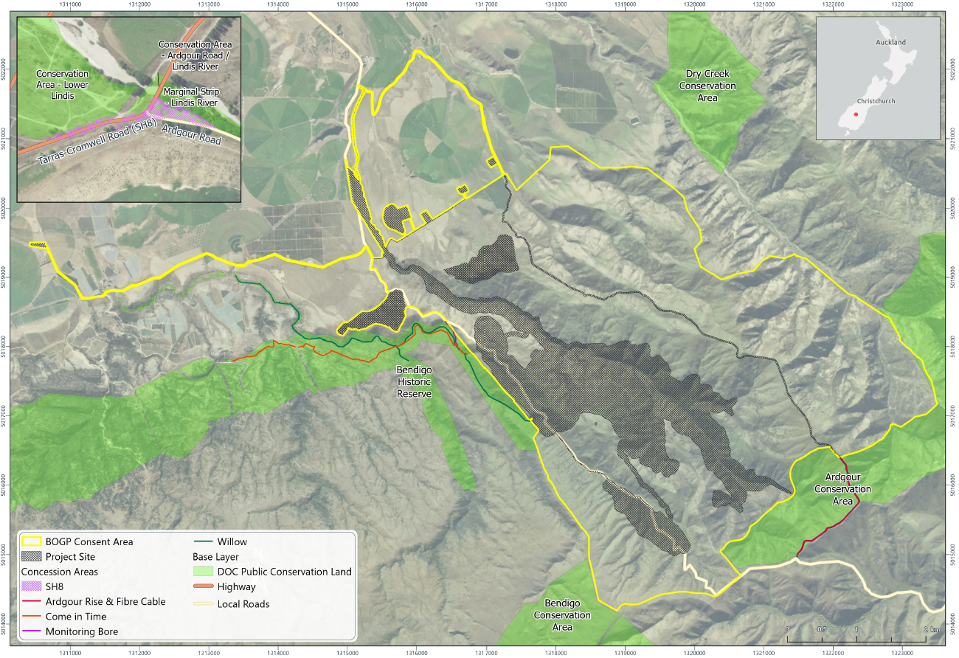
SCHEDULE 6
Map 1: BOGP Consent Area
Note: the Direct Disturbance footprint (“DDF”) is shown as the Project Site.
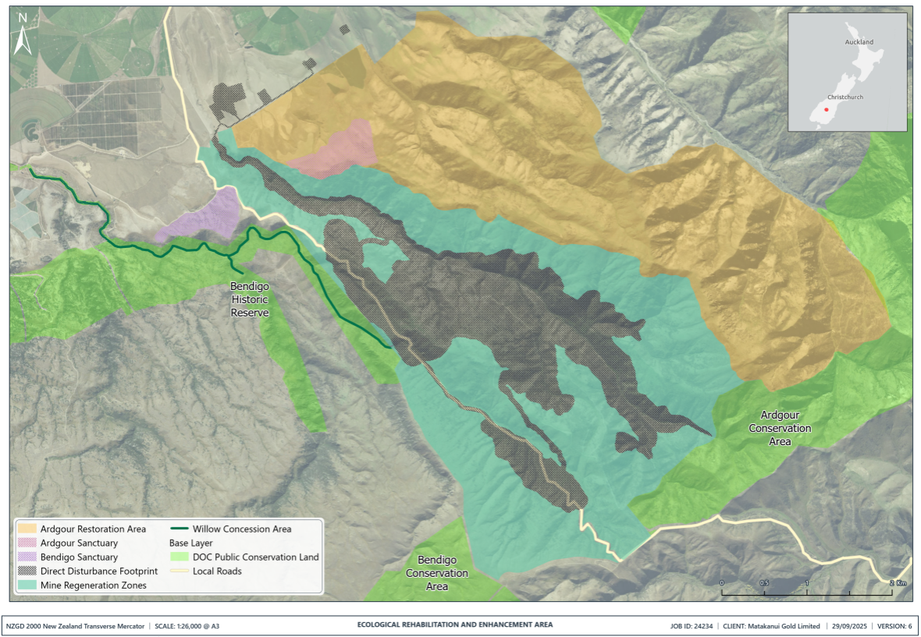
Map 2: Ecological Rehabilitation and Enhancement Area

Attachment 1: Amphibian and Reptile Distribution System (ARDS) card
ARDS CARD | New Zealand Amphibian/Reptile Distribution Scheme  Herpetofauna Administrator, RD&I, Department of Conservation, P.O. Box 10420, Wellington. |  |  |  |  |  |  |  |  |  |  |  |  |  |  |  |  |  |  |  |  |  |  |  |  |  |  |  |  |  | Card No:
Observer: |  |  |  |  |  |  |  |  |  |  |  |  | Date: |  |  |  |  |  |  |  |  |  | Locality Name:
Observer: | Initials |  | Surname |  |  |  |  |  |  |  |  |  | Alt (m):
Address: |  |  |  |  |  |  |  |  |  |  |  |  |  |  |  | Easting |  |  |  |  |  |  |  |  |  |  |  | Northing
 |  |  |  |  |  |  |  |  | GPS
 |  |  |  |  |  |  |  | Series |  |  |  |  |  |  | Map No. |  |  |  |  |  | Easting |  |  |  |  |  |  |  |  |  | Northing
Affiliation: |  |  |  |  |  |  |  | Area Office: |  |  |  |  |  |  |  |  |  |  | Conservancy: |  |  |  |  |  |  |  |  |  |  | Ecol. District:
Species name |  | No. |  |  | Time |  | Habitat |  |  |  | Weather |  |  |  |  |  | Weather  Light  - Fine/Sunny  - Part Cloudy  - Overcast  - Showers  - Rain  - Night  - 0-½ Moonlit  - ½-1 Moonlit  Temperature  - Hot  - Warm  - Moderate  - Cool  - Cold  Wind  - Calm  - Light breeze  - Mod breeze  - Gusty  - Strong winds |  |  |  |  |  |  |  |  | Major Habitat Types  - Beech Forest  - Podocarp forest  - Broadleaf forest  - Exotic forest  - Scrub  - Sub-alpine  - Alpine  - Undeveloped tussock land  - Developed farmland  - River terrace  - Fresh water
e.g. Hoplodactylus maculatus |  | 6 |  |  | 18:00 |  | 16, D, E |  |  |  | 6,2,1
Voucher specimen(s) |  |  |  | Yes/No |  | Specify:
Photograph(s) |  |  |  | Yes/No
Extra notes on reverse side |  |  |  | Yes/No |  |  |  |  |  |  |  |  |  |  |  |  |  |  |  |  |  |  |  |  |  | - Wet land  - Coastal  - Scree  - Bare rocks  - Beach  - Urban |  |  |  |  |  |  |  | Micro habitats  A Foliage  B Trunk  C Branches  D Under stones  E Under wood  F Open ground  G Crevices  H
Notes:
Identified by:
Authority used:

