BENDIGO-OPHIR GOLD PROJECT
SCHEDULE ONE
COMMON CONDITIONS TO THE CENTRAL OTAGO DISTRICT COUNCIL AND OTAGO REGIONAL COUNCIL RESOURCE CONSENTS
UPDATED 28 AUGUST 2026

The base version of the following conditions is the version of the conditions dated 22 June 2026 that was provided to the EPA and Expert Panel following the Concurrent Hearings in Wellington.
All additional changes made during the four conditions workshops held in July and August 2026 with planning experts from Otago Regional Council, Central Otago District Council, the Department of Conservation and Kā Rūnaka are presented in track changes.
The conditions shaded in light grey wash are where some of the parties have not had sufficient time to fully consider the proposed amendments including as a result of gaining technical advice (with any final comments expected to be provided by 7 September 2026).
Comments are included for some conditions to provide further context / clarification for changes made (where appropriate), to record points of disagreement between MGL and one or more parties, and to identify conditions where discussion between MGL and parties are in progress and are expected to be resolved by 14 September 2026.
These track changed conditions do not have updated numbering and cross-references (refer to the clean version where this has been updated).

tABLE OF Contents
General 1
Interpretation 1
Hours of Operation 6
Company Liaison Officer 6
Community Liaison Group 6
Complaints Procedure 8
Annual Work Programme 9
Annual Monitoring and Compliance Report 12
Peer Review Panel 14
Management and Monitoring Plans 16
Publicly Available Management Plans and Monitoring Reports 20
Tangata Whenua 21
Accidental Discovery Protocol 23
Landscape and Ecological Rehabilitation 24
Terrestrial Ecology 47
Offsetting and Compensation 93
Covenant 98
BOGP Biodiversity and Heritage Enhancement Fund 98
Mine Rehabilitation and Closure 100
Bond 102
Matakinui Trust 105
Review of Conditions 109
Administration 109

Attachments
Attachment 1: Consent Documentation
Attachment 2: Plans
Attachment 3: Rehabilitation Management Approach for Nationally or Regionally At-Risk and Threatened plant species in the Direct Disturbance Footprint
Attachment 4: Standards, Requirements and Success Criteria for Rehabilitation of the Direct Disturbance Footprint
Attachment 5: Vegetation Establishment Criteria, Success Criteria, Triggers for Contingency and Contingency Action by Vegetation Type
Attachment 6: Standards, Requirements and Success Criteria for Maintenance and Enhancement in the Mine Regeneration Zone
Attachment 7: Plant Types, Sources, Densities, Location Priorities and Success Criteria for the Direct Disturbance Footprint (DDF) and Mine Regeneration Zones
Attachment 8: Plant Pest Species and Management Objectives for Control Zones
Attachment 9: Mammalian Pest Management Plan Monitoring Targets
Attachment 10: Records of Title against which the Bond is to be Registered

General
No. | Condition
C1 | The activities authorised by the consents must be undertaken in general accordance with the information included in the consent documentation listed in Attachment 1 to these conditions. This documentation includes :  - The Substantive Application Report prepared by Mitchell Daysh Limited dated 31 October 2025 and supporting technical documents submitted by Matakanui Gold Limited (“the Consent Holder”) to the Environmental Protection Authority ("EPA") in support of its application for authorisation of the Bendigo-Ophir Gold Project (“BOGP”) under the Fast-track Approvals Act 2024 (“Act”);  - Additional and / or amended technical documents and management plans submitted by the Consent Holder to the EPA during the post-lodgement phase of the BOGP application; and  - Various responses to further information requested by administering agencies and the Expert Panel during the post-lodgement phase of the BOGP application.
C2 | In the event of any conflict or discrepancy between the documents referred to above and the conditions of the consents, the conditions prevail.

Interpretation
No. | Condition
Acronyms and Abbreviations
C3 | Acronyms and abbreviations used in these conditions have the following meanings:
  Abbreviation
  Act | Fast-track Approvals Act 2024
  AEP | Annual Exceedance Probability
  AQMP | Air Quality Management Plan
  ARAMP | Ardgour Restoration Area Management Plan
  BOGP | Bendigo-Ophir Gold Project
  BOMP | Biodiversity Outcome Monitoring Plan
  BPO | Best Practicable Option
  CODC | Central Otago District Council
  Cushionfield ARP | Applied Research Plan for the conservation, management, rehabilitation and expansion of cushionfield
  DDF | Direct Disturbance Footprint
  DOC | Department of Conservation
  ELF | Engineered Landform
  EPA | Environmental Protection Authority
  GPS | Global Positioning System
  HAIL | Hazardous Activities and Industries List
  HIMP | Habitat Impact Management Plan
  HSW-HS | Health and Safety at Work (Hazardous Substances) Regulations
  LERMP | Landscape and Ecological Rehabilitation Management Plan
  LINZ | Toitū Te Whenua Land Information New Zealand
  LUC | Land Use Consent
  masl | Metres above sea level
  MGL | Matakanui Gold Limited
  MIW | Mine Impacted Water
  NTU | Nephelometric Turbidity Unit (the standard unit of measurement for turbidity, which quantifies the cloudiness of a fluid caused by suspended particles, such as those in water)
  NZTM | New Zealand Transverse Mercator
  ORC | Otago Regional Council
  RL | Reduced Level
  RMA | Resource Management Act 1991
  RPMP | Otago Regional Pest Management Plan 2019-2029 (Otago Regional Council, 2019)
  SEQE | Suitably Experienced and Qualified Ecologist
  SQEP | Suitably Qualified and Experienced Person
  SH | State Highway
  SNA | Significant Natural Area
  SSESCP | Site Specific Erosion and Sediment Control Plan
  TIMP | Terrestrial Invertebrate Management Plan
  TSF | Tailings Storage Facility
  TSP | Total Suspended Particulate
  WTP | Water Treatment Plant
Defined Terms
C4 | For the purposes of the consents and all associated conditions:  - Any reference to “the consents” means the resource consents granted under the Fast-track Approvals Act 2024 for BOGP activities within the jurisdiction of CODC and ORC under the RMA;  - The “Project Site” mean the areas identified on Plan 1 - Project Overview Plan annexed as part of Attachment 2 to these conditions covering 568 hectares. The project site includes:  - The areas within which mining operations (excluding exploration drilling) will occur including open pits, an underground mine, the TSF, ELFs, processing plant, haul roads and supporting / ancillary activities and infrastructure;  - Two bores on the Bendigo Terrace and associated pipelines for the supply of fresh water;  - An upgrade to the intersection of SH8 and Ardgour Road; and  - The construction of Ardgour Rise – a new road to maintain public access between Ardgour Terrace and Thomsons Saddle.  - The “BOGP Consent Area” means the entire Bendigo-Ophir Gold Project including exploration activities, mining operations within the project site, and all associated ancillary, monitoring, mitigation, off-setting and compensation activities and supporting infrastructure and activities within, and in the vicinity of, the Project Site as shown on Plan 2 – BOGP Consent Area annexed as part of Attachment 2 to these conditions. For the avoidance of doubt, the BOGP Consent Area includes the areas that are the subject of Concessions within Public Conservation Land;  - “Exploration” means any activity undertaken for the purpose of identifying mineral deposits or occurrences and evaluating the feasibility of mining particular deposits or occurrences of 1 or more minerals; and includes any drilling, dredging, or excavations (whether surface or subsurface) that are reasonably necessary to determine the nature and size of a mineral deposit or occurrence; and to “explore” has a corresponding meaning;  - “Mining operations” means operations in connection with mining, exploring, or prospecting for any Crown owned mineral and includes, when carried out at or near the site where the mining, exploration, or prospecting is undertaken:  - The extraction, transport, treatment, processing, and separation of any mineral or chemical substance from the mineral; and  - The construction, maintenance, and operation of any works, structures, and other land improvements, and of any related machinery and equipment connected with the operations; and  - The removal of overburden by mechanical or other means, and the stacking, deposit, storage, and treatment of any substance considered to contain any mineral; and  - The deposit or discharge of any mineral, material, debris, tailings, refuse, or wastewater produced from or consequent on the operations; and  - The doing of all lawful acts incidental or conducive to the operations.  - “Supporting infrastructure and activities” means any infrastructure and/or activities established or undertaken for the purpose of facilitating mining operations, including buildings, structures, security fencing, use and maintenance of access tracks and roads, installation of pipelines, culverts, windrows, channels, silt ponds, sediment traps, monitoring equipment, communications towers, temporary generators and refuelling activities;  - “Commencement date” and “commencement of the consents” means the date on which the decision is served issued under section 88 of the Fast-track Approvals Act 2024 or any later date on which the last of any appeals brought under section 99 are determined;  - “First exercised” means that date on which the activities authorised by any consent are first undertaken, either in whole or in part;  - “The Councils” means Central Otago District Council (“CODC”) and Otago Regional Council (“ORC”);  - “Active closure” means the period of time when all mining activities are completed and rehabilitation activities are in progress (including profiling to final landforms, decommissioning of infrastructure, construction of water treatment facilities and capping of the ELFs and TSF);  - “Passive closure and / or post-closure” means the period of time when final site closure arrangements are in place and the active WTP (or PTS) continues to operate, with ongoing site monitoring to ensure it is a long-term stable landform;  - “Points of Interest (“POIs”)” are referred to in the Biosecurity and Plant Pest Management Plan and are specific locations where plant pest control work has been undertaken, or plant pests are found.  - “PM₁₀” refers to inhalable airborne particulate matter with a diameter of 10 micrometres or less.  - “Mine-Impacted Water” includes all water that has been in contact with mined materials, or is involved in, the processing process. The mine circuit water is made up of two categories:  Surficial MIW, which includes run off from:  - Haul roads;  - Topsoil stockpiles (low arsenic-bearing);  - General infrastructure areas; and  - ELF surfaces.  Mine circuit water:  - ELF seepage;  - TSF seepage and decant water;  - Pit water (i.e. pit sump water, pit lake water);  - Run-off/seepage from arsenic-rich soil stockpiles;  - Underground water; and  - Processing Plant and Infrastructure Area.  - “Cushionfields” is defined by the presence of cushion-forming plants (including Raoulia species) and / or the dominance (greater than 20% cover) of bryophytes or bare ground (i.e. stone, gravel, sand and silt).  - “Spring annuals” at the Project Site are the Myosotis brevis, Ceratocephala pungens, Myosotis antarctica subsp. Antarctica and Myosurus minimus species that occur both within and outside of cushionfields (defined in these conditions).  - “Kā Rūnaka” is defined as the collective of Te Rūnanga o Moeraki, Kāti Huirapa Rūnaka ki Puketeraki, Te Rūnanga o Ōtākou and Hokonui Rūnanga.

Hours of Operation
No. | Condition
C5 | The hours of operation for the BOGP are 24 hours a day, 7 days a week provided that:  - No surface blasting in open pits shall occur before 10 am and no later than 9 pm; and  - The aggregate pits must not be operated beyond 7.30 am to 6.30 pm Monday to Saturday, except when needed to respond to any emergency situations or undertake any emergency works within the Project Site.

Company Liaison Officer
No. | Condition
C6 | Prior to the exercise of the consents, the Consent Holder must appoint a person (the “Company Liaison Officer”) to be the primary point of contact between the Consent Holder, the community and the Councils. The Consent Holder must advise the Otago Regional Council, Central Otago District Council and the Department of Conservation of the name and contact details of the Company Liaison Officer.
C7 | The Consent Holder may replace the Company Liaison Officer from time to time but must maintain a Company Liaison Officer for the duration of the mining operations undertaken pursuant to the consents.
C8 | The name of the current Company Liaison Officer, together with the phone number and email address they can be contacted at, must be available on the Consent Holder’s website prior to the exercise of the consents and up-to-date details must remain on the website for the duration of mining operations authorised by the consents.

Community Liaison Group
No. | Condition
NEW | Within 3 months of commencement of the consents, the Consent Holder must establish a Community Liaison Group (“CLG”) which is to remain in operation during the mine construction and mine operation phases of the BOGP.  Purpose  The purpose of the CLG is to facilitate open communication, collaboration, and mutual understanding between the Consent Holder, community and relevant stakeholders. The aims of the CLG must be to address concerns, share information, and foster cooperative relationships to support community well-being and project success.  A Terms of Reference must be prepared for the CLG. The Terms of Reference will be developed in association with CLG members and subject to approval by the Councils.  Objectives  The objectives of the CLG must be:  - To provide an additional forum for discussion and engagement between the Consent Holder, community representatives and key stakeholders;  - To enhance transparency and trust through regular communication;  - To promote community engagement activities undertaken by the Consent Holder.  - To identify and address community concerns in a proactive manner;  - To provide feedback and recommendations on activities that impact the community; and  - To promote inclusivity of diverse community perspectives.  Membership  The CLG must consist of:  - An independent chairperson;  - A minimum of three-to-five representatives of the local community;  - One iwi representative (if requested by the BOGP Kaitiaki Governance Group);  - One representative of each of the Councils;  - One representative from the Department of Conservation; and  - At least two company representatives on behalf of the Consent Holder, including the person with direct managerial responsibility for environmental management at the mine present at all meetings.  Administration  The Consent Holder will provide facilities for the meeting and be responsible for recording of minutes.  The role of the Chairperson is to be a convenor, facilitator, mediator and advisor for the committee. They must undertake their role in an independent manner, and refrain from perceptions of bias either for or against the company or any individual or group of representatives on the committee.  The chairperson appointed requires the prior approval of the Councils.  The local community and other stakeholder representatives will be appointed following advertisement in the local press. Representatives will be selected to represent neighbours and the local community.  In selecting the community representatives, preference will be given to candidates who can represent the concerns of a variety of interest groups. Selection criteria are:  - Willingness to contribute constructively;  - Experience and ability to provide feedback to the community and stakeholder groups; and  - Current residence in the local area and/or awareness of local and other relevant issues.  Meeting Frequency  The CLG must determine the frequency of its meeting with a minimum of two meetings and maximum of four meetings per annum.

Complaints Procedure
No. | Condition
C9 | Upon receiving a complaint, the Consent Holder must as soon as practicable, but no later than within 48 hours, undertake the following steps:  - Initiate an investigation of the complaint received;  - Advise the Councils of receipt of the complaint; and  - Advise the Department of Conservation if the complaint received relates to an activity on or affecting Public Conservation Land.  The Consent Holder must then respond to any complaints as soon as practicable after receipt.
C9A | The Consent Holder must maintain and keep a Complaints Register for any complaints received in relation to activities authorised by these consents. As a minimum, the register must record the following:  - The name of the complainant (if known / revealed);  - The date, time, and details of the complaint;  - The incident that resulted in the complaint, if known, including its location;  - The wind direction and wind speed at the time of the complaint (if the complaint relates to a discharge to air or the emission of noise);  - Any corrective action taken by the Consent Holder in response to the complaint, including timing of that corrective action;  - Communication with the complainant in response to the complaint; and  - Recommendations to update any relevant procedures or management plans to prevent any recurrence of problems.
C10 | The Complaints Register must be made available to the Councils on request or as otherwise specified in specific resource consent conditions for the Bendigo-Ophir Gold Project. A summary of any complaints received in the previous 12 months, and any action taken to address the complaints must be included in the Annual Monitoring and Compliance Report required by Condition C12 of these conditions.

Annual Work Programme
No. | Condition
C11 | By 31 July of each year that the consents are exercised, the Consent Holder must provide in writing to the Councils an Annual Work Programme for the following year commencing on 1 September (for information purposes). The Annual Work Programme must include:  - A summary of the site establishment and / or mining operations proposed for the following year, including:  - Plans showing the areas within which works will occur and a description of the nature and extent of the works proposed including any new buildings and structures; and  - The anticipated volume of earthworks proposed in each of the areas identified on the plans above; and  - Any ecological and heritage management requirements (including but not limited to pre-clearance surveys, salvaging of species and monitoring);  - A description of the proposed sequencing of the works referred to in (a) above and the environmental procedures to be adopted to manage the works including the erosion and sediment control measures in place or proposed to control sediment laden runoff in accordance with the conditions of the consents;  - Details of the proposed progressive rehabilitation and revegetation of active mining areas over the following year including:  - Any exposed areas that will be subject to interim management / progressive rehabilitation measures to minimise water infiltration through exposed areas and minimise the discharge of dust to air;  - A general description of how any proposed rehabilitation, including any areas proposed for progressive rehabilitation aligns with the rehabilitation outcomes specified in the conditions of the consents (which can be by way of, or reference to, the relevant management plans);  - A description of proposed rehabilitation methods (which can be by way of, or reference to, the relevant management plans);  - The details of the location, design (including shape form and contour) and construction of all permanent structures forming part of rehabilitation works;  - Details of all proposed rehabilitation, topsoil to be stripped and stockpiled, surface pre-treatment and re-use of topsoil on finished areas in the next 12 months;  - Drainage details for disturbed and recently rehabilitated areas;  - Details of any vegetation rehabilitation planned for the next 12-month period, including the areas to be rehabilitated, methods proposed, results of previous trials and rehabilitation work, any further trials proposed, and any revegetation or rehabilitation problems encountered and the steps being taken to resolve these; and  - Details of the management of areas previously rehabilitated; and  - A contingency closure plan describing in detail the steps that would need to be taken if mining operations stopped in the next 12 months.  Each year, the Consent Holder must provide a copy of the Annual Work Programme to the Community Liaison Group and the BOGP Kaitiaki Governance Group.

Annual Monitoring and Compliance Report
No. | Condition
C12 | By 30 November of each year that the consents are exercised, the Consent Holder must provide in writing to the Councils an Annual Monitoring and Compliance Report which must include the following:  - The extent to which the Annual Work Programme for the previous year has been achieved;  - The results of all monitoring required by the conditions of the consents for the BOGP;  - A summary of the complaints register from the previous 12 months and any action taken to address the complaints as required by Conditions C9 and C10;  - A record of the areas where exploration activities have been undertaken within the BOGP Consent Area beyond the DDF (to demonstrate compliance with the 3-hectare limitation set out in Condition 2 of the CODC Land Use Consent) along with a record of how areas of ecological and heritage value have been avoided, any accidental damage that has occurred, and any rehabilitation that has been completed;  - An Annual Ecological Monitoring Report setting out the results of all the monitoring and reporting required by the conditions of this consent relating to all terrestrial ecology matters;  - Blasting Summary Report as required by Condition 22 of the CODC Land Use Consent;  - Any compliance reporting requirements as specified in the Construction Noise and Vibration Management Plan (Condition NEW0E) and Operational Noise Management Plan ( Condition 21) in the CODC Land Use Consent;  - A log for each water take bore drilled during that calendar year;  - A list of any decommissioned bores, including their logs;  - A register of ponds and reservoirs located in the project site as required by Condition 24 of the ORC General Conditions (Schedule Two);  - Instream Works Aquatic Ecology monitoring as required by Condition 23 of the ORC General Conditions (Schedule Two);  - A register of the tailings storage locations in the Project Site as set out in Condition 33 of the ORC General Conditions (Schedule Two);  - Documentation demonstrating that the TSF has complied with the specifications as set out in Condition 27 of the ORC General Conditions (Schedule Two);  - All work undertaken on each individual ELF for the previous year as set out in Condition 53 of the ORC General Conditions (Schedule Two);  - Annual Surface Water and Groundwater Monitoring Report as required by Condition 15 of the ORC General Conditions (Schedule Two) including the volume of water taken from the Bendigo Aquifer as required by Condition 8 of Water Permit CB13/0215; and  - The air quality monitoring report required by Condition 84 of the ORC General Conditions (Schedule Two);  - An assessment of the extent to which the conditions of the consents have been complied with, including an explanation as to the reasons why any conditions have not been complied with; and  - Any recommended alternative methods necessary to achieve the objective and outcomes required by the conditions of the consents if they have not been achieved in the previous year.  Advice Notes: All documentation and information provided as part of the Annual Monitoring and Compliance Report must be provided in electronic format, with any raw data provided in an excel spreadsheet.

Peer Review Panel
No. | Condition
NEW | The Consent Holder must fund the establishment and operation of a Peer Review Panel which is to be administered by the Councils.  Purpose  The purpose of the Peer Review Panel is to assist the Councils in the supervision and monitoring of the exercise of the consents in relation to:  - Geochemistry and mine-impacted waters;  - Hydrogeology; and  - Ecology.  Membership  Membership of the Peer Review Panel is to be mutually agreed by CODC, ORC and the Consent Holder (and in consultation with the Department of Conservation). It must comprise of up to six suitably qualified and experienced experts in the fields of expertise listed above which are intended to provide focussed, expert advice in relation to the disciplines listed above which are critical to the success of the BOGP (particularly where elements of adaptive management may be required).  Process and Function  The Peer Review Panel will determine its own processes and procedures for conducting its work and meetings, as it sees fit. The Peer Review Panel must be established in time to review the first Annual Monitoring and Compliance Report to be provided by the Consent Holder by 30 November each previous year in accordance with Common Condition C12, and meet not less than once every 12 months thereafter and generally in February or March each year (following the release of the Annual Monitoring and Compliance Report). The Peer Review Panel may also meet at any time as may be specifically requested by the Councils.  The functions of the Peer Review Panel are to:  - Review the Annual Monitoring and Compliance Report; and  - Provide advice and recommendations to the Councils in relation to any of the matters arising from the Annual Monitoring and Compliance Report that require different or additional actions to ensure compliance with consent conditions and the achievement of ultimate closure outcomes. This can include, but not limited to, recommendations in relation to:  - Actions to be included in the next Annual Work Programme (to be provided by the Consent Holder by 31 July of each year for the following year commencing on 1 September in accordance with Common Condition C11);  - The need for additional monitoring; and  - Changes to management plans and consent conditions;  - Review and provide advice and recommendations to the Councils in relation to any proposed changes to management plans or consent conditions which relate to the areas of expertise represented by the Peer Review Panel; and  - Invite the Consent Holder to discuss the findings and recommendations arising from any aspect of the above with a view to reaching a mutually agreed way forward in relation to any matters.

Management and Monitoring Plans
No. | Condition
Certification of Management Plans
NEW | The Consent Holder must follow the process set out below for any plans, documents, designs, or specifications (hereafter referred to in this condition as ‘documents’) requiring written certification from the Otago Regional Council and Central Otago District Council:  - Documents requiring written certification must be submitted to the Otago Regional Council and Central Otago District Council in electronic form (to compliance@orc.govt.nz and monitoring@codc.govt.nz), or in hard copy form if requested;  - Works to which the documents relate must not commence until the Consent Holder has received certification from the Otago Regional Council and Central Otago District Council;  - If the response from Otago Regional Council and / or Central Otago District Council is that it / they are not able to certify the documents, the reasons and recommendations are to be provided in writing and the Consent Holder must consider the Otago Regional Council / Central Otago District Council’s reasons and recommendations and resubmit amended documents for written certification; and  - If provided for in conditions, certified documents may be amended at the request of the Consent Holder subject to written recertification undertaken in accordance with parts (a) to (c) of this condition, with references in those clauses to certification to be read as recertification.  Advice Notes:  - The certification (or withholding certification) of a monitoring plan, management plan or any other document by CODC or ORC must be based on the CODC or ORCs assessment as to whether the document adequately addresses its objectives or requirements as set out in the relevant condition requiring the document’s certification.  - Should the monitoring plan, management plan or any other document supplied in accordance with clause (a) of this condition, in the opinion of the CODC or ORC, achieve the requirements of the relevant condition(s) requiring the document’s certification, then CODC or ORC will issue a written confirmation (which will constitute ‘the certificate’) to the Consent Holder that the requirements of the relevant condition(s) have been satisfied;  - Where the monitoring plan, management plan or other document supplied in accordance with clause (a) of this condition, in the opinion of CODC or ORC, does not achieve the requirements of the relevant condition(s) requiring the document’s certification, then CODC or ORC will advise the Consent Holder in writing of the shortcomings, including additional information or measures it considers necessary to meet the requirements of the relevant condition(s) and ask that the management plan(s) or document(s) be modified to address the concerns, and then be resubmitted; and  Certification must not be unreasonably withheld or delayed, and certification or a response requiring changes to a document is expected, on a best endeavours basis, to take no longer than 20 working days provided that the Consent Holder provides Otago Regional Council and / or Central Otago District Council 10 working days’ notice prior to the lodgement of documents for certification, otherwise it is expected to take no longer than 30 working days.
C13 | The Consent Holder must lodge the following management plans with Central Otago District Council for certification:  - Construction Noise and Vibration Management Plan;  - Operational Noise and Vibration Management Plan;  - Blasting Noise and Vibration Management Plan;  - Access Road Construction Traffic Management Plan;  - Soil Management Plan;  - Hazardous Substances Management Plan;  - Lighting Management Plan.  Advice Note: Consent conditions setting out the objectives and environmental outcomes that must be achieved in relation to each of the management plans / documents listed above are set out in these Common Conditions (where they are applicable to both Otago Regional Council and Central Otago District Council) or in the Land Use Consent within Central Otago District Council’s jurisdiction where they relate solely to territorial authority functions.  Advice Note: The Blasting Noise and Vibration Management Plan and Lighting Management Plan may require certification from the Department of Conservation under separate consents / authorisations.
NEW | The Consent Holder must lodge the following management plans with Otago Regional Council for certification:  - Erosion and Sediment Control Management Plan (including any SSESCPs);  - Water Management Plan;  - Open Pit Ground Control Management Plan;  - Underground Mine Ground Control Management Plan;  - Subsidence Assessment Management Plan;  - Exclusion Zone and Public Safety Management Plan;  - Tailings Management Plan;  - Pond and Reservoir Management Plan;  - Engineered Landform Management Plan;  - Air Quality Management Plan; and  - Freshwater Ecology Management and Monitoring Plan.  Advice Note: Consent conditions setting out the objectives and environmental outcomes that must be achieved in relation to each of the management plans / documents listed above are set out in these Common Conditions (where they are applicable to both Otago Regional Council and Central Otago District Council) or the various Resource Consents within Otago Regional Council’s jurisdiction where they relate solely to regional council functions.
NEW | The Consent Holder must lodge the following management plans with Central Otago District Council and Otago Regional Council for certification:  - Landscape and Ecological Rehabilitation Management Plan;  - Habitat Impact Management Plan;  - Avifauna Management Plan;  - Lizard Management Plan;  - Terrestrial Invertebrate Management Plan;  - Ardgour Restoration Area Management Plan;  - Matakanui Sanctuary Management Plan;  - Mammalian Pest Management Plan;  - Biosecurity and Plant Pest Management Plan; and  - Biodiversity Outcome Monitoring Plan.  The Consent Holder must seek feedback from the Department of Conservation in relation to the management plans listed above and record how that feedback (if received) has been addressed and provide it with the management plans for certification by the Councils.  Advice Note: The Consent Holder must also submit the Lizard Management Plan and Avifauna Management Plan (and sections of management plans that contain provisions relevant to lizards and avifauna) to the Department of Conservation for certification as a Wildlife Authority is required for activities relating to lizards and avifauna under the Wildlife Act 1953.
NEW | The Consent Holder must ensure that all management plans listed in Conditions X-X (above), and any subsequent amendments, are prepared by a Suitably Qualified and Experienced Person (“SQEP”).
NEW | The Consent Holder must ensure that all management plans listed in Conditions X-X (above) contain Trigger Action Response Plans (“TARPs”), if and as necessary as determined by the SQEP that has prepared the relevant management plan, to describe the remedial actions or contingencies measures to be undertaken to ensure the environmental outcomes set out in the conditions of the consents will be achieved.
NEW | Where an activity authorised by this consent is addressed in one or more of the management plans / documents listed in Conditions NEW [above], and the management plans / documents have been certified by the relevant Council(s), the Consent Holder must undertake the activity in general accordance with the most recently certified version of that management plan / document.
C14 | The Consent Holder must ensure that a copy of the latest version of each management plan / document referred to in Common Conditions C13-15, including any certified amendments, is available onsite at all times and that each copy is updated within 5 working days of any amendments being certified.
C15 | In the event of any conflict or discrepancy between a management plan / document and the conditions of the consents, the conditions prevail.
Amendments to Management Plans / Documents
C16 | The Consent Holder may propose amendments to any of the management plans / documents referred to in Common Conditions C13-15 at any time (including any Site-Specific Erosion and Sediment Control Plans prepared in accordance with the Erosion and Sediment Control Management Plan (“SSESCP”)).  Advice Note: Any conditions of the consents that need to be amended (to be consistent with any proposed amendments to management plans / documents) will need to be the subject of an application under s.127 of the RMA at the same time as any request to amend the management plans / documents.
C17 | Any proposed amendments to any plan must be submitted to the relevant Council (see Conditions NEW [above]) for certification in accordance with Condition CX1 (below). Any works associated with the amendments must not commence until certification has occurred, provided that this condition shall not apply to minor and / or administrative changes which can occur without the need for certification (and the relevant Council being advised of those amendments in writing within 5 working days).  When submitting any proposed amendments to management plans to the relevant Council, the Consent Holder must confirm whether there are any consequential amendments required to other management plans.
C17A | If the monitoring required in these conditions (particularly the monitoring required as part of the Biodiversity Outcome Monitoring Plan required in accordance with Conditions CX-X) identifies that progress will not demonstrably achieve the stated ecological outcomes, the Consent Holder must then amend the relevant management plans to implement adaptive management or contingency measures to ensure that the stated ecological outcomes are achieved within 35 years of the commencement of the consents. These measures may include, but are not limited to, the following:  - Changes to the animal and weed pest management regime, including changes to:  - Target species;  - Control targets and associated methodology, including the provision of additional pest exclusion fence(s);  - Spatial scales and location(s); and  - Management regime durations.  - Native revegetation and enrichment planting, including changes to:  - Plant species composition, relative abundance and density of species planted;  - Extent and scale of plantings; and  - Duration and type of planting maintenance (i.e. animal browse control and west pest management in accordance with clause (a) above).  - Additional habitat enhancement via deployment of appropriately sourced and deployed boulderfields; and  - Ecologically appropriate species translocations.

Publicly Available Management Plans and Monitoring Reports
No. | Condition
C22 | The following documents required by the consents must be made publicly available by being posted on the Consent Holder’s website as follows:  - Management plans referred to in Common Conditions C13, NEW and NEW (Schedule One) must be posted within 20 working days of certification; and  - The Annual Monitoring and Compliance Report must be posted within 5 working days of it being accepted by the Councils.  Advice Note: Only the current versions of the management plans and monitoring reports are required to be displayed on the Consent Holder’s website.

Tangata Whenua
No. | Condition
BOGP Kaitiaki Governance Group
C23 | - Within 1 month of commencement of the consents the Consent Holder must invite the following parties (collectively “Kā Rūnaka”) to establish the BOGP Kaitiaki Governance Group:  - Te Rūnanga o Moeraki;  - Kāti Huirapa Rūnaka ki Puketeraki;  - Te Rūnanga o Ōtākou; and  - Hokonui Rūnanga.  - If the invitation is accepted, membership of the BOGP Kaitiaki Governance Group must comprise:  - Up to four representatives appointed by Kā Rūnaka; and  - Up to two representatives appointed by the Consent Holder.  - An alternate for each representative may also be appointed.  - By agreement of the BOGP Kaitiaki Governance Group:  - Advisors to Kā Rūnaka or the Consent Holder; and / or  - Representatives from Central Otago District Council, Otago Regional Council and / or the Department of Conservation,  may be invited to attend BOGP Kaitiaki Governance Group meetings as required to support achievement of the purpose set out in Condition X.  - The BOGP Kaitiaki Governance Group will meet quarterly, either in person or online, unless a different meeting frequency is agreed upon between the members.  - The BOGP Kaitiaki Governance Group shall remain in place unless and until the Consent Holder is advised in writing by Kā Rūnaka that they no longer wish to participate.
C24 | - The purpose of the BOGP Kaitiaki Governance Group is to maintain oversight by Kā Rūnaka of management of the impacts of the Project on cultural values and to provide for the incorporation of mātauraka in management of these effects.  - The objectives of the BOGP Kaitiaki Governance Group are to:  - Facilitate ongoing engagement and communication between the Consent Holder and mana whenua about the work programme and management of the BOGP Consent Area, including measures to be taken to ensure rehabilitation and offset outcomes are maintained in the long term;  - Provide a forum for mana whenua to share mātauraka Māori and cultural perspectives relevant to the Project and the environment of the BOGP Consent Area;  - Enable mana whenua to provide feedback to the Consent Holder on management plans and updates prior to their certification by regulators;  - Support the preparation and oversee the implementation of the Cultural Health Programme and cultural rehabilitation standard as described in Condition X below;  - Provide a forum for consideration of concerns identified by mana whenua in the Cultural Health Programme and / or as a result of other monitoring, and consideration of proposals for actions to address these concerns;  - Provide access to the BOGP Consent Area for the purposes of mahika kai harvest, cultural monitoring and other customary practices;  - Facilitate involvement of mana whenua, and use of appropriate tikaka, in activities involving taoka species (including monitoring, salvage and relocation of species, reporting of injury or death of species, and revegetation); and  - Support initiatives that recognise and provide for mana whenua values associated with the environment of the BOGP Consent Area and that support and build awareness of the ongoing relationship of mana whenua to the area.
C25 | - The Consent Holder must:  - Record the main points arising from each meeting of the BOGP Kaitiaki Governance Group and make that record available to all members of the Group within 10 working days following each meeting, with such record to be approved as true and correct with any necessary amendments by the BOGP Kaitiaki Governance Group no later than its next meeting;  - Provide a written response to proposals and recommendations made by the BOGP Kaitiaki Governance Group, except where the Group agrees this is not necessary;  - At each meeting of the group, report on the following occurrences since the previous meeting:  - Record of death or injury of birds or lizards;  - Complaints received and any actions taken in response, as recorded under Condition C9A NEW; and  - Activities of the Community Liaison Group established under Condition X.  - Provide reasonable opportunity for input on tikaka and kawa in respect to any proposed flora and fauna species re-introductions;  - Provide the opportunity for the BOGP Kaitiaki Governance Group to submit advice to the independent bond assessor to be taken account of in the annual calculation of the bond required by Condition C123;  - Within 5 working days of their completion, provide the following reports to the BOGP Kaitiaki Governance Group for consideration:  - The Annual Work Programme required by Condition C11;  - The Annual Monitoring and Compliance Report required by Condition C12; and  - The MRZ Target Report required by Condition X (if the report is needed to be prepared).  - Within 30 working days of receipt of the Annual Monitoring and Compliance Report, the BOGP Kaitiaki Governance Group must provide an Annual Kaitiaki Oversight Report to the Councils. Contents of this report will include:  - A summary of the Group’s activities in the previous year;  - Reporting on the results of any monitoring carried out during that year; and  - Identification of any concerns and / or recommendations relating to that monitoring or to the findings of the Annual Monitoring and Compliance Report.
C26 | The Consent Holder must:  - Provide a venue for BOGP Kaitiaki Governance Group meetings at the Consent Holder’s cost;  - Meet the reasonable costs of all appointed Rūnaka representatives associated with them attending BOGP Kaitiaki Governance Group meetings and undertaking the functions of the BOGP Kaitiaki Governance Group; and  - Resource any other reasonable needs or costs associated with the functioning of the BOGP Kaitiaki Governance Group, including the costs of the Cultural Health Programme described in Condition X.
Cultural Health Programme
C27 | - Within 6 months of its establishment, the BOGP Kaitiaki Governance Group shall commission a baseline cultural health assessment for the BOGP Consent Area. The scope and approach of the assessment will be determined by the Group. As a minimum, the scope will include:  - Assessment of the health of wāhi tūpuna, taoka species and wai māori; and  - Assessment of the risks of Project activities to the existing cultural health.  - Within 12 months of completion of the baseline cultural health assessment, the BOGP Kaitiaki Governance Group will identify a programme to address cultural health risks associated with the mine operation. This programme may include, but is not limited to:  - Involvement of mana whenua and incorporation of mātauraka into management approaches, rehabilitation activities and environmental monitoring;  - Appropriate amendments to management and monitoring plans;  - Additional rehabilitation or offset measures;  - Other measures to recognise cultural impacts and enhance cultural health;  - Measures to increase awareness among Project staff and the general public about the associations of Kāi Tahu to the BOGP Consent Area; and  - Timeframes for implementation of agreed measures.  - The programme will include:  - Development of a cultural rehabilitation standard to form the basis for actions by the Consent Holder to remediate the whenua and wai during the operational phase;  - A cultural health monitoring programme incorporating 3-yearly monitoring against the baseline cultural health assessment and any additional monitoring agreed by the BOGP Kaitiaki Governance Group, and  - An associated programme for review of management plans to address the results of monitoring.  - Reporting on the cultural health programme will form part of the Annual Kaitiaki Oversight Report provided for in Condition X.
Feedback on Draft Management Plans and Updates to Management Plans
C28 | The Consent Holder must:  - At least 15 working days prior to their submission for certification, seek advice and input from Kā Rūnaka on draft management and monitoring plans required by the conditions of this consent, and any updates to these plans;  - For any feedback received within 10 working days of the plans being provided to Kā Rūnaka, record a response to that feedback, setting out the extent to which the feedback has been implemented in the management / monitoring plan. Where the feedback has not been implemented, the reasons for this as well as any alternative proposals to address the concern(s) must be recorded; and  - Provide the record of response in (b) together with the management or monitoring plan or update to Kā Rūnaka and also provide this information to the Councils when lodging the management or monitoring plan for certification.  Advice Note: Prior to establishment of the BOGP Kaitiaki Governance Group as set out in Condition X, draft documents for feedback are to be provided to Kā Rūnaka via the following: [email to be confirmed]. When the BOGP Kaitiaki Governance Group is operating, communication will be via Kā Rūnaka representatives in that group.

Accidental Discovery Protocol
No. | Condition
C32 | In the event that any previously unidentified archaeological (pre-1900) and heritage (post-1900) sites, features or artifacts of heritage value are located when exercising the consents, the following procedures must be undertaken by the Consent Holder:  - All work must cease, and where practicable machinery shutdown, within 20 m of the discovery;  - The Consent Holder must notify the Heritage New Zealand Regional Archaeologist;  - If the site appears to be of Māori origin, the Consent Holder must also notify the tangata whenua entities listed in (d) below of the discovery and ensure site access to enable appropriate cultural procedures and tikanga to be undertaken (as long as all statutory requirements under the Heritage New Zealand Pouhere Taonga Act 2014 and the Protected Objects Act 1975 have been met);  - The tangata whenua entities referred to in (c) are:  - Te Rūnanga o Moeraki;  - Kāti Huirapa Rūnaka ki Puketeraki;  - Te Rūnanga o Ōtākou; and  - Hokonui Rūnanga.  - If human remains (koiwi tangata) are discovered, the Consent Holder must also advise the New Zealand Police;  - Works affecting the discovery must not recommence until Heritage New Zealand provides written approval or an archaeological authority has been obtained. Such authorisations must be provided to the Councils;  - All archaeological artefacts (pre-1900) and artefacts of heritage value (post-1900) are to be retained and offered to the Cromwell Museum (excluding Māori artefacts which are to be dealt with in accordance with the Accidental Discovery Protocol and the Protected Objects Act 1975); and  - Stone from the stone huts, dam, culverts and revetments should be offered to the Department of Conservation for re-use in repurposing or repairing archaeological sites or heritage features in the surrounding landscape. Prior to their re-use, all stone should be kept in a secure storage location, with material from each site stored discretely to preserve the provenance.  Except where it relates to koiwi, this condition only applies to those areas not subject to an archaeological authority obtained under the Fast-track Approvals Act 2024 or Heritage New Zealand Pouhere Taonga Act 2014.  Advice Note: The Heritage New Zealand Pouhere Taonga Act 2014 provides for the recording, protection, and preservation of archaeological sites whether registered or not. As such, any land use activity likely to damage, modify or destroy any pre-1900 archaeological site (whether recorded or unrecorded) will require an archaeological authority from Heritage New Zealand for the work to lawfully proceed. This applies to all sites, regardless of whether a building or resource consent has been granted or not.
C33 | The Consent Holder shall ensure that all staff and contractors involved in any form of earthworks or excavation associated with the BOGP complete a training programme as part of site induction to ensure they are familiar with the requirements of, and importance of adhering to, the Accidental Discovery Protocol set out in Condition C32 prior to them being involved in undertaking any earthworks or excavation.

Landscape and Ecological Rehabilitation
No. | Condition
Advice Note: Conditions C34-C103 below include conditions relating to each of the management plans focusing on specific aspects of the terrestrial ecology of the BOGP Consent Area. The General Conditions relating to all of the resource consents within the jurisdiction of Otago Regional Council include conditions relating the Water Management Plan and the Freshwater Ecology Management and Monitoring Plan which addresses aquatic ecology.
Landscape and Ecological Rehabilitation Management Plan
C34 | The Consent Holder must prepare and implement the Landscape and Ecological Rehabilitation Management Plan (“LERMP”) certified in accordance with Condition C15 (or as amended in accordance with the relevant consents), and which forms part of the consents.  Primary Objective  The primary objective of the LERMP is to enable the modified mined landscape to be re-integrated into the Dunstan Mountains Outstanding Natural Landscape (“ONL”) and natural ecosystems. This includes enabling indigenous ecosystems to be re-established and ensuring rehabilitated landforms can be absorbed within a broader connected mosaic of native revegetation which reflects the legible transition between, and ecological integrity of, the south and north Dunstan Mountains, west of Thomsons Saddle.  Advice Note: The LERMP is a key document which sets out the proposed management of effects of the BOGP on the landscape and ecology within the Project Site. A range of other management plans address specific aspects of the ecology associated with the Project Site (and the mitigation of those effects within the wider BOGP Consent Area) and are set out under separate headings below.
C35 | Landscape Objectives  The rehabilitation strategy in the LERMP must be designed to achieve the following overarching landscape objectives:  - Recognise and protect backdrop and skyline integrity when shaping mine elements within the context of an ONL;  - Ensure rehabilitated and closure landforms (including habitat rock stacks) remain responsive to the underlying ONL context;  - Create safe, stable engineered landforms with high erosion resistance;  - Address heritage place loss through maintaining public vehicle access over Dunstan mountains during and following mining operations via Ardgour Rise Road (replacing Thomson Gorge Road);  - Identify and respond to cultural values including mana whenua;  - Provide for wetland values; and  - Reinstate public recreation access to Rise and Shine Creek valley and through the natural low point of Thomson Saddle for walking, cycling and equestrian use at the completion of mining operations within the Project site .
C36 | Rehabilitation Objectives  The rehabilitation strategy in the LERMP must be designed to achieve the following overarching rehabilitation objectives:  - Create landforms and land covers that reflect coarse, heterogeneous mosaics characteristic of native-dominated Central Otago ecosystems;  - Enhance ecological values and resilience across the Mine Regeneration Zones (“MRZ”);  - Support native plants, invertebrates, birds and lizards, including nationally and regionally Threatened, At-Risk, or socially / culturally important species; and  - Establish and maintain at rehabilitated indigenous swamp / marsh wetland communities to support wetland species.  Advice Note: Condition CX sets out the outcomes to be achieved for the rehabilitated wetland communities and Condition CX sets out the landscape and ecological outcomes that are to be achieved in the MRZ Management Units.
C36A | Infrastructure Objectives  The rehabilitation strategy in the LERMP must be designed to achieve the following objectives for the establishment and maintenance of infrastructure:  - Retain or repurpose selected built infrastructure post-mining where beneficial for the post-mining land use as set out in the Mine Closure Plan (such as parts of gravel pits and plant areas which do not detract from the underlying landscape);  - Maintain light-vehicle tracks for ongoing ecological management; and  Provide truck access, storage, and turn-around areas until active and passive water treatment systems are decommissioned.
C37 | Management Plan Requirements  To achieve the objectives of the LERMP set out in Conditions C35 to C36A, the LERMP must include, as a minimum:  - Landscape, rehabilitation and infrastructure objectives (as per Conditions C35 and C36A above);  - Rehabilitation strategy, including specific strategies and measurable outcomes for key elements of the Project Site and how rehabilitation will integrate with operational parts of the BOGP, Rehabilitation Zones, Contingency Zones and Mine Regeneration Zones;  - Timeframes and sequences;  - Landscape Management Units (“LMU”) directing the nature of rehabilitation following completion of mining activity;  - Mine Regeneration Zones (“MRZ”) directing rehabilitation of the adjoining landscape context within which mining activity occurs;  - Measures for vegetation protection, salvage, removal, stockpiling and reuse, landform modification, drainage and hydrology, root zone reinstatement, revegetation and pest control; and  - Monitoring programmes and review of rehabilitation performance.  Advice Note: For the avoidance of doubt, in regard to clause (b), the rehabilitation strategy and measure outcomes (i.e. success criteria) for cushionfields and spring annuals are defined in the Applied Research Plan for the Conservation, Management, Rehabilitation and Expansion of Cushionfield (“Cushionfield ARP”) and set out in Conditions CX-X of these conditions).
C38
Direct Disturbance Footprint
NEW | The Consent Holder must undertake ecological rehabilitation progressively over approximately 480 hectares of habitat within the Direct Disturbance Footprint (“DDF”) (shown on Plan 3 – Ecological Rehabilitation and Enhancement Area in Attachment 2 to these conditions), excluding the majority of the permanent pit lakes and pit walls, and permanent infrastructure.
NEW | Ecological Salvaging  The Consent Holder must undertake ecological salvaging within the DDF in accordance with the relevant certified management plans listed in Conditions C13-15, including:  - Salvaging of specific Threatened plant species (as mature plants, seedlings, divisions, rhizomes, cuttings and / or seeds), to appropriate relocation sites that have been subject to enhancement (including rehabilitation and offset / compensation areas as shown on Plan 3 – Ecological Rehabilitation and Enhancement Area in Attachment 2 to these conditions);  - Salvaging of non-Threatened plant species as live transplants to inoculate wetlands and tussock with a minimum of 0.5 hectares of live transplants for wetlands and at least 25,000 live transplants for tussocks with basal diameter greater than 100 mm, for re-planting in rehabilitation areas within the DDF and MRZs (in accordance with the LERMP and ARAMP, and also for the purposes of invertebrate conservation under the TIMP);  - Salvaging of live transplants of Carex kaloides within wetlands;  - Salvaging of plants, rhizomes, cuttings and / or seed from the Nationally and Regionally Threatened and At-Risk plant species from the DDF as specified in Attachment 3 of these conditions (Appendix E7 of the LERMP) for propagation where practicable;  - Salvage and successful striking of at least 10 cuttings (and growing into seedlings for planting) from each individual kowhai in the DDF that is removed;  - Salvaging of plant material containing target invertebrates (specified in the TIMP) including Carmichaelia, Olearia and taramea roots; and  - Salvaging and relocating habitat features to ecological rehabilitation sites (including wood, rocks, cut vegetation slash, rubble pits and weathered boulders greater than 0.5 m diameter with options to include rocks to 0.3 m diameter), to enrich edges of contingency zones (where nearby) and available rehabilitation areas, and otherwise for their storage for later use in rehabilitation and deployment in offset / compensation sites.
NEW | Objectives for Mine Components  The objectives for each mine component of the BOGP in DDF (as shown on Plan 4 – Landscape Management Units in Attachment 2 to these conditions) are set out as follows:  Modified Areas  - TSF:  - Native vegetation establishment (including to protect capping and prevent the exposure of tailings);  - The creation of the TSF Wetland (consisting of at least 2 hectares of swamp wetlands and 4 hectares of ephemeral marshland); and  - The naturalisation of the embankment to remove linear features, disestablish cut-off drains and replace culverts with fords (while providing for a permanent vehicle access track across the TSF).  - Shepherds ELF and SRX ELF:  - The avoidance of benching and minimisation of the extent to which permanent highwalls will remain visible in the context of an enduring, broader visible mountain backdrop;  - The progressive finish of final contours that creates a range of contours and aspects that blend in as much as possible with the adjacent landforms, including the avoidance of linear features and vertical cuts over 2 m in height;  - The establishment of sufficient depths and heterogeneity of root zones to support rehabilitation with native revegetation;  - The establishment of a coarse heterogeneous mosaic of vegetation covers on the final landforms as soon as possible to visually assimilate within surrounding landcover for sediment and erosion control purposes; and  - The establishment of a broad low-biomass fire buffer that is maintained along the top of the ELFs to connect with and complement the wider fire buffer network;  - Western ELF:  - The landform is shaped to create specific slopes, aspects and soils to support revegetation trials and lizard habitats, including cushionfield, spring annual herbs and tussocks; and  - The landform is constructed within the first 3 years of gold processing.  - Pit benching, batters and pit lakes:  - Pit benches are left with rough surfaces and established vegetation at edges where it meets a natural surface;  - Riparian greyland shrub vegetation is established on haul roads; and  - Public access to the pit lakes is restricted.  - Come-in-Time Open Pit Backfill (“CIT Backfill”):  - To backfill the CIT Open Pit to resemble the pre-mining landforms to the extent possible and support the permanent reestablishment of native vegetation mosaic that includes native spring annual herbs and cushionfields (through the implementation of the Cushionfield ARP);  - Haul roads:  - Landform rehabilitation and native revegetation that disrupts linear form, including the rehabilitation of all areas other than a 4 m maximum width of running surface required for permanent access tracks (which will also act as a firebreak); and  - Overburden is recontoured and distributed to reflect the surrounding landform.  - Processing Plant Infrastructure:  - The processing plant building and structures and associated infrastructure are removed (unless beneficial for the post-mining land use);  - Complete the final earthworks contours south of the Processing Plant, including ripping and recontouring with overburden and soils, so that the area integrates with the adjacent landform;  - Establish vegetative cover on the final landform as soon as possible to support integration within the surrounding land cover;  - Establish wetlands covering at least 0.5 hectares associated with passive water treatment system and at least 0.5 hectares of tall forest species.  - Soil stockpiles:  - Landform rehabilitation and native revegetation at stockpile footprints within the DDF; and  - Return land to productive agricultural land use at stockpile footprints at the Ardgour Terrace Site.  - Ardgour Terrace Site (Construction Works Accommodation, Offices, Quarries, Magazine and Emulsions Facilities):  - Remove all buildings and structures and associated infrastructure and rehabilitate land to productive agricultural land use.  Enhanced Areas  - For wetlands, the re-establishment of indigenous swamp / marsh wetland communities within the DDF of equivalent (if not greater) condition that contain an increased proportion of indigenous obligate and facultative wetland plant species. This is to be achieved through the establishment of over 7.5 hectares of indigenous swamp / marsh wetland communities comprising:  - The TSF Wetland, consisting of at least 2 hectares of swamp wetlands (with at least 0.5 hectares of open water) and 4 hectares of ephemeral marshland during the active-closure phase (Years 10-12);  - The Shepherds Creek Wetland, consisting of at least 0.5 hectares of direct transfer wetland sods that include Carex kaloides in Year 1, and a further 0.5 hectares by way of direct transfer sods, salvaged individual plants and nursery-raised seedlings before the end of Year 3; and  - A further 0.5 hectares of wetland to be constructed in the Shepherds Creek Wetland in the post-closure phase as part of the passive water treatment system.  Advice Note: These mine components are referred to as Modified Areas and Enhanced Areas (with respect to wetlands) on Plan 4 – Landscape Management Units in Attachment 2 to these conditions.
NEW | Standards and Requirements for Mine Components  To achieve the overarching objective and associated landscape, rehabilitation and infrastructure objectives of the LERMP stated in Conditions CX-X, and the objectives for each mine component stated in Condition CX [above] the Consent Holder must rehabilitate each mine component in DDF (as shown on Plan 4 – Landscape Management Units in Attachment 2 to these conditions).  This rehabilitation must be undertaken to meet the relevant requirements and success criteria set out in Attachment 4 to these conditions, which are presented (as applicable) under the following headings:  - Timeline;  - Key features;  - Infrastructure actions;  - Vegetation actions;  - Habitat enhancement;  - Water management;  - Vegetation success criteria;  - Habitat success criteria;  - Infrastructure success criteria; and  - Monitoring schedules.  Advice Note: These mine components are referred to as Modified Areas and Enhanced Areas (with respect to wetlands) on Plan 4 – Landscape Management Units in Attachment 2 to these conditions.
NEW | The methods used to achieve the landscape and ecological rehabilitation objectives for the ELFs in Condition X [above] must not undermine the water quality outcomes for the ELFs as required by Condition 14 (Surface Water Quality Compliance Limits), Condition 17 (Groundwater Quality Compliance Limits) and Condition NEW (ELF Oxygen Ingress Limits) and Attachments 2 and 3 of the Schedule Two Conditions which apply to all of the resource consents within the jurisdiction of the Otago Regional Council.  In the event of an incompatibility between the landscape / ecological outcomes and the water quality outcomes, the water quality outcomes prevail.
NEW | Standards and Requirements for Vegetation Types  To achieve the overarching objective and associated landscape, rehabilitation and infrastructure objectives of the LERMP stated in Conditions CX-X, the Consent Holder must rehabilitate the DDF to achieve the minimum area and requirements for each vegetation type set out in Attachment 5 to these conditions. The requirements for each vegetation type are presented in Attachment 5 under the following headings:  - Vegetation type;  - Numbers / quantities;  - Location;  - Ecological success target;  - Trigger for contingency and monitoring; and  - Contingency actions.
Mine Regeneration Zones
NEW | As part of the offsetting and compensation programme, the Consent Holder must maintain and enhance at least 889 hectares of Mine Regeneration Zones (“MRZ”) (shown in Plan 3 – Ecological Restoration and Enhancement Area in Attachment 2 to these conditions) surrounding the DDF, which will be ecologically enhanced as part of the offset / compensation package for the Project for a minimum of 35 years following the commencement of the consents.
NEW | Objectives  The objective of the four MRZ Management Units (shown as Enhanced Areas on Plan 4 – Landscape Management Units in Attachment 2 to these conditions) is to protect and enhance indigenous ecosystems to provide increased flow and diversity of indigenous plants and animal propagules into the DDF and protect against fire by establishing fire buffers. The objectives for each individual management unit are set out as follows:  - MRZ-A Management Unit:  - Native regeneration on the northern side of Shepherds ELF and TSF while protecting Shepherds Creek headwaters, seepages, and riparian zones; and  - Connectivity and taramea enhancement, including connecting the high-elevation Ardgour Conservation Area to the low-elevation Shepherds Gorge area, and the establishment of snow tussock areas to create a biodiversity halo that benefits both areas and extends into mined zones.  - MRZ-B1 Management Unit:  - Protect and enhance cushionfield, native spring annual herbs, and associated invertebrates as dominant components of vegetation mosaic; and  - Provide increased flow and diversity of native propagules across and into Western ELF.  - MRZ-B2 Management Unit:  - Primarily protect / buffer the cushionfield habitat in MRZ-B1; and  - Secondarily enhance ecological values of currently degraded ecosystem and provide increased flow and diversity of native propagules across and into RAS Open Pit and Shepherds ELF.  - MRZ-B3 Management Unit:  - Enhance ecological values of currently degraded ecosystem and provide increased flow and diversity of native propagules across and into SRX Open Pit and SRX ELF, soil stockpiles, Shepherds ELF and TSF; and  - Protect and enhance Jean Creek's riparian zones and seepages, and ephemeral streams and seepages that will flow onto southern side of TSF at closure.
NEW | Standards and Requirements in the Mine Regeneration Zone Management Units  To achieve the overarching objective and associated landscape, rehabilitation and infrastructure objectives of the LERMP stated in Conditions CX-X, and the objectives for each MRZ Management Unit stated in Condition CX [above], the Consent Holder must maintain and enhance the MRZ Management Units (as shown on Plan 4 – Landscape Management Units in Attachment 2 to these conditions).  These maintenance and enhancement activities must be undertaken to meet the relevant requirements and success criteria set out in Attachment 6 of these conditions, which are presented (as applicable) under the following headings:  - Timeline;  - Key features;  - Infrastructure actions;  - Vegetation actions;  - Habitat enhancement;  - Water management;  - Vegetation success criteria;  - Habitat success criteria;  - Infrastructure success criteria; and  - Monitoring schedules.  Advice Note: These MRZ Management Units are referred to as Enhanced Areas on Plan 4 – Landscape Management Units in Attachment 2 to these conditions.
NEW | Targets for the Mine Regeneration Zones  - The Consent Holder must achieve the following targets by hectare of ecosystem within each MRZ Management Unit at 35 years after the commencement of consents once all ecological restoration and enhancement measures are completed:  Note: The exotic pasture is a maximum area, with the other areas being a minimum area.  - If the Peer Review Panel considers any of the ecosystem targets in this condition are unlikely to be met by the 30th anniversary after the commencement of the consents, the Consent Holder must prepare a MRZ Target Report that sets out recommended alternatives and / or additional measures that are proposed to achieve the ecosystem targets in the table above, or suitable alternative ecosystem targets to ensure similar ecological outcomes will be achieved;  - The MRZ Target Report must be certified by the Councils and implemented over the following 5 years until the 35th anniversary of the commencement of the consents; and  - The progress towards the achievement of the ecosystem targets set out in the MRZ Target Report is to be included as part of the Annual Monitoring and Compliance Report required under Condition C12 of these consents, which is to be reviewed annually by the Peer Review Panel.  Advice Note: If prepared, the MRZ Target Report is to be provided to the BOGP Kaitiaki Governance Group as required by Condition C25.
  Vegetation Type | MRZ A | MRZ B1 | MRZ B2 | MRZ B3
  Exotic Pasture | 55 | 24 | 0 | 0
  Mixed Depleted Herbfield and Grassland | 0 | 54 | 3 | 0
  Native Dominant Tussockland | 26 | 0 | 3 | 120
  Native Herbfield and Shrubland | 20 | 0 | 0 | 0
  Mixed Native Tussock Shrubland / Exotic Pasture | 244 | 8 | 30 | 148
  Mixed Scrubland | 23 | 0 | 18 | 40
  Native Dominant Scrubland | 117 | 3 | 0 | 91
  Total Area | 485 | 89 | 54 | 399
Additional Standards and Requirements in the Direct Disturbance Footprint and Mine Regeneration Zones
NEW | The Consent Holder must establish the Nationally or Regionally At-Risk and Threatened plant species in the DDF and / or MRZ Management Units in accordance with the rehabilitation management approach provided in Attachment 3 of these conditions (specified in Appendix E.7 of the LERMP).
NEW | The Consent Holder must establish the plant types at the locations and densities within the DDF and / or MRZ Management Units as set out in Attachment 7 of these conditions (specified in Table 8 of the LERMP), which are presented (as applicable) under the following headings:  - Plant Type;  - Source;  - Planting Density;  - Location Priority; and  - Success Criteria.
Soil Stockpiling and Protection of Stockpiled Assets
NEW | The Consent Holder must ensure that:  - Soil stockpiles are constructed with an outer-most layer comprised of the upper 20 to 30 cm of soil (where present) together with (unmulched) live stripped vegetation;  - Soil stockpiles are to be maintained in ways to promote regeneration of native plant species, minimise non-native weed species (as specified in the Biosecurity and Plant Pest Management Plan, refer to Condition C69) and minimise erosion;  - Rocks less than 30 to 50 cm are stripped together with soils and stored within the same stockpiles; and  - Adequate soils and weathered brown rock are salvaged and stockpiled to deliver the root zones specified in Appendix D of the LERMP.
NEW | Soil stockpiles must be treated to protect them from wind erosion if not used within 3 months in accordance with the Erosion and Sediment Control Management Plan (“ESCMP”) and any Site-Specific Erosion and Sediment Control Plan (“SSESCP”).  The volume of stockpiled assets and their locations must be reported annually as part of the Annual Monitoring and Compliance Report (refer to Condition C12) and compared against the area and volumes required to rehabilitate open areas:  - Soils;  - Wetland soils (i.e. organic enriched);  - Weathered boulders for lizard habitat construction; and  - Brown rock / weathered fine materials suitable for root zones.  The soils stripped from the SRX Open Pit must be reported separately as these soils cannot be used outside the Rise and Shine Creek catchment due to elevated arsenic concentrations in some soils within the catchment.
Monitoring and Reporting
C44 | The Consent Holder must engage a suitably qualified and experienced ecologist and landscape architect to prepare an annual BOGP Landscape and Ecological Rehabilitation Monitoring Report, which is to form part of the Annual Monitoring and Compliance Report required by Condition C12 of these consents, that covers activities addressed in the LERMP for the previous year. The purpose of the monitoring is to:  - Recognise trends early to allow optimisation (e.g. identifying favourable micro-sites or successful rates of seed for short-term erosion control that allows native establishment);  - Address pest problems when first observed (e.g. removing plant pest seedlings while young or controlling browsing mammals);  - Manage changeable climatic conditions (e.g. delaying planting in drought years or applying more intensive erosion control practices in very dry years);  - Determine whether the activities intended to be undertaken each year have been completed, and if not, whether there are justifiable reasons for this; and  - Provide robust data on progress towards achieving the rehabilitation outcomes of the LERMP.
C45 | The BOGP Landscape and Ecological Rehabilitation Monitoring Report must include:  - A description of the works and other actions completed by the Consent Holder in the previous twelve months;  - Where aspects of the LERMP have not been implemented in accordance with expected timeframes, the reasons why, and the measures that have been taken by the Consent Holder to address the shortcoming;  - An assessment of the progress towards achieving the objectives and outcomes of the LERMP. Where the report identifies that the outcomes have not been achieved or maintained the Report must include:  - The reasons why the outcomes have not yet been achieved;  - Specific measures that have already been implemented, or are required to be implemented to address the failure to achieve outcomes; and  - The new timeframe / period for achievement of the outcomes.  - Details of any amendments needed for the LERMP or any other related management plan.
NEW | The Consent Holder must, within 10 years following the commencement of the consents and every 5 years thereafter for the term of the consents, publish (on a best endeavours basis) the rehabilitation methodology, learnings and outcomes achieved as a result of the implementation of the LERMP in a peer reviewed published scientific journal for other ecologists to access.
Wetland Monitoring and Compensation within the Direct Disturbance Footprint
NEW | Shepherds Creek Wetland  The Consent Holder must undertake annual monitoring of the Shepherds Creek Wetland in accordance with the requirements of the Biodiversity Outcomes Monitoring Plan (“BOMP”), and must implement the following actions within the timeframes specified below, as required:  - If, after 5 years, of wetland monitoring at the Shepherds Creek Wetland:  - Monitoring demonstrates that wetland vegetation cover is not trending towards a stable or expanding wetland with greater than 66% wetland vegetation cover, the Consent Holder must develop a programme of works to achieve self-sustaining status within 10 years of the establishment of the wetland; and/or  - Monitoring demonstrates that some areas of wetland are not trending towards self-sustaining (and are unlikely to become self-sustaining), the Consent Holder must establish additional areas of wetlands in Shepherds Creek to ensure that a minimum of 1 hectare of self-sustaining wetlands can be established by active closure; and  - If, after 10 years, of wetland monitoring at the Shepherds Creek Wetlands, monitoring demonstrates that portions of the wetland are not self-sustaining (and are unlikely to become self-sustaining by passive closure) and this conclusion is supported by the Peer Review Panel and the Councils, the Consent Holder must provide funding of $30,000 per non-self-sustaining hectare of wetland to the BOGP Biodiversity and Heritage Enhancement Committee (“BOGP BHEC”) to be used for the enhancement of other wetlands in the Dunstan Ecological District.  Advice Notes:  - The Shepherds Creek Wetlands are proposed to be established during Year 1 and Year 3.  For this condition, ‘self-sustaining’ means greater than 66% wetland vegetation cover as measured in permanent vegetation plots, with Carex kaloides present and actively growing and with the area of the individual wetlands stable or expanding at Year 10).
NEW | TSF Wetland  The Consent Holder must undertake annual monitoring of the TSF Wetland in accordance with the requirements of the BOMP, and must implement the following actions within the timeframes specified below, as required:  - If, after 5 years, of wetland monitoring for the TSF Wetland:  - Monitoring demonstrates that wetland vegetation cover is not trending towards a stable or expanding wetland with greater than 66% wetland vegetation cover as measured in permanent vegetation plots over a portion of the wetland (including the presence of actively growing Carex kaloides), then the Consent Holder must develop a programme of works to achieve stable or expanding status within 10 years of the establishment of the wetland; and/or  - Monitoring demonstrates there is less than 0.5 hectares of open water present at spring maxima and less than 2 hectares of permanent swamp with native sedge cover in two successive surveys in Year 4 and Year 5 of the wetland establishment, the Consent Holder must implement alternative methods to ensure the full wetland area can be rehabilitated and become self-sustaining within 10 years of the establishment of the wetland. Alternative methods may include:  - Changes to outlet structure height;  - Changes to how run-on water enters and flows through the wetland system; and  - The addition of surface materials and/or planting.  - If, after 10 years, of wetland monitoring for the TSF Wetland, monitoring demonstrates that more than 40% of the swamp and/or marsh wetlands do not have greater than 66% wetland vegetation cover as measured in permanent vegetation plots (including actively growing Carex kaloides), the Consent Holder must undertake works to:  - Facilitate the expansion of the swamp / marsh wetlands; and / or  - Improve the quantity / quality of the vegetation cover in the swamp / marsh wetlands.  - The works required under clause (b) may include, but are not limited to:  - Changes to outlet structure height;  - Changes to how run-on water enters and flows through the wetland system; and  - The addition of surface materials and / or planting.  - The Consent Holder must continue to undertake ongoing annual monitoring to determine whether the works undertaken under clause (b) have been successful and the wetland is self-sustaining.  - If after 15 years of wetland monitoring for the TSF wetland, monitoring demonstrates that portions of the wetland are not self-sustaining (and are unlikely to be established as self-sustaining) and this conclusion is supported by the Peer Review Panel and the Councils, the Consent Holder must provide funding of $50,000 per non-self-sustaining hectare of wetland to the BOGP Biodiversity and Heritage Enhancement Committee (“BOGP BHEC”) to be used for the enhancement of other wetlands in the Dunstan Ecological District.  Advice Note: The TSF Wetland is proposed to be established at the start of the active closure phase.
Wetland Monitoring outside the Direct Disturbance Footprint
NEW | Rise and Shine Creek Wetland Monitoring  The Consent Holder must, in the first 12 months following the commencement of the consents, undertake quarterly synoptic surveys of surface water flows across the Rise and Shine Creek Wetlands (shown in Plan X of Attachment X to these conditions) over a 12-month period to enhance understanding of the seasonal variability of water movement within the wetland (e.g. to compare winter saturated conditions with drier summer conditions). This monitoring must at a minimum include:  - Continuous groundwater level monitoring with pressure transducers installed in shallow piezometers;  - Continuous surface water level monitoring with pressure transducers installed in still wells;  - Three quarterly site inspections and synoptic surveys (i.e. in the spring, autumn and summer months) that include:  - Manual water level measurements;  - Stream flow measurements; and  - Pressure transducer data downloads.  Following the completion of these surveys, the Consent Holder must prepare a Wetland Hydrological Characterisation Report that assesses the hydrological function of the Rise and Shine Creek Wetland. This report must be provided to ORC upon its completion.
NEW | Following the completion of the quarterly synoptic surveys required under Condition NEW (above), the Consent Holder must undertake performance monitoring in the Rise and Shine Creek Wetlands. The purpose of this monitoring is to confirm that drawdown from RAS Open Pit is:  - Not indirectly influencing the Rise and Shine Wetlands (outside the zone of direct disturbance); or  - The proposed flow augmentation approach is mitigating any potential indirect effects on these wetlands.  The performance monitoring must be informed by the results of the Wetland Hydrological Characterisation Report, at a minimum include:  - Continuation of continuous groundwater and surface water level monitoring required under Condition NEW [above]; and  - Twice-yearly (i.e. in summer and winter months) site inspections including manual water level measurements and pressure transducer data downloads.  The results of this performance monitoring must be included in the Annual Monitoring and Compliance Report required by Condition C12.
NEW | 12 months prior to the commencement of mining operations at the SRX Open Pit, the Consent Holder must establish and implement the same wetland hydrological characterisation and performance monitoring programme (including the preparation of a Wetland Hydrological Characterisation Report that must be provided to ORC) set out in Conditions NEW-NEW for the wetlands located adjacent to the SRX Open Pit.

Terrestrial Ecology
No. | Condition
C46 | Condition Deleted – Ecological Management Plan Framework
C47 | Condition Deleted – Ecological Management Plan Framework
Habitat Impact Management Plan
C48 | The Consent Holder must prepare and implement the Habitat Impact Management Plan (“HIMP”) certified in accordance with Condition C15 (or as amended in accordance with relevant conditions), and which forms part of the consents.  Objective  The objective of the HIMP is to describe measures to avoid or minimise adverse effects on wetland and terrestrial vegetation, including the salvaging of soils, species, vegetation or habitat, and ensure effective coordination of effects management by overviewing the suite of effects measures detailed in the following plans:  - Avifauna Management Plan;  - Lizard Management Plan;  - Terrestrial Invertebrate Management Plan; and  - Landscape and Ecological Rehabilitation Management Plan.
C48A | Management Plan Requirements  - To achieve the objective set out in Condition C48, the HIMP must include, as a minimum: Pre-habitat impact protocols, including delineation, procedures for vegetation and habitat protection and to minimise impacts on fauna;  - Habitat clearance protocols, including demarcation of habitat/vegetation to be cleared and retained, seasonal constraints, and supervision requirements;  - Salvage, storage / stockpiling and reuse of vegetation (i.e. vegetation transfer), soils, coarse wood, rocks, stones, and shingle throughout the BOGP Consent Area, in accordance with the Landscape and Ecology Rehabilitation Management Plan (“LERMP”) protocols;  - The salvage of organic enriched wetland soils that are preferentially used for wetland rehabilitation; and  - Compliance monitoring and reporting requirements.
C49 | Limits, Standards and Requirements  The following specific limits, standards and requirements must be included in, and achieved through the implementation of the HIMP required under Condition C48 [above]:  - No habitat clearance can occur until all pre-clearance management measures have been undertaken or are in place as confirmed by a Suitably Experienced and Qualified Ecologist;  - Prior to any habitat clearance:  - The DDF (including any heritage features within the DDF) must be physically demarcated to ensure that habitat clearance activities only occur within the DDF as shown in Plan 3 – Ecological Restoration and Habitat Enhancement Area in Attachment 2 to these conditions;  - Pre-clearance surveys, fauna and threatened plant management and fauna / plant salvaging must be undertaken in accordance with the Applied Research Plan for the Conservation, Management, Rehabilitation and Expansion of Cushionfield (“Cushionfield ARP”), LERMP, Lizard Management Plan, Avifauna Management Plan, and Terrestrial Invertebrate Management Plan;  - Pre-clearance surveys must also include identification, GPS logging and physical delineation of nationally or regionally Threatened, At-Risk or otherwise notable plants and habitats (i.e. rock outcrops) within the contingency zones, and any efforts made to avoid adverse effects on these plants;  - Pre-clearance surveys of pest plant species to allow segregation of soils containing gorse (and sedum if present); and  - Suitable sediment and erosion controls to be installed in accordance with the Erosion and Sediment Control Management Plan and any relevant Site-Specific Erosion and Sediment Control Management Plans as required by Conditions X-X of the ORC General Conditions (Schedule Two).  - Habitat clearance must adhere to the specific timing restrictions for indigenous fauna (birds, lizards and invertebrates), specified in the management plans listed above in Condition C49(b)(ii).  - The extent of habitat clearance within the DDF (as identified in Plan 3 in Attachment 2 to these conditions) , must not exceed the direct loss of up to 607 hectares of terrestrial habitat and approximately 3.1 hectares of wetland habitat; and  - Following habitat clearance, the upper 20 to 30 cm of soil and attached tussock and / or scrub vegetation (not mulched) must be stripped together and placed on the surface of soil stockpiles. Underlying root zone must be stripped separately and stockpiled.  Advice Note: In respect of clause (d), The total area of disturbance of cushionfield is to be confirmed through detailed cushionfield monitoring. Disturbance of the full area of cushionfield is subject to the implementation and success of the Cushionfield ARP (refer Condition CX).
Avifauna Management Plan
C51 | The Consent Holder must prepare and implement the Avifauna Management Plan (“AMP”) certified in accordance with Condition C15 (or as amended in accordance with relevant conditions), and which forms part of the consents.  Objective  The objective of the AMP is to describe measures to avoid or minimise adverse ecological effects on indigenous avifauna species during construction and operation of the BOGP.  Advice Note: The AMP relates to both resource consents administered by the Councils and the Wildlife Authority administered by the Department of Conservation.
C52 | Management Plan Requirements  To achieve the objective set out in Condition C51 above, the AMP must include, as a minimum:  - An overview of avifauna values in the BOGP Consent Area, including native bird species and their national and regional threat status, an overview of potential effects, pre-clearance survey requirements and effects management;  - A protocol for inadvertent native bird injury or death (including reference to Wildlife Approval requirements);  - A protocol for accidental discovery of Threatened species, including staff induction requirement, reporting hierarchy (including requirement to report to Central Otago District Council and iwi) and data recording requirement; and  - Compliance monitoring and reporting requirements.
C53 | Limits, Standards and Requirements  The following specific limits, standards and requirements must be included in, and achieved through the implementation of the AMP required under Condition C51 [above]:  - For any land disturbance activities to be undertaken during the bird breeding season (between August to March inclusive), pre-clearance surveys must be undertaken within the proposed disturbance footprint within 72 hours of the vegetation / habitat clearance, to detect the presence and location of any active native avifauna nests;  - Surveys to be undertaken by a suitably experienced and qualified ecologist(s) (“SEQE”);  - If a pre-clearance survey detects native nesting birds, the location of nests will be GPS recorded, and where birds, eggs or chicks are present, exclusion zones must be clearly demarcated and maintained until chicks have fledged, including the following setback distances as standard (unless the SEQE recommends a greater setback):  - 200 m for karearea / eastern falcon;  - 50 m for pipit and any other Threatened and At-Risk bird species; and  - 30 m for other native bird species;  - SEQE to monitor the nest and confirm when chicks have fledged or the nest has failed, at which time vegetation/habitat within the exclusion zone can be cleared;  - Measures to deter falcon from collision with high fences and windows;  - Incidents of native bird injury or death to be notified to Central Otago District Council and Otago Regional Council within five working days, with an investigation report to follow within 30 working days, which must include the following information:  - The cause of the incident, emergency response measures (if applicable) and the response proposed to avoid a recurrence of the issue;  - An assessment undertaken by a SEQE which describes any associated adverse effects; and  - Proposed measures to address those identified effects.
C54 | Monitoring and Reporting  An annual Avifauna Management Compliance Report must be prepared, as part of the Annual Monitoring and Compliance Report required by Condition C12, and must include:  - Maps showing the locations of bird nesting areas;  - Information on nesting bird survey effort, avoidance procedures and fledging outcomes including the number and timing of successful fledging or otherwise;  - Reporting on incidents of native bird injury or death and any measures taken to reduce the risk of further incidents; and  - Recommendations for improvements to effects avoidance and minimisation protocols (where required).
Lizard Management Plan
C56 | The Consent Holder must prepare and implement the Lizard Management Plan (“LMP”) certified in accordance with Condition C15 (or as amended in accordance with relevant conditions), and which forms part of the consents.  Objective  The objective of the LMP is to detail the methods that will be used to avoid or minimise adverse ecological effects on native lizards during construction and operation of the BOGP.
Management Plan Requirements

;

C57A | Management Plan Requirements  To achieve the objective set out in Condition C56, the LMP must include, as a minimum:  - Salvaging methods and timing;  - Data collection and recording, including:  - Identification number for each individual;  - Date and time of capture and weather conditions;  - Capture methodology;  - Capture location (GPS coordinates), capture methodology, habitat type;  - Species, sex (reproductive status for females), age class and Snout to Vent Length and tail status (regenerating versus original tail) and overall health and condition; and  - A minimum of one photograph of each captured lizard will be taken, including at least one photograph showing the dorsal surface clearly.  - Handling, transport and release protocols, including:  - Transportation of all lizards to comply with the Animal Welfare (Transport within New Zealand) Code of Welfare (2018) or subsequent amendments; and  - Transit and storage container requirements including providing ventilation, maintaining the ambient temperature, providing vegetation / leaf litter in containers and storage timeframes as determined appropriate by a SEQE;  - Relocation site requirements;  - Inadvertent lizard injury or death protocols;  - Incidental discovery protocol for Threatened species, including staff induction requirement, reporting hierarchy, data collection and report requirement, and discovery of new species protocol; and  - Compliance monitoring and reporting requirements.  Advice Note: To survey, capture, relocate, kill or otherwise disturb lizards, an FTAA Wildlife Approval is required.
C57B | Limits, Standards and Requirements  The following specific limits, standards and requirements must be included in, and achieved through the implementation of the LMP required under Condition C56 [above]:  - Lizard salvage is only undertaken when the temperature exceeds 12 degrees Celsius from 1 September to 30 April inclusive;  - A minimum of 7,700 Kawarau geckos are relocated into the Bendigo and / or Battery Hill Sanctuaries (which are detailed in the Matakanui Sanctuary Management Plan);  - A minimum of 800 southern grass skinks are salvaged from within the DDF and relocated into the Battery Hill Sanctuary (which is detailed in the Matakanui Sanctuary Management Plan);  - All salvage and relocation of lizards must be undertaken with appropriate data collection, including data and time of release, weather conditions, location (GPS coordinates) and habitat type and release photograph(s); and  - Habitat features for lizards must be deployed within rehabilitated areas of the DDF, with locations, clustering and shapes approved by a landscape architect as consistent with the natural landscape. The features will include (as a minimum):
  Habitat feature | Deployment
  Rock stacks | 480 rock stacks (average of 1 per hectare, totalling at least 1 hectare) must be placed within the mined ecological rehabilitated area once sites are ready for ecological rehabilitation.
  Rubble pits | To be created at a minimum average density of 1 per 5 hectare.  Rubble pits are defined as shallow excavated features (nominally 0.5 m depth x 10 m x 4-6 m wide), filled with approximately 20-40 mm diameter rock, to provide habitat for small terrestrial invertebrates while excluding larger mammalian predators.
  Vegetation | Rock stacks and rubble pits over 480 hectares within the DDF must be revegetated in accordance with specifications set out in the LERMP required under Condition CX of these conditions, with the expectation that all of this habitat excluding the 7.5 hectares of proposed wetland rehabilitation will support lizards.
C58 | Monitoring and Reporting  An annual Lizard Compliance Monitoring Report must be prepared, as part of the Annual Monitoring and Compliance Report required by Condition C12, and must include:  - Confirmation that lizard effects avoidance and minimisation protocols were followed in accordance with the LMP and HIMP, and associated proposed conditions, including:  - Description of methods and results relating to lizard salvaging operations;  - Confirmation that salvage targets were met for each species;  - Maps illustrating where avoidance or minimisation measures were undertaken; and  - ;  - Recommendations for potential changes to improve the effectiveness of lizard management.  - .
Terrestrial Invertebrate Management Plan
C60 | The Consent Holder must prepare and implement the Terrestrial Invertebrate Management Plan (“TIMP”) certified in accordance with Condition C15 (or as amended in accordance with relevant conditions), and which forms part of the consents.  Objective  The objective of the TIMP is to avoid or minimise adverse effects arising from the BOGP on indigenous terrestrial invertebrates. The TIMP will describe management of terrestrial indigenous biodiversity, focusing on notable invertebrate species which are:  - Protected under the Wildlife Act;  - Threatened or At-Risk, having been assessed under the New Zealand Threat Classification System; or  - Species that represent high conservation importance.  Advice Notes:  - Of the notable species identified, the TIMP will identify priority species for targeted management – being those notable species for which a practicable and effective management, mitigation, or monitoring response can be implemented to address BOGP-related effects. Notable species not identified as priority species will continue to benefit from the community-level habitat protection, pest management, and rehabilitation measures set out in the TIMP.  - “High conservation importance” means, in relation to a terrestrial invertebrate species not otherwise captured by clause (a) or (b) of this condition, species for which sufficient information exists to determine that:  - It is taxonomically distinct or undescribed in a manner giving rise to uncertainty as to its conservation status, where similar or closely related species are known to be classified as Threatened or At-Risk under the New Zealand Threat Classification System, or are otherwise identified as being of conservation significance, in other areas; or  - It would likely be classified as Threatened or At-Risk under the New Zealand Threat Classification System if formally assessed or reassessed.
C61 | Management Plan Requirements  To achieve the objective set out in Condition C60 above, the TIMP must include, as a minimum:  - Measures to be taken by the Consent Holder prior to and during habitat clearance to avoid or minimise effects on terrestrial invertebrates, including:  - Pre-clearance surveys and measures;  - Salvage and relocation protocols for Inophloeus new sp. and Phaulacridium otagoense and targeted host plants, including relocation site(s) selection and habitat enhancement measures, and post-mining salvage and relocation; and  - Disturbance minimisation;  - Requirements for a research and captive breeding study for Sporophyla oenospora in accordance with Condition C64 (below);  - An implementation timeline for protocols and measures; and  - Compliance monitoring and reporting requirements.
Terrestrial Invertebrate Management Plan - Limits Standards and Requirements
C61A | To achieve the objective stated in Condition C60, the Consent Holder must achieve the following outcomes, which must also be included in the TIMP:  - Relocated population establishment - Relocated populations of Inophloeus new sp. and Phaulacridium otagoense persist at receiving sites without further translocation, as demonstrated through the TIMP's 5-year post-relocation monitoring programme and with interim monitoring and reporting at Year 1, Year 3 and Year 5 following each translocation event;  - Habitat suitability - Receiving site habitat meets the defined suitability criteria for the target species, as confirmed by a suitability assessment completed no more than three months prior to each translocation event;  - Minimisation of direct construction effects - Direct mortality and injury to target species during works is minimised through pre-clearance salvage and exclusion measures that are implemented immediately prior to, and maintained during, each phase of vegetation clearance;  - Landscape-scale invertebrate effects management - Effects on target invertebrate species are avoided and minimised, and residual effects are managed such that invertebrate communities at the Project Site continue to recolonise and re-establish on rehabilitated areas over time. Recolonisation and re-establishment, including species richness and abundance where measurable, must be monitored and reported in accordance with the Biodiversity Outcomes Monitoring Plan, with reporting at intervals of no more than 5 years; and  - Adaptive management - Management responds to monitoring outcomes, including the monitoring data collected under clauses (a) to (d), with remedial action triggered where outcomes are not met, or it is becoming apparent they are unlikely to be met.  Advice Note: For the purposes of clause (e), given the experimental nature of many of the proposed programmes, it is reasonably likely that some monitoring outcomes will not be met or will not be met within the timeframes anticipated. Where this occurs, the specific action required will not be predetermined, and will instead be developed at the time, drawing on new or improved techniques as they become available.
Pre-Clearance Surveys
C63 | Pre-clearance terrestrial invertebrate habitat assessment surveys must be undertaken by a suitably qualified and experienced entomologist as follows:  - A minimum of two (2) weeks prior to any site disturbance (including site disturbance caused by lizard salvage works);  - With a survey area that must extend 50 m beyond the planned disturbance footprint; and  - With approximately 1 hour of survey effort per hectare of land (except for less complex habitat e.g. bare ground).  Pre-clearance assessments will identify, confirm, and document potential habitat and identify where further protocol actions are required, including but not limited to the following:  - Suitable habitat and designated areas for terrestrial invertebrate salvage and relocation targeting:  - Inophloeus new sp.; and  - Phaulacridium otagoense.  - Areas of host plants of key species scheduled for relocation under the LERMP (refer Condition C13), including:  - Taramea (Aciphylla aurea);  - Fescue tussock (Festuca novae-zelandiae);  - Silver tussock (Poa cita);  - Native broom (Carmichaelia spp.) (removing foliage, not live plants); and  - Olearia (Olearia odorata and Olearia bullata).  - Areas where pre-salvage surveys are required to establish baseline invertebrate numbers on existing host plants, prior to plant relocation.  All surveys must be documented and made available to the Central Otago District Council and / or Otago Regional Council upon request.
C63A | The Consent Holder must ensure that no ground disturbance, vegetation clearance or earthworks occurs within 250 m of the recorded location of the two Sporophyla oenospora individuals (shown on Plan 5 – Habitat Boundary for Sporophyla oenospora in Attachment 2 to these conditions).
Captive-Breeding Study for Sporophyla oenospora
C64 | If multiple individuals of Sporophyla oenospora are detected and the host plant has been or can be identified, the Technical Lead must prepare a Captive Breeding Study Feasibility Assessment that assesses whether a viable founding population of Sporophyla oenospora can be established through without unacceptable risk to wild individuals.  The Captive Breeding Study Feasibility Assessment must be initiated no more than three (3) months after finding the individual and provided to the Councils for information purposes within 20 working days after its completion.  If the Technical Lead considers the captive breeding study is suitable in the Captive Breeding Study Feasibility Assessment, then the Consent Holder must prepare a detailed programme plan within three months of that decision. The detailed programme plan must include the following at a minimum:  - A survey phase to locate and detect the species, and conduct field research to understand life history traits and behaviours;  - Identification of the host plant(s);  - Host plant propagation trials (subject to availability of host plant);  - Captive rearing and breeding trials;  - Documenting all stages regardless of outcomes; and  - Recommended management measures for the programme’s success.  Advice Notes:  - Technical Lead means the lead ecologist for the terrestrial invertebrate discipline, which for the avoidance of doubt, is distinct from a Suitably Qualified and Experienced Practitioner (“SQEP”).  - Captive breeding will not be initiated solely on the basis of a single detection or if the host plant remains unidentified, given the risk of removing individuals from a critically small wild population and the current lack of knowledge of Sporophyla oenospora’s host plant.
Salvaging of Target Terrestrial Invertebrate Species and Host Plants
C65 | Invertebrate salvage of Inophloeus new sp and Phaulacridium otagoense and host plants must be undertaken within the Project Site where a Suitably Qualified and Experienced Person (“SQEP”) identifies that suitable habitat exists for each target species.  Live invertebrate salvage must coincide with peak terrestrial invertebrate activity (October-March inclusive) and where practicable undertake salvaging within the following optimal species-specific windows:  - Inophloeus new sp.: Ideally during taramea flowering, or if not practical, late October-March inclusive; and  - Phaulacridium otagoense: December-March inclusive.  A suitably experienced and qualified person is to identify and survey suitable release sites at least two weeks before starting salvage and relocation operations. Release sites must be located outside the DDF.
C66 | The Consent Holder must undertake post-mining salvage and relocation of Phaulacridium otagoense back to rehabilitated areas within the DDF. The Consent Holder is to prepare a post-mining salvage and relocation plan within a year prior to mine rehabilitation starting under the LERMP. The plan will be implemented no later than two years from the start of rehabilitation, provided appropriate habitat has been re-established.
C67 | The Consent Holder must undertake a programme to translocate target native vegetation with known relationships to invertebrates and where target invertebrate species (the target species listed in Condition C63 [pre-clearance survey condition above] are found () from the DDF to nearby areas outside the DDF, as described in the LERMP. The following added requirements for plant relocations outside of the LERMP and under the TIMP must include:  - Carmichaelia plants (foliage only) to be relocated within the same species outside of the DDF, including near the Bendigo Sanctuary in areas that will not be disturbed during construction;  - Silver and fescue tussock with at least 90% of the root zone (to be relocated within 100 m of areas where Ichneutica toroneura and Elachista helonoma have been previously recorded) during months tussock survival is most likely;  - Each release site for Inophloeus new sp. will require an extra 10 plants, if practical, while considering the total number of relocated plants and can be supplemented with nursery grown tussock; and  - Relocate small Olearia, if trials indicate more than 30% survival.
C67A_ | Monitoring and Reporting  The Consent Holder must undertake long-term monitoring and annual reporting of relocated terrestrial invertebrates to assess the presence and relative abundance of relocated species and to determine the success of salvage and relocation efforts. This monitoring must be undertaken for three seasons over five years post-relocation, with the following assessments undertaken annually:  - Salvage and relocation operations:  - Confirmation that management protocols were followed in accordance with the TIMP and these consent conditions, including:  - A description of the methods and results relating to salvage operations; and  - Maps illustrating where management measures were undertaken;  - Description and justification of relocation site selection for salvaged invertebrates;  - Progress results from baseline assessments and ongoing surveys carried out under the TIMP, displayed in an informative format, including:  - Baseline and ongoing surveys of invertebrate release sites;  - Assessment of target invertebrate presence on host plants for salvage; and  - Baseline and ongoing surveys of host plant release sites;  - Recommendations for any potential changes to improve the efficacy of invertebrate management in relation to the TIMP scope and required outcomes (as set out in Condition C61A above);  - Photographs showing evidence of effects management measures being undertaken including documentation of:  - Salvaged and relocated invertebrates;  - Salvaged and relocated host plants, and associated invertebrates if possible; and  - Relocation and release sites.  - Ongoing research and relocation components:  - Annual reporting of ongoing operations under the TIMP for the duration of the respective programmes below (if and when applicable):  - Descriptions, outcomes and recommendations from the Phaulacridium otagoense post-mining relocation programme; and  - Descriptions, outcomes and recommendations from the Sporophyla oenospora captive breeding study.  The results of this monitoring must be provided in an annual Invertebrate Compliance Monitoring Report to be submitted to the Councils every 12 months (as part of the overarching BOGP Annual Ecological Monitoring Report required under Condition C13).  The final annual Invertebrate Compliance Monitoring Report must include a collation of information submitted over time.
Biosecurity and Plant Pest Management Plan
C69 | The Consent Holder must prepare and implement the Biosecurity and Plant Pest Management Plan (“BPPMP”) certified in accordance with Common Condition C15 (or as amended in accordance with relevant conditions), and which forms part of the consents.  Objective  The objective of the BPPMP is to establish the framework for managing biosecurity risks and controlling plant pests within the Ecological Rehabilitation and Enhancement Area (as shown on Plan 3 in Attachment 2 to these conditions), over the mining operations, active closure and post-closure phases of the BOGP to support the stated biodiversity outcomes in these conditions for the Ecological Rehabilitation and Enhancement Area.
C70 | Management Plan Requirements  To achieve the objective set out in Condition C69 above, the BPPMP must, as a minimum:  - Identify and address relevant legislative requirements;  - Identify plant pest target species and include a process to map their locations on an annual basis;  - Include a plant pest control strategy that sets out measurable targets for elimination, control or containment and covers phasing, control zones, control methods and timing;  - Provide a framework for management of Points of Interest(“POI”);  - Inspection and verification compliance monitoring and reporting requirements, and a continuous improvement / adaptive management process; and  - Protocols and implementation measures to address key biosecurity risks, which include (but are not limited to) the following:  - Importation of materials to site;  - Nursery and plant production;  - Equipment and vehicle contamination;  - Human-mediated spread; and  - Redback spider management.
C70A | Biosecurity and Plant Pest Management Plan Outcomes  To achieve the objective stated in Condition C69, the Consent Holder must achieve the following outcomes, which must also be included in the BPPMP:  - Establishment of resilient native plant communities as a result of progressive reduction in plant pest populations;  - Maintenance of effective biosecurity standards; and  - Successful integration of pest management with broader restoration objectives set out within the conditions of the consent for the ecological restoration and habitat enhancement areas (shown on Plan 3 in Attachment 2 to these conditions).  Advice Note: the ecological outcomes that the BPPMP must achieve are defined in the Ardgour Restoration Area Management Plan (“ARAMP”) and the Landscape and Ecological Rehabilitation Management Plan (“LERMP”) and associated conditions of the consents, which establish restoration targets for each area of the ecological restoration and habitat enhancement areas. The BPPMP is one of the mechanisms through which those outcomes that to be achieved.
C70AA | Limits, Standards and Requirements  The Consent Holder must implement a plant pest control framework that is set out in the BPPMP and includes the following phases:  - Phase One: The Consent Holder must implement the Knockdown Phase when entering a previously untreated area or a new infestation until the following completion triggers have been achieved:  - Achievement of 80% reduction in pest density within a treatment area which is maintained for one full growing season;  - No seed production is observed for a species-specific minimum period set out in the BPPMP; and  - Treatment areas show a stable trend toward further population decline.  - Phases Two: The Consent Holder must implement the Suppression Phase once the completion triggers for the Knockdown Phase above have been met, and must continue to implement the Suppression Phase until the following completion triggers have been achieved:  - Plant pest population levels are less than 5% of the original infestation levels for two consecutive growing seasons;  - No reproductive individuals are detected for species-specific minimum periods set out in the BPPMP; and  - Natural recruitment (germination / establishment) has reduced to background levels.  - Phase Three: The Consent Holder must implement the Surveillance Phase once the completion triggers for the Suppression Phase above have been met, and must continue to implement the Surveillance phase to:  - Identify new incursions within one growing season; and  - Treat new detections before reproductive maturity.
C70AAA | Limits, Standards and Requirements  The Consent Holder must achieve the management objectives for each plant pest species set out in Attachment 8 for the various control zones shown on Plan 6 – Plant Pest Control Zones in Attachment 2 to these conditions:
C73 | Ground engaging machinery including trucks or off-road vehicles entering the Project Site must be inspected to confirm they are clean being free from soil, plant matter and fauna (including invertebrates) refused entry until rectified.  Materials used for road sheeting (e.g. gravels), erosion control (e.g. hydro-mulching, mulches, straw) and revegetation (e.g. seeds, nursery plants, hydroseeding equipment) must be inspected and assessed as ‘clean’ before use. A minimum 500 m² hardening off area must be established on Ardgour Terrace to facilitate nursery plant biosecurity management.
NEW | The Consent Holder must establish its own on-site native plant nursery with a minimum 50 m buffer kept clear of weeds, pest plants, and restoration or rehabilitation planting to manage biosecurity risks.  The primary purpose of the on-site native plant nursery is to provide a hardening-off area for plants sourced from external nurseries, however, may also be used for propagation where practicable.
NEW | The Consent Holder may accommodate plants sourced from approved external nurseries in its on-site native plant nursery provided all propagation materials and nursery inputs are clean, tested and sourced from reputable suppliers with appropriate biosecurity certifications.
Monitoring and Reporting
C71 | A Plant Pest Annual Operational Plan must be prepared annually to cover the following season’s planned control operations. The plan must include:  - A work plan summary;  - Site-specific plans including performance criteria, methods, timing and locations;  - Compliance and safety protocols including agrichemical compliance procedures, biosecurity protocols, safety procedures; and  - Monitoring and reporting requirements.  The Plant Pest Annual Operational Plan must be made available to Central Otago District Council and / or Otago Regional Council on request.
C72 | The Consent Holder must prepare annual performance reporting of the BPPMP, which will form part of the BOGP Annual Ecological Monitoring Report required under Condition C12).  The reporting must include:  - A summary of biosecurity and plant pest control activities undertaken during the preceding twelve (12) month period, including timing, methods employed, chemical types and quantities where applicable, mapped treatment locations, and target species within treated areas;  - Outcomes reporting and performance evaluation of control activities undertaken; and  - Recommendations for future work and for managing emerging risks (if applicable).
Mammalian Pest Management Plan
C74 | The Consent Holder must prepare and implement the Mammalian Pest Management Plan (“MPMP”) certified in accordance with Condition C15 (or as amended in accordance with relevant conditions), and which forms part of the consents.  Objective  The objective of the MPMP is to provide a full suite of methods to monitor, control and reduce the impacts of mammalian pests within operational, rehabilitation and ecological enhancement areas across the BOGP Consent Area, including to:  - Ensure compliance with relevant legislation and consent requirements relating to mammalian pest management;  - Support achievement of the ecological outcomes across the Ecological Rehabilitation and Enhancement Area for the BOGP (shown on Plan 3 in Attachment 2 to these conditions); and  - Reduce mammalian pest populations in project areas outside the Bendigo and Battery Hill Sanctuaries (collectively referred to as the Matakanui Sanctuaries).
C75 | Management Plan Requirements  To achieve the objective set out in Condition C74 above, the MPMP must, as a minimum include:  - For each control zone, the mammalian pest species to be managed, the management objective for each species, and the performance measures or thresholds that will be used to assess effectiveness. Pest species to be managed will include (but not be limited to):  - Mice;  - Ship and Norway Rats;  - Hedgehogs;  - Weasels, ferrets and stoats;  - Feral cats;  - Possums;  - Rabbits; and  - Ungulates (deer, goats and pigs).  - The location and extent of each pest management zone, including maps at an appropriate scale;  - The pest control methods to be used in each control zone, including timing, frequency, duration, implementation requirements, and any relevant biosecurity, animal welfare, health and safety, or public notification requirements;  - Monitoring methods and requirements using national best practice, monitoring locations, monitoring frequency, targets, triggers and thresholds for additional control, including those set out in Attachment 9 – Mammalian Pest Management Plan Monitoring Targets to these conditions;  - Procedures for recording, managing and quality-assuring monitoring and control data;  - Compliance monitoring and reporting requirements, including the content and timing of reporting to the relevant Council; and  - Adaptive management procedures, including how monitoring results will be reviewed and how control methods, effort, timing or thresholds or new technology (including adoption of new technology as it becomes available over time) will be amended where the MPMP objectives are not being achieved.  Advice Note: The national best practice monitoring methods referred to in Clause (d) is currently tracking tunnels for mice however this may change as best practice methods evolve over time.
C75A | Limits, Standards and Requirements  The Consent Holder must undertake mammalian pest control measures / monitoring in accordance with the certified MPMP, including the monitoring type and timing, targets and thresholds for additional control described in Attachment 9 - Mammalian Pest Management Plan Monitoring Targets, to achieve the following specified objective and success criteria for each target species:
  Target Species | Objective | Success Criteria
  Feral cats | Achieve sustained population suppression of feral cats across the key BOGP areas to protect indigenous and vulnerable wildlife including birds, lizards and invertebrates. | Less than 2 detections per 2000 camera hours.
  Feral deer | Prevent vegetation and habitat damage from browsing feral deer activities and enhance vegetation values and protect indigenous species. | Zero detections on camera traps and no reported signs.
  Feral goats | Achieve control of feral goats across the BOGP areas to enhance vegetation values, protect indigenous species and prevent habitat modification. | Zero detections on camera traps and no reported signs.
  Feral pigs | Achieve control of feral pigs across the BOGP areas to enhance vegetation values, protect indigenous species and prevent ecological degradation from feral pig activities. | Zero detections on camera traps and no reported signs.
  Lagomorphs (rabbits and hares) | Maintain compliance with Otago RPMP requirements for rabbits.  Reduce competition with native species.  Prevent vegetation damage across the majority of the BOGP areas.  Implement minimal control strategy in cushionfield habitats where rabbit browsing helps maintain threatened ecosystems (as described in the Cushionfield ARP). | Less than 3 on the Modified McLean Scale.
  Hedgehogs | Reduce hedgehog population density in key restoration areas within the BOGP to reduce pressure and minimise predation on vulnerable native fauna including native ground-nesting birds, lizards and invertebrates. | Less than 3 detections per 2000 camera hours.
  Mustelids (ferrets, stocks and weasels) | Achieve sustained population suppression across the BOGP areas to reduce predation pressure on native fauna including native ground-nesting birds, lizards and invertebrates. | Less than 3 detections per 2000 camera hours.
  Possums | Maintain possum populations at levels that minimise impacts on restoration activities and native fauna to:  - Prevent excessive damage to rehabilitation and restoration plantings; and  - Support successful ecosystem restoration outcomes. | Equal to or less than an average Chewcard Index (“CCI”) of 6%.
  Rats | Implement selective intensive targeted control within high-value areas to protect salvaged lizards and invertebrates after relocation operations and, if required, suppress rat populations in key landscape areas to reduce predation impacts on native species in support of the Ardgour Restoration Area Management Plan (“ARAMP”) objectives. | 100% of monitoring activities completed on time with approved methods  (Note: monitoring only begins after the ARAMP review determines control to be worthwhile).
  Mice | Implement selective targeted control within high-value areas to reduce predation impacts on native birds and lizards in support of the ARAMP objectives. | Less than 30% occupancy.
C77 | Monitoring and Reporting  An annual Mammalian Pest Management Plan Report must be prepared, as part of the Annual Monitoring and Compliance Report required by Condition C12, and must include:  - An assessment of whether the MPMP objectives, targets and thresholds have been achieved;  - Control programme summaries including dates, methods used, spatial coverage by zone and annotated maps of control device placement;  - Analysis of catch statistics, camera trap and indicator indices, toxic operation outcomes and year-on-year performance comparisons and evaluation of progress against ecological targets, and overview of ecological trends including native species response and habitat improvements;  - Any exceedance of trigger thresholds and the additional control or other management response undertaken or proposed;  - Forward planning sections that detail adjustments to pest control strategy / methods (if applicable), timing, effort, monitoring, thresholds or adaptive management procedures ; and  - The proposed monitoring and pest control programme for the next reporting period, including any proposed trials, resource requirements and threshold reviews.
C78 | All reports prepared under the MPMP must be made available to Central Otago District Council and / or Otago Regional Council on request.
Matakanui Sanctuary Management Plan
C78A | The Consent Holder must establish approximately 67 hectares of predator-exclusion fenced areas, consisting of the following:  - The approximately 52-hectare Battery Hill Sanctuary; and  - The approximately 29-hectare Bendigo Sanctuary.  These sanctuaries are shown on Plan 3 - Ecological Rehabilitation and Enhancement Areas in Attachment 2 to these conditions.
C79 | The Consent Holder must implement the Matakanui Sanctuary Management Plan (“MSMP”) certified in accordance with Condition C15 (or as amended in accordance with relevant conditions), and which forms part of the consents.  Objective  Objective  The objective of the predator-proof sanctuaries is to restore and preserve biodiversity within the Battery Hill and Bendigo Sanctuary areas through comprehensive protection and species recovery, which will be achieved through the following:  - Protection and enhancement of existing local ecology assets;  - Prevention of invasive pests accessing sensitive habitats;  - The creation of secure environments for native flora and fauna regeneration; and  - Enabling reintroduction of significant taonga species.  Advice Note: The detail of the ecological outcomes to be achieved within the two predator-free sanctuaries are specified in the conditions of consent relating to the management of lizards.
C80 | Management Plan Requirements  To achieve the objective set out in Condition C79 above, the MSMP must include, as a minimum:  - Objectives and targets of the fenced sanctuaries;  - A management framework for sanctuary design and establishment that provides comprehensive supervision of sanctuary operations;  - An eradication programme for all mammalian predators;  - Plant pest controls, pest prevention controls and biosecurity measures;  - Monitoring, surveillance and maintenance system protocols;  - Habitat enhancement and species management measures for lizard and invertebrate species; and  - Requirements for data management and recording, compliance monitoring and reporting, and adaptive management process; and  - An Incursion Response Protocol prior to the completion of each sanctuary fence, including triggers for:  - Fence inspection, repair or replacement (if necessary) to maintain the integrity of the fence;  - Alert and mobilisation of resources / contractors;  - Rapid assessments;  - Species-specific control deployment (e.g. trapping);  - Intensive monitoring; and  - Post-incursion review.
C81 | Limits, Standards and Requirements  The following specific limits, standards and requirements must be included in, and achieved through the implementation of the MSMP required under Condition X above:  - Design and construct two pest exclusion fences that meet the technical standards and timeframes contained within the certified MSMP;  - Certify all quality assurance tests, and obtain signoff from suitably qualified pest fence construction expert(s) before pest eradication starts;  - Complete all regulatory requirements for aerial or broadcast brodifacoum bait application, according to the Ministry for Primary Industries National Operating Plan 63 (“OP-63”) Code of Practice (or fulfil alternative regulatory requirements if brodifacoum use regulations have been modified);  - Eliminate 100% of mammalian pest species within each pest-exclusion fenced area within 3 years of fence completion;  - Sustain pest-free sanctuary status through rapid response eradication of any target species incursions, with complete removal achieved within 6 months of detection;  - Establish a monitoring network capable of detecting breaches;  - Respond to and start repairs to any defects within 12 hours of detection (where possible);  - Start response within 48 hours of suspected breach in accordance with the Incursion Response Protocol, with key personnel alerted within 24 hours;  - Promote the re-establishment of diverse local plant species throughout the sanctuaries;  - Create a suitable environment for the reintroduction of Threatened species (from outside of the BOGP Consent Area) within 6 years of fence completion; and  - Establish measurable biodiversity outcome monitoring that informs management decisions.
C82 | Monitoring and Reporting  The Consent Holder must undertake the following monitoring :  - Regular fence infrastructure integrity monitoring and surveillance , and maintenance of a comprehensive surveillance database to track fence condition assessments, maintenance issues and pest detections. This is to include;  - Regular fence inspections for major defects;  - Monthly detailed fence inspections for minor defects; and  - Annual structural assessments of all fence components by an experienced predator-proof fence contractor to identify, address and prevent long-term fence degradation;  - Pest-detection monitoring throughout the operational life of the sanctuary, including the following methods:  - Trained pest detection dogs (quarterly sweeps of the sanctuary areas in Year 1, six-monthly sweeps in Year 2, and annual sweeps of the area from Year 3);  - Camera trap monitoring (with cameras placed at approximately 1 device per 3 hectares density);  - Non-toxic bait stations monitoring, placed at targeted locations (e.g. locations of high bait take or with suitable habitat);  - Modified McLean Scale monitoring for rabbits undertaken annually between months of March to May inclusive (at least 3 assessment transects per sanctuary);  - Plant pest surveys (six-monthly vegetation surveys throughout both sanctuaries, with additional targeted inspections of high-risk incursion points (e.g. gates, recently disturbed areas, and aligned with flowering periods for optimal species identification); and  - Ad-hoc staff reporting system.
C83A | An annual MSMP Report must be prepared, as part of the Annual Monitoring and Compliance Report required by Condition C12, and must include:  - Statistical analysis of catch rates, bait consumption, detection frequencies on monitoring devices and changes in pest distribution over time, with statistics presented to clearly display potential temporal / spatial trends or patterns;  - Details of possum and rabbit ground control operations;  - Details of biosecurity breaches or incursions / response works, if applicable; and  - Comprehensive evaluation of the pest control programme against management objectives with recommendations for improvement.
C84 | All reports prepared under the MSMP must be made available to Central Otago District Council and / or Otago Regional Council on request.
Ardgour Restoration Area Management Plan
C84A | The Consent Holder must establish and provide for the long-term protection, restoration and management of the Ardgour Restoration Area as identified in Plan 3 - Ecological Rehabilitation and Enhancement Area in Attachment 2 to these conditions, comprising approximately 1,263 hectares in area.
C85 | The Consent Holder must implement the Ardgour Restoration Area Management Plan (“ARAMP”) certified in accordance with Condition C15 (or as amended in accordance with relevant conditions), and which forms part of the consents.  Objective  The objective of the ARAMP is to enhance woody ecosystems and to sustain or increase cushionfield ecosystems.  Advice Note: Cushionfield ecosystems may also be referred to as indigenous dominated herbfield (cushionfield) in other conditions.
C86 | Management Plan Requirements  To achieve the objective set out in Condition C85 above, the ARAMP must include, as a minimum:  - Restoration approach and intended outcomes;  - Management goals and actions across the Ardgour Restoration Area, including those for fencing, access tracks, grazing and fertiliser use, restoration planting, wetlands, mammalian and plant pest management, Ardgour Rise road corridor, species specific management (including cushionfields), fire management, biodiversity outcome monitoring and photo monitoring;  - Identification of land management units and management objectives for each land management unit; and  - Inspection and compliance monitoring and reporting and continuous improvement process, including requirements to:  - Undertake annual operational monitoring, including using photo-points; and  - Undertake biodiversity outcome monitoring in accordance Condition C96 [BOMP monitoring condition] to assess progress against the 35-year outcomes listed in Condition C87 (35-year outcomes below); and  - Mechanisms to ensure the biodiversity gains can be maintained beyond the 35-year term (including through the establishment, operation and funding of the Matakinui Trust).  The ARAMP required under Condition C86 [above] must also include the following specific requirements in Condition C84 to Condition C92 (specific conditions starting from condition directly below) which must be complied with.  Advice Note: In respect of clause (e), Condition NEW X of these conditions sets out the functions and responsibilities for the Matakinui Trust, which includes a requirement to maintain the ecological outcomes within the Ecological Restoration and Enhancement Area (which includes the Ardgour Restoration Area) that have been achieved through the implementation of the Ardgour Restoration Area Management Plan.
C87 | Limits, Standards and Requirements  To achieve the objective stated in Condition C85, the Consent Holder must achieve the following 35-year outcomes, which must also be included in the ARAMP:  - The area of vegetation that meets the definition of Native Dominant Scrubland has increased from 22 hectares to at least 32 hectares in Land Management Unit (“LMU”) 1, from 82 hectares to at least 123 hectares in LMU 2 and 0 hectares to at least 8 hectares in LMU 3 over 35-years from the commencement of management described in this plan (refer to advice note below);  Advice Note: Interim targets will be built into the five-yearly Ardgour Restoration Area Plans required under Condition C92 [below].  - The diversity of native tree, shrub and liane species in existing native scrubland have increased so that on average there are at least five native woody species (comprising at least two tree, two shrub and one liane species) in monitoring transects in LMUs 1 and 2;  - For non-woody areas of LMUs 1, 2 and 3 (excluding cushionfields), at least 30% of this area has native woody vegetation regenerating comprising at least 2,000 native woody shrub species per hectare;  - The average annual abundance of native seed dispersing birds (tauhou, korimako and tuī) is at least 50% greater in native dominant scrubland and 25% greater in mixed scrubland in LMUs 1, 2 and 3 than they were in the 2023 and 2024 bird surveys in these areas;  - There is evidence of natural dispersal of native species within the areas of native woody vegetation in LMU 1 and 2 as evidenced by the presence of unplanted individuals of native shrubland and forest species (fern, herb, woody) (excluding matagouri, scented tree daisy and mingimingi) in at least 50% of vegetation monitoring transects over and above what is present in the baseline monitoring;  - Kōwhai seedlings are establishing naturally and persisting in proximity (within 100 m) to at least five of the nine kōwhai groves that are currently present in the Ardgour Restoration Area);  - Survival of planted mataī and tōtara on alluvial surfaces in LMU 4 is greater than 50% and surviving plants are greater than 5 m tall; and  - The extent of cushionfields in LMU 5 is the same or greater than as mapped in 2026 through the Applied Research Programme for Conservation Management, Rehabilitation and Expansion of Cushionfield. The number of individuals of the three four key Nationally Threatened and At-Risk cushionfield plant species present within monitored populations shows an increasing or at least stable population in comparison to 2026 base line numbers (allowing for annual variation of ± 25%).  Advice Note: LMUs are identified in the ARAMP and include:  - LMU 1 – Broad Gully shrublands;  - LMU 2 – Upper Dry Creek shrublands;  - LMU 3 – Lower and Middle Dry Creek shrublands;  - LMU 4 – Alluvial valley flats;  - LMU 5 - Cushionfields;  - LMU 6 – Exotic pasture; and  - LMU 7 – Short tussock grassland;
C89 | In sourcing seeds for propagation and planting, the Consent Holder must ensure that at least 25% are sourced from outside the Dunstan Ecological District but within the Central Otago Ecological Region and, where appropriate, from sites in adjacent ecological regions.  Where the opportunity occurs, source seeds for propagation and planting from plants within the DDF of the BOGP.
C90 | The Consent Holder must initiate and continue mammalian and plant pest control programmes within the Ardgour Restoration Area as laid out in the Mammalian Pest Management Plan required under Condition C74, and Biosecurity and Plant Pest Management Plan required under Condition C69.
C91 | The Consent Holder must permanently remove cattle grazing from, and cease applying any fertiliser or seed to, the Ardgour Restoration Area, prior to the commencement of any works authorised under this consent related to the Ardgour Restoration Area, except where fertiliser is specifically required for conservation purposes.
C92 | Ardgour Restoration Area Plans  The Consent Holder must prepare and submit to the Central Otago District Council successive detailed five-year restoration plans (“the Ardgour Restoration Area Plan”) by the end of the five-year anniversary following commencement of the consent. These plans should be prepared by a qualified ecologist experienced in restoration ecology and include:  - A detailed programme of activities to be carried out in the next five years to contribute to achieving the 35-year outcomes set out in the ARAMP and Condition C87; and  - Interim 5-year targets to ensure that suitable progress is being made towards achieving the 35-year outcomes set out in the ARAMP and Condition C87.  The Consent Holder must implement these successive restoration plans until it can be demonstrated that the 35 year-outcomes have been achieved.
C92A | Monitoring and Reporting  The Consent Holder must provide an annual report on progress on the ARAMP to Central Otago District Council and Otago Regional Council by 30 November each year as part of the Annual Monitoring and Compliance Report required in Condition C12 of these conditions. Each annual report must report on progress towards the achievement of the outcomes specified in each five-year restoration plan, the 35-year outcomes set out in Condition C87 and on the following:  - Verification that livestock have been excluded and / or that their numbers have been reduced to target stock density levels and / or stated timings in the Ardgour Restoration Area;  - A summary of native planting undertaken including species, grades, numbers, locations and methods, including representative photos and an analysis of plant establishment / survival;  - A summary of mammalian pest and ecological plant pest management activities undertaken during the year, including corresponding results, dates and methods for each control activity;  - A summary of any adaptive management or contingency responses during the year to ensure thresholds for control targets will be achieved;  - Any challenges or issues encountered with livestock management, habitat restoration, mammalian pest or ecological weed management, or monitoring, along with how these difficulties were overcome or if they remain ongoing; and  - Any new tools, technologies and methods deemed likely to improve the efficiency and effectiveness of livestock management, vegetation enhancement and habitat restoration, mammalian pest, or ecological weed management, which must be incorporated into the following years’ pest management practices if suitable.
Biodiversity Outcome Monitoring Plan
C93 | The Consent Holder must prepare and implement the Biodiversity Outcome Monitoring Plan (“BOMP”) certified in accordance with Condition C15 (or as amended in accordance with relevant conditions), and which forms part of the consents.  Objective  The objective of the BOMP is to provide for monitoring and reporting against biodiversity objectives and outcomes stated in consent conditions for terrestrial and wetland ecology, and to inform adaptive management or contingency measures where required.
C94 | Monitoring Plan Requirements  To achieve the objective set out in Condition C93 above, the BOMP must include, as a minimum:  - Biodiversity outcome monitoring objectives and monitoring study area;  - Biodiversity outcome metrics and targets (for both rehabilitation sites and offset / compensation sites);  - Terrestrial biodiversity monitoring and wetland biodiversity monitoring programme, including:  - Baseline monitoring methods for determining existing biodiversity state; and  - Methods for monitoring biodiversity values to quantify response to ecological rehabilitation and compensation actions; and  - Biodiversity outcome monitoring and reporting requirements.
C95 | Limits, Standards and Requirements  The Consent Holder must monitor the extent to which the following outcomes are achieved.  The BOMP must include the biodiversity outcomes within the DDF (rehabilitation) described below.  Rehabilitation Targets within the DDF (within 35 years of the commencement of the consents)  Note: Baseline values are as per the baseline monitoring report required under Condition 103 (below).  The BOMP must include the following biodiversity outcomes outside the DDF (Offsetting and Compensation) within 35 years of the commencement of the consents:  - A net increase in vegetation values for woody vegetation, taramea and marsh wetlands that exceeds residual loss shall occur within 35 years of commencement of impact across 2,219 hectares of offset / compensation sites (shown on Plan 3 – Ecological Rehabilitation and Habitat Enhancement Area in Attachment 2 to these conditions), being:  - Approximately 889 hectares of Mine Regeneration Zones adjacent to the DDF ;  - The approximately 1,263-hectare Ardgour Restoration Area;  - The approximately 52-hectare Battery Hill Sanctuary;  - The approximately 29-hectare Bendigo Sanctuary (;  And must achieve net positive / net gain outcomes for the values and species listed in Condition C109 (further below in consent).  - The metrics used to monitor the net increase in vegetation / fauna values must include the following:  - Areal extent of native-dominated vegetation / habitat cover across the offset / compensation areas;  - Mean species richness of native tree, shrub and liana species;  - Mean indigenous dominance of plants;  - Presence of naturally dispersed native woody vegetation species (excluding matagouri, tree daisy and mingimingi);  - Mean species richness and combined abundance of the nationally / regionally Threatened plant assemblages;  - Mean abundance of seed dispersing native birds; and  - Mean abundance of Kawarau gecko and Southern grass skink.
  Ecological Value | Outcome Description | Outcome Value (within DDF)
  Native vegetation | Native habitat coverage | At least 70% of the DDF having a native vegetation / habitat mosaic dominated by indigenous woody shrubland and tussock with lesser amounts of cushionfield, taramea, and marsh and swamp wetland habitats.
  Native vegetation | Mean native plant species richness | An increase of greater than 50% mean native plant species richness relative to the pre-mining state.
  Native vegetation | Threatened / At-Risk plants | A 10% increase in mean nationally or regionally Threatened or At-Risk plant species richness and combined relative abundance per vegetation monitoring plot relative to baseline condition within the DDF.
  Native vegetation | Mean avifauna species richness | An increase in mean abundance of seed dispersing native avifauna relative to baseline condition within the DDF.
  Lizards | Mean lizard abundance for Kawarau gecko and southern grass skink. | Lizard abundance will achieve the baseline condition for each species listed here, within the DDF.
Monitoring and Reporting
C96 | The Consent Holder must ensure that integrated terrestrial biodiversity monitoring stations are selected in accordance with the protocol in the BOMP, using a stratified random approach to ensure representative spatial cover and adequate replication across the ecological rehabilitation and offset / compensation sites.  The biodiversity reporting requirements in Condition C104 (below) will include the following monitoring:  - Baseline monitoring (Year 0) data collection at all terrestrial and wetland monitoring sites, which must commence in the spring / summer prior to the commencement of compensation actions in each offset / compensation area  - A baseline monitoring report must be produced which includes:  - Verification that the baseline monitoring programme has been undertaken in accordance with this condition and relevant requirements and methods set out in the BOMP;  - Baseline monitoring results including statistics, maps and representative photos;  - Recommendations for improving the monitoring programme (if required);  - Monitoring undertaken at monitoring stations on 5-year rotational cycles (each year, one-fifth of the monitoring stations will be monitored) commencing once rehabilitation or offset / compensation actions commence at each site, and continuing for 35-years following the commencement of the consents or earlier if the stated biodiversity outcomes have been verified (with separate targeted spring annual surveys at least 5 yearly at suitable times of the year once the Cushionfield ARP has concluded); and  - Final monitoring at Year 35.  Within 60 days of the completion of baseline (Year 0 and 1) monitoring, the Consent Holder must submit a pre-impact baseline monitoring report to the Councils. This report must be prepared by an SEQE and must contain interim targets (with reference to the biodiversity outcomes listed in this condition above) for those monitoring biodiversity indicators set out in the certified BOMP, which must include:  - Vegetation classification;  - Indigenous vegetation species richness;  - Native ecosystem structure for shrubland and tussock systems;  - Seedling and sapling density;  - Herbaceous cover;  - Native avifauna species composition and number and location from monitoring station;  - The presence of Kawarau gecko and southern grass skinks;  - Wetland vegetation composition, indigenous dominance and relative abundance; and  - Wetland bird presence (only within swamp/marsh wetland complex to be created as part of the DDF rehabilitation).
C97 | Annual Biodiversity Outcome Monitoring Reports will be provided to the Councils as part of the Annual Ecological Monitoring Report required under Condition C12. The report must include:  - Verification that biodiversity outcome monitoring was completed in accordance with Condition 102 and Condition 103 above and the methods set out in the certified BOMP;  - Monitoring results including analysis against baseline conditions and monitoring results from previous years, and relevant maps and representative photos;  - Recommendations for any adaptive management measures if interim results suggest that progress is unlikely to meet stated year 35 outcomes stated in Condition 118); and  - Any recommendations to improve the monitoring programme.  Advice Note: The Consent Holder may also be required to provide the Annual Biodiversity Outcome Monitoring Reports to the Department of Conservation in accordance with any Wildlife Authority regarding lizards and avifauna matters.
C97A | Should interim results from the biodiversity outcome monitoring reports required in Condition 104 (directly above) indicate that stated biodiversity outcomes in Condition 102 are unlikely to be achieved, adaptive management options must be developed and implemented to ensure the 35-year outcomes will be achieved.  The location, scale, intensity, frequency, location and duration of the proposed adaptive management measure(s) must be commensurate with requirements for achieving the stated biodiversity outcomes within the stated timeframe (35 years).
C98 | At Year 35, a final Biodiversity Outcome Monitoring Compliance Report must be submitted to Central Otago District Council and Otago Regional Council to confirm completion of the biodiversity outcome monitoring programme. This report must include, but not be limited to:  - Verification that the monitoring has been undertaken in accordance with relevant Condition 103 and Condition 104 and the methods set out in the certified BOMP;  - Monitoring results and analysis against baseline conditions, including relevant maps and representative photos; and  - Verification that outcomes for wetland and terrestrial biodiversity values affected by the project activities stated in Condition 105 (above) and net positive / net gain outcomes stated in Condition 118 (further below) have been achieved.  Should the final Annual Biodiversity Outcome Monitoring Report provided in Year 35 indicate that outcomes stated in Condition 118 have not been achieved despite implementation of adaptive measures, contingency management and associated monitoring measures will be required to be developed, including the type, quantum and location of contingency measures and associated monitoring requirements.
Applied Research Plan for Conservation, Management, Rehabilitation and Expansion of Cushionfield
C101 | The Consent Holder must implement an Applied Research Plan for the conservation, management, rehabilitation and expansion of cushionfield (“Cushionfield ARP”) for at least 7 years. The research programme is to include the following components:  - Component 1: Mapping of the present extent of cushionfield across the areas shown on Plan 3 – Ecological Rehabilitation and Habitat Enhancement Area in Attachment 2 to these conditions) to determine its present distribution and confirm success criteria including for the cushionfield condition attribute using ground-based surveys and testing drone-captured aerial photography (Year 1);  - Component 2: Identification of the current pressures on cushionfield and best current management for the cushionfield vegetation type (Year 2);  - Component 3: Identification of areas where cushionfield could be most likely enhanced (including a range of typical co-occurring herbaceous and woody species), and development of a range of practical extensive and intensive interventions and (Year 2);  - Component 4: Implementation of restoration trials and establishment of permanent plots (from Year 2);  - Component 5: Development of methods for Raoulia propagation and establishment (from Year 2);  - Component 6: Protection and replanting of genetically diverse kōwhai treeland and shrubland areas within cushionfield mosaic (from Year 2); and  - Ongoing monitoring of works for Components 4 to 6 over at least 7 years.
C102 | Spring Annuals Success Criteria  The Cushionfield ARP set out in Condition C101 (directly above) must achieve the following success criteria for spring annuals:  - Increase the net number of discrete sub-populations (groups) of Ceratocephala pungens within the landscape managed by the Consent Holder over 10 years by establishing new sub-populations of this species in the Ecological Rehabilitation and Enhancement Areas (shown on Plan 3 in Attachment 2 to these conditions) inside and / or outside of the DDF;  - Develop methods for ex-situ (nursery) propagation and establishment of Ceratocephala pungens over 6 years that result in more than 200 individuals reaching maturity over two successive seasons; and  - Deliver a net increase in the areas over which sub-populations or groups of Myosurus minimus subsp. novae zealandiae, Myosotis brevis and Myosotis antarctica subsp. antarctica are present within the landscape managed by MGL over 10 years.  Advice Notes:  - In respect of clause (a) ‘net number’ is used as 1) some sub-populations are proposed to be removed through mining and mining-related activities, 2) sub-populations may naturally ‘move’ over decades, requiring disturbance to create suitable bare soils in spring and 3) sub-populations in areas where grazing by sheep is stopped may be supressed by growth of taller plants.  - In respect of clause (b), Ceratocephala pungens (along with the other native spring annuals species) germinates, emerges, matures, sets seed and dies within weeks to several months on an annual basis, so each year is a new generation of plants.
C102A | Cushionfield Success Criteria  The Cushionfield ARP set out in Condition C101 (above) must achieve the following success criteria for cushionfields:  - For mined areas (the DDF):  - The establishment of a minimum of 19 hectares of cushionfield (reducing to 14.5 hectares if the Come-in-Time Open Pit is not mined in accordance with Condition 103 below) with a cushionfield condition score of 4 or 5; and  - At least 50% of plots with raoulia cover greater than 13% or cover at Class 3 or higher (defined as 6 to 25% cover), and at least 20% of plots with raoulia cover at Class 4 or higher (defined as 26 to 50% cover).  - For managed areas (the Ecological Rehabilitation and Enhancement Area excluding the DDF):  - An increase in net area of cushionfield of more than 10% prior to active closure; and  - An increase in cushionfield condition score, with a significant reduction in plots with cushionfield condition scores of less than 2 on a 5-point scale (where 5 is high-quality cushionfield).  Advice Notes:  - For the success criteria in clause (a), the established cushionfield will include at least 2 hectares and up to 5 hectares of trials located on the Western ELF constructed early in mine life (by Year 3 to the extent practicable), with the best-performing methods applied more widely to suitable aspects, including the Shepherds ELF.  An explanation of the cushionfield condition score and the measurement methods to be employed to monitor achievement of the success criteria in this condition are detailed in the further information response to RFI 11 of the Expert Panel, titled ‘Measures of success for rehabilitation of cushionfields and spring annuals’, prepared by Manaaki Whenua – Landcare Research Group, dated 27 July 2026.
C103A | Spring Annuals and Cushionfields Compensation at Completion of Cushionfields ARP  If the success criteria for spring annuals and /or cushionfields in Conditions C102 and C103 are not achieved by the completion of the Cushionfields ARP (10 years after the commencement of the consents for spring annuals and at active closure for cushionfields) then the Consent Holder must undertake the following sequential actions:  - If sufficient progress has been made toward achieving the success criteria for spring annuals and cushionfields (defined as achievement of 80% or more of the success criteria), the Consent Holder must continue the programme of works and / or initiate a revised programme of works beyond the 10-year life of the Cushionfield ARP to maintain progress towards achieving the success criteria. These works must be undertaken following advice from the Peer Review Panel and certification by the Councils that the continued or revised programme of works is likely to achieve the success criteria.  - If insufficient progress has been made toward achieving the success criteria for spring annuals and cushionfields (defined as achievement of less than 80% of the success criteria), or the achievement of the success criteria is determined to be impracticable or unachievable, the Consent Holder must develop and undertake an alternative programme of works to address the remaining gap between the outcomes achieved and the success criteria set out in Conditions C102 and / or C103. Any alternative programme of works:  - Must be implemented in the BOGP Consent Area to the extent practicable, or an alternative site as appropriate, to achieve equivalent outcomes for spring annuals and cushionfields; and  - Must be undertaken following advice from the Peer Review Panel and certification by the Councils that the alternative programme of works is likely to achieve equivalent outcomes for spring annuals and cushionfields.
C103B | Spring Annuals Compensation at Passive Closure  - If the success criteria for spring annuals in Condition C102 are not achieved by passive closure, and are considered unlikely to be achieved by the Peer Review Panel and the Councils, the Consent Holder must purchase land that contains suitable spring annual habitat outside of the BOGP Consent Area and Ecological Rehabilitation and Enhancement Area (shown on Plan 3 in Attachment 2 to these conditions) and implement an appropriate legal mechanism to protect the spring annuals habitat in perpetuity.  - The spring annuals habitat protected must be at least equivalent to the residual shortfall in the following metrics relative to the applicable spring annuals success criteria:  - The number of discrete sub-populations (groups) of Ceratocephala pungens; and / or  - The area occupied by sub-populations of Myosurus minimus subsp. novae-zelandiae, Myosotis brevis, and Myosotis antarctica var. antarctica.  The Councils must certify that the alternative spring annuals habitat proposed to be protected is equivalent to the residual shortfall determined as part of this condition.  Advice Notes:  - For the purposes of this condition, a failure to achieve the success criteria may be evidenced by a net reduction in the number of discrete sub-populations (groups) of Ceratocephala pungens and / or a net reduction in the area occupied by sub-populations of Myosurus minimus subsp. novae-zelandiae, Myosotis brevis, or Myosotis antarctica var. antarctica within the Ecological Rehabilitation and Enhancement Area.  - Legal mechanism could include, but are not limited to, Covenants imposed under Section 108 of the Resource Management Act 1991 and QEII Covenants.  - This condition has been proffered on an Augier basis on behalf of the Consent Holder.
C103C | Cushionfields Compensation at Passive Closure  If the success criteria for cushionfields in Condition C102A are not achieved by passive closure and are considered unlikely to be achieved by the Peer Review Panel and the Councils, the Consent Holder must:  - Establish alternative rehabilitation objectives for areas where cushionfield rehabilitation has not been successful and rehabilitate this area for an alternative vegetation type; and  - Purchase land that contains cushionfield habitat outside of the BOGP Consent Area and Ecological Rehabilitation and Enhancement Area (shown on Plan 3 in Attachment 2 to these conditions) and implement an appropriate legal mechanism to protect the cushionfield habitat in perpetuity. The cushionfield habitat protected must be at least equivalent to the area of land for which the cushionfield success criteria have not been achieved in the DDF and the Ecological Restoration and Enhancement Area.  The Councils must certify that the alternative cushionfield habitat proposed to be protected is equivalent to the residual shortfall determined in accordance with this condition.  Advice Notes:  - Legal mechanism could include, but are not limited to, Covenants imposed under Section 108 of the Resource Management Act 1991 and QEII Covenants.  - This condition has been proffered on an Augier basis on behalf of the Consent Holder.
Mining of the Come-in-Time Open Pit
C103 | Mining of the 23.26 hectare Come-in-Time (“CIT”) Open Pit (including establishing haul roads) will be staged to allow the implementation of the Cushionfield ARP:  - The early disturbance area can proceed from the commencement date of this consent within the 2.7-hectare area shown in Plan 7 – Come-in-Time Open Pit Early Disturbance Area in Attachment 2 to these conditions; and  - Disturbance of the remainder of the CIT Open Pit footprint can only proceed if sufficient numbers of spring annuals are discovered in the wider Dunstan Ecological District such that either net gain outcomes can be demonstrably achieved, and / or the population of the two spring annuals (Myosotis brevis and Ceratocephala pungens) within the CIT Open Pit footprint recorded in 2025 is equal to or less than 1% of the known population of these spring annuals plants in the wider Dunstan Ecological District. This can be demonstrated by either one or a combination of the following methods:  - The propagation and / or species recovery in the surrounding offsetting and compensation sites as informed by the Cushionfield ARP; and / or  - The discovery of further spring annual populations within the wider Dunstan Ecological District.  The Consent Holder must provide a report prepared by a suitably qualified and experienced expert to CODC and ORC for certification confirming that the criteria set out in this condition have been met prior to any disturbance within the CIT Open Pit beyond the initial 2.7-hectare area shown in Plan 7 of Attachment 2 to these conditions.

Offsetting and Compensation
No. | Condition
Advice Note: The following conditions are provided separate to the landscape and ecological rehabilitation and terrestrial ecology conditions as they relate to the entirety of Ecological Rehabilitation and Enhancement Area shown in Plan 3 of Attachment 2 to these conditions.
Offsetting / compensation must be undertaken at the following locations:
- MRZ Management Units surrounding the Project Site;
- The Ardgour Restoration Area; and
- The predator-free fenced Matakanui Sanctuary Areas, consisting of the Battery Hill Sanctuary and Bendigo Sanctuary,
as shown Plan 3 - Ecological Rehabilitation and Enhancement Area in Attachment 2 of these conditions..
C108 | The habitat types within the collective Ecological Rehabilitation and Enhancement Area described in Condition C107 [above] must be restored and enhanced to include:  - Exotic pasture or herbfield (387 hectares) – to be progressively replaced by native regenerating shrubland and forest species through restorative management;  - Mixed depleted herbfield (cushionfield) and grassland (395 hectares) – to be managed to sustain and maintain indigenous biodiversity values with a focus on enhancing habitat for Threatened and At-Risk flora, including spring annuals;  - Mixed tussock shrubland and exotic grassland (720 hectares) and mixed scrubland (172 hectares) – to be managed to increase the indigenous dominance and diversity of native shrubland species;  - Native dominant tussockland (350 hectares) – to be managed to sustain and enhance tussock grassland indigenous dominance and diversity;  - Native taramea herbfield and shrubland (78 hectares) – to be managed to sustain and enhance indigenous dominance and diversity;  - Native dominant scrubland (262 hectares) – to be managed to increase indigenous dominance and diversity; and  - Willow management activities along a 6.7 km length of Bendigo Creek and Clearwater.
C109 | Net positive or net gain 35-year outcomes must be achieved in the Ecological Rehabilitation and Enhancement Area set out in Condition C107 and within DDF (as applicable),) for the following values:  - Habitat type:  - Exotic pasture or herbfield (net gain for native elements);  - Mixed tussock shrubland and exotic grassland (net gain for native elements);  - Mixed scrubland (net gain for native elements);  - Native-dominant tussockland (net gain in condition);  - Native taramea herbfield and shrubland (net gain in extent and condition);  - Native-dominant scrubland (net gain in extent and condition);  - Alluvial podocarp forest (net gain in extent and condition); and  - Marsh / swamp wetlands, including open water (net gain in extent and condition).  - Bird species (net positive):  - New Zealand falcon (eastern form);  - New Zealand pipit;  - Silvereye;  - Bellbird;  - Plant species (net positive):  - Kōwhai (Sophora microphylla);  - Juncus distegus;  - Mikimiki (Coprosma virescens);  - Blue wheatgrass (Anthosachne aprica);  - Olearia lineata;  - Scented tree daisy (Olearia odorata);  - Styphelia nana;  - Pimelea aridula subsp.aridula;  - Carex diandra;  - Bladder Fern (Cystopteris tasmanica);  - Festuca mathewsii subsp. mathewsii;  - Buchanan's sedge (Carex buchananii);  - Geranium potentilloides;  - Rumex flexuosus;  - Bidibid / piripiri (Acaena buchananii);  - Spineless acaena (Acaena inermis);  - Carex kaloides;  - Carmichaelia petrei;  - Geranium aff. Microphyllum;  - Olearia bullata;  - Pimelea notia;  - Pimelea prostrata subsp. Prostrata;  - Plant species (net gain):  - Stout dwarf broom (Carmichaelia monroi);  - Coprosma brunnea;  - Coral broom (Carmichaelia crassicaulis crassicaulis);  - Olearia cymbifolia;  - Veronica rakaiensis;  - Carmichaelia nana;  - Tussock bindweed (Convolvulus verecundus subsp. Verecundus);  Advice Notes:  - “Net gain” means that biodiversity offsetting can be demonstrated; and  - “Net positive” means that biodiversity compensation is expected to deliver a positive outcome for the ecological value.
NEW | The Consent Holder must use the following metrics to verify the stated net positive or net gain 35-year outcomes set out in Condition C109 above:  For habitats:  - Remote sensing (spatial extent);  - Indigenous dominance;  - Mean indigenous plant species richness; and  - % occurrence and relative abundance of notable plants.  For bird species:  - Indigenous avifauna species richness;  - Indigenous avifauna assemblage abundance; and  - Relative abundance / conspicuousness.  For notable plant species:  - Occupancy (% occurrence across monitoring programme replicates); and  Relative abundance (number of plants or % cover per unit area).

Covenant
No. | Condition
C113 | Prior to the cessation of mining operations, the Consent Holder must at its own cost register covenants in a form to be approved by Central Otago District Council, which provide legal protection in perpetuity in relation to the environmental outcomes for the following offset and compensation areas:  - MRZs;  - The Ardgour Restoration Area;  - The Bendigo and Battery Hill Sanctuaries; and  - The DDF to the extent it is surrounded by the MRZs.  The environmental outcomes that are to be specified in the covenant referred to above are:  - The ongoing maintenance of the landscape and ecological values within the areas the subject of the covenant post mining, including the enhanced state of some of those values as a result of the implementation of consent conditions (including the implementation of various management plans) relating to the Bendigo-Ophir Gold Project granted by an Expert Panel under the Fast-track Approvals Act 2024 in insert final date if application is granted;  - Monitoring and maintenance of the residual structures within the areas set out in clauses (a) to (d) above, including the TSF and ELFs so they remain in a stable, rehabilitated state, and water treatment systems;  - The exclusion of domestic livestock except to the extent it is beneficial for the maintenance and potential enhancement of ecological values;  - The protection of archaeological sites and the heritage landscape (including sites and features);  - Outcomes of the Cultural Health Programme identified in accordance with Conditions X; and  - Public access as shown on Plan 8 – Landscape Closure Plan in Attachment 2 to these conditions.  The covenant is to be in favour of the Central Otago District Council (being the relevant Territorial Authority) and place an obligation to achieve the environmental outcomes set out above on the owner of the land to which the covenant relates.

BOGP Biodiversity and Heritage Enhancement Fund
No. | Condition
C114 | From the third anniversary of the commencement of the consents or six months after commercial production is declared, whichever occurs later, the Consent Holder must establish a BOGP Biodiversity and Heritage Enhancement Committee (“BOGP BHEC”). The BOGP BHEC shall be made up of:  - The Consent Holder’s Environment Manager (who shall also be the Chairperson of the BOGP BHEC);  - An expert in ecology / biodiversity appointed by the Consent Holder;  - An expert in heritage appointed by the Consent Holder; and  - An iwi representative appointed by Kā Rūnaka (required by Condition C23).  The purpose of the BOGP BHEC is to:  - To enhance heritage values outside of the BOGP Consent Area within Central Otago; and  - Identify and fund projects and activities that will, in relation to ecological projects, protect and enhance threatened or at-risk species (including lizards) or ecosystems outside of the BOGP Consent Area within the Dunstan Ecological District.  The Consent Holder must provide an annual funding of $1,000,000 + GST for the activities of the BOGP BHEC for every year in which gold is produced up to a maximum of 10 years, of which $500,000 + GST per year is for purpose (a) and $500,000 + GST per year is for purpose (b) above. Any money not spent within any particular year shall be carried forward and added the following year’s funding.  As part of the Annual Monitoring and Compliance Report (required by Condition C12), the Consent Holder must provide an annual summary setting out the following information:  - A description of what projects and activities have been funded and/or implemented by the BOGP BHEC;  - The ecological and heritage benefits that have been achieved and/or that are anticipated to be achieved;  - The value of that funding; and  - The residual funding remaining (if any) in the relevant reporting period (to be carried over to the following year).  Advice Notes:  - This condition has been proffered on an Augier basis on behalf of the Consent Holder.  - Projects contained in the Central Otago Heritage Plan prepared by the Department of Conservation would be likely candidates for the purposes of achieving purpose (e) above.  - Additional funds may be provided to enhance wetlands within the Dunstan Ecological District if the proposed new rehabilitated wetlands within the DDF are not successful (refer to Conditions CX-CX).

Mine Rehabilitation and Closure
No. | Condition
Mine Closure Plan
C115 | Within six months of the commencement of the consents, the Consent Holder must submit an updated Mine Closure Plan to CODC and ORC for certification.  The Mine Closure Plan must be updated and submitted for re-certification by 31 July every three years thereafter (in conjunction with the delivery of the Annual Work Programme for each of those years as required by Condition C11) to incorporate anticipated works within the next three-year period.  Advice Note: The updating of the Mine Closure Plan should take into account any new technical information and / or amendments to relevant environmental standards.
C116 | The Mine Closure Plan required by Condition C115, must ensure that the rehabilitation and closure activities for the BOGP are undertaken so that the following objectives / closure outcomes are achieved within the timeframes stated in consent conditions or, if no specific timeframe is explicitly set out in a condition, prior to the expiry of the relevant consents:  - Safety hazards have been appropriately managed, and effective controls are in place;  - Key heritage values have been protected during closure implementation;  - All infrastructure not required to support post mining land use(s) has been removed and appropriately disposed unless otherwise approved by the Councils;  - Soil contamination caused by the operation is appropriately remediated or managed including the implementation of any recommendations in the Detailed Site Investigation required by Condition NEW in the Land Use Consent administered by the Central Otago District Council;  - The final landform is geotechnically stable as demonstrated through the achievement of the following closure criteria:  - For the TSF, ELFs and slopes above the TSF:  - For slope displacement, annual deformation rates (horizontal and vertical) are below 5 mm per year and show a flat, nonincreasing trend over a period of three years;  - Piezometer readings are stable (allowing for any seasonal cycles) and do not show elevated pore pressures or sustained upward trends  - Drains are functioning and seepage flows are stable and in-line with design expectations (which must be expressed as maximum seepage rates in each revision of the Mine Closure Plan);  - No evidence of new or widening cracks, scarps, or bulging;  - Vegetation is established and self-sustaining; and  - The potential adverse effects of rill erosion and ravelling can be managed by the establishment of a long-term monitoring and maintenance program.  - For open pits:  - No measurable movement exceeding survey uncertainty over a defined period (5 years from cessation of open pit mining);  - For crest regression, no progressive retreat beyond predicted long-term limits;  - There is a stable groundwater regime with no adverse pore pressure trends; and  - Erosion rates are below agreed landform evolution thresholds.  - Disturbed areas have been appropriately revegetated in accordance with the conditions of the consents ;  - Water quality and hydrological function of the Shepherds Creek and Rise and Shine Creek (including the stream diversions associated with these creeks) meet parameters specified in consent conditions, and the final landform integrates appropriate surface water management controls;  - Pit lakes have developed in line with modelled parameters, as demonstrated through model calibration;  - Any required ongoing sludge management processes and disposal;  - Details of any ongoing management, maintenance, monitoring, and reporting required by any other consent conditions or proposed by the Consent Holder to ensure post-closure compliance with all compliance standards and other management plans;  - A strategy has been implemented that manages impacts of mine closure on the workforce; and  - Closure implementation, including ongoing responsibilities (including financial responsibility) for the environmental outcomes required to be maintained beyond the term of the consents, that enables the relinquishment of tenure and associated obligations held by MGL.  Advice Note: In relation to clause (g) of this condition, water quality parameters specified in consent conditions can be achieved on an enduring basis through active and / or passive water treatment.
C116A | Long-Term Geotechnical Monitoring Requirements  The Consent Holder must undertake the following long-term monitoring to ensure the geotechnical closure criteria outcomes in clauses (e) and (f) in Condition C116 are achieved:  - Monitoring of the slope displacement criteria to determine annual deformation rates must be undertaken annually for the first five years and then reduce to intervals determined appropriate by a SQEP. This monitoring must continue to be undertaken until a SQEP confirms that deformation is reduced to negligible levels; and  - Visual inspects and piezometer readings must be undertaken annually, with the frequency of monitoring reviewed at five-yearly intervals. This monitoring must continue to be undertaken until no movement is demonstrated over a 10-year period.  The results of this monitoring must be included in the Annual Monitoring and Compliance Report required by Condition C12 to these conditions.
C117 | The Mine Closure Plan required under Condition C115 must set out the details of the actions, methods, measurable metrics where appropriate and monitoring programmes to ensure the requirements of Condition C116 are satisfied.
C118 | Once certified by the Councils, the Consent Holder must implement the Mine Closure Plan.

Bond
No. | Condition
C119 | Within six months of the commencement of the consents, and reviewed annually thereafter or at a timing agreed between the Consent Holder and the Councils, the Consent Holder must provide and maintain jointly in favour of the Councils a bond to:  - Secure compliance with all the conditions of the consents and to enable any adverse effects on the environment resulting from the Consent Holder’s activities, whether authorised by a resource consent or not, to be avoided, remedied, mitigated, offset or compensated for;  - Secure the completion of rehabilitation and closure in accordance with the conditions of the consents and in accordance with any Mine Closure Plan to be certified by the Councils;  - Ensure the performance of any monitoring obligations of the Consent Holder under the consents; and  - Enable the Councils to undertake monitoring and management of the project site until the objectives and closure outcomes set out in Condition C48 are achieved.  Advice Note: The commencement of site and mine development is not subject to the prior certification of the initial bond report.
C120 | The bond must be in a form approved by the Councils and must, subject to Conditions C121-C129, be on the terms and conditions required by the Councils.
C121 | Section 109(1) of the Resource Management Act 1991 must apply to the bond, and the bond must be registered under the Land Transfer Act 2017 by the Consent Holder at its expense against the Records of Title of the properties annexed as Attachment 10 to these conditions.
C122 | Unless the bond is a cash bond, the performance of all the conditions of the bond must be guaranteed by a guarantor acceptable to the Councils. The guarantor must bind itself to pay for the carrying out and completion of all works required to satisfy any condition in the event of any default of the Consent Holder, or any occurrence of any adverse environmental effect requiring remedy.
C123 | The Consent Holder must engage a suitably qualified and experienced independent assessor to prepare a report that is provided to the Councils annually and in accordance with the Conditions below.  The amount of the bond must be fixed annually by the Councils and must be sufficient to cover the estimated costs (including contingencies) of meeting the requirements of C119, taking into account:  - The methodology set out in the Lane Associates Limited report “Bendigo-Ophir Gold Project Bond Introduction” dated 27 May 2025;  - The Annual Works Programme required by Condition C11 of these conditions;  - The Mine Closure Plan;  - The amount of funds required to achieve the remaining ecological outcomes required by the LERMP and terrestrial ecology management plans;  - Any advice received from the BOGP Kaitiaki Governance Group / Kā Rūnaka in respect of cultural risks associated with the activities undertaken by the Consent Holder and the implementation of the cultural rehabilitation standard for the mine site as provided for in Condition X;  - The extent that funds are set aside in escrow or held by the Matakinui Trust for the purposes of post-closure management of the ecological rehabilitation and enhancement areas in accordance with Condition NEW below (shown on Plan 3 in Attachment 2 to these conditions).  The amount of the bond must be advised in writing to the Consent Holder at least one month prior to the review date.  Advice Note: It is expected that the finalisation of the bond quantum will be fixed by the Councils and paid by the Consent Holder prior to the implementation of the next Annual Works Programme commencing 1 September each year.
C124 | The amount of the bond to achieve the purposes set out in Condition C119 must include:  - The estimated costs (including any contingencies necessary) of rehabilitation and closure in accordance with the conditions of this consent, on completion of the mining operations proposed for the next year and described in the Rehabilitation and Closure Plan and Annual Work Programme;  - Any further sum which the suitably qualified and experienced independent assessor recommended by the Consent Holder and approved by the Councils consider necessary to allow for remedying any adverse effect on the environment, including cultural effects, that may arise from the exercise of this consent;  - The estimated costs of monitoring, in accordance with the monitoring conditions of this consent until completion of closure of the site;  - Any further sum which the suitably qualified and experienced independent assessor recommended by the Consent Holder and approved by the Councils consider necessary for monitoring any adverse effect on the environment that may arise from the exercise of this consent including monitoring anything which is done to avoid, remedy, or mitigate an adverse effect; and  - Any further sum required for the Councils to establish the Matakinui Trust in the event that it has not already been established by the Consent Holder in accordance with Conditions CX-X.
C125 | Should the Consent Holder not agree with the amount of the bond fixed in accordance with Condition C119 then the matter must be referred to arbitration in accordance with the provisions of the Arbitration Act 1996.  Arbitration must be commenced by written notice by the Consent Holder to each of the Councils advising that the amount of the bond is disputed, and such notice is to be given by the Consent Holder within two weeks of receipt of notification of the amount of the bond.  If the parties cannot agree upon an arbitrator within a week of receiving the notice from the Consent Holder, then an arbitrator must be appointed by the President of the Institute of Professional Engineers of New Zealand. Such arbitrator must give an award in writing within 30 days after his or her appointment, unless the Consent Holder and the Councils agree that time must be extended. The parties must bear their own costs in connection with the arbitration.  In all other respects, the provisions of the Arbitration Act 1996 must apply. Pending the outcome of that arbitration and subject to Condition C126, the existing bond must continue in force. That sum must be adjusted in accordance with the arbitration determination.
C126 | If, for any reason other than default of the Councils, the decision of the arbitrator is not made available by the 30th day referred to above, then the amount of the bond must be the sum fixed by the Councils, until such time as the arbitrator does make their decision. At that stage the new amount must apply. The Consent Holder must not exercise this consent if the variation of the existing bond or new bond is not provided in accordance with this condition.
C127 | The bond may be varied, cancelled, or renewed at any time by agreement between the Consent Holder and the Councils provided that cancellation will not be agreed to unless a further or new bond acceptable to the Councils is available to replace immediately that which is to be cancelled (subject however to the condition below as to release of the bond on the completion of closure of the site to the Councils' satisfaction).
C128 | The Councils must release the remaining bond on:  - The completion and / or achievement of the objectives and outcomes set out in the Mine Closure Plan as set out in Condition CX(a) – (j); and  - Once the Councils are satisfied that the Matakinui Trust has been established in accordance with Conditions CX-X below.
C129 | All costs (including the costs of the Councils) relating to the bond must be paid by the Consent Holder.

Matakinui Trust
No. | Condition
NEW | Matakinui Trust Establishment  The Consent Holder must establish the Matakinui Trust no later than Year 6 of gold production(the Consent Holder may, at its sole discretion, establish the Matakinui Trust sooner). The purpose of the Matakinui Trust is to be the owner of the land defined in Condition NEW X below (“the Trust Land”) post-mining, but prior to the expiry of the consents, and to manage effects and maintain conditioned and covenanted ecological outcomes beyond the term of the consents.  The functions and responsibilities of the Matakinui Trust will be, but not limited to, the following:  - Monitor and maintain the residual structures and geotechnical landforms within the Trust Land, including the Tailings Storage Facility and engineered landforms, so that they remain in a stable rehabilitated state;  - To hold any transferred resource consents or to obtain any new resource consents required for the lawful on-going activities within the Trust Land;  - Without limiting the above, to take out reasonable insurance cover against relevant and insurable risks;  - To continue to fulfil the obligations of the covenant (refer to Condition C113) on the title of the Trust Land;  - Maintaining water treatment (either active or passive) to ensure compliance with relevant water quality resource consent conditions, including sludge removal and disposal;  - Decommissioning of either active or passive water treatment facilities;  - Establishment of passive water treatment facilities to ensure on-going compliance with relevant water quality resource consent conditions;  - Maintaining predator-proof eco-sanctuaries;  - Maintaining wide-scale pest control within the ecological restoration and habitat enhancement areas;  - Maintaining the ecological outcomes (including any managed grazing) within the Ecological Restoration and Enhancement Area that have been achieved through the implementation of the following management plans:  - Habitat Impact Management Plan;  - Avifauna Management Plan;  - Lizard Management Plan;  - Terrestrial Invertebrate Management Plan;  - Landscape and Ecological Rehabilitation Management Plan;  - Ardgour Restoration Area Management Plan;  - Matakanui Sanctuary Management Plan;  - Mammalian Pest Management Plan;  - Biosecurity and Plant Pest Management Plan;  - Biodiversity Outcome Monitoring Plan;  - Pond and Reservoir Management Plan;  - Water Management Plan; and  - Freshwater Ecology Management and Monitoring Plan.  - Maintaining public access ways within the covenanted land and any new heritage features from this mine;  - Monitoring and reporting;  - Ensure that cultural values are adequately reflected and addressed in all aspects of the above; and  - To invest any funds held to generate the necessary income to pay for the above purposes.  Advice Note: The existence of the Matakinui Trust does not, in any way, diminish or derogate any responsibilities of the Consent Holder to comply with the conditions of the consents while it remains the holder of any aspects of the consents and/or the relevant landowner while the Trust does not own the Trust Land.
NEW | The Consent Holder may only transfer the Trust Land and any of the consents (or aspects of the consents), including any associated obligations, to the Matakinui Trust with the written approval of the Councils and DOC.
NEW | Matakinui Trust Membership  The purpose, membership, functions, responsibilities and powers of the Matakinui Trust shall be recorded in a Trust Deed which must be developed with input from Kā Rūnaka and approved by the Councils and the Department of Conservation.  The Trust must initially comprise no more than three trustees (with the trustees to appoint a chair with a casting vote in the event that an even number of trustees are appointed) – referred to as the “Interim Trustees”. The composition of the Interim Trustees is to include:  - One trustee appointed by Kā Rūnaka;  - One trustee appointed by the Councils; and  - One trustee appointed by Matakanui Gold Limited.  No later than five years prior to planned mine closure, the composition of the Trustees must be expanded to comprise no less than five and no more than seven trustees (with the trustees to appoint a chair with a casting vote in the event that an even number of trustees are appointed) – referred to as the “Long-Term Trustees”. The composition of the Long-Term Trustees is to include:  - One trustee appointed by Kā Rūnaka;  - Two trustees appointed by the Councils;  - One trustee appointed by DOC; and  - One trustee appointed by Matakanui Gold Limited until the completion of the active closure phase of the mine and beyond that at its discretion.  The composition of the Interim and Long-Term Trustees must reflect the skills required to manage the post-closure responsibilities associated with the BOGP.  The Long-Term Trustees may appoint additional trustees beyond those appointed above, including a trustee from the community, at their discretion.  Advice Note: Any future amalgamation of the Councils does not reduce the number of trustees to be nominated by the Councils or any future successor(s).
NEW | Subject to Condition NEW X above, prior to the expiry of the consents (if not renewed), the Consent must transfer to the Matakinui Trust, at no cost to the Matakinui Trust, the following areas of land as shown on Plan 3 - Ecological Rehabilitation and Enhancement Area in Attachment 2 to these conditions:  - MRZs;  - The Ardgour Restoration Area;  - The Bendigo and Battery Hill Sanctuaries; and  - The DDF to the extent it is surrounded by the MRZs.
NEW | The Consent Holder will be responsible for all costs associated with the establishment of the Trust. Any solicitor appointed to act for the Trust must be independent of the solicitors acting for the Consent Holder and must be approved by the Councils.
NEW | To provide the funding required for the Matakinui Trust to perform its purpose, functions, and responsibilities and to exercise its powers as set out in Conditions NEW X and X above, the Consent Holder must transfer NZ$5 million per year from Year 6 of gold production into an escrow arrangement approved by the Councils for that year and every year thereafter whilst producing gold until funds within the escrow account total the sum determined via the bond calculation for post-closure in accordance with Conditions C119 – C129 above, up to a maximum of NZ$50 million, subject to the following.  - When the Matakinui Trust is established, the accrued funds in the escrow account must be transferred to the Matakinui Trust along with any subsequent annual payments required in accordance with the above following the establishment of the Matakinui Trust; and  - If at the time the Trust Land is transferred to the Matakinui Trust there are insufficient funds to fulfil its obligations in relation to any transferred or held resource consents or the covenant relating the Trust Land (or both) (as demonstrated through the annual bond calculation which includes the post-closure obligations required in Condition C123), the Consent Holder must provide additional funding to the extent required.  Advice Note: This condition has been proffered on an Augier basis on behalf of the Consent Holder.

Review of Conditions
No. | Condition
C130 | The Councils may, in accordance with Sections 128 and 129 of the Resource Management Act 1991, serve notice on the Consent Holder of its intention to review the conditions of the consents within three months of the provision of the annual Compliance and Monitoring Report each year, or within two months of any enforcement action taken by the Council(s) in relation to the exercise of the consents, or on receiving monitoring results, for the purpose of:  - Determining whether the conditions of the consents are adequate to deal with any adverse effect on the environment which may arise from the exercise of the consent and which it is appropriate to deal with at a later stage, or which becomes evident after the date of commencement of the consent;  - To address any adverse effects on the environment which have arisen as a result of the exercise of the consents that were not anticipated at the time of commencement of the consent;  - To review the adequacy of, necessity for, and frequency of any of the monitoring programmes or management plans that are part of the conditions of the consents;  - Ensuring the conditions of this consent are consistent with any relevant National Environmental Standards, regional and district plans, and / or the Otago Regional Policy Statement;  - Any review under this condition must recognise and provide for the matters set out in the Resource Management Act 1991; and / or  - That there is consistency (no conflict) between any proposed adaptive management measures and the conditions of the consents.

Administration
No. | Condition
C131 | The Consent Holder must pay to the Councils all actual and reasonable charges arising from the monitoring of the conditions of the consents and any other administrative charges fixed in accordance with Section 36 of the Act, or any charge prescribed in accordance with regulations made under Section 360 of the Act.  The Councils may also charge the Consent Holder for the reasonable costs associated with any technical experts that the Councils need to engage to assist with the review of documentation (including certification, annual work programmes, annual monitoring and compliance reports and management plans) or to provide technical advice in relation to resource management issues associated with the operation of the BOGP.
C132 | Where information is required to be provided to the Otago Regional Council in the conditions of these consents this is provided in writing to compliance@orc.govt.nz

ATTACHMENT 1
Consent Documentation

Substantive Application Documentation

Part A – Substantive Application Document
Ref | Document
A.01 | Covering Letter to the Environmental Protection Authority
A.02A | Legal Overview
A.02B | Legal Overview (REDACTED)
A.03 | Environmental Protection Authority Substantive Application Form – also completed online
A.04 | List of Lodged Documents
A.05 | Acronyms and Glossary
A.06 | Substantive Application Document Cover Page
A.07 | Substantive Application Document Table of Contents
A.08 | Section 1 – Introduction
A.09 | Section 2 – Existing Environment
A.09R | Section 2 – Existing Environment (REDACTED)
A.10 | Section 3 – Project Description
A.11 | Section 4 – Approvals Sought
A.12 | Section 5 – Consultation and Engagement
A.13 | Section 6 – Assessment of Environmental Effects
A.14 | Section 7 – Management and Monitoring of Actual and Potential Environmental Effects
A.15 | Section 8 – Fast-track Approvals Act 2024 Requirements
A.16 | Section 9 – Conclusion
A.17 | Proof of Payment – Remittance Advice

Part B – Technical Reports
Ref | Document
B.00 | Cover and List of Documents
B.01 | Benje Patterson (People and Places) – Economic Impacts of the Bendigo-Ophir Gold Project (Benje Patterson 2025)
B.02 | Kōmanawa Solutions Limited - Bendigo Groundwater Bore Take Effects Assessment (Kōmanawa 2025a)
B.03 | Kōmanawa Solutions Limited - Groundwater Existing Environment and Effects Assessment (Kōmanawa 2025b)
B.04 | Kōmanawa Solutions Limited - Surface Water and Catchment Existing Environment and Effects Assessment (Kōmanawa 2025c)
B.05 | Kōmanawa Solutions Limited - Groundwater Modelling Analysis for Mining Bendigo-Ophir Gold Deposit (Kōmanawa 2025d)
B.06 | Mine Waste Management Limited - Mine Impacted Water Overview Report (MWM 2025)
B.06A | Mine Waste Management Limited - Mine Impacted Water Overview Report – Appendix B to G
B.06B | Mine Waste Management Limited - Mine Impacted Water Overview Report – Appendix H
B.06C | Mine Waste Management Limited - Mine Impacted Water Overview Report – Appendix I to O
B.07 | Greg Ryder Consulting - Recommended Water Quality Compliance Limits for the Bendigo Ophir Gold Project (Ryder 2025)
B.08 | Alliance Ecology Consulting - Assessment of Ecological Effects (Alliance 2025) (10 March 2026)
B.08A | Alliance Ecology Consulting - Assessment of Ecological Effects (Alliance 2025) REDACTED
B.09 | Habitat NZ - Mammalian Pest Survey (Habitat NZ 2025a)
B.10 | Habitat NZ - Native Bat Survey (Habitat NZ 2025b)
B.11 | Habitat NZ - Terrestrial Invertebrate Survey (Habitat NZ 2025c)
B.11A | Habitat NZ - Terrestrial Invertebrate Survey (Habitat NZ 2025c) REDACTED
B.12 | RMA Ecology - Wetland Values Assessment (RMA Ecology 2025a)
B.13 | RMA Ecology - Vegetation Values Assessment (RMA Ecology 2025b)
B.13A | RMA Ecology - Vegetation Values Assessment (RMA Ecology 2025b) REDACTED
B.14 | RMA Ecology - Avifauna Values Assessment (RMA Ecology 2025c)
B.14A | RMA Ecology – Avifauna Values Assessment (RMA Ecology 2025c) REDACTED
B.15 | RMA Ecology - Lizard Values Assessment (RMA Ecology 2025d)
B.15A | RMA Ecology - Lizard Values Assessment (RMA Ecology 2025d) REDACTED
B.16 | Manaaki Whenua Landcare Research - Applied Research Plan for Conservation Management, Rehabilitation and Expansion of Cushionfield (Landcare 2025)
B.17 | Water Ways Consulting - Assessment of Effects on Aquatic Habitat (Waterways 2025)
B.18 | Boffa Miskell - Assessment of Freshwater Ecological Effects (Boffa Miskell 2025a)
B.19 | Boffa Miskell - Landscape, Natural Character and Visual Effects Assessment (Boffa Miskell 2025) (2 Parts)
B.19A | Boffa Miskell – Landscape Graphic Supplement
B.19B | Boffa Miskell – Landscape Visual Simulations (4 Parts)
B.20 | Engineering Geology Limited - Site-Specific Seismic Hazard Study Report (EGL 2025a)
B.21 | Engineering Geology Limited - Shepherds Tailings Storage Facility Technical Report (EGL 2025b)
B.22 | Engineering Geology Limited - Site Geotechnical Factual Report (EGL 2025c) (3 Parts)
B.23 | Engineering Geology Limited - Shepherds Silt Pond Technical Report (EGL 2025d)
B.24 | Engineering Geology Limited - Rise and Shine Pit – Creek Diversion Technical Report (EGL 2025e)
B.25 | Engineering Geology Limited - Process Plant and Infrastructure Geotechnical Report (EGL 2025f)
B.26 | Engineering Geology Limited - Erosion and Sediment Control Report (EGL 2025g)
B.27 | Engineering Geology Limited - Shepherds, Western and Srex Engineered Landforms and Come In Time Pit Backfill Technical Report (EGL 2025h)
B.28 | Peter O’Bryan & Associates - Geotechnical Assessment - Open Pit and Underground Mining -Rise and Shine Deposit (POB 2025)
B.29 | Marshall Day Acoustics - Assessment of Noise and Vibration Effects (Marshall Day 2025)
B.30 | Stantec - Integrated Transport Assessment (Stantec 2025)
B.31 | Cosgroves Limited - Exterior Lighting Report (Cosgroves 2025)
B.32 | Geocontam Risk Management - Preliminary Site Investigation (GRM 2025)
B.33 | Pattle Delamore Partners - Assessment of Environmental Effects from the Discharge of Contaminants into Air (PDP 2025)
B.34A & B | New Zealand Heritage Properties Limited - Heritage Assessment (NZHP 2025a) (2 Parts) (10 March 2026)
B.35 | New Zealand Heritage Properties Limited - Magazine and Emulsion Tank Memorandum (NZHP 2025b)
B.36 | New Zealand Heritage Properties Limited - Construction Camp Heritage Assessment (NZHP 2025c)
B.37 | New Zealand Heritage Properties Limited - Ardgour Rise Realignment Memorandum (NZHP 2025d)
B.38 | New Zealand Heritage Properties Limited - Come in Time Track Memorandum (NZHP 2025e)
B.39 | Rob Greenaway & Associates - Recreation Assessment (Greenaway 2025)
B.40 | Mine Closure Management – Mine Closure Plan (MCM 2025)
B.41 | Process Flow - BOGP Post Closure Active Water Treatment Plant Order of Magnitude Study (Process Flow 2025)
B.42 | Hydro Geochem Group - BOGP Wetland Drawdown Assessment (HGG 2025a)
B.43 | Hydro Geochem Group – BOGP Flow Augmentation Strategy (HGG 2025b)
B.44 | Lane Associates Limited – Bond Introduction (Lane Associates 2025)

Part C – Project Maps
Ref | Document
C.00 | Cover and List of Documents
C.01 | BOGP Location Overview
C.02 | BOGP Project Site Layout
C.03 | BOGP Consent Area (10 March 2026)
C.04 | Permitted Mining Tenure Area - Overview
C.05 | Permitted Mining Tenure Area - Zoomed
C.06 | Project Site Land Ownership – Overview
C.07 | Project Site Land Ownership – Borefield Pipeline 1
C.08 | Project Site Land Ownership – Borefield Pipeline 2
C.09 | Project Site Land Ownership – Borefield Pipeline 3
C.10 | BOGP Consent Area and Adjacent Land Ownership
C.11 | Adjacent Land Ownership – SH8 Intersection (10 March 2026)
C.12 | Bendigo Conservation Covenant – Overview
C.13 | Bendigo Conservation Covenant – Project Site
C.14 | Bendigo Conservation Covenant – Uplift Area
C.15 | Planning Context
C.16 | Highly Productive Land
C.17 | Arsenic-Rich Soils
C.18 | Come-in-Time Open Pit Early Disturbance Area
C.19 | Indicative Rise and Shine Creek Culvert Location
C.20 | BOGP Project Site – General Arrangement of Ardgour Terrace Site
C.21 | Project Site Access
C.22 | Ardgour Rise and Chorus Fibre Cable Alignment (10 March 2026)
C.23 | Ecological Rehabilitation and Enhancement Area
C.24 | Proposed Concessions Overview (10 March 2026)
C.25 | Proposed Ardgour Rise Concession
C25A | Proposed Fibre Optic Cable Concession (10 March 2026)
C.26 | Proposed Ardgour Rise Concession – GPS Coordinates
C.26A | Proposed Fibre Optic Cable Concession - GPS Coordinates (10 March 2026)
C.27 | Proposed State Highway 8 Concession (10 March 2026)
C.28 | Proposed State Highway 8 Concession – GPS Coordinates (10 March 2026)
C.29 | Proposed Come-in-Time Concession
C.30 | Proposed Come-in-Time Concession – GPS Coordinates
C.31 | Proposed Willow Concession
C.32 | Proposed Willow Concession – GPS Coordinates
C.33 | Proposed Monitoring Bore Concession (10 March 2026)
C.34 | Proposed Monitoring Bore Concession – GPS Coordinates (10 March 2026)
C.35 | Engineering Geology Limited – Stage Plans
C.36 | Proposed Stream Diversions

Part D – Proposed Approvals and Conditions
Ref | Document
D.00 | Cover and List of Documents
D.01 | CODC Land Use Consent and Conditions
D.02 | Otago Regional Council Resource Consents and Conditions
D.03 | Schedule One - Central Otago District Council and Otago Regional Council Common Conditions
D.04 | Schedule Two – General Conditions for Otago Regional Council Resource Consents
D.05 | Archaeological Authority and Conditions
D.06 | Concession and Conditions for Ardgour Rise
D.07 | Concession and Conditions SH8 and Ardgour Road Intersection
D.08 | Concession and Conditions for Access Route to CIT Battery
D.09 | Concession and Conditions for Willow Management
D.10 | Concession and Conditions for Monitoring and Access
D.11 | Wildlife Act Authority and Conditions

Part E – Existing Authorisations
Ref | Document
E.00 | Cover and List of Documents
E.01 | Existing Mineral Exploration Permit 60311 (April 2018)
E.02 | Existing Mineral Exploration Permit 60311 Extension (April 2023)
E.03 | Existing Relevant Consents and Approvals (Compiled)
E.04 | Bendigo Conservation Covenant 2000
E.05 | Bendigo Conservation Covenant Letter of Agreement Variation (23 November 2023)

Part F – Consultation and Engagement
Ref | Document
F.00 | Cover and List of Documents
F.01 | Ardgour Station Access Agreement (REDACTED) – August 2019
F.02 | Bendigo Station Access Agreement (REDACTED) – December 2017
F.03 | Ardgour Station – Signed Affected Persons Approval
F.04 | Ardgour Station – Signed Affected Persons Approval (REDACTED)
F.05 | Bendigo Station - Signed Affected Persons Approval
F.06 | Bendigo Station - Signed Affected Persons Approval (REDACTED)
F.07 | CODC Approval as Landowner Letter
F.08 | CODC Approval as Landowner Letter (REDACTED)
F.09 | Matakanui Station - Signed Affected Persons Approval
F.10 | Matakanui Station - Signed Affected Persons Approval (REDACTED)
F.11 | Ardgour Station – Land Acquisition Agreement Announcement – July 2025
F.12 | Formal Consultation Letters to Administering Agencies
F.13 | Formal Notification Letters to Local Authorities
F.14 | CODC Response Letter – Section 30 of the FTA Act
F.15 | ORC Response Letter – Section 30 of the FTA Act
F.16 | Bendigo-Ophir Gold Project Pre-Application Engagement Report

Part G – Management Plans
Note: The versions of the management plans below are latest versions that form part of substantive application that is being determined by the Expert Panel. With the exception of the Archaeological and Heritage Management Plan, the management plans below will be updated and certified by the Councils (and in some cases the Department of Conservation) prior to the relevant activities for the BOGP being undertaken.
Ref | Document
G.00 | Cover and List of Documents
G.01 | Water Management Plan (22 June 2026)
G.03 | Habitat Impact Management Plan (22 June 2026)
G.04 | Avifauna Management Plan (22 June 2026)
G.05 | Lizard Management Plan (22 June 2026)
G.05A | Lizard Management Plan REDACTED
G.06 | Terrestrial Invertebrate Management Plan (22 June 2026)
G.07A | Landscape and Ecological Rehabilitation Management Plan (22 June 2026)
G.07B | Landscape and Ecological Rehabilitation Management Plan – Appendices (22 June 2026)
G.07BA | Landscape and Ecological Rehabilitation Management Plan - Appendices REDACTED
G.08 | Ardgour Restoration Area Management Plan (22 June 2026)
G.09 | Matakanui Sanctuary Management Plan (22 June 2026)
G.10 | Mammalian Pest Management Plan (22 June 2026)
G.11 | Biosecurity and Plant Pest Management Plan (22 June 2026)
G.12 | Biodiversity Outcome Monitoring Plan (22 June 2026)
G.13 | Freshwater Ecology Management and Monitoring Plan
G.14 | Erosion and Sediment Control Management Plan
G.15 | Engineered Landform Management Plan (22 June 2026)
G.16 | Tailings Management Plan (22 June 2026)
G.17 | Pond and Reservoir Management Plan
G.18 | Noise and Vibration Management Plan (22 June 2026)
G.19 | Access Road Construction Traffic Management Plan
G.20 | Soil Management Plan (22 June 2026)
G.21 | Hazardous Substances Management Plan (22 June 2026)
G.22 | Archaeological and Heritage Management Plan (22 June 2026)
G.23 | Air Quality Management Plan (22 June 2026)
G.NEW | Draft Blasting and Vibration Management Plan (22 June 2026)
G.NEW | Draft Construction Noise Management Plan (22 June 2026)
G.NEW | Light Management Plan (22 June 2026)

Part H – RMA Rules Assessment and Objectives and Policies
Ref | Document
H.00 | Cover and List of Documents
H.01 | RMA Rules Assessment
H.02 | Full Relevant Statutory Provisions Table

Part I – Landowner Details and Records of Title
Ref | Document
I.00 | Cover and List of Documents
I.01 | Records of Title and Landowner Table
I.02 | Records of Title and Landowner Table (REDACTED)
I.03 | Records of Title – Properties within the BOGP Consent Area
I.04 | Records of Title – Properties Adjacent to the BOGP Consent Area

Part J – Early Works Documents
Ref | Document
J.00 | Cover and List of Documents
J.01 | Land Use Consent Application for Activities on Ardgour Terrace (RC250126)
J.02 | Land Use Consent Application for Construction of Ardgour Rise (RC250248)

Part K – Additional Reports and Supporting Information
Ref | Document
K.01 | Kōmanawa Solutions Limited - Post Closure Impacts on the Ardgour Aquifer dated February 2025 (10 March 2026)
K.02 | Boffa Miskell - Assessment of Dunstan Mountains Outstanding Natural Landscape dated May 2024 (10 March 2026)
K.03 | CES - Ardgour Rise Re-Alignment Vegetation Survey and Botanical Biodiversity dated May 2025 (10 March 2026)
K.04 | E3 Scientific - Freshwater Ecological Assessment dated May 2023 (10 March 2026)
K.05 | Hydro Geochem Group - BOGP MWSF Seepage Risk Assessment (10 March 2026)
K.06 | Marshall Day Acoustics - BOGP Blasting Vibration Effects on Heritage Structures (10 March 2026)
K.07 | New Zealand Heritage Properties Limited - CV for Dr Naomi Woods (10 March 2026)

Expert Panel Further Information Request Responses
Note: It is only the information in the following responses to Requests for Further Information (“RFI”) that amends the activities associated with the BOGP (compared to what was proposed in the substantive application documentation submitted to the EPA in October 2025 set out in the tables above) that is relevant for the purposes of Condition C1.

Document
Expert Panel RFI 1 Response – Various Topics (17 April 2026)
Expert Panel RFI 3 Response – Lighting Modelling (22 May 2026)
Expert Panel RFI 4 Responses – Geology, Geotech and Engineering (3 June 2026)
Expert Panel RFI 5 Responses – Bendigo Conservation Covenant Mapping (5 June 2026)
Expert Panel RFI 6 Responses – Hazardous Installations Report (22 June 2026)
Joint Expert Response to Minute 29 of the Expert Panel – Groundwater (22 June 2026)
Expert Panel RFI 7 Responses – Matakinui Trust (12 June 2026)
Expert Panel RFI 8 Responses – Vehicle Lighting (12 June 2026)
Expert Panel RFI 9 Responses – Traffic and Recreation (12 June 2026)
Expert Panel RFI 10 Responses – Heritage and Vibration (17 June 2026)
Expert Panel RFI 11 Responses – Various Topics (17 August 2026)
Joint Expert Response to Minute 40 of the Expert Panel – Geotechnical (17 August 2026)

Other Further Information Request Responses
Note: It is only the information in the following responses to RFI’s that amends the activities associated with the BOGP (compared to what was proposed in the substantive application documentation submitted to the EPA in October 2025 set out in the tables above) that is relevant for the purposes of Condition C1.
Ref | Document
Department of Conservation Completeness Assessment – MGL Responses Compiled (22 December 2025)
Central Otago Further Information Response – Noise and Vibration (5 February 2026)
Otago Regional Council Further Information Response – Planning and General Matters Part 1 (5 February 2026)
Otago Regional Council Further Information Response – Planning and General Matters Part 2 (11 February 2026)
Department of Conservation Further Information Response (13 February 2026)
BOGP Substantive Application Updates Summary Memorandum to the EPA (10 March 2026)

ATTACHMENT 2
Plans
Plan 1 - Project Overview Plan
Plan 2 – BOGP Consent Area
Plan 3 – Ecological Rehabilitation and Enhancement Area
Plan 4 – Landscape Management Units
Plan 5 – Habitat Boundary for Sporophyla oenospora
Plan 6 – Plant Pest Control Zones
Plan 7 – Come-in-Time Open Pit Early Disturbance Area
Plan 8 - Landscape Closure Plan

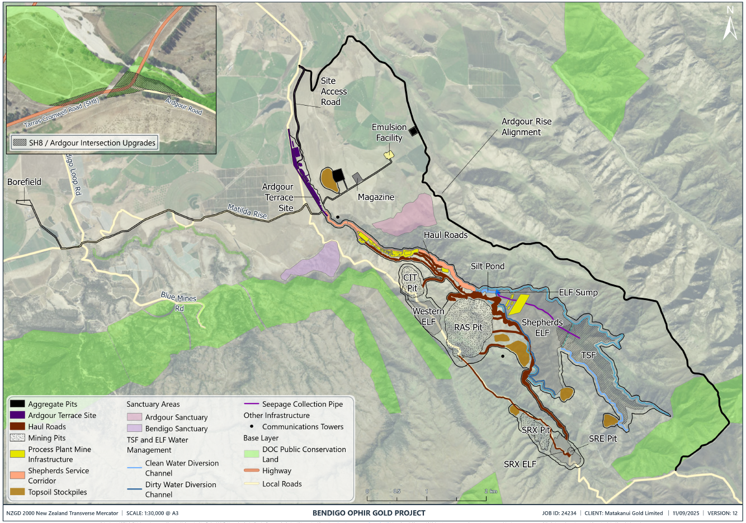

Plan 1: Project Overview Plan
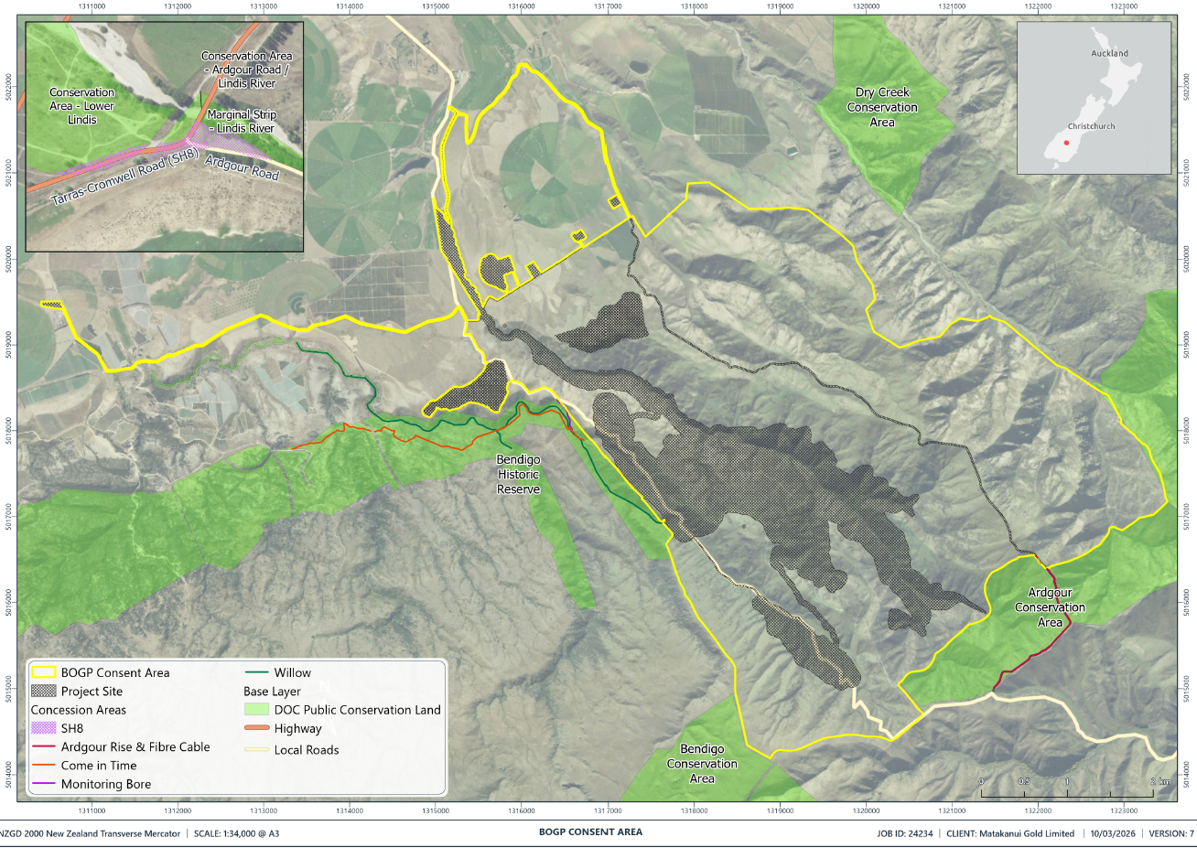

Plan 2: BOGP Consent Area

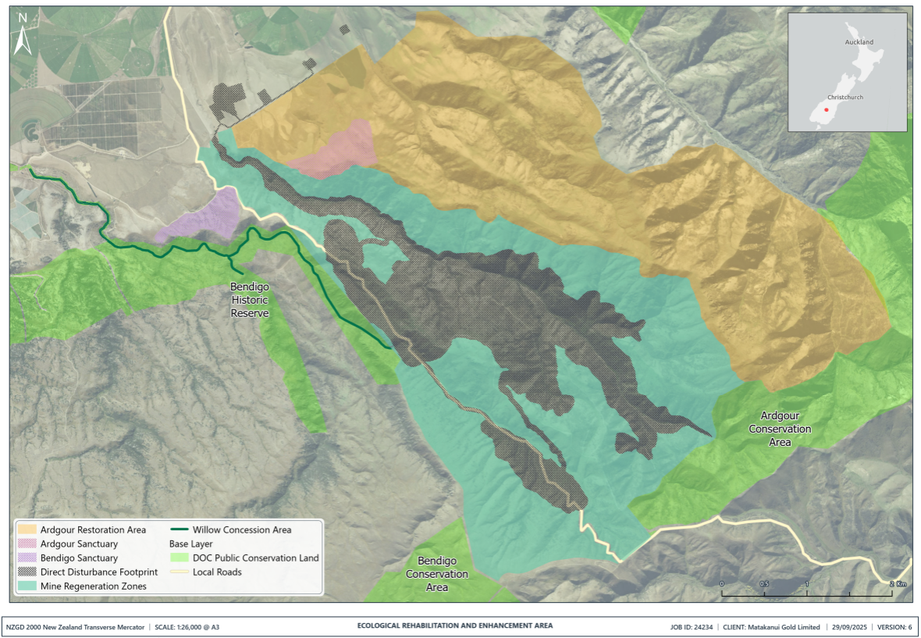

Plan 3: Ecological Rehabilitation and Habitat Enhancement Areas
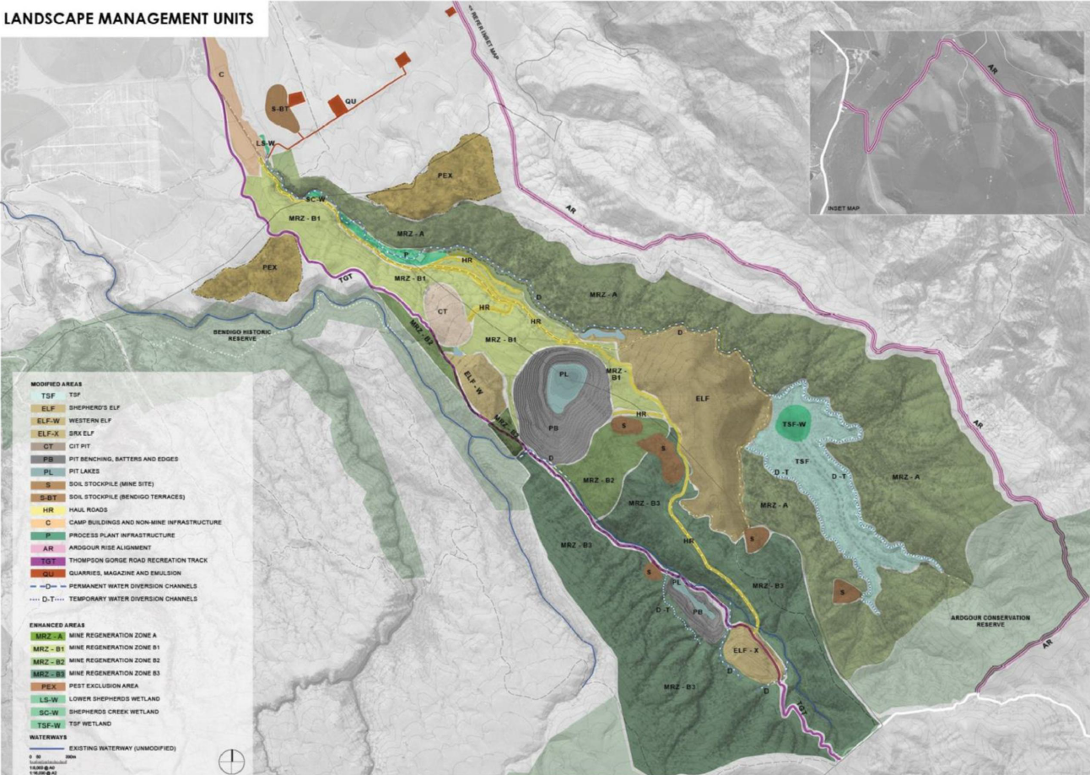

Plan 4: Landscape Management Units
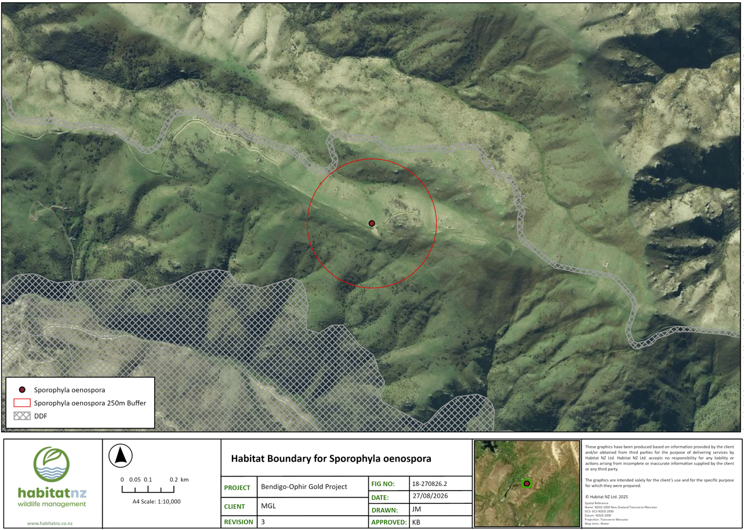

Plan 5: Habitat Boundary for Sporophyla oenospora

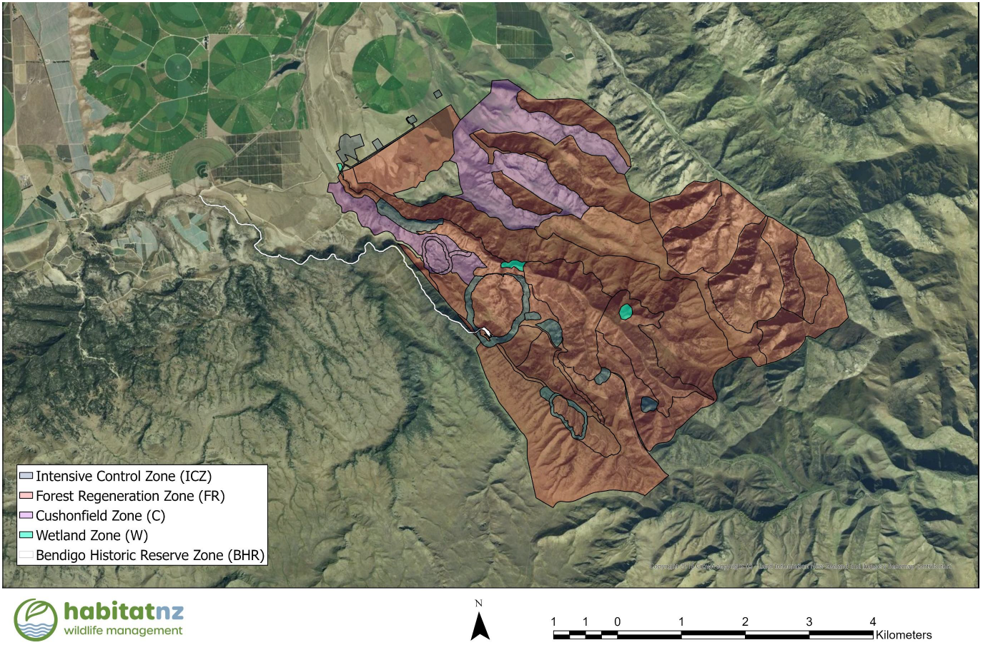

Plan 6: Plant Pest Control Zones
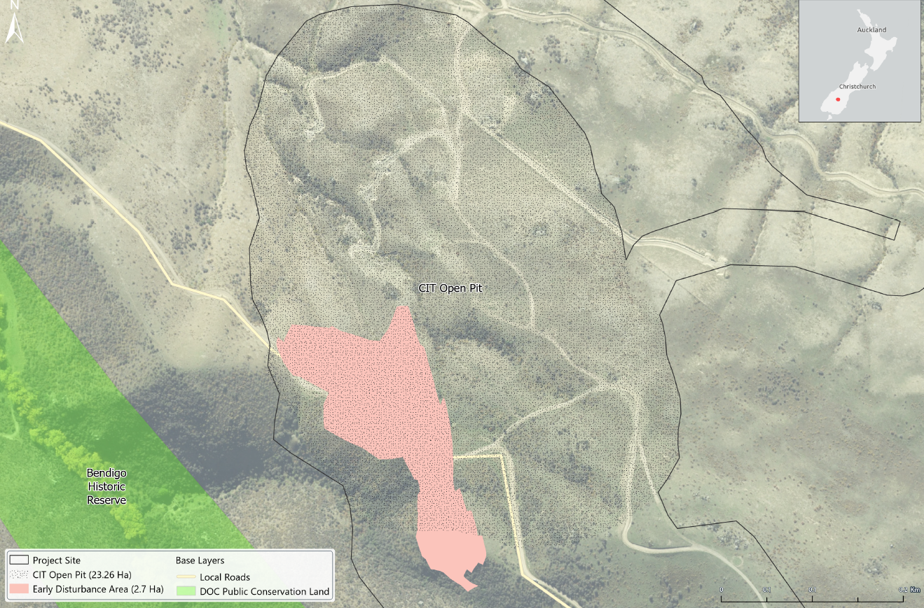

Plan 7: Come-in-Time Open Pit Early Disturbance Area
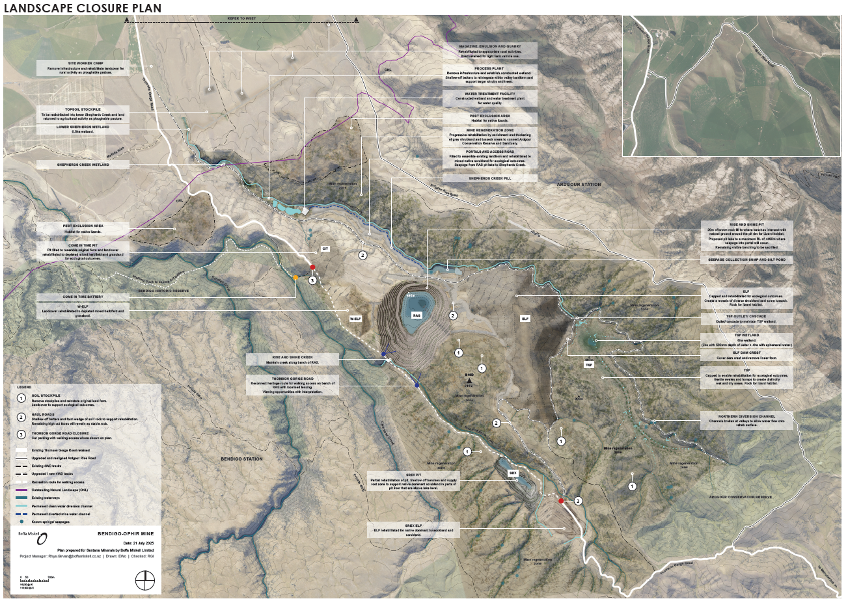

Plan 8: Landscape Closure Plan

ATTACHMENT 3
Rehabilitation Management Approach for Nationally or Regionally At-Risk and Threatened plant species in the Direct Disturbance Footprint
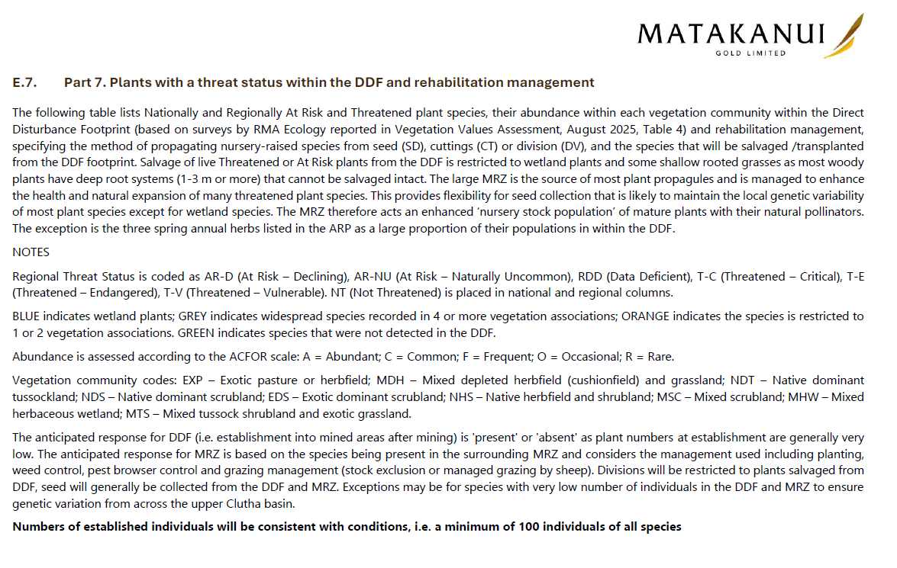
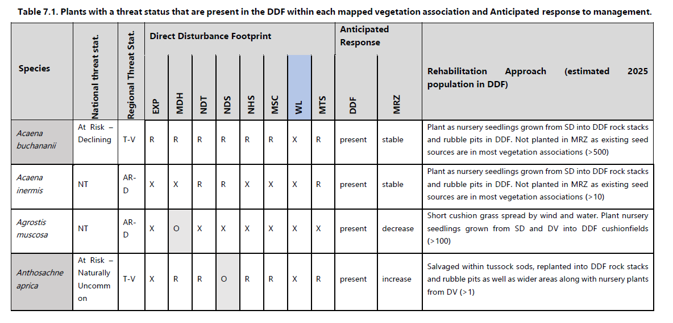

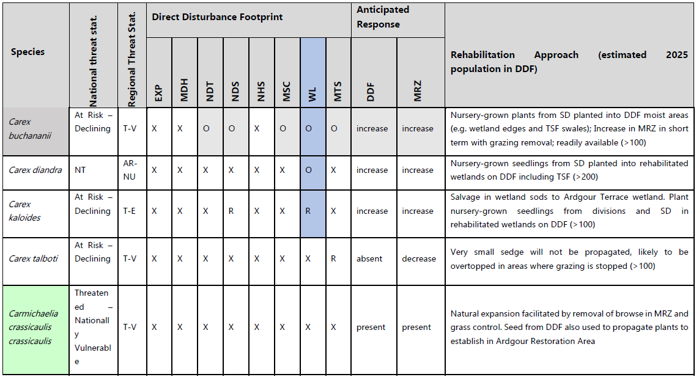

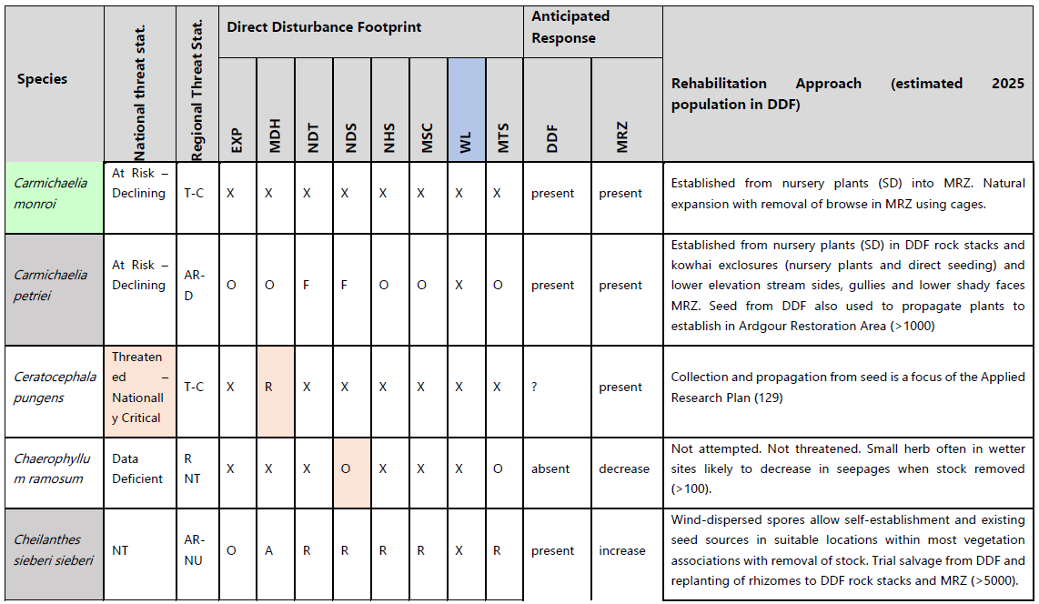

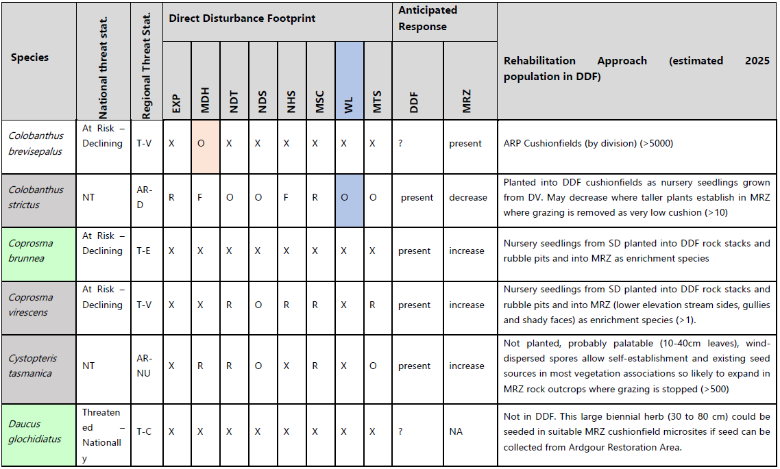

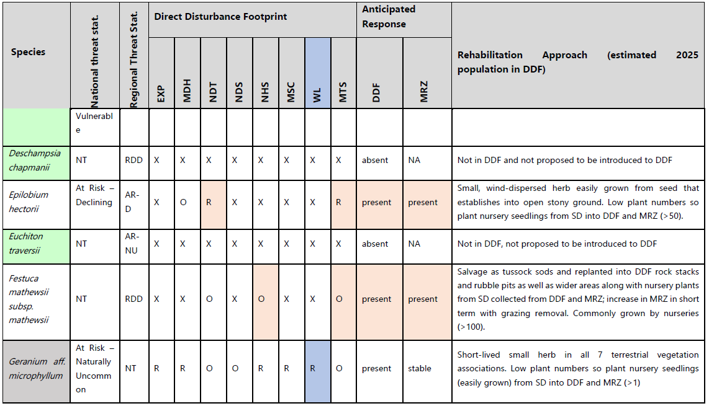

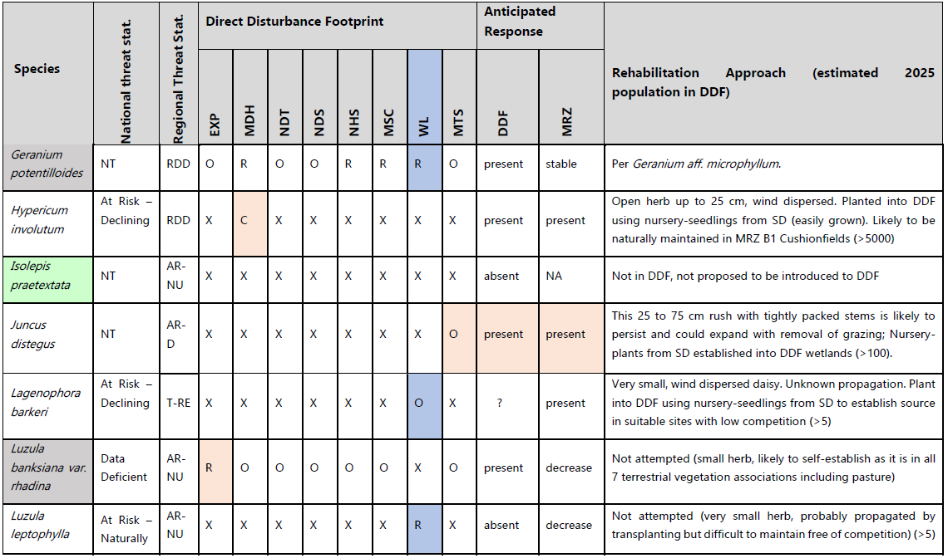

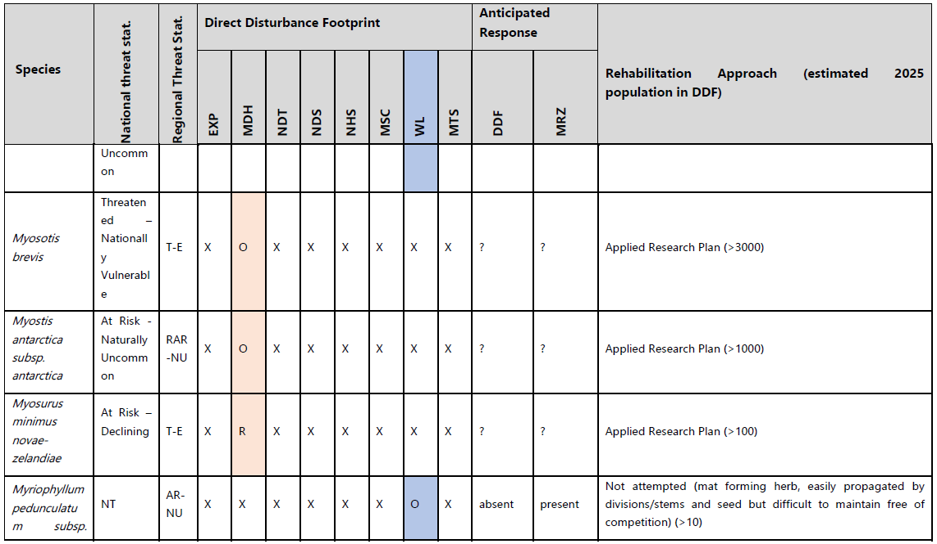

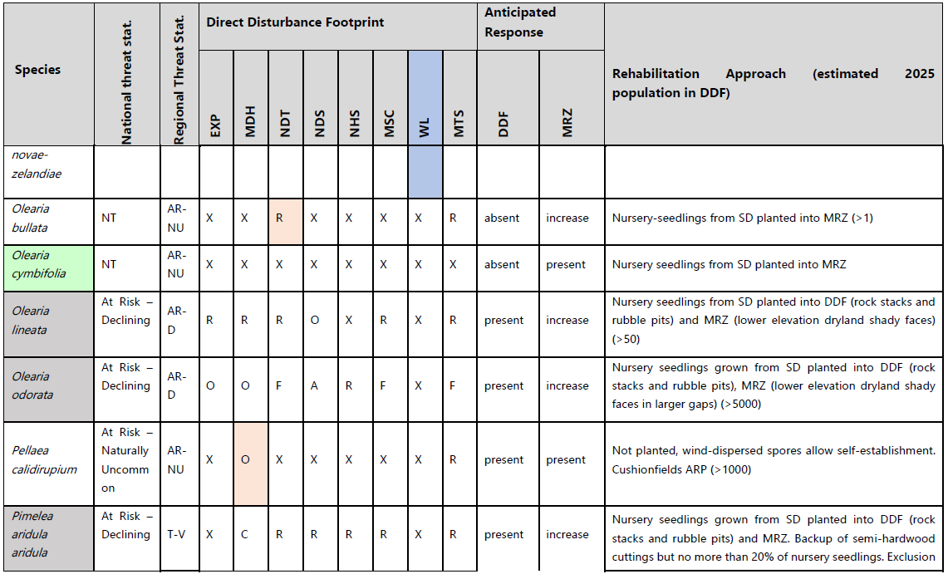

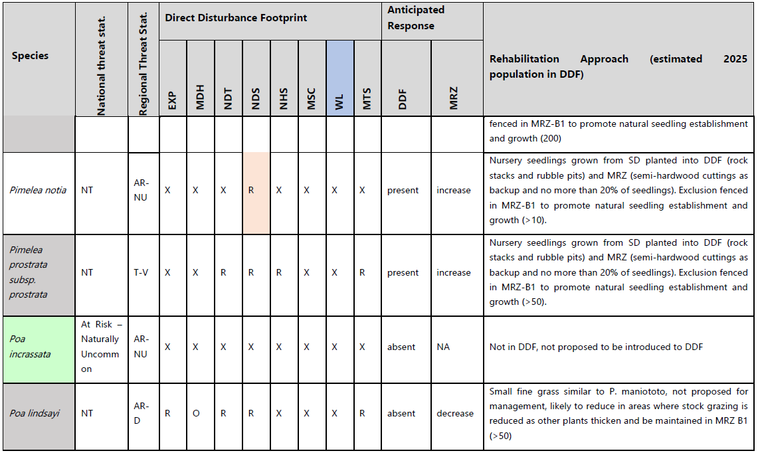

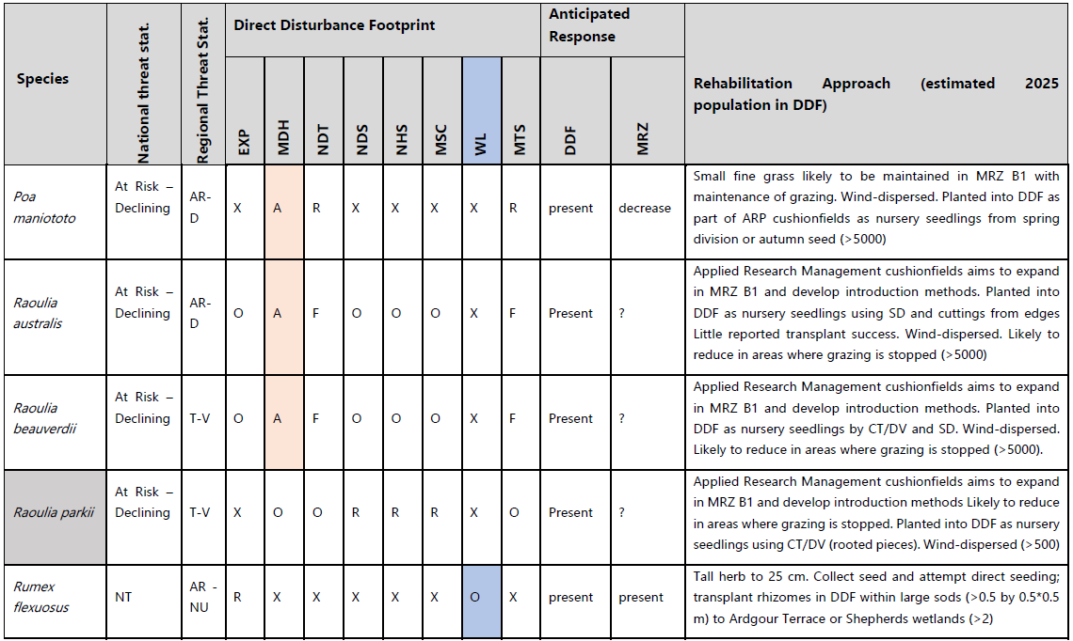

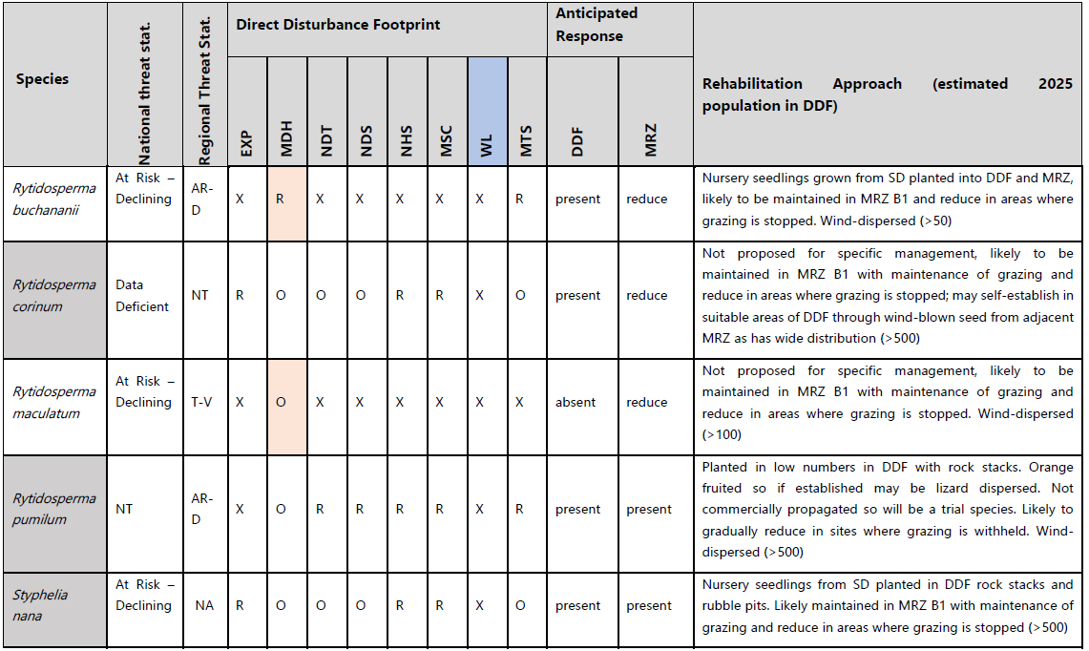

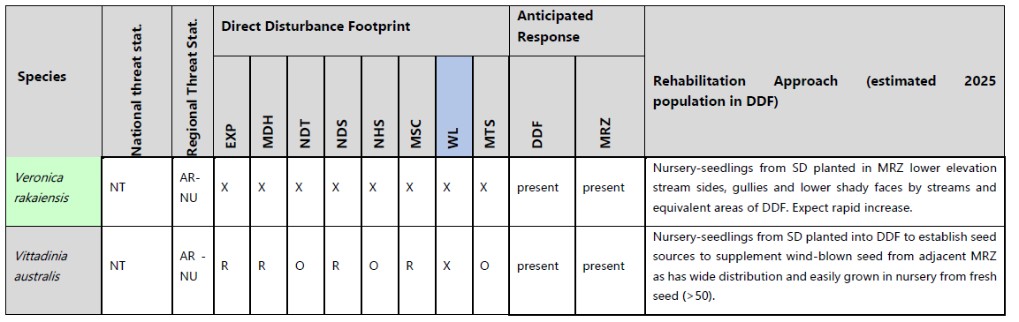

ATTACHMENT 4
Standards, Requirements and Success Criteria for Rehabilitation of the Direct Disturbance Footprint
Unit Code | Management Unit | Initial Habitat Area (ha) | Timeline | Key Features | Infrastructure Actions | Vegetation Actions | Habitat Enhancement | Water Management | Vegetation Success Criteria | Habitat Success Criteria | Infrastructure Success Criteria | Monitoring Schedule
TSF | Tailings Storage Facility | 75 | Years 10-12 | Tussock shrubland vegetation mosaic with 6 ha wetlands, 0.5 ha open water, 137 rock stacks above 1 in 10-year ponded area. | Install at least 1.2 m protective cap.  Install outlet infrastructure and ‘break’ diversion drains.  Build embankment access track and naturalise form. | Temporary erosion control.  Hydroseed.  Plant wetlands at 7,500 plants/ha.  Plant swales and bunds 1,500 plants/ha.  Remove non-native trees. | Build 137 rock stacks above inundation level.  Create swale / bund topography (additional depth on bunds).  Establish tussock clusters. | Create at least 2 ha permanent wetland.  Build at least 4 ha ephemeral wetland.  Maintain at least 0.5ha open water patches (a mosaic).  Install engineered outlet.  Bring water from diversion drains onto TSF. | At least 75% planted seedling survival at 3 years and active growth.  At least 66% native wetland vegetation cover with target threatened species established.  Native species dominance.  Minimal invasive plant species, with pest plant covers diminishing. | At least 137 functional rock stacks.  At least 2ha permanent wetland, 0.5 ha open water at spring maxima as a mosaic.  At least 4ha ephemeral wetland.  Lizard colonization evidence (tussock skink and gecko). | Capping integrity maintained.  Outlet functionality confirmed.  Access track, fords and diversion drains are stable.  Embankment stability. | Annual vegetation surveys.  Quarterly water monitoring  Bi-annual lizard surveys.  Monthly infrastructure checks.
ELF-S | Shepherds ELF | 116 | Year 10-12 | Vegetation mosaic with 212 rock stacks, 60 rubble pits and fire buffer across ridgeline. | Shape final landforms, scallop, apply 1-2 m brown rock, then 10 to 50 cm soil.  Remove linear terracing.  Create access roads and fire buffer.  Install drainage systems. | Temporary erosion control. Hydroseed.  Plant native nursery stock at 1500 plants/ha in clusters.  Transplant salvaged tussocks.  Establish shrubland mosaic. | Create 25 to 50% deep root zones.  Build 212 rock stacks.  Create 60 rubble pits.  Deliver at least 5% rock cover.  Create fire buffer zones. | Build permanent diversion.  Create riffle and pool sequences.  Install riparian planting and salvage from adjacent areas.  Design low flow and high flow habitat features. | Greater than 75% planted seedlings survival at age 3 years and active growth.  At least 20% native plant cover by Year 10.  Vegetation mosaic established and tussock nodes expanding by Year 10.  Minimal erosion occurrence.  Species diversity targets met. | At least 212 rock stacks functional.  At least 60 rubble pits occupied.  Wildlife corridor established.  Habitat mosaic established with variation in native vegetation structure and dominant species. | Landform stability maintained.  Drainage system functional.  Visual integration achieved.  Fire buffer effective. | Annual vegetation monitoring.  Seasonal erosion surveys.  Bi-annual fauna surveys.  Quarterly infrastructure inspections.
ELF-W | Western ELF | 18 | Years 2-3 | Cushionfield and general rehabilitation trials, 33 rock stack and rubble pit refinement (minimum 10 rubble pits) | Complete landform by Year 2.  Install cushionfield trial infrastructure.  Refine root zone construction methods. | Hydroseed.  Trial plant establishment techniques.  Apply Cushionfield ARP.  Monitor establishment rates,  growth and spread. | Build 33 trial rock stacks (refine technique).  Create 10 trial rubble pits (refine technique).  Monitor lizard colonization and use of habitats. | Refine erosion control methods.  Monitor drainage patterns.  Assess water retention.  Refine design approaches.
ELF-X | SRX-ELF | 15.8 | Years 8-12 | Vegetation mosaic with 29 rock stacks and 8 rubble pits, taramea. | Complete landform integration by Year 12. | Hydroseed.  Vegetation mosaic including taramea. | Build 29 rock stacks.  Create 8 rubble pits. | Manage surface water flows to minimise erosion.
PB | Pit Benching & Batters | 92 | Years 1-8 | Root zone wedges 0.1 to 4 m deep, extend along benches at least 20 m from natural ground level. | Place root zone wedges.  Treat upper benches.  Install bench edge treatments.  Develop access systems. | Hydroseed.  Enhance edge vegetation.  Reduce edge plant pests.  Enhance bench revegetation.  Monitor natural colonization. | Enhance edge habitat with strategic rocks.  Enhance edge connectivity. | Manage surface water flows.  Manage flows in in-pit diversions.  Enhance habitat in permanent in-pit diversions. | Native vegetation established on areas with root zones (20m).  Native dominated edges thriving.  Erosion control effective.  Pest plant species fail to establish (are not reproductive). | Edge connectivity established with batters.  Lizard access to batters confirmed.  Habitat diversity created. | Safety standards maintained. | Two-yearly vegetation surveys by drone.  Quarterly safety inspections.
CT | CIT Pit (backfilled) | 13.8 | Years 8-12 | Native herbfield, specialized grazing, 25 rock stacks, 7 rubble pits, patches of kowhai, native broom. | Backfill pit.  Landform integration by Year 12. | Spring annual herbs & cushionfield focus. | Build 25 rock stacks.  Create 7 rubble pits. | Manage surface water flows to minimise erosion. | Refer to Cushionfield ARP. |  | Landform stability maintained.  Drainage system functional.  Visual integration achieved.
PL | Pit Lakes | 18.1 | Years 8+ | Emergent aquatic vegetation on haul road, kowhai patch, boulder placement. | Place boulders within lake edge along haul road and on haul road.  Place root zone on haul road using wedges.  Exclude vehicles. | Hydroseed.  Plant above lake level along haul road.  Establish kowhai and grey scrub. | Install boulders across lake edge in clusters ensuring part of the submerged boulders will emerge above the water. | Manage surface water flows (pit walls and haul road).  Minimise lake edge erosion.
S | Soil Stockpiles (Mine site) | 24 | Throughout | Staged removal and rehabilitation, 44 rock stacks, 13 rubble pits. | Restore original landform contours that are stable.  Re-establish drainage.  Rip or spot mound stockpile base.  Scallop surface and spread root zone. | Temporary erosion control.  Hydroseed.  Plant native nursery stock at 1500 plants/ha in clusters.  Establish vegetation mosaic that complements adjacent areas. | Build 44 rock stacks.  Create 13 rubble pits.  Deliver at least 5% rock cover. | Manage surface water flows to minimise erosion.  Reinstate ephemeral watercourses and seepages.  Use armouring where necessary.
S | Soil Stockpile - Ardgour Terraces | 6.8 | Years 1-3 | Agricultural production (tillable, homogenous soils) and infrastructure capability. | Restore original landform contours that are stable.  Re-establish drainage.  Rip mound stockpile base. | Temporary erosion control.  Establish vegetation cover that complements adjacent areas. | Nil. | Manage surface water flows to minimise erosion.
HR | Haul Roads | 50 | Throughout | Light vehicle access, low biomass fire buffers, targeted deep spot mounding, root zone wedges against cuts greater than 2 m height. | Break linear features.  Scarify cut faces.  Place root zone wedges against cuts greater than 2m. Deconstruct bunds.  Create access roads and fire buffer.  Rip or spot mound greater than 0.5 m depth except permanent tracks. spread root zone. | Hydroseed.  Enhance edge vegetation and plant long-term bunds.  Reduce edge plant pests.  Move parts of bunds with plants and root zone, plant native nursery stock and establish seed germination zones. | Deliver at least 5% rock cover. | Manage surface water flows to locally concentrate and infiltrate water in ways that maintain surface stability and assist vegetation establishment.  Remove culverts where practical and replace with fords. | Per ELF and S. | Per ELF and S. | Reduced to light vehicle access tracks.  Fire buffer established. | Per ELF and S.
C | Construction Camp & Ancillary | 1.2 | Years 4-10 | Complete removal and restoration to support productive, tillable pasture. | Remove hard infrastructure.  Maintain culverts or convert to fords.  Shape final landforms, ensure suitable drainage.  Spread root zone or gravel.  Fence riparian zone. | Enhance soil stockpile quality.  Establish dense pasture or cereal cover.  Minimise agricultural plant pests.  Establish riparian zone planting. | Establish riparian zone to wetland.  Establish kowhai in riparian zone. | Manage runoff quality and quality from roads, hardstand.  Minimise risk of upstream erosion and manage hydrology within Ardgour Terrace wetland.  Enhance resilience of unfenced watercourse sections.
P | Process Plant Mine Infrastructure | 4.3 | Years 10+ | Wetland area, 0.5 ha trees in deep soils, enable water treatment infrastructure. | Refer to Mine Closure Plan. | Refer to Mine Closure Plan | Refer to Mine Closure Plan | Refer to Mine Closure Plan
AR | Ardgour Rise Alignment | Variable | Years 1-2 | Vehicle Access  Rehabilitated, fill batters. | Manage runoff, maintain culverts. | Enhance fill vegetation.  Reduce edge plant pests.  Monitor natural colonization. |  | Manage runoff, maintain culverts
TGT | Thomson Gorge Recreation Track | Variable | Years 10-12 | Walking access, revegetation enhances safety and minimises fire risk. |  |  |  |  | N/A | N/A | Recreation route reinstated.  Wayfinding and lookout opportunities.  Safety standards maintained.  Fire buffer established | Quarterly safety inspections.  Annual road surface assessments to maintain free-drain, gravel surface.  Six-monthly plant pest and fire buffer assessments.
QU | Quarries, Magazine & Emulsion | 6.56 | Years 1-5 | Gravel pit development, magazine restoration | Remove hard infrastructure.  Maintain culverts or convert to fords.  Shape final landforms, ensure suitable drainage.  Spread root zone or gravel.  Fence riparian zone. | Enhance soil stockpile quality.  Establish dense pasture or cereal cover.  Minimise agricultural plant pests. |  | Manage runoff quality and quality from roads, hardstand.  Minimise risk of upstream erosion and manage hydrology within Ardgour Terrace wetland.  Enhance resilience of unfenced watercourse sections.
W | Wetlands | 7 | Years 1-30 | TSF wetland, Shepherds Creek wetlands and Process Plant wetlands. | Establish Plant handling area and wetland in Lower Shepherd Creek.  Construct Shepherds Creek wetlands 2 x 0.5ha.  Process plant wetlands at end of mine life (associated with passive water treatment system at passive closure). | Direct transfer of wetland sods containing Carex 0.4 ha in Year 1 for Shepherds Creek wetlands. | Kowhai planting in riparian area. |  | Refer to Conditions CX-X (Wetland monitoring and compensation conditions). | Refer to Conditions CX-X (Wetland monitoring and compensation conditions). | Refer to Conditions CX-X (Wetland monitoring and compensation conditions). | Refer to Conditions CX-X (Wetland monitoring and compensation conditions).
D | Clean Water Diversion Channels | Variable | Throughout | Permanent access along some diversions, habitat enhancement

ATTACHMENT 5
Vegetation Establishment Criteria, Success Criteria, Triggers for Contingency and Contingency Action by Vegetation Type
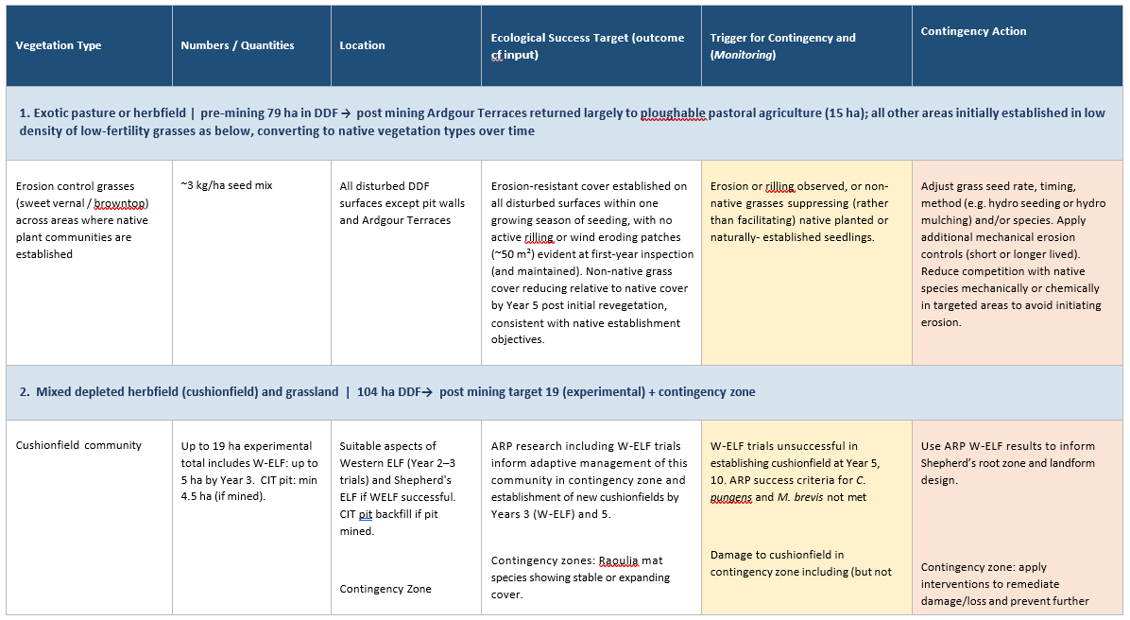
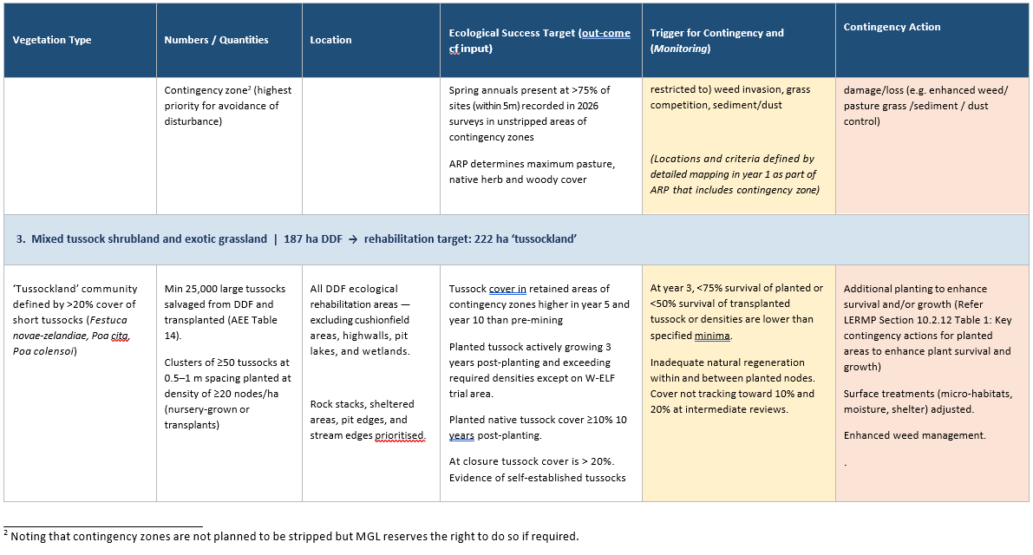
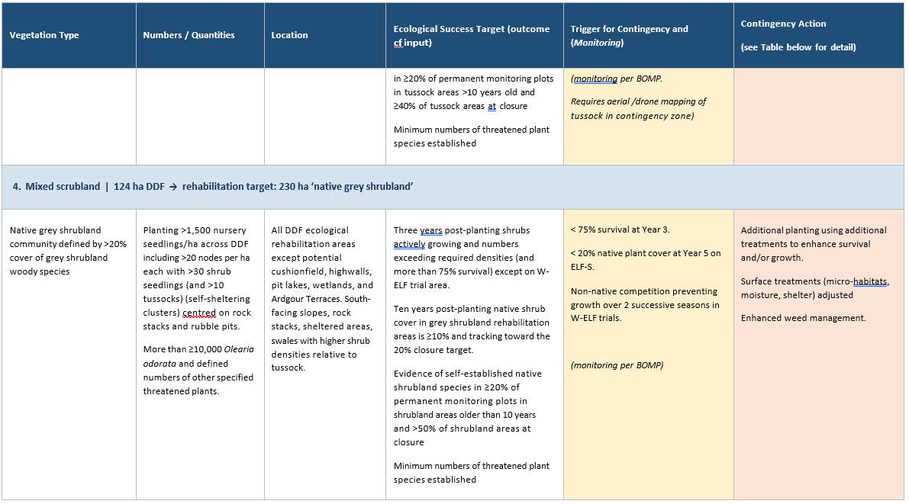

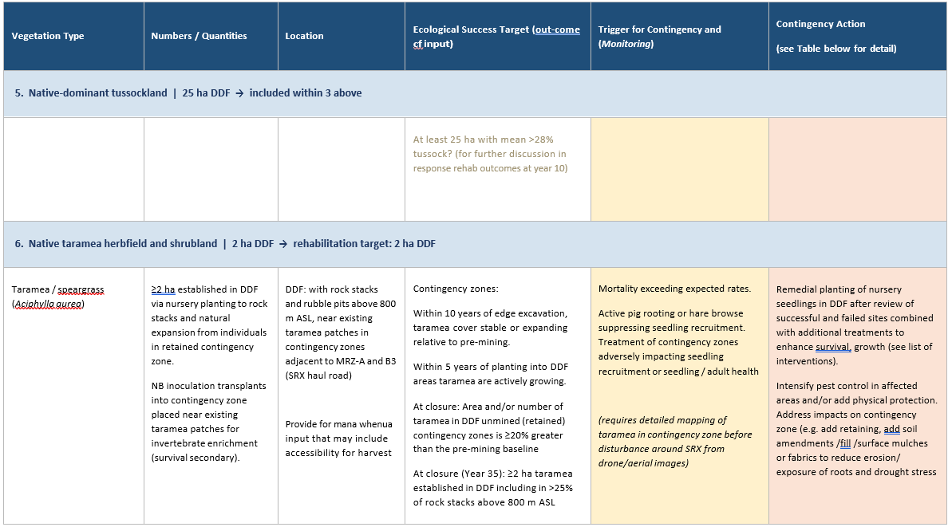

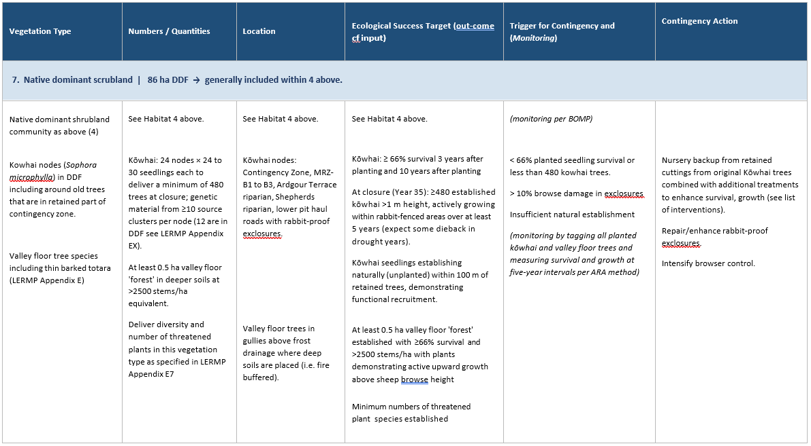

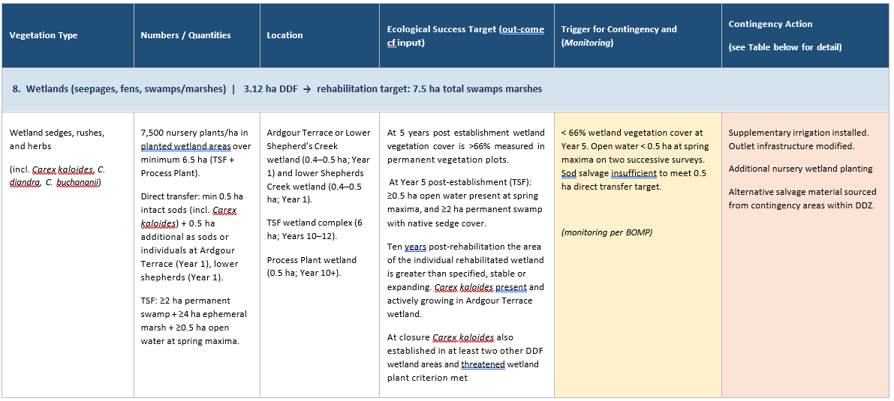

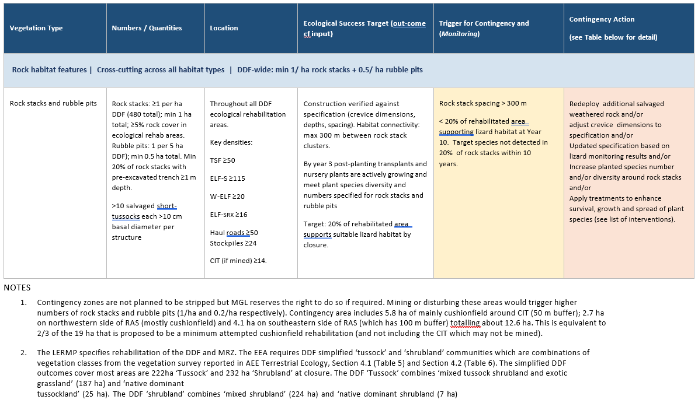

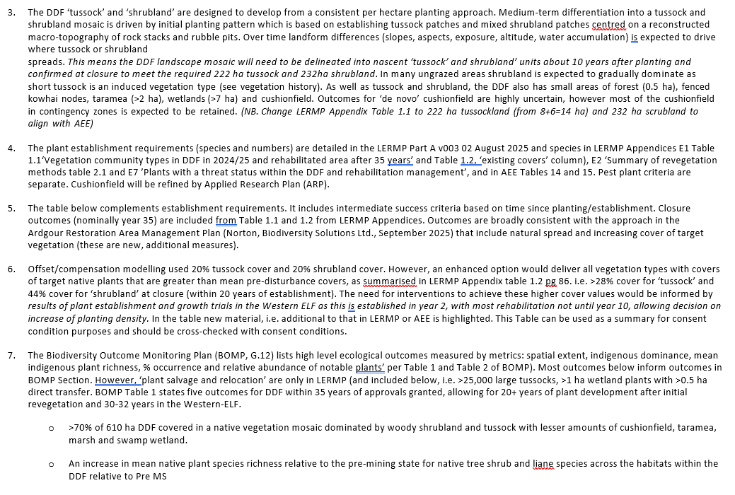

ATTACHMENT 6
Standards, Requirements and Success Criteria for Maintenance and Enhancement in the Mine Regeneration Zone
Unit Code | Management Unit | Initial Habitat Area (ha) | Timeline | Key Features | Infrastructure Actions | Vegetation Actions | Habitat Enhancement | Water Management | Vegetation Success Criteria | Habitat Success Criteria | Infrastructure Success Criteria | Monitoring Schedule
MRZ-A | Mine Regeneration Zone A | 434 | Years 1-35 | Stock exclusion, snow tussock planting, taramea expansion. | Install stock-proof boundary fencing  Build maintenance access  Establish fire breaks | Control targeted plant pests.  Enhance plant species diversity.  Control pest browsers.  Establish snow tussock.  Expand taramea. | Enhance habitat structure and leaf litter habitats.  Create habitat corridors.  Increase plant species hosting threatened invertebrates.  Monitor fauna response. | Enhance riparian zones.  Exclude stock.  Enhance degraded seepage zones.
MRZ-B1 | Mine Regeneration Zone B1 | 69 | Years 1-35 | Controlled grazing, species protection. | Install stock fencing.  Build stock watering system (troughs).  Install rabbit exclosures.  Establish access tracks. | Control targeted plant pests.  Control competing plant pests.  Protect, enhance cushionfields.  Manage grazing timing.  Enhance spring annuals.  Control pest browsers. | Establish new high-value plants (seedlings).  Protect high-value plants.  Increase cover and health of high-value plants.  Monitor threatened species. | Stop stock water extraction.  Protect seepage areas from stock.  Enhance degraded seepage zones.  Enhance natural stream flow. | Expansion of cushionfield area.  Enhanced cushionfield condition.  Increase in spring annual populations and individuals.  Elimination of reproductive brier. | Regeneration of Pimelea aridula and native brooms in ex-closures.  Natural recruitment of kowhai seedlings in ex-closures containing adult trees and active growth of planted kowhai within 5 years. | Fence integrity maintained.  Stock water system functional. | Plant monitoring determined by Cushionfield ARP.  Quarterly infrastructure checks.
MRZ-B2 | Mine Regeneration Zone B2 | 30 | Years 1-35 | Controlled grazing, enrichment planting, plant pest and competition management. | Install boundary fencing  Create internal subdivisions if necessary  Create kowhai enclosures  Build stock watering system  Maintain access routes  Establish fire breaks | Control targeted plant pests.  Protect, enhance cushionfields.  Enhance plant species diversity (enrichment planting).  Control competing plant pests.  Manage grazing intensity.  Protect remnant kowhai.  Control pest browsers. | Enhance rock features.  Establish kowhai.  Enhance habitat connectivity.  Monitor lizard populations.  Increase plant species hosting threatened invertebrates. | Protect riparian zones.  Enhance degraded seepage zones. | Cushionfield area maintained.  Spring annual population stable.  Forms an effective buffer for cushionfields.  No expansion of brier.  Minimal invasive plant species, pest plant covers diminishing.  Reduction in pasture cover.  Target plant species naturally recruiting. | Enhanced native plant species diversity.  Enhanced plant structure in scrub areas with vines. Threatened lizard species populations enhanced. | Fence integrity maintained.  Water system functionality.  Access track condition maintained.  Grazing infrastructure effective. | Two-yearly plant surveys.  Bi-annual threatened species counts.  Monthly grazing assessments.  Quarterly infrastructure checks.
MRZ-B3 | Mine Regeneration Zone B3 | 357 | Years 1-35 | Browse control then exclusion, enrichment planting, plant pest and competition management. | Install boundary fencing.  Install temporary stock water supply (for sheep).  Build maintenance access.  Establish fire breaks. | Control targeted plant pests.  Control competing plant pests.  Protect, enhance remnant kowhai and taramea.  Enhance plant species diversity.  Control pest browsers. | Create habitat corridors  Enhance rock features  Establish kowhai in ex-closures  Increase plant species hosting threatened invertebrates  Monitor fauna response | Protect Jean Creek headwaters.  Enhance wetland areas.  Control, then exclude stock.  Improve aquatic habitat. | Over 5000 snow tussocks established in nodes over at least 5 ha with long-lived woody trees. Natural recruitment of snow tussock observed within 10 years. | Connectivity established across areas that were dominated by pasture.  Taramea recruitment observed within 5 years, greater than 5% increase in taramea area within 10 years. | Fire buffers and access tracks condition maintained. | Two-yearly plant surveys.  Bi-annual planted threatened species counts.  Quarterly infrastructure checks.

ATTACHMENT 7
Plant Types, Sources, Densities, Location Priorities and Success Criteria for the Direct Disturbance Footprint (DDF) and Mine Regeneration Zones
Plant Type | Source | Planting Density | Location Priority | Success Criteria
Tussocks | Salvaged from site and nursery grown. | 25,000 minimum salvaged tussocks planted in clusters of 50 plants at up to 1 m spacing. | Rock stacks and rubble pits, sheltered areas (swales, hollows), pit edges, stream edges. | Pre-mining cover of native tussock and shrubs in ‘mixed tussock shrubland’ and ‘native dominant tussockland’ achieved in DDF after 15 years (i.e. a minimum cover of 34% comprised of 7 to 28% tussock cover and 6 to 19 % native shrubs (Appendix E1, Table 1.2).
Shrubs | Local nurseries, hardened on-site. | 1,000-1,500 per hectare in the DDF and 250 to 1500 plants per hectare in the MRZs. | Rock stacks and rubble pits, deeper soils, protected slopes and moister micro-sites. | 75% survival of planted vegetation at 3 years post establishment with active growth.  Exceed minimum numbers required for each threatened plant species 3 years post establishment with active growth.  Natural regeneration occurring between planted areas showing ecosystem expansion
Kowhai | Local nurseries using plant sourced from Clutha Basin genetics primarily by seed with on-site cuttings. | 24 nodes with at least 30 seedlings per node ensuring diverse genetics. | Contingency zone & MRZ B1-B3, Ardgour Terrace riparian area, Shepherds riparian, lower pit haul road. | 66% survival 3 years post establishment with active growth.
Taramea | Nursery grown. | Variable. | Near existing taramea, rock stacks & rubble pits above 800m above sea level. | 75% survival of planted vegetation at three years post-establishment.
Wetland Plants | Salvaged sods (including Carex kaloides). | 7500 nursery plants per hectare with at least 0.5 hectares of direct transfer. | Wetlands. | 66% cover at 5 years post establishment, stable or expanding cover.
Erosion Control | Seed mix. | 3kg per hectare of sweet vernal and / or browntop. | Most disturbed surfaces (not pit walls). | Effective erosion control on all slopes, minimal soil losses.
Source: Table 8 of the Landscape and Ecological Rehabilitation Management Plan (page 77).

ATTACHMENT 8
Plant Pest Species and Management Objectives for Control Zones
Table below shows the current and likely future plant species and associated control objectives for each plant pest control zone of the Bendigo-Ophir Gold Project. Purple cells indicate a species subject to the outcomes of the Cushionfield ARP within that zone.
Common Name | Scientific Name | Type | Intensive Control Zone (ICZ) | Forest Regeneration (FR) | Cushionfield Zone (C) | Bendigo Historic Reserve Zone (BSR) | Wetland Zone (W)
Black Poplar | Populus nigra | Woody | Elimination | Elimination | Elimination | Not Targeted | Elimination
Rowan | Sorbus aucuparia | Woody | Elimination | Elimination | Elimination | Not Targeted | Elimination
Stone Fruit | Prunus spp. | Woody | Elimination | Elimination | Elimination | Not Targeted | Elimination
Wilding Conifers | Larix/Pinus spp. | Woody | Elimination | Elimination | Elimination | Not Targeted | Elimination
Willow | Salix × fragilis | Woody | Elimination | Elimination | Elimination | Elimination | Elimination
Buddleia | Buddleja davidii | Woody | Elimination | Elimination | Elimination | Not Targeted | Elimination
Elderberry | Sambucus nigra | Woody | Elimination | Elimination | Elimination | Not Targeted | Elimination
Boxthorn | Lycium ferocissimum | Woody | Elimination | Elimination | ARP Outcome | Not Targeted | Elimination
Cotoneaster | Cotoneaster spp. | Woody | Elimination | Elimination | Elimination | Not Targeted | Elimination
Flowering Currant | Ribes sanguineum | Woody | Elimination | Elimination | Elimination | Not Targeted | Elimination
Gooseberry | Ribes uva-crispa | Woody | Elimination | Elimination | Elimination | Not Targeted | Elimination
Broom | Cytisus scoparius | Woody | Elimination | Elimination | Elimination | Not Targeted | Elimination
Gorse | Ulex europaeus | Woody | Elimination | Elimination | Elimination | Not Targeted | Elimination
Hawthorn | Crataegus monogyna | Woody | Elimination | Elimination | Elimination | Not Targeted | Elimination
Sweet Brier | Rosa rubiginosa | Woody | Elimination | Not Targeted | Elimination | Not Targeted | Not Targeted
Thyme | Thymus vulgaris | Herbaceous | Elimination | Elimination | Elimination | Not Targeted | Elimination
Non-native Climbing Vines | Clematis spp. | Woody | Elimination | Elimination | ARP Outcome | Not Targeted | Elimination
Biting Stonecrop | Sedum acre | Herbaceous | Elimination | Elimination | ARP Outcome | Not Targeted | Elimination
Stinking Iris | Iris foetidissima | Herbaceous | Elimination | Elimination | Elimination | Not Targeted | Elimination
Foxglove | Digitalis purpurea | Herbaceous | Elimination | Not Targeted | ARP Outcome | Not Targeted | Not Targeted
Hemlock | Conium maculatum | Herbaceous | Elimination | Not Targeted | ARP Outcome | Not Targeted | Not Targeted
Mullein | Verbascum thapsus | Herbaceous | Elimination | Not Targeted | ARP Outcome | Not Targeted | Not Targeted
Thistles | Various species | Herbaceous | Elimination | Not Targeted | ARP Outcome | Not Targeted | Control
Australian Bidibidi | Acaena spp. | Herbaceous | Elimination | Not Targeted | ARP Outcome | Not Targeted | Not Targeted
California Poppy | Eschscholzia californica | Herbaceous | Elimination | Not Targeted | ARP Outcome | Not Targeted | Not Targeted
Viper's Bugloss | Echium vulgare | Herbaceous | Elimination | Not Targeted | ARP Outcome | Not Targeted | Not Targeted
Male Fern | Dryopteris filix-mas | Herbaceous | Elimination | Elimination | ARP Outcome | Not Targeted | Elimination

ATTACHMENT 9
Mammalian Pest Management Plan Monitoring Targets
Species | Monitoring target | Threshold for additional control | Monitoring type and timing
Feral cats | < 2 detections per 2000 Camera Hours (“CH”) | >3 detections per 2000 CH | Quarterly camera trap monitoring for predators (February, May, August and November).
Hedgehogs | <3 detections per 2000 CH | >6 detections per 2000 CH | Quarterly camera trap monitoring for predators (February, May, August and November).
Mustelids | <3 detections per 2000 CH | >5 detections per 2000 CH | Quarterly camera trap monitoring for predators (February, May, August and November).
Lagomorphs | ≤3 on the Modified McLean Scale | >3 on the Modified McLean Scale | Twice yearly monitoring (April and October)
Possums | ≤6 CCI (chewcard index) | >6 CCI | Twice yearly chewcard monitoring (May and November).
Ungulates (feral deer, feral goats and feral pigs) | Zero detections on camera traps and no reported signs | >2 detections within a 3-week period (camera trap or observations) or direct impacts on plantings | Annual camera trap monitoring for ungulates (November and December) and observations of plantings.
Rats | 100% of monitoring activities completed on time with approved methods | ≥10% Tracking Tunnel Index (“TTI”). | Quarterly tracking tunnel monitoring (February, May, August and November).  Note: monitoring begins once ARAMP review.

ATTACHMENT 10
Records of Title against which the Bond is to be Registered

