

Hunua Quarry Development
Lizard Management Plan
Prepared for Winstone Aggregates

11 September 2026

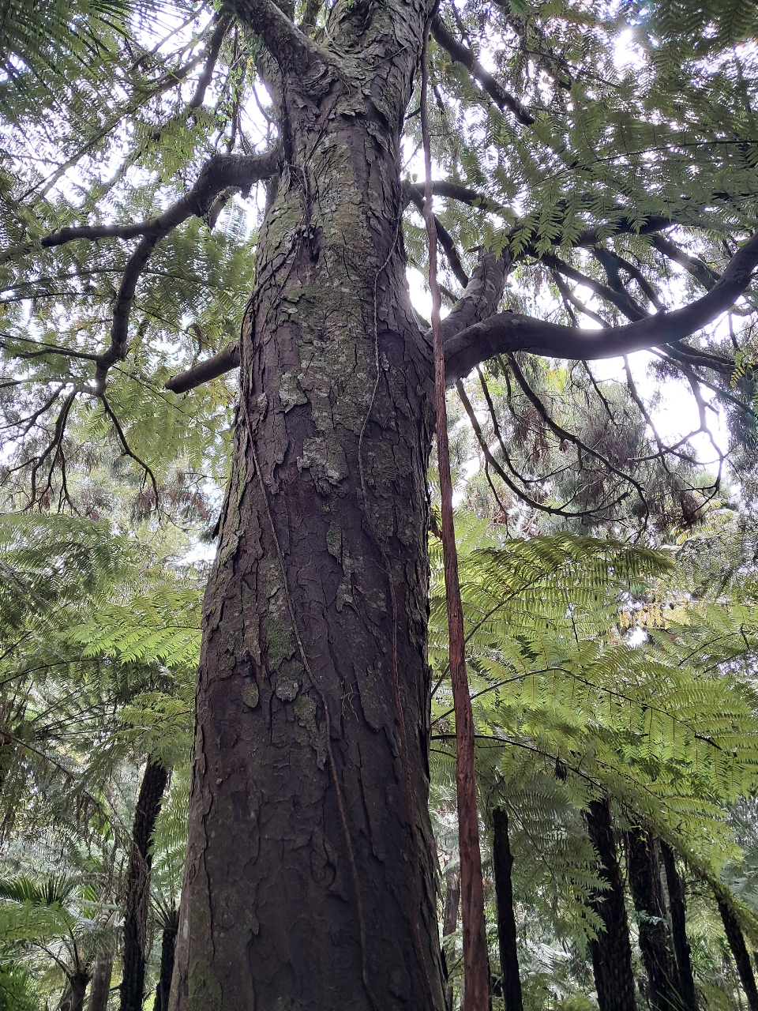

 |  | Boffa Miskell is proudly a  Toitū net carbonzero certified consultancy
Document Quality Assurance
This document may be cited as:
Boffa Miskell Limited 2026. Hunua Quarry Development: Lizard Management Plan. Report prepared by Boffa Miskell Limited for Winstone Aggregates.
For any information regarding this report please contact:
Ian Boothroyd | Ecology | Partner | ian.boothroyd@boffamiskell.co.nz
Revision /version: | Issue date: |  | Prepared by: | Description: | Reviewed by:
Final Draft V5 | 11/09/2026 |  | Katherine Muchna  Senior Principal Ecologist / Herpetology | Final | Ian Boothroyd  Senior Principal Ecologist / Partner
Approved for issue:
Ian Boothroyd | Ecology | Partner | 22/6/2026
Release and Reliance
This report has been prepared by Boffa Miskell Limited on the instructions of our Client, in accordance with the agreed scope of work. If it is intended to support an application under the Fast-track Approvals Act 2024, it may be relied upon by the Expert Panel and relevant administering agencies for the purposes of assessing the application.
While Boffa Miskell Limited has exercised due care in preparing this report it does not accept liability for any use of the report beyond its intended purpose. Where information has been supplied by the Client or obtained from external sources, it has been assumed to be accurate unless otherwise stated.
File name & Project number: [Hunua Quarry FTAA_Lizard Management Plan.docx] BM250767
Template revision: 20250829 0000
Cover photograph: Elegant gecko © Katherine Muchna, 2021

Executive Summary
Winstone Aggregates Limited (a division of Fletcher Concrete and Infrastructure Limited) (Winstone or the applicant) is seeking approvals through the Fast-track Approvals Act 2024 (“FTAA”) to expand the existing quarry operation at 489 Hunua Road, Hunua.
This Lizard Management Plan (LMP) describes the management of native lizards within the quarry expansion area. The LMP is informed by ecological assessments and surveys carried out by Boffa Miskell (2025-26) and Bioresearches / RMA Ecology (2007 -2025). This report provides the information required for a Wildlife Approval application under the FTAA.
A Wildlife Approval is required for the capture and relocation of native lizards for the purpose of protecting lizards within the quarry area. This LMP describes:
- The native lizard species potentially present on the Project Site.
- An assessment of potential effects on native lizards.
- Measures to avoid and minimise / remedy these impacts (including through capture and relocation) in areas of potential lizard habitat.
- Methods to prepare the release site and capture, temporarily hold and relocate lizards.
The Wildlife Approval checklist (Checklist E) is provided in Appendix 1 to guide the reader to relevant sections of this Management Plan.
The proposed lizard management to capture and salvage lizards is focused on the mature kānuka forest where elegant geckos have been recorded previously, as well as higher quality native forest habitats and edge habitats that may be occupied by native skink species.
Potential effects on non-threatened lizard fauna can be mitigated and minimised through salvage of individuals within the identified potential habitats and replacing the extent of habitat removed within the wider Site at the completion of mining.

CONTENTS

Executive Summary i
1.0 Introduction 1
2.0 Purpose of the proposed activity (s7, cl 2(1)(i) of the FTAA) 1
3.0 Actions to be carried out and locations in which the activity will be carried out 2
3.1 Actions to be carried out 2
3.2 Site Location, History and Context 2
4.0 Assessment of the activity against the purpose (s7, cl 2(1)(c) of the FTAA) 4
5.0 Wildlife species, impacts and effects 5
5.1 Survey records(s7, cl 2(1)(d) of the FTAA) 5
5.2 BioWeb records 7
5.3 Lizard habitats within the site 10
5.4 Numbers impacted and effects (s7, cl 2(1)(c) and (e) of the FTAA) 10
6.0 Methods (s7, cl 2(1)(g) and (k) of the FTAA) 16
6.1 Overview s7, cl 2(1)(f) of the FTAA) 16
6.2 Approach 16
6.3 Avoid 16
6.4 Minimise 16
6.5 Compensation 22
7.0 Post release monitoring and reporting 23
7.1 Reporting 23
7.2 Post-release monitoring 23
8.0 Wildlife Act offences (s7, cl 2(1)(l) of the FTAA) 24
9.0 Consultation (s7, cl 2(1)(n) of the FTAA) 24
10.0 Additional supporting documentation (s7, cl 2(1)(o) of the FTAA) 24
11.0 References 24

Appendices
Appendix 1: Wildlife Approval checklist
Appendix 2: Elegant gecko salvage records and Site history
Appendix 3: Lizard survey habitats 2025-2026

Figures
Figure 1: Site location and context. 3
Figure 2: Lizard surveys 2025-2026. 6
Figure 3: Herpetofauna records 9
Figure 4: Vegetation cover and quarry staging. 12
Figure 5: Lizard search efficiency for geckos salvaged between 2011-2025 (RMA Ecology). No geckos were detected in 2022 and 2024. 13

Introduction
Winstone Aggregates Limited (a division of Fletcher Concrete and Infrastructure Limited) (Winstone or the applicant) is seeking approvals through the Fast-track Approvals Act 2024 (“FTAA”) to expand the existing quarry operation at 489 Hunua Road, Hunua (‘the Project”).
This Lizard Management Plan (LMP) forms part of the substantive application under the Fast Track Approval legislation, and specifically the application for a Wildlife Approval under Schedule 7, clause 2 of the FTAA. The Project is being advanced under the FTAA as a Listed Project, reﬂecting its regional and national signiﬁcance. This application seeks approval to capture, temporarily hold and relocate, and kill native lizard species. Lizards likely to be present on the site are classified as At Risk - Declining.
This document follows the format of the Wildlife Approval checklist (Checklist E) to ensure that all required information is provided. The Wildlife Approval Checklist is also provided in Appendix 1 to assist the reader.
This report was prepared based on lizard and vegetation survey data collected by Boffa Miskell, as well as previous lizard salvage reports prepared by RMA Ecology (RMA Ecology 2018, 2025).
This report should be read in conjunction with:
- Hunua Quarry: Assessment of Ecological Effects (AEE, Boffa Miskell, 2026a).
- Hunua Quarry: Pest Management Plan (PMP, Boffa Miskell, 2026b)
- Substantive application report (Boffa Miskell, 2026c)

Purpose of the proposed activity (s7, cl 2(1)(i) of the FTAA)
Winstone seeks a wildlife approval to:
- capture, temporarily hold and relocate lizards prior to site clearance works for the purpose of protecting animals within the works footprint; and
- incidentally kill lizards, recognising that trapping / handling activities carry some risk of injury or mortality, and that any remaining undetected lizards may also incidentally be killed during site works.
The approach to the management of native lizards within the Site prior to, and during works, is described within this management plan.
Winstone seeks that the duration of the wildlife approval be 10 years to ensure that that the term of the approval adequately covers the initial stages of the operation. Winstone intends to apply for a variation to extend the term of the approval as required beyond the initial 10-year term. The term of the resource consent applied for is 35 years, but vegetation removal / land use is in perpetuity.
The requested term is 1 September 2026 – 1 September 2036.

Actions to be carried out and locations in which the activity will be carried out

Actions to be carried out
The specific actions proposed involving protected wildlife are:
- capturing lizards using pitfall / funnel traps and by hand;
- handling lizards to identify species, measure and photograph them;
- releasing lizards into a prepared release site; and
- incidental killing of lizards that could not be captured.
Catching and handing actions are to occur within the Site.

Site Location, History and Context

Location (s7, cl 2(1)(h) of the FTAA)
Hunua Quarry has operated for about 100 years and is recognised as one of Auckland’s three most strategically important sources of aggregate. The quarry lies within the foothills of the Hunua Ranges east of Papakura, which contain the most extensive areas of native vegetation in Manukau ED (most of Manukau ED is pastoral farmland). Further eastward, the forested Hunua Ranges are encompassed within the Hunua Ecological District. The quarry is located at -37.086851, 175.001521 (NZTM). The consented pit boundary and quarry development extent that form part of this application is shown in Figure 1.
Two lizard release sites are proposed (see Section 6.4.3):
- Tiritiri Matangi Island for up to 75 elegant geckos (Naultinus elegans) into the Lighthouse Valley area (-174.895054°‎, -36.603120°‎), or elsewhere as directed by DOC staff.
- Hunua Ranges Regional Park for other lizard species and as a back-up site for elegant geckos. The exact release location is not known at present, but the coordinates of -175.169532°‎, -37.123853°‎ (NZTM), near Moumoukai Farms Track is close to several of the potential release sites.
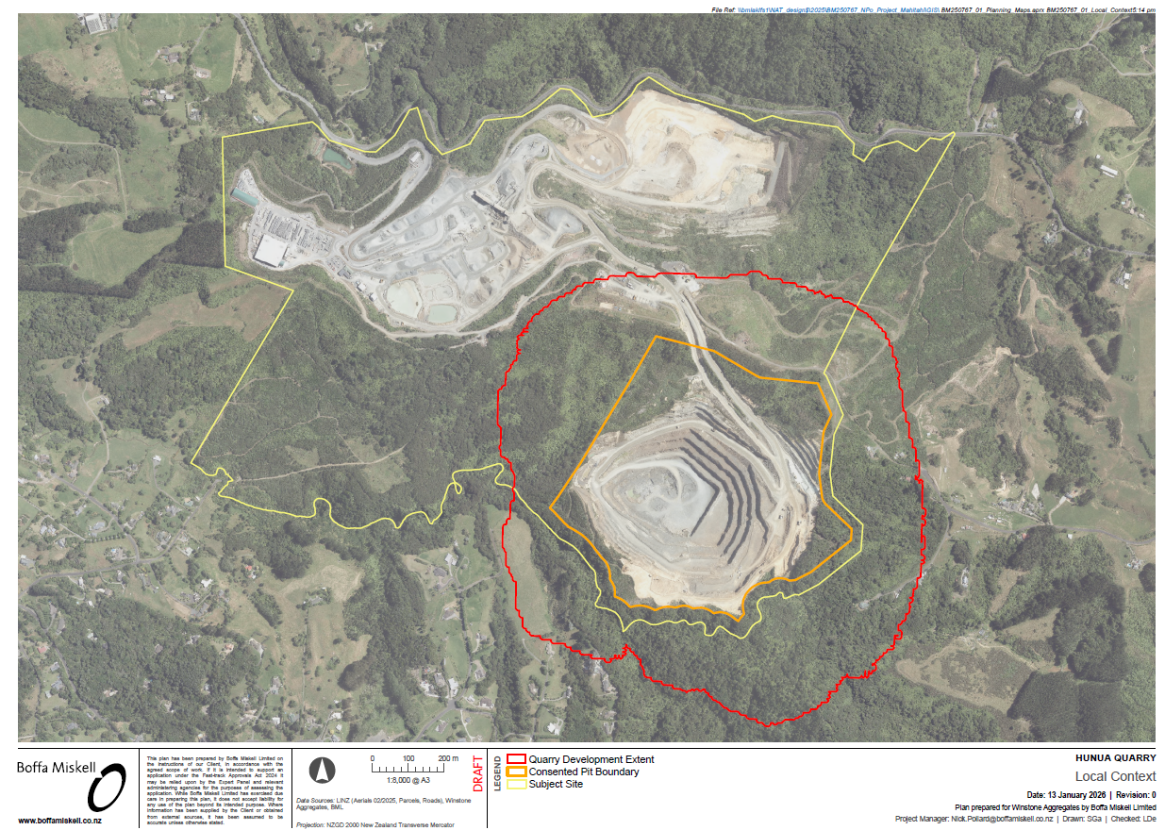

Figure 1: Site location and context.

Site history
Hunua Quarry has progressively expanded into the surrounding vegetation over its 100 year history. In 2007, elegant geckos (Naultinus elegans, previously Auckland green gecko) were detected in mature kanuka within the site. In 2011, a Lizard Relocation Plan (LRP) was prepared to guide lizard management within the site. A total of 152 elegant geckos were relocated between 2011 and 2025.

Vegetation cover and features
Within the quarry property, SEA_T_5323 is a mature example of the ‘taraire, tawa, podocarp forest’ (WF9) ecosystem described in Singers et al. (2017). This SEA wraps around the Symonds Hill pit on the western, southern and eastern boundaries (Figure 2). The WF9 vegetation type occurs throughout the Auckland Region, while some of the best examples occur in the Hunua Ranges where the steep topography was unsuitable for conversion to farmland. According to Singers et al. (2017), the WF9 forest ecosystem has a Regional IUCN threat status of “Endangered”. The forest type has been substantially reduced by clearance for agriculture and is vulnerable to browsing, notably by possums and goats. Auckland Council calculate the overall mapped area of SEA_T5323 as 615 ha.
Outside of SEA_T_5323, the Site includes an area that was revegetated in 2010 as a previous biodiversity offset for previously consented works. This area comprises 15 - 17-year-old plantings of kānuka and mixed broadleaved scrub across a series of gullies and low ridges.
Much of the understorey of the forested areas show evidence of grazing from possums and possibly ungulates, with broadleaf and podocarp seedlings clearly absent in some areas, and hardier ferns and unpalatable/divaricating shrub species dominating the otherwise-sparse undergrowth.

Assessment of the activity against the purpose (s7, cl 2(1)(c) of the FTAA)
The primary purpose of the Wildlife Act 1953 (“Wildlife Act”) is the protection of wild animals.
The activities subject to wildlife approval are consistent with the protective purpose of the Wildlife Act, as protection of lizards is achieved through:
- capturing and relocating lizards in habitat clearance areas prior to, during and after vegetation removal activities; and
- creation of a lizard release site with habitats designed to support lizards, and pest control to suppress predators.

Wildlife species, impacts and effects

Survey records(s7, cl 2(1)(d) of the FTAA)
As described above, a population of elegant gecko (Naultinus elegans) was discovered at the Hunua Quarry Stage 5 expansion footprint in 2007. Between 2011 and 2025, 152 geckos were salvaged. Initially, lizards were translocated to a release site within the wider quarry area in the south-east corner of Friedman Block paddock and an area to the north of the Hay Paddock. We understand that later translocations moved lizards to a release site on Tiritiri Matangi Island. Salvage data is provided in Appendix 2.
No native lizards were detected on the Site during the 2025-26 surveys, despite the presence of potential habitat (Figure 2). Lizard survey methods included:
- Arboreal Artificial Cover Objects (ACOs) were deployed at four locations in transects of 10. The transects were located in four forest types (Transect 1: mature kānuka, Transect 2: mixed kānuka and podocarp, Transect 3: broadleaf, and Transect 4: mature gulley species (pūriri, rimu and kānuka)). This survey was intended to target forest gecko, as elegant gecko do not occupy arboreal ACOs). Refuges were left in-situ for at least eight weeks to allow lizards to become habituated to the covers. These were checked on the 23/02/2026 during warm, sunny weather, no geckos were detected. Large numbers of Auckland tree weta (Hemideina thoracica) and cave weta (Pachyrhamma longipes), banded tunnelweb spider (Hexathele hochstetteri) and cockroaches inhabited the ACOs.
- Ground-based double layered ACO’s were deployed over five transects of 10 ACOs. Ground based ACOs were located in tree fern-dominated regenerating forest; mature kanuka with fern-dominated understory; taraire, tawa, podocarp forest; bracken and rank grass; and native early succession broadleaf / weedy scrub mix. This survey method was designed to detect copper and ornate skink. These were checked on 23 February 2026 during warm, sunny weather and no native lizards were detected. Two adult plague skink were observed but not captured.
- Manual searching methods were used to search for lizards under refugia (logs, artificial materials, sunny track sides) was carried out opportunistically across the Site. During warm sunny weather three adult and one juvenile skink were seen and not caught. Copper skink and plague skink look similar and share the same habitat. However, based on open sun-basking behaviour and rapid, direct escape manoeuvres paired with anatomical features (long, slim tail) they are likely plague skink. One non-native juvenile plague skink was caught on 23 February 2026.
- Nocturnal visual searches (spotlighting) were carried out over one night to supplement existing arboreal gecko records.
Further lizard surveys are proposed in March 2026.

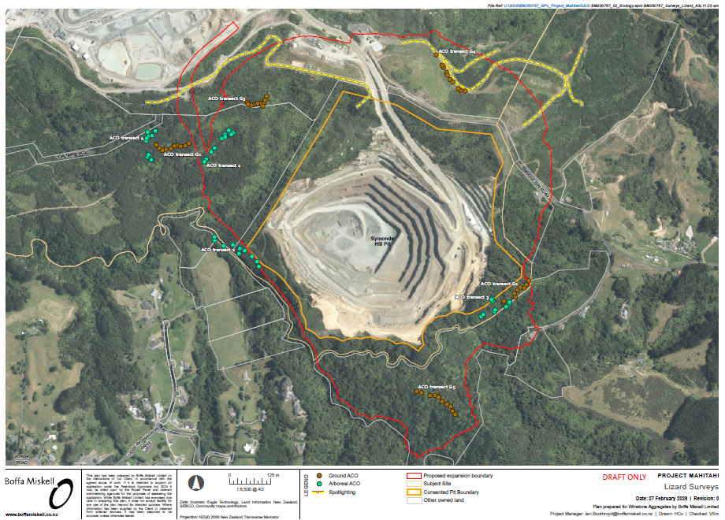
Figure 2: Lizard surveys 2025-2026.

BioWeb records
Lizards are cryptic and difficult to detect, particularly at low densities and in the presence of predators. The DOC Herpetofauna (BioWeb) Database provides useful additional information on taxa potentially present within a given search area to supplement survey data, while recognising that Bioweb records reflect observer expertise and the level of search effort in an area.
Information about native lizards present, or potentially present, at the Site are drawn from Bioweb and Auckland Council fauna records (within 20 km), and published species distribution information. From these records, the following herpetofauna community was established (Table 1, Figure 3).
- Elegant gecko (Naultinus elegans) are present within the Site
- Copper skink (Oligosoma aeneum), Ornate skink (O. ornatum) forest gecko (Mokopirirakau granulatus) and Pacific gecko (Dactylocnemis pacificus) may be present based on habitats and distribution records but have not been detected previously.
- Plague skinks (Lampropholis delicata) are known from the site but are classified as an unwanted organism. No management is proposed for plague skinks, and they are not discussed further.
None of the species identified in Table 1 are classified as ‘Threatened’ in the New Zealand Threat Classification System.

Table 1: Native herpetofauna records within 20 km of the Project Site and species' habitat preferences. Elegant gecko (pale blue row) are the only species confirmed from the site.
Species | Threat classification (Hitchmough et al., 2025, Melzer et al., 2022) | Habitat (Van Winkel et al., 2018) | Most recent record | Number of records
Elegant gecko (Naultinus elegans) | At Risk – Declining  Regionally Declining | Gumland, scrubland and forested habitats | 2021 | 5
Forest gecko (Mokopirirakau granulatus) | At Risk – Declining  Regionally Declining | Forests, scrubland and herbfields across a broad range of elevations. | 2018 | 3
Pacific gecko (Dactylocnemis pacificus) | Not Threatened  Regionally Declining | Coastal and lowland habitats including boulder beaches, scrubland, flaxland and forest. | >20 yrs | 1
Copper skink  (Oligosoma aeneum) | At Risk – Declining  Regionally Declining | Lowland habitats such as coastal vegetation, grassland, scrub and forest. Refuges include leaf litter, rocks, logs, flax and rank grass. | 2021 | 44
Ornate skink  (Oligosoma ornatum) | At Risk – Declining  Regionally Declining | Forests, scrublands and grassland habitats. | >20 yrs | 1

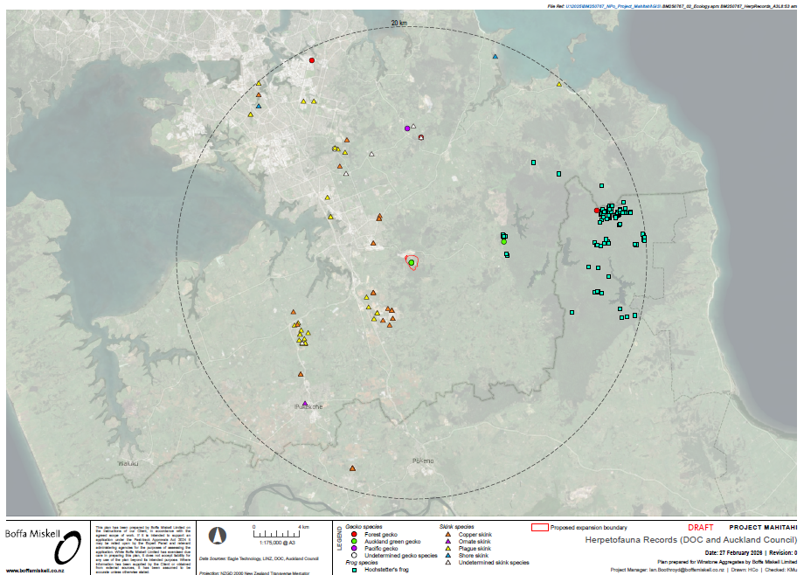
Figure 3: Herpetofauna records

Lizard habitats within the site
Gecko habitats within the Site include kānuka shrublands and forest throughout the Symonds Hill area with geckos being captured from tall kānuka trees at heights between 7 m and 10 m. This is despite the abundance of mature and sapling mānuka, and abundant other native species in the surrounding area. These vegetation types are very similar to those within the proposed quarry expansion and access road route. No other native lizard species have been detected within the site during gecko salvage activities, although other vegetation types and habitats are potentially suitable.
Photos of survey locations are provided in Appendix 3, and vegetation cover is mapped in Figure 2.

Numbers impacted and effects (s7, cl 2(1)(c) and (e) of the FTAA)

Description of proposed works
The Symonds Hill Pit development will occur in eight indicative stages over up to 66 years (Figure 3) to allow continuous production while progressively implementing environmental mitigation and rehabilitation. However, to enable operational flexibility and the need to respond to market conditions, the staging and programme may not be followed sequentially.
Each stage, along with an overview of the activities to be undertaken and whether these are part of the enabling works or ‘business as usual’ (i.e., extraction and processing) quarrying activity is listed in Table 2 and shown in Figure 4. The time required to achieve each stage is also set out, although this is approximate and no requirements or conditions are proposed to be based upon such timeframes. Earthwork volumes, vegetation clearance and offsetting requirements will be linked to the stages set out below.
Quarrying activities that will have actual or potential adverse ecological effects include forest clearance, explosions, truck movement, light / noise disturbance. Anticipated impacts associated with these activities include noise, dust, vibration.
Creation of new forest edge and consequent openness will mean the potential transmission of quarry works noise into forest interiors, potentially affecting fauna sensitive to noise disturbance. Similarly, dust generated by quarry operations is more likely to be deposited along exposed forest margins, where it can coat leaves and suppress sensitive understorey and epiphytic flora, reduce air quality, affect native frogs and lizards, and potentially increase sediment levels in streams.

Table 2: Stages of development of Symonds Hill Pit, Hunua Quarry Development.
Stage | Activity | Nature of the works | Approximate duration (years)
1 | Tributary realignment | Enabling works | 4
1 | Stripping campaign to the northwest - already consented, occurs concurrently with the tributary realignment. | Extraction and processing | 4
2 | Stream diversion completed | Enabling works | 1
2 | NW cut down to 105RL. | Extraction and processing | 1
2 | Construct the western haul road. | Enabling works | 1
3 | Incremental stripping (vegetation clearance) campaigns: south from current pit crest towards stream diversion down to 120RL | Extraction and processing | 1
4 | Incremental stripping (vegetation clearance) campaigns: southwest of the stream diversion and adjacent to the southern site boundary | Extraction and processing | 54
5 | Incremental stripping (vegetation clearance) campaigns: southern boundary towards the current pit | Extraction and processing | 54
6 | Incremental stripping (vegetation clearance) campaigns: in an anticlockwise direction, extending the pit to the south and northwest and deepening the pit | Extraction and processing | 54
7 | Realign the western haul road, so that it runs, for a short distance, along the southeast extent of the pit. This will enable the pit to extend to the northwest | Enabling works | 54
7 | Incremental stripping (vegetation clearance) campaigns: in an anticlockwise direction, extending the pit to the southwest and northwest and deepening the pit | Extraction and processing | 54
8 | Incremental stripping (vegetation clearance) campaigns: in an anticlockwise direction, extending the pit to the northwest and north | Extraction and processing | 54

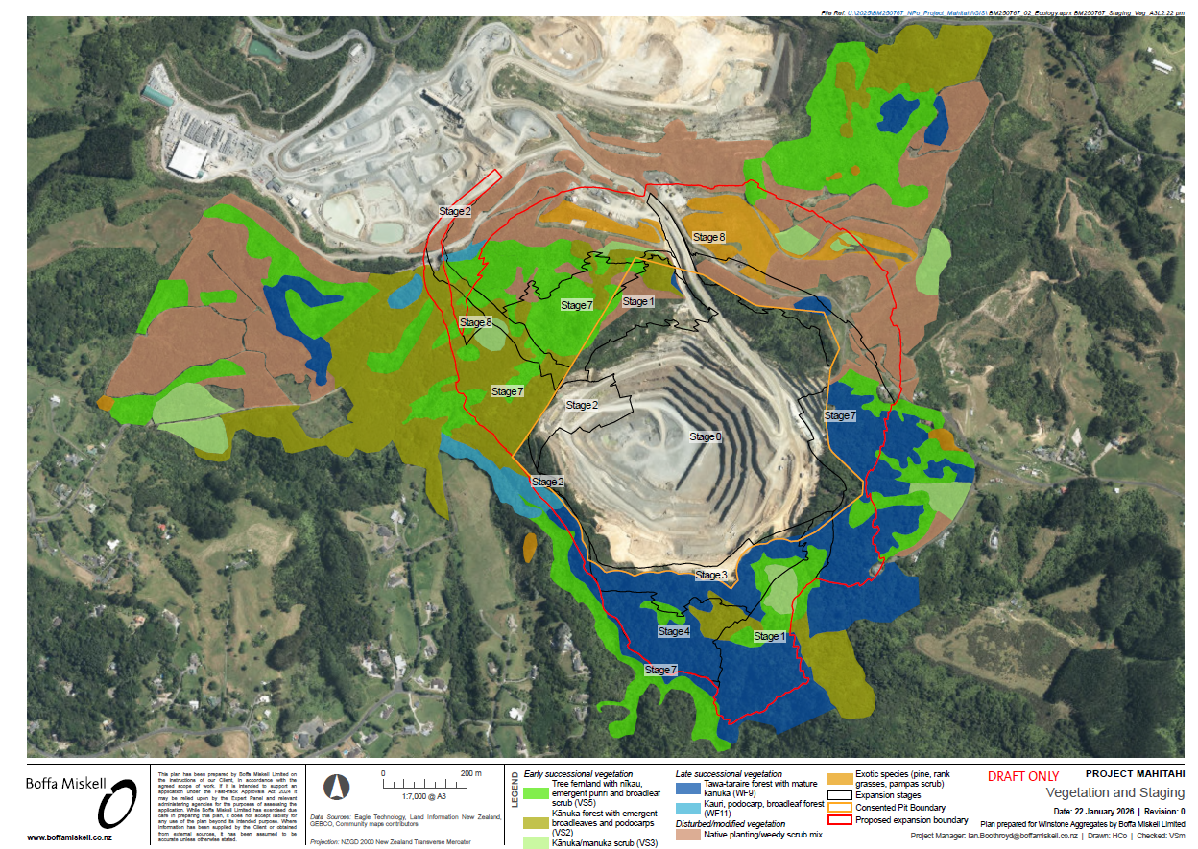
Figure 4: Vegetation cover and quarry staging.

Numbers impacted
Based on previous gecko salvage records, search efficiency ranged from 3.4 person hours / gecko to 44.5 person hours / gecko. In general, between 2011 and 2025 fewer geckos were salvaged in each salvage event and geckos took longer to find / capture. Whether this decline in catch reflects differences in habitat, search area or a true population decline is unknown (Table 3, Figure 5).
Table 3: Number of geckos salvaged in each salvage event between 2011-2025 (RMA Ecology)
Date | 2011 | 2014 | Feb-16 | Oct-16 | Nov-16 | Dec-16 | Feb-18 | Feb-19 | Feb-20 | Feb-22 | Feb-24 | Apr-25
Number of geckos | 45 | 66 | 12 | 5 | 10 | 4 | 2 | 5 | 1 | 0 | 0 | 2

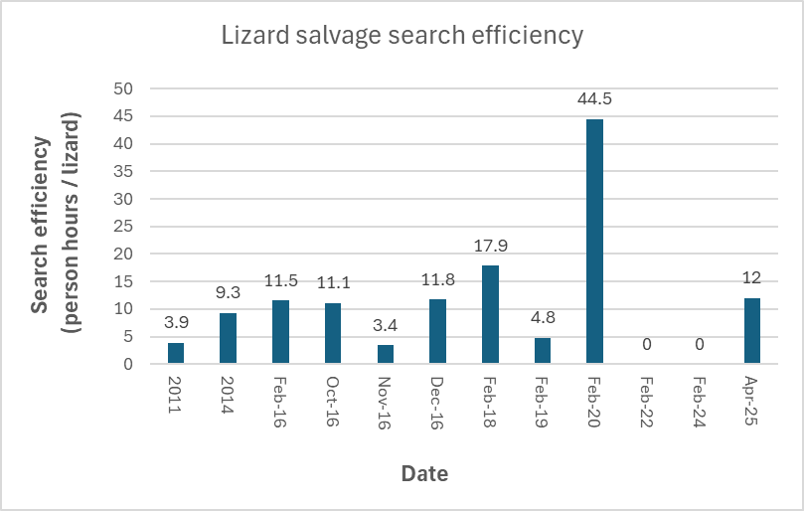
Figure 5: Lizard search efficiency for geckos salvaged between 2011-2025 (RMA Ecology). No geckos were detected in 2022 and 2024.

Nevertheless, over the life of the project (66 years), approximately 48.6 ha of vegetation will be cleared. This area includes 3 key habitat types for elegant geckos (based on previous salvage findings), comprising 25.35 ha (Table 4):
- Kānuka forest with emergent broadleaves & podocarps
- Tawa-taraire forest with mature kānuka
- Kānuka/manuka scrub
Other native vegetation types (Veg 1, 4, 6) may provide habitat for elegant geckos, or other (as yet undetected) lizard species, although this is considered unlikely.
We estimate that <75 geckos will be impacted by the proposed expansion. No other lizard species have been detected within the site and it is not possible to estimate how many, if any would be impacted.

Table 4: Extent of different vegetation types within the proposed expansion area. Key elegant gecko habitats are highlighted in blue (Veg 2, 3, 5). These areas will be subject to a high effort lizard salvage. Other potential lizard habitats are highlighted in grey (Veg 1, 4, 6) and will be subject to a lower lizard salvage effort.
Code | Vegetation type | Area (ha) | % of total
Veg 1 | Tree-fernland with nīkau, emergent pūriri and broadleaf scrub | 10.14 | 20.9
Veg 2 | Kānuka forest with emergent broadleaves & podocarps | 8.38 | 17.2
Veg 3 | Tawa-taraire forest with mature kānuka | 14.93 | 30.7
Veg 4 | Native planting/weedy scrub mix | 8.71 | 17.9
Veg 5 | Kānuka/manuka scrub | 2.04 | 4.2
Veg 6 | Kauri, podocarp, broadleaf forest | 0.26 | 0.53
Veg 7 | Exotic scrub | 4.15 | 8.54
Total |  | 48.61

Potential effects of the proposed activity if lizards are present (sch 7, clause 2(1) (e) and (j) of the FTAA)
Injury, death or disturbance during vegetation clearance
In the absence of mitigation and specific fauna management, forest clearance will result in the likely mortality of lizards and the loss / modification of habitat, particularly of the elegant gecko. Most of the vegetation loss is not the preferred habitat type of the elegant gecko, however,
8.38 ha of the preferred mature kānuka habitat will be cleared. A further 14.93 ha of tawa-taraire forest with mature kānuka, and 2.04 kānuka/manuka scrub will also be cleared. These three vegetation categories are classified here (conservatively) as “key elegant gecko habitats”. In total 44.46 ha of potential lizard habitat will be cleared (i.e., all vegetation except exotic scrub in Table 4.)
Habitat loss and fragmentation
Habitat fragmentation is unlikely to result from the pit expansion as vegetation will be cleared in stages without leaving isolated vegetation fragments. Based on the vegetation types in Table 4, 25.35 ha of key habitat for elegant geckos, and other lizards, will be removed. A further 19.11 ha of lower quality lizard habitat will be cleared.
Noise, dust and vibrations
Potential sub-lethal effects include ongoing disturbance from elevated noise, dust, light and vibration levels which can impact animal health and breeding success. The dust generated by quarry operations is more likely to be deposited along exposed forest margins, where it can coat leaves and suppress sensitive understorey and epiphytic flora, impacting the food and air quality for native lizards.
Exposure to predators
Progressive habitat clearance to expose a new forest edge may increase exposure to predators.

Summary of potential effects if lizards are present
The proposed management methods to address these impacts are summarised in Table 5 and described in detail in Section 6.0.
Table 5: Summary of effects management for lizards.
Effect | Management method
Habitat loss and fragmentation | Habitat loss is a certainty if lizards are present. Indigenous forest revegetation in a combined area of 52.5 ha is described in the AEE.
Injury, death and disturbance during construction | Lizard surveys and salvage will be undertaken in potential habitat areas (i.e. vegetation categories 1-6) prior to clearance. These surveys will be extended beyond these areas if suitable habitat has expanded and lizards may have dispersed into those areas.  Where lizards are detected, they will be captured and relocated to a prepared release site using standard salvage and relocation methods by a suitably qualified and experienced ecologist(s).
Noise, dust and vibrations | Noise, dust and vibration levels are managed through consent conditions and industry best practice. Whilst these conditions are usually targeted to reduce impacts on workers and neighbouring properties they do provide manage effects
Exposure to predators | Pest management is proposed across the site, comprising new and existing pest management areas. Pest management is detailed in the Hunua Quarry Pest Management Plan.
Stress and disease transmission | Lizards will be placed in individual containers and kept in a cool place until released. Handling will be minimised to ensure they do not become stressed. All traps will be checked daily in the morning.  Lizard handling will follow best practice and hygiene protocols to minimise the risk of disease transmission. Details on storing and handling procedures are provided in the Section 6.4.2.4 of this report.
Lizard release site: pest control and research (positive) | Intensive mouse control is proposed at the release site, as described in Section 6.4.3 of this report. We also identify research opportunities for drone surveys of geckos in the release site.

Methods (s7, cl 2(1)(g) and (k) of the FTAA)

Overview s7, cl 2(1)(f) of the FTAA)
As described below, lizard management will follow best practise standards provided in Department of Conservation guidance documents. These include methods to survey and capture lizards (DOC 2012) and follow the ’Principles for Lizard Salvage Translocations’ (DOC 2019) and ‘Guidance for lizard habitat clearance’ (DOC 2023).
It is not possible for mining operations to avoid all potential lizard habitat. The rationale for lizard salvage as a management tool is provided in Section 6.3.1. This addresses Principle 3 of the 9 Principles of Lizard Salvage, “alternatives to moving lizards must be considered”.

Approach
The lizard management for this project is based on the lizard habitat assessment described in Section 5.3, which determined the a large proportion of the area is suitable for lizards, and that habitat clearance in these areas will be staged over a long time period. The management approach prior to any clearance is to:
- Delineate habitat clearance areas.
- Survey / salvage likely habitat for lizards prior to clearance.
- Carefully fell vegetation and repeatedly check felled vegetation for geckos over a three week period.
- Mulch felled material following all checks.

Avoid
If native lizards are present within the Site, it is not possible to avoid impacts on them as the project proposal requires that all the vegetation within the Site is removed. Previous lizard salvages at the Site have successfully captured lizards, although details of the persistence of those salvaged individuals are unavailable. For this reason, lizard salvage is the proposed management method, and a new release site is proposed.

Minimise

Dust management
Dust management within the Site is guided by the Air Quality performance standards and the discharge to air consent. Management actions to reduce dust dispersal within the Site (and to prevent settling on adjacent vegetation) include:
- Covering dust sources: e.g. clad the fixed processing plant in areas where dust generation could become a nuisance; potential dust generating conveyors are covered where practicable to contain dust.
- Water sprays: e.g. fitting exposed transfer points with fixed water sprays to suppress dust emissions wherever practicable. Large volumes of water are maintained on site and are available for dust suppression purposes and a water tanker is to be used on working areas during windy / dry conditions.
- Reduce exposure: i.e., areas of exposed material with dust generating potential (e.g. clay banks) are kept to a practicable minimum, revegetating areas that will not be further disturbed as soon as possible.
- Minimise dusty activities during adverse conditions: e.g. blasting will be restricted if windy conditions are likely to carry visible dust emissions beyond the quarry boundary where they could create a nuisance.
- Minimising dust emissions: e.g. by sequential firing during blasting and using minimum force; efficient extraction of dust on drilling equipment.

Lizard survey and salvage
Any lizard survey and salvage will occur in suitable weather conditions between October to April and will be undertaken in fine weather conditions between 12 - 25○C.

Pre salvage survey
Pre-salvage surveys will be undertaken within 6 months of any vegetation clearance operation. Survey intensity will reflect the quality of the habitat to be cleared, acknowledging that over the life of the consent and the duration of the proposed extraction, vegetation communities will change. Nonetheless, for the duration of the Wildlife Approval (10 years) vegetation communities will follow the categories in Table 4. This approach will be reviewed before the 10-year period has elapsed, and the success / failure of this approach assessed.
For high quality lizard habitat (Vegetation categories 2, 3 and 5), a minimum of:
- Trapping / manual searches / tracking tunnels / artificial retreats over 5 days
- Spotlight surveys over 2 nights
For lower quality lizard habitat (Vegetation categories 1, 4 and 6), a minimum of:
- Trapping / manual searches / tracking tunnels / artificial retreats over 2 days
- Spotlight surveys over 1 night
Trapping intensity in potential habitats will begin with approximately 10 m spacings of trapping tools in likely habitats, micro-sited around habitat features to maximise detection. Tracking tunnels will also be deployed at approximate 10 m spacings to detect lizard presence over this period. The initial trapping period will be a for 5 trap days in suitable weather as determined by the Project Herpetologist.
If lizards are detected at any time, salvage activities will begin immediately and trapping intensity will increase to 5 m spacing of trap tools in an approximate grid layout. The trapping period will extend for a maximum of 10 trap days, (including the 5 day survey period). The habitat area will be fenced with lizard-proof fencing to prevent lizards dispersing into the area from surrounding habitats.
If no lizards are detected after 5 days, trapping will cease in that area. Post-felling management may still be required, dependent on vegetation composition (i.e. presence of mature kānuka).
All lizards captured will be taken to the release site, or into quarantine within 8 hours (Section 6.4.2.3).

Methods of lizard capture / salvage
Lizard survey and salvage tools are consistent with the DOC Biodiversity Inventory and Monitoring Toolbox (DOC 2012). Methods include:
Live trapping using pitfall or mesh funnel traps:
Transects and/or grids of traps will be installed throughout each area that will be subject to vegetation clearance. Pitfall traps will be installed in combination with ARs, at roughly 10m intervals in close proximity to habitat features to ensure that a trap is located within the home range of as many terrestrial lizards in the area as possible.
Pitfall traps consist of a four-litre bucket that is dug into the ground so that the lip of the bucket sits flush with the soil surface (or slightly below). Buckets have small puncture holes at the base to allow water to drain through (ensuring lizards won’t drown in case of heavy rain). A single layer of Onduline AR will be used to cover each pitfall trap and will be anchored down using pegs or weighed down using a rock or log. Traps will contain a damp sponge or moss, and pear or banana bait as well as leaves / grass for cover.
Mesh funnel traps will be filled with grass (to provide cover for trapped lizards), a piece of damp sponge or moss and pear or banana bait. Traps will be placed in shaded areas or covered in vegetation to prevent lizards overheating.
All traps and ARs will be installed at least 6 weeks in advance of trapping, although traps will be non-operational. All traps will be inspected within 24 hours from the last check in suitable weather.
Artificial retreats (ARs): A network of ARs will be deployed on the ground throughout edge vegetation and habitats that are to be cleared. ARs will be deployed as double-layered stacks and targeted to vegetation and micro-sites that represent potential terrestrial lizard habitat such as pampas / flax tussocks and wood debris. This tool requires a six-week lead in time for lizards to habituate to the novel items and begin utilising them as refuge. Following six weeks in-situ, ARs will be inspected daily. If possible, inspections will be made in the mornings before 9 am or late afternoons after 3 pm (or later), to maximise the likelihood of lizards being present.
Manual and visual searches:
Hand-searching will be undertaken throughout potential habitats during the survey period. This involves lifting and inspecting beneath any potential object of lizard refuge (e.g. logs, woody debris and sifting through leaf litter where present).
Mechanical habitat removal
If lizards continue to be trapped on the 10th day of trapping, mechanical methods will be employed to capture any remaining lizards. This includes using a digger with a claw attachment to ‘scrape back’ grassy habitats and deconstruct pampas tussocks.
Post-felling manual searches of felled vegetation:
Felled trees will be heaped into small piles a minimum distance from where they were felled. These piles will be searched for geckos over twice per week over a period of three weeks during daylight hours and after sunset. Searches will be in weather conditions suitable to lizard emergence (i.e., >12 ○C, light winds, clear / fine). Piles can be mulched / removed after 3 consecutive searches with no lizards detected. The Project Herpetologist or a suitable qualified Ecologist must be present when the pile is moved or mulched to capture disturbed lizards.

Lizard transport and release
Lizards will be held individually in cloth bags in a secure, vented container out of the sun. Lizards will be transported to the release site or captive holding facility and will not be held for more than 8 hours.
Lizards will be released into prepared habitats (e.g. dense grassland and woody refuge piles) in the release site.

Risks and animal ethics considerations
Potential risks associated with the proposed management plan:
- Overheating: lizards will be placed in individual containers and kept in a cool place until released. Handling will be minimised to ensure they do not become stressed. All traps will be checked daily in the morning. Pitfall site selection, trap placement and equipment will follow the guidance of Turner et. al. (2024) to prevent elevated temperatures within the pitfall traps.
- Overcrowding/competition: overcrowding or competition at the release site is considered a low risk given the size of the wider site (i.e. Hunua Ranges Regional Park). A lizard survey will be carried out at the release site prior to any lizard salvage and additional habitat features will be added.
- Displacement: A lizard-proof fence will prevent rehoming into the works area in areas where lizards are detected in adjacent habitat.
- Injury/death: lizards will be captured by a suitably trained herpetologist or individual. The LMP requires best practice and hygiene protocols to minimise the risk of injury, mortality or disease transmission.
Potential risks mentioned here will be minimised using an experienced herpetologist and suitably experienced field staff under the supervision of the herpetologist.

Lizard release sites

Location and rationale
Elegant geckos
The Applicant is in discussion with DOC to release up to 75 elegant geckos on Tiritiri Matangi Island. This site was suggested by DOC as the island is thought to have a robust elegant gecko population, established from former translocated individuals. Geckos translocated as part of this project would supplement the resident lizard population and introduce a broader genetic diversity. Elegant geckos now resident on Tiritiri Matangi Island were sourced from Hunua Quarry translocations dating from approximately 2016.
Geckos would be ‘hard released’ (i.e., released without enclosures), following disease screening and short-term captive holding (to ensure lizards are released as a group). Department of Conservation Operations Managers would assist the Project Herpetologists to manage the release of lizards to the island.
A formal baseline lizard survey, prior to lizard release; and then ongoing lizard monitoring will be required to assess translocation outcomes.
Based on previous salvage results (Section 5.4.2), It is unlikely that more than 75 elegant geckos will be salvaged from the Project Site. Suitability of the release site is addressed in Table 6.

Table 6: Assessment of the proposed elegant gecko release site based on Principle 6 of the Lizard Salvage Guidelines (DOC 2019).
Principle relating to salvage and release | Description | Detail/Activity
1. The site must be ecologically appropriate and have long-term security | Resident lizard communities must be understood | Lizard populations within Tiritiri Matangi Island are well known, although population sizes are not. A survey for elegant gecko will be undertaken prior to release.
 | The release site must be an appropriate distance from the impact site | Tiritiri Matangi Island is within the Auckland region.
 | The location must be within the species natural geographic range. | The site is within the natural range of the species.
2. The habitat at the site must be suitable for the salvaged species | Vegetation composition and size: | Vegetation on Tiritiri Matangi Island comprises a mix of native vegetation communities including coastal forest; (pōhutukawa, kohekohe, puriri) and planted vegetation including kānuka scrub/forest.
 | Habitat enhancement | No habitat enhancement is proposed at this stage
 | Edge effects | Most of the island is vegetated and edge effects are not a concern. Geckos will be released into suitable vegetation, near resident geckos.
3. The site must provide protection from predators | Habitat must protect from predators, or effective pest control must be in place. Must include full suite of predators including trapping for mice | The island is predator free.
4. The site must be protected from future disturbance | Land tenure must ensure long term protection from disturbance | The island is managed by DOC and protected from future disturbance / development

Other lizard species
The applicant is in the final stages of discussion with the Auckland Council Parks team regarding project opportunities that include lizard release to a suitable release site in Hūnua Regional Park. Following a site visit to assess potential release areas around the proposed offset vegetation management (weed control and revegetation) areas, several potential sites were identified. Due to the staged nature of the vegetation clearance associated with the project, several release sites may be required. These sites had the following attributes:
- Located in the southern part of the Regional Park (which has less recreational activity / fewer visitors).
- Located in sites where visibility to the public could be reduced.
- Adjacent to kānuka scrub/forest or mānuka dominated scrub.
- Northern orientation with sunny edges for basking. These sites have a clear edge to improve detection probability as well as adjoining areas where weed (e.g. blackberry) control and revegetation is proposed, to expand the effective habitat area.
- Connected to large areas of native vegetation.
- Baseline pest control (3 yearly 1080 aerial drops) with potential for localised mouse control and pest monitoring.
Further release site details are provided below and in Table 6.
- Elegant geckos (surplus to the maximum of 75 to be released to Tiritiri Matangi Island) will be released into a soft-release pen in an area with intensive local mouse control. Ongoing success monitoring (once the soft pen is removed) will incorporate both standard spotlighting methods, and novel / developing drone survey methods. We consider that the intensive mouse control in and around the release site would provide increased protection for geckos. The addition of drone surveys to detect lizards in complex forest habitat provides useful research data.
- Forest geckos (if present) will be released into arboreal ARs in the same intensive local mouse control area.
- Skinks will be released into the pen with abundant ARs and wood debris in the mouse control area.
The details of soft release pens, quarantine, mouse control and the exact location of a release site will be confirmed prior to any works commencing. The first stage of clearance is proposed for 2028.

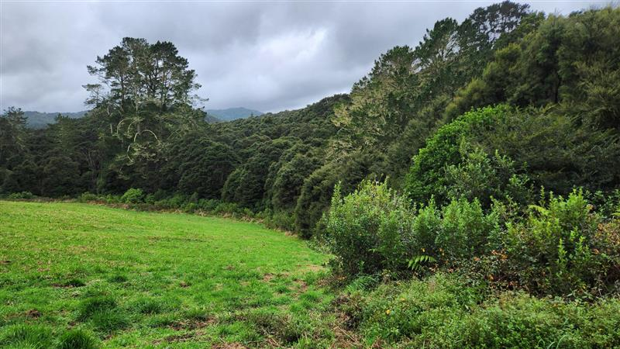
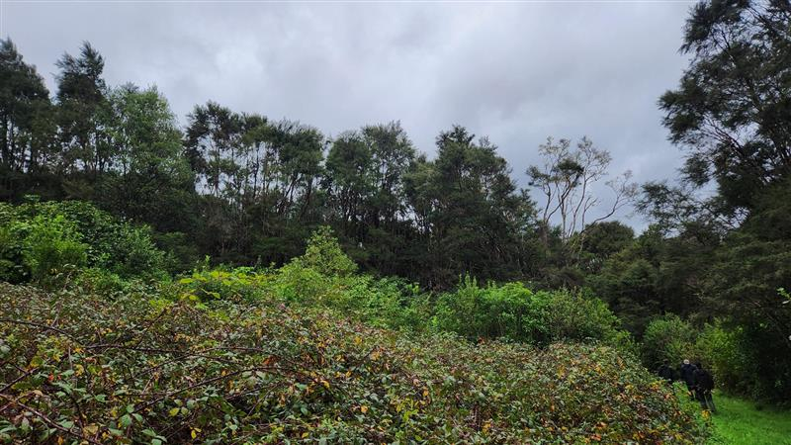
Figure 6: Example proposed lizard release areas with kanuka / manuka vegetation cover. These areas adjoin proposed offset vegetation management (weed control and revegetation) areas.

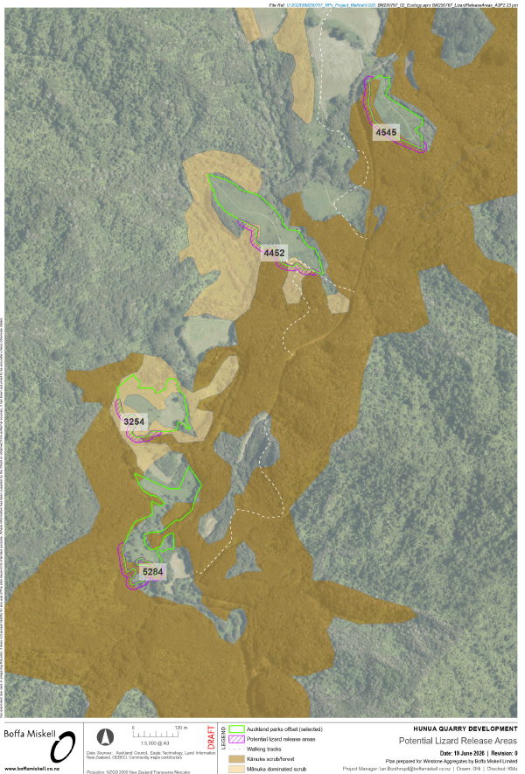
Figure 7: Potential lizard release areas Hunua Regional Park
Table 7: Assessment of the proposed lizard release site based on Principle 6 of the Lizard Salvage Guidelines (DOC 2019).
Principle relating to salvage and release | Description | Detail/Activity
1. The site must be ecologically appropriate and have long-term security | Resident lizard communities must be understood | Skinks and geckos are present within Hūnua Regional Park, but densities and population sizes are unknown. A survey will be undertaken before the release location is confirmed.
 | The release site must be an appropriate distance from the impact site | Hūnua Regional Park is approximately 15km from the impact site.
 | The location must be within the species natural geographic range. | The site is within the natural range of the species.
2. The habitat at the site must be suitable for the salvaged species | Vegetation composition and size: | Vegetation within the release site comprises kānuka scrub/forest. The park is more than 14,000 ha in size.
 | Habitat enhancement | Wood debris piles and replanting in immediately adjacent habitat is proposed.
 | Edge effects | Edge effects are not considered to be a significant issue in this part of the park due to the terrain (in a lower elevation area) and the extensive forest cover.
3. The site must provide protection from predators | Habitat must protect from predators, or effective pest control must be in place. Must include full suite of predators including trapping for mice | Predator control is already in place across the park, but localised mouse control is proposed around the release area.
4. The site must be protected from future disturbance | Land tenure must ensure long term protection from disturbance | The release site is within a Regional Park, permanently protected from disturbance / development.

Predator control at release site (Hūnua Regional Park Site only)

Local mouse control, using toxins and / or traps is proposed in an area of 5 ha in the vicinity of the release site. Further engagement with Auckland Council Parks / Environmental Services teams is required to ensure this proposal aligns with long term goals for the Park.

Contingency actions
Lizards can inhabit unlikely locations and sometimes be found in surprising abundance. Therefore, Table 8 identifies potential issues that could arise and contingency actions to address them.

Table 8: Proposed contingency actions.
Situation | Description | Contingency Action(s)
Higher number of lizards captured than expected | During the salvage, a higher number of lizards are being captured than expected or numbers of lizards in traps are not decreasing. | If the number of lizards captured by the 10th trapping day isn’t declining, destructive searches and mechanical habitat removal is proposed to remove any remaining habitat onsite so lizards are unlikely to disperse back into the site.
Lizard monitoring does not detect translocated individuals | Elegant geckos can be individually identified by their patterning. It is possible to follow individuals through their life if they can be detected. If geckos cannot be detected in the release area during post-release monitoring, contingency actions will apply. | In the first instance, monitoring surveys will intensify in order to try and detect geckos in the release area.

Incidental discovery protocol
The following incidental discovery protocol (IDP) has been described for the scenario in which a lizard is discovered during works, following implementation of the lizard salvage. Plague skinks are present within the Site and all contractors will be trained to identify plague skinks during their environmental induction.
If a lizard is discovered:
- All activities in a 10 m radius around where the lizard was observed must cease immediately and searches for any other lizards must be carried out. If the lizard came from a habitat feature (e.g. log pile) this should be fenced off with lizard-proof silt fencing until it can be thoroughly searched by a suitably experienced person.
- The Project Herpetologist must be notified within 2 hours of the sighting.
- If the lizard is sighted, provide details such as:
  - Colouration and patterning.
  - Shape and size (e.g. robust or slender, approximate length).
  - Location it was found in.
- Where possible, the lizard should be captured and placed into a breathable container with some vegetation inside to provide cover. The container must be placed out of the sun and kept cool. The following should also be recorded:
  - Date and time of capture.
  - Location.
  - Weather during capture.
  - Presumed species.
  - Photographs of the animal and capture location.
- The lizard shall be kept until the Project Herpetologist is able to attend and identify the species and assess the health of the lizard. If the lizard is healthy, it should be released into the created lizard release site, or at another suitable location at the discretion of the Project Herpetologist and DOC.
- If a deceased lizard is found, it should be photographed, and the Project Herpetologist must be contacted. The Project Herpetologist will then consult with DOC on how to proceed.
- If an injured lizard is found, the Project Herpetologist must be contacted immediately for advice on how to proceed. A veterinarian may need to be contacted for advice. DOC will also be notified of the finding.

Adaptive Management
Minor adaptations to the current methods proposed in this LMP may be made at the discretion of the Project Herpetologist. This will enable the appropriate management of lizard populations that are encountered during the lizard salvage within the site, habitat quality and type of species encountered.
Minor adaptations to the implementation of the LMP will only apply to lizard salvage effort and extent, and only where changes will increase the likelihood of capturing lizards. Specifically:
- Changes to effort can only increase the level of effort (i.e., increased trap density, increased number of checks, additional trap / salvage methods)
- Changes to extent can only respond to the extent and types of habitats available at the time of salvage (i.e., mapped grassland becomes shrubland and different methods are required, a slip on the quarry face removes habitat). Any changes to extent will be <10% of total clearance area per stage.
Any changes implemented under the Adaptive Management criteria will be notified within 24 hours and will be included in permit reporting.
For any changes required outside of these criteria, the Project herpetologist will seek advice from the Auckland Regional Operations Manager (auckland@doc.govt.nz) in the first instance.

Post release monitoring and reporting

Reporting
Lizard salvage outcomes will be reported by the Project Herpetologist to DOC (per requirements of the Wildlife Approval). Reports will be provided by 30 June of the year the activity took place. Reports will include how the Lizard Management Plan was implemented including any difficulties encountered with capture and handling, and what contingency actions were required. This report will also include:
- Species and number of animals released;
- Detailed maps of the capture and release location; and
- A description of the habitat quality and extent, survey effort and lizard survey results.
ARDS cards will be submitted to DOC by the Project Herpetologist within 1 month following the end of the salvage.

Post-release monitoring
Post-release monitoring will be triggered if any elegant geckos are translocated, or more than 10 of any other lizard species are translocated. The condition and suitability of the soft release pen will be assessed quarterly.
Monitoring will include annual repeat surveys using methods described in Section 6.4.2.2, including live traps, artificial retreats and visual searches (but will not include destructive searches). Monitoring will have the objective of assessing population persistence and breeding (i.e. gravid females, or juveniles present in the population) for up to 3 years following release.
If translocated geckos are not detected for two consecutive monitoring rounds, surveys will be carried out twice per year (in October and February) with double the search effort for a further two years. If translocated geckos are still not detected, the translocation will be assumed to have failed, and a penalty fee will apply.

Wildlife Act offences (s7, cl 2(1)(l) of the FTAA)
The Substantive Application Report confirms at that there is no criminal history or involvement in any pending criminal proceedings of the applicant, company director, trustee, partner and anyone else involved with the application, in respect of offences under the Wildlife Act.

Consultation (s7, cl 2(1)(n) of the FTAA)
Winstone has undertaken consultation with mana whenua and the Department of Conservation for this Application, and specifically regarding management of lizards at the Project Site. Details are provided in the substantive application.

Additional supporting documentation (s7, cl 2(1)(o) of the FTAA)
This assessment was informed by the documents referenced throughout and listed in the references (Section 11).

References
Boffa Miskell, 2026a. Hunua Quarry: Assessment of Ecological Effects (AEE). Prepared for Winstone Aggregates.
Boffa Miskell, 2026b. Hunua Quarry: Pest Management Plan (PMP). Prepared for Winstone Aggregates.
Department of Conservation. 2012. Biodiversity and monitoring toolbox: Herpetofauna (multiple). Department of Conservation, Wellington, New Zealand
Department of Conservation. 2019. Guidelines and model for producing management plans for New Zealand lizards. Prepared by the Department of Conservation Lizard Technical Advisory Group.
Department of Conservation. 2019. Key principles for lizard salvage and transfer in New Zealand. Prepared by the Department of Conservation Lizard Technical Advisory Group.
Department of Conservation. 2023. Reducing the impacts of development on New Zealand lizards Guidance for developers, consenting authorities and ecologists/herpetologists. Prepared by the Department of Conservation Lizard Technical Advisory Group.
Hitchmough R, Barr B, Knox C, Lettink M, Monks JM, Patterson GB, Reardon JT, van Winkel D, Makan T, Michel P. 2026. Conservation status of reptiles in Aotearoa New Zealand, 2025. Wellington: Department of Conservation. New Zealand Threat Classification Series 50.
Melzer, S., R. Hitchmough, D. van Winkel, C. Wedding, S. Chapman, M. Rixon (2022). Conservation status of reptile species in Tāmaki Makaurau / Auckland. Auckland Council technical report, TR2022/3
RMA Ecology 2018. Symonds Hill pit development: salvage of geckos. Letter dated 23 February 2018.
RMA Ecology 2025. Symonds Hill pit development: salvage of geckos. Letter dated 14 May 2025.

Appendix 1: Wildlife Approval checklist

Appendix 2: Elegant gecko salvage records and Site history

During ecological surveys associated with the Assessment of Environmental Effects conducted by Bioresearches Ltd (2007), a population of Auckland green gecko (Naultinus elegans elegans), now known as the elegant gecko, was discovered in the then proposed Stage 5 quarry footprint. The elegant gecko is classified as At Risk-Declining (Hitchmough et al 2026) and all lizards and geckos are absolutely protected by the Wildlife Act 1953. Elegant gecko occurs within kānuka shrublands and forest throughout the Symonds Hill area, within vegetation types very similar to those within the proposed quarry expansion and access road route. Accordingly, these geckos are almost certain to be in areas of kānuka vegetation within the proposed works footprint. As detailed above, kānuka dominated, and vegetation with some kānuka makes up approximately 52 % of the vegetation cover proposed for removal.
Resource consents 34132 and LU 8730 issued for the development of the Symonds Hill Extraction Area required that a Lizard Relocation Plan be developed and implemented. The methods for salvage, capture and relocation are described in a Lizard Relocation Plan (LRP) and which is used as a guide for lizard salvage from the pit development footprint.
The results of salvage and relocation of elegant geckos at Symonds Hill are provided in Table 5.
For the 2018 salvage operations, RMA Ecology (2018) report that all geckos were caught from tall kānuka trees with geckos at heights between 7 m and 10 m. This is despite the abundance of mature and sapling mānuka, and abundant other native species within patches or nearby. No other geckos or skinks were observed or captured within the proposed clearance areas. In their conclusion to the 2025 salvage operations report, RMA Ecology (2025) stated that the two elegant geckos were both found within mature kānuka forest, confirming this habitat type as the highest quality within the current vegetation clearance footprint.
Table 5: Summary statistics of elegant geckos salvaged from Symonds Hill, 2011 to 2025 (from RMA Ecology 2018 and 2025).
Year | Gender¹ |  | Reproductive status |  |  | Person search hours | Search efficiency²
Year | Male | Female | Juvenile | Sub-adult / Adult | Gravid | Person search hours | Search efficiency²
2011 | 15 | 19 | 11 | 16 | 11 | 142 | 3.9
2014 | 24 | 25 | 17 | 24 | 8 | 484 | 9.3
Feb 2016 | 6 | 6 | 0 | 7 | 5 | 137.5 | 11.5
Oct 2016 | 0 | 5 | 0 | 4 | 1 | 55.5 | 11.1
Nov 2016 | 1 | 6 | 3 | 0 | 7 | 37 | 3.4
Dec 2016 | 3 | 1 | 0 | 0 | 0 | 47 | 11.8
Feb 2018 | 0 | 2 | 0 | 0 | 1 | 35.8 | 17.9
Feb 2019 | 3 | 2 | 0 | 4 | 1 | 24 | 4.8
Feb 2020 | 1 | 0 | 0 | 1 | 0 | 44.5 | 44.5
Feb 2022 | 0 | 0 | 0 | 0 | 0 | 15.25 | N/A
Feb 2024 | 0 | 0 | 0 | 0 | 0 | 12 | N/A
Apr 2025 | 2 | 0 | 0 | 2 | 0 | 24 | 12
¹ Gender was not able to be determined for three geckos during salvaging in 2014 and four geckos in 2011. ² Person hours search for each gecko.

Appendix 3: Lizard survey habitats 2025-2026

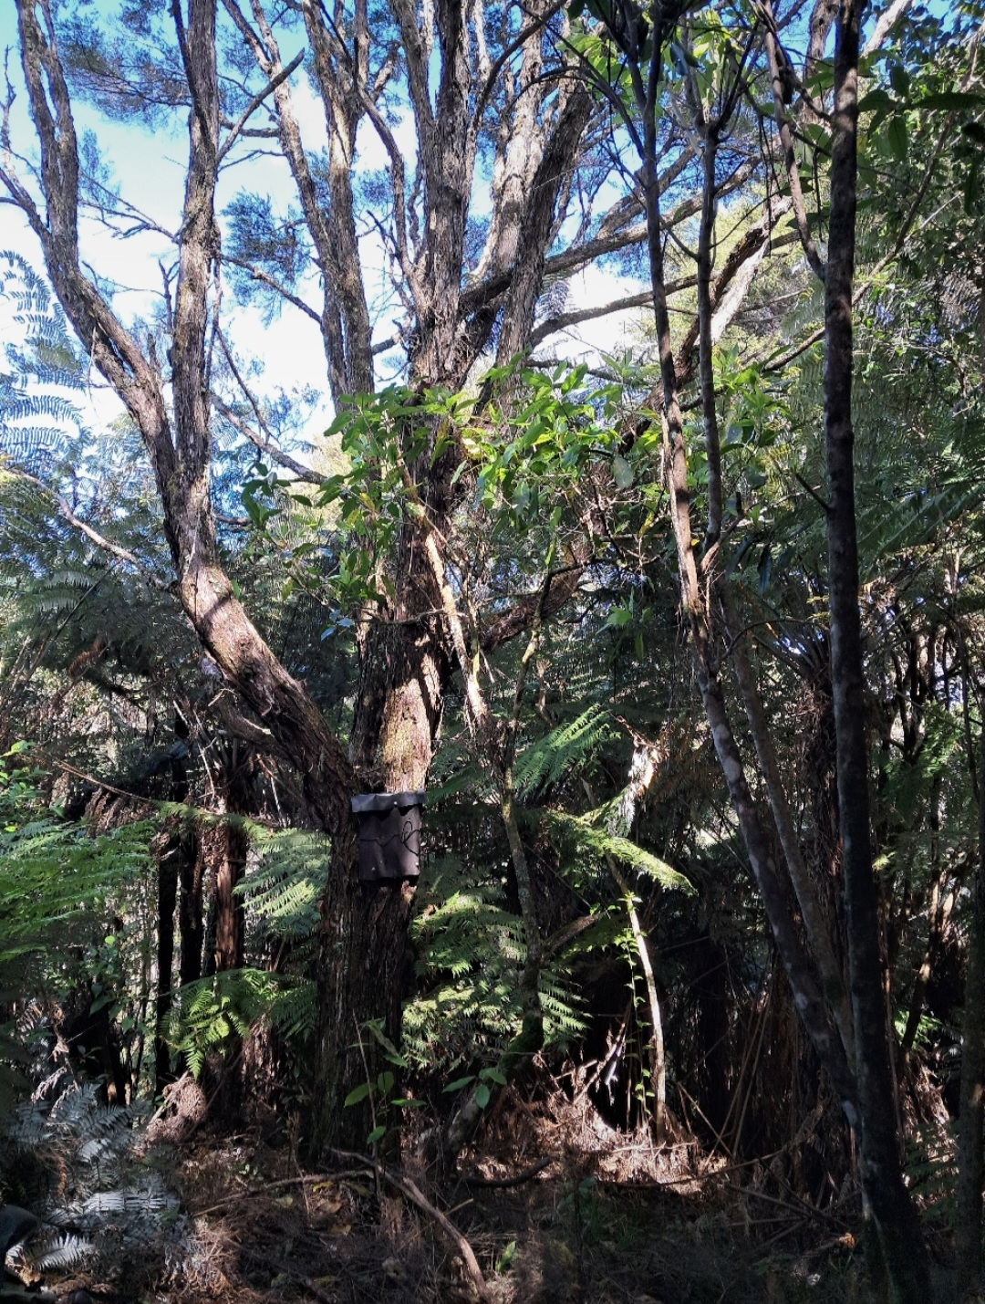 | 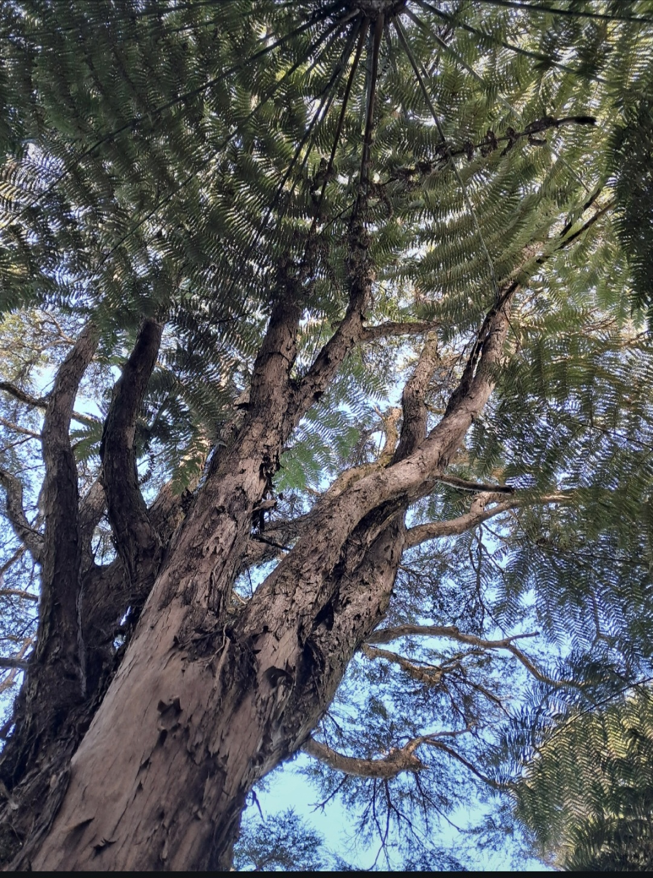 | 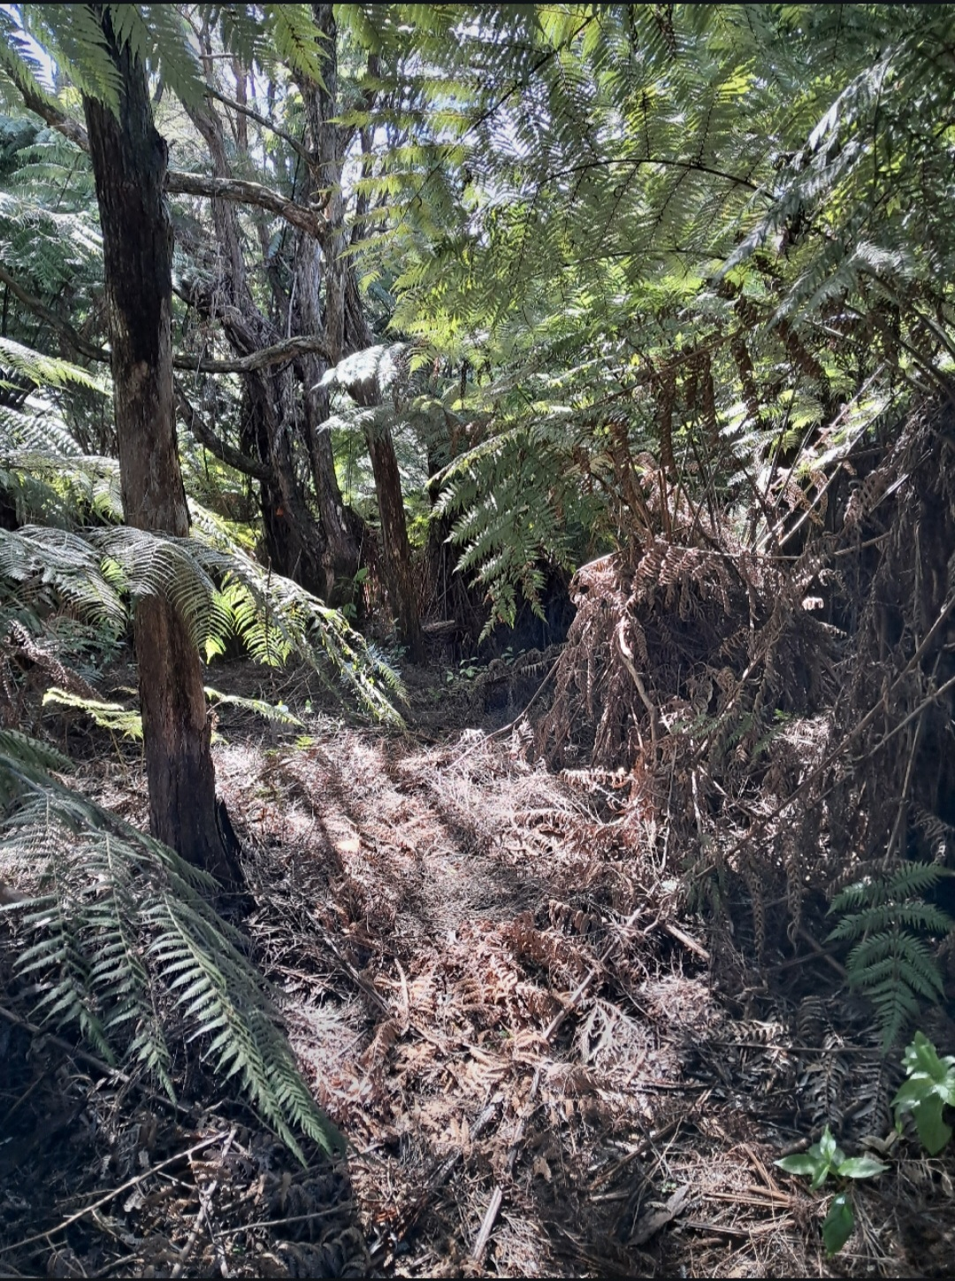
Transect 1: Mature Kanuka with silverfern understory. Some hangehange, gahnia and sapling scrub growing in canopy gaps between mature canopy trees.
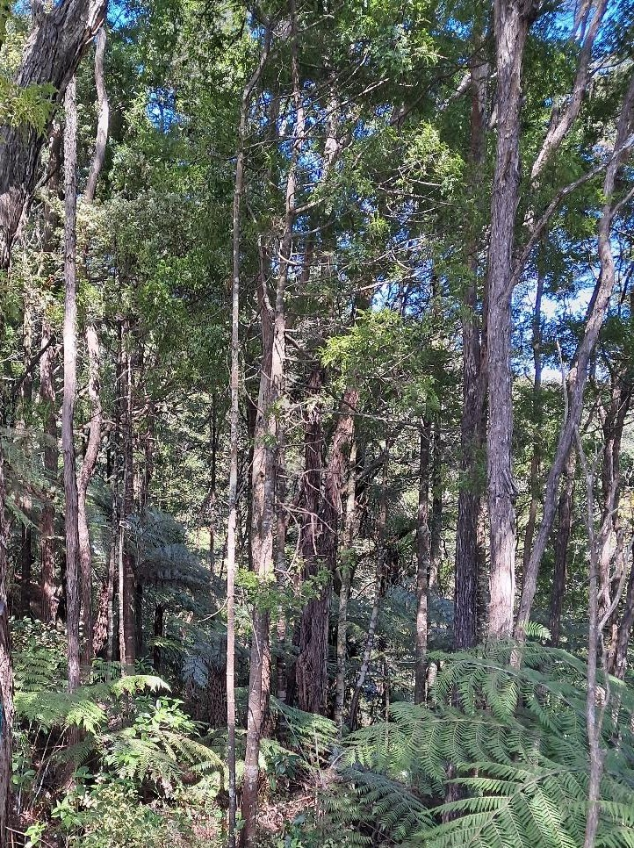 | 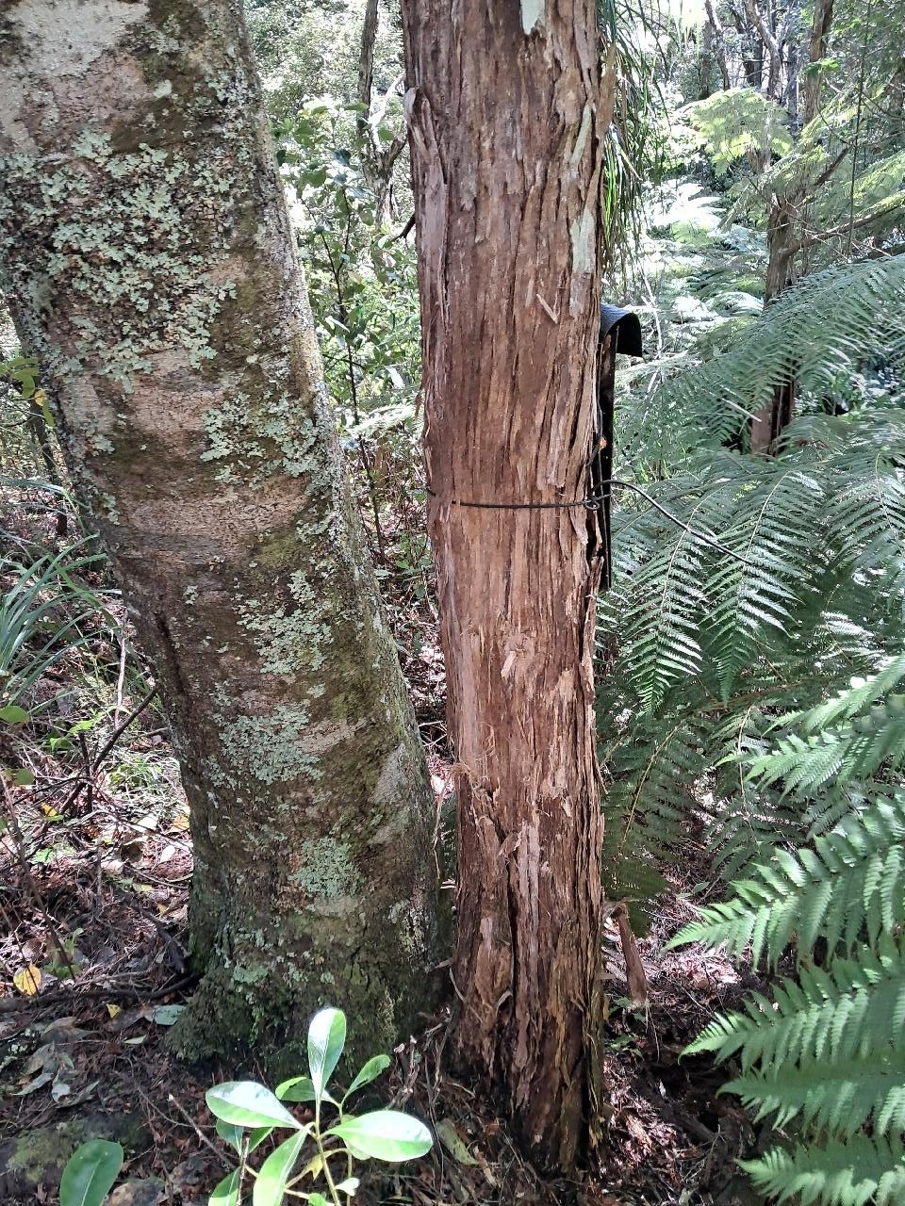 | 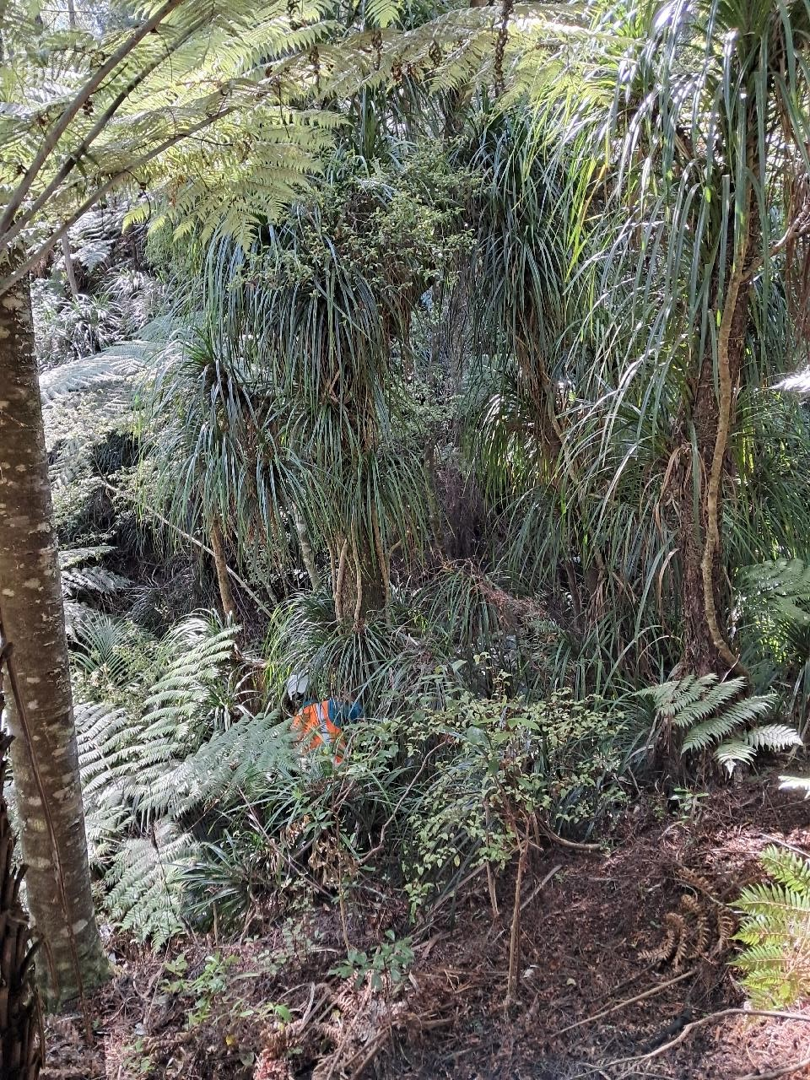
Transect 2: Mixed kanuka and podocarp. Understory dominated by silver fern, kanono, hangehange, and toropapa. Some keikei along gulley sides.
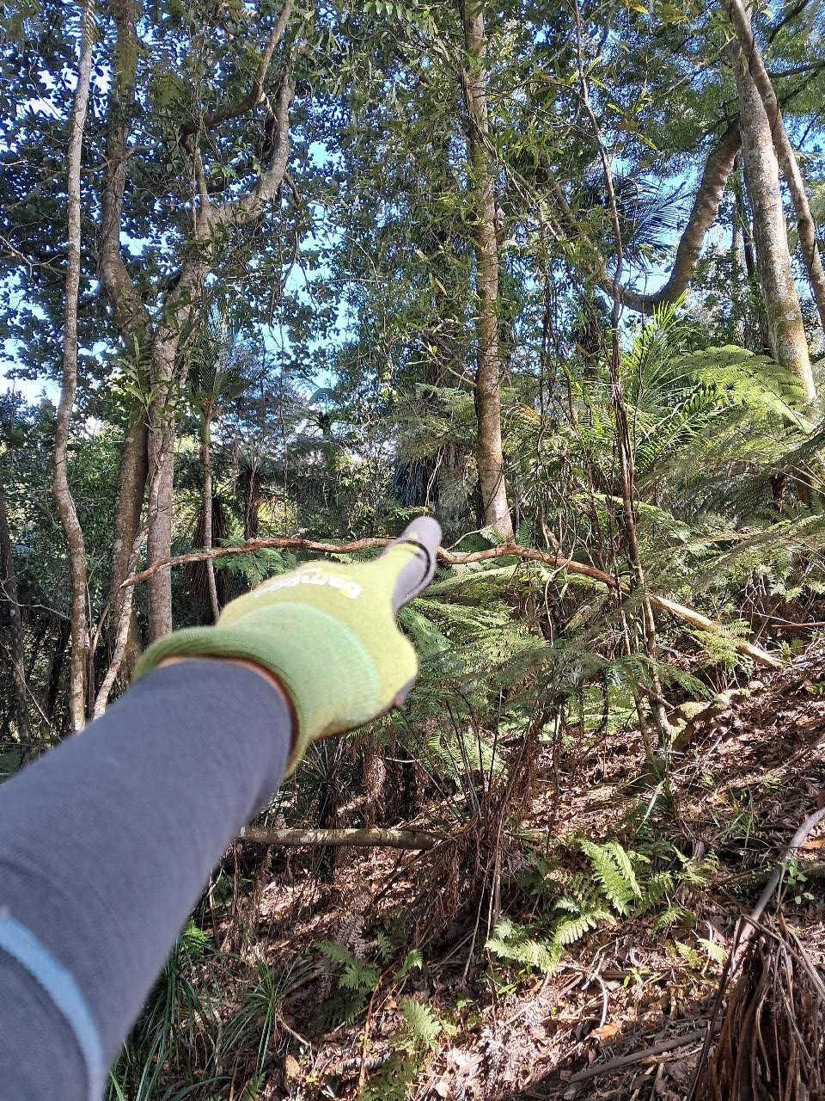 | 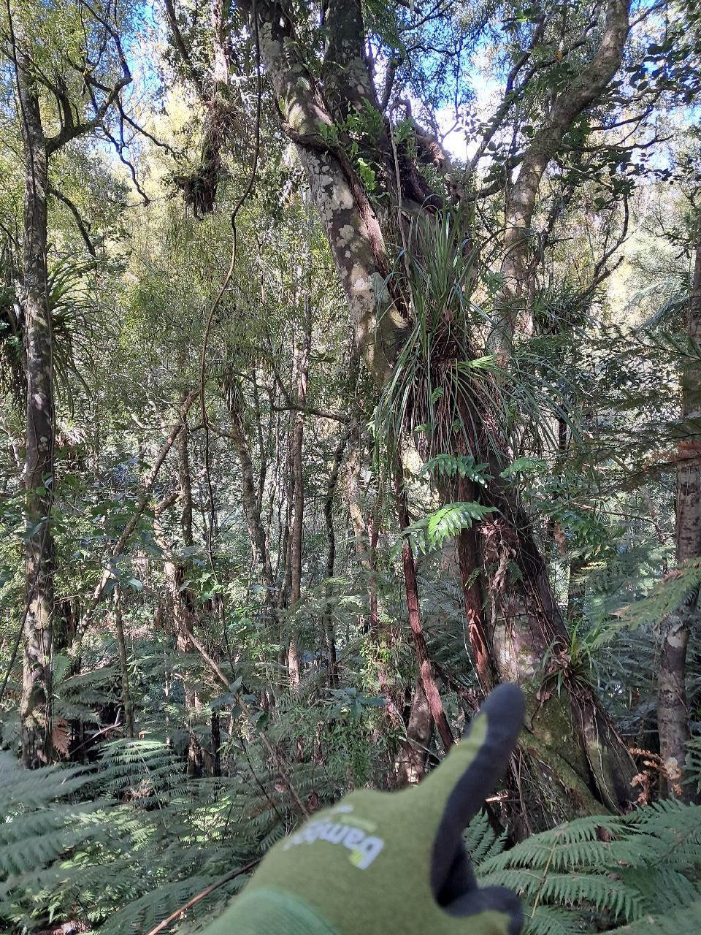 | 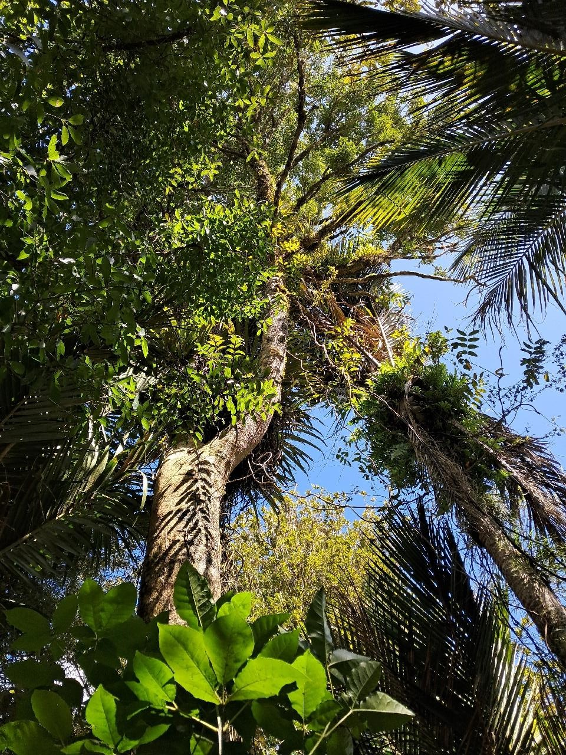
Transect 3: Broadleaf forest (tawa, taraire, kohekohe). Nikau, silverfern, mahoe, supplejack and hangehange dominated understory.
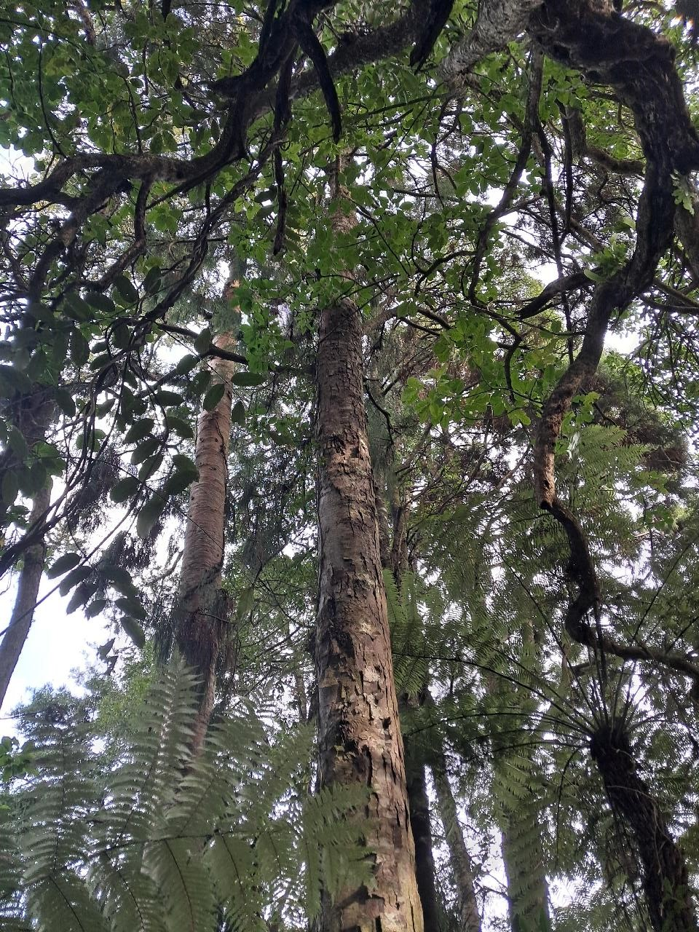 | 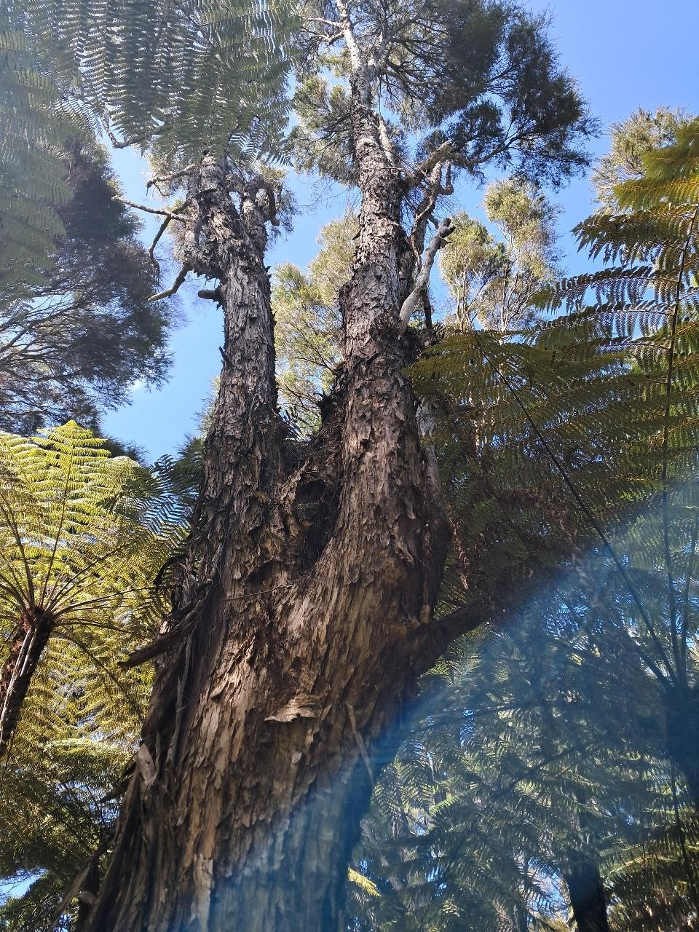 | 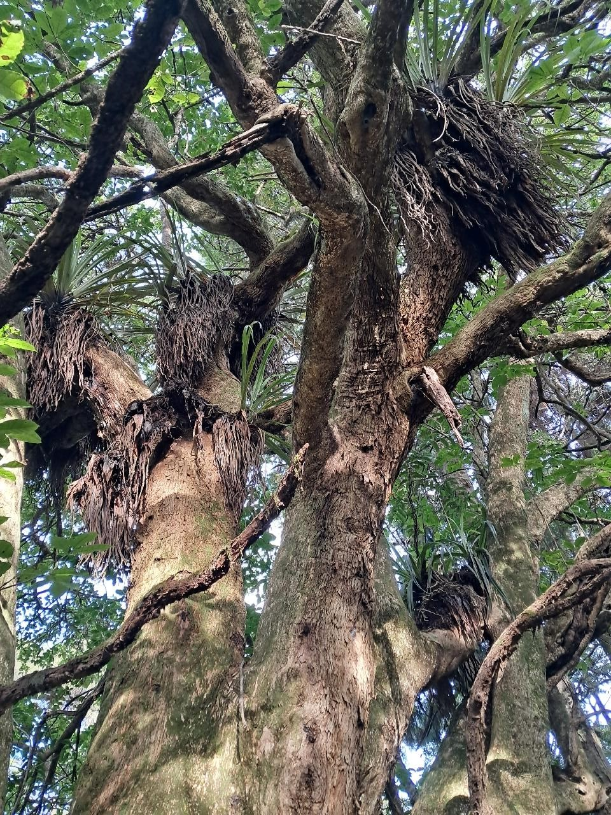
Transect 4: Mature gulley species (Rimu, Puriri, Kahikatea) and kanuka. Silver fern, hangehange, nikau dominated understory.

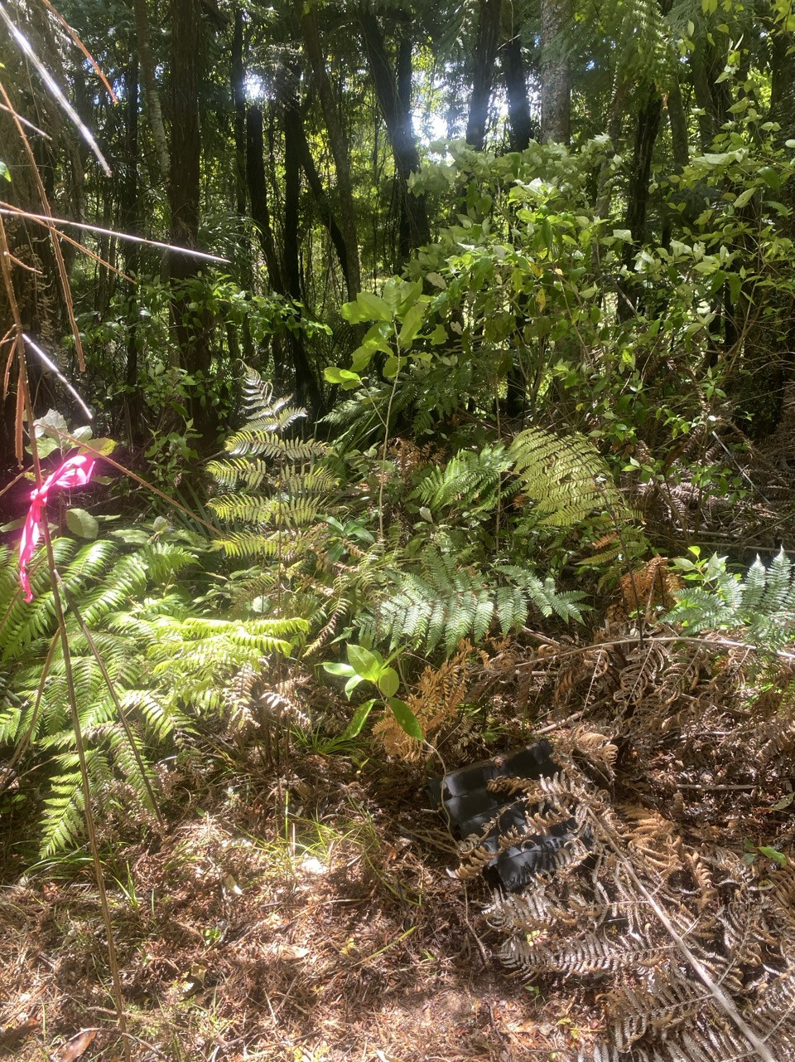 | 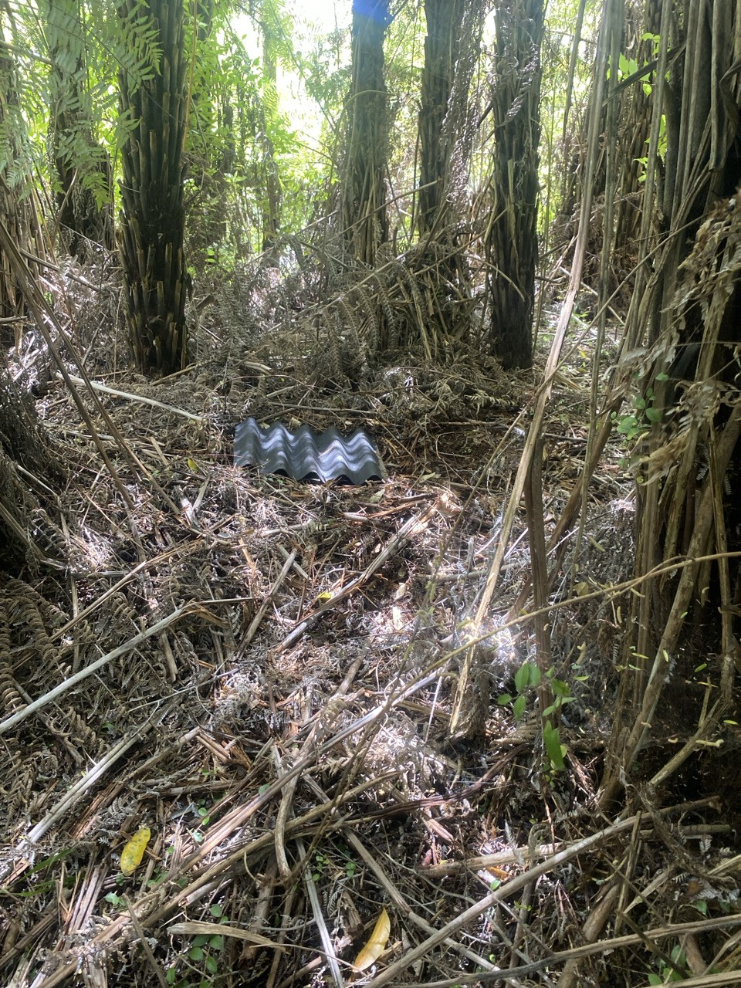 | 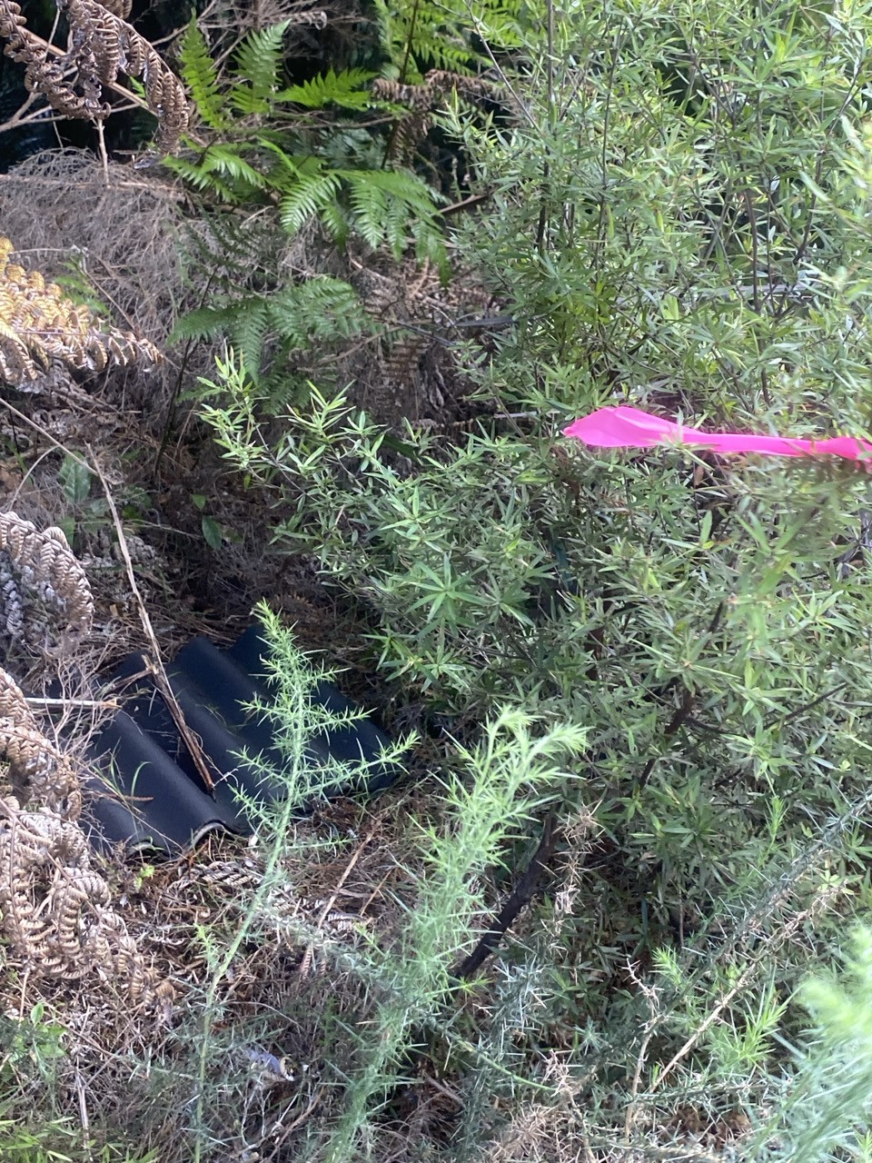
Tree fern-dominated regenerating forest
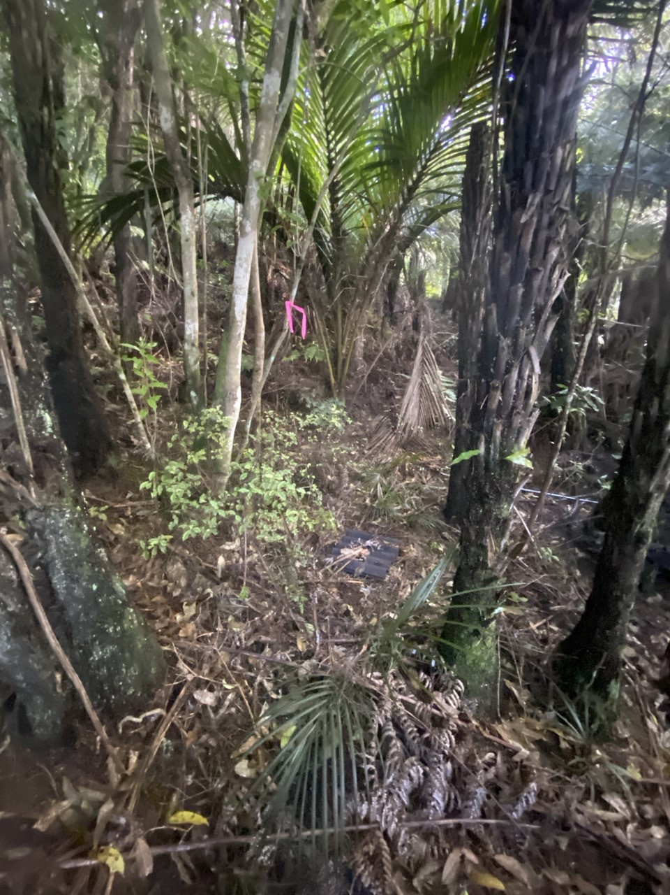 | 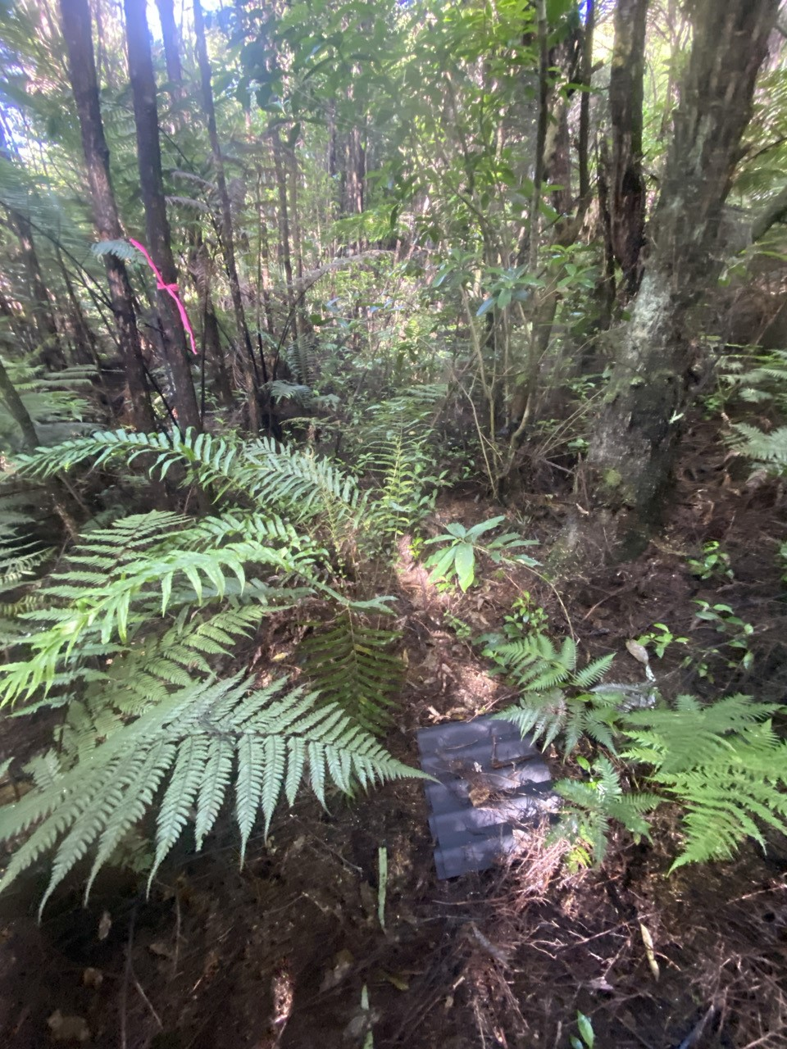 | 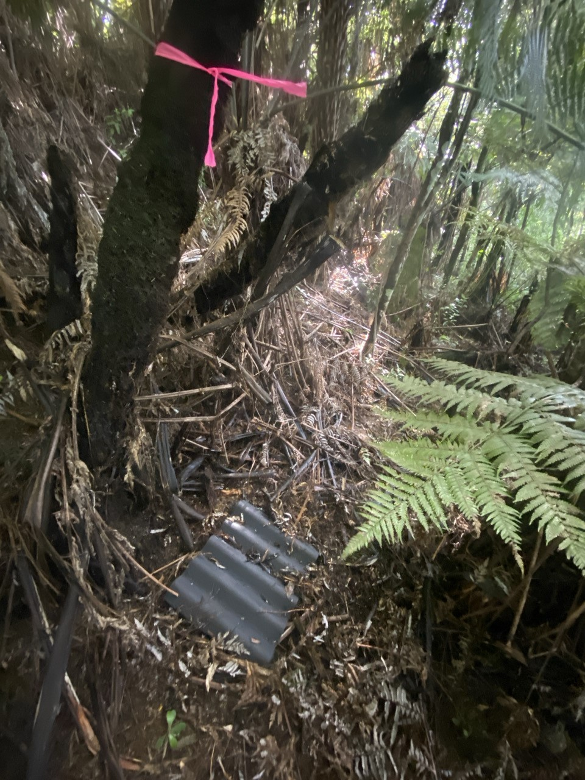
Mature kanuka with fern-dominated understory
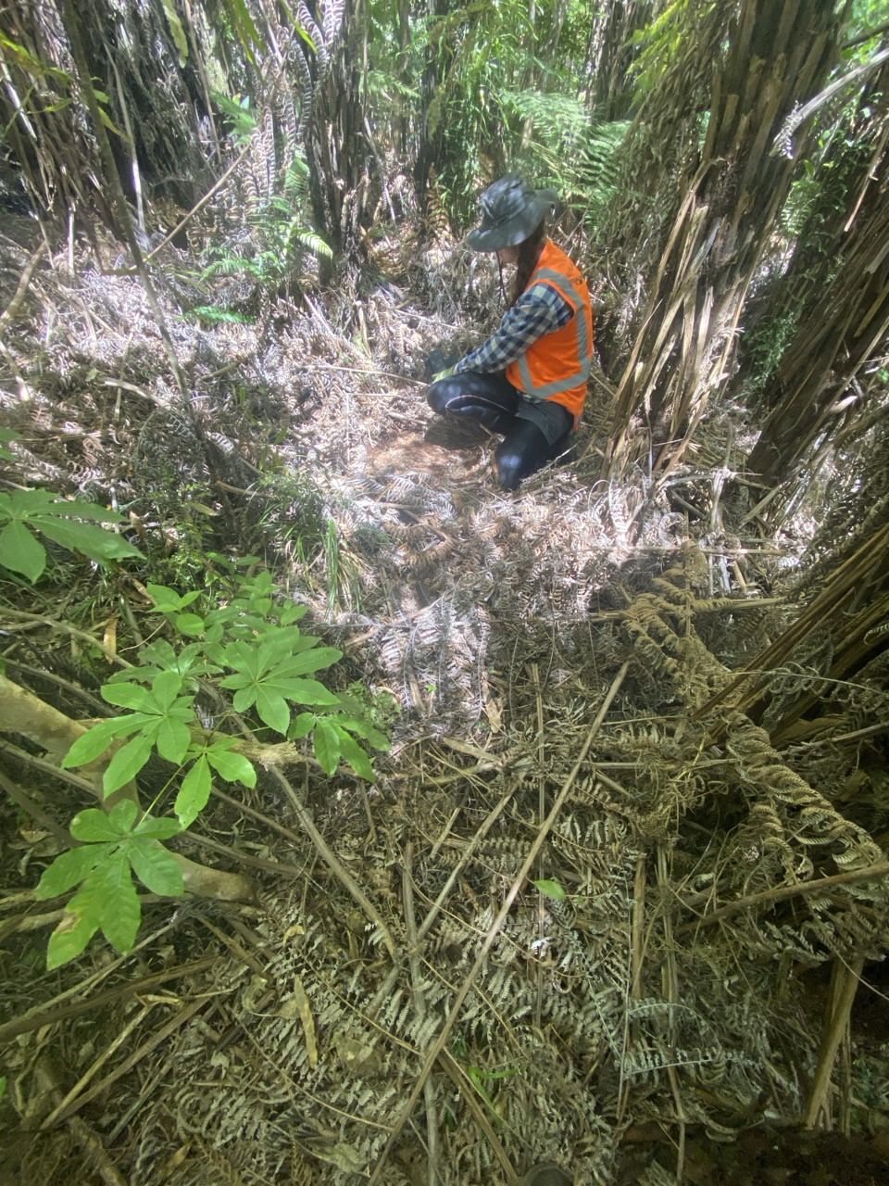 | 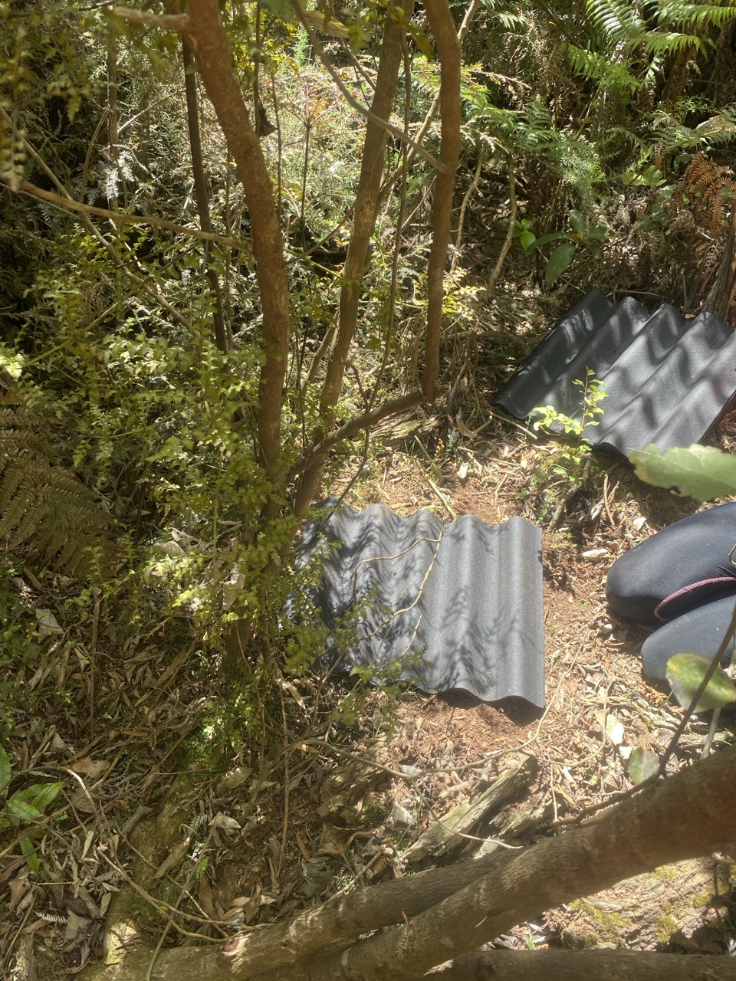 | 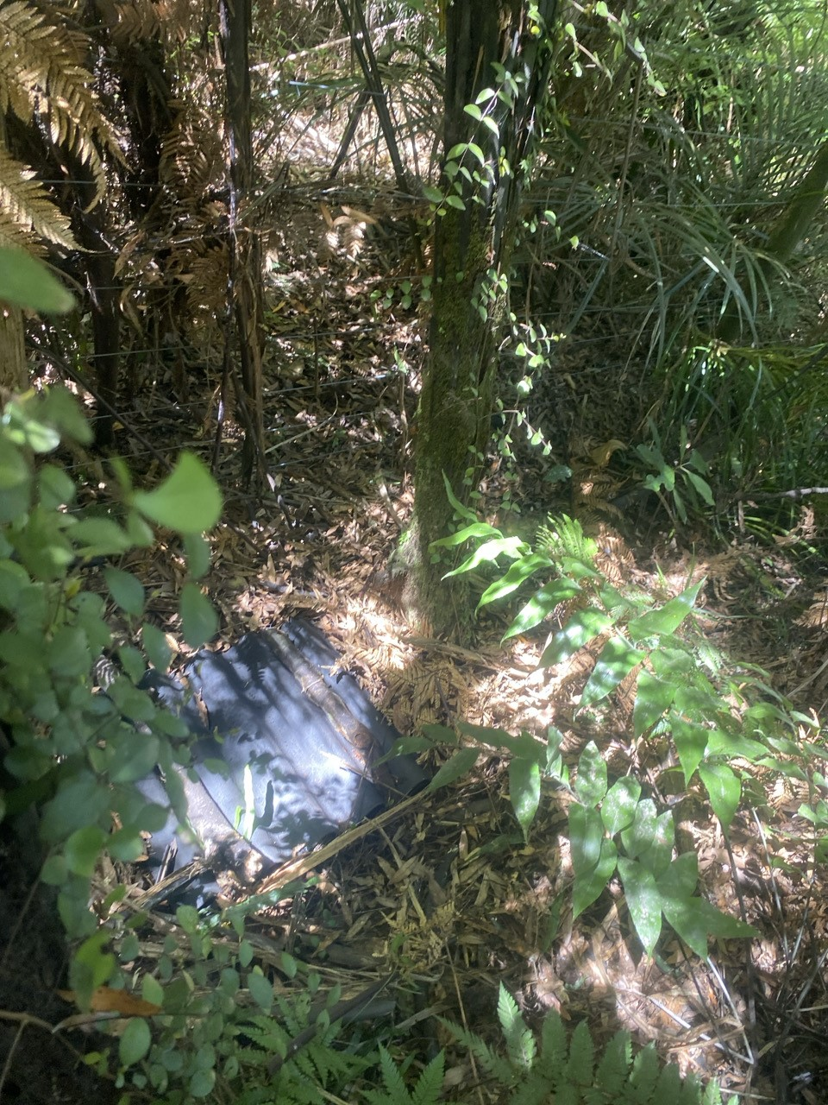
Taraire, tawa, podocarp forest
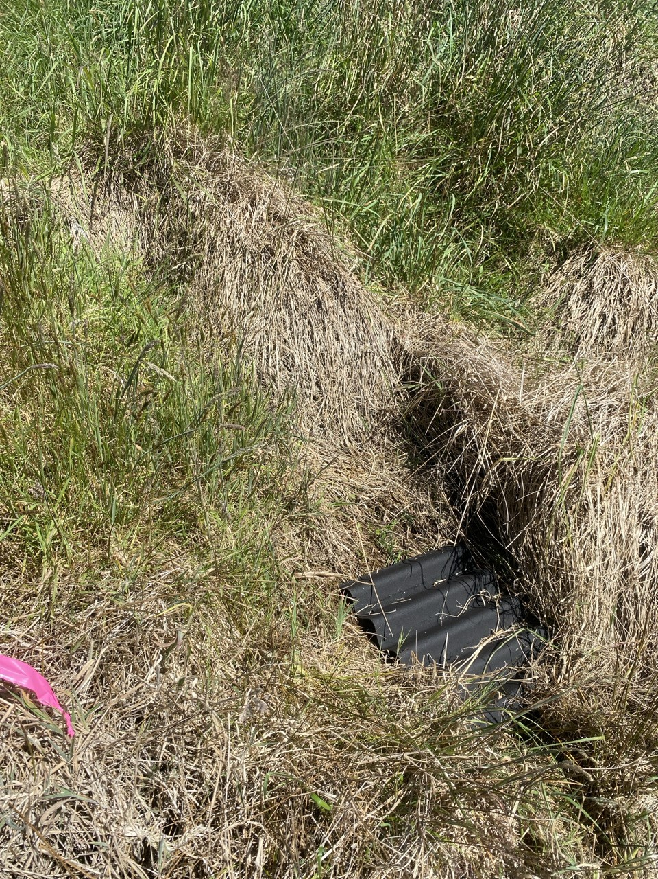 | 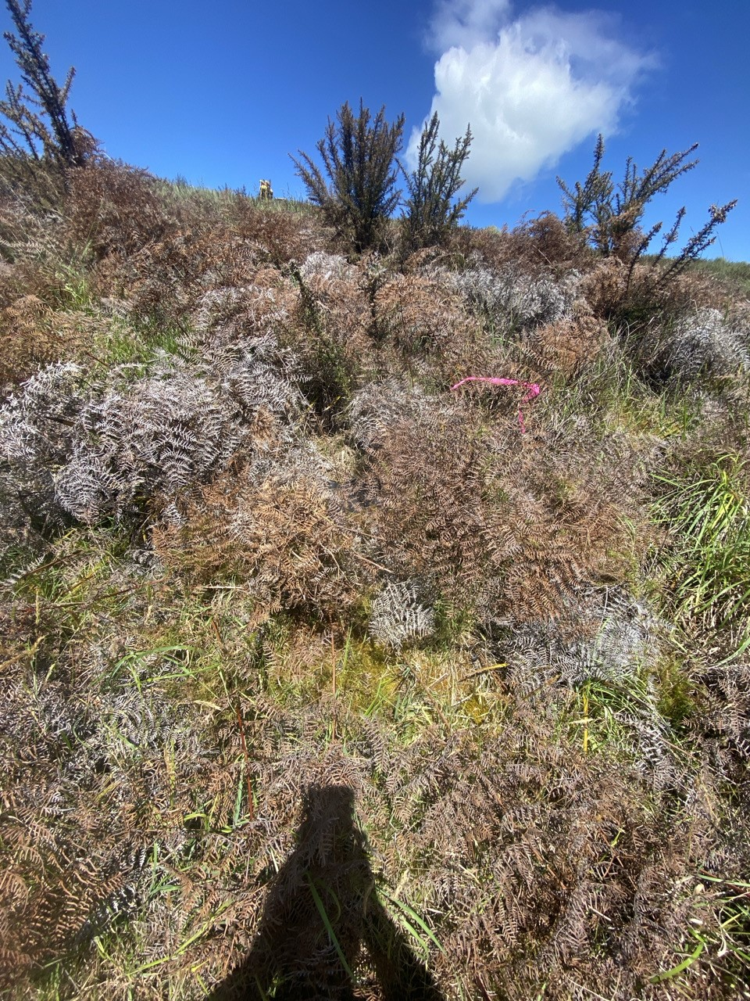 | 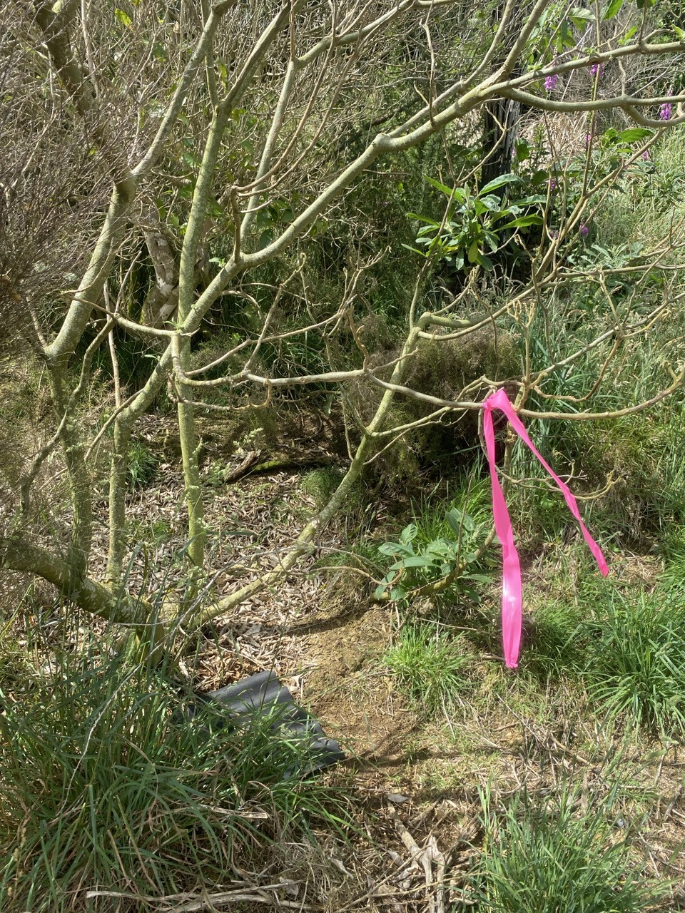
Bracken, rank grass
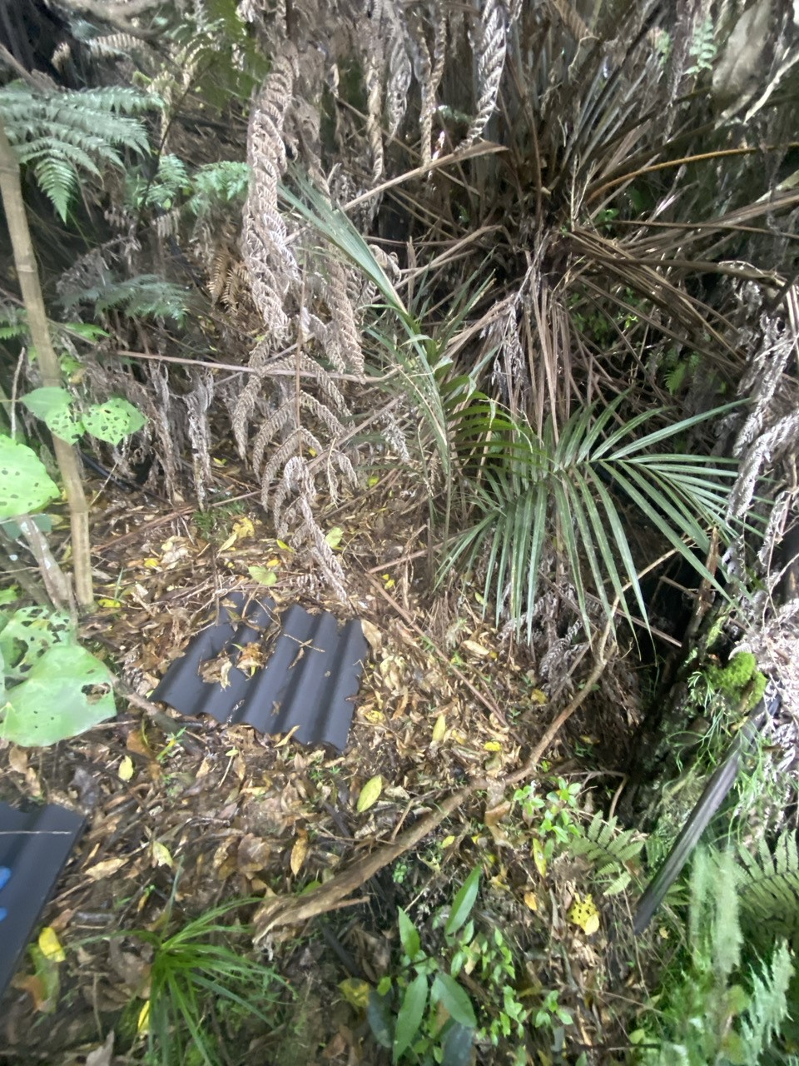 | 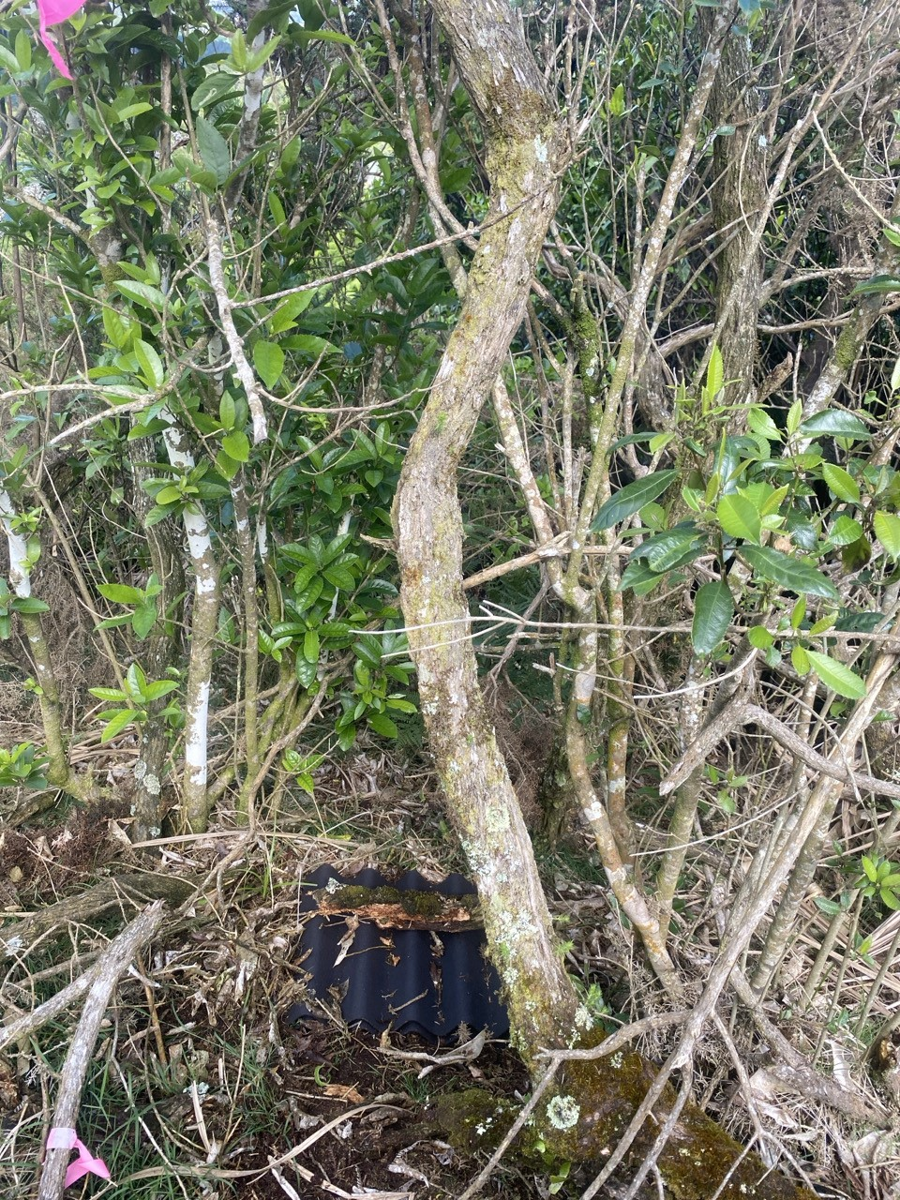 | 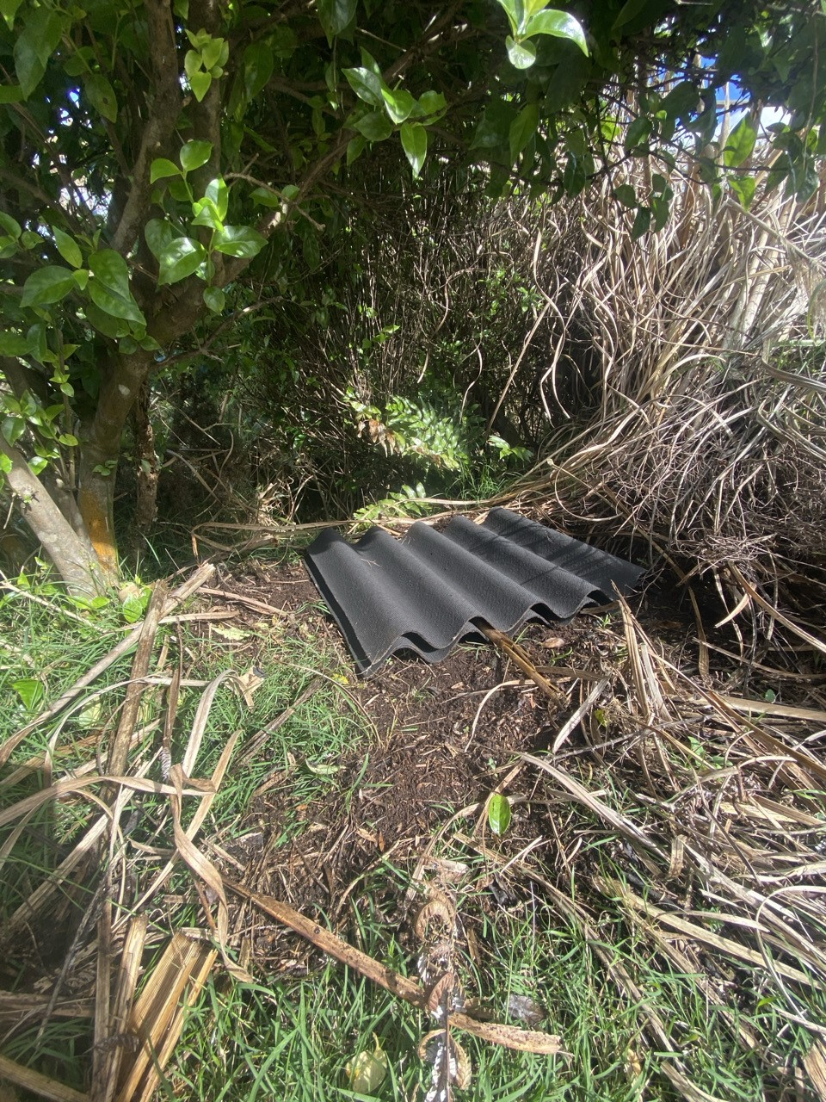
Native early succession broadleaf / weedy scrub mix

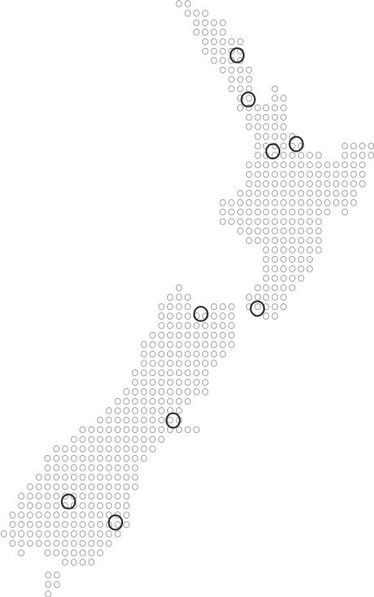
Together. Shaping Better Places.
Boffa Miskell is a leading New Zealand environmental consultancy with nine offices
throughout Aotearoa. We work with a wide range of local, international private and public
sector clients in the areas of planning, urban design, landscape architecture, landscape
planning, ecology, biosecurity, Te Hīhiri (cultural advisory), engagement, transport
advisory, climate change, graphics, and mapping. Over the past five decades we
have built a reputation for creativity, professionalism, innovation, and
excellence by understanding each project’s interconnections with the
wider environmental, social, cultural, and economic context.

www.boffamiskell.co.nz

Whangarei | Auckland | Hamilton | Tauranga | Wellington | Nelson | Christchurch | Queenstown | Dunedin
09 358 2526 | 09 358 2526 | 07 960 0006 | 07 571 5511 | 04 385 9315 | 03 548 8551 | 03 366 8891 | 03 441 1670 | 03 470 0460

Within SEA_T_5323, taraire is co-dominant with kohekohe.
Principle 1 of the 9 Principles of Lizard Salvage.
Principle 1 of the 9 Principles of Lizard Salvage: Lizard species’ values and site significance must be assessed at both the development and receiving sites.
Principle 2 of the 9 Principles of Lizard Salvage: Actual and potential development-related effects and their significance must be assessed.
Vegetation clearance is a land use consent and is granted in perpetuity. The project is “ to enable the extraction of aggregate for a further 50 years, with the potential to support further operations for up to 80 years.”
Principle 5 of the 9 Principles of Lizard Salvage: Lizard salvage, transfer and release must use the best available methodology
Principle 6 of the 9 Principles of lizard salvage: Receiving sites and their carrying capacity must be suitable in the long term.
Principle 9 of the 9 Principles of Lizard Salvage: Contingency actions are required when lizard salvage and transfer activities fail.
Principle 7 of the 9 Principles of Lizard Salvage: Monitoring is required to evaluate the salvage operation.
Principle 7 of the 9 Principles of Lizard Salvage: Reporting is required to communicate outcomes of salvage operations and encourage process improvements.

