

ATTACHMENT TWENTY-NINE

Environmental Monitoring Management Plan (“EMMP”)
Version 1.2 (Clean) - Updated 07/08/2026
 | Site: | Te Ākau Bream Bay Sand Extraction Site
 | Report Title: | Environmental Monitoring Management Plan for the Te Ākau Bream Bay Sand Extraction Site

Date | Version | Description | Certified
4 July 2025 | 1 | Draft for RC Application
12 May 2026 | 1.1 | Updates to sections 2.5, 6.10 and 6.11 following EPA feedback.
7 August 2026 | 1.2 | Updates to the Glossary, Sections 1 - 7, Appendix B, Appendix E and Appendix F

Contents
1. INTRODUCTION 1
2. EMMP CERTIFICATION, REVIEW AND KEY REPORTING DATES 2
2.1 EMMP Version and Certificate Dates 2
2.2 EMMP Review Dates 2
2.3 EMMP Review Methodology 2
2.4 Pre-Sand Extraction Assessment Report (PSEAR) 3
2.5 Sand Extraction Monitoring Report (SEMR) 3
3. ENVIRONMENTAL MONITORING DESIGN RATIONALE 5
3.1 Monitoring for benthic ecology effects 5
3.2 Monitoring for bathymetric effects 7
4. CELLS AND CONTROL AREAS 8
4.1 Sand Extraction from Cells 8
4.2 Cell Exclusion Criteria 9
4.3 Cell Reopening Criteria 9
5. PRE-SAND EXTRACTION ASSESSMENT REPORT (PSEAR) 10
5.1 Bathymetry monitoring 10
5.2 Drop camera images 11
5.3 Sediment Texture 12
5.4 Benthic Monitoring 13
5.5 Epibenthic dredge tows 14
5.6 Atypical results 14
5.7 Statistics 14
5.8 Written Deliverables 15
6. SAND EXTRACTION MONITORING REPORT (SEMR) 16
6.1 Metocean data 16
6.2 Bathymetry monitoring 16
6.3 Drop camera images 19
6.4 Sediment Texture 20
6.5 Benthic Monitoring 21
6.6 Epibenthic dredge tows 22
6.7 Atypical results 23
6.8 Statistics 23
6.9 Assessment of Monitoring and Reporting Methodologies 24
6.10 Plume Monitoring 24
6.10.1 Monitoring locations 24
6.10.2 Methodology 25
6.10.3 Consent Conditions 25
6.10.4 Trigger response 25
6.10.5 Monitoring and reporting schedule 26
6.11 SEMR Recommendations, Triggers and Management Responses 26
6.11.1 Application of the Control Site Envelope and Weight of Evidence Assessment 29
6.12 SEMR Addressing Increase in Extraction Volume 32
6.13 Written Deliverables 33
7. METHODOLOGY FOR UNDERWATER SOUNDSCAPE CHANGE MEASUREMENT AND ASSESSMENT ………………………………………………………………………………………………………………33
7.1 Objective 33
7.2 Site selection 34
7.3 Measurement methodology 34
7.4 Soundscape change assessment methodology 35
7.5 Methodology for soundscape change assessment 35
7.6 Reporting 37
7.7 Mitigation options 37
7.8 Certification 38
8. SAND EXTRACTION AND VESSEL TRACKING RECORDS 38
8.1 Reporting Requirements 38
9. LOGS 39
10. CHANGE OF EXTRACTION/DISCHARGE METHODOLOGY AND/OR VESSEL 39
Appendix A Proposed Sand Extraction Area Drawing 41
Appendix B Proposed Extraction And Control Cells Drawing 42
Appendix C Pre Sand Extraction Monitoring Reports (PSEAR) 44
Appendix D Sand Extraction Monitoring Reports (SEMR) 45
Appendix E Approved Sand Extraction Area (ASEA) 46
Appendix F Sensitive Benthic Communities 47
Appendix G Seabird Interaction Log 49
Appendix H Marine Reptiles Sighting Log 51
Appendix I Marine Mammals Sighting Log 53
Appendix J Marine Mammals Incident Log 55
Appendix K Applications for Change of Vessel or Extraction and/or Discharge Methodology and the NRC Approval 57

Glossary
Term | Definition
Action level | a monitoring result that indicates a management response is required.
Adverse ecological effect | a change in benthic ecological condition that is ecologically meaningful, likely attributable to sand extraction, and outside the expected range of natural variability or recovery trajectory.
ASEA | Approved Sand Extraction Sub-Area
Baseline condition | the pre-extraction condition recorded by the PSEAR and any other approved pre-extraction monitoring.
Benthic community | the animals and other organisms living on or within the seabed sediments, including infauna and epifauna recorded by grab samples, imagery, dredge tows or other approved monitoring methods.
Cell | The Cells defined on the Bioresearches Drawing “Map Showing Proposed Sand Extraction Area and Proposed Control Areas” dated 18/09/2024 or at any subsequent revisions, in Appendix Two.  These cells are 1000m x 200m in area.
Community composition | the identity and relative abundance of taxa present in a sample. Community composition is generally assessed using multivariate methods such as Bray-Curtis similarity, nMDS, PCO, PERMANOVA, SIMPER or equivalent methods.
Consent Holder | McCallum Bros. Ltd
Control site envelope | the expected range of natural variability recorded at the control sites. For univariate indicators, this may be expressed as a prediction interval, ±2 within control standard deviations, percentile range or other statistically justified range. For multivariate indicators, it may be expressed as the range of similarity, ordination space, distance from a control centroid, or other statistically justified multivariate reference range.
Control site trajectory | the direction and magnitude of change through time recorded at the control sites. It is used to assess whether changes in the extraction area are consistent with natural temporal change or are diverging in a way that may indicate an extraction-related effect.
Convergence | movement of extraction cell values toward the range of conditions recorded at the control sites. Convergence is used to assess recovery and does not require exact return to the original baseline condition.
Cumulative adverse trajectory | repeated small changes, or multiple indicators changing in the same adverse direction through time, that together suggest a developing ecological effect even if no single indicator alone is determinative.
Divergence | movement of extraction-cell values away from the control-site envelope and/or the control-site trajectory.
DOC | Department of Conservation
Ecologically meaningful | a change that is large enough, persistent enough, spatially extensive enough, or relevant enough to ecological function or sensitive receptors to matter ecologically.
EMMP | Environmental Monitoring Management Plan
Extraction Area | The proposed sand extraction area
Extraction cell trajectory | the direction and magnitude of change through time within a cell or group of cells from which sand has been extracted.
FTAA | Fast Track Approvals Act (2024)
Functional groups | groups of organisms that perform similar ecological roles, such as suspension feeders, deposit feeders, bioturbators, tube builders, shell-associated taxa and benthic prey taxa.
Key taxa | taxa that are common, abundant, functionally important, sensitive, habitat-forming, important as prey, or otherwise useful for interpreting ecological change such as bryozoans, tubeworm-associated taxa, horse mussels and scallops.
Management guidepost | an indicative value used to help interpret the magnitude of change. Management guideposts are not fixed ecological thresholds and must not be applied in isolation.
MBES | Multibeam Echo Sounder
MBL | McCallum Bros. Ltd
NRC | Northland Regional Council
Persistent | a change that is recorded over more than one monitoring event, or that remains evident through time after considering natural variability, storm effects, seasonal effects and other relevant pressures.
PSEAR | Pre-Sand Extraction Assessment Report
Recovery | convergence of monitored extraction cells toward the range of conditions recorded at the control sites. Recovery does not require exact return to the original baseline condition.
SEMR | Sand Extraction Monitoring Report
Sensitive Benthic Communities | Means the habitats described in the table included in Appendix F.
SQEP | Suitably Qualified and Experienced Person
Underwater Soundscape | The underwater soundscape at a receiver is the sum of the noise from all sound sources including fish, invertebrates and marine mammals, weather (as specified in the EMMP), sand movements and vessels measured using the Leq descriptor over any calendar month at the monitoring location.
Univariate indicator | a single measured ecological or sediment variable, such as taxa richness, abundance, Shannon diversity, mud content, median grain size, shell content, scallop density or abundance of a key taxon.

INTRODUCTION
McCallum Bros Limited (“MBL”) holds resource consent (TBC) for sand extraction at the Te Akau Bream Bay Sand Extraction site. This document is the Environmental Monitoring Management Plan (“EMMP”) required under Condition 16.

The Objectives of this EMMP are:

(1) To outline a monitoring programme to:
a) Provide the baseline ecological and bathymetric information for subsequent monitoring.
b) Identify areas where sand extraction is not to be undertaken.
c) Identify benthic ecological or bathymetric changes arising from the sand extraction.
d) To identify that the underwater noise monitoring does not represent a soundscape change that exceeds 3db.
e) Confirm compliance with Condition 31 (Plume)

(2) Identify changes required to the sand extraction method to minimise any identified significant unanticipated adverse ecological, bathymetric and/or coastal processes effects on the environment.

This is a living document which includes the following:
- Methodology and timing of EMMP Reviews
- The monitoring objectives and rationale
- Cell and control sites identification
- Pre Sand Extraction Assessment (“PSEAR”) Methodology
- Sand Extraction Monitoring Report (“SEMR”) Methodology
- Underwater Noise Modelling Verification
- Sand Extraction and Vessel Track Reporting Methodology
- Approved Sand Extraction Sub Areas
This EMMP is also the depository for the other ecological log and reporting requirements.

This EMMP has been compiled by MBL with input from the following SQEPs:

Section | Inputs
1, 2, 3.1, 4, 5, 6, 8, 9, 10. Appendix F | Simon West – Bioresearches
2, 3.2, 4, 5.1, 6.1, 6.2, 6.11 | Eddie Beetham – Tonkin + Taylor  Richard Reinen-Hamill
6.10 | Pete Wilson – SLR Consulting New Zealand
7 | Matt Pine, Jon Styles – Styles Group
Appendix G | David Thompson
Appendix H | Dylan van Wynkel
Appendix I, J | Helen McConnell

EMMP CERTIFICATION, REVIEW AND KEY REPORTING DATES
This section:
- Records the dates and nature of the EMMP updates and certification.
- Sets out the EMMP review dates.
- Records the dates of completed PSEARs.
- Sets out the dates SEMR’s are required.
All updates, including any changes to monitoring methodology, are required to be provided to NRC for certification (except for administrative and de minimis changes provided for under Condition 12) before any changes are implemented.

EMMP Version and Certificate Dates
Update Number | Date of Update | Nature of Update | Certification from NRC required | Certification Date
Original | 4/07/2025 | Submitted with Application | No

EMMP Review Dates
Under Condition 16, this EMMP is to be reviewed at least at year three, year five and then every five years from the commencement of the consent with the reviewed EMMP having to then be submitted to NRC for certification. The dates the reviewed EMMP are due at NRC are:
Review Due | Submitted
1 November 2029
1 November 2031
1 November 2036
1 November 2041
1 November 2046
1 November 2051

EMMP Review Methodology
The objective of the review is:
- To identify any changes required to the monitoring methodology and timing to provide better understanding of observed effects, if any, arising from the sand extraction.
- To include new or revised sampling techniques if current sampling methods did not work as expected.
- To adopt new technology that makes data collection easier and/or more accurate.
The review should be commenced at least 6 months prior to the date the updated EMMP is due at NRC. The review is to be led by the MBL Environmental Manager (or similar) and is to involve the following personnel:
- The ecologist(s) (or their replacement) responsible for preparing the ecological inputs any PSEAR or SEMR completed during the preceding 5-year period.
- The coastal processes specialist (or their replacement) responsible for preparing any coastal processes (including bathymetric survey reviews) into any PSEAR or SEMR completed during the preceding 5-year period.
- Any other environmental specialist (or their replacement) used to provide input into any specific environmental issue which has been identified through the SEMR process or in any required responses to NRC s128 reviews or responses to complaints during the preceding 5 year period.
- Te Pouwhenua o Tiakiriri Kūkupa Trust (Te Parawhau ki Tai) are to be provided any proposed changes to the EMMP for their review and comments. Te Parawhau ki Tai are to be given 20 working days to undertake the review and provide any comments.
The review shall consider:
- Any recommendations from the SEMR reports
- Any comments and recommendations received from Te Parawhau ki Tai after their review of any proposed changes to the EMMP.
The updated EMMP shall be submitted to NRC along with a letter identifying the changes made and the basis for these changes.

Pre-Sand Extraction Assessment Report (PSEAR)
The following Pre-Sand Extraction Assessment Reports have been completed and approved along with their Approved Sand Extraction Sub Area Plans.

PSEAR Number and Date | ASEA Plan Number and Date | ASEA Cells Covered | Approved | ASEA Superseded
1 (added date) | 1 (add date) | All (to confirmed) | Approved as part of the consent. | No

The Approved Sand Extraction Sub-Area Plans are included in Appendix E.

Sand Extraction Monitoring Report (SEMR)
Under Condition 37, the Consent Holder must prepare a SEMR for those ASEA’s where sand extraction has occurred since the last SEMR monitoring in those years specified in the Table below.

SEMR Required
If no increase in sand extraction volume is to occur during the life of the consent:

Years 2-4

Then every 3rd year for the remainder of the period the consent is given effect to or at a lesser period if recommended in any SEMR and for the final year the consent is given effect to.
If an increase in sand extraction volume occurs:

Annually for Year 2 onwards until 3 years after the increase in the sand extraction volume has commenced.

Then every 3rd year for the remainder of the period the consent is given effect to or at a lesser period if recommended in any SEMR and for the final year the consent is given effect to.

The SEMR is to be undertaken in accordance with the methodology outlined in Section 6 of this EMMP.

The SEMR is to include an updated ASEA Map and any recommended changes to the sand extraction method and extraction volumes based on the findings, monitoring and reporting of that SEMR.

The SEMR must be submitted to the NRC for certification by 31 October of the year it is required. The monitoring required to prepare the SEMR must be completed in February/March/April of that year.

The following SEMR have been completed and approved along with their Approved Sand Extraction Sub Area Plans.

Year | ASEA Plan Number and Date | ASEA Cells | Approved | ASEA Superseded
Year 2
Year 3
Year 4
Year 5
Year 6
Year 7
Year 10
Year 13
Year 16
Year 19
Year 22
Year 25
Year 28
Year 31
Year 34
At completion

The ASEA are included in Appendix C.

ENVIRONMENTAL MONITORING DESIGN RATIONALE

Monitoring for benthic ecology effects
The monitoring design is based on a “cause” and “effect” basis, as well as a trend analysis of accumulative effects basis:
- “Cause” is defined as sand extraction.
- “Effects” are those changes in the bathymetry, sediment characteristics and habitat attributes or benthic communities that are outside the range of natural variability recorded at the control sites having regard to ecological significance, persistence, spatial extent and likely causation.
Practical experience suggests that most natural populations show fluctuations from time to time that are not parallel from place to place. As a result, there is considerable interaction between space and time in the data from any sampling design. An ecologically realistic proposition is that an environmental impact on the abundance of a population in some location should be defined as an anthropogenic perturbation that causes more temporal change in the population than is usually the case in similar populations in other similar locations where no such disturbance occurs.

Benthic communities are expected to naturally show seasonal variation in composition and abundance. In order to maximise the abundance and composition and minimise temporal variation sampling for benthic biota will be conducted in late summer to mid-autumn (February to April inclusive).

Benthic communities are expected to naturally show variation in composition and abundance as a result of changes in depth. Comparisons between cells or groups of cells should only compare cells of a similar depth.

A typical environmental monitoring design often involves ‘Before’ sampling in ‘Impact’ and ‘Control’ locations followed by ‘After’ sampling in the same ‘Impact’ and 'Control’ locations, i.e. BACI. It has been recognised in the international literature (Underwood, 1991^{[1]}, 1992^{[2]}, 1994^{[3]})

that a simplistic BACI design has a number of deficiencies which do not adequately allow for natural spatial and temporal variations, particularly over large areas, which can lead to false assessments of effects. Due to the size of the proposed sand extraction area, a simplistic BACI comparison of ecological parameters from before and after sand extraction in both control and impact zones will not effectively account for the ecological spatial and multi-year temporal variation that may occur at the site over the life of the consent. Therefore, the monitoring design that was chosen uses asymmetrical beyond BACI methods where possible.

In terms of the use of multiple control sites, the logic of the design is that an impact in one site should cause the composition and abundance of animals in the community to change more than expected on average in undisturbed sites. Composition and abundances in the control, undisturbed sites will continue to vary in time, independently of one another. On average, however, they can be expected to continue as before. Individual control sites may differ and may change significantly from one another. It is expected that on average the set of control sites should continue to show similar behaviour. Impacts are those disturbances that cause average composition and abundance in a site to change more than is found on average.

The PSEAR Report 2025 which covers the full sand extraction area provides the true ‘Before’ monitoring samples as this assessment was undertaken prior to any sand extraction occurring in this area.

Because the sand extraction is an ongoing series of events, the ‘After’ samples will be a series of samples during sand extraction until the end of the consent as part of the SEMR reporting. The SEMR monitoring will record the benthic ecology and potential effects relative to natural variation in the benthic ecology, over a period of time. These periodic monitoring events will then be assessed for any trends which may show cumulative effects from a number of smaller potentially undetected effects. If effects and or trends differentiating the impact sites from the control sites are detected, then there is a potential opportunity to manage the sand extraction to attempt to minimise any effects.

Consistent with this asymmetrical beyond BACI approach, the SEMR trigger framework is based on a reference condition and trajectory approach. This is appropriate because benthic communities in open coast sandy environments are naturally variable through time and space. Baseline data from the PSEAR in Appendix C provide the pre-extraction condition and remain important for interpreting change, but the primary trigger reference is the range of conditions recorded at the control sites and the trajectory of change through time.

This approach is consistent with comparable benthic monitoring and adaptive management frameworks, which emphasise the need for monitoring designs that can distinguish extraction related change from normal spatial and temporal variability, rather than simply documenting departure from a starting condition. Environmental effects monitoring programmes also commonly assess effects by comparing exposure areas with control areas. For example, the Canadian Environmental Effects Monitoring framework for benthic invertebrates uses control area variability and critical effect sizes, including ±2 standard deviations from control conditions for benthic density, taxa richness and Simpson’s evenness. Dredging adaptive management guidance also supports tiered response levels and corresponding management responses, so that small or uncertain changes trigger further investigation while larger or more certain changes trigger direct management action. Recent marine aggregate recovery studies likewise assess recovery as convergence toward comparable control conditions, rather than requiring exact return to the original baseline condition.

For this purpose, the control site envelope is the expected range of natural variability recorded at the control sites. For univariate indicators, including taxa richness, abundance, Shannon diversity, key taxa, functional groups and sediment texture, the control site envelope may be expressed as a 95% prediction interval, ±2 within control standard deviations, or another statistically justified control site range. A confidence interval around the control mean may be reported, but should not be used alone as the ecological trigger range unless it is demonstrated to be appropriate for that indicator.

For multivariate community composition, the control site envelope may be expressed using PERMANOVA, Bray-Curtis similarity, nMDS, PCO trajectory analysis, distance from the control centroid, Mahalanobis distance, or another statistically justified multivariate method. In practical terms, the key question is whether extraction cell assemblages are changing in a different direction or at a greater magnitude than the control sites.

Accordingly, the ecological criteria used in the SEMR are to be assessed by reference to divergence from the control site envelope and the trajectory of change through time, rather than as fixed absolute values in isolation.

An adverse ecological effect may therefore be indicated where one or more monitored extraction cells exhibit a persistent and ecologically meaningful divergence from the control site trajectory, a persistent and ecologically meaningful change in the benthic condition away from the control site condition, and where divergence is likely attributable to sand extraction.

These criteria are to be interpreted together. A single exceedance of a numerical value will not automatically indicate an adverse ecological effect unless the change is substantial, involves functional groups, sensitive habitat or protected taxa, or is clearly attributable to extraction. Exceedances of multiple indicator values will by weight of evidence provide a higher confidence of an adverse ecological effect. Conversely, repeated directional divergence from the control site trajectory may indicate an adverse ecological effect even where no single indicator, on its own, is determinative.

Monitoring for bathymetric effects
Monitoring of the shoreface and offshore bathymetry is being undertaken to confirm the extraction is not having an adverse effect on coastal processes. Monitoring and analysis of bathymetry will be undertaken inside the extraction area, at adjacent control sites, and along six bathymetric profile transects that extend to shore (as far shoreward as practicable). The adjacent control areas are used to quantify natural variation and survey accuracy as a reference for understanding change within the extraction area.
Specific monitoring objectives are to:
- Identify cumulative change in sea-bed level and volume within the extraction area.
- Identify and manage any unexpected dredge track anomalies.
- Identify and manage any unexpected seabed lowering on the shoreface.
Repeat bathymetric surveys of the extraction area are recommended to monitor the change in seabed level and volume. Analysis of cut and fill volumes can be undertaken to understand the change over time. Calculation of difference in seabed level since the baseline survey can be used to understand if there is progressive lowering over time. Bathymetric survey cut and fill volumes can be compared to dredge volume records. In a closed system the surveyed cut volume should be close to the recorded extraction volume. Bathymetric surveys have an error of approximately ±0.15 m and the rate of seabed lowering across the full area is approximately -0.016 m/yr based on the annual extraction volume, with individual tracks of -0.1 m. Therefore, it may take multiple years before measurable change beyond the error margin is detected in bathymetric surveys.

MBL have a dredge track management plan based on using equipment that extracts to a maximum depth of 0.1 m on a single pass, and no repetition of the same dredge line in any 12-month period. This is to avoid dredge track anomalies, defined as a single extraction track with a width less than 2 m and a depth exceeding 0.4 m below the surrounding seabed level and longer than 100 m in length. Such an anomaly may locally interrupt coastal processes. Bathymetric monitoring across the extraction site should be collected and analysed to identify and manage dredge track anomalies. If an anomaly is identified during the monitoring, that is attributable to sand extraction, that cell will be excluded from the ASEA.

If an adverse effect on coastal morphology were to occur as a result of the extraction, the first location where this would be realised is a lowering of the lower shoreface close to the proposed extraction area. Monitoring of the lower shoreface is undertaken in the form of:
- Bathymetric monitoring of a 220 m bathymetric control area on the landward (west) and northern and southern sides of the extraction area, to identify and manage any unexpected loss in volume on the adjacent lower shoreface that could be attributed to sand extraction.
- Bathymetric profiles from the proposed extraction area to the shoreline (as close to shore as practical – no greater than 5 m in water depth) are recommended to confirm the stability of the seabed landward of the proposed extraction area.

CELLS AND CONTROL AREAS
To aid in the monitoring and management of the sand extraction, the proposed sand extraction area has been divided into cells 1000 m long and 200 m wide orientated along the shore in the general direction of the dredging runs.

Three control sites have been identified. Due to differences in seafloor slope, the seaward extent of each control area will vary to match the depth range in the sand extraction area. However, each extends 1000 m parallel to the shoreline. All control areas are subdivided into cells of 1000 m long by 200 m wide, consistent with the dimensions of the cells in the proposed extraction area.

An area with of width of 220 m has been identified on the landward, northern and southern side of the sand extraction site as a further bathymetric monitoring area.

The Cell and Control Area Plan is included in Appendix B.

Sand Extraction from Cells
Cells where sand extraction can occur are identified in the operative ASEA plan. The current approved plan is listed in Section 2 of this Report and included in Appendix C.

The initial approved ASEA was approved as part of the coastal permit. Subsequent ASEA’s will be prepared either through the PSEAR or the SEMR process.

Cell Exclusion Criteria
An ASEA must not include areas of the seafloor which contain any of the following:

  - Sediment with an average proportion of mud (grain size finer than 0.063 mm) exceeding 20% by weight; or
  - Areas of immobile layers (e.g. rock) or historic facies (e.g. partly consolidated orange Pleistocene sand deposit); or
  - Sensitive benthic communities (as defined by Attachment Four); or
  - Any absolutely protected species under the Wildlife Act 1953, excluding any species for which a Wildlife Authority is held; or
  - Extraction track(s) longer than 100m with a width of less than 2m and a depth exceeding 0.4m below the typical adjacent seabed levels defined as the seabed area within 10m of each track edge; or
  - Cell(s) or parts of cells which have been recommended for closure from sand extraction in an SEMR on the grounds that bathymetry monitoring within the bathymetric control area shows progressive lowering of the seabed across two or more annual surveys and the average change in seabed level across the 220 m width of the control area relative to the pre-extraction baseline survey (2025) exceeds 0.15 m, indicating a likely adverse effect of sand extraction that cannot be explained by natural processes and/or storm events; or
  - Cell(s) or parts of cells which have been recommended for closure from sand extraction in an SEMR on the grounds that they demonstrate a trajectory of benthic change that is divergent from the trajectory of benthic change in the control site envelope having regard to the extent to which the change, or elements of the change, are likely to be attributable to sand extraction or natural variability, storm events, seasonal variation, other activities or a combination of those factors.

Cell Reopening Criteria
Where an area has been excluded from the ASEA, under Condition 20, a new PSEAR report can be prepared under Condition 22 for that cell(s) to determine if it can be included in a new ASEA.

In the event of a cell(s) having being closed as a result of non-compliance with Condition 20 (f) and (g), the SQEP may recommend under Condition 22 that cell(s) remains closed despite it now complying with the requirements of Condition 20 (f) and (g) if they consider there are circumstances where opening the cell may generate future adverse effects. The following are the relevant clauses from Condition 22:

- Where a cell(s), or part of a cell which has been recommended for closure under condition 20 f), include a conclusion from an SQEP that seabed levels within the bathymetric control area have stabilised having regard to natural processes, storm events and sand extraction; or
- Where a cell(s), or part of a cell was excluded under Condition 20g), include a conclusion from an SQEP that the cell(s) has recovered to the point at which it is inside the control site envelope or exhibits a trajectory of benthic change that is not divergent from the trajectory of benthic change in the control sites having regard to the extent to which the change, or elements of the change are likely to be attributable to sand extraction or to natural variability, storm events, seasonal variation, other activities or a combination of these factors.
- Include confirmation from a SQEP(s) that the cell(s) or part of a cell can be reopened based on a) to d) above.

The updated ASEA plan is to be submitted to NRC for certification.

PRE-SAND EXTRACTION ASSESSMENT REPORT (PSEAR)
A PSEAR in 2025 was completed for the full extraction area and submitted as part of the Resource Consent Application and was the basis for the initial approved ASEA.

Subsequent PSEAR’s will be required if:
- For extraction in any cell covered in the approved ASEA 2024 which sand extraction has not occurred in prior to 1 April 2027.
- For extraction in any cell not covered by a currently approved ASEA.
- For extraction in any cell where no extraction has occurred in the preceding 36-month period.
Any new PSEAR is to be certified by NRC in accordance with Condition 22. The PSEAR is to also address the outcomes of any additional monitoring for future PSEAR’s recommended in earlier SEMR’s.

The timeline included in clauses 1 and 3 above is on the basis that the baseline bathymetry and ecological data is valid for an approximately 3 year period from the date of monitoring.

The PSEAR is to include:

Bathymetry monitoring
Bathymetric survey collection using MBES with ±0.15 m vertical accuracy or better:
- Within the extraction area, covering at least the cells covered by the PSEAR and the adjoining cells.
- The control areas.
- A 220 m wide area outside of the extraction area to the west (landward), north and south.
- Six across shore bathymetric profiles (in the locations shown in Appendix B) that extend from seaward of the extraction to as shallow as practicable - no greater than 5 m in water depth.

The MBES survey output is to comprise of:
- Gridded bathymetry surface data at a spatial cell resolution of 1 m horizontal.
- A colour-shaded bathymetric map of all data collected and otherwise relied on for the PSEAR.
- Separate colour-shaded bathymetric maps of the extraction area and control areas.
- Close up (high resolution) colour shaded bathymetric maps of any anomalous features.
- Profile sections for the 6 profiles from shore to offshore.
- Map view of all MBES backscatter data (separate map).
- 15 detailed cross-sections across the sand extraction area (including the 100 m inshore margin), Northern and Southern Control areas (as shown on Appendix B), including relative seabed levels and chainages, water depths, cross-section start and end coordinates to allow accurate comparisons between annual surveys.

Drop camera images
As part of the requirement to assess the benthic communities drop camera images will be taken concurrently or prior to Ponar grab and dredge tow sampling. During each sampling event Drop camera photographs and Ponar grab samples are to be taken in the same stratified random locations in each of the extraction area and control cells.

Drop camera images of 1 m² of the seabed, plus lateral views are to be recorded at:
- At least five stratified random locations within each control area cells,
- At least three stratified random locations, within cells where sand extraction will occur.

The cameras will have a resolution of at least 20MP, including RAW capture. The cameras will be set to record images at 2-second intervals at the best available image quality setting, and the best representative images selected. A vertical image of the seabed will be framed by a 1 m² quadrat to allow measurements and quantification and have a compass for orientation. The lateral image will provide a wider view of the seabed nearby.

The images will have multiple uses;
- To assess changes in fine scale (< 1 m) bed forms and as confirmation of the multibeam interpretations,
- To provide an indication of substrate heterogeneity,
- To assess epibenthic habitat for the presence of any conspicuous sensitive benthic species or communities.

Sample locations will be predetermined based on cells, with the cells spilt equally based on the number of samples per cell, sampling points will be randomly located with the spilt cells, but no closer than 50 m from any other sample point. The sampling locations will be located by GPS, with sampling occurring as close as possible but no greater than 20 m from the planned location. These locations will be common to the seabed photographs, sediment texture and benthic biota sampling.

The seabed photography survey output is to comprise of;
- Tabulated results, describing geomorphology and biota observed,
- Maps of key data if deemed necessary,
- Figures presenting each selected photograph.

Sediment Texture
Seabed sediment samples will be collected from:
- At least five stratified random locations within each control area cell,
- At least three stratified random locations, within the cells where sand extraction will occur.

For the proposes of experimental design, the site is deemed to be the cell, and each sample is thus a replicate. Each grab sample will be common to both sediment texture and benthic biota sampling. Samples will be collected with a modified Standard Ponar Grab sampler or similar quantitative technique, with a sample area of at least 250 x 285 mm (0.071 m²), and a bite depth of about 100 mm, producing sample volumes of 1 - 4 Litres. If the sample volume is less than 2 Litres the grab sample will be discarded and repeated.

The grab will be lowered to the seabed in a controlled manner halting 1-2 m above the seabed, before being lowered gently to the seabed. The grab will be triggered and raised a few metres above the seabed by hand with care to avoid the grab recontacting the seabed as a result of swell troughs etc and then raised to the surface by winch. The contents of the grab will be deposited in a clean fish bin. The volume of sample will be assessed to confirm a suitable sample has been collected.

The sample will be homogenised by mixing, a 100 ml subsample will be collected with an aluminium scoop into a clean new polyethylene ‘zip lock’-type bag, sealed and double bagged with a pre-printed waterproof label (identifying site, sample date and testing required) between the two bags. A second 100 ml scoop will be collected and composited with other samples from the same cell, sealed and double bagged with a pre-printed waterproof label (identifying site, sample date and testing required) between the two bags. All sediment samples will be placed in a chilly bin and protected from warming. Sediment texture samples will only be chilled in the fridge and not frozen prior to transportation to the laboratory.

Grain size testing will be conducted initially on the cell composite samples, by an accredited laboratory such as Hill Laboratories using accredited testing methods. Samples will be wet-sieved through six sieves (2.0, 1.0, 0.5, 0.25, 0.125, and 0.063 mm) and the remainder collected in the pan. The sieved samples will then be dried and weights recorded as percentages of the total sample. If the composite samples show potential sediment texture trigger exceedances, (greater than 15% silt and clay), then the individual samples from those cells will be tested.

The sediment texture survey output is to comprise of;
- Tabulated results, including sediment texture classification,
- A map or maps showing the distribution of the percentage of silt and clay-sized particles,
- Statistical comparisons between initial, previous and current survey results as per Section 6.7.

Benthic Monitoring
Benthic biota samples will be collected from:
- At least five stratified random locations within each control area cell,
- At least three stratified random locations within cells where sand extraction will occur.

For the proposes of experimental design, the site is deemed to be the cell, and each sample is thus a replicate. Each grab sample will be common to both sediment texture and benthic biota sampling.

Once the two 100 ml sediment texture sub-samples have been removed from the grab sample, the sample will be sieved as soon as practicable after collection by puddle washing each whole sample through both 3 mm and 1 mm mesh sieves with seawater. Where possible the biota in the sieves will be kept below the puddle water level. No greater than 500ml sub samples will be washed through the sieves at any one time, in order to maximise the potential for observation of macrofauna for the presence of cup corals, by a suitably qualified and experienced person. The 3 mm sieve mesh size was selected to retain larger material and allow a rapid visual assessment of the sample as it is being processed for the presence of cup corals, by a suitably qualified and experienced person, before preservation. If absolutely protected species, sensitive species (Appendix F), or known macrofauna are found alive, they will be photographed, enumerated, and returned to the seabed. The 1 mm sieve mesh was selected based on the known coarser sediment particle size present, mesh sizes any smaller result in the majority of the sample being retained.

The material retained on both sieves will be combined and transferred to a polyethylene ‘zip lock’-type bag with a pre-printed waterproof label (identifying site, sample date and testing required), and preserved in a solution of 5% glyoxal, 70% ethanol seawater solution. They will be sealed and placed in a second polyethylene ‘zip lock’ bag and packed into labelled plastic containers for transportation to the laboratory.

Following sieving or if sieving is delayed after sampling, all samples will be stored in a cool shaded location and sieved within six hours of collection.

Prior to sorting, the samples will be rinsed through a 1 mm sieve with fresh water and placed in a white sorting tray. All fauna will be picked out of the samples and placed in labelled vials of 70% ethanol solution prior to taxonomic identification. Fauna will be counted and identified to the lowest taxonomic group possible. Only animals with intact heads and live and dead coral will be counted and identified.

Any biota recorded in the seabed photographs not represented in the benthic biota grab samples at the same location will be added to the quantitative benthic biota data, based on its density of occurrence. Otherwise, it will be added as 1 observed individual to provide a more complete diversity.

The benthic biota survey output is to comprise of;
- Tabulated results, including summary statistics,
- Maps showing the distribution of summary statistics,
- Maps showing the distribution and density of key species based on the combined biota data,
- Statistical comparisons between initial, previous and current survey results as per Section 6.7.

Epibenthic dredge tows
The grab sampling targets the smaller more densely occurring biota within the substrate, and may accidentally capture larger epibenthic biota. However, the area sampled is small and thus the larger biota will not be adequately sampled by the grab sampler. The seabed photographs provide some additional abundance data, but they do not provide size data, nor do they adequately sample the lower-density biota such as carrier shells, scallops, or starfish. It is also difficult to determine the living status of gastropod shells observed. Previous sampling has shown that the carrier shells provide microhabitat for brachiopods, which are listed as a sensitive species in Appendix F. Photographs and or video are not sufficient to determine the presence of brachiopods, as they are often obscured under the shells or by other biota, thus epibenthic dredge tows are required to retrieve individual larger biota which can then be identified and measured.

Epibenthic dredge tows will be collected from one random location, spread across two cells (adjoining along the seaward side) within the sand extraction area and control areas.

Each epibenthic dredge tow will consist of lowering a 600 mm wide dredge fitted with a 35 mm mesh bag, to the seafloor and towing at low speed (~<1kt) for approximately 200 m between two predetermined GPS points, in an alongshore direction. All species captured during each tow will be removed and immediately sorted. All larger macrofauna such as bivalves, hermit crabs and starfish, will be identified, photographed, counted, measured and returned to the sea. The larger macrofauna, flora and shell fragments will be examined for smaller macrofauna attached, these will be identified and counted, this will include any attached life stages of stony corals.

The epibenthic biota survey output is to comprise of;
- Tabulated results, including summary statistics,
- Maps showing the distribution and density of key species based on the combined biota data,
- Statistical comparisons between current survey area results as per below.

Atypical results
If any of the previous sampling methods indicate atypical seabed conditions, then additional video sampling will be conducted in the areas indicated, either by towed video sled and or remote operated vehicle, with the aim of confirming and defining the geographic position of anomalies and if they meet the criteria for exclusion under Condition 20.

Statistics
The aim of the statistics for the PSEAR is to describe the data and test for similarity between the control and sand extraction areas.

The infauna in each biota grab sample will be summarised by the following descriptive statistics:
- the number of individuals,
- the number of taxa,
- the Shannon-Wiener Diversity Index,
- the density of key taxa such as scallops, bryozoans and tubeworm-associated taxa,
- the percentage of functional groups.
Variations in these indices will be compared by an Analysis of Variance (ANOVA) test if the assumptions of normality and equal variance were not met then nonparametric analogous tests will be conducted. The nonparametric equivalent of the one-way analysis of variance (ANOVA) is the Kruskal–Wallis test by ranks. If Significant differences were detected, then pairwise multiple comparison procedures such as Tukey tests or equivalent will be conducted to determine where the difference were.

A multivariate analysis approach will allow examination and testing of differences in species assemblages or grain size data between samples, cells and groups of cells.

Typically, the raw benthic biota data has a lot of taxa with very few individuals, the following protocols will be applied in order to “clean” the data to reduce “noise” levels in the data set. If taxa are recorded in 5 samples or less, then taxa will be grouped with similar taxa by either genus or family when possible. If no obvious grouping is present, then these samples will be retained. If fewer than 5 individuals of a taxa are recorded in all the samples, then the taxa will either be deleted or combined in a higher taxon grouping.

Grain size percentages are not independent, an increase in one component must be offset by a decrease in another. This violates assumptions of many standard statistical methods. To properly analyse this kind of data, a transformation that accounts for the constant-sum constraint, such as Centred Log-Ratio (CLR) Transformation is required.

The multivariate data of the sediment texture and benthic biota surveys will be visualised by nonmetric Multi-Dimensional Scaling (nMDS) plots. nMDS is a rank-based ordination technique used to visualize similarities or dissimilarities among samples in a low-dimensional space, typically for ecological community data. It creates an ordination based on a distance or dissimilarity matrix, preserving the rank order of the distances rather than the actual distances, allowing for flexible use with many types of ecological distance measures like Bray-Curtis. It is widely used for detecting patterns and gradients in multivariate ecological data.

Permutational Multivariate Analysis of Variance (PERMANOVA) is a non-parametric multivariate statistical test used to compare groups of objects, typically ecological communities or other complex datasets. Multivariate data can differ in relation to the location of the centroid of each group within the multivariate cloud and in the spread of data within a group around each centroid. PERMANOVA tests the null hypothesis that the centroids (multivariate means) and dispersion (spread) of the groups, defined in terms of a chosen distance or dissimilarity measure, are equivalent across all groups. Rejection of the null hypothesis suggests there are significant differences in group centroids and/or dispersion. In order to determine the sources of differences between groups if determined to be statistically significant, the analysis method SIMPER (Similarity Percentage), will be used to assess the contribution of each species or variable to the overall dissimilarity between groups. It breaks down the percentage contribution of individual species to explain differences observed, helping identify species mostly responsible for group separation.

Written Deliverables
A draft PSEAR Report including the outputs outlined above and an updated ASEA plan.

The draft PSEAR Report must be provided to Te Parawhau ki Tai for their review and comments. Te Parawhau ki Tai will be given 20 working days to complete that review and provide comments. Comments from Te Parawhau ki Tai may include results from their hapu-led monitoring and an assessment of the findings against mātauranga Māori indicators of mauri.

A final PSEAR Report, including the updated ASEA plan, must then be prepared. The final report must document any comments received from Te Parawhau ki Tai and provide a response to those comments, including an explanation of where, and how, those comments have been addressed and any resulting changes have been incorporated into the final report and updated ASEA.

SAND EXTRACTION MONITORING REPORT (SEMR)
Condition 37 and Section 2 (above) sets out the timing of when sampling for a SEMR is required and the timing for the delivery of SEMR to NRC.

The SEMR assesses the effects occurring as a result of sand extraction in those cells where sand extraction has occurred since the last SEMR. The SEMR is to also address the outcomes of any additional monitoring recommended in earlier SEMR’s.

The following monitoring programme is to be undertaken for an SEMR:

Metocean data
Monitoring of control areas to be used as a reference for natural variation to determine potential effect of extraction. Metocean conditions during the analysis period including winds, wave and water levels during each monitoring period should be characterised in each monitoring report, using the best available data.

Bathymetry monitoring
Bathymetry monitoring is to occur inside the extraction area, at control sites and areas and at discrete profiles along the shoreface to collectively:
- Inside the extraction area, identify the change in volume and bed level and any seafloor bathymetry anomalies due to the combined influence of natural sedimentation processes and extraction.
- Within the control sites and across the bathymetric profiles identify any (unexpected) changes to the lower shoreface morphology that may be associated with the extraction.
- Along the profiles extending towards the shore identify changes in the upper shoreface to detect the landward limit of dynamic profile change.
Bathymetric survey collection using MBES with ±0.15 m vertical accuracy or better:
- Within the extraction area, covering at least the cells covered by the PSEAR and all the adjoining cells to those covered by the PSEAR.
- The northern and southern control sites and a 220m wide bathymetric control area outside of the extraction area to the west (landward) and along the northern and southern edges of the extraction area.
- Six across shore bathymetric profiles that extend from seaward of the extraction to as shallow as practicable, but at least to the 5 m depth contour (relative to Chart Datum).

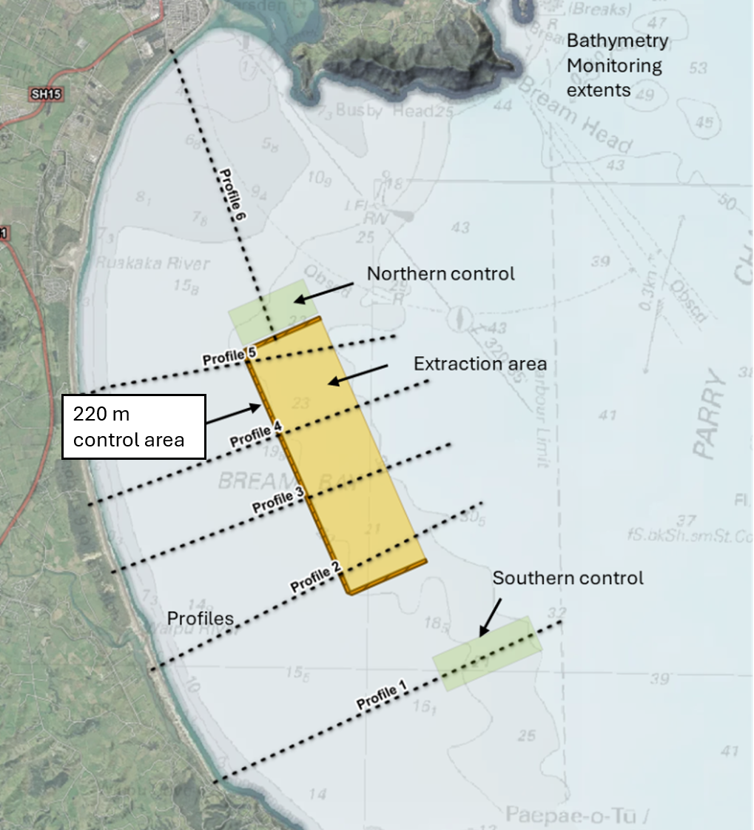
Figure 1: Locations for bathymetry monitoring. Note: Refer to Appendix B for the official map. Source: Tonkin + Taylor.
The MBES survey output is to comprise of:
- Gridded bathymetry surface data at a spatial cell resolution of 1m horizontal.
- A colour-shaded bathymetric map of all data collected and otherwise relied on for the PSEAR.
- Separate colour-shaded bathymetric maps of the extraction area control areas.
- Close up (high resolution) colour shaded bathymetric maps of any anomalous features.
- Profile sections for the 6 profiles from shore to offshore.
- Map view of all MBES backscatter data (separate map).
- Fifteen detailed cross-section transect across the sand extraction area the adjacent 220 m control area and control sites, including relative seabed levels and chainages, water depths, cross-section start and end coordinates to allow accurate comparisons between annual surveys. Analysis transects to be spaced every 500 m as in figure below.
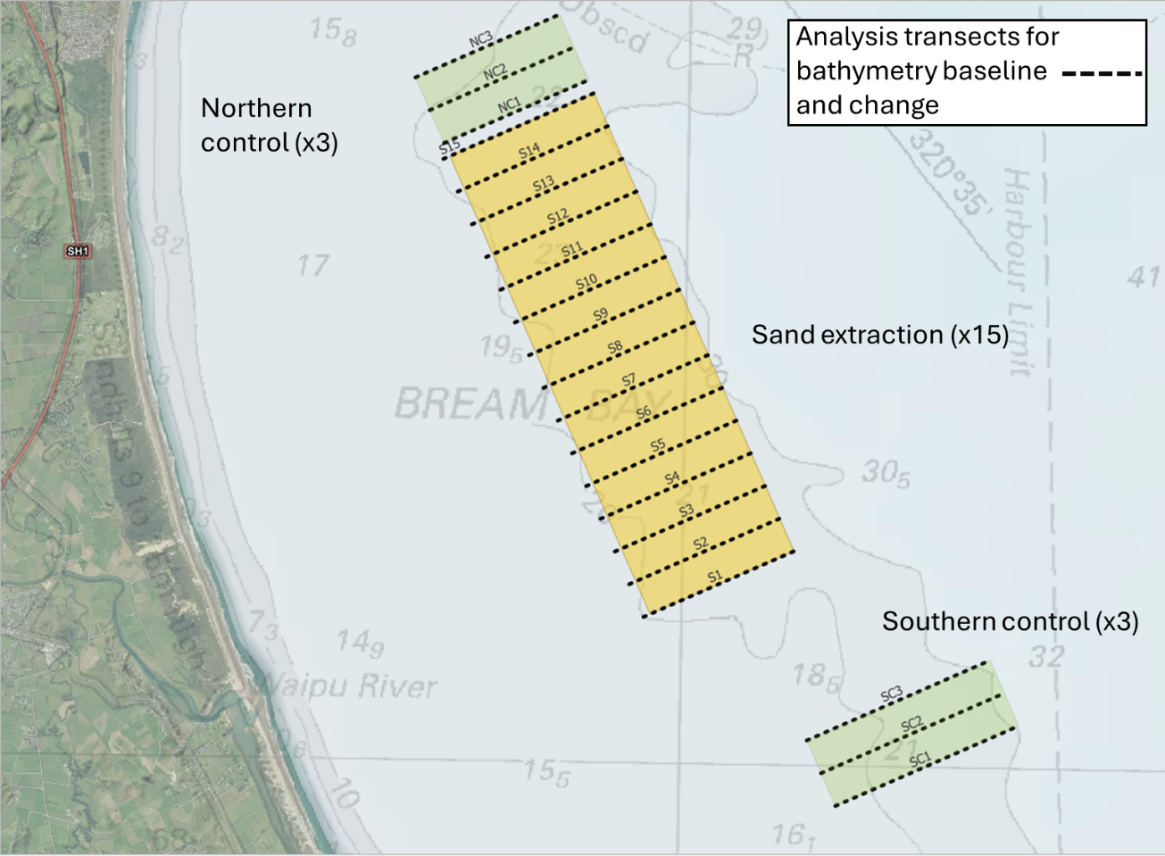
Figure 2: Analysis transects for bathymetry monitoring. Note: Refer to Appendix B for the official map. Source: Tonkin + Taylor.
Assessment:
Analysis of bathymetric survey data with reference to the pre-extraction baseline and all previous monitoring surveys during the consent duration to:
- Identify the presence of any track anomalies that exceed 2 m wide, 0.4 m depth, and 100 m in length.
- Identify potential cumulative effects and inter survey seabed and volume changes by comparing bathymetric difference maps for the most recent survey to the pre-extraction baseline (i.e. for potential cumulative effects), and to the previous surveys (for progressive changes over the consent period).
- Comparing the bathymetry cut volume to the extraction volume records (acknowledging survey accuracy limitations).
- Identify the presence of any changes of the shoreface in the 220 m wide control area that is above the survey error margin of ±0.15 m, and check against change in bed level at control sites.
- Identify any changes of the shoreface between the extraction area and the shore using the six profiles
- Provide interpretation of the causes of any changes that cannot be explained by extraction volume records and tracks, taking survey error, natural processes and storm events into consideration.

Recommendations
Provide adaptive management recommendations that are proportionate to the findings. These are set out below and inform a trigger alert response that is presented in Table 1:
- No adverse effects detected. No track anomalies or seabed changes that exceed the criteria above that cannot be explained by natural processes and/or storm events. Response - No change to the extraction activity.
- Alert for negative trend: Observed seabed lowering within the control area adjacent to where dredging has occurred that cannot be explained by natural processes and/or storm events that is within the survey error margin (i.e. -0.1 to -0.15 m). Response: Increase bathymetric monitoring frequency to 6 monthly.
- Track management: Track anomalies identified within the extraction area that exceed the dimensions in Table 1 being 2 m wide, 0.4 m deep, and 100 m in length. Response - Close cell until recovery is confirmed as per Table 1.
- Adapt for localised effects: Observed seabed lowering beyond ±0.15 m survey error within the seaward half of the bathymetric control area (i.e. seaward 110 m) that cannot be explained by natural processes and/or storm events. Response: Close the most landward cells adjacent to the bathymetric control areas that present a lowering trend and increase bathymetric monitoring frequency to 6 monthly.
- Adapt for minor effects: Observed seabed lowering within the control area that cannot be explained by natural processes and/or storm events with the magnitude of change outside the margin of error (e.g. ±0.15 m) across the entire width of the control area. Response: Close at least the most landward row of cells and consider closing multiple rows of cells to move extraction seaward. A reduction in total extraction volume would occur through maintaining cell-based extraction limits and track spacing/intervals. Increase bathymetric monitoring frequency to 6 monthly and undertake additional site investigations if needed to understand potential effects.
- Identify more than minor effects: A more than minor effect could include bathymetric profile monitoring data showing an observed seabed lowering of the lower shoreface landward of the control area that cannot be explained by natural processes and/or storm events. This could be progressive seabed lowering over multiple surveys that is likely attributed to extraction effects propagating shoreward, when assessed by a SQEP with consideration of metocean conditions, storm events, extraction locations and volumes. Response: Recommend as a minimum, closure of all landward cells across multiple rows of cells to effectively move the activity seaward. A reduction in total extraction volume would occur through maintaining cell-based extraction limits and track spacing/intervals. Increase bathymetric monitoring frequency to 6 monthly and undertake additional site investigations to understand potential effects.

Drop camera images
As part of the requirement to assess the benthic communities as per Condition 16 (and any relevant consent conditions), drop camera images will be taken concurrently or prior to Ponar grab and dredge tow sampling. During each sampling event Drop camera photographs and Ponar grab samples are to be taken in the same stratified random locations in each of the monitoring and control cells. Drop camera images of 1 m² of the seabed, plus lateral views are to be recorded at:
- At least five stratified random locations within each control area cell,
- At least three stratified random locations within cells of the ASEA where sand extraction has occurred since the last SEMR.
The cameras will have a resolution of at least 20MP, including RAW capture. The cameras will be set to record images at 2-second intervals at the best available image quality setting, and the best representative images selected. A vertical image of the seabed will be framed by a 1 m² quadrate to allow measurements and quantification and have a compass for orientation. The lateral image will provide a wider view of the seabed nearby.

The images will have multiple uses;
- To assess changes in fine scale (< 1m) bed forms and as confirmation of the multibeam interpretations,
- To provide an indication of substrate heterogeneity,
- To assess epibenthic habitat for the presence of any conspicuous sensitive benthic species or communities.
Sample locations will be predetermined based on cells, with the cells spilt equally based on the number of samples per cell, sampling points will be randomly located with the spilt cells, but no closer than 50 m from any other sample point. The sampling locations will be located by GPS, with sampling occurring as close as possible but no greater than 20 m from the planned location. These locations will be common to the seabed photographs, sediment texture and benthic biota sampling.

The seabed photography survey output is to comprise of;
- Tabulated results, describing geomorphology and biota observed,
- Maps of key data if deemed necessary,
- Figures presenting each selected photograph.

Sediment Texture
Seabed sediment samples will be collected from:
- At least five stratified random locations within each control area cell,
- At least three stratified random locations within cells of the ASEA where sand extraction has occurred since the last SEMR.
For the proposes of experimental design, the site is deemed to be the cell, and each sample is thus a replicate. Each grab sample will be common to both sediment texture and benthic biota sampling. Samples will be collected with a modified Standard Ponar Grab sampler or similar quantitative technique, with a sample area of at least 250 x 285 mm of seabed (0.071 m²), and a bite depth of about 100 mm, producing sample volumes of 1 - 4 Litres. If the sample volume is less than 2 Litres the grab sample will be discarded and repeated.

The grab will be lowered to the seabed in a controlled manner halting 1-2 m above the seabed, before being lowered gently to the seabed. The grab will be triggered and raised a few metres above the seabed by hand with care to avoid the grab recontacting the seabed as a result of swell troughs and then raised to the surface by winch. The contents of the grab will be deposited in a clean fish bin. The volume of sample will be assessed to confirm a suitable sample has been collected.

The sample will be homogenised by mixing, a 100 ml subsample will be collected with an aluminium scoop into a clean new polyethylene ‘zip lock’-type bag, sealed and double bagged with a pre-printed waterproof label (identifying site, sample date and testing required) between the two bags. A second 100 ml scoop will be collected and composited with other samples from the same cell, sealed and double bagged with a pre-printed waterproof label (identifying site, sample date and testing required) between the two bags. All sediment samples will be placed in a chilly bin and protected from warming. Sediment texture samples will only be chilled in the fridge and not frozen prior to transportation to the laboratory.

Grain size testing will be conducted initially on the cell composite samples, by an accredited laboratory such as Hill Laboratories using accredited testing methods. Samples will be wet-sieved through six sieves (2.0, 1.0, 0.5, 0.25, 0.125, and 0.063 mm) and the remainder collected in the pan. The sieved samples will then be dried and weights recorded as percentages of the total sample. If the composite samples show potential sediment texture trigger exceedances, (greater than 15% silt and clay), then the individual samples from those cells will be tested.

The sediment texture survey output is to comprise of:
- Tabulated results, including sediment texture classification,
- A map or maps showing the distribution of the percentage of silt and clay-sized particles,
- Statistical comparisons between initial, previous and current survey results as per Section 6.7.

Benthic Monitoring
Benthic biota samples will be collected from:
- At least five stratified random locations within each control area cell,
- At least three stratified random locations within cells of the ASEA where sand extraction has occurred since the last SEMR.
For the proposes of experimental design, the site is deemed to be the cell, and each sample is thus a replicate. Each grab sample will be common to both sediment texture and benthic biota sampling.

Once the two 100 ml Sediment Texture sub-samples have been removed from the grab sample, the sample will be sieved as soon as practicable after collection by puddle washing each whole sample through both 3 mm and 1 mm mesh sieves with seawater. Where possible the biota in the sieves will be kept below the puddle water level. No greater than 500ml sub samples will be washed through the sieves at any one time, in order to maximise the potential for observation of macrofauna for the presence of cup corals, by a suitably qualified and experienced person. Biota retained on the 3 mm sieve will be visually inspected by a SEQP for the presence of cup corals or notable macrofauna. If detected they will be photographed, enumerated, and returned to the seabed to minimize potential sampling impacts. The 1 mm sieve mesh was selected based on the known coarse sediment particle sizes, mesh sizes any smaller result in the majority of the sample being retained.

The remaining material retained on both sieves will be combined and transferred to a polyethylene ‘zip lock’-type bag with a pre-printed waterproof label (identifying site, sample date and testing required), and preserved in a solution of 5% glyoxal, 70% ethanol seawater solution. They will be sealed and placed in a second polyethylene ‘zip lock’ bag and packed into labelled plastic containers for transportation to the laboratory.

Following sieving or if sieving is delayed after sampling, all samples will be stored in a cool shaded location and sieved within six hours of collection.

Prior to sorting, the samples will be rinsed on a 1 mm sieve with fresh water and placed in a white sorting tray. All fauna will be picked out of the samples and placed in labelled vials of 70% ethanol solution prior to taxonomic identification. Fauna will be counted and identified to the lowest taxonomic group possible. Only animals with intact heads will be identified and counted, by an SQEP benthic taxonomist. Both living and dead corals will be identified and counted, with the living and dead specimens counted separately. Any biota recorded in the seabed photographs not represented in the benthic biota grab samples at the same location will be added to the quantitative benthic biota data, based on its density of occurrence. Otherwise, it will be added as 1 observed individual to provide a more complete diversity.

The benthic biota survey output is to comprise of;
- Tabulated results, including summary statistics,
- Maps showing the distribution of summary statistics,
- Maps showing the distribution and density of key species based on the combined biota data,
- Statistical comparisons between initial, previous and current survey results as per Section 6.6.

Epibenthic dredge tows
The grab sampling targets the smaller more densely occurring biota within the substrate, and may accidentally capture larger epibenthic biota. However, the area sampled is small and thus the larger biota will not be adequately sampled by the grab sampler. The seabed photographs provide some additional abundance data, but they do not provide size data, nor do they adequately sample the lower-density biota such as carrier shells, scallops, or starfish. It is difficult to determine the living status of gastropod shells observed. Previous sampling has shown that the carrier shells provide microhabitat for brachiopods, which are listed as a sensitive species in Appendix F. Photographs and or video are not sufficient to determine the presence of brachiopods, as they are often obscured under the shells or by other biota, thus epibenthic dredge tows are required to retrieve individual larger biota which can then be identified and measured.

Epibenthic dredge tows will be collected from one random location, spread across two cells (adjoining along the seaward side) within the sand extraction area and control areas.

Each epibenthic dredge tow will consist of lowering a 600 mm wide dredge fitted with a 35 mm mesh bag, to the seafloor and towing at low speed (~<1kt) for approximately 200 m between two predetermined GPS points, in an alongshore direction. All species captured during each tow will be removed and immediately sorted. All larger macrofauna such as bivalves, hermit crabs and starfish, will be identified, photographed, counted, measured and returned to the sea.

The epibenthic biota survey output is to comprise of;
- Tabulated results, including summary statistics,
- Maps showing the distribution and density of key species based on the combined biota data,
- Statistical comparisons between previous and current survey results as per Section 6.6.

Atypical results
If any of the previous sampling methods indicate atypical seabed conditions, then additional video sampling will be conducted in the areas indicated, either by towed video sled and or remote operated vehicle, with the aim of confirming and defining the geographic position of anomalies and if they meet the criteria for exclusion under Condition 20.

Statistics
The infauna in each biota grab sample will be summarised by the following descriptive statistics:
- the number of individuals,
- the number of taxa,
- the Shannon-Wiener Diversity Index
- the density of key taxa such as scallops, bryozoans and tubeworm-associated taxa,
- the percentage of functional groups.
Variations in these indices will be compared by an Analysis of Variance (ANOVA) test if the assumptions of normality and equal variance were not met then nonparametric analogous tests were conducted. The nonparametric equivalent of the one-way analysis of variance (ANOVA) is the Kruskal–Wallis test by ranks. The nonparametric equivalent of the two-way analysis of variance (ANOVA) is the Scheirer–Ray–Hare (SRH) test. If Significant differences were detected, then pairwise multiple comparison procedures such as Tukey tests or equivalent will be conducted to determine where the difference were.

A multivariate analysis approach will allow examination and testing of differences in species assemblages or grain size data between samples, cells and groups of cells.

Typically, the raw benthic biota data has a lot of taxa with very few individuals, the following protocols will be applied in order to “clean” the data to reduce “noise” levels in the data set. If taxa are recorded in 5 samples or less, then taxa will be grouped with similar taxa by either genus or family when possible. If no obvious grouping is present, then these samples will be retained. If fewer than 5 individuals of a taxa are recorded in all the samples, then the taxa will either be deleted or combined in a higher taxon grouping.

Grain size percentages are not independent an increase in one component must be offset by a decrease in another. This violates assumptions of many standard statistical methods. To properly analyse this kind of data, a transformation that accounts for the constant-sum constraint, such as Centred Log-Ratio (CLR) Transformation is required.

The multivariate data of the sediment texture and benthic biota surveys will be visualised by nonmetric Multi-Dimensional Scaling (nMDS) plots. nMDS is a rank-based ordination technique used to visualize similarities or dissimilarities among samples in a low-dimensional space, typically for ecological community data. It creates an ordination based on a distance or dissimilarity matrix, preserving the rank order of the distances rather than the actual distances, allowing for flexible use with many types of ecological distance measures like Bray-Curtis. It is widely used for detecting patterns and gradients in multivariate ecological data.

Permutational Multivariate Analysis of Variance (PERMANOVA) is a non-parametric multivariate statistical test used to compare groups of objects, typically ecological communities or other complex datasets. Multivariate data can differ in relation to the location of the centroid of each group within the multivariate cloud and in the spread of data within a group around each centroid. PERMANOVA tests the null hypothesis that the centroids (multivariate means) and dispersion (spread) of the groups, defined in terms of a chosen distance or dissimilarity measure, are equivalent across all groups. Rejection of the null hypothesis suggests there are significant differences in group centroids and/or dispersion. In order to determine the sources of differences between groups if determined to be statistically significant, the analysis method SIMPER (Similarity Percentage), will be used to assess the contribution of each species or variable to the overall dissimilarity between groups. It breaks down the percentage contribution of individual species to explain differences observed, helping identify species mostly responsible for group separation.

Testing will be conducted to determine whether there are differences between the sand extraction area and the control areas as a whole, and whether there are changes over time in the sand extraction area relative to the control areas. If changes are detected in the sand extraction area, additional testing will be undertaken to determine whether any particular locations are affected differently. Because benthic communities and sediment characteristics vary naturally with water depth, meaningful spatial comparisons are generally limited to locations within equivalent depth bands. Accordingly, spatial analyses will primarily compare cells in the alongshore direction within similar depth ranges. An attempt will also be made to determine whether observed differences are related to varying extraction intensity between cells. Results will be interpreted in the context of the control site envelope, the control site trajectory, ecological significance, and whether any observed divergence is likely attributable to extraction.

Assessment of Monitoring and Reporting Methodologies
The SEMR is to include a review of the monitoring and reporting methodologies to identify any issues arising from the monitoring and reporting methodology being used and to make recommendations to modify/improve the monitoring or reporting methodologies. This may also enable adopting new technology that can improve accuracy and efficiency. Adopting new survey methods should only be undertaken after a trial overlap to ensure compatibility with baseline and past monitoring data.

Plume Monitoring
Turbidity monitoring of the plume shall be conducted during active extraction on three occasions in the first year and then in conjunction with each SEMR to assess the impact of the sand extraction process on water clarity and confirm that the effects are similar to those that have been assessed and that there is compliance with Conditions 31 and 31A.

Monitoring locations
Monitoring shall be conducted at the following locations:
- Plume: 500 m down current from the vessel, aligned with the direction of the sediment plume.
- Background: two locations approximately 300–500 m away from the plume location, perpendicular to either side of the plume direction. These locations must be outside the influence of the plume and serve as background reference points.

Methodology
Turbidity measurements shall be carried out in the field using a handheld optical turbidity sensor and a Van Dorn (or similar) grab sampler.

At least five repeat sensor measurements and five discrete water samples shall be collected within the plume down current from the operating vessel within a one-hour timeframe. During normal sand extraction operations, the survey vessel shall position itself approximately 500 m behind the operating vessel in the direction of the plume, with the sampling location selected to ensure measurements are obtained within the plume under the prevailing conditions. The turbidity sensor shall be lowered to a depth between 2 to 5 m water depth, and a reading shall be recorded once the sensor output has stabilised. At the same time a discrete water sample shall be collected at a water depth between 2 to 5 m using a 5 L Van Dorn grab sampler deployed over the side of the field vessel. Each grab sample shall be sub-sampled into a pre-labelled laboratory-supplied bottle, stored in a chilli bin and dispatched to an appropriately accredited laboratory with a chain of custody on the same day. The survey vessel shall then catch up to the operating vessel and reposition itself approximately 500 m behind the working vessel to repeat this process. Water samples shall be analysed for turbidity (detection limit of 0.05 NTU) and Total Suspended Solids (TSS) (detection limit of 3 g/m³).

During each monitoring occasion, the following shall be recorded for each of the three locations:
- Date and time;
- GPS co-ordinates;
- Photographic evidence of the output of the handheld optical turbidity sensor; and
- Turbidity measurements.
The median of the turbidity measurements and water sample results taken approximately 500 m behind the William Fraser within the sediment plume will be used to determine the turbidity level within the upper 2-5 m of the water column as required for Condition 31.

Consent Conditions
The turbidity level within the upper 2-5 m of the water column at approximately 500 m from the William Fraser in the direction of the plume shall not be more than 2 NTU higher than the greater of either of the two background turbidity measurements.

Trigger response
If the trigger above (6.9.3) is exceeded;
- The known seabed sediment texture composition of the area extracted at the time of water quality sampling will be reviewed,
- An investigation into the maintenance and operation of the ship and its operations shall be conducted to determine whether it is working to the level expected.
Repeat sampling shall be conducted within one month. Further expertise will be required if repeat sampling also exceeds the trigger response. Actions could include, for example, revision of the seabed sediment texture composition exclusion criteria, and or the upgrade or replacement of ship components to achieve compliance with Condition 42.

Monitoring and reporting schedule
Plume monitoring surveys shall be carried out during normal operating conditions at the following times:
- Within 20 working days of the sand extraction activity commencing (commencement survey); and
- At 6 months after sand extraction has commenced (6-month survey); and
- At 12 months after sand extraction has commenced (12-month survey); and
- Thereafter, in conjunction with each SEMR for the duration of the project (SEMR survey(s)).

In accordance with Condition 31A, the results of the plume monitoring shall be submitted to NRC within 10 working days after receipt of the water sample data from the laboratory for each of the commencement survey, 6-month survey, and 12-month survey.

The results of the plume monitoring surveys after Year 1 and required by Condition 31 shall be included in the corresponding SEMR for that year, which is to be submitted in accordance with Condition 37 and as set out in Section 2.5 of this EMMP.

SEMR Recommendations, Triggers and Management Responses
Each SEMR is to include:
- A clear statement as to whether any significant adverse ecological, bathymetric or coastal process effects have been identified. If no significant adverse effects are identified, this is to be stated.
- An assessment of benthic ecological change relative to the control sites, previous monitoring results and, where relevant, the baseline condition.
- An assessment of whether monitored extraction cells are converging toward, remaining within, or diverging from the control site envelope and control site trajectory.
- An assessment of whether any observed changes are likely to be attributable to sand extraction, natural variability, storm events, seasonal variation, other activities, or a combination of factors.
- Recommendations for any changes to extraction location, extraction intensity, recovery periods, cell availability, monitoring frequency, monitoring methods, or the EMMP.
- A summary of the annual and cumulative area disturbed, cells in recovery, recovery status of previously disturbed cells, and any cumulative benthic trends.
- Reporting on indicators relevant to benthic ecological condition and function, including taxa richness, abundance, Shannon diversity, community composition, sediment texture, scallop density and size classes, cup coral records, bryozoans, tubeworm associated taxa, shell associated taxa, functional groups, benthic prey resource indicators, and recovery status.
- An updated ASEA plan whether each cell is suitable for extraction, excluded from extraction, or subject to further assessment.

The SEMR must classify bathymetry monitoring results into one of the following response levels:

Table 1: Bathymetric Response Levels
Response Level | Meaning | Test | Required Response
1 No adverse effects detected | Extraction is operating within expected parameters. No evidence of coastal effects attributable to extraction. The system is behaving within the envelope of natural variability. | • No track anomalies within the extraction area that exceed 2 m wide, 0.4 m depth, and 100 m in length.  • No changes exceeding ±0.15 m within the 220 m wide control area that cannot be explained by natural processes and/or storm events.  • Bathymetric difference maps show no progressive seabed lowering trends beyond natural variability. | • No change to the extraction activity.  • Continue annual bathymetric monitoring programme as consented.  • Record findings in the Sand Extraction Monitoring Report.
2 Seabed change | Seabed change detected in the control area across the seaward half of the bathymetric control area at the lower threshold of concern (within the outer third of the survey error margin). No confirmed evidence of shoreface connectivity effects. | • Observed seabed lowering within the control area adjacent to where dredging has occurred between -0.10 m and -0.15 m (i.e. within the outer third of the ±0.15 m survey error margin) that cannot be explained by natural processes and/or storm events | • Increase monitoring frequency to capture inter-annual variability — additional survey within 6 months.  • Record findings and any recommendations
3 Track management | Track anomalies occur within the extraction area. No seabed level change in the control area or evidence of shoreface connectivity effects. | • Track anomalies within the extraction area that exceed 2 m wide, 0.4 m depth, and 100 m in length are present. | • Close cell where track anomalies are detected until recovery has occurred (geometry of anomaly no longer meets test).  • Increase monitoring frequency to capture inter-annual variability — additional survey within 6 months.  • Record findings and any recommendations
4 Adapt activity proportional to localised effects | Seabed lowering across the seaward half of the bathymetric control area beyond the survey error margin. A potential early signal of extraction-related effects on the shoreface. Extraction must be modified and additional investigation undertaken. | • Seabed lowering within the control area that cannot be explained by natural processes and/or storm events AND is outside the survey error margin (i.e. greater than ±0.15 m), present across the seaward half of the bathymetric control area. E.g. the seaward half only — the seaward 110 m of the 220 m wide bathymetric control area. | • Recommend closure of landward cells adjacent to areas of control site seabed lowering.  • Additional bathymetric survey/investigations required in the areas where changes are identified.  • Monitoring report to include detailed interpretation and causal analysis.
5 Adapt activity proportional to minor effects | Measurable seabed lowering across the full bathymetric control area beyond the survey error margin. A potential early signal of extraction-related effects on the shoreface. Extraction must be modified and additional investigation undertaken. | • Progressive seabed lowering over multiple surveys averaged across the control area that cannot be explained by natural processes and/or storm events AND is outside the survey error margin (i.e. greater than ±0.15 m), present across the 220 m wide bathymetric control area. | • Recommend closure of all landward cells across at least one row and potentially multiple rows of cells to effectively move the activity seaward.  • Recommend a reduction in dredge volumes achieved through cell closure by maintaining cell limits and track spacing as per SEOP .  • Recommend additional surveys/investigations required in areas where changes are identified.
6 More than minor effects detected | Seabed lowering has propagated landward of the control area beyond the survey error margin. | • Analysis of bathymetric profiles show progressive seabed lowering landward of the 220 m control area on the lower shoreface that:  Cannot be explained by other activities, natural processes and/or storm events; and  Is outside the survey error margin of ±0.15 m.  Successive lowering trend confirmed across at least two consecutive annual surveys (to exclude single-event anomalies).  (iv) Is likely indicating the extracting is having an effect that is propagating towards the shore. | • Recommend as a minimum closure of all landward cells across multiple rows of cells to effectively move the activity seaward.  • Recommend a reduction in dredge volumes achieved through cell closure by maintaining cell limits and track spacing as per the SEOP.  • Recommend additional surveys/investigations required in areas where changes are identified.

The SEMR must classify ecological monitoring results into one of the following response levels:

Table 2: Benthic Ecological Response Levels
Response level | Meaning | Indicative test | Required response
No concern / recovered | Extraction cell or cell group are within the expected control site envelope and are moving with, remaining within, or converging toward the control site trajectory. | Values are within the control site prediction interval, ±2 within control standard deviations, or equivalent multivariate control envelope. No adverse directional trend is present. | Continue monitoring in accordance with the EMMP.
Watch / early warning | one indicator shows a possible adverse departure, or  one or more indicators are approaching the edge of the control-site envelope,  but the pattern is not persistent or clearly attributable to extraction. | One indicator falls outside, or approaches the edge of, the control site envelope on one monitoring occasion; or a weak directional trend is apparent but not yet persistent. | Investigate in the SEMR. Review sediment data, storm history, seasonal factors, extraction history, other activities and control site trends. Continue annual monitoring unless the SEMR demonstrates a longer interval remains appropriate.
Trigger / increased monitoring | multiple indicators showing early warning level responses,  or the same or related indicators show repeated departure from the control site envelope,  indicating a developing cumulative divergent trajectory that may be attributable to extraction. | The same or related indicators fall outside the control site envelope over two monitoring events,  or several indicators move in an divergent direction relative to the control site trajectory. | Undertake targeted analysis. Maintain or increase monitoring frequency. Review extraction pattern, cell recovery status and need for targeted monitoring or precautionary cell management.
Action | A substantial, persistent, or ecologically meaningful extraction related divergence is identified, including delayed recovery, sensitive habitat effects, protected taxa triggers, or clear adverse community level change. | A substantial departure from the control site envelope;  significant Time × Treatment interaction;  clear multivariate divergence;  sensitive habitat or protected taxa;  delayed recovery;  or adverse change likely attributable to extraction. | Implement management response, which may include cell suspension or closure for an extended recovery period, reduced extraction intensity, changed extraction pattern, reduced annual extraction volume, or review of the EMMP or consent conditions.

Application of the Control Site Envelope and Weight of Evidence Assessment

In applying the control site envelope, the SEMR must assess whether the apparent envelope for the relevant monitoring event is representative of natural variability. The control site envelope must not be applied as a single event statistical boundary in isolation where the control data for that event are unusually narrow, unusually homogeneous, or otherwise inconsistent with the range of control site variability recorded in the baseline or previous SEMRs.

For univariate indicators, the control site envelope should be based on a statistically justified reference range that may include pooled same season control data, baseline control data, previous SEMR control data, or a mixed effects model incorporating survey year and control area. Where the within control variance in a single monitoring event is unusually small, a conservative variance floor must be applied, based on the pooled or historical within control variance for that indicator, unless the SEMR demonstrates that the narrower range is ecologically justified.

Before classifying a result as a Trigger / Increased Monitoring or Action level response, the SEMR must include a control site diagnostic check. This check must consider whether the control sites in that monitoring event are unusually homogeneous, unusually variable, affected by an outlier, affected by storm or seasonal conditions, or otherwise inconsistent with previous control site behaviour.

A result must not be classified as an Action level response solely because an extraction cell value falls outside a narrow single event control site envelope. Unless the change involves sensitive benthic habitat, protected taxa, a substantial sediment or habitat shift, or another clearly serious ecological effect, an Action level response requires a weight of evidence assessment demonstrating that the change is persistent, ecologically meaningful, and likely attributable to sand extraction.

The weight of evidence assessment must consider, as relevant, the magnitude of change, persistence through time, number of indicators affected, direction of change relative to the control site trajectory, multivariate community response, sediment and habitat condition, extraction history, storm and seasonal effects, and whether the same or related response is observed in more than one cell or monitoring event.

Professional judgement by an SQEP is required when interpreting all trigger and action level responses.

From an ecological perspective, the SEMR must assess whether:
- The cell values for taxa richness, abundance, Shannon diversity, key taxa, sediment texture or functional group indicators fall outside the range of natural variability recorded at the control sites.
- The cell trajectory is moving away from the control site trajectory over time, rather than fluctuating in a similar direction and magnitude to the control sites.
- The divergence is persistent, including whether the same or similar divergence is observed over two consecutive SEMRs.
- The divergence is substantial enough to require action after a single SEMR, particularly where it involves sensitive benthic habitat, protected taxa, a clear sediment shift, or a clear community composition shift.
- The divergence is ecologically meaningful, having regard to the magnitude of change, spatial extent, duration, taxa affected, functional groups affected, and the ecological value of the affected habitat.
- The divergence is likely attributable to sand extraction, after considering natural variability, seasonal effects, storm events, wider environmental change, fishing, port related activities, and any other relevant pressures.

For univariate indicators, an adverse ecological trajectory may be indicated by:
- A continuing decline in mean taxa richness, abundance, Shannon diversity, or key taxa in extraction cells relative to the control site envelope.
- A decline in extraction cell values that exceeds the lower bound of the control site range, prediction interval, or ±2 within control standard deviation range.
- A decline in taxa richness or Shannon diversity of greater than approximately 30% relative to the control site trajectory, where that change is persistent and attributable to extraction.
- A reduction in the abundance of key taxa, including polychaetes, bivalves, amphipods, suspension feeders, bioturbators, or other dominant prey or functional taxa, of greater than approximately 50% relative to the control site trajectory, where that change is persistent and attributable to extraction.

For multivariate community composition, an adverse ecological trajectory may be indicated by:
- Directional divergence of extraction-cell assemblages away from control site assemblages in nMDS, PCO, Bray-Curtis similarity, PERMANOVA, Mahalanobis distance, or equivalent multivariate analysis.
- A significant Time × Treatment interaction, or equivalent test result, showing that the extraction cells are changing through time in a different direction or at a greater magnitude than the control sites.
- A persistent reduction in similarity between extraction cell assemblages and control site assemblages that is greater than the range of dissimilarity recorded among the control sites.
- SIMPER or equivalent analysis identifying that the divergence is being driven by ecologically relevant taxa or functional groups, rather than by minor changes in rare or low abundance taxa only.

For functional indicators, an adverse ecological trajectory may be indicated by:
- Persistent divergence from the control site trajectory in the abundance or occurrence of functional groups, including suspension feeders, deep-burrowing bioturbators, tube builders, shell associated taxa or key benthic prey taxa.
- A shift of greater than approximately 30% in the composition or representation of functional groups relative to the control site trajectory, where that shift is persistent and attributable to extraction.
- Evidence that extraction cells are recovering numerically in terms of abundance or richness but are not converging with control sites in community composition or functional structure.
For key taxa, an adverse ecological trajectory may be indicated by:
- Persistent divergence from the control site trajectory in the abundance or occurrence of key taxa, including, bryozoans, tubeworm associated taxa, horse mussels, scallops, or key benthic prey taxa.
- A shift of greater than approximately 30% in the composition or representation of key taxa relative to the control site trajectory, where that shift is persistent and attributable to extraction.
- Evidence that extraction cells are recovering numerically in terms of abundance or richness but are not converging with control sites in abundance.

For sediment and habitat indicators, an adverse ecological trajectory may be indicated by:
- Persistent divergence in median grain size, mud content, shell content, or sediment composition from the control site trajectory.
- A sediment change that remains outside the control site envelope and is associated with changes in benthic community composition, functional groups, or habitat suitability.
- A reduction in biogenic habitat cover, shell associated habitat, or other habitat forming features within or adjacent to extraction cells relative to the control site trajectory.
- The identification, loss, reduction, or disturbance of sensitive benthic communities, including scallop beds, horse mussel beds, brachiopod beds, bryozoan fields, calcareous tubeworm thickets, sponge gardens, rhodolith beds, peat/consolidated habitat, or other sensitive benthic communities.

Where a watch / early warning level change is identified, the SEMR must state the additional analysis undertaken and whether the matter should be monitored further, whether targeted monitoring is required, or whether a higher response level has been reached.

Where a trigger / increased monitoring level change is identified, the SEMR must recommend whether annual monitoring should continue, whether targeted monitoring is required, whether any cell should remain in recovery for longer, and whether extraction should be spatially redistributed.

Where an action level change is identified, the SEMR must recommend one or more management responses. Available responses include, but are not limited to:
- Continuing annual monitoring rather than moving to three yearly monitoring.
- Increasing monitoring frequency or adding targeted monitoring.
- Closing the affected cell or cells.
- Applying a buffer through closing adjacent cells where required.
- Extending the recovery period before a PSEAR is undertaken to reopen any cell.
- Reducing extraction intensity in affected cells by changing the spatial pattern of extraction.
- Reducing the annual extraction volume.
- Reviewing the EMMP or relevant consent conditions.

The SEMR must clearly state the recommended management response, the reason for that response, the cells affected, and the monitoring required in the following SEMR to determine whether the response has been effective.

SEMR Addressing Increase in Extraction Volume
Following three years of extraction at the initial annual extraction limit of 150,000 m³/year, the relevant SEMR must assess whether the effects of extraction are within the expected and manageable effects envelope before any increase in annual extraction volume to 250,000 m³/year occurs.

For the assessment to be relied on, annual sand extraction must have exceeded 145,000 m³ in each of the three consecutive years immediately preceding the SEMR. This ensures that the assessment is based on monitoring undertaken during extraction at, or close to, the initial maximum annual extraction volume of 150,000 m³/year.

If annual sand extraction has not exceeded 145,000 m³ in each of the three consecutive years immediately preceding the relevant SEMR, the increase to 250,000 m³/year must not occur. In that circumstance, the proposed increase must be reassessed in a later SEMR once three consecutive years of extraction exceeding 145,000 m³/year have occurred.

The purpose of this assessment is to determine whether extraction at 150,000 m³/year has been managed so that significant adverse bathymetric, coastal process and benthic ecological effects are avoided, remedied or mitigated, and whether the proposed increase is not expected to result in significant adverse effects. The assessment must consider the monitoring results from the initial extraction period, the control site envelope, the control site trajectory, the recovery status of previously disturbed cells, and any response levels identified under section 6.10.

Sand extraction cannot increase to 250,000 m³ per annum with a maximum sand extraction rate of 25,000 m³ per month if:

- For each of the previous three consecutive years, annual sand extraction has not exceeded 145,000 m³; and
- Monitoring since the commencement of sand extraction has identified lowering within the 220 m wide bathymetry control area (western side of the extraction area only) exceeding 0.15 m on average which cannot be explained by natural processes (having regard to any bathymetric changes at the northern and southern control sites, the six bathymetric profiles, and hydrodynamic conditions over the three-year period); and
- Monitoring since the commencement of sand extraction has identified ecologically significant statistical adverse change in the benthic biota assemblage, composition, and abundance relative to changes which cannot be explained by natural processes (having regard to the northern, southern and remote control sites); and
- The SEMR required under Condition 37 addressing the change in the extraction volume has not been certified by the Council.

The Consent Holder may choose to delay increasing the extraction volume.

Written Deliverables
A draft SEMR Report including the outputs outlined above and an updated ASEA plan.

The draft SEMR Report is to be provided to Te Parawhau ki Tai for their review and comments. Te Parawhau ki Tai will be given 20 working days to complete that review and provide comments. Comments from Te Parawhau ki Tai may include results from their hapu-led monitoring and assessment of findings against mātauranga Māori indicators of mauri.

A final SEMR Report, including the updated ASEA plan, must then be prepared. The final report must include any comments received from Te Parawhau ki Tai and explain whether, and how, those comments have been addressed.

METHODOLOGY FOR UNDERWATER SOUNDSCAPE CHANGE MEASUREMENT AND ASSESSMENT

Objective
The objective of the Acoustic Monitoring Program (AMP) is to demonstrate that change in the underwater soundscape level at the monitoring locations arising from the Project does not exceed 3dB L_{eq} over any calendar month, or to set out the change and any mitigation response(s) if it is greater than 3dB.

The underwater soundscape is defined in the approval conditions as:

The underwater soundscape at a receiver is the sum of the noise from all sound sources including fish, invertebrates and marine mammals, weather (as specified in the EMMP), sand movements and vessels measured using the Leq descriptor over any calendar month at the monitoring location.

The AMP has three primary components:
- Continuous acoustic measurements for six months to quantify the soundscape before the Project (the ‘before Project’ measurements) and for the same six months with the Project (the ‘with Project’ measurements).
- Assessment of the ‘before Project’ and ‘with Project’ soundscapes, and
- Production of a report setting out the results of the measurement and assessment and the calculation of the overall soundscape change in decibels, adjusted for the maximum permitted extraction volumes in Stages 1 and 2.

Site selection
The AMP monitoring will be undertaken at a location in southern area of Te Ākau Bream Bay approximately 2km north of Langs Beach as selected by a SQEP.
This area of Te Ākau Bream Bay is selected for the monitoring because it is remote from the shipping channels and extraction area and is predicted to have low levels of existing anthropogenic noise sources.
More specifically:
- The soundscape at the monitoring location is predominantly natural, consisting predominately of geophonic and biophonic sound sources.
- The introduction of the Project is predicted to have a higher cumulative effect in the southern areas of Te Ākau Bream Bay where anthropogenic noise is at its lowest, and where the monitoring is proposed.
- By contrast, the northern parts of Te Ākau Bream Bay (closer to the extraction area) are nearer Whangarei Harbour entrance and where shipping traffic converges to narrow shipping lanes that increase the anthropogenic contribution to the soundscapes.

Measurement methodology
- The monitoring location will contain at least one underwater sound recorder. Each recorder must produce 16-bit raw audio files at 48 kHz sampling rates or better. This sampling rate is required to capture the complete soundscape frequency range that is relevant for the marine mammal species that occur in Te Ākau Bream Bay.
- Higher sampling rates are not required as Very High Frequency (VHF) cetaceans (such as hector’s dolphins) producing narrow-band high frequency echolocation clicks are not present in Te Ākau Bream Bay.
- The recorder(s) must be secured 1-2m off the seafloor on moorings specifically designed to minimise extraneous noise sources. This is critical due to the reliance of sound pressure levels being measured to determine the soundscape change due to the Project.
- The recording periods must be continuous (not duty-cycled) for the monitoring period.
- The recordings must be continuous for at least six months before the Project and for at least the same six months with the Project. The ‘with Project’ measurements must commence at the same time as the commencement of extraction.
- Short periods of downtime in the monitoring are permitted provided these are avoided as far as practicable and are due to unforeseen circumstances for reasons such as device loss or failure, timer or data errors, the intervals between swapping recorders during the monitoring, or bad weather delaying retrieval before battery failure or memory capacity being reached. Any gaps in recordings must be clearly defined and explained in the final report.

Soundscape change assessment methodology
The analysis methods/protocol should follow that described in Pine et al. (2021). Additional and specific requirements are set out below:
- Measured sound levels should be calculated for each calendar month of the ‘before Project’ and ‘without Project’ measurement campaigns.
- Measured sound levels are likely to require adjustment to remove hours with high geophony (such as breaking waves and significant swells).
  - Exclusions are likely to be required for wind speeds over 10 knots and/or when the average swell height exceeds 2.5m. The Report shall specify the exclusion parameters.
  - Wind speeds should be taken from the nearest weather station with as near 360º exposure as possible. Northport is best location for these data, available via NIWA’s CliFlo database.
  - The geophony exclusion parameters and exclusions in the ‘before Project’ measurements must be specified following analysis of all hours and sea conditions prior to the Project commencing.
  - The same exclusion parameters must be applied to the ‘with Project’ measurements when the Project commences.
- The daily and monthly data shall be processed following the methodology in Pine et al. (2021). Any variations to this methodology shall be made clear and justified.
- The change in soundscape at the monitoring locations generated by the Project shall be reported for each calendar month, for at least six months. The ‘before Project’ and ‘with Project’ monthly comparisons shall be for the same calendar months (e.g. August 2025 without Project vs August 2026 with Project) unless (7.5) applies below.

Methodology for soundscape change assessment where:

1. ‘Before Project’ monitoring is not available for the same calendar months as the ‘with Project’ monitoring. It is possible that consent may be granted, and extraction could commence in advance of the ‘before Project’ measurements being available for the same six-month period. If that situation arises, there would be no ‘before Project’ measurement data collected for the same calendar months in which extraction could commence.

Or

2. Where monitoring is required at a time when the ‘before Project’ measurements are no longer representative of the soundscape that exists at that time. A Soundscape Change assessment may be required at some time in the future when the ‘before Project’ measurements are out of date and no longer representative of the soundscape that might exist at that time. This could be due to increased or decreased shipping traffic, changes in recreational vessel movements or other changes. The timeframe for such a change could not be forecast at the time this EMMP was prepared.
The following methodology must be followed if (A) or (B) above apply:
  - Soundscape measurements must be undertaken in accordance with the Measurement Methodology set out above, and as soon as practicable following the granting of consent (if it is not already underway).
  - Sand extraction will only be undertaken for approximately 3.5 hours each day. Soundscape measurements in the remaining 20 hours (approximately) will represent the soundscape for the period that sand extraction was not undertaken. The soundscape measurements for each day shall be processed to determine the hourly L_{eq} level for the whole hours that sand extraction makes no measurable contribution to the soundscape.
  - The soundscape for the full day shall be calculated by:
    - Removing the soundscape measurement data where sand extraction did contribute measurably to the soundscape,
    - Calculating the L_{eq} level between sunrise and sunset where sand extraction did not contribute measurably to the soundscape,
    - Substituting the L_{eq} value (from ii) for when sand extraction did contribute measurably to the soundscape,
    - Recalculating the 24-hour L_{eq} from the data derived from i. and ii. above,
    - These recalculated 24-hour L_{eq} levels become the equivalent without sand extraction days for the purpose of the without sand extraction and with sand extraction comparisons required in the Reporting section below.
  - The analysis in section 7.5 may be supplemented with or explained by additional statistical (non-L_{eq}) acoustic data if required.

Reporting
The consent holder must prepare a report as follows:
- Interim Report – no later than eight weeks after the commencement of extraction or the first full 12 calendar months of ‘before Project’ measurements – whichever is the earlier. The Interim Report must set out:
  - The details of all measurements, including locations, wind speed and direction, swell height (if available) and any issues, deficiencies or gaps in the data.
  - The exclusion parameters for geophony and the reasons for their selection, and the L_{eq} levels for each calendar month following those exclusions.
- Final Report – within eight weeks of collecting the recorder/hydrophone after the first six months of ‘with Project’ measurements. The Final Report must set out:
  - All findings from (1) above for ‘before Project’ data,
  - An analysis of the six months of ‘with Project’ measurements using the same assessment methods as for the ‘before Project’ measurements,
  - An analysis of the data collected following the methodology in 7.5 (B) if that is implemented.
  - A method and results for adjusting the ‘with Project’ measurements to represent the contribution of the Project to the soundscape based on maximum extraction rates for Stages 1 and 2 as set out in Condition 23.
  - Comparisons of:
    - With and without sand extraction measured data. The data for with sand extraction months must show the actual extraction rates for those months.
    - With and without sand extraction measured data with adjustments to the with sand extraction data to show the contribution of the Project to the soundscape change using maximum sand extraction rates for Stages 1 and 2 as set out in Condition 23.
  - The soundscape changes for each calendar month shall be expressed as an average, in decibels and rounded to one decimal place.
  - An ultimate conclusion on the average monthly change in soundscape at the monitoring location for each calendar month, arising due to the commencement of extraction, when adjusted for the maximum extraction rates for Stages 1 and 2 set out in Condition 23.
  - An assessment of mitigation options if required, and as set out below.

Mitigation options
If the Final Report demonstrates that sand extraction changed the monthly soundscape at the monitoring locations by an average of 3dB or less in all calendar months, no further action is required.
If the Final Report shows that sand extraction changed the monthly soundscape at the monitoring location by more than 3dB in any calendar month, the Final Report shall set out the mitigation options that will be adopted by the consent holder to reduce the soundscape change arising from sand extraction to no more than 3dB in any calendar month at the monitoring location.
The mitigation options could be physical (e.g. reducing the noise of sand extraction operations at source) or by management (e.g. reducing the time spent in the area).

Certification
The Final Report must be submitted to the Northland Regional Council within 32 weeks of the commencement of the Project.

SAND EXTRACTION AND VESSEL TRACKING RECORDS
Under Condition 34 the following information is to be retained by MBL and submitted to the NRC:

- The date, time and sea conditions during the period of extraction and the water depth of extraction.
- The volume of sand extracted from each cell where extraction has occurred.
- The total volume of sand extracted. In the event that the William Fraser is not fully loaded, the Consent Holder must report the volume of the incomplete load calculated from the onboard sensors measuring compliance with the load line marked on the vessel’s hull in accordance with Maritime NZ requirements before any unloading of sand. The record must include for each load:
- A screenshot or other verifiable way of showing the date and time, and the reading of the sensors; and
- The volume of the load by reference to the load-line.
- An electronic record of the track of the William Fraser (using a GPX file format or equivalent) and mapped using a differential global positioning system (“DGPS”) showing:
- A complete track of the William Fraser from the entry point into and departure point from the sand extraction area.
- A track of the William Fraser showing when the draghead is on the seabed extracting sand and when the dredge head is above the seabed and not extracting sand.

Reporting Requirements
The Consent Holder must provide to the NRC a copy of the records required by Condition 35 quarterly from the commencement of the consent along with a running record of the total volume of sand extraction to date for each cell, and for that month, year and consent period.

If no sand extraction has occurred during that quarterly period, then a statement to that effect will be provided to the NRC.

LOGS
This EMMP is the depository for the various logs required to be kept by the consent holder.

These are:
- Seabird Interaction Log (Condition 38) (Appendix G)
A log is to be maintained to record any seabird fatality or injury arising from an interaction with the William Fraser, recording time and date of interaction, species involved (and a photograph if practical).
A record shall also be kept of any seabird which after alighting on the William Fraser is unable to leave the vessel without assistance (but which appears otherwise uninjured).
This is to be submitted to DOC quarterly for information collection purposes.

- Marine Reptile Sighting Log (Condition 39) (Appendix H).
A log is to be maintained to record any sightings of marine reptiles recording location, time and date of sighting, species sighted and a photograph (if practical).
The log is to be submitted to DOC within 5 working days of a marine reptile sighting.

- Marine Mammal Sighting Log (Condition 40) (Appendix I).
All sightings of Marine Mammals must be recorded in the “Marine Mammal Sighting Log”. A summary the daily Marine Mammal records log shall be submitted to DOC, Te Parawhau ki Tai, and the Patuharaheke Te Iwi Trust Board annually for information collection purposes.

- Marine Mammal Incident Log (Condition 41) (Appendix J).
The Consent Holder must record and report any incident which results in injury or mortality to a marine mammal to the NRC, Te Parawhau ki Tai, and the Patuharakeke Iwi Trust Board and the DOC as soon as practicable.

CHANGE OF EXTRACTION/DISCHARGE METHODOLOGY AND/OR VESSEL
Any change to the approved sand extraction and/or discharge methodology and/or the use of an alternative vessel(s) for extraction to the William Fraser will require written certification from the NRC, before any change in the sand extraction operation or vessel(s) used for the sand extraction.

Any proposed change of vessel or extraction and/or discharge methodology must be notified in writing to the NRC and be accompanied by a report prepared by a SQEP(s) that:
- Identifies the proposed changes and the reasons why the change is being made; and
- Identifies and quantifies expected underwater noise changes resulting from the change and the potential changes in effects arising from these changes (if any);
- Identifies and quantifies expected changes in the discharge (including the size and duration of the visible plum) and the potential changes in effects arising from these changes (if any);
- Identifies any changes to the drag-head extraction width and depth and extraction rates, and the potential changes in effects arising from these changes (if any);
- Includes any changes required to any certified Management Plans; and
- Includes a report from an independent engineering surveyor stating the volume of sand in cubic metres that is carried by the new vessel(s) for extraction and transport when loaded to the load line marked on the vessel’s or vessels’ hull(s) in accordance with Maritime NZ requirements.

The applications for changes and the NRC approval are included in Appendix K

Change Number | Date Lodged | Summary of Changes Sought | Date Approved By NRC | Date Implemented

Appendix A Proposed Sand Extraction Area Drawing
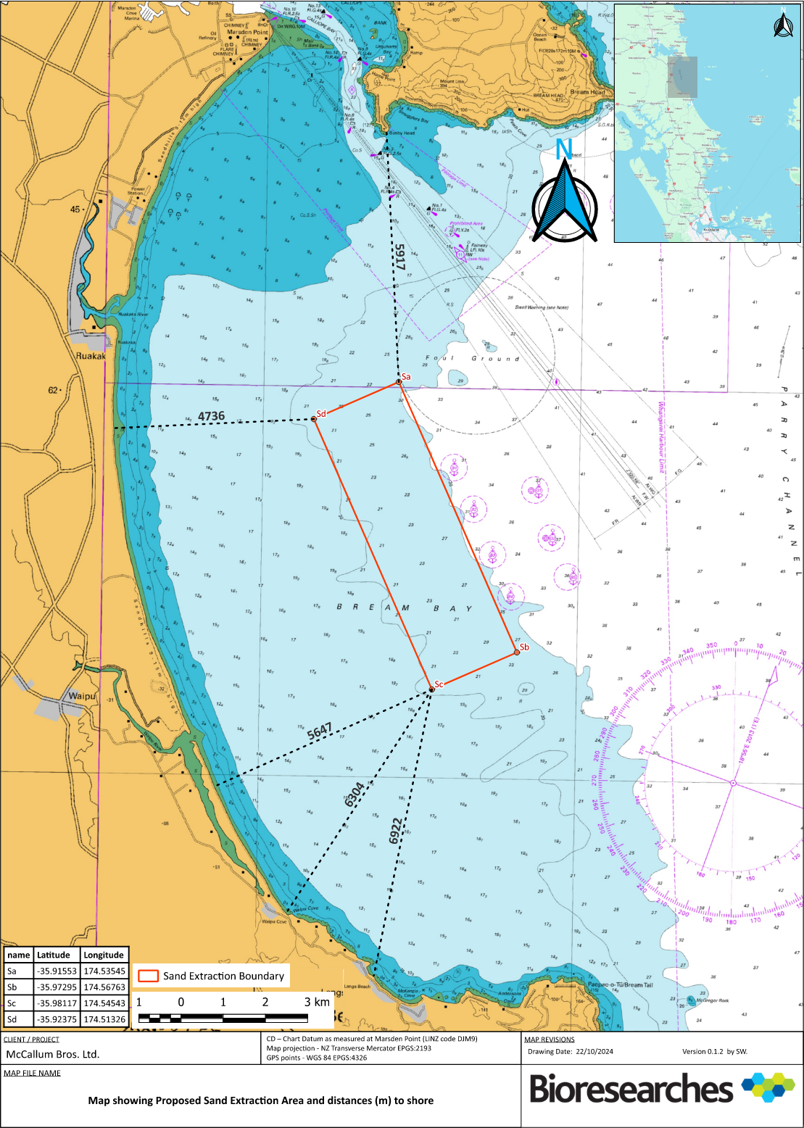

Appendix B Proposed Extraction And Control Cells Drawing
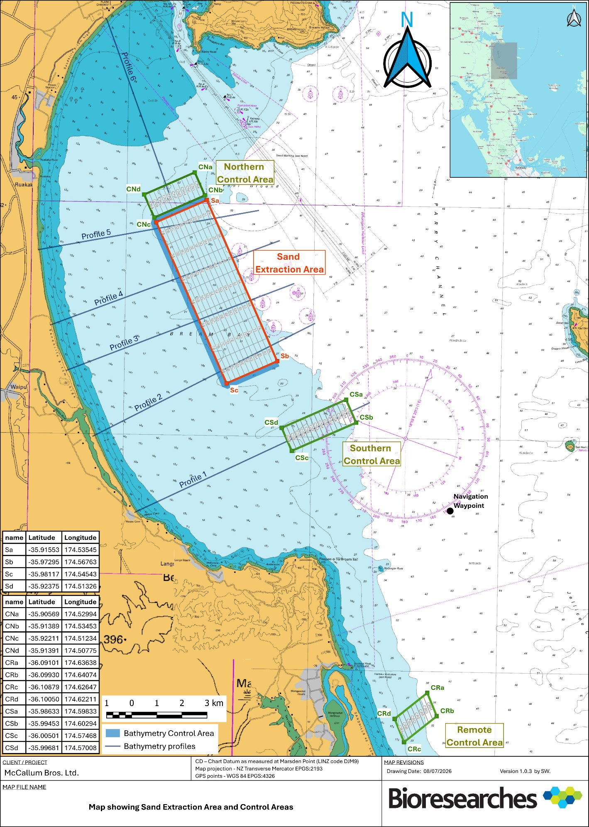

Appendix C Pre Sand Extraction Monitoring Reports (PSEAR)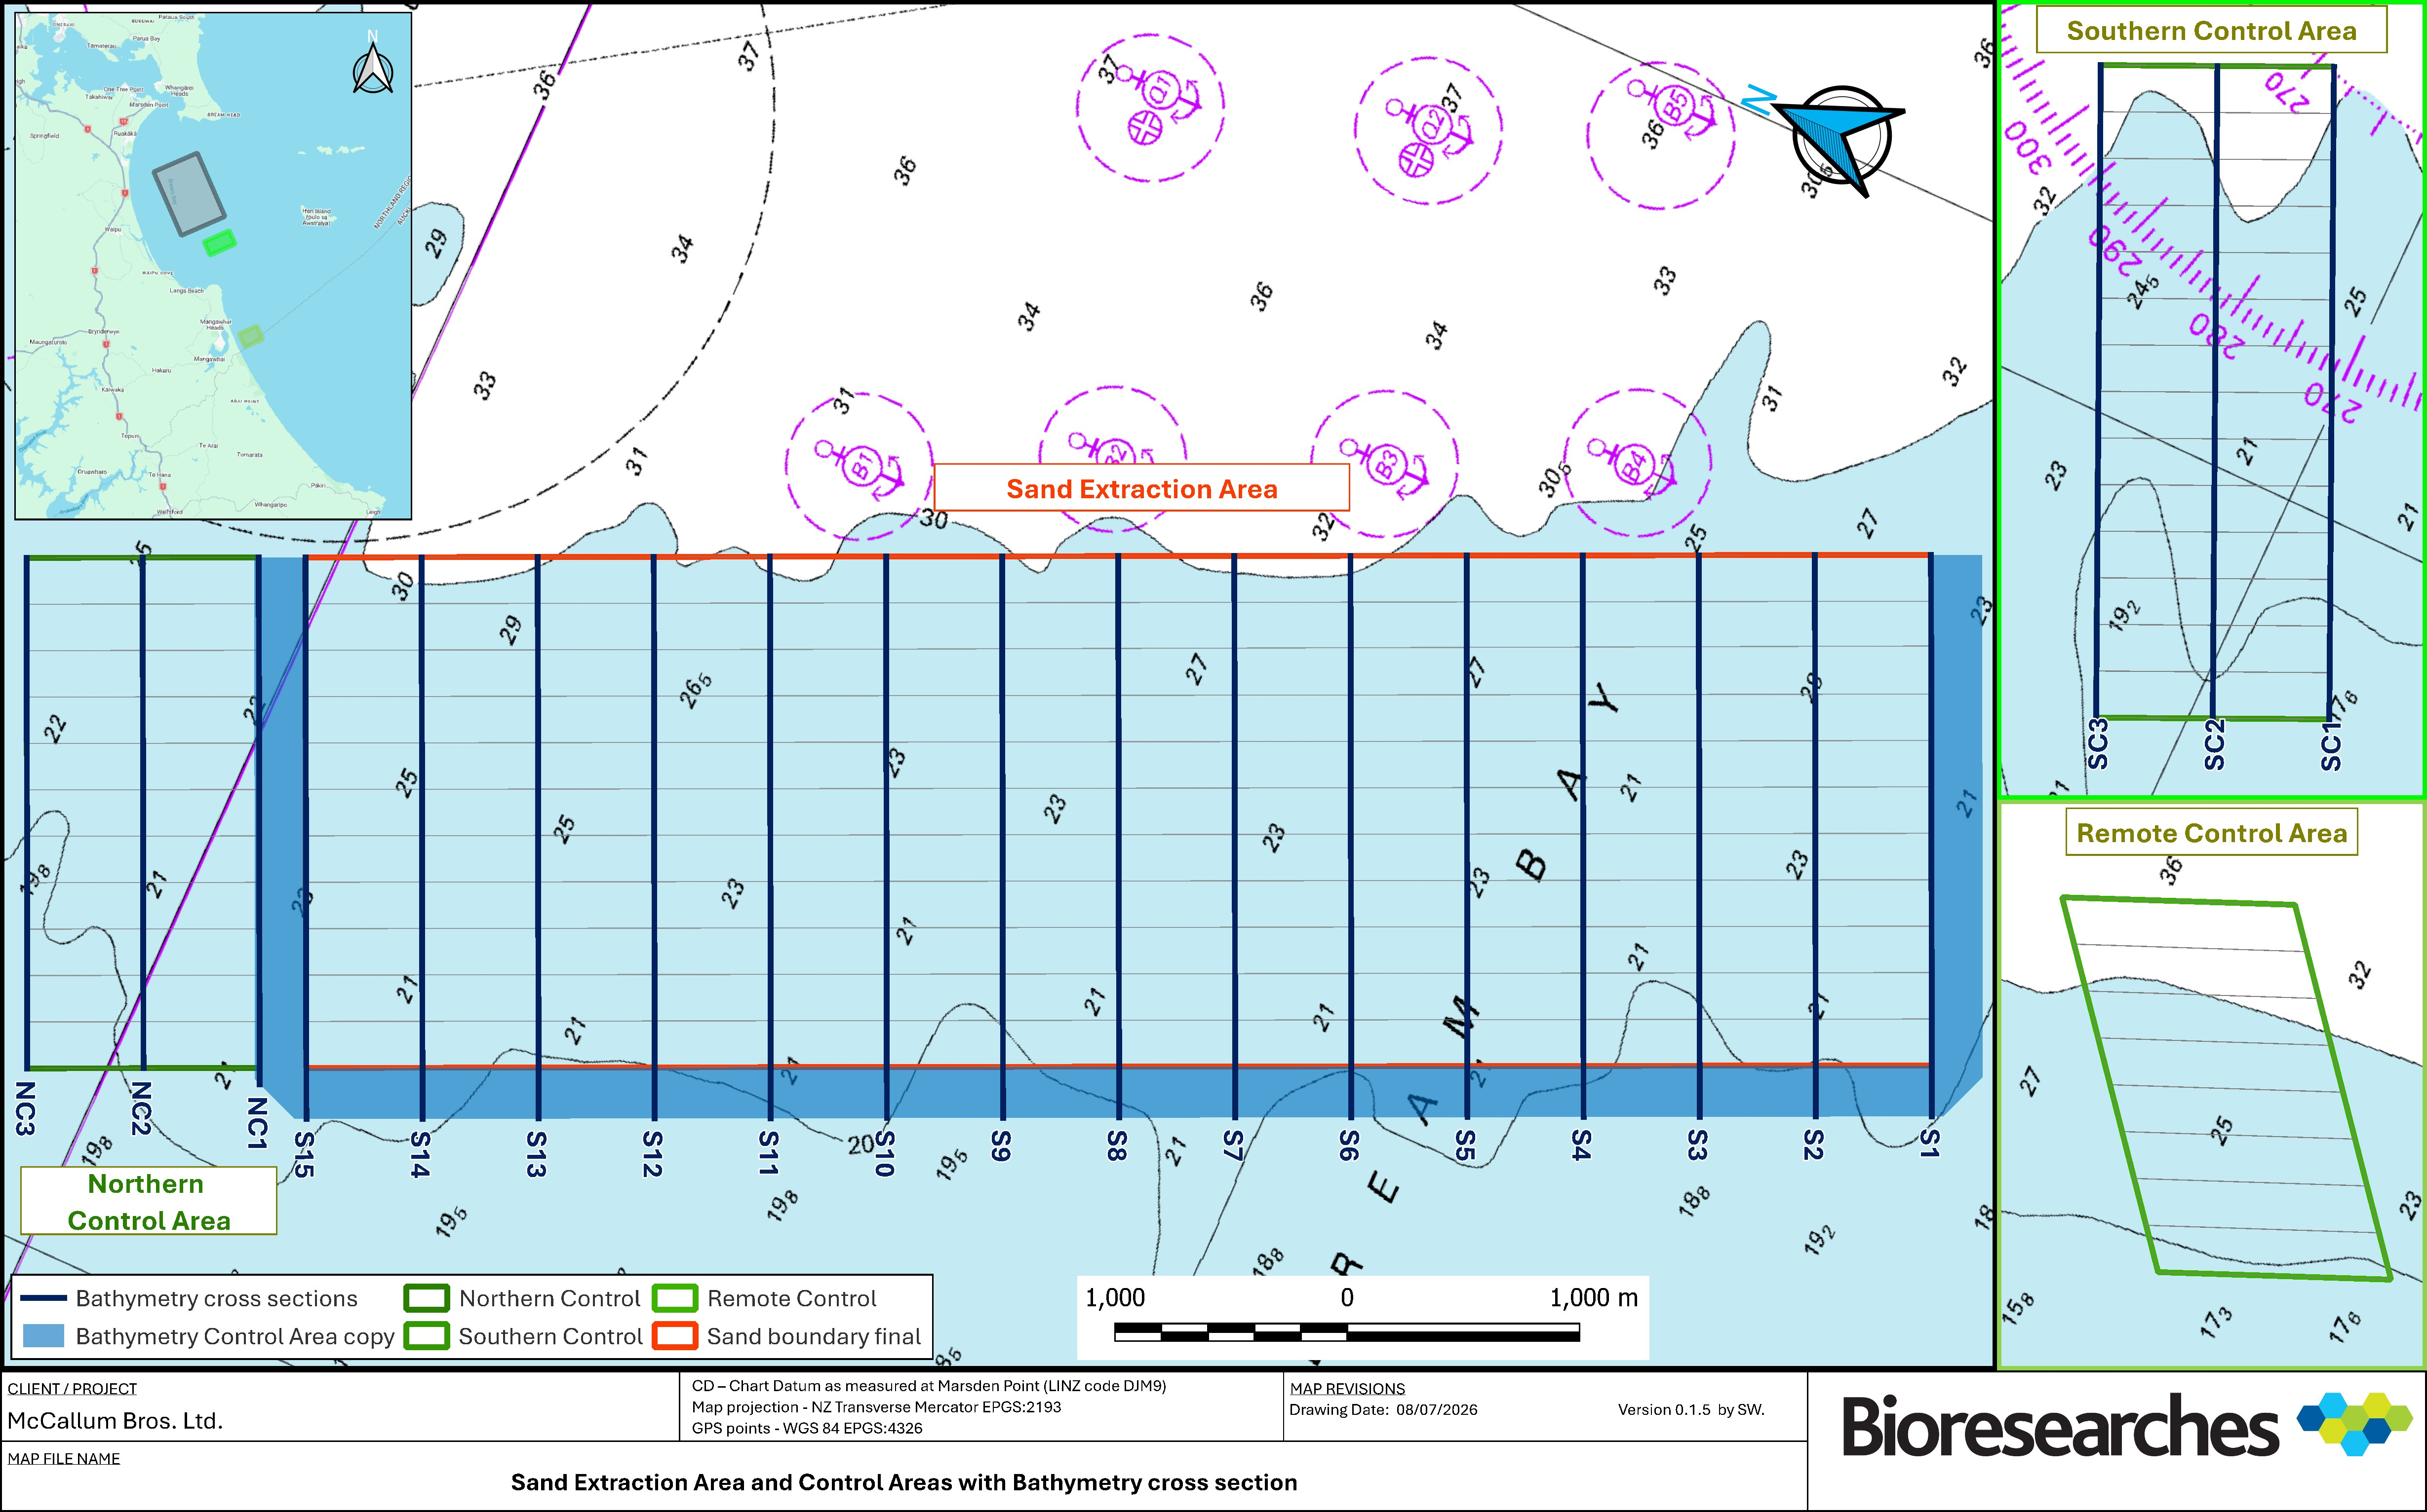

Appendix D Sand Extraction Monitoring Reports (SEMR)

To be appended as per the delivery timeframes set out in Section 2.5.

Appendix E Approved Sand Extraction Area (ASEA)
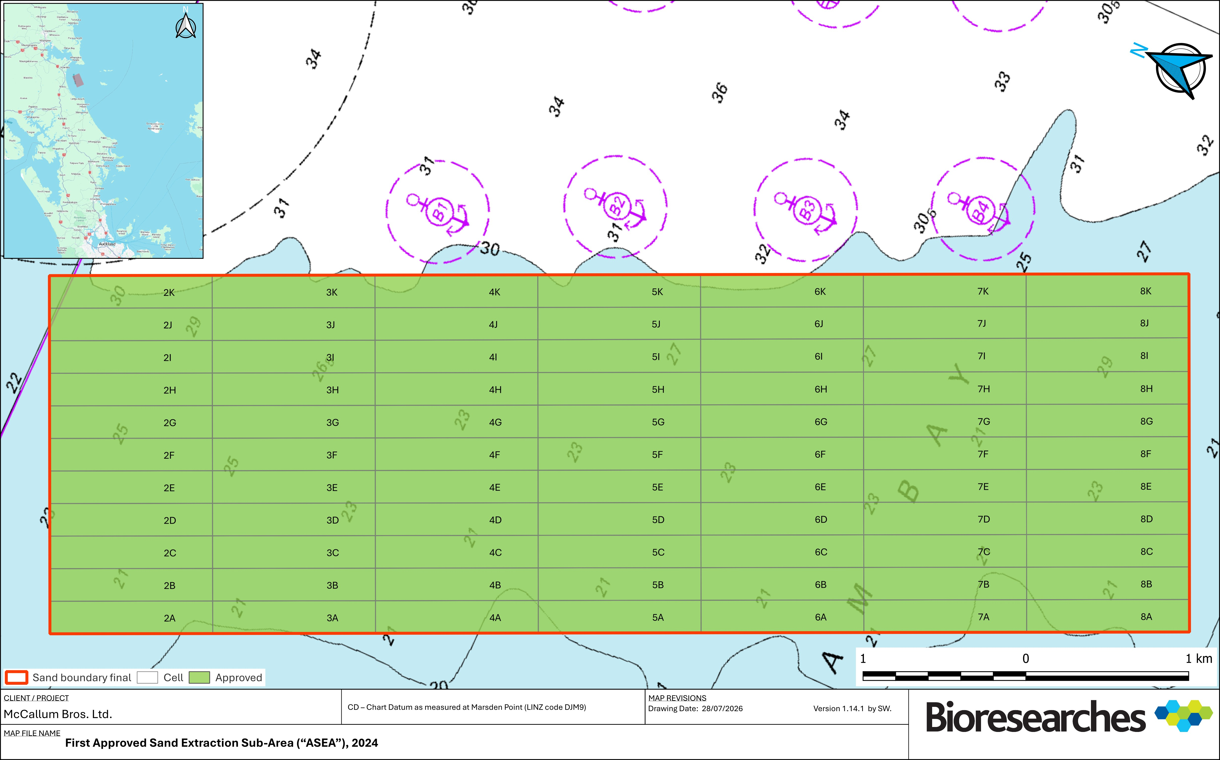

Appendix F Sensitive Benthic Communities
Habitat | Primary indicators
Beds of large bivalve molluscs | A bed of large bivalves exists where living specimens of bivalve species:  - are estimated to cover 30% or more of the seabed on average in visual images of either 1m² or lateral view; or  - comprise 30% or more by average weight or volume in grab samples.  Large bivalves include:  Horse mussels (Atrina zelandica)  Large dog cockle, (Tucetona laticostata)  Dredge oysters (Ostrea Chilensis)  Green lipped mussels (Perna canaliculus)  Geoducks (Panopea zelandica and P. smithae)  Trough Shells (Spisula discors and S. murchisoni)  Triangle Shell (Crassula aequilatera)  Shellfish known to pass through dredge alive at greater than 90% are excluded;  Clam (Dosinia anus, D. subrosea, Bassina yatei)  Myadora sp.
Scallops (Pecten novaezelandiae)  Scallop beds and developing scallop recovery areas | A scallop bed requiring exclusion is indicated where legal or near legal scallops (>100 mm shell width) occur at an average density of ≥0.1 scallops/m² across a cell or relevant part cell. This density should be reviewed when Fisheries New Zealand publishes an accepted commercially viable scallop bed density or other relevant scallop bed density guidance.  A developing scallop bed requiring review is indicated where sublegal scallops 70–99 mm shell width occur at an average density of ≥0.2 scallops/m² across a cell or relevant part cell.  Juvenile scallops <70 mm shell width are not an automatic exclusion trigger based on a single observation. However, repeated observations showing a clear recruitment pulse, or an average density of approximately ≥1 scallop/m² across a cell or relevant part cell, require further assessment and, if confirmed, cell exclusion or avoidance.  These indicators are to be applied using the combined results of video or photographic observations and epibenthic dredge tow data, with greater weight given to consistent results across multiple samples than isolated individual records.
Brachiopod beds | A brachiopod bed exists if:  - one live brachiopod occurs per m² of seabed sampled using seabed photographs; or  - one or more live specimens occur in grab samples.
Bryozoan thicket | A bryozoan thicket (here the term thicket is used synonymously with the terms bed, reef, meadow, etc.) is present if:  - colonies of large frame-building bryozoan species cover at least 50% of the seabed in visual imaging surveys;  - one or more colonies of large frame building bryozoan species occur per m² of seabed sampled using towed sampling gear; or  - one or more large frame building bryozoan species is found in grab samples.
Calcareous tube worm thickets | A sensitive tube worm thicket is present if:  - 2 or more colonies of a mound forming species of tube worm are found in any grab sample; or  - 2 or more colonies are observed at a greater than 10% coverage in a visual image, either 1m² or lateral view.
Chaetopteridae worm fields | A sensitive Chaetopteridae worm field is present if worm tubes and/or epifaunal species:  - contribute 25% or more of the volume of a sample collected in a grab sample; or  - colonies of tube worm species cover at least 50% of the seabed in visual imaging surveys.
Macro-algae beds | Detection of a single occurrence of any fixed specimen of a red, green or brown macroalga at greater than 30% cover is sufficient to indicate that this habitat has been encountered.
Rhodolith (maerl) beds | A rhodolith bed exists if:  - a single specimen of a rhodolith species is found in grab sample; or  - there is more than 10% cover of living coralline thalli in visual images.
Sea pen field | A sea pen field exists if:  - one or more specimens of any species of sea pen is found in a grab sample; or  - two or more specimens per m² are found in seabed imaging surveys.
Sponge gardens | A sponge garden exists if metazoans of Class Demospongiae, Class Hexactinellida, Class Calcarea or Class Homoscleromorpha:  - are estimated to cover 25% or more of the seabed in visual images of either 1m² or lateral view.
Adapted from: MacDiarmid, A. et al (2013). Sensitive marine benthic habitats defined. NIWA client report number WLG2013-18. National Institute of Water and Atmospheric Research, Wellington, New Zealand. Available at: https://environment.govt.nz/publications/sensitive-marine-benthic-habitats-defined/

Appendix G Seabird Interaction Log
Date |  | Location (e.g. inshore) | Trip Number | Time | Observer Initials and Designation | Dredge Activity (dredging or in transit) | Species | Number of Individuals
1
2
3
4
5
6
Continue on Next Page

Approx. Distance from Vessel |  | Heading of Animal from Vessel | Animal Behaviour (e.g. feeding, underway, breaching etc.) | Avoidance/Mitigation Method | Incidents or Mortality (report to Council and DOC if so) | GPS Coordinates
1
2
3
4
5
6

Appendix H Marine Reptiles Sighting Log
Date |  | Location (e.g. inshore) | Trip Number | Time | Observer Initials and Designation | Dredge Activity (dredging or in transit) | Species | Number of Individuals
1
2
3
4
5
6
Continue on Next Page
Approx. Distance from Vessel |  | Heading of Animal from Vessel | Animal Behaviour (e.g. feeding, underway, breaching etc.) | Avoidance/Mitigation Method | Incidents or Mortality (report to Council and DOC if so) | GPS Coordinates
1
2
3
4
5
6

Appendix I Marine Mammals Sighting Log
Date |  | Location (e.g. inshore) | Trip Number | Time | Observer Initials and Designation | Dredge Activity (dredging or in transit) | Species | Number of Individuals
1
2
3
4
5
6
Continue on Next Page

Approx. Distance from Vessel |  | Heading of Animal from Vessel | Animal Behaviour (e.g. feeding, underway, breaching etc.) | Avoidance/Mitigation Method | Incidents or Mortality (report to Council and DOC if so) | GPS Coordinates
1
2
3
4
5
6

Appendix J Marine Mammals Incident Log
Date |  | Location (e.g. inshore) | Trip Number | Time | Observer Initials and Designation | Dredge Activity (dredging or in transit) | Species | Number of Individuals
1
2
3
4
5
6
Continue on Next Page

Approx. Distance from Vessel |  | Heading of Animal from Vessel | Animal Behaviour (e.g. feeding, underway, breaching etc.) | Avoidance/Mitigation Method | Incidents or Mortality (report to Council and DOC if so) | GPS Coordinates
1
2
3
4
5
6

Appendix K Applications for Change of Vessel or Extraction and/or Discharge Methodology and the NRC Approval

^{[1]} Underwood, A. J. (1991). Beyond BACI: experimental designs for detecting human environmental impacts on temporal variations in natural populations. Marine and Freshwater Research, 42(5), 569-587. ^{[2]} Underwood, A. J. (1992). Beyond BACI: the detection of environmental impacts on populations in the real, but variable, world. Journal of experimental marine biology and ecology, 161(2), 145-178. ^{[3]} Underwood, A. J. (1994). On beyond BACI: sampling designs that might reliably detect environmental disturbances. Ecological applications, 4(1), 3-15.
^{[3]} Joint Nature Conservation Committee. (2018). Monitoring guidance for marine benthic habitats (JNCC Report No. 598, revised June 2018). Joint Nature Conservation Committee. ^{[4]} Environment Canada. (2012). Metal mining technical guidance for environmental effects monitoring. Environment Canda. ^{[5]} Environment and Climate Change Canada. (2022). Effects on fish habitat: Benthic invertebrate community survey. Government of Canada. ^{[6]} Central Dredging Association (2024). Adaptive management: A CEDA information paper. Central Dredging Association. ^{[7]} Mcllwaine, P. S. O., Barry, P.J., Curtis, M., & Cooper, K.M. (2025). Tracking long-term benthic recovery at a disused marine aggregate extraction site using monitoring tools developed for the marine aggregate industry. Estuarine, Coastal and Shelf Science, 319, Article 109278.
Monitoring period is likely to be 1-2 years, so to obtain baseline data over all seasons. However, a complete summer and winter are the minimums as the two extremes for vessel activity and different weather effects.

