BENDIGO-OPHIR GOLD PROJECT
SCHEDULE TWO
GENERAL CONDITIONS WHICH APPLY TO ALL OF THE RESOURCE CONSENTS WITHIN THE JURISDICTION OF THE OTAGO REGIONAL COUNCIL
UPDATED 28 AUGUST 2026

These conditions are the clean updated condition sets following the four conditions workshops held in July and August 2026 with planning experts from Otago Regional Council, Central Otago District Council, the Department of Conservation and Kā Rūnaka.
The conditions shaded in light grey wash are where some of the parties have not had sufficient time to fully consider the proposed amendments including as a result of gaining technical advice (with any final comments expected to be provided by 7 September 2026).
Comments are included for some conditions to record points of disagreement between MGL and one or more parties, and to identify conditions where discussion between MGL and parties are in progress and are expected to be resolved by 14 September 2026.
Cross references to other conditions have been updated and are highlighted in yellow wash for ease of finding and checking the accuracy of those cross references when the conditions are finalised. In some instances, a short description of the condition being cross referenced is also provided in square brackets.

tABLE OF Contents

Erosion and Sediment Control 4
Climate Change 10
Water Management 10
Freshwater Ecology Management and Monitoring Plan 15
Geotechnical Management 20
Landslide Risk 20
Open Pits 20
Rise and Shine Underground 23
Dam Structures 24
Tailings Storage Facility 25
Shepherds Seepage Collection Sump and Shepherds Creek Silt Pond 27
Engineered Landforms 29
Stream Diversions and Clean Water Diversion Channels 34
Discharges of Contaminants to Air 36
Attachments to General Conditions for Regional Consents 46

Attachments
Attachment 1: Permanent Diversions and Silt Ponds
Attachment 2: Surface Water Monitoring Locations
Attachment 3: Groundwater Monitoring Locations
Attachment 4: Groundwater Performance Monitoring Location Details
Attachment 5: Surface Water Compliance Parameters and Limits
Attachment 6: Groundwater Compliance Parameters and Limits
Attachment 7: Contents of Ground Control Management Plan for Open Pit Mines
Attachment 8: Tailings Storage Facility Subsurface Drain Layout Plan
Attachment 9: Shepherds Seepage Collection Sump
Attachment 10: Meteorological Monitoring Sites
Attachment 11: Dust Deposition Monitoring Sites
Attachment 12: Particulate Monitoring Sites

Erosion and Sediment Control
No. | Condition
General / Spill Requirements
1 | All earthmoving machinery, and ancillary equipment must be operated in a manner which ensures spillages of fuel, oil and similar contaminants are prevented to the greatest extent practicable. Refuelling and lubrication activities must be set back at a distance of at least 10 m from any water body, ephemeral water body, or overland flow paths that contain flowing water, that is sufficient to ensure that any spillage can be contained and not enter surface water.  This condition does not apply to refuelling of generator sets within proximity waterbody where the area is suitably bunded to prevent any spill from entering any water bodies.
2 | The Consent Holder must install hydrocarbon interceptor(s) at any hardstand area where vehicle maintenance or refuelling occurs.
3 | In the event of a spill of fuel, oil or any other contaminants, the Consent Holder must clean up the spill as soon as detected and take measures to prevent a recurrence.
4 | The Consent Holder must inform the Otago Regional Council (compliance@orc.govt.nz) within 24 hours of any spill event that occurs outside of contained areas, within 10 m of a water body and exceeds the relevant trigger for that hazardous substance in the Spill Response Procedure to be included in the Hazardous Substances Management Plan required by Condition 53 of the Land Use Consent Conditions under the jurisdiction of Central Otago District Council and must provide the following information:  - The date, time, location and estimated volume of the spill;  - The cause of the spill;  - The type of contaminant(s) spilled;  - Clean up procedures undertaken;  - Details of the steps taken to control and remediate the effects of the spill on the receiving water body;  - An assessment of any potential effects of the spill on the receiving water body and measures to be undertaken to prevent a recurrence; and  - A copy of any expert advice obtained by the Consent Holder in responding to the spill.
Erosion and Sediment Control Management Plan
5 | The Consent Holder must prepare and implement the Erosion and Sediment Control Management Plan (“ESCMP”) certified in accordance with Common Condition C18 of Schedule One (or as amended in accordance with relevant conditions), and which forms part of the consents.  Objective  The objective of the Erosion and Sediment Control Management Plan is to protect the environment from erosion and sediment generating activities that occur as a consequence of land disturbance on the Project Site
6 | Management Plan Requirements  To achieve the objective set out in Condition 5, the ESCMP must include, as a minimum:  - Required site erosion sediment control management structure, practices and procedures;  - Required weather monitoring;  - Required erosion and sediment controls design standards;  - Required Site-Specific Erosion and Sediment Control Plans (“SSESCP”);  - Required erosion and sediment control monitoring and review; and  - Required reporting and record keeping.
7 | Management Plan Outcome  To achieve the objective stated in Condition 5, the Consent Holder must achieve the following outcome which must also be included in the ESCMP:  - Erosion and sediment control measures are effective, or are reviewed and revised, to meet the surface and groundwater water quality compliance limits and air quality discharge limits in these conditions that apply to Otago Regional Council through the preparation of Site-Specific Erosion and Sediment Control Plans (“SSESCP”) that are prepared for each key area of the Project Site.
8 | Limits, Standards and Requirements  The following specific limits, standards and requirements must be included in, and achieved through the implementation of the ESCMP (and subsequent SSESCP’s) required under Condition 5:  - The sizing of all erosion and sediment controls as follows:  - Clean and dirty water diversions and sediment retention ponds or bunds sized for a 1 in 2-year rainfall event where the erosion and sediment control is only required for less than 12 months;  - Clean and dirty water diversions and sediment retention ponds or bunds sized for a 1 in 5-year rainfall event where erosion and sediment control is only required for 12 to 24 months;  - Clean and dirty water diversions and sediment retention ponds or bunds sized for a 1 in 10-year rainfall event where erosion and sediment controls are required for a period greater than 24 months; and  - Culverts and ford crossings sized for 1 in 2-year rainfall event; and  - Settling zones for all sediment retention ponds and decanting earth bunds between a depth of 0.6 m to 2 m to achieve laminar flow across the pond.
Site-Specific Erosion and Sediment Control Plan
9 | All earthworks undertaken in the areas listed in this condition must be completed in accordance with a Site-Specific Erosion and Sediment Control Plan (“SSESCP”) developed for that area:  - Administration and work camp area;  - Process Plant and Infrastructure Area;  - Rise and Shine Pit, Haul Road, Shepherds ELF, Shepherds Silt Pond, and Shepherds Tailings Storage Facility;  - Western ELF;  - Come in Time Pit and Backfill; and  - SRX Pit, SRE Pit, and SRX Engineered Landform.
10 | Management Plan Requirements  The SSESCP must contain, at a minimum, the following information:  - Administrative Requirements:  - Weekly site inspections of specific erosion and sediment control measures (such as sediment retention ponds);  - Monthly environmental reporting;  - Pre and post rainfall inspections of specific erosion and sediment control measures (such as sediment retention ponds);  - Independent audit by a Suitably Qualified and Experienced Person;  - Notification and management of environmental incidents;  - Records and registers;  - Environmental roles and responsibilities of personnel (including nomination of Principal Contractor); and  - Site induction;  - Operational Requirements:  - Detailed of the erosion and sediment controls, including:  - Detailed layout plans of the proposed erosion and sediment controls. Layout plans must cover progressive construction, stabilisation and rehabilitation of each area;  - Detailed design of any specific diversion channels or bunds and associated outfall structures;  - Detailed design of any sediment retention ponds or decanting earth bunds;  - Details of any stabilisation works required; and  - Details of dust control approach (where site-specific approach is required);  - Water quality monitoring including sampling locations, frequencies, and triggers including site-specific relationship between turbidity and total suspended solids to enable real-time turbidity monitoring; and  - Chemical and fuel management;  - Sufficient detail to address the following matters:  - Assessment of soil characteristics within earthworks catchments and the necessity for additional erosion and sediment control practices;  - Specific erosion and sediment control works (locations, dimensions, capacity etc);  - Catchment boundaries and contour information;  - Details of construction methods;  - Timing and duration of construction and operation of control works;  - Processes in place if unexpected, contaminated land is encountered;  - Contingency measures for snow and / or frost events (in relation to chemical treatment);  - Adaptive management processes if the controls are found to be inadequate;  - Measures to avoid silt and / or sediment tracking onto sealed roads and then to water for the duration of the earthworks;  - Details relating to the management of exposed areas;  - Monitoring and maintenance requirements; and  - Details relating to the management of long-term soil stockpiling.
11 | The SSESCP required by Condition 9 must be prepared by a suitably qualified and experienced environmental practitioner and must be submitted to Otago Regional Council for certification no less than 20 working days prior to the proposed commencement of the activities in the area subject to that SSESCP.  The purpose of the certification is to confirm that the SSESCP is in accordance with the objective of the Erosion and Sediment Control Management Plan as set out in Condition 5, the requirements for the SSESCP set out in Condition 10 and the relevant standards and requirements in this section of the conditions.
Erosion and Sediment Control - Standards and Requirements and Monitoring and Reporting
12 | The concentration of Total Suspended Solids (“TSS”) in the discharge from any sediment retention device that discharges into Shepherds Creek or Rise and Shine Creek (including diverted sections of those streams) must not exceed 50 mg/L (in dry weather conditions) except when the background concentration of TSS upstream of the point of discharge exceeds that limit, in which case Condition 13(b) will apply.
13 | The works authorised by this consent must not cause:  - Increases in upstream or downstream flows which cause flooding on adjacent land; or  - A conspicuous change in visual clarity in any river beyond the zone of reasonable mixing including downstream of the outlet of any sediment retention device (compared to upstream of the point of discharge).  Advice Note: For the purposes of this condition, the length of the zone of reasonable mixing downstream of the outlet of a sediment retention device is the greater of 50 m, or 10 times the wetted channel width of the receiving environment at the estimated seven day mean annual low flow
14 | The Consent Holder must monitor TSS discharged from each sediment retention device on a monthly basis.
15 | For all sediment retention devices with a planned operational life of 24 months or longer and that discharge into Shepherds Creek or Rise and Shine Creek (including diverted sections of those streams), the Consent Holder must:  - Establish a paired TSS–turbidity relationship for the discharge using representative monitoring data, and calculate a turbidity trigger level based on:  - The TSS compliance limit;  - The regression relationship between turbidity and TSS; and  - The residual variability of that relationship. The trigger should incorporate a conservative buffer (e.g. set at a turbidity value corresponding to 85% of the TSS limit, adjusted for prediction error).  - Establish a paired TSS–turbidity relationship for an appropriate upstream monitoring site using representative monitoring data, and calculate a turbidity trigger level based on:  - The TSS compliance limit;  - The regression relationship between turbidity and TSS; and  - The residual variability of that relationship. The trigger should incorporate a conservative buffer (e.g. set at a turbidity value corresponding to 85% of the TSS limit, adjusted for prediction error);  - Undertake ongoing turbidity monitoring in the discharge from each sediment retention device and at the upstream monitoring site(s), supplemented by weekly TSS sampling for the first six months and then monthly TSS sampling thereafter;  - After the TSS-turbidity relationship has been established, the Consent Holder must update the TSS–turbidity regression and associated trigger level annually as additional data points are collected;  - In the event that the turbidity trigger for the discharge from each sediment retention device is exceeded (but the turbidity trigger for the upstream monitoring site is not) the Consent Holder must:  - Immediately collect a confirmatory TSS sample from the discharge and upstream monitoring site; and  - Cease discharge until the turbidity in the discharge falls below the trigger level developed under clause (a) of this condition due to natural processes or until additional remedial engineering measures are implemented or turbidity at the upstream monitoring site rises above the trigger level developed under clause (b) of this condition;  - Report the results of confirmatory TSS sampling to ORC Compliance; and  - If the TSS sample confirms non-compliance, implement the relevant corrective and reporting procedures.
16 | All disturbed or cut vegetation, soil or debris must be placed in a position where it will not enter, nor cause erosion of, any water body.

Climate Change
No. | Condition
17 | The Consent Holder must make specific allowance for climate change in the assessment of inflow design flood flows for the design of the Tailings Storage Facility (“TSF”), and all diversion channels, pipes or culverts, and ponds associated with the BOGP. The Consent Holder is to use climate change scenario Representative Concentration Pathway (“RCP”) 8.5 for such assessment, unless a clear justification is provided why an alternative RCP is appropriate.  These components are listed below and shown on the plan in Attachment 1 – Permanent Diversions and Silt Ponds to these conditions:  - North TSF Clean Water Diversion Channel;  - North ELF Stream Diversion;  - Shepherds ELF Clean Water Diversion Channel;  - Pipe across the TSF Crest;  - Shepherds Creek Stream Diversion;  - Process Plant Clean Water Diversion Channel;  - RAS Stream Diversion;  - SRX ELF Clean Water Diversion Channel;  - SRX ELF Dirty Water Diversion Channel; and  - Shepherds Silt Pond.

Water Management
No. | Condition
Water Management Plan
18 | The Consent Holder must implement the Water Management Plan (“WMP”) certified in accordance with Condition C18 in the Common Conditions in Schedule One (or as amended in accordance with relevant conditions), and which forms part of the consents.  Objective  The primary objective of the WMP is to ensure that water is managed in a way that protects the environment, supports operational needs, and meets regulatory requirements.  The key objectives of the WMP are to:  - Identify roles and responsibilities for MGL personnel to ensure the management plan achieves its objectives;  - Protect the receiving environment by ensuring any water discharges do not cause contamination that adversely affects aquatic ecology or human health;  - Explain the water quality limits set out in resource consents and relevant guidelines;  - To ensure water use is sustainable across all phases of the project, including construction, operations, closure, and post-closure, and does not lead to long-term depletion of surface or ground water bodies;  - Classify and manage water appropriately based on its source and quality (e.g. clean water, mine impacted water and aquifer water);  - Design and implement infrastructure that supports effective water capture, diversion, treatment, and discharge;  - Monitor water quality and quantity to inform adaptive management processes and ensure compliance;  - Support closure outcomes by ensuring water management infrastructure and practices align with long-term rehabilitation goals; and  - Identify and manage risks associated with water quality and quantity through a structured risk management framework.
19 | Management Plan Standards, Limits and Requirements  To achieve the objective stated in Condition 18, the Consent Holder must achieve the following outcomes, which must be included in the WMP:  - Reliable water supply to the processing plant;  - Effective water availability and distribution across the site to support mining and associated activities;  - Controlled movement and storage of various water classes;  - Water discharges within compliance limits;  - Proactive monitoring and adaptive management processes and relevant triggers;  - Long-term sustainability of water use in a water-deficit environment;  - Zero release of untreated mine-impacted water during operations and construction phases (except surficial mine-impacted water and RAS Open Pit water used for dust suppression purposes provided it does not exceed 500mg/L of sulfate); and  - Successful transition to active and post-closure, including active and passive water treatment systems that help achieve water quality objectives.  Advice Note: Mine-impacted water (including the sub-categories of surficial and mine circuit water) is defined in the Common Conditions that apply to Central Otago District Council and Otago Regional Council in Schedule One.
Monitoring and Compliance
Surface Water Monitoring
20 | The Consent Holder must undertake monthly surface water quality monitoring at the following locations, which are shown on the plan in Attachment 2 – Surface Water Monitoring Locations, in relation to the parameters set out in Attachment 5 – Surface Water Compliance Parameters and Limits:  Compliance Site  - SC01 – Shepherds Creek Compliance Site.  - RS03 – Rise and Shine Creek Compliance Site.  Control Site  - CC01 – Clearwater Creek Control Site.  Monitoring Site  - SW13 - Lindis River at Ardgour Road (ORC State of the Environment Monitoring Site); and  - SW14 - Bendigo Creek at BSL Gauging Site (Bendigo Station).
21 | The Consent Holder must undertake continuous water monitoring at SC01, RS03 and CC01 as follows:  - Flow meter or water level;  - Electrical conductivity; and  - Turbidity (NTU).
Surface Water Quality Compliance Limits
22 | The Consent Holder must comply with the Surface Water Quality Compliance Limits set out in Attachment 5 at:  - SC01 – Shepherds Creek Compliance Site; and  - RS03 – Rise and Shine Creek Compliance Site.  Advice Note: The Surface Water Quality Compliance Limits define the environmental outcomes that the operation of the BOGP must achieve in relation to surface water and are the subject of consent conditions as well as being set out in the WMP. In addition to the Surface Water Quality Compliance Limits, the WMP includes an extensive programme of ‘performance monitoring’. The latter is for internal management purposes to assist the Consent Holder in the achievement of the Surface Water Quality Compliance Limits and is not the subject of specific consent conditions (other than Common Condition C18 (Schedule One) requiring the Consent Holder to implement the WMP). Despite that, the results of the performance monitoring must form part of the Annual Surface Water and Groundwater Monitoring Report required by Condition C14.
Groundwater Monitoring
23 | The WMP must set out the groundwater performance monitoring the Consent Holder must implement, including:  - Monitoring purpose, location, frequency, and parameters being measured;  - Reporting of data in the annual report by a Suitably Qualified and Experienced Person;  - Advice by a Suitably Qualified and Experienced Person on trends; and  - Identification of any adaptive management responses triggered by the performance monitoring data.
24 | The Consent Holder must undertake monthly groundwater quality and groundwater level monitoring at the following locations, which are shown on the plan in Attachment 3 – Groundwater Monitoring Locations, in relation to the parameters set out in Attachment 6 - Groundwater Compliance Parameters and Limits:  - GW01 – Compliance Bore (Ardgour Station); and  - Base Bore – Production Bore (Abstraction Borefield).  Advice Note: The Base Bore is also subject to conditions attached to the Water Take Consent CB13/0215 including a requirement to record and telemeter the rate of take.
25 | The Consent Holder must undertake continuous water monitoring at the two groundwater monitoring locations listed in Condition 24 as follows:  - Water level; and  - Electrical conductivity.
26 | The Consent Holder must, at a minimum, undertake groundwater performance monitoring at the locations set out in Attachment 4 of these conditions.
Groundwater Compliance Limits
27 | The Consent Holder must comply with the Groundwater Quality Compliance Limits set out in Attachment 6 at:  - GW01– Compliance Bore (Ardgour Station); and  - Base Bore – Production Bore (Abstraction Borefield).  Advice Note: The Groundwater Quality Compliance Limits define the environmental outcomes that the operation of the BOGP must achieve in relation to ground water and are the subject of consent conditions as well and being set out in the WMP. In addition to the Groundwater Quality Compliance Limits, the WMP includes an extensive programme of ‘performance monitoring’. The latter is for internal management purposes to assist the Consent Holder in the achievement of the Groundwater Quality Compliance Limits and is not the subject of specific consent conditions (other than Common Condition C18 (Schedule One) requiring the Consent Holder to implement the WMP). Despite that, the results of the performance monitoring must form part of the Annual Surface Water and Groundwater Monitoring Report required by Condition 34.
Accuracy of Water Measuring Systems
28 | As part of the design and implementation of any water measuring systems, and upon any subsequent request of the Otago Regional Council, the Consent Holder must undertake an assessment of the accuracy of the water measuring system(s). Each system must have a reliable calibration to water flow and must be maintained to an accuracy of +/- 5%. The assessment must be undertaken by an independent, qualified person and evidence documenting the assessment must be forwarded to the Otago Regional Council within one (1) month of the assessment occurring.
Modelling Studies
29 | The Consent Holder must maintain the Water and Load Balance Model (“WLBM”) to refine site water surpluses and deficits against anticipated effects as well as understand how the Tailings Storage Facility will recover following extreme precipitation events. The WLBM must, at a minimum:  - Represent the operational period of mining;  - Include all relevant mine domains (including all engineered landforms, the tailings storage facility and open pit and underground dewatering);  - Forecast operational water balance and quality conditions;  - Incorporate sensitivity scenarios addressing uncertainty in climatic variability, worst-case scenarios (examples include high net percolation, poorer water quality, high flows and high dewatering estimates); and  - Be updated annually over the life of mine to incorporate performance monitoring data (including empirical flow rates and source terms) or as updated mine plans materially change how water is managed on site.  The WLBM must be made available to the Otago Regional Council on request.
30 | As the WLBM is updated with empirical data collected as part of the performance monitoring programme (refer to Condition 34), the Consent Holder must revise the project water balance and provide an update to the Otago Regional Council in the Annual Surface Water and Groundwater Monitoring Report (refer to Condition 34).
31 | Prior to the final detailed design of Mine Waste Storage Facilities (“MWSF”), including the tailings storage facility and engineered landforms, the Consent Holder must commission 3D contaminant transport modelling studies to support the design of seepage collection elements to achieve appropriate levels of seepage collection to ensure downstream receptors are not adversely affected. The contaminant transport modelling studies must be made available to the Otago Regional Council on request.
32 | The Consent Holder must commission a comprehensive pit lake model that will include biogeochemical processes, nutrient assessment, and scenario modelling. This should be completed as part of closure readiness planning during the mining operations phase of the BOGP.
33 | To inform the Mine Closure Plan, the Consent Holder must prepare a WLBM for the Closure and Post Closure phases of the BOGP.
Reporting
34 | The Consent Holder must, as part of the Annual Monitoring and Compliance Report required by Condition C14 in the Common Conditions in Schedule One, provide to the Otago Regional Council a report (“Annual Surface Water and Groundwater Monitoring Report”) which includes:  - A summary all monitoring undertaken during the previous year, including compliance and performance monitoring (as set out in these conditions and / or the Water Management Plan as applicable), and the results of that monitoring including tables, graphs and summary data of water quality, flow and water level monitoring;  - A summary of compliance and / or non-compliance with resource consent conditions that specify surface water and groundwater compliance limits; and  - A summary of any works that have been, or are proposed to be, undertaken to improve environmental performance and/or compliance with consent limits.

Freshwater Ecology Management and Monitoring Plan
No. | Condition
Freshwater Ecology Management and Monitoring Plan
35 | The Consent Holder must implement the Freshwater Ecology Management and Monitoring Plan (“FEMMP”) certified in accordance with Common Condition C18 (or as amended in accordance with relevant conditions), and which forms part of the consents.  The objective of the FEMMP is to achieve equal or better aquatic ecological and riparian vegetation values within the watercourses within the BOGP Consent Area.  With respect to stream diversions, the objectives of the FEMMP are to:  - Design and implement stream diversions replicate the existing Shepherds Creek and Rise and Shine Creek to the extent practicable (including mimicking the width and length, hydrology, natural meandering and aquatic habitat);  - To promote the naturalisation of stream diversions over the life of the BOGP;  - To prevent infill run-off or sediment-laden water entering the rehabilitated streams; and  - To reestablish revitalised instream indigenous flora and fauna (including through the placement of rocks, soil and salvaged plants and the establishment of runs, riffles and small and large pools) and riparian margins to enhance the aquatic ecosystem habitat.
36 | To achieve the objective set out in Condition 35, the FEMMPP must, at a minimum, include:  - A summary of the aquatic ecological values within water bodies affected by the project and the potential effects of the project on these values;  - Details of the approach to be taken to manage adverse effects on aquatic ecology values within the affected water bodies;  - Maps showing:  - The location and extent of streams to be diverted and artificial watercourses to be created; and  - The location and extent of stream reaches and artificial watercourses proposed for restoration works;  - Stream diversion design principles (in accordance with Condition 37);  - Details of monitoring and reporting to the Otago Regional Council prior to, during, and post construction and operation to determine if the FEMMPP objectives are being met (including the requirements in Condition 38);  - Aquatic ecological monitoring of macroinvertebrates and periphyton in accordance with Condition 39; and  - Details of the roles and responsibilities of key staff responsible for implementing the FEMMP.
Stream Diversions
37 | Stream diversions must be undertaken in accordance with the following high-level principles of design:  - As much as practicable, the diversion should be designed with an average width of no less than 0.8 m, and preferably 1 m for Shepherds Creek, and no less than 0.5 m for Rise and Shine Creek;  - As much as possible, the stream diversion channel must be of a similar length to the channel to be reclaimed. This aims to ensure that there is no loss of extent and values of the watercourse;  - While the channel design does not have to replicate the form of the channel to be reclaimed, it must have a low-flow (or baseflow) channel, a bank full channel and a floodplain area (where available);  - As much as possible, water flow should mimic the hydrological character of the existing watercourse (i.e. flows intermittently or permanently same as existing channel);  - The design (on paper) of the final diversions must have a Stream Ecological Valuation (“SEV”) score equal to or greater than that measured in the corresponding diverted reaches prior to works beginning as set out in the FEMMP; and  - The area of the final diversion at seven day mean annual low flow (“7dMALF”) must be equal to or greater than that measured in the corresponding diverted reaches prior to works beginning.  Advice Note: The stream ecological values valuation of the existing streams and final diversion designs are to be calculated by a suitably qualified and experienced person (“SQEP”) in accordance with the methodologies set out the “Stream Ecological Valuation (SEV): A User’s Guide (Auckland Council Report No. GD2011/001). Auckland Council, Auckland, New Zealand”. For the avoidance of doubt, no further or additional SEVs need to be constructed for any other purpose in relate to these consents.  The following functions are not considered when calculating the SEV:  - Fish fauna intact; and  - Invertebrate fauna intact.
Monitoring and Reporting
38 | By 30 November each year, the Consent Holder must prepare an Annual Freshwater Ecology Monitoring Report as part of the Annual Monitoring and Compliance Report, required by Common Condition C14 in Schedule One, which covers activities for the previous year’s monitoring period. The monitoring report must include:  - A description of the stream works, riparian planting, and other related actions completed by the Consent Holder in the previous twelve months, and a description of how and to what extent these works contribute towards achieving the SEV scores required under Condition 37;  - The results of the aquatic ecological monitoring and sediment quality monitoring required under Conditions 39 and 40;  - Where aspects of the FEMMP have not been implemented in accordance with expected timeframes, the Annual Monitoring and Compliance Report must include the reasons why, and the reasonably practicable measures that have been taken by the Consent Holder to address the failure to meet those timeframes; and  - Whether there should be amendments made to the FEMMP which would better assist the Consent Holder in meeting the objectives of the FEMMP and the requirements in the freshwater ecology conditions.
Aquatic Ecological Monitoring
39 | The Consent Holder must undertake the following aquatic ecological monitoring:  - Annual summer macroinvertebrate and periphyton monitoring undertaken in Shepherds Creek at sites located upstream and downstream of the treated seepage water discharge point as set out in the FEMMP;  - The frequency, location and methodology of annual summer macroinvertebrate and periphyton monitoring must be set out in the FEMMP;  - Macroinvertebrate monitoring is undertaken in accordance with the quantitative hardbottom protocols described in Stark et al. (2001) (or any subsequent approved update);  - Periphyton biomass and cover monitoring must be undertaken in accordance with the relevant National Environmental Monitoring Standards (“NEMS”) protocols (MfE, 2022);  - If monitoring demonstrates a reduction in Quantitative Macroinvertebrate Community Index (“QMCI”) and Macroinvertebrate Community Index (“MCI”) of greater than 20% above natural background variation between the upstream and downstream sites, the Consent Holder must engage a suitably qualified and experienced person (“SQEP”) to investigate the cause of the change and recommend appropriate remedial actions; and  - If periphyton biomass exceeds 200 mg chlorophyll-a per m² and / or weighted composite periphyton cover exceeds 50% at the downstream site but not at the upstream site, the Consent Holder must engage a SQEP to investigate the cause of the degradation change and recommended appropriate remedial actions.  The results of this monitoring and any recommended remedial actions undertaken must be included in the Annual Monitoring and Compliance Report under Condition C14 in the Common Conditions in Schedule One.
Sediment Quality Monitoring
40 | The Consent Holder must undertake the following sediment quality monitoring programme:  - Baseline sediment quality monitoring to develop and maintain a Baseline Sediment Quality Record for Shepherds Creek and Rise and Shine Creek. The Baseline Sediment Quality Record for each creek must:  - Comprise sediment quality monitoring results collected prior to the commencement of mining operations at the relevant upstream reference site specified in clause (b) before and during mining operations; and  - Contain no fewer than 20 data records for each parameter listed in the Toxicant Default Guideline Values (“DGV-High”) for Sediment Quality in the ANZG Guidelines within five years of the commencement of mining operations.  - Annual monitoring of the quality of deposited fine sediment (less than 2 mm) in Shepherds Creek and Rise and Shine Creek downstream of where mine-impacted water enters the creeks at:  - SC01 – Shepherds Creek Compliance Site;  - RS03 – Rise and Shine Creek Compliance Site;  - An appropriate control site between CC01- Clearwater Creek Control Site and RS03 – Rise and Shine Creek Compliance Site;  - At a suitable reference site in Shepherds Creek upstream of where mine-impacted water enters; and  - A suitable reference site in Rise and Shine Creek upstream of where mine-impacted water enters.  - The methodology and frequency of the baseline and annual sediment quality monitoring must be set out in the FEMMP, and at a minimum must include the following requirements:  - Monitoring to be undertaken by an SQEP;  - Samples must be analysed by an IANZ accredited laboratory; and  - The development of a Sampling and Analysis Quality Plan (“SAQP”) with reference to appropriate MfE approved sampling protocols.  - If the annual sediment quality monitoring demonstrates that:  - Sediment quality exceeds the DGV-High sediment limits defined in the ANZG Guidelines at SC01 and or RS03, or where monitoring identified a concentration of any contaminant that exceeds the established baseline concentration by more than 20% where the increase is attributable to the BOGP activities; or  - The five-year median concentration for any parameter at SC01 or RS03 exceeds the 80th percentile concentration calculated from the most recent 20 monitoring results in the Baseline Sediment Quality Record,  The Consent Holder must engage a SQEP to investigate the source and ecological implications of elevated sediment concentrations and to identify remedial actions. The results of the monitoring and any recommended remedial actions must be included in the Annual Monitoring and Compliance Report under Condition C14 in the Common Conditions in Schedule One.  Advice Note: The upstream reference sites specified in clause (b)(iv) and(v) must have similar bed-substrate to the applicable downstream site to the extent possible and must be at the same location as aquatic ecological performance monitoring reference sites specified in the FEMMP.

Geotechnical Management

Landslide Risk
No. | Condition
Landslide Risk – All Structures
41 | Prior to the commencement of construction of any open pit, underground mine, ELF, TSF, large dam, or processing plant (here after referred to in this condition as “infrastructure”), the Consent Holder must:  - Engage a suitably qualified and experienced geotechnical engineer to investigate and identify active or potentially active landslides within in and around the proposed site of any infrastructure and assess the landslide risk to that infrastructure;  - Prepare and implement a Landslide Monitoring and Management Plan (“LMMP”) the objective of which is to ensure that landslides are monitored and managed in a way that protects people and the environment throughout mine operations, active closure, and passive closure of the BOGP;  - Engage a suitably qualified and experienced independent engineer to undertake a peer review of the LMMP, and include the findings of the LMMP required by (b) and the peer-review required by (c) of this condition into any detailed design of any infrastructure; and  - Specifically for the TSF, include the LMMP within the Dam Safety Management System required for compliance with the New Zealand Society on Large Dams Dam Safety Guidelines 2024.  Advice Note: The Consent Holder may elect to prepare a single LMMP that covers all relevant mine components or (several LMMPs for different mine components) and an LMMP is only required to be prepare prior to commencement of the initial construction activities for each mine component (not subsequent construction phases).

Open Pits
No. | Condition
Open Pit Ground Control Management Plan
42 | Prior to the excavation of each open pit, the Consent Holder must provide to the Otago Regional Council for certification an Open Pit Ground Control Management Plan (“Open Pit GCMP”) prepared by suitably qualified and experienced geotechnical engineer.  Objective  The objective of the Open Pit GCMP is to provide for the systematic management of geotechnical risks associated with open pit mining, through monitoring, identification, modelling, assessment, and mitigation of hazards, to prevent ground related injuries and damage to infrastructure, and to ensure continuity of mining.
43 | Management Plan Requirements  The Open Pit GCMP must, at a minimum, include the following:  - All of the matters listed in the example table of contents shown in Attachment 7 of this consent; and  - All of the recommendations for pre-mining and during-mining monitoring and modelling (that are relevant to open pit mining) set out in Application Report B.28 Geotechnical Assessment Open Pit & Underground Mining Rise & Shine Deposit, by Peter O’Bryan & Associates, dated June 2025.  The Consent Holder may elect to provide one combined GCMP for all four open pits, or it may provide a separate Open Pit GCMP for each individual pit.
44 | The Consent Holder must review the Open Pit GCMP annually, and in the event of:  - Any significant geotechnical incident;  - Following any major design change to an open pit; or  - When monitoring indicates that original design assumptions may no longer be valid.  The Consent Holder must provide any updated Open Pit GCMP to the ORC for certification.
45 | At least one year prior to planned active closure of the BOGP, the Consent Holder must provide an updated version of the Open Pit GCMP to ORC for certification which includes details of the proposed post-closure monitoring regime for the four open pits.
Geotechnical Stability Outside the Project Site
46 | Where project works may alter geotechnical stability, a minimum Factor of Safety of 1.5 must be maintained under static loading for all ground outside the project site as shown on Plan 2 – BOGP Consent Area annexed as part of Attachment 2 – Plans to the Common Conditions in Schedule One which apply to all of the resource consents within the jurisdiction of the Central Otago District Council and Otago Regional Council.
47 | Prior to the excavation of each open pit, the Consent Holder must provide to the Otago Regional Council for certification a Geotechnical Stability Assessment prepared by a suitably qualified and experienced geotechnical or mining engineer. This assessment must:  - Model potential failure surfaces and assess Factor of Safety for areas outside the project site as shown on Plan 2 – BOGP Consent Area annexed as part of Attachment 2 – Plans of Common Conditions in Schedule One which apply to all of the common conditions which apply to all of the resource consents within the jurisdiction of the Central Otago District Council and Otago Regional Council; and  - Identify any mitigation measures or monitoring required to maintain compliance with Condition NEW 12.
48 | The Consent Holder must review the Geotechnical Stability Assessment annually, and in the event of:  - Any significant changes in geology, structural geology or groundwater conditions that may impact geotechnical stability outside of the Project Site;  - Any change in mining sequence or pit geometry; or  - Following any significant geotechnical incident (such as landslides, slips or subsidence).  The Consent Holder must provide any updated Geotechnical Stability Assessment to ORC for certification.
Exclusion Zone and Public Safety Management Plan
49 | No less than 12 months prior to the cessation of mining operations, the Consent Holder must:  - Provide to Otago Regional Council for certification a geotechnical assessment, prepared by a suitably qualified and experienced geotechnical engineer which assesses residual stability risks and safety considerations for the purpose of designating an appropriate exclusion zone, within which it is necessary to prevent public access, around each of the RAS and SRX pits; and  - Prepare and implement An Exclusion Zone and Public Safety Management Plan certified in accordance with Common Conditions C15 (or as amended in accordance with relevant conditions), and which forms part of the consents. The Exclusion Zone and Public Safety Management Plan must be prepared by a suitably qualified and experienced person or persons, and must include at a minimum:  - The location and dimensions of the exclusion zone around each of RAS and SRX pits;  - The type and specification of physical barriers and signage that will be implemented;  - Long-term (in perpetuity) maintenance requirements for the barriers and signage; and  - The legal and practical mechanisms that will secure the ongoing maintenance requirements of the barrier and signage are met.  Advice Note: The Consent Holder may elect to include this assessment within or alongside the Mine Closure Plan that must be submitted to Otago Regional Council in accordance with Common Condition C136 which apply to all of the resource consents within the jurisdiction of the Central Otago District Council and Otago Regional Council.
50 | Prior to first allowing public access to the site, the Consent Holder must implement the implement the Exclusion Zone and Public Safety Management Plan, including by constructing the barriers, installing signage, and securing any necessary legal mechanisms to ensure the ongoing requirements of the plan are met.

Rise and Shine Underground
No. | Condition
Subsidence Assessment Management Plan
51 | Prior to the commencement of any underground mining activities, the Consent Holder must prepare and implement a Subsidence Assessment Management Plan (“SAMP”) certified in accordance with Common Conditions C15 (or as amended in accordance with relevant conditions), and which forms part of the consents.  Objective  The objective of the Subsidence Management Plan is to provide for the systematic management of ground subsidence risks associated with underground mining, through monitoring, identification, modelling, assessment, and mitigation of hazards, to avoid or minimise impacts on surface infrastructure, surface water features and land stability.
52 | Management Plan Requirements  To achieve the objective set out in Condition 51, The SAMP must include, as a minimum:  - Identify and evaluate the potential for ground subsidence resulting from the proposed mining operations, including predicted magnitude, extent, and timing of subsidence effects;  - Assess potential impacts on surface infrastructure, surface water features and land stability within the area of influence;  - Investigation and analysis including in-situ stress management and numerical modelling of the mining sequences, to inform the potential for surface subsidence in the area overlying planned underground mining;  - Including a monitoring and management regime that specifies:  - Baseline ground level measurements prior to mining;  - Ongoing monitoring methods and frequency during mining and post-closure of the underground mine; and  - Trigger levels for subsidence and corresponding mitigation actions.
Underground Ground Control Management Plan
53 | Prior to the commencement of underground mining, the Consent Holder must provide to the Otago Regional Council for certification an Underground Ground Control Management Plan (“Underground GCMP”) prepared by suitably qualified and experienced geotechnical engineer.  Objective  The objective of the Underground GCMP is to provide for the systematic management of geotechnical risks associated with open pit mining, through monitoring, identification, modelling, assessment, and mitigation of hazards, to prevent ground related injuries and damage to infrastructure, and to ensure continuity of mining.
54 | Management Plan Requirements  To achieve this objective set out in Condition 53, the Underground GCMP must include, as a minimum:  - All of the matters listed in the example table of contents shown in Attachment 7 of these conditions; and  - All of the recommendations for pre-mining and during-mining monitoring and modelling (that are relevant to underground mining) set out in Application Report B.28 Geotechnical Assessment Open Pit & Underground Mining Rise & Shine Deposit, by Peter O’Bryan & Associates, dated June 2025.

Dam Structures
No. | Condition
55 | All classifiable dams under the Building Act 2004 must be identified and recorded on a register and location plan. The register and location plan must be kept on file and be provided to the Otago Regional Council on request and at any time that the register is updated. The register must include:  - A unique identification;  - Location coordinates;  - Normal operating volume;  - Maximum stored volume;  - Dam height;  - Spillway design criteria; and  - Large Dam status, and Potential Impact Classification (“PIC”) (where required).
Large Dams
56 | All artificial barriers (dams and associated structures) for the BOGP that are designed and constructed to hold back water or other fluid to form a pond or reservoir and used for the storage, control or diversion of water must be assessed to determine whether they meet the definition of a Large Dam under the Building Act 2004.  Advice Note: A Large Dam is defined as a dam that has a height greater than or equal to 4 m and forms a reservoir that holds greater than or equal to 20,000 m³ of water or other fluid.  Advice Note: All dams forming part of the BOGP must comply with all relevant sections of the Building Act 2024, and Building (Dam Safety) Regulations 2022, and Large Dams must comply with the relevant recommendations of the NZ SOLD New Zealand Dam Safety Guidelines (“NZDSG”). On that basis, the requirements of the aforementioned guidelines and regulations, which are administered in another jurisdiction, are not repeated in the conditions of these consents.
57 | Closure of each individual Large Dam must be integrated into the overall Mine Closure Plan and Landscape and Ecological Rehabilitation Management Plan to ensure alignment of environmental, social, and land use outcomes.

Tailings Storage Facility
No. | Condition
58 | The TSF must be constructed, operated and maintained in accordance with the following design specifications:  - A design crest height of up to 690 mRL; and  - A minimum freeboard level sufficient to impound the surface water run-off arising from the Probable Maximum Precipitation (“PMP”) event without overtopping, plus a 1 m freeboard.  Following significant rainfall or any other event that reduces freeboard, the pond level within the TSF must be drawn down as soon as practicable to restore minimum freeboard in accordance with the approved design (Building Consent).
59 | The Consent Holder must install during construction of the TSF a primary seepage collection system for the TSF, which must be in general accordance with the ‘Subsurface Drain Layout Plan’ shown in Attachment 8, and include the following, at a minimum:  - Tailings underdrains;  - Embankment chimney drain;  - Upstream cutoff drain;  - Low permeability core; and  - Pipes to convey collected seepage to the Shepherds ELF seepage collection sump.
60 | The Consent Holder must ensure that the primary seepage collection system is in place prior to the first discharge of tailings to the TSF.
Tailings Management Plan
61 | The Consent Holder must prepare and implement the Tailings Management Plan (“TMP”), certified in accordance with Common Condition C18 (or as amended in accordance with relevant conditions), and which forms part of the consents.  Objective  The objective of the Tailings Management Plan is to ensure the protection of people, the environment, and the integrity of the TSF.
62 | Management Plan Requirements  To achieve the objective in Condition 61 the TMP must include:  - An overview of the regulatory context and industry guidelines;  - Roles and responsibilities;  - Design, construction, operation, closure and post closure management procedures;  - Emergency response and risk management approaches;  - The process for change management; and  - Record keeping, reviewing and auditing requirements, including a requirement to review the TMP annually or in the event of any discharge of tailings.
Decommissioning and Rehabilitation of the Tailings Storage Facility
63 | Decommissioning and rehabilitation of the TSF must be integrated into the overall Mine Closure Plan to achieve the following objectives:  - Developing an acceptable and functional landform which integrates within the landscape;  - Providing acceptable, stable, post-closure landforms;  - Ensuring the secure storage of the tailings in a manner which minimises the risk of release of potential contaminants into the environment in the longer term;  - Describing the legal and practical mechanisms by which ongoing monitoring and maintenance requires will be ensured through the active and passive closure phases; and  - Reduce monitoring and maintenance procedures when environmental risks are assessed to be negligible.
64 | Prior to the final closure of the TSF, the Consent Holder must engage a suitably qualified and experienced engineer to prepare a report that determines the tailings settlement profile and period to confirm the final capping requirements.  The Consent Holder must integrate the findings from this report, including any final capping requirements, into the final Mine Closure Plan as required by Condition C137.
65 | Once the TSF has been capped in accordance with the final Mine Closure Plan (refer to Condition C137), the Consent Holder must, at a minimum, undertake ongoing monitoring and maintenance of the following during the active-closure phase:  - Pore water pressures and seepage flows;  - Capped tailings surface (for surface erosion and vegetation management);  - Water quality in surrounding receptors; and  - Structural integrity of the TSF and associated infrastructure.  Following the active closure phase, the Consent Holder may reduce monitoring and maintenance requirements to a level consistent with the long-term land use.

Shepherds Seepage Collection Sump and Shepherds Creek Silt Pond
No. | Condition
Shepherds Seepage Collection Sump
66 | Prior to commissioning the TSF and the construction of the Shepherds ELF, the Shepherds Seepage Collection Sump must be formed at the toe of the Shepherds Engineered Landform (“Shepherds ELF”) to manage seepage water reporting from the TSF and the Shepherds ELF underdrainage system.
67 | The Shepherds Seepage Collection Sump must be internally lined with geomembrane and drains be installed below the lining. Water from the liner underdrain must be returned to the seepage collection sump.
68 | Pipe outlets reporting to the seepage collection sump from both the TSF and Shepherds ELF underdrainage systems must be designed to prevent oxygen advection into the Shepherds ELF.
69 | The seepage reporting to Shepherds Seepage Collection Sump must be conveyed for use at the processing plant during mine operations, the Active Water Treatment Plant during active closure and the passive water treatment system during post-closure.
The Consent Holder must install the following secondary seepage interception measures at the Shepherds Seepage Collection Sump prior to the first discharge of tailings to the TSF:
- Seepage interception wells;
- Seepage interception drains; and
- Cutoffs walls / grout curtains.
All collected seepage that exceeds the surface water quality compliance limits (set out in Attachment 5 to these conditions) must be conveyed into the mine water circuit for use or storage during mining operations, the Active Water Treatment Plant during active closure and the passive water treatment system during post-closure.
Shepherds Creek Silt Pond
71 | The design of the Shepherds Creek Silt Pond (“Shepherds Silt Pond”) must provide sediment retention control for run off from Shepherds ELF in accordance with the sediment retention sizing requirements in the certified Erosion and Sediment Control Plan.  The Shepherds Creek Silt Pond must be designed for the climate change scenario RCP 8.5 for the period of 2031-2050 and the auxiliary spillway must be designed to pass inflow design flood associated with a 1 in 1,000-year ARI flood event.
72 | The Shepherds Creek Silt Pond must be constructed, operated and maintained in accordance with the following design specifications:  - 5,500 m³ of dead storage for sediment retention;  - 30,000 m³ of water storage for back up process water; and  - A maximum volume at crest full of 112,000 m³ including the volumes of a) and b) above.  All sediment removed from the Shepherds Silt Pond must be placed into the bulk fill zone of any of the four engineered landforms within the Project Site.
73 | The Consent Holder must ensure that safe and reliable access is maintained to the Shepherds Silt Pond during both active and post-closure to undertake all necessary inspections, maintenance, sediment removal and water management systems activities.
Pond and Reservoir Management Plan
74 | The Consent Holder must prepare and implement the Pond and Reservoir Management Plan (“PRMP”) certified in accordance with Common Condition C18 (or as amended in accordance with relevant conditions), and which forms part of the consents.  Objective  The objective of the PRMP is to ensure the protection of people, the environment, and the integrity of the ponds and reservoirs that form part of the BOGP.
75 | Management Plan Requirements  To achieve the objective of the PRMP set out in Condition 74 the plan must include:  - An overview of the regulatory context and industry guidelines;  - Roles and responsibilities;  - Design, construction, operation, closure and post closure management procedures;  - Emergency response and risk management approaches;  - Continuous improvement measures;  - The process for change management; and  - Record keeping, reviewing and auditing requirements.

Engineered Landforms
No. | Condition
76 | Engineered Landforms (“ELFs”) must be located in general accordance with the footprints shown on Plan 1 – Project Overview Plan in Attachment 2 to the Common Conditions in Schedule One.
Engineered Landforms Management Plan
77 | The Consent Holder must prepare and implement the Engineered Landform Management Plan (“ELFMP”) certified in accordance with Common Condition C18 in Schedule One (or as amended in accordance with relevant conditions), and which forms part of the consents.  Objective  The objective of the ELFMP is to set out the framework to ensure that Engineered Landforms (“ELFs”) are designed, constructed, and closed in a manner that is safe, stable, and minimises long-term water treatment requirements (i.e. environmental risks) by limiting oxygen and water ingress into the waste rock contained within the ELFs.
78 | Management Plan Requirements  The ELFMP must including, as a minimum, the following:  - Define roles and responsibilities for MGL personnel to ensure effective implementation;  - Development of a materials classification and management process to ensure correct placement of materials during ELF construction;  - Define various construction elements of ELF design;  - Define ELF design criteria and design documentation;  - Define ELF construction sequencing;  - Provide details on required ELF construction and performance monitoring to validate ELF design and construction effectiveness;  - Define ELF reporting requirements;  - Identification and management of key risks associated with ELF construction and mine-impacted water that could impact water quality objectives during mining operations, passive-closure and post-closure periods; and  - Establish a change management process for ELFMP updates and recertification.
79 | Management Plan Outcomes  The following outcomes must be achieved through the implementation of the ELFMP required under Condition 77:  - The minimisation of long-term geochemical risks and engineered landforms that support active and passive-closure water quality goals;  - Long-term geotechnical stability of the engineered landforms; and  - Successful transition to mine closure, including meeting the ecological rehabilitation outcomes set out in the conditions of consent and the water quality compliance objectives for completed ELF’s.
Engineered Landform Design Requirements
80 | All individual ELFs must be subject to a specific detailed design documented within Detailed Design Report, Construction Drawings, Specifications, and Construction Monitoring and Inspection schedule. The detailed design and documentation for each individual ELF must be reviewed and approved by a Chartered Professional Engineer experienced in geotechnical and civil engineering.
81 | The Consent Holder must keep construction monitoring and as-built records on file and provide them to Otago Regional Council on request.
82 | The Consent Holder must undertake ELF cover system field trials for the purpose of validating the net percolation rate of 20% that was assumed in the Substantive Application. The trial must be undertaken as follows:  - A field trial methodology must be provided to the Otago Regional Council within 6 months of the commencement of the consents;  - After the provision of the field trial methodology to the Otago Regional Council, and within 12-18 months of commencing bulk earthworks, the Consent Holder must commence the ELF cover system field trials. Trials must be undertaken for three to five years to confirm seasonal variances;  - An annual monitoring report on trial progress must be prepared by a SQEP and provided to the Otago Regional Council; and  - At the completion of the trials the Consent Holder must provide a final report to the Otago Regional Council on the trial results that:  - Confirms that a no greater than 20% net percolation rate will be achieved, and sufficient materials are available to construct the proposed cover system to achieve the net percolation rate; or  - If the net percolation rate is greater than 20%, details on the consequences and the proposed methods to address the effects associated with the larger net percolation rate (including any necessary changes to the Water Management Plan and / or the Engineered Landform Management Plan).  Advice Note: Substantive Application refers to the Substantive Application Report prepared by Mitchell Daysh Limited dated 31 October 2025 and supporting technical documents submitted by Matakanui Gold Limited (the” Consent Holder”) to the Environmental Protection Authority in support of its application for authorisation of the Bendigo-Ophir Gold Project under the Fast-track Approvals Act 2024.
83 | The Consent Holder must construct and rehabilitate the Shepherds ELF, Western ELF and the SRX ELF to ensure that, at completion, oxygen ingress into the ELF is less than 5% at 20 horizontal metres into the ELF with a clear diffusion profile and no advective oxygen ingress, where:  - The diffusion profile is measured by oxygen probes installed up to depths of 50 horizontal metres into the ELF;  - Advective oxygen ingress is prevented (i.e. no significant oxygen concentration spikes); and  - Oxygen profiles are reviewed by a suitably experienced and qualified person (“SQEP”) to confirm that the design objective has been achieved (i.e. no advective oxygen ingress).
84 | If at completion advective oxygen ingress into the Shepherds ELF, Western ELF or the SRX ELF is greater than 5% at 20 horizontal metres as required by Condition 83, the Consent Holder must prepare a report to be provided to the Otago Regional Council which identifies:  - The consequences of the increased oxygen ingress; and  - The proposed methods to address the effects associated with the increased oxygen ingress (including any necessary changes to the Water Management Plan and / or the Engineered Landform Management Plan).
Monitoring and Reporting
85 | The Consent Holder must summarise all work completed on each individual ELF for the past year in the Annual Monitoring and Compliance Report required by Condition C14 in the Common Conditions in Schedule One. This must include:  - A description of the completed works;  - The actual material volume and tonnage stored in each ELF;  - The balance of material volume and tonnage required and available for earthworks rehabilitation of the site; and  - Review of construction versus design for each individual ELF by a Chartered Professional Engineer, noting any non-compliance items and recommendations in accordance with Condition C14 in the Common Conditions in Schedule One.
86 | The Consent Holder must summarise the proposed work on each individual ELF for the year ahead in the Annual Work Programme required by Condition C13 in the Common Conditions in Schedule One. This must include:  - A description of the proposed works;  - The estimated material volume and tonnage in each ELF at the end of the year; and  - The estimated balance of material volume and tonnage required and available for earthworks rehabilitation of the project site at year end.
87 | On closure of an individual ELF (completion of all design and rehabilitation earthworks), the Consent Holder must ensure the final construction is reviewed against the detailed design by a Chartered Professional Engineer experienced in geotechnical and civil engineering. Any remedial measures are to be recommended. A copy of the completion report must be submitted to the Otago Regional Council.
Shepherds Engineered Landform
88 | The Shepherds ELF must not exceed a height of 775 mRL.
89 | The Consent Holder must install subsurface drainage beneath the downstream toe of Shepherds ELF to collect seepage water and discharge it to the Shepherds Seepage Collection Sump.
90 | The toe of Shepherds ELF shall be detailed to limit oxygen ingress into the core of the ELF, in general accordance with Attachment 9 - Shepherds Seepage Collection Sump to these conditions.
91 | Surface water run-off from the Shepherds ELF must be collected and diverted to the Shepherds Creek Silt Pond.
Western Engineered Landform
92 | The Western ELF must not exceed a height of 725 mRL or capacity of 5.2 million cubic metres.
93 | The Consent Holder must install subsurface drainage beneath the downstream toe of the Western ELF and divert and discharge seepage water collected from the Western ELF for use within the processing plant during mine operations and the active water treatment plant (or passive treatment system) during mine closure.
94 | Surface water run-off from the Western ELF must be collected and diverted to the Western ELF Silt Pond.
SREX Engineered Landform
95 | The SRX ELF must not exceed a height of 887.5 mRL or capacity of 5.2 million cubic metres.
96 | Surface water run-on from upslope of the SRX ELF must be intercepted and diverted around the SRX ELF and discharged into the Rise and Shine Creek.
97 | The Consent Holder must ensure that seepage water from the SRX ELF is collected and discharged to the SRX Open Pit void.
Come-in-Time Backfill
98 | Upon the completion of mining the Come-in-Time (“CIT”) Open Pit, the Consent Holder must backfill the pit void to establish a free draining surface that allows the rehabilitation of slopes similar to the pre-mining landform.
99 | Seepage water and surface water run-off collected from the CIT Backfill must be diverted for use within the processing plant during mining operations and the water treatment plant (or passive treatment system) during mine closure.
100 | Upslope diversion bunds or clean water diversion channels must be constructed during operation to prevent surface water run-on to the CIT Backfill.

Stream Diversions and Clean Water Diversion Channels
No. | Condition
101 | The Consent Holder must construct the North TSF Clean Water Diversion Channel (shown on the plan in Attachment 1 – Permanent Diversions and Silt Ponds to these conditions) around the northern margins of the TSF impoundment area to intercept and divert run-on water to Shepherds Creek.  The design of the diversion channel must be prepared and reported on by a Suitably Qualified and Experienced Person (“SQEP”) and the diversion channel must be sized to allow passage of a 1 in 10-year Annual Return Interval (“ARI”) 24 to 72-hour duration flood event during the operational life of the TSF.  The diversion channel must be designed for the climate change scenario RCP 8.5 for the period of 2081-2100.
102 | The Consent Holder must construct the North ELF Stream Diversion (shown on the plan in Attachment 1 – Permanent Diversions and Silt Ponds to these conditions) around the northern margins of the Shepherds ELF to intercept and divert run-on water to Shepherds Creek.  The design of the diversion channel must be prepared and reported on by a SQEP, and the diversion channel must be sized to allow passage of a 1 in 20-year ARI event, for all storm durations for the operational life of the ELF and 1 in 100-year ARI event for closure.  The diversion channel must be designed for the climate change scenario RCP 8.5 for the period of 2081-2100.
103 | The Consent Holder must construct the Shepherds ELF Clean Water Diversion Channel (shown on the plan in Attachment 1 – Permanent Diversions and Silt Ponds to these conditions).  The design of the clean water diversion channel must be prepared and reported on by a SQEP, and the clean water diversion channel must be sized to allow passage of a 1 in 20-year ARI event, for all storm durations for the operational life of the ELF and 1 in 100-year ARI event for closure.  The diversion channel must be designed for the climate change scenario RCP 8.5 for the period of 2081-2100.
104 | The Consent Holder must construct a pipe across the TSF Crest (shown on the plan in Attachment 1 – Permanent Diversions and Silt Ponds to these conditions).  The design of the pipe must be prepared and reported on by a SQEP, and the pipe must be sized to allow passage of a 1 in 10-year ARI event, 24 to 72-hour duration flood event during the operational life of the TSF.  The pipe must be designed for the climate change scenario RCP 8.5 for the period of 2031-2050.
105 | The Consent Holder must construct the:  - Shepherds Creek Stream Diversion;  - Process Plant Clean Water Diversion Channel; and  - RAS Stream Diversion;  As shown on the plan in Attachment 1 – Permanent Diversions and Silt Ponds to these conditions to enable the continued capture and conveyance of clean surface flows through the Shepherds Creek and Rise and Shine Creek catchments.  The design of the stream diversions and clean water diversion channel must be prepared and reported on by a SQEP, and the stream diversions and clean water diversion channel must be sized to allow passage of a 1 in 100-year ARI event, for all storm durations for the mining operations phase and for closure.  The diversion channel must be designed for the climate change scenario RCP 8.5 for the period of 2081-2100.
106 | The Consent Holder must construct the SRX Clean Water Diversion Channel (shown on the plan in Attachment 1 – Permanent Diversions and Silt Ponds to these conditions).  The design of the clean water diversion channel must be prepared and reported on by a SQEP, and the clean water diversion channel must be sized to allow passage of a 1 in 10-year ARI event, 24 to 72-hour duration flood event for the mining operations phase.  The diversion channel must be designed for the climate change scenario RCP 8.5 for the period of 2031-2050.
107 | The Consent Holder must construct the SRX ELF Clean Water Diversion Channel (shown on the plan in Attachment 1 – Permanent Diversions and Silt Ponds to these conditions) to intercept and divert run-on water to Rise and Shine Creek.  The design of the clean water diversion channel must be prepared and reported on by a SQEP, and the clean water diversion channel must be sized to allow passage of a 1 in 10-year ARI event, 24 to 72-hour duration flood event for the operational life of the SRX ELF and 1 in 100-year ARI event for closure.  The diversion channel must be designed for the climate change scenario RCP 8.5 for the period of 2081-2100.
108 | The Consent Holder must construct the SRX ELF Dirty Water Diversion Channel (shown on the plan in Attachment 1 – Permanent Diversions and Silt Ponds to these conditions) to capture and convey dirty water from the SRX ELF to the SRX Open Pit.  The design of the dirty water diversion channel must be prepared and reported on by a SQEP, and the dirty water diversion channel must be sized to allow passage of a 1 in 50-year ARI event, for all storm durations for the operational life of the SRX ELF.  The diversion channel must be designed for the climate change scenario RCP 8.5 for the period of 2081-2100.
109 | The Consent Holder must ensure that surface water run-off from the SRX ELF is collected and discharged to an appropriately sized sediment retention pond to accommodate flows in a 1 in 50-year ARI event in accordance with a Site-Specific Erosion & Sediment Control Plan as required by Condition 2.  The sediment retention pond described above must be designed for the climate change scenario RCP 8.5 for the period of 2031-2050.

Discharges of Contaminants to Air
No. | Condition
General Requirements
110 | There must be no particulate matter or gaseous emissions in any discharge to air that gives rise to offensive, objectionable, noxious or dangerous adverse effects (as defined in Section 16.2.9 of the Regional Plan: Air for Otago as at the date of the commencement of this consent) at any location beyond the boundary of the BOGP Consent Area.
111 | The Consent Holder must provide a written report to the Otago Regional Council within five days of receiving a complaint from the public or of being notified by the Otago Regional Council that a discharge to air has resulted in an objectionable effect at or within any land beyond the boundary of BOGP Consent Area. The report must comply with the requirements of Condition 14(k) and at a minimum include:  - The date, time, of the event;  - The incident that resulted in the event, if known, including if relevant the dust source and the location;  - Observations and photographs from a site inspection undertaken during the event or as soon as practical after the event;  - Review meteorological data from the on-site station for the period in the lead up to and during the event;  - The nature and timing of any measures implemented by the Consent Holder to avoid, remedy or mitigate any adverse effects; and  - The steps proposed to be taken in future to prevent recurrence of similar events.
112 | The Consent Holder must implement the measures set out in Condition 111(f) above, if any, as soon as practicable and no more than one month following the incident, to the satisfaction of the Otago Regional Council.
Air Quality Management Plan
113 | The Consent Holder must prepare and implement the Air Quality Management Plan (“AQMP”) certified in accordance with Common Condition C18 (or as amended in accordance with relevant conditions), and which forms part of the consents.
114 | Objectives  The overarching objective of the AQMP is to set out actions and measures to ensure that air discharges from the BOGP do not result in noxious, dangerous, objectionable, or offensive dust or gases within private land beyond the boundary of the BOGP Consent Area.  The key objectives of the AQMP are:  - Identify and categorise sources of air contaminants, including dust and gaseous emissions;  - Outline mitigation strategies for managing air quality impacts during the establishment, operation, and restoration phases of the project;  - Establish monitoring protocols for assessing the effectiveness of air quality controls;  - Promote proactive and adaptive management of air quality risks; and  - Provide the management and monitoring framework to ensure compliance with Condition 110.
115 | Management Plan Requirements  To achieve the objectives in Condition 114, the AQMP must include, as a minimum:  - Identification of the sources and characteristics of dust sources including the construction and operation of access and haul roads, the construction phase of the relevant upgrades of public roads, ore processing plant, tailings storage facility, the pits, stockpiles, and engineered landforms;  - Identification of the sources and characteristics of the gaseous pollutants discharged from the processing plant, machinery, and underground portals;  - The number and location of meteorological and particulate monitoring instruments;  - The dust mitigation measures proposed, including design measures for the construction and operation of access and haul roads, the construction phase of the relevant upgrades of public roads, ore processing plant, the tailings storage facility, the pit, stockpiles, and engineered landforms;  - The procedure for visual dust monitoring, including monitoring method, monitoring locations, sampling frequency, analysis of samples, reporting of results and the arsenic environmental performance criteria;  - Mitigation measures to manage the discharge of gaseous pollutants from the processing plant, machinery and underground portals;  - The water demand calculations, water supply requirements and methods for applying dust suppression water to the BOGP;  - The environmental monitoring methods, including visual monitoring, instrumental dust monitoring and triggers and response requirements;  - The monitoring programme activities and frequency of monitoring;  - Monitoring of windspeed and wind direction, and total suspended particulate (“TSP”) or PM10 at a minimum of two locations within the Project Site’s valley system;  - Monitoring of windspeed and wind direction, and TSP or PM₁₀ at a minimum of one location within the Project Site administration area on the Ardgour Terrace;  - The wind speed, TSP and PM₁₀ trigger levels to determine the circumstances where additional dust control measures, or if required, the cessation of work, is necessary to ensure Condition 110 is complied with;  - Procedure for the Arsenic Ambient Air Sampling Programme including monitoring method, monitoring locations, sampling frequency, analysis of samples, reporting of result and the arsenic environmental performance criteria;  - Details of the key personnel responsible for ensuring that mining operations are carried out in accordance with the AQMP; and  - A process for investigating and reporting on any complaints about dust levels.
Monitoring and Reporting
Meteorological Monitoring
116 | Meteorological instruments must be installed, calibrated, maintained and operated by the Consent Holder for the duration of the consents in accordance with manufacturer recommendations to measure the following:  - Wind speed;  - Wind direction;  - Rainfall;  - Relative humidity; and  - Temperature.
117 | Meteorological instruments must be sited, installed, operated, maintained and calibrated as far as practical in accordance with the requirements of AS/NZS 3580.14:2014 Methods for Sampling and Analysis of Ambient Air – Part 14: Meteorological Monitoring for Ambient Air Quality Monitoring Applications and at a minimum, must be located at the following locations (which are shown in Attachment 10 - Meteorological Monitoring Sites to these conditions):  - Ardgour Terrace;  - RAS; and  - SRX.  Advice Note: The Lake Clearview meteorological monitoring site is not included in this condition as it will be shifted to the BOGP Administration Site location on Ardgour Terraces (referred to as the Ardgour Terrace Site) at the time those facilities have been established. The Ardgour Terrace Site is shown as a green circle in Attachment 10 – Meteorological Monitoring Sites.
118 | Monitoring Frequency  The Consent Holder must undertake continuous real-time meteorological monitoring for the parameters listed in Condition 116.
119 | Actions, Triggers and Responses  - The Consent Holder must follow the actions and responses for low, medium and high dust risk levels as set out in the table below and in AQMP:  - The Consent Holder must ensure that the meteorological monitoring sites provide real time data to the site staff through the sending of email and SMS text alerts to site staff (as identified in the AQMP) when the dust risk level reaches medium or high.
  Dust Risk Level | Wind Speed | Wind Direction (blowing from) | Response
  Low | Less than 5 m/s | All directions | None
  Medium | 5 – 7.5 m/s | Westerly three-quarters (136$°$N through west to 44$°$N) | - Prepare for mitigation actions.  - Visual inspection of dust discharges.  - Implement water application for dust suppression if required.
  High | 5 – 7.5 m/s | Easterly quarter (45$°$N through east to 135$°$N) | - Apply due caution to dust generation.  - Dust monitoring and dust mitigation when dust is being generated during the construction or use of the access road within 300 m of Dwelling 3.
  High | Greater than 7.5 m/s | All directions | - Operators to visually identify any dust discharges and sensitive receptors within 500 m in downwind direction.  - Dust mitigation measures are to be implemented as appropriate in response to any dust discharges witnessed.  - If dust is observed crossing the boundary and blowing toward sensitive receptors which are located within 500 m of the source, the dust generating operation is to cease.
Dust Deposition Monitoring
120 | Dust deposition monitoring gauges must be sited, installed, operated, maintained and calibrated as far as practical in accordance with the requirements of Australia / New Zealand AS/NZS 3580.10.1:2016 (Deposited matter - Gravimetric method) and at a minimum, must be located at the following locations (which are shown in Attachment 11 - Dust Deposition Monitoring Gauge Sites to these conditions):  - Ardgour Flats (Site Type - Background);  - CIT Valley (Site Type - Impact);  - CIT Stamper (Site Type - Impact;  - CIT Valley North (Site Type - Impact); and  - RAS Monitoring Site (Site Type - Impact).  Operational dust deposition monitoring must commence when bulk materials are being handled and / or excavated on the Project Site.
121 | Monitoring Frequency  The Consent Holder must collect the dust deposition monitoring filter from each monitoring site listed in Condition 120 for sampling every 30 days (+ / - 2 days).
122 | Actions, Triggers and Responses  The Consent Holder must:  - Determine the background concentration rate of deposited dust for the Project Site prior to any significant soil or rock excavation commencing as detailed in the AQMP; and  - If any dust deposition monitoring gauge (set out in Condition 120) indicates 6 g/m² over 30 days above the background dust deposition concentration rates, the Consent Holder must then:  - Identify the key source(s) of dust impacting the sites which have exceeded the dust deposition trigger level; and  - Review, and if needed, improve the dust mitigation measures being used on the relevant dust sources within the Project Site in accordance with the processes set out in the AQMP.
Particulate Monitoring
123 | Particulate monitoring instruments must be installed, calibrated, maintained and operated by the Consent Holder for the duration of the consents in accordance with manufacturer recommendations to measure the following:  - Total suspended particulates (“TSP”); and  - PM10.
124 | Particulate monitoring instruments must be sited, installed, operated, maintained and calibrated as far as practicable in accordance with the requirements of AS/NZS 3580.14:2016 Methods for Sampling and Analysis of Ambient Air – Part 1.1 Guide to siting air monitoring equipment and at a minimum, must be located at the following locations (which are shown in Attachment 12 – Particulate Monitoring Sites to these conditions):  - Ardgour Terrace;  - CIT Valley North; and  - TBC Processing Plant.  Advice Note: The Lake Clearview meteorological monitoring site is not included in this condition as it will be shifted to the BOGP Administration Site location on Ardgour Terraces (referred to as the Ardgour Terrace Site) at the time those facilities have been established. The Ardgour Terrace Site is shown as a yellow circle in Attachment 12 – Particulate Monitoring Sites.
125 | Monitoring Frequency  The Consent Holder must undertake real-time continuous ambient air quality monitoring for TSP and PM₁₀.
126 | PM₁₀ Limit  The Consent Holder must ensure that the concentration of PM₁₀ at the Ardgour Terrace Site (which is representative of the site boundary) does not exceed 50 micrograms per cubic metre expressed as a 24-hour mean.  Advice Note: This reflects the ambient air quality standard for PM₁₀ concentrations in Schedule 1 of the Resource Management (National Environmental Standard for Air Quality) Regulations 2004.
127 | Actions, Triggers and Responses  The Consent Holder must undertake the following actions if TSP or PM₁₀ exceeds the following trigger levels at any particulate monitoring site listed in Condition 124 above:  TSP  - If TSP exceeds a 1-hour rolling average concentration of 300 μg/m³, the Consent Holder must:  - Identify the key source(s) of dust impacting the site;  - Review, and if needed, improve the dust mitigation measures being used on the relevant dust sources; and  - Continue reviewing dust monitoring data until the 1-hour rolling average TSP concentration falls below 300 μg/m³.  - If TSP exceeds a 1-hour rolling average concentration of 500 μg/m³, the Consent Holder must:  - Identify the key source(s) of dust impacting the site; and  - If on-site dust sources are identified, halt these dust generating activities until the 1-hour rolling average TSP concentration falls below 500 μg/m³.  PM₁₉  - If PM₁₀ exceeds a 1-hour rolling average concentration of 100 μg/m³, the Consent Holder must:  - Identify the key source(s) of dust impacting the site;  - Review, and if needed, improve the dust mitigation measures being used on the relevant dust sources; and  - Continue reviewing dust monitoring data until the 1-hour rolling average PM₁₀ concentration falls below 100 μg/m³.  - If PM₁₀ exceeds a 1-hour rolling average concentration of 250 μg/m³, the Consent Holder must:  - Identify the key source(s) of dust impacting the site; and  - If on-site dust sources are identified, halt these dust generating activities until the 1-hour rolling average PM₁₀ concentration falls below 250 μg/m³.  The Consent Holder must ensure that the particulate monitoring sites provide real time data to the site staff, with a dust monitoring system to provide email and SMS text alerts to site staff (as identified in the AQMP) when concentrations exceed the trigger levels outlined in this condition.
Arsenic Air Quality Monitoring
128 | The Consent Holder must undertake arsenic air quality monitoring by analysing PM₁₀ filter samples for arsenic content as described below and as detailed in the AQMP:  - Background concentrations of airborne arsenic must be monitored as detailed in the AQMP prior to the commencement of any significant soil or rock excavation works;  - Operational monitoring of airborne arsenic concentrations must commence when bulk topsoil with arsenic content that exceeds 70 mg/kg is being handled and / or excavated on site, or the processing plant is commissioned;  - Two arsenic monitoring sites must be located at:  - Crushing plant – at approximately E1316281 N5018859; and  - Elevated arsenic soil stockpiles within the Come-in-Time Valley – at approximately E1317355 N5017261;  - The arsenic monitoring at the crushing plant (part of the processing plant) must commence when the processing plant is commissioned;  - The Consent Holder must collect the operational monitoring filters from each monitoring site at least monthly (but this may occur more frequently depending on whether sufficient mass of particulate matter has accumulated on the filter);  - The sampling must be undertaken in accordance with US EPA Method IO-3.1 and analysis for arsenic must be undertaken by an IANZ accredited independent laboratory;  - The Consent Holder must collect filters across a 12-month period to provide an annual average concentration to be compared against arsenic limit of 0.0055 micrograms per cubic metre (as an annual average in the PM₁₀ fraction);  - The process for the review of the airborne arsenic monitoring programme results is as follows:  - After the completion of background monitoring, the Consent Holder must engage a suitably qualified and experienced independent air quality practitioner chosen in consultation with Otago Regional Council to review and interpret the monitoring data and determine the background concentrations of arsenic in air;  - After 12 consecutive months of operational monitoring, the Consent Holder must engage a suitably qualified and experienced air quality practitioner chosen in consultation with Otago Regional Council to review and interpret the monitoring data and determine the operational concentrations of arsenic in air;  - If the operational arsenic monitoring shows that arsenic concentrations in ambient air are not above the arsenic limit set out in clause (g), or if the recommendation of the independent suitably qualified and experienced air quality practitioner is that arsenic monitoring is not required, the Consent Holder may:  - Advise Otago Regional Council of its intention to cease the monitoring, and the date by which it intends to do so; or  - Elect to continue monitoring. If this option is selected, the Consent Holder may choose to follow the review process in Clause (g)(ii) annually to determine if monitoring should continue for subsequent years.  Advice Notes  - In respect of clause (c), arsenic monitoring sites will be located downwind of the crushing plant (part of the main processing plant) and the arsenic soil stockpile. Downwind means the monitoring site must be between the plant / stockpiles and the receptors to the northeast.  - In respect of clause (e), maximum exposure time is required to accumulate sufficient mass on the filters, however, exposure time may be reduced if sufficient material can be collected on the filters within a shorter time period.
129 | The Consent Holder must undertake real-time continuous ambient air quality monitoring for total suspended particulate (“TSP”) or PM₁₀ as detailed in the AQMP. The AQMP will define TSP and PM₁₀ trigger concentrations which if exceeded must require:  - The data logging system to send an email and text alert to the site manager: and  - The relevant tiered dust mitigation measures defined by the AQMP to be implemented.  Advice Note: The AQMP defines the relevant tiered dust mitigation measures to be implemented in response to the TSP or PM₁₀ monitoring.
Record Keeping and Monitoring and Reporting
130 | The meteorological and particulate data must be retained in the form of an electronic record for the duration of the consents.
131 | All meteorological and particulate monitoring data must be made available to the Otago Regional Council on request.
132 | The Consent Holder must keep daily logs that include:  - Date, time and results of the daily inspections of visible dust emissions;  - Likely source(s) of any observed dust travelling beyond the boundary;  - Weather conditions during the day;  - The frequency of use of dust suppression measures;  - Dust and ore processing plant emissions control equipment malfunctions and any remedial actions taken;  - Any unusual on-site activities; and  - Records of any complaints or other community feedback.
133 | The Consent Holder must, as part of the Annual Monitoring and Compliance Report required by Condition C14 in the Common Conditions in Schedule One, submit an annual Air Quality Monitoring Report to the Otago Regional Council. The Air Quality Monitoring Report must, as a minimum, include:  - A summary of the results of the visual and instrumental monitoring required by this consent;  - Reporting on compliance with the relevant air quality conditions in this section;  - Any reasons for non-compliance or difficulties in achieving compliance with the conditions of this resource consent;  - Any works that have been undertaken to improve environmental performance or that are proposed to be undertaken in the upcoming year to improve environmental performance in relation to the activities included in this consent; and  - A summary of any amendments proposed to the AQMP.

Attachments to General Conditions for Regional Consents

Attachment 1 – Permanent Diversion and Silt Ponds
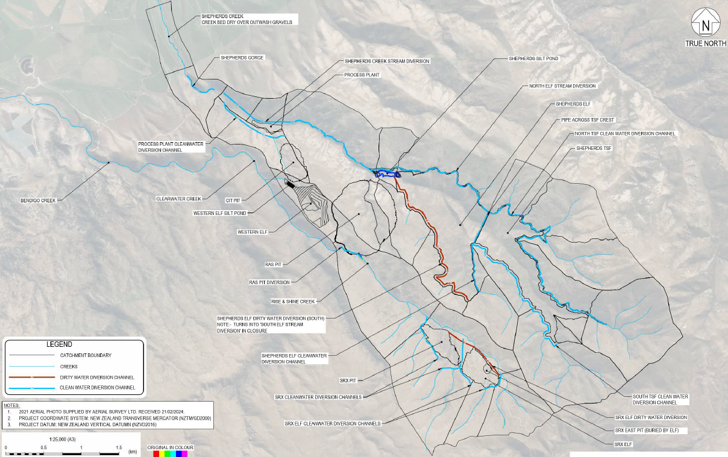

Attachment 2 – Surface Water Monitoring Locations
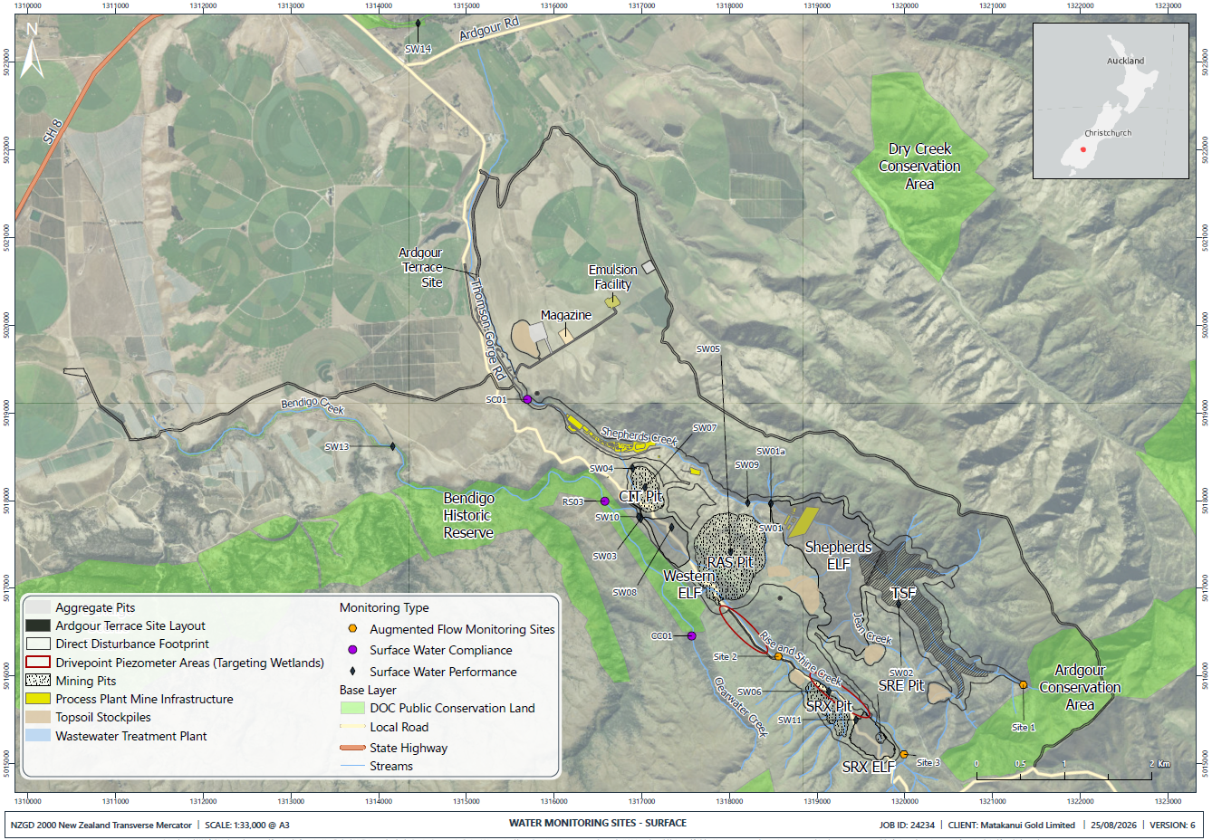

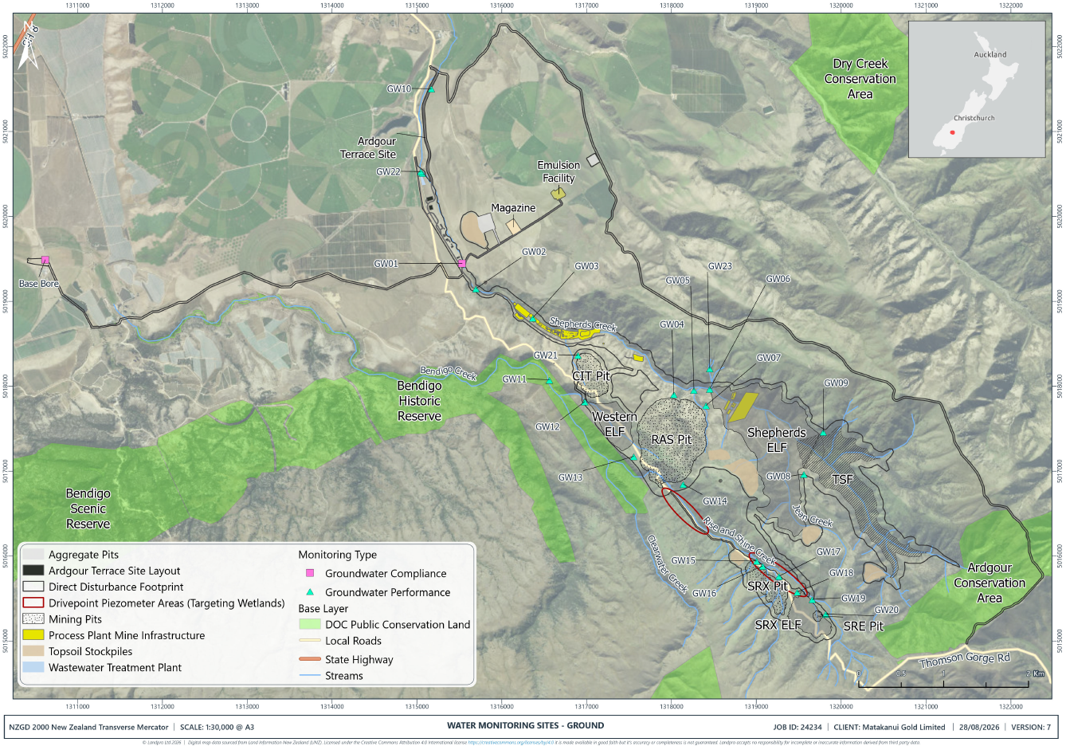
Attachment 3 – Groundwater Monitoring Location

Attachment 4 – Groundwater Monitoring Location Details
Site ID | Status | Location |  | Depth m | Purpose
Site ID | Status | East NZTM | North NZTM | Depth m | Purpose
GW02A | Installed | 131564 | 5019259 | 16.5 | Contamination pathway monitoring.
GW02B | Installed | 1315641 | 5019259 | 17 | Contamination pathway monitoring.
GW02C | Installed | 1315641 | 5019259 | 21 | Contamination pathway monitoring.
GW03A | Installed | 1315641 | 5019259 | 9.26 | Seepage bypass monitoring.
GW03B | Installed | 1315641 | 5019259 | 7 | Seepage bypass monitoring.
GW03C | Installed | 1315641 | 5019259 | 18.18 | Seepage bypass monitoring.
GW04 | Installed | 1317999 | 5017910 | 100 | Drawdown monitoring.
GW05 | Installed | 1318261 | 5017910 | 150 | Drawdown monitoring.
GW06A | Installed | 1318472 | 5017958 | 6 | Seepage bypass monitoring.
GW06B | Installed | 1318472 | 5017958 | 7.9 | Seepage bypass monitoring.
GW06C | Installed | 1318472 | 5017958 | 15 | Seepage bypass monitoring.
GW07 | Prior to mining | N/A | N/A | N/A | Drawdown monitoring.
GW08 | Prior to mining | N/A | N/A | N/A | Seepage bypass monitoring.
GW09 | Prior to mining | N/A | N/A | N/A | Seepage bypass monitoring.
GW10 | Installed | 1315170 | 5021504 | 64.5 | Monitoring between Shepherds Creek and the Ardgour Aquifer.
GW11 | Prior to mining | N/A | N/A | N/A | Contamination pathway monitoring.
GW11B | Prior to mining | N/A | N/A | N/A | Contamination pathway monitoring.
GW12A | Prior to mining | N/A | N/A | N/A | Seepage bypass monitoring.
GW12B | Prior to mining | N/A | N/A | N/A | Seepage bypass monitoring.
GW13 | Installed | 1317575 | 5017314 | 100 | Drawdown/ wetland monitoring.
GW14 | Installed | 1318227 | 5016921 | 215 | Drawdown/ wetland monitoring.
GW15 | 12 months prior to SRX | N/A | N/A | N/A | Drawdown/ wetland monitoring.
GW16 | Installed | 1319075 | 5015883 | 70 | Drawdown/ wetland monitoring.
GW17 | 12 months prior to SRX | N/A | N/A | N/A | Drawdown monitoring.
GW18 | 12 months prior to SRX | N/A | N/A | N/A | Seepage bypass monitoring.
GW19 | Installed | 1319619 | 5015485 | 9 | Seepage bypass monitoring.
GW20 | 12 months prior to CIT | N/A | N/A | N/A | Seepage bypass monitoring.
GW21 | 12 months prior to CIT | N/A | N/A | N/A | Drawdown monitoring.
GW22 | Installed | 1315045 | 5020526 | 87.5 | Influence from wastewater treatment discharges.
GW23 | Installed | 1318449 | 5018210 | 100 | Drawdown monitoring.

Attachment 5 – Surface Water Compliance Parameters and Limits
PARAMETER  (units are mg/L unless stated otherwise) | SC01 | RS03 | BASIS FOR COMPLIANCE ASSESSMENT
pH (unitless) | 6.5 - 9.0 | 6.5 - 9.0 | Within stated pH range
Turbidity (NTU) | 5 | 5 | Over a 5-year rolling period, 80% of samples, when flows are at or below median flow, are to meet the limit
Ammoniacal-nitrogen (NH₃-N) Total | 0.24 (annual median)  0.4 (annual 95th %ile) | 0.24 (annual median)  0.4 (annual 95th %ile)
Nitrate-nitrogen (NO₃-N) Total | 1.1¹ | 1.1¹ | Annual 95%ile
Cyanide (CN-) (Total) | 0.007 ² | 0.007 ² | Annual 95%ile
Sulphate (SO₄²⁻) (total) | 250³ | 500⁴ | SC01 – maximum absolute value  RS03 – No more than 20% samples exceed compliance limit over a 12-month period
Aluminium (Al) (dissolved) | 0.055⁵ | 0.055⁵ | Annual 95%ile
Antimony (Sb) (total) | 0.02³ | 0.074 (chronic) | The average of 5 (monthly samples over a 5-month period)
Antimony (Sb) (total) | 0.02³ | 0.25 (acute) | Maximum absolute value
Arsenic (As(V)) (dissolved)⁶ | 0.013 | 0.042 | Annual 95%ile
Boron (B) (dissolved) | 0.94 | 0.94 | Annual 95%ile
Cadmium (Cd) (dissolved) | 0.0002⁷ | 0.0002⁷ | Annual 95%ile
Chromium (Cr) (dissolved) | 0.001⁸ CrVI  0.006⁸ CrIII | 0.001⁸ CrVI  0.006⁸ CrIII | Annual 95%ile
Cobalt (Co) (dissolved) | 0.001⁹ (chronic)  0.11¹⁰ (acute) | 0.001⁹ (chronic)  0.11¹⁰ (acute) | Chronic - Annual 95%ile  Acute - Maximum absolute value
Copper (Cu) (dissolved) | 0.0014 | 0.0014 | Annual 95%ile
Iron (Fe) (total) | 0.3¹¹ | 0.3¹¹ | Annual 80%ile
Manganese (Mn) (dissolved) | 1.9 | 1.9 | Annual 95%ile
Molybdenum (dissolved) | 0.01¹² | 0.034 | Annual 95%ile
Selenium (Se) total | 0.005 | 0.005 | Annual 95%ile
Zinc (Zn) (dissolved) | 0.008¹³ | 0.008¹³ | Annual 95%ile

- ANZG 95% species protection (toxicant). Value shown applies to soft water (<30 mg/L CaCO₃). Corresponding guideline values:
- Moderately hard (30–150 mg/L CaCO₃): 2.6 mg/L
- Hard (>150 mg/L CaCO₃): 29 mg/L.
- Un-ionised HCN measured as CN (ANZG 2018), adjusted for pH and temperature based on (ANZG, 2018).
- MAV = Maximum Acceptable Value – (NZ drinking water standards)
- TV is hardness and chloride dependent:
- If hardness is <100 mg/L (as CaCO3), the sulphate compliance limit = 500 mg/L.
- If chloride is <5 mg/L, the sulphate compliance limit = 500 mg/L
- If the hardness is 100–500 mg/L AND if chloride is 5–<25 mg/L, the sulphate compliance limit is (in mg/L):
[-57.478 + 5.79*(hardness mg/L CaCO3) + 54.163*(chloride mg/L)] * 0.65
- If hardness is between 100 and 500 mg/L AND if chloride is between ≥25 and ≤500 mg/L, the sulphate limit is (in mg/L):
[1276.7+5.508*(hardness mg/L CaCO3) +1.457*(chloride mg/L)] * 0.65
- A minimum of 12 samples must be collected over any rolling 12-month period.
- For compliance limits in A to D, no more than 20% of samples collected over a rolling 12-month period may exceed the relevant compliance limit.
- An acute compliance limit = 1,000 mg/L averaged over 4 days and not to be exceeded more than once in a one-year period, OR in more than 10% of samples over a one-year period.
- Value applies at pH ≥6.5; reduces to 0.0008 mg/L at pH <6.5.
- Measured as total dissolved arsenic (AsIII+AsV). Analysis for AsV will be specifically undertaken if total concentration exceeds the TV.
- Adjustment to trigger value (TV) applied as HMTV = TV (H/30)^{0.89}, where hardness modified trigger value (HMTV in ug/L), trigger value (TV in ug/L) at a hardness of 30 mg/L as CaCO₃; H, measured hardness (mg/L as CaCO₃) of a fresh surface water.
- Measured as total Cr (CrIII+CrVI), additional analysis for CrVI fraction if exceedance occurs. HMTV = TV (H/30)^{0.82}, where hardness modified trigger value (HMTV in ug/L), trigger value (TV in ug/L) at a hardness of 30 mg/L as CaCO₃; H, measured hardness (mg/L as CaCO3) of a fresh surface water. HMTV cannot be used on CrVI 0.0067 mg/L is a fixed limit.
- The Canadian Federal Water Quality Guideline (FWQG) for cobalt (Environment Canada, 2017), which incorporates hardness and is based on a more comprehensive toxicity dataset, is adopted for compliance assessment. The chronic (long-term) guideline is calculated as:
FWQG = exp((0.414 × ln hardness) − 1.887). For typical hardness (~100 mg/L as CaCO₃), this equates to approximately 1 µg/L.
- An acute (maximum) guideline of 0.11 mg/L (Nagpal, 2004) is also adopted as a not-to-be-exceeded limit.
- ANZG Interim working guideline from Canada (CCREM, 1987), annual 80%ile compliance.
- Draft ANZG 2023 Livestock Drinking Water Guideline.
- Adjustment to trigger value (TV) to be applied as HMTV = TV(H/30)^{0.85} where hardness modified trigger value (HMTV in ug/L), trigger value (TV in ug/L) at a hardness (30 mg/L as CaCO₃); H, measured hardness (mg/L as CaCO₃) of a fresh surface water

Attachment 6 – Groundwater Compliance Parameters and Limits
PARAMETER  (units are mg/L unless stated otherwise) | GROUNDWATER COMPLIANCE | BASIS FOR COMPLIANCE ASSESSMENT
pH (unitless) | 7.0 – 8.5¹ | Within stated pH range
Total Dissolved Solids (TDS) | 1000¹ | Maximum absolute value
Ammoniacal-nitrogen (NH₃-N) Total | 1.5¹ | Maximum absolute value
Nitrate-nitrogen (NO₃-N) Total | 11.3¹ | Maximum absolute value
Cyanide (CN-) Total | 0.08¹ | Maximum absolute value
Sulphate (SO₄²⁻) Total | 250¹ | Maximum absolute value
Aluminium (Al) Dissolved | 1¹ | Maximum absolute value
Antimony (Sb) Dissolved | 0.02¹ | Maximum absolute value
Arsenic (As(V)) Dissolved | 0.01¹ | Maximum absolute value
Boron (B) Dissolved | 0.5² | 12-month 80th %ile
Cadmium (Cd) Dissolved | 0.004¹ | Maximum absolute value
Chromium (Cr) Dissolved | 0.05¹ | Maximum absolute value
Chloride (Cl) Total | 175² | 12-month 80th %ile
Cobalt (Co) Dissolved | 0.05² | 12-month 80th %ile
Copper (Cu) Dissolved | 0.4² | 12-month 80th %ile
Fluoride (F) Dissolved | 1² | 12-month 80th %ile
Iron (Fe) Total and Dissolved | 0.2¹ | Maximum absolute value
Lead (Pb) Dissolved | 0.01¹ | Maximum absolute value
Manganese (Mn) Dissolved | 0.2² | 12-month 80th %ile
Mercury (Hg) Dissolved | 0.002³ | Long-term median
Molybdenum (Mo) Dissolved | 0.01² | 12-month 80th %ile
Selenium (Se) Dissolved | 0.04² | 12-month 80th %ile
Sodium (Na) Total | 175² | 12-month 80th %ile
Strontium (Sr) Dissolved | 4⁴ | Long-term Median
Uranium (U) Dissolved | 0.01² | 12-month 80th %ile
Zinc (Zn) Dissolved | 2² | 12-month 80th %ile

- MAV = Maximum Acceptable Value – (NZ drinking water standards)
- ANZG (2024) Long-term Irrigation Water Guideline
- Draft ANZG 2023 Livestock Drinking Water Guideline
- US EPA 2012

Attachment 7 – Contents of Ground Control Management Plan for Open Pit Mines
GROUND CONTROL MANAGEMENT PLAN
Example / guideline only
Table of Contents
1. INTRODUCTION
1.1 Scope & Purpose
1.2 Roles & Responsibilities
1.2.1 Site Senior Executive
1.2.2 Open Pit Mine Manager
1.2.3 Mine Superintendent
1.2.4 Shift Supervisor
1.2.5 Geology Manager / Geology Superintendent
1.2.6 Geotechnical Engineer
1.2.7 Geotechnical Consultant
1.2.8 Voids Officer (if relevant)
1.2.9 Survey Department
1.2.10 All Personnel working within the OPs
1.3 Project Site Overview
1.3.1 Historic Mining (where relevant)
1.3.2 Climate
1.4 Definitions / abbreviations
2. GEOLOGY OVERVIEW
2.1 Bendigo-Ophir regional geology
2.2 RAS deposit lithology
2.3 RAS, CIT & SRX deposits
2.4 Bendigo-Ophir structural overview
2.5 Rock weathering profiles
2.6 Regional stress regime & seismicity
3. GROUNDWATER MODEL
3.1 Groundwater models RAS, CIT, SRX
4. GEOTECHNICAL MODELS
4.1 Bendigo-Ophir RAS
4.1.1 Rock mass units
4.1.2 Structural data
4.1.3 Geotechnical domains & design sectors et cetera
Repeat for other pits / deposits
5. POTENTIAL PIT WALL INSTABILITY/FAILURE MODES & CONTROLS
5.1 General
5.2 Potential site-specific mechanisms
5.3 Void Management Plan (if relevant)
5.4 Controls to mitigate / manage potential wall failures
5.5 Signs of pit wall instability
6. GEOTECHNICAL HAZARDS
6.1 Hazard Type
6.2 Hazard Identification
6.3 Geotechnical investigation & reporting schedule
6.4 Geotechnical Hazard Map, alerts & Risk Register
7. DATA COLLECTION & MONITORING
7.1 General
7.1.1 Visual - photography & videos
7.1.2 Mapping
7.1.3 Prisms
7.1.4 Other options which could be considered
7.1.7 Laboratory Testing
7.1.8 Piezometers
7.1.9 Rainfall gauges
8. MINING OVERVIEW PLAN
8.1 Open Pit Mine Plans
8.1.1 RAS
8.1.2 CIT
8.1.3 SRX
8.1.4 SRE
8.2 Mine design
8.3 Design parameters
8.4 Mine design & approval
8.5 Mine planning / sequencing
9. IMPLEMENTATION OF THE SLOPE DESIGN
9.1 Pit wall excavation
9.2 Final pit walls
9.3 Wall development blasting practices
9.4 Batter scaling
9.5 Ground support (if relevant for local issues)
9.6 Water / groundwater management e.g. depressurisation drilling
10. REVIEW & RECONCILIATION
10.1 As built reconciliation to design
10.2 Mapping
10.3 Slope performance
10.4 Pit slope failure records
11. GEOTECHNICAL RISK MANAGEMENT
11.1 Document control of design
11.2 Mine design parameters
11.4 Safety protocol
11.5 Trigger Action Response Plans (TARPS)
11.6 Withdrawal of persons in the event of a significant failure
11.7 Protocol after a significant failure event
11.8 Reviews / audits
12. TRAINING
12.1 Ground awareness training, hazard identification, job-specific hazards & reporting
12.2 Training requirements are job dependent & will vary for various positions
12.3 Auditable records are maintained for all employees working (even temporarily) in OPs
12.4 Re-training / refresher training is performed on change of practice/ position &/ or time basis
12.5 Standard Work Instructions include reference to geotechnical hazards & awareness required for particular tasks
13. COMMUNICATION & DOCUMENTATION
13.1 Monthly Geotechnical Monitoring Report
13.2 Geotechnical memoranda
13.3 Pit slope failure / rockfall report
13.4 Final wall sign off
13.5 Meetings
13.6 Presentations
All documentation pertaining to the GCMP; geotechnical investigation, assessment & reporting; mine planning; personnel training & work procedures et cetera are stored on the Company network.
The GCMP (section by section) lists the locations of relevant documentation & records.
APPENDICES
CRITICAL CONSIDERATIONS
The GCMP is designed such that a third-party familiar with standard / typical mining protocols but not necessarily familiar with the Bendigo-Ophir Project would be able to navigate & interrogate the plan.
Internal audits / reviews of the GCMP are performed to confirm that the plan exactly reflects site practices. The GCMP must state precisely what the plan contains and how the plan is executed. Procedures/ actions which may have been considered ostensibly beneficial to open pit or underground operations but are not performed are omitted entirely from the GCMP.

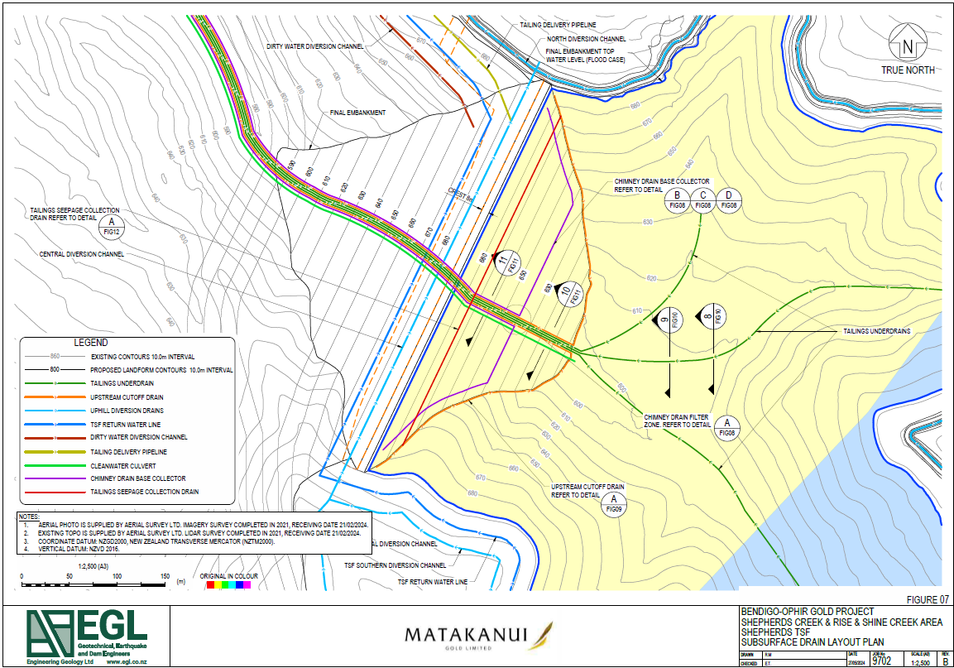
Attachment 8 – Tailings Storage Facility Subsurface Drain Layout Plan

Attachment 9 – Shepherds Seepage Collection Sump
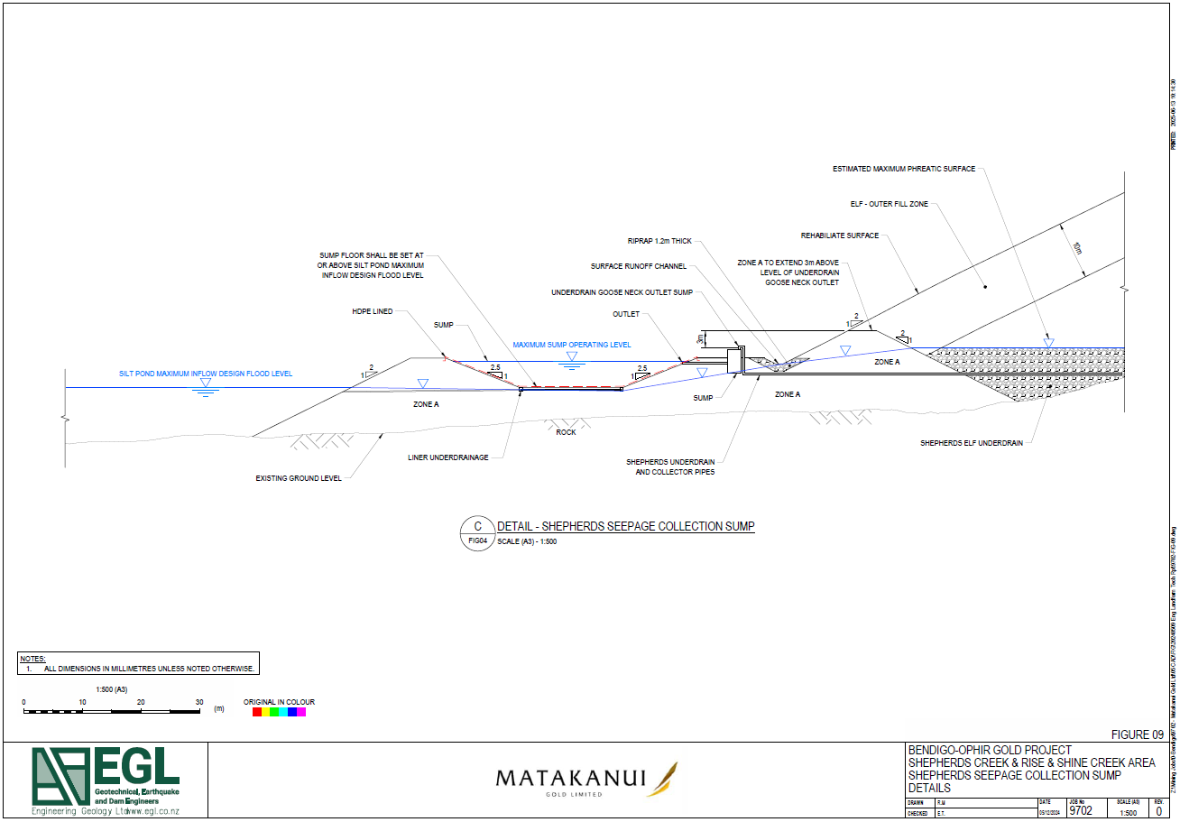

Attachment 10 – Meteorological Monitoring Sites
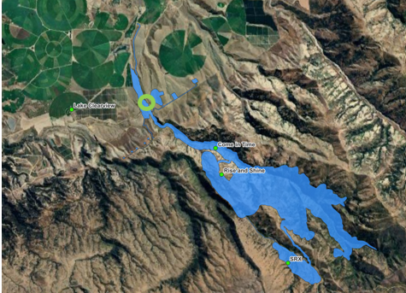

Attachment 11 – Dust Deposition Monitoring Gauge Sites
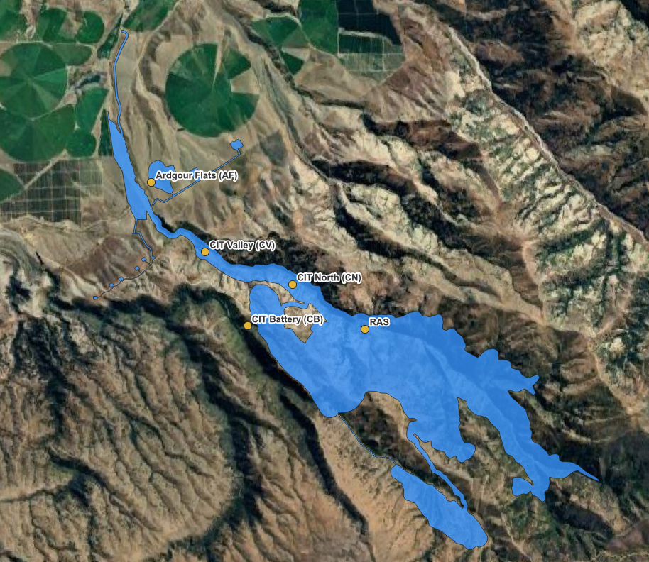

Attachment 12 – Particulate Monitoring Sites
