Note to the draft conditions: Expert Panel changes are in green, Lodestone previous changes are in red (as at 13 July) and the latest Lodestone changes are in blue or purple (20 July).

Land Use Consent under section 9 of the RMA

Administering Authority: Mackenzie District Council

Activity:
1. The construction, operation, maintenance and decommissioning of the Haldon Solar Farm, including the use and storage of hazardous substances, earth works, vegetation clearance and for structures and activities not otherwise provided for in the General Rural Zone in the Mackenzie District Plan.
2. The construction, operation, maintenance and decommissioning of a substation associated with the Haldon Solar Farm.
3. The upgrade of an existing National Grid Transmission Line under Regulation 39 of the Resource Management (National Environmental Standards for Electricity Transmission Activities) Regulations 2009.

Location – Haldon Station, Haldon Arm Road, Twizel

Legal Description: Part Reserve 1358, Record of Title CB437/82

Commencement Date:

Lapse Date: 01 July 2036

Duration: 35 years, unless it has been surrendered or cancelled at an earlier date

 | General Conditions | Panel comment
 | Compliance with plans  The Solar Farm must be constructed, operated, maintained and decommissioned in general accordance with the information and plans submitted by the Consent Holder in support of application number FTAA-2508-1097. Plans and information that comprise this application are listed in Attachment 6.  In the event of any conflict between the documents listed in Attachment 6, or any management plan prepared under these conditions and these conditions, the conditions prevail. | Shifted from previous conditions 6 and 7.  Lapse date included above.
 |  | Duration included above
Monitoring fees
Pursuant to section 36 of the Resource Management Act 1991, the Consent Holder must pay the actual and reasonable costs incurred by Mackenzie District Council when monitoring the conditions of this resource consent, including but not limited to costs associated with:
- site visits;
- review and certification of management plans;
- monitoring of works; and
- administration.
Complaints management
The Consent Holder must maintain a register of any complaints received regarding the activities authorised by this resource consent. As a minimum, the register must include:
- the name and contact details (if supplied) of the complainant;
- the nature and details of the complaint;
- the location, date and time of the complaint and the alleged event giving rise to the complaint;
- weather conditions at the time of the complaint, where relevant to the complaint;
- other activities in the area that may have contributed to the complaint;
- the outcome of the Consent Holder’s investigation into the complaint; and
- a description of any measures taken by the Consent Holder to respond to the issue raised by the complainant.
 | The Consent Holder must notify the Mackenzie District Council of any complaint received that relates to the activities authorised by this resource consent as soon as reasonably practicable and no later than two working days after receiving the complaint.
 | The Consent Holder must respond to any complainant as soon as reasonably practicable and in any event, within five working days of the complaint being received, advise the Mackenzie District Council and the complainant of the outcome of the Consent Holder’s investigation and all measures taken, or proposed to be taken, to respond to the complaint. | Clarification
 |  | Shifted to condition 1
 |  | Shifted to condition 1
 | The Consent Holder must ensure that all contractors engaged to undertake activities authorised by this resource consent are supplied with a copy of and made aware of the conditions and management plans that apply to this resource consent that are relevant to their work area and the measures required for compliance with the conditions.
 | The Consent Holder must:  - notify the Mackenzie District Council as to the intended commencement date of any works authorised as part of this resource consent at least 20 working days before such works commence;  - appoint a representative(s) who must be the principal contact person for the Mackenzie District Council in regard to matters relating to this resource consent and:  - inform the Mackenzie District Council of the representative’s name and contact details at least 10 working days before works authorised by this resource consent commence; and  - in the event that the principal contact person changes, must inform the Mackenzie District Council of a new representative’s contact details within 10 working days of the principal contact person’s appointment  Advice Note: The Consent Holder is to contact Mackenzie District Council through planning@mackenzie.govt.nz. | Improved certainty
 | A copy of this resource consent and all management plans required in accordance with this resource consent must be kept on site at all times during the construction work and must be produced without unreasonable delay upon request from an agent of the Mackenzie District Council.
 | Kaitiaki Governance Group
 | At least three months prior to the commencement of any construction works, the Consent Holder must invite mana whenua to establish the Kaitiaki Governance Group in relation to the Solar Farm. The invitation must seek direction on the makeup of the Kaitiaki Governance Group, frequency of hui and group composition.  Advice Note: Mana whenua status is to be determined by Kā Papatipu Rūnaka which comprises Te Rūnanga o Arowhenua; Te Rūnanga o Waihao; and Te Rūnanga o Moeraki. | Consistent wording
The Kaitiaki Governance Group must comprise:
- up to three representatives of the Consent Holder; and
- up to three representatives appointed by mana whenua who elect to participate in the Kaitiaki Governance Group.
When and if required, representatives from the Canterbury Regional Council, Mackenzie District Council, the Department of Conservation, and/or the Landowners, may be invited to attend Kaitiaki Governance Group meetings by agreement of the Kaitiaki Governance Group.
The purpose of the Kaitiaki Governance Group includes:
- facilitating ongoing engagement and communication between the Consent Holder and mana whenua;
- supporting the preparation and overseeing the implementation of the Strategic Cultural Programme as described in Conditions 15 to 17 below;
- enabling discussions between the Consent Holder and mana whenua on the effectiveness of the measures implemented by the Consent Holder to manage impacts on mana whenua values;
- providing feedback to the Consent Holder on the required management plans;
- providing a forum for mana whenua to share mātauranga M āori and cultural perspectives relevant to the Solar Farmand the surrounding environment;
- providing access to the Solar Farm for the purposes of Mahika kai harvest and other customary practices; and
- identifying initiatives that recognise and provide for mana whenua values associated with the taiao.
Advice Note: Initiatives may include, but are not limited to, interpretive signage, pouwhenua, and/or artworks in locations agreed between the Consent Holder and mana whenua.
 | The Consent Holder must invite the Kaitiaki Governance Group to meet at least quarterly during construction of the Solar Farm. During operation of the Solar Farm (generation of electricity), the Kaitiaki Governance Group must meet at an agreed frequency, with at least one meeting held each calendar year. | Consistent wording and differentiating solar farm from works required in the Compensation Area.
 | The Consent Holder must:  - provide the Kaitiaki Governance Group with up-to-date information relevant to the design, construction, operation and decommissioning of the Solar Farm;  - seek advice from the Kaitiaki Governance Group on the draft management plans required by the conditions of this consent, at least twenty working days prior to their submission for certification;  - record any advice provided by the Kaitiaki Governance Group (including advice from Aoraki Environmental Consultancy and/or Aukaha) on the draft management plans and append that advice to the relevant management plan; and  - a response to each comment, describing how the advice has been adopted or otherwise into the management plan. | Improved clarity
 | The Consent Holder must maintain a record of matters raised through the Kaitiaki Governance Group and the Consent Holder’s response to those matters. Such records must be made available to Mackenzie District Council on request.
 | Prior to the commencement of construction works for the Solar Farm, a Strategic Cultural Programme must be prepared by the Kaitiaki Governance Group and provided to Mackenzie District Council for information. The Strategic Cultural Programme must be implemented for the duration of the Solar Farm. | Consistent wording and differentiating solar farm from works required in the Compensation Area.
The purpose of the Strategic Cultural Programme is to:
- set out a programme of works that integrates project outcomes and initiatives required by this resource consent to promote the mana of the taiao and the people;
- recognise and provide for mana whenua values of the area affected by the activities authorised by these resource consents and support the management of the impacts on those values through the implementation of monitoring, restoration and enhancement measures; and
- incorporate mātauranga Māori into environmental management associated with the Solar Farm.
The Strategic Cultural Programme must include:
- Provision for participation of mana whenua in the monitoring, mitigation, restoration, and/or enhancement activities for the Solar Farmand other affected areas associated with the Solar Farm, as required by the conditions of this resource consents;
- mechanisms to incorporate mātauranga Māori into environmental management practices associated with the Solar Farm;
- cultural awareness or induction initiatives for project staff and contractors;
- processes to identify and respond to matters affecting mana whenua values, including the health and wellbeing of the taiao, that may arise during the construction or operation of the Solar Farm; and
- processes for periodic review of the programme to enable adaptation over time.
 | If mana whenua representatives invited to participate in the Kaitiaki Governance Group advise the Consent Holder that they do not wish to participate in the preparation or implementation of the Strategic Cultural Programme, the Consent Holder will not be required to comply with Conditions 15 to 17. For the avoidance of doubt, the Consent Holder must still demonstrate that reasonable steps have been taken to invite mana whenua to participate in accordance with Condition 9.
 | In the event no separate agreement is in place between the Consent Holder and mana whenua in relation to this resource consent, the Consent Holder must meet the costs of establishing, resourcing, and paying (on an ongoing basis for the duration of this consent, where applicable) for any of the roles and functions of mana whenua as set out in these conditions.
 | The Consent Holder must, subject to any relevant health and safety requirements, ensure that mana whenua representatives have access to all relevant parts of the Site to enable them to carry out any of the roles and functions as set out in these conditions. | Consistent wording
 | Start of Works
 | Pre-construction site meeting  At least 10 working days prior to any construction works authorised by this consent commencing on the Solar Farm, the Consent Holder must hold a pre-construction meeting that is located at the Solar Farmand must invite representatives from:  - Mackenzie District Council;  - Canterbury Regional Council;  - Te Rūnanga o Arowhenua, Te Rūnanga o Waihao and Te Rūnanga o Moeraki;  - Transpower NZ Ltd;  - the contractor; and  - any other party representing the Consent Holder.  At a minimum, the following must be covered at the meeting:  - scheduling and staging of the works;  - responsibilities of and contact details for all relevant parties;  - expectations regarding communication between all relevant parties;  - ecological expectations and obligations;  - site familiarisation; and  - confirmation that all relevant parties have copies of this resource consent and all associated Management Plans and understand the obligations contained in those documents.  Advice Note: in the case that any of the invited parties, other than a party representing the Consent Holder, does not attend this meeting, the Consent Holder will have complied with this condition, provided the invitations are sent at least 15 working days prior to the meeting. In relation to Transpower attendance, written notice of the pre-construction meeting should be sent to: transmission.corridor@transpower.co.nz. | Consistent wording, improved clarity and differentiating solar farm from works required in the Compensation Area.
 | Construction Management Plan
 | At least 20 working days prior to the commencement of any construction works on the Solar Farm, the Consent Holder must submit a Construction Management Plan, that has been prepared by a suitably qualified and experienced construction manager, to the Mackenzie District Council for certification (the “initial Construction Management Plan”). Certification is required to demonstrate that the Construction Management Plan provides the means to achieve the purpose and matters set out in Condition 23.  Advice Note: The Construction Management Plan must be consistent with all other management plans for the consented activity certified by Canterbury Regional Council or Mackenzie District Council. | Consistent wording, improved clarity and differentiating solar farm from works required in the Compensation Area.
 | The purpose of the Construction Management Plan is to outline the construction methods and management procedures to be implemented on the Solar Farm so as to avoid, remedy or mitigate adverse construction-related effects on the environment. To achieve this purpose, the plan must include:  - confirmation of the construction works programme, including staging of work and construction methodologies;  - site plans, including the location of installations, internal access routes, parking areas and laydown areas;  - identification of the key personnel and contact person(s);  - procedures for recording complaints regarding construction activities including the maintenance of a register of any complaints received regarding the construction activities, as provided for in Condition 3:  - methods and systems to inform and train all persons working on the Solar Farm of potential environmental issues and how to avoid, remedy or mitigate potential adverse effects, including any buffers around ecological values identified on the construction site that are to be avoided by construction traffic;  - publicity and safety measures, including signage, to inform adjacent landowners and occupiers and other road users;  - identification of management procedures to deal with any potential effects of construction activity on the environment;  - waste minimisation and management measures;  - measures to avoid introduction or spread of weed or pest species, including fencing requirements;  - information to demonstrate that construction activities undertaken on the Solar Farm will meet the safe distances within the New Zealand Electrical Code of Practice for Electrical Safe Distances 2001 (NZECP 34: 2001) or any subsequent revision of the code, including:  - an outline of the construction methods and management procedures to be implemented on site so that works near the National Grid are undertaken safely and potential adverse effects on the National Grid assets are appropriately managed; and  - protocols to ensure that existing transmission lines and support structures will remain accessible during and after construction activities;  - protocols to manage accidental discovery of contaminated materials;  - measures to ensure general construction Conditions 44 and 45 are met; and  - protocols to manage accidental cultural heritage and archaeology discovery and preservation of discovered artefacts, including a list of contact names and numbers relevant to that discovery, in accordance with Condition 47. | Noise conditions included
 | Prior to submitting the Construction Management Plan to the Mackenzie District Council, the draft Construction Management Plan must be provided to Transpower NZ Ltd, with an invitation to provide feedback within 10 working days. The Consent Holder must ensure that all written feedback on the draft Construction Management Plan received from Transpower NZ Ltd within the 10-working day timeframe is provided to the Mackenzie District Council when submitted for certification. This must include a clear explanation of how comments on the draft Construction Management Plan have been addressed - whether it has been incorporated into the final Plan, and if not, the reasons for its exclusion. | Consistent wording with condition 31
 | Work on the Solar Farm may not commence until the initial Construction Management Plan is certified by the Mackenzie District Council. | Clarity that the certified plan needs to be in place.
 | The Construction Management Plan may be amended at any time. Any amendments must be:  - made in consultation with Transpower NZ Ltd;  - only for the following purposes:  - improving the efficacy of the management of construction effects-related management activities;  - applying best practicable measures to mitigate adverse effects;  - consistent with the conditions of this resource consent; and  - submitted in writing to the Mackenzie District Council for certification, prior to any amendment being implemented. | Improved clarity  Advice note redundant.
 | The certified Construction Management Plan must be complied with throughout the construction phase of the Solar Farm. | Improved clarity and differentiating solar farm from works required in the Compensation Area.
 | Construction Traffic Management
 | At least 20 working days prior to the commencement of any construction works on the Solar Farm, the Consent Holder must submit a Construction Traffic Management Plan, prepared by a suitably qualified and experienced Traffic Engineer, to the Mackenzie District Council for certification. Certification is required to demonstrate that the Construction Traffic Management Plan provides the means to achieve the purpose and matters set out in Condition 29. | Improved clarity and differentiating solar farm from works required in the Compensation Area.  Advice note redundant
The purpose of the Construction Traffic Management Plan is to ensure that:
- construction traffic, particularly heavy traffic, is safely accommodated along all routes to the Solar Farm;
- construction traffic can safely turn at intersections without affecting the safety of the intersections;
- construction traffic can safely turn onto and off the Solar Farmat the proposed access location without impacting the safety of the frontage road;
- vehicles associated with construction can be accommodated onsite; and
- adverse effects of the condition of the public road network as a result of construction traffic are avoided, remedied and mitigated.
 | To achieve the purpose, the Construction Traffic Management Plan must include:  - details of the construction programme and planned traffic flows;  - scheduling of deliveries within construction hours;  - identification of travel routes, site access points and staff/contractor parking, including details of any measures to enable shared transport, including compliance with Conditions 35, 36 and 43;  - details of signage to provide guidance to the Solar Farm;  - measures to manage road safety including such measures as signage, driver protocols, monitoring and reporting requirements;  - measures to minimise the effects of construction traffic on local amenity, including the management of dust from the use of unsealed roads;  - details of any road safety assessments undertaken;  - methods for recording and accounting for pavement maintenance (including structures such as bridges and cattlegrids), including compliance with Conditions 40 to 42;  - planning for, and details of over-weight / over-dimension transport movements, including any relevant permit provisions;  - provision for planning and managing the safety and efficiency of stock movements in conjunction with vehicle movements associated with the Solar Farm;  - incident reporting mechanisms, recording and reporting methods, including steps for remedial actions (if required);  - provision for emergency services access;  - temporary traffic management planning, including at one-lane bridges;  - provision and publicity of contact details (such as an 0800 number) so that members of the public and road users have a known point of contact for any traffic related issues that may arise during the construction of the Solar Farm;  - measures to ensure no standing or parking of construction-related vehicles on public roads; and  - measures for the ongoing review of the effectiveness of the Construction Traffic Management Plan. | Improved certainty
 | Prior to submitting the Construction Traffic Management Plan to Mackenzie District Council, the draft Construction Traffic Management Plan must be provided to the New Zealand Transport Agency with an invitation to provide feedback within 10 working days. The Consent Holder must ensure that all written feedback on the draft Construction Traffic Management Plan received from the New Zealand Transport Agency within the 10 working day timeframe is provided to Mackenzie District Council when submitted for certification. This must include a clear explanation of how each comment on the draft Construction Traffic Management Plan has been addressed - whether it has been incorporated into the final Plan, and if not, the reasons for its exclusion.
 | Work on the Solar Farm may not commence until the Construction Traffic Management Plan is certified by the Mackenzie District Council. | Clarity that the certified plan needs to be in place.
 | The Construction Traffic Management Plan may be amended at any time. Any amendments must be:  - made in consultation with the New Zealand Transport Agency;  - only for the following purposes:  - improving the efficacy of the construction traffic management measures;  - applying best practicable measures to mitigate adverse effects;  - consistent with the conditions of this resource consent; and  - submitted in writing to the Mackenzie District Council for certification, prior to any amendment being implemented. | Advice note redundant.
 | The certified Construction Traffic Management Plan must be complied with throughout the construction phase of the Solar Farm. | Improved clarity and differentiating solar farm from works required in the Compensation Area.
 | Access
 | Access to the Solar Farmfor construction traffic must be via a single access point to be established from Haldon Arm Road within 200 m of grid reference (NZTM 2000) E1379570, N5086610. The access must be constructed so that it can accommodate truck and trailer units turning left into and right out of the site within the formed carriageway. A queue space of 24 m must be provided at the access, within the Solar Farm. | Improved certainty
 | At least 20 working days prior to the commencement of construction works on the Solar Farm, the Consent Holder must submit the design of the access and parking areas as prepared by a suitably qualified and experienced practitioner to the Mackenzie District Council for certification that confirms the design is practicable for the intended use and constructed to an all-weather standard. The design of the car park must identify sufficient area to accommodate the parking demands, and the access is to include details regarding internal passing locations. | Improved certainty
 | Prior to the commencement of operation of the Solar Farm (the first generation of electricity), the Consent Holder must provide plans of the proposed permanent access arrangement to the Solar Farmto the Mackenzie District Council for certification. The permanent access must be designed to accommodate the vehicle tracking of the reasonably foreseeable maintenance vehicles including appropriate gate setbacks to ensure queuing does not extend to the public road carriageway. The formation of the permanent access must be to an all-weather standard and the Consent Holder is to confirm that appropriate sight distance is achieved to Haldon Arm Road. Areas of existing access that are redundant are to be returned to the existing verge condition.  Advice note: The Consent Holder may consider use of the construction access for ongoing operations and maintenance. | Improved certainty
Prior to the commencement of construction on the Solar Farm, the Consent Holder must develop a detailed design for the upgrade of the intersection between the two legs of Haldon Road located approximately at grid reference (NZTM 2000 E1405270, N5114480) and known locally as “Dog Kennel Corner”. The design of this upgrade must be undertaken in consultation with the New Zealand Transport Agency and the Mackenzie District Council in their capacities as Roading Authorities.
The design must be in general accordance with indicative works illustrated in Attachment 2 to this consent and incorporate:
- widening of the western leg of Haldon Road to accommodate a large heavy vehicle (such as a truck and trailer) to turn left in while a single-unit truck waits to turn right out and vice versa;
- realignment of the eastern leg of Haldon Road as it approaches State Highway 8 to improve the driver observation angle to the left; and
- associated line marking and signage.
The final design must be submitted to the New Zealand Transport Agency and the Mackenzie District Council for certification in their capacities as Roading Authorities.
Prior to the commencement of construction on the Solar Farm, the Consent Holder must undertake the upgrades at Dog Kennel Corner in accordance with the design as certified in Condition 38 . The completed State Highway 8 intersection realignment works must be certified by a suitably experienced Chartered Professional Engineer that the works have been completed in accordance with the certified design, with that certification provided to the New Zealand Transport Agency and Mackenzie District Council.
Advice Note: It is a requirement of the Government Roading Powers Act 1989 that any person wanting to carry out works on a state highway first gain the approval of the New Zealand Transport Agency for the works and that a Corridor Access Request (CAR) is applied for and subsequently a Work Access Permit issued (WAP) before any works commence. A CAR will be required for the State Highway 8 Intersection works.
Advice Note: Detailed design approval from the New Zealand Transport Agency must be gained by the Consent Holder prior to applying for a CAR. The detailed design must be prepared by a suitably qualified professional. In developing the detailed design, the Consent Holder will need to consult with the New Zealand Transport Agency appointed Safety Engineer and the state highway maintenance contractor for the Mackenzie District Council.
Advice Note: A Corridor Access Request is made online via www.submitica.co.nz. The CAR needs to be submitted at least 21 working days before the planned start of works. The Corridor Access Request will need to include:
  - The detailed final design for the State Highway 8 / Haldon Road intersection upgrade;
  - A Construction Traffic Management Plan that has attained approval from the New Zealand Transport Agency appointed state highway maintenance contractor for the Mackenzie District Council.
 | At least two months prior to the commencement of construction of the Solar Farm, the Consent Holder must engage a suitably qualified and experienced road maintenance engineer to prepare a programme to assess and record the condition of the road surface on Haldon Road and Haldon Arm Road. This programme must be submitted to the Mackenzie District Council for certification at least 40 working days before the assessment is conducted. The assessment and recording of the road surface condition must be undertaken in consultation with the Mackenzie District Council’s Transportation Manager and may not occur until the programme is certified by the Mackenzie District Council.  The road surface condition rating must be used as the baseline (including vehicle counts) for assessing the works required to return the road surface to at least its standard / condition prior to the commencement of the construction.  Advice Note: The programme may be provided as part of the Construction Traffic Management Plan. | Improved certainty
 | The Consent Holder must reimburse the Mackenzie District Council for the cost of the road surface maintenance (potholes / surface rutting etc) caused by the activities authorised by this consent. The maintenance cost will be calculated on a prorate basis against the baseline heavy vehicle traffic volumes and taking into account any financial assistance received by Council for road maintenance or funding otherwise committed to road maintenance.
 | Following the completion of construction works, the Consent Holder must return the road surface condition of Haldon Road and Haldon Arm Road to no worse than that identified in the road surface condition survey carried out in accordance with Condition 40 of this consent at the Consent Holder’s expense, where not otherwise reimbursed in accordance with Condition 41. | Reservation of discretion removed
 | Prior to the commencement of construction works on the Solar Farm, the Consent Holder must identify and commit to practicable measures to minimise private vehicle travel to and from the Solar Farm for construction workers during the construction period, including (but not limited to):  - car-pooling incentives, such as ride-share arrangements or other mechanisms, to encourage shared vehicle trips;  - shuttle bus or shared transport service operating between the Site and identified local accommodation hubs where construction staff are anticipated to be accommodated; and  - staggered construction start and finish times, where required, to reduce concentrated vehicle movements during peak periods.  Construction works on the Solar Farm may not commence until the above matters have been certified in writing by Mackenzie District Council as meeting the requirements of this condition to minimise private travel to and from the site. The certified measures must be implemented and maintained for the duration of the construction period. | Improved certainty
 | Construction General
 | All construction works must be restricted to between 7.30am and 6.00pm from Monday to Saturday. There must be no works on Sundays or public holidays. The restriction on hours of works does not apply to low noise generating activities, such as site set up or staff meetings, which may occur outside of these hours, Monday to Saturday only. | Improved certainty.  Advice note deleted as it potentially conflicts with the condition.
 | Noise from construction work must not exceed the typical duration limits recommended in, and must be measured and assessed in accordance with, New Zealand Standard NZS 6803: 1999 “Acoustics – Construction Noise” as set out below:  Advice Note: The construction noise limits do not apply at any building that is unoccupied during construction work. NZS6803:1999 requires construction noise to be measured outside occupied buildings at a point 1m from the wall most exposed to the sound under investigation and at a height 1.2 to 1.5m above the relevant floor height (no adjustment for façade effect reflections is to be made to the measured sound level). NZS6803:1999 states that noise should not be measured for more than one-hour at any location, and that 15-minutes will often be adequate. | Table 4 not identified.
  Time of week | Time period | Noise  Limit
   |  | Laeq | LAFmax
  Weekdays | 0630-0730 | 60 | 75
   | 0730-1800 | 75 | 90
   | 1800-2000 | 70 | 85
   | 2000-0630 | 45 | 75
  Saturdays | 0630-0730 | 45 | 75
   | 0730-1800 | 75 | 90
   | 1800-2000 | 45 | 75
   | 2000-0630 | 45 | 75
  Sundays & Public Holidays | 0630-0730 | 45 | 75
   | 0730-1800 | 55 | 85
   | 1800-2000 | 45 | 75
   | 2000-0630 | 45 | 75
 | Prior to the commencement of any construction works on the Solar Farm, the Consent Holder must provide to the Mackenzie District Council a copy of the Erosion and Sediment Control Plan for the construction of the Solar Farm, that has been certified by Canterbury Regional Council under the conditions of the regional consents for the Site. | Final sentence and advice note are redundant
 | In the event of discovery of sensitive material (which is not authorised to be disturbed by any resource consent or other statutory authority), the Consent Holder must take the following steps:  - Immediately cease all works within 20 metres of any part of the discovery, including shutting down all earth disturbing machinery and stopping all earthmoving activities;  - Secure the area of the discovery, including a sufficient buffer area to ensure that all sensitive material remains undisturbed;  - Inform relevant authorities and parties immediately of the discovery, including:  - New Zealand Police if the discovery of human remains or koiwi;  - Mackenzie District Council in all cases;  - Heritage New Zealand Pouhere Taonga if the discovery is an archaeological site, Māori cultural artefact, human remains or koiwi; and  - Mana Whenua if the discovery is an archaeological site, Māori cultural artefact, or koiwi.  - Wait for and enable an inspection of the site by the relevant authority or agency that must occur within 20 working days of notification;  - Following site inspection and consultation with all relevant parties (including owner and Consent Holder), the Mackenzie District Council will determine the area within which work must cease;  - Work within the area determined by the Mackenzie District Council above must not recommence until all of the following requirements, so far as relevant to the discovery, have been met:  - Heritage New Zealand Pouhere Taonga has confirmed that an archaeological authority has been approved for the work or that none is required.  - Any required notification under the Protected Objects Act 1975 has been made to the Ministry for Culture and Heritage.  - Any material of scientific or educational importance must be recorded and if appropriate, recovered and preserved.  - Where the site is of Māori origin and an authority from Heritage New Zealand Pouhere Taonga is not required, the Mackenzie District Council will confirm, in consultation with Mana Whenua, that:  - any koiwi have either been retained where discovered or removed in accordance with the appropriate tikanga; and  - any agreed revisions to the planned works to be/have been made in order to address adverse effects on mana whenua values. | This condition differs from the condition on the CRC consents. Alignment is preferred. The consent authorities may wish to propose a more aligned condition.
 | Management of Existing Transmission Infrastructure
The Solar Farm must be designed, constructed and operated in accordance with the New Zealand Electrical Code of Practice for Electrical Safe Distances 2001 (NZECP 34:2001) or any subsequent revision to the code, including all buildings or structures are be located within 12 metres of any outer visible edge of the foundation of any National Grid support structure; except for non-conductive fencing, which can be located 6 metres from any outer visible edge of the support structure foundation.
In addition:
- all buildings and structures must be located to ensure vehicle access is maintained to the National Grid transmission lines and support structures, for maintenance at all reasonable times, and emergency works at all times.
- all internal access roads and gates providing access to the National Grid transmission lines must have a minimum width of 6 metres, or a 4 metre accessway formation width provided there is at least 1 metre either side of the formation width to provide a physical width of 6 metres, to allow access for operation and maintenance of the National Grid transmission assets at all reasonable times, and emergency works at all times. All access road gates must have a minimum width of 6 metres; and
- Battery Energy Storage Systems (BESS) must be set back at least 50 metres from the centreline of any National Grid transmission line.
Advice Note: Transpower has a right to access its existing assets under section 23 of the Electricity Act 1992. Any development on the site must not preclude or obstruct this right of access. It is an offence under section 163D of the Electricity Act 1992 to intentionally obstruct any person in the performance of any duty or in doing any work that the person has the lawful authority to do under section 23 of the Electricity Act 1992.
 | All machinery, vehicles and mobile plant must maintain a minimum clearance distance of 4m from the live overhead conductors (wires) of the National Grid transmission lines at all times to avoid the potential of machinery striking the lines. This includes any loads being lifted or transported underneath the transmission lines.
 | The substation works must be designed and constructed to limit the electro magnetic field exposure at or beyond the boundary of the Transpower Grid Injection Point, Substation site to the International Commission on Non-Ionising Radiation Protection, Guidelines for limiting exposure to time-varying electric, magnetic, and electromagnetic fields (1 Hz to 100 kHz) (Health Physics, Vol 99, No. 6, Pg 818-836, Dec 2010).
 | Any Transpower Grid Injection Point, Substation works or equipment must be designed to comply with NZS 6869:2004 Limits and Measurement Methods of Electromagnetic Noise from High-Voltage AC Power Systems, 0.15 to 1000 MHz.
 | Landscape Management
 | In the event that the woody vegetation currently present on the lakeshore of Lake Benmore / Te Ao Marama on the southern border of the Solar Farm is programmed to be or has been removed to the extent that it no longer provides visual screening of the Solar Farm from Lake Benmore / Te Ao Marama, the Consent Holder must successfully implement the landscape mitigation plan prepared by Boffa Miskell dated 26 February 2026 [as set out in Attachment 3] for the purpose of restoring visual screening of views of the Solar Farm from Lake Benmore / Te Ao Marama. Any planting required must occur within 12 months of the removal of the woody vegetation.  To achieve this landscape planting, the Consent Holder must:  - secure plants that have been grown under contract and hardened off to suit the environment they are being planted into;  - consider eco-sourcing of any indigenous plant species;  - undertake planting during the best time of year in this location to assist with establishment success;  - provide irrigation to assist with establishment success for the first two years; and  - undertake release weeding and replacement of any unsuccessful planting for the first five years. | Improved certainty
 | Prior to the operation of the Solar Farm (the first generation of electricity), the Consent holder must establish landscape mitigation planting in Conservation/Release Area 1 (as shown on Attachment 4), in accordance with the Landscape Planting Concept outlined in Attachment 5.  To achieve this landscape planting, the Consent Holder must:  a) secure plants that have been grown under contract and hardened off to suit the environment they are being planted into;  b) undertake planting during the best time of year in this location to assist with establishment success;  c) provide irrigation to assist with establishment success for the first two years; and  d) undertake release weeding and replacement of any unsuccessful planting for the first five years. | This mitigation was advanced in response to a request for information. A condition is appropriate.
The Consent Holder must meet the minimum fencing requirements set out in the following table.
Location | Specification
Solar Farm | A rabbit-permeable security fencing (up to 2 m) with 100mm x 50mm mm mesh.
Compensation Area | Fence at minimum 1.2 m above ground with ≤6 mm mesh designed to exclude juvenile mice.  Mesh material to be marine-grade 316 stainless steel (or similar) for corrosion resistance and longevity, with a wire gauge that resists rodent gnawing.  Ground skirt: horizontal mesh apron extending ~400–500 mm outward at ground level (pinned) or buried, to prevent burrowing and undermining.  Solid cap (roller or curved cap) to prevent purchase by climbing animals.  Gates: pest-proof, self-closing, preferably double-gate airlocks, with continuous mesh and seals matching the fence.
Lizard Conservation Areas 3 & 4 (as shown in Attachment 4) | Standard stock fencing with up to 0.5 m non-permeable polythene or similar, with buried toe to prevent lizards returning to the Solar Farm.

 | Permanent structures associated with the development, except fencing, must not be erected within 300 m of Haldon Arm Road.
 | The final design and construction of the Compensation Area must be undertaken by a suitability qualified and experienced contractor in mammalian pest exclusion fencing.
 | The Consent Holder must ensure that the fencing requirements, including inspection frequencies and maintenance and repair are undertaken in accordance with the Pest Animal Management Plan to ensure the fence integrity is maintained for the duration of the consent.
 | Ecological Management
 | The Consent Holder must engage a suitably qualified and experienced ecologist to prepare an overarching Ecological Management Plan. The Ecological Management Plan must be developed in consultation with the Department of Conservation and submitted to the Mackenzie District Council for certification at least 20 working days prior to the commencement of any construction works on the Site (of either the Solar Farm or works required for the Compensation Area). Certification is required to demonstrate that the Ecological Management Plan will provide the means to achieve the purpose and matters set out in Condition 59.  Advice note:  Seasonality requirements associated with any pre-construction surveys may dictate that the development and certification of the Ecological Management Plan will need to occur in advance of the minimum 20 working day requirement. | Improved certainty  Advice note redundant.
 | The purpose of the Ecological Management Plan is to set out the response methods and management procedures to be implemented on site so as to avoid, remedy or mitigate potential adverse effects, and where required, offset and compensate for residual adverse ecological effects during the construction and operation of the Solar Farm.  To achieve this purpose, the Ecological Management Plan must:  - include records of engagement with the Department of Conservation in relation to the development of the Ecological Management Plan, including details of how issues raised by the Department of Conservation have been addressed or reasons why they are not addressed;  - set out the approach that has been taken to the management of effects, including in relation to applied research, monitoring, adaptive management and fall-back effects management actions in the event that predicted ecological outcomes are not achieved;  - provide a summary of the ecological values assessments that have been undertaken and identify potential effects arising from the construction and operation of the Solar Farm;  - set out how effects are to be managed on:  - the outwash ecosystem;  - lizards;  - Threatened and At-risk plants;  - Threatened and At-risk invertebrates; and  - avifauna.  The Ecological Management Plan must also set out:  - ecological objective/s and outcomes;  - measures to avoid or minimise/mitigate or rehabilitate adverse ecological effects associated with Solar Farm activities;  - the day to day ecological management for the Solar Farm, the Conservation / release areas and the Compensation Area;  - indigenous planting methods within the Solar Farm and Compensation Area and conservation/release areas including ecosourcing and seed collection, plant propagation, site preparation, planting specifications, and planting maintenance and monitoring, outcome targets and adaptive management and contingency actions as required;  - weed management within the Solar Farm and Compensation Area, including target species, control methods and targets and monitoring and adaptive management actions;  - pest animal management, including fencing requirements and animal control elimination or reduction targets as set out in the Pest Animal Management Plan;  - applied research, monitoring and reporting commitments, including establishment of a Technical Review Panel;  - adaptive management including response to triggers and thresholds linked to stated ecological objectives and outcomes;  - compensation programme including triggers and applied research and monitoring to verify that ecological outcomes have been achieved;  - roles and responsibilities; and  - timeframes for implementing and reviewing the Ecological Management Plan.  In the event of conflict between the Ecological Management Plan and a flora or fauna specific management plan, the flora or fauna specific plan will prevail.  Advice note: The Consent Holder must work with the Department of Conservation to secure feedback on the Ecological Management Plan within 20 working days of its provision or alternatively confirm with the Department of Conservation a timeframe for which certification of the Ecological Management Plan will occur. | As further changes have been made, this draft plan may no longer be wholly appropriate.  Greater specificity about management plan components  This condition could conflict with Technical Review Panel conditions  Clarity in the case of conflicting provisions
 | Works on the Solar Farm and the Compensation Area may not commence until the Ecological Management Plan is certified by the Mackenzie District Council. | Clarity that the certified plan needs to be in place.
 | The Ecological Management Plan may be amended at any time. Any amendments must be prepared in consultation with the Department of Conservation and must be:  - only for the purpose of:  - improving ecological outcomes; or  - applying best practicable measures to mitigate adverse effects;  - consistent with the conditions of this resource consent; and  - submitted in writing to the Mackenzie District Council for certification, prior to any amendment being implemented. | Advice note redundant.
 | The Consent Holder must undertake the activities authorised by this consent in accordance with the certified Ecological Management Plan at all times. | Improved certainty
 | Technical Review Panel
 | The Consent Holder must establish a Technical Review Panel comprising representation from the Consent Holder, the Kaitiaki Governance Group, Mackenzie District Council, Canterbury Regional Council and the Department of Conservation prior to the commencement of construction works on the Solar Farm.  Meetings of the Technical Review Panel must be convened at the initiation of Solar Farm operation (the first generation of electricity), and the first, second, fifth and tenth anniversaries of the Solar Farm operations for the following purposes:  - to develop the applied ecological research programme and to administer the approval process for funding of applied ecological research  - to review the results from ecological monitoring and applied ecological research undertaken in accordance with the requirements of this consent;  - to recommend amendments to ecological management plans and ecological monitoring programmes arising from the review of ecological monitoring results; and  - to review and confirm compensation recommendations should any of the taxa-specific triggers, responses and thresholds set out in Condition [64] be reached.  In addition to the above, on the tenth anniversary of Solar Farm operations, and based on a further review of the outcomes of all monitoring and mitigation undertaken as required by this consent, the Technical Review Panel must make a final determination on any requirement for ecological compensation in response to any residual ecological effects from the construction and operation of the Solar Farm that have not been avoided, mitigated or offset.  The scale and nature of any compensation determined by the Technical Review Panel must be commensurate with the actual residual impacts that have been identified and will be binding on the Consent Holder.  Advice Note: The Kaitiaki Governance Group, Mackenzie District Council, Canterbury Regional Council and/or the Department of Conservation may appoint an independent expert on their behalf to fulfil this role.  Advice Note: Technical Review Panel and compensation elements of this condition were proposed on an Augier basis by the Applicant.  Advice Note: If representatives invited to participate in the Technical Review Panel advise the Consent Holder that they do not wish to participate, the Consent Holder will not be deemed non-compliant with this condition. For the avoidance of doubt, the Consent Holder must still demonstrate that reasonable steps have been taken to invite the participants in accordance with this condition. | Improved certainty  More comprehensive oversight appropriate  Moved from below  Improved certainty/workability
For purposes of the Technical Review Panel making interim decisions at Years 2 and 5, and a final determination at Year 10, the following taxa-specific thresholds will apply:
Ecological Receptor and Objective | Methods | Trigger  (Year of Operation) | Management Response | Avoid Threshold
Threatened or At-risk (TAR) Terrestrial Invertebrates.  Objective: no net loss of robust grasshopper, minute grasshopper, Otago short-horned grasshopper, and the Tekapo ground wētā. | Population index within the Solar Farm site relative to post-translocation baseline.  Robust grasshopper: sweep transects.  Minute/Otago short-horned grasshopper: sweep-net transects.  Tekapo ground wētā: baited transects and pitfall traps. | Year 2: ≥10% decline from post-translocation baseline in any targeted species within the Solar Farm site.  Year 5: a further ≥10% decline (cumulative ≥20%). | Year 2: Undertake further salvage operation for that target species from the Solar Farm site into the Compensation Area.  Year 5: Undertake further salvage operation for that target species from the Solar Farm site into the Compensation Area. | Year 10: a statistically significant decline at the Solar Farm from baseline population values, and no increase in population at the Compensation Area.  Response: $50,000 per TAR invertebrate species for which a statistically significant decline is recorded.
Threatened or At-risk (TAR) dryland plants  Objective: no net loss such that a greater number of individuals of each species are established and surviving than are estimated to have been killed within the solar farm footprint. | A statistically robust pre-construction baseline survey during the months of September to November prior to the start of construction.  Protection of up to 20 individuals of each Threatened plant species on the solar site through caging, where those plants are not within areas of planned solar farm infrastructure (excluding solar panels).  Salvage/ propagation of TAR plants.  Repatriation of TAR nursery plants into the Compensation Area. | Year 2: ≥20% death of caged plants in the solar farm site.  Year 5: a further ≥10% decline (cumulative ≥30%) of caged plants in the solar farm site.  Year 5: failure to successfully propagate a species.  Year 5: >50% failure (mortality) of repatriated plants in the Compensation Area. | Year 2: Failure at Solar Farm site - assess possible causes for mortality and apply remediations.  Year 5: Failure at Solar Farm site - transplant all remaining TAR plants from the solar farm footprint to nursery care as part of the TAR propagation and repatriation project.  Year 5: Failure of repatriated plants – investigate alternative planting locations on public land, trial increasing numbers of repatriated plants into the Compensation Area. | Year 10: Failure to re-establish TAR species at the Compensation Area in numbers greater than estimated to have been lost within the Solar Farm.  Response: Fixed compensation payment to DOC of $10,000/year for two years per failed TAR species ($20,000 total), directed at threat control for other wild populations of that species.  Response: Remaining nursery stock of that TAR species released to DOC or other conservation entities.
Lizards  Objective: no net loss of native lizards | Artificial Cover Objects (ACO) to estimate pre-release abundance index at the Solar Farm, Compensation Area, and lizard release Conservation Zones.  Repeat ACO surveys to record abundance post-release. | Year 2: ≥20% decline from the baseline across the combined Solar Farm, Compensation Area, and lizard release Conservation Zones.  Year 5: a further ≥10% decline (cumulative ≥30%) across the combined Solar Farm, Compensation Area, and lizard release Conservation Zones. | Year 2: Additional habitat enhancement for lizards within the Solar Farm and/or Conservation Zones (but not the Compensation Area).  Year 5: Additional animal pest control for lizards within the Solar Farm and/or Conservation Zones (but not the Compensation Area). | Year 10: Following a Year 10 survey, the loss of native lizards from any of the Solar Farm, Compensation Area and Conservation Zones.  Response: Compensation as directed by the Technical Review Panel for TAR species.
Avifauna  Objective: no net loss of Threatened or At-risk avifauna species | At least 95% detection probability for carcasses (large and small birds assessed separately), including pre- and post-construction searcher efficiency trials and carcass persistence trials as per Condition [xx]. | Species-specific annual mortality triggers, measured 1 July – 30 June each year as specified in Condition [121]. | On exceedance: 48-hour notification to Department of Conservation, mana whenua, and Mackenzie District Council; 15-working-day investigation report; DOC and mana whenua review; MDC certification; mandatory updates to the Avifauna Management Plan and Bird Collision Monitoring Plan. | Avoid ongoing annual mortality of TAR birds due to solar farm operation.  Response: Payment of $1,000,000 (CPI-adjusted from 1 July 2026) to DOC, payable on or before commencement of physical works – a single fixed, upfront amount in full and final satisfaction of avifauna compensation obligations (not species-differentiated or tied to the trigger table).
Outwash Plain Community  Objective: no loss of outwash plain extent | Monitoring programme will obtain a pre-construction state of the outwash plain. | - | - | Year 10: Technical Review Panel to determine if outwash plain has been lost as a result of the Solar Farm.  Response:  Protection in perpetuity of up to 350 ha of outwash plain environment outside of the Solar Farm site (inclusive of the 180 ha Compensation Area).

 | Following any determination by the Technical Review Panel requiring additional ecological compensation, the Consent Holder must, within 60 working days, prepare and submit an Ecological Compensation Plan to the Mackenzie District Council for certification within 60 working days of receipt of that determination. Certification is required to demonstrate that the Ecological Compensation Plan responds to the purpose and matters set out in Condition 66.
The purpose of the Ecological Compensation Plan is to demonstrate that any proposed ecological compensation actions are commensurate with the residual ecological effects identified in the Technical Review Panel’s determination. To achieve this purpose, the Ecological Compensation Plan must include:
- any amendments required to the ecological management plans and ecological monitoring programmes required under this consent;
- the ecological compensation measures to be implemented and residual ecological effects to which they respond;
- implementation timeframes;
- monitoring and reporting requirements; and
- how implementation of the Technical Review Panel's determination will be demonstrated to the Mackenzie District Council.
 | The Consent Holder must undertake the activities authorised by this consent in accordance with the certified Ecological Compensation Plan.
 | The Technical Review Panel must design and administer a programme of statistically robust applied ecological research and monitoring designed to improve the knowledge and understanding of effects of solar development in dryland environments, including:  a) the effects of panel shading and associated microclimatic change on dryland vegetation, Threatened and At-risk plant species, and basking and other open-habitat invertebrates;  b) the efficacy of salvage, propagation, translocation and relocation of Threatened and At-risk plants and invertebrates;  c) bird-strike collision rates and mechanisms, and the reliability of the carcass-detection methodologies; and  d) the ecological gains actually delivered by providing a compensation area, predator-exclusion fencing and pest management (including reduction and control).  The Applied Research Programme must include independent peer review of research methods and reporting, have access to all monitoring data and reporting required by conditions of this consent, and publication where appropriate. | Shifted from applied research condition below and improved certainty.
 | The Technical Review Panel will determine its own processes and procedures for conducting its meetings and decision-making process. The Technical Review Panel may engage other specialist services for purposes of technical review or input on an as-required basis at the reasonable cost of the Consent Holder.
 | The Consent Holder must provide an appropriate level of funding and administrative support for the Technical Review Panel to enable it to fulfil its functions. | More than administrative support will be required, especially with bringing the research programme into the above conditions
 | Compensation Area and Conservation / Release Sites | Consistent terminology
 | In order to achieve the outcomes of the certified ecological management plan, the Consent Holder must establish and maintain a compensation area of approximately 180 ha in size located to the north of the Solar Farmand lizard and invertebrate release sites (as shown on Attachment 4) for the purpose of:  - maintaining and enhancing an area of outwash plain ecosystem with ecological values similar to the Solar Farm site including through appropriate native plantings and deployment of habitat features (e.g. boulders (boulderfield) or coarse wood for the purpose of enhancing habitat and carrying capacity for invertebrates, lizards or threatened plants;  - providing bird foraging and nesting habitat in a pest-controlled environment;  - improving the likelihood of survival of relocated salvaged invertebrates and facilitating the recovery of resident invertebrates;  - improving the likelihood of survival of repatriated repatriation of Threatened or At-risk plants salvaged from the Solar Farm and/or deriving from nursery propagation, protecting and or facilitating the recovery of existing threatened plant values; and/or  - monitoring and research to verify stated outcomes and inform adaptive management and contingency actions were required. | Improved certainty
 | The Compensation Area must include the following features:  - Predator proof fencing that also excludes uncontrolled vehicle access and is designed in accordance with Condition 54;  - removal of briar rose and stonecrop;  - pest management in accordance with the targets set out in Condition 76;  - restoration planting; and  - provision for ongoing monitoring and maintenance. | Improved certainty
 | Construction works must not commence on the Solar Farm until:  (a) the Compensation Area is established and fenced, and pest animal control is underway; and  (b) the Mackenzie District Council has been provided with written confirmation that the Consent Holder has entered into an enduring legal arrangement to provide for the Compensation Area to be protected in perpetuity for nature conservation. Such arrangements may include covenanting or similar registered title instrument. | Ensuring the Compensation Area is established early, for any translocation etc.
 | The Consent Holder must manage the Compensation Area for the life of the Solar Farm in accordance with the certified Ecological Management Plan.
Based on the results from the 10-year Technical Review Panel review, and following consideration of the results of the ecological monitoring required by the conditions of this consent to determine whether the objectives of the certified ecological management plans have been achieved, the Technical Review Panel must determine the need for additional adaptive management responses that may include the following:
- increased or decreased pest control within the Compensation Area;
- establishment of an additional compensation area of up to 170 ha if considered commensurate with the actual residual impacts identified; and /or
- other outcomes determined by the Technical Review Panel as part of the 10-year review described in Condition 63.
The Consent Holder must demonstrate to the satisfaction of the Mackenzie District Council that suitable land can be secured for the purpose set out in Condition 75(b). The additional compensation area must be:
- of sufficient size to give effect to the Technical Review Panel's determination (up to 170 ha);
- suitable to achieve the ecological objectives of the relevant ecological management plans;
- legally secured prior to implementation; and
- managed in accordance with the Ecological Management Plan required under this consent.
 | Pest Animal Management Plan
 | The Consent Holder must engage a suitably qualified and experienced mammalian pest management expert to prepare a Pest Animal Management Plan. The Pest Animal Management Plan must be submitted to the Mackenzie District Council for certification at least 20 working days prior to the commencement of any construction works on the Solar Farm or the Compensation Area. Certification is required to demonstrate that the Pest Animal Management Plan will provide the means to achieve the purpose and matters set out in Condition 75.  Advice note:  The Pest Animal Management Plan may be incorporated into the overarching Ecological Management Plan framework. | Improved certainty, timing to align with Compensation Area establishment  Advice note redundant.
 | The purpose of the Pest Animal Management Plan is to provide details on how pest animals will be managed on the Solar Farm, the Compensation Area and the release areas during the construction and operation of the Solar Farm and achieve the target outcomes shown in Condition 76.  To achieve this purpose, the Pest Animal Management Plan must:  - establish an initial eradication programme and an ongoing biosecurity and incursion detection and response protocol to achieve and maintain near-zero mammalian pest density within the fenced areas;  - identify control measures and methodologies for how pest management will be undertaken, which will include descriptions of spatial configuration of bait lines and baiting and/or trapping details including types of baits/traps and frequency of baiting/servicing;  - identify times of year to focus on particular pest management strategies;  - identify control targets for each pest species (e.g. using tracking tunnel and / or trapping indices);  - give effect to the Canterbury Regional Pest Management Plan;  - identify surveillance methodologies in accordance with standard accepted practice, including but not limited to trail cameras, waxtags, chew cards, tracking tunnels, kill and live capture traps;  - establish mechanisms to report annually on the results of pest mammal to the Mackenzie District Council; and  - set out the details of monitoring programmes for Baseline, Reduction Target and Response as per Condition 76. | Consistent wording and improved certainty
The following pest animal targets and thresholds will apply:
Species | Location | Target | Threshold (where additional management is required to be implemented)
Possum | Solar Farm | <5% Residual Trap Catch | >10% Residual Trap Catch
Possum | Conservation / Release Areas and Compensation Area | Functional eradication | Any detection
Rabbits | Solar Farm | Annual review of rabbit populations, or earlier if an irruption is observed.
Rabbits | Conservation / Release Areas and Compensation area | Annual review of rabbit populations, or earlier if an irruption is observed
Rodents | Solar Farm | <10% tracking tunnel index | >15% tracking tunnel index
Rodents | Conservation / Release Areas and Compensation area | Functional eradication | Any detection
Hedgehogs | Solar Farm | <5% Residual Trap Catch | >10% Residual Trap Catch
Hedgehogs | Conservation / Release Areas and Compensation area | Functional eradication | Any detection
Mustelids | Solar Farm | <5% Residual Trap Catch | >10% Residual Trap Catch
Mustelids | Conservation / Release Areas and Compensation area | Functional eradication | Any detection
Feral cats | Solar Farm | <5% Residual Trap Catch | >10% Residual Trap Catch
Feral cats | Conservation / Release Areas and Compensation area | Functional eradication | Any detection

 | Works on the Solar Farm or the Compensation Area may not commence until the Pest Animal Management Plan is certified by the Mackenzie District Council. | Certainty of timing.
 | The Consent Holder must undertake the activities authorised by this consent in accordance with the certified Pest Animal Management Plan at all times. | Improved certainty
 | The Consent Holder must undertake the following monitoring of mammalian pest management:  - Baseline monitoring: Prior to the commencement of mammalian pest management, pest monitoring must be undertaken to establish baseline data on pest animal densities of target species;  - Reduction target monitoring: reduction target monitoring must be undertaken in February, May, August and November of each year to verify that the reduction targets outlined in the table contained in Condition 76. have been achieved for target species; and  - Response monitoring: In the event monitoring required by (b) identifies that targets have not been achieved on two consecutive monitoring occasions, or pest populations meet or exceed a threshold set out in the Table in Condition 76, the Consent Holder must implement additional pest animal management in accordance with the Pest Animal Management Plan. | Improved certainty and increased frequency from annual checks proposed, which is inadequate for a pest eradication area.
 | The Consent Holder must provide an annual report prepared by a suitably qualified and experienced ecologist to the Mackenzie District Council that sets out the results of the monitoring required in Condition 76. The report must also consider the status of the rabbit populations within the Solar Farm and Compensation Area and make recommendations on control levels to be maintained for purposes of controlling weeds within these locations.
 | Plant Management Plan
 | The Consent Holder must undertake all activities authorised by this consent in a manner that ensures there is no net loss of Threatened or At-risk dry land plants as a result of the exercise of this consent and as measured against the results of the baseline monitoring required to be undertaken in Condition 91.
 | In order to achieve the outcome in Condition 84, the Consent Holder must engage a suitably qualified and experienced ecologist in Threatened or At-risk dry-land plant ecology to prepare a Plant Management Plan. The Plant Management Plan must be developed in consultation with the Department of Conservation and submitted to the Mackenzie District Council for certification at least 20 working days prior to the commencement of any construction works on the Solar Farm. Certification is required to demonstrate that the Plant Management Plan will provide the means to achieve the purpose and matters set out in Condition 86.  Advice note:  The Plant Management Plan may be incorporated into the overarching Ecological Management Plan framework. | Improved certainty  Advice note redundant
 | The purpose of the Plant Management Plan is to set out the methods and management procedures to be implemented on site so as to achieve no net loss of Threatened or At-risk dry-land plants during the construction and operation of the Solar Farm.  To achieve this purpose, the Plant Management Plan must :  - detail the ecological management programme that will be implemented to meet the triggers, responses and avoid thresholds set out in Condition 64 for Threatened or At-risk dry-land plants during construction and operation of the Solar Farm;  - document the on-going management measures that will be adopted by the Consent Holder, including the avoidance, management, restoration and maintenance of Threatened or At-risk dry-land plants within both the Solar Farm and the Compensation Area; and  - ensure that any long-term effects are appropriately managed through monitoring, adaptive management where appropriate, and implementation of appropriate responses. | As further changes have been made, this draft plan may no longer be wholly appropriate.
The Plant Management Plan must include:
- records of engagement with the Department of Conservation in relation to the development of the Plant Management Plan, including details of how issues raised by the Department of Conservation have been addressed or reasons why they are not addressed;
- measures to be undertaken during construction to avoid or minimise effects on Threatened or At-risk dry-land plants, including:
  - details of pre-construction survey results and the flagging / isolating of Threatened or At-risk dry-land plants and the setbacks / buffer zones around where they are identified or located where applicable;
  - vegetation clearance protocols, including provision for supervision and oversight of works by a suitably qualified and experienced ecologist;
  - minimisation of earthworks and vehicle tracking through demarcation of access routes and co-locating of infrastructure such as roads, trenches and cabling; and
  - management of weeds, including monitoring requirements and control targets for weeds;
- identification of opportunities for seed collection, salvage, translocation and propagation of Threatened or At-risk dry-land plants, including identification or establishment of suitable nursery care;
- adaptive management responses, including those in described in Condition 93, in the event that the purpose of the Plant Management Plan is not being or is unlikely to be met; and
- research, monitoring and reporting commitments.
 | The Plant Management Plan may be amended at any time. Any amendments must be prepared in consultation with the Department of Conservation and must be:  - only for the following purposes:  - improving ecological outcomes;  - applying best practicable measures to mitigate adverse effects;  - consistent with the conditions of this resource consent; and  - submitted in writing to the Mackenzie District Council for certification, prior to any amendment being implemented. | Improved certainty  Advice note redundant
 | Construction works on the Solar Farm may not commence until the Plant Management Plan is certified by the Mackenzie District Council. | Certainty of timing
 | The Consent Holder must undertake the activities authorised by this consent in accordance with the certified Plant Management Plan at all times. | Improved certainty
 | Prior to the construction of the Solar Farm, the Consent Holder must engage a suitably qualified and experienced ecologist to prepare, in consultation with the Department of Conservation, a statistically robust pre-construction baseline monitoring plan for Nationally Threatened or At-risk dry-land plants within the Solar Farm and Compensation Area in accordance with the requirements of the Plant Management Plan.  The pre-construction baseline monitoring plan must include:  - records of engagement with the Department of Conservation in relation to the development of the pre-construction monitoring plan, including details of how issues raised by the Department of Conservation have been addressed or reasons why they are not addressed;  - confirmation that the baseline survey will be undertaken during the months of September to November prior to the start of construction to optimise detection probability for spring annuals;  - details of the scope and duration of the surveys;  - methodologies for the recording of the locations of any Nationally Threatened or At-risk dry land plants if/when discovered;  - any further actions that are to be taken to provide immediate avoidance and protection for the identified plants (e.g. placement of cages for protection) that are Nationally Threatened; and  - details on how appropriate ecological buffers are to be established around the identified plants to avoid damage during construction or operation of the Solar Farm and how that buffer is to be incorporated into the final design of the Solar Farm. | Improved certainty and protection outcomes
 | The Consent Holder must undertake the pre-construction baseline monitoring plan and submit the results of the monitoring and actions taken to identify and protect any Nationally Threatened plants to Mackenzie District Council prior to construction activities commencing on the Solar Farm.
 | Where live Nationally Threatened plant species are located within the Solar Farm, each plant (up to a maximum of 20 individuals), along with an appropriate shading buffer (up to 10m) must be avoided in the final layout of the Solar Farm and protected from introduced mammalian herbivores using mesh cages and clearly identified with visual and virtual flagging. The avoided locations will not be within the alignment or footprint of planned roading or building locations within the layout. The caged area will be maintained to avoid the exotic vegetation dominating within cages. | 10m suggested – the Panel welcomes alternate views with reasoning.
During the construction of the Solar Farm, the Consent Holder must engage a suitably qualified and experienced ecologist to prepare an annual compliance monitoring report in accordance with the requirements of the Plant Management Plan.
- The annual compliance monitoring report must include:
- results of the pre-construction baseline surveys at the Solar Farm and the Compensation Area, including maps;
- confirmation of any incidental discovery of additional Threatened or At-risk plant specimens and actions taken to avoid effects on that specimen where practicable;
- confirmation of any seed collection, plant salvage and/or translocations undertaken in accordance with the Plant Management Plan and associated consent conditions;
- results of any salvage and relocation;
- any recommendation to improve the effectiveness of the Plant Management Plan.
- The Consent Holder must submit the compliance monitoring report to the Mackenzie District Council on 1 July of each year for the duration of the construction of the Solar Farm.
 | Prior to the commencement of operations of the Solar Farm (the first generation of electricity), the Consent Holder must engage a suitably qualified and experienced ecologist to prepare, in consultation with the Department of Conservation and the Technical Review Panel, a statistically robust applied research and monitoring plan to determine whether the objective of the Plant Management Plan is being achieved.  The plant applied research and monitoring plan must include:  - records of engagement with the Department of Conservation in relation to the development of the plant monitoring plan, including details of how issues raised by the Department of Conservation have been addressed or reasons why they are not addressed;  - a review of the findings from the monitoring undertaken during construction;  - confirmation of the representative monitoring locations within the Solar Farm and Compensation Area;  - sampling frequencies and methodologies including seasonal and/or cryptic species;  - records of environmental parameters including air temperature, soil temperature, soil moisture and light levels;  - results of the success of any seed collection, propagation and planting of plants undertaken;  - review of the results of pest control measures;  - incidental discovery procedures;  - procedures for reviewing the effectiveness of the proposed monitoring;  - independent peer review of the monitoring plan and reports by a suitably qualified and experienced ecologist and bio-statistician; and  - reporting requirements, including the development and publishing of research and an annual monitoring report. | Increased certainty of robust research and monitoring
 | The Consent Holder must undertake the applied research monitoring required by the plant monitoring plan for twenty years following commencement of operation of the Solar Farm or until consistency with the objective of the Plant Management Plan has been demonstrated. | Improved certainty, and timeframe more appropriate for Threatened species monitoring
 | The Consent Holder must submit the annual plant applied research and monitoring report to the Mackenzie District Council on 1 July of each year for the duration of the monitoring period that includes the results of the applied research and monitoring programme and setting out of any adaptive management or contingency responses should the results indicate that the objective of the Plant Management Plan is not being or are unlikely to be achieved.  If applied research or monitoring results indicate that the purpose of the Plant Management Plan is not being or are unlikely to be achieved, adaptive management or contingency responses include the following:  - additional seed collection, propagation and planting of Threatened or At-risk plants;  - increased pest control within the Solar Farm and Compensation Area;  - other actions as determined by the Technical Review Panel.  Advice note: Compensation actions for Threatened or At-risk plants may provide for implementation by Department of Conservation. | Potentially conflicts with Technical Review Panel condition
 | Herpetofauna
 | The Consent Holder must undertake all activities authorised by this consent in a manner that ensures there is no net loss of herpetofauna as a result of the exercise of this consent and as measured against the results of the baseline monitoring required to be undertaken in Condition 104.
 | In order to achieve the outcome in Condition 98, the Consent Holder must engage a suitably qualified and experienced ecologist in herpetofauna to prepare a Lizard Management Plan. The Lizard Management Plan must be consistent with the document titled “Key Principles for Lizard Salvage and Transfer in New Zealand, 2019” and be developed in consultation with the Department of Conservation. The Lizard Management Plan must be submitted to Mackenzie District Council for certification at least 20 working days prior to the commencement of any construction works on the Solar Farm. Certification is required to demonstrate that the Lizard Management Plan will provide the means to achieve the purpose and matters set out in Condition 100.  Advice note:  The Lizard Management Plan may be incorporated into the overarching Ecological Management Plan framework. | Improved certainty  Advice note redundant
 | The purpose of the Lizard Management Plan is to set out the response methods and management procedures to be implemented on site so as to achieve no net loss of herpetofauna during the construction and operation of the Solar Farm.  To achieve this purpose, the Lizard Management Plan must include:  - Details of the ecological management programme that will be implemented to meet the triggers, responses and avoid thresholds set out in Condition 64 for herpetofauna during construction and operation of the Solar Farm;  - records of engagement with the Department of Conservation in relation to the development of the Lizard Management Plan, including details of how issues raised by the Department of Conservation have been addressed or reasons why they are not addressed;  - a description of the measures to minimise adverse effects on lizards, including through lizard salvage and relocation;  - Location of release sites, including consideration of whether the predator-free Compensation Area is a preferable location;  - requirements for release sites, including creation and enhancement of habitat and predator control;  - requirements for post-release monitoring and reporting;  - accidental discovery procedures; and  - roles and responsibilities. | As further changes have been made, this draft plan may no longer be wholly appropriate.  The compensation area may be a more suitable location than the small conservation areas.
 | Construction works on the Solar Farm may not commence until the Lizard Management Plan is certified by the Mackenzie District Council. | Certainty as to timing
 | The Lizard Management Plan may be amended at any time. Any amendments must be prepared in consultation with the Department of Conservation and must be:  - only for the following purposes:  - improving ecological outcomes;  - applying best practicable measures to mitigate adverse effects;  - consistent with the conditions of this resource consent; and  - submitted in writing to the Mackenzie District Council for certification, prior to any amendment being implemented. | Improved certainty  Advice note redundant
 | The Consent Holder must undertake the activities authorised by this consent in accordance with the certified Lizard Management Plan at all times.  Advice note: Nothing in these resource consents removes the need for the Consent Holder to apply for any approvals required under the Wildlife Act 1953. For the avoidance of doubt, this resource consent does not constitute lawful authority under the Wildlife Act. | Improved certainty.
Prior to the construction of the Solar Farm, the Consent Holder must engage a suitably qualified and experienced ecologist to prepare, in consultation with the Department of Conservation, a statistically robust pre-construction baseline monitoring plan for herpetofauna within the Solar Farm and Compensation Area in accordance with the requirements of the Lizard Management Plan.
The pre-construction baseline monitoring plan must include:
- records of engagement with the Department of Conservation in relation to the development of the pre-construction monitoring plan, including details of how issues raised by the Department of Conservation have been addressed or reasons why they are not addressed;
- confirmation that the baseline survey will be undertaken during the months of November to February prior to the start of construction to optimise detection probability for herpetofauna; and
- details of the scope and duration of the surveys.
During the construction of the Solar Farm, the Consent Holder must engage a suitably qualified and experienced practitioner to prepare an annual compliance monitoring report in accordance with the requirements of the Lizard Management Plan.
- The annual compliance monitoring report must include:
- confirmation that any salvage and relocation operations were undertaken in accordance with the Lizard Management Plan and associated consent conditions;
- results of any salvage and relocation;
- if required, results of any monitoring at the release site(s), including pest monitoring results;
- representative photos of the salvage methodologies used, and lizards captured at the salvage site(s) and release site(s); and
- any recommendation to improve the effectiveness of lizard management of the Lizard Management Plan.
- The Consent Holder must submit the compliance monitoring report to the Mackenzie District Council on 1 July of each year for the duration of the construction of the Solar Farm.
- Following the completion of all lizard salvage, relocation and associated monitoring, the annual compliance monitoring report shall cease if consistency with the objectives of the Lizard Management Plan has been achieved. The Consent Holder must submit a final report summarising the implementation of the Lizard Management Plan to the Mackenzie District Council within three months of fulfilling the obligations of the Lizard Management Plan.
 | Prior to the commencement of operations of the Solar Farm, the Consent Holder must engage a suitably qualified and experienced ecologist to prepare in consultation with the Department of Conservation a lizard monitoring plan to determine whether the purpose and stated no net loss outcomes for lizards have been achieved via the Lizard Management Plan in regard to the salvage and relocation programme and proposed compensation measures within the Compensation Area and Conservation/Release Areas .  The lizard monitoring plan must include:  - records of engagement with the Department of Conservation in relation to the development of the lizard monitoring plan, including details of how issues raised by the Department of Conservation have been addressed or reasons why they are not addressed;  - details of lizard monitoring methods at the Solar Farm, Compensation Area and within the Conservation Zones including monitoring techniques, monitoring locations (maps), monitoring frequency, monitoring duration and data collection including records of environmental parameters including air temperature, soil temperature, soil moisture and light levels  - Details of any animal handling procedures that may be required as part of any Wildlife Act permissions;  - ;  - review of the results of relevant pest control measures;  - incidental discovery procedures;  - procedures for reviewing the effectiveness of the proposed monitoring; and  - reporting requirements, including the development of an annual monitoring report. | Improved certainty
 | The Consent Holder must undertake the monitoring required by the lizard monitoring plan for ten years following commencement of operation of the Solar Farm or until consistency with the purpose of the Lizard Management Plan has been demonstrated, whichever is the longer period. | Improved certainty and longer duration is appropriate for stated no net loss outcome
 | The Consent Holder must submit the annual lizard monitoring report to the Mackenzie District Council on 1 July of each year for the duration of the monitoring period that includes the results of the monitoring and setting out of any adaptive management responses should the results indicate that the purpose of the Lizard Management Plan is not being or are unlikely to be achieved.  If monitoring results indicate that the purpose of the Lizard Management Plan is not being or are unlikely to be achieved, adaptive management or contingency responses include the following:  - Additional habitat enhancement for lizards within existing Compensation Area and/or Conservation/Release Areas ;  - increased pest control;  - The provision of additional compensation area(s) that are enhanced for lizards through mammalian pest management and/or habitat enhancement  - other actions as determined by the Technical Review Panel. | Improved certainty
 | Terrestrial Invertebrates
 | The Consent Holder must undertake all activities authorised by this consent in a manner that ensures there is no net loss of robust grasshopper, minute grasshopper, Otago short-horned grasshopper and the Tekapo ground wētā as a result of the exercise of this consent and as measured against the results of the post-translocation baseline monitoring required to be undertaken in Condition115
 | In order to achieve the outcome in Condition 109, the Consent Holder must engage a suitably qualified and experienced ecologist in invertebrates to prepare a Terrestrial Invertebrate Management Plan. The Terrestrial Invertebrate Management Plan must be developed in consultation with the Department of Conservation and submitted to the Mackenzie District Council for certification at least 20 working days prior to the commencement of any construction works on the Solar Farm. Certification is required to demonstrate that the Terrestrial Invertebrate Management Plan will provide the means to achieve the purpose and matters set out in Condition 111.  Advice Note:  The Terrestrial Invertebrate Management Plan may be incorporated into the overarching Ecological Management Plan framework. | Improved certainty  Advice note redundant
 | The purpose of the Terrestrial Invertebrate Management Plan is to set out the response methods and management procedures to be implemented on site so as to achieve no net loss outcomes for robust grasshopper, minute grasshopper, Otago short-horned grasshopper and the Tekapo ground wētā within the Solar Farm during the construction and operation of the Solar Farm.  To achieve this purpose, the Terrestrial Invertebrate Management Plan must include:  - Details of the ecological management programme that will be implemented to meet the triggers, responses and avoid thresholds set out in Condition 64 for Terrestrial Invertebrates during construction and operation of the Solar Farm;  - records of engagement with the Department of Conservation in relation to the development of the Terrestrial Invertebrate Management Plan, including details of how issues raised by the Department of Conservation have been addressed or reasons why they are not addressed;  - details of post-translocation baseline surveys at the Solar Farm, the Compensation Area and the Conservation Zones;  - a description of the measures to minimise onsite adverse effects on invertebrates, including through pest-proof fencing, pest control, invertebrate salvage and relocation such that the no net loss outcome will be achieved;  - requirements for the release site(s) within the Compensation Area including fencing, habitat enhancement and predator control;  - an incidental discovery protocol;  - a description of the monitoring and reporting requirements; and  - roles and responsibilities. | As further changes have been made, this draft plan may no longer be wholly appropriate.
 | Construction works on the Solar Farm may not commence until the Terrestrial Invertebrate Management Plan is certified by the Mackenzie District Council. | Certainty as to timing
 | The Terrestrial Invertebrate Management Plan may be amended at any time. Any amendments must be prepared in consultation with the Department of Conservation and must be:  - only for the following purposes:  - improving ecological outcomes;  - applying best practicable measures to mitigate adverse effects;  - consistent with the conditions of this resource consent; and  - submitted in writing to the Mackenzie District Council for certification, prior to any amendment being implemented. | Improved certainty  Advice note redundant
The Consent Holder must undertake the activities authorised by this consent in accordance with the certified Terrestrial Invertebrate Management Plan at all times.
Advice note: Nothing in these resource consents removes the need for the Consent Holder to apply for any approvals required under the Wildlife Act 1953. For the avoidance of doubt, this resource consent does not constitute lawful authority under the Wildlife Act.
Prior to the construction of the Solar Farm, the Consent Holder must engage a suitably qualified and experienced ecologist to prepare, in consultation with the Department of Conservation, a statistically robust baseline post-translocation monitoring plan for terrestrial invertebrates within the Solar Farm and Compensation Area in accordance with the requirements of the Terrestrial Invertebrate Management Plan.
The post-translocation baseline monitoring plan must include:
- records of engagement with the Department of Conservation in relation to the development of the post-translocation monitoring plan, including details of how issues raised by the Department of Conservation have been addressed or reasons why they are not addressed;
- confirmation that the post-translocation baseline survey will be undertaken during the months of November to February prior to the start of construction to optimise detection probability for terrestrial invertebrates; and
- details of the scope and duration of the surveys.
 | During the construction of the Solar Farm, the Consent Holder must engage a suitably qualified and experienced ecologist to prepare an annual compliance monitoring report in accordance with the requirements of the Terrestrial Invertebrate Management Plan.  - The annual compliance monitoring report must include:  - results of the pre-construction baseline surveys at the Solar Farm, the Compensation Area and Conservation/release Areas re;  - confirmation that salvage and relocation operations were undertaken in accordance with the Terrestrial Invertebrate Management Plan and associated consent conditions;  - results of any salvage and relocation, including representative photos of the salvage methodologies used, and invertebrates captured at the salvage site(s) and release site(s);  - response of invertebrates to mammalian pest management and habitat enhancement within the Compensation Area and Conservation/Release Areas; and  - any recommendation to improve the effectiveness of the Invertebrate Management Plan.  - The Consent Holder must submit the compliance monitoring report to the Mackenzie District Council on 1 July of each year for the duration of the construction of the Solar Farm.  - Following the completion of all invertebrate salvage, relocation and associated monitoring, the annual compliance monitoring report shall cease. The Consent Holder must submit a final report summarising the implementation of the Terrestrial Invertebrate Management Plan to the Mackenzie District Council within three months following the final invertebrate release. | Improved certainty of outcomes
 | Prior to the commencement of operations of the Solar Farm, the Consent Holder must engage a suitably qualified and experienced ecologist to prepare, in consultation with the Technical Review Panel and the Department of Conservation, a terrestrial invertebrate monitoring plan to determine whether the purpose and stated no net loss outcomes for terrestrial invertebrates has been achieved via the Terrestrial Invertebrate Management Plan.  The invertebrate monitoring plan must include:  - records of engagement with the Department of Conservation in relation to the development of the invertebrate monitoring plan, including details of how issues raised by the Department of Conservation have been addressed or reasons why they are not addressed;  - a review of the findings from the monitoring undertaken during construction;  - confirmation of the representative monitoring locations within the Solar Farm, Compensation Area and invertebrate release site;  - sampling frequencies and methodologies for targeted species, including details of any animal handling procedures that may be required as part of any Wildlife Act permissions;  - records of environmental parameters including air temperature, soil temperature, soil moisture and light levels;  - review of the results of pest control measures;  - incidental discovery procedures;  - procedures for reviewing the effectiveness of the proposed monitoring  - independent peer review of the monitoring plan and reports; and  - reporting requirements, publishing of research and an annual monitoring report. | Improved certainty  Technical Review Panel role in monitoring and reporting enhanced.
 | The Consent Holder must undertake the monitoring anticipated by the invertebrate monitoring plan for twenty years following commencement of operation of the Solar Farm or until consistency with the purpose of the Terrestrial Invertebrate Management Plan has been demonstrated, whichever id the longer duration. | Improved certainty and timeframe that is more appropriate for stated no net loss outcome.
 | The Consent Holder must submit the annual invertebrate monitoring report to Mackenzie District Council on 1 July of each year for the duration of the monitoring period that includes the results of the monitoring and setting out of any adaptive management responses should the results indicate that the purpose of the Terrestrial Invertebrate Management Plan is not being or are unlikely to be achieved.  If monitoring results indicate that the objective of the Terrestrial Invertebrate Management Plan is not being or are unlikely to be achieved, adaptive management responses include the following:  - establishment of additional areas of suitable habitat for the species within the Solar Farm or Compensation Area;  - additional translocation of invertebrates to the release areas;  - increased pest control;  - creation of additional release habitat; and/or  - other actions as determined by the Technical Review Panel. | Improved certainty
 | Avifauna Management
 | The Consent Holder must engage a suitably qualified and experienced ecologist in avifauna to prepare an Avifauna Management Plan. The Avifauna Management Plan must be developed in consultation with the Department of Conservation and submitted to the Mackenzie District Council for certification at least 20 working days prior to the commencement of any construction works on the Solar Farm. Certification is required to demonstrate that the Avifauna Management Plan will provide the means to achieve the purpose and matters set out in Condition 113.  Advice Note: T  he Avifauna Management Plan may be incorporated into the overarching Ecological Management Plan framework. | Improved certainty  Advice note redundant
 | The purpose of the Avifauna Management Plan is to set out the response methods and management procedures to be implemented on the Solar Farm to contribute to achieving no net loss of Threatened or At-risk avifauna species during the construction and operation of the Solar Farm.  To achieve this purpose, the Avifauna Management Plan must include:  - records of engagement with the Department of Conservation in relation to the development of the Avifauna Management Plan, including details of how issues raised by the Department of Conservation have been addressed or reasons why they are not addressed;  - design features of the Solar Farm that mitigate potential effects on birds, including panel tracking and stowing angles and management of lighting;  - identification of bird species that are likely to use or interact with both the Solar Farm and Compensation Area, and monitoring methodologies and frequencies to determine that use or interaction;  - methods for identifying nesting bird behaviours and protocols to minimise their disturbance when identified;  - details of the collision mortality thresholds and response actions required in accordance with Condition 120m ;  - requirements for reporting; and  - the review and evaluation of the Avifauna Management Plan, including a review of any new technologies to reduce risk of potential bird collisions with panels. | No draft plan has been provided
 | Construction works on the Solar Farm may not commence until the Avifauna Management Plan is certified by the Mackenzie District Council. | Certainty as to timing
 | The Avifauna Management Plan may be amended at any time. Any amendments must be prepared in consultation with the Department of Conservation and must be:  - only for the following purposes:  - improving ecological outcomes;  - applying best practicable measures to mitigate adverse effects;  - consistent with the conditions of this resource consent; and  - submitted in writing to the Mackenzie District Council for certification, prior to any amendment being implemented. | Improved certainty  Advice note redundant
 | The Consent Holder must undertake the activities authorised by this consent in accordance with the certified Avifauna Management Plan at all times. | Improved certainty
Any construction works on site occurring during the bird breeding season (1 July to 1 March) must be undertaken in accordance with the requirements of the Avifauna Management Plan and include the following requirements:
- a site inspection by a suitably qualified and experienced ornithologist / ecologist must be undertaken no more than 48 hours prior to works commencing to determine whether any indigenous birds are nesting on the Solar Farmon or in the vicinity of the construction area(s);
- if nesting birds, eggs or chicks are found, then works must not commence until after an exclusion zone has been established around the nesting birds, eggs or chicks within which construction must not commence until after nesting activities have ceased. Exclusion zones must be 100 metres, or smaller if considered appropriate by the suitably qualified and experienced ecologist; and
- if works are paused for eight successive days or more, then are resumed during the breeding season, a new site inspection in the vicinity of the construction area(s) will be required.
 | Bird Collision Monitoring Plan
 | The Consent Holder must engage a suitably qualified and experienced ecologist in avifauna to prepare a Bird Collision Monitoring Plan. The Bird Collision Monitoring Plan must be developed in consultation with the Department of Conservation and submitted to the Mackenzie District Council for certification at least 20 working days prior to the commencement of any construction works on the Solar Farm. Certification is required to demonstrate that the Bird Collision Monitoring Plan will provide the means to achieve the purpose and matters set out in Condition 119. | Improved certainty  Advice note redundant
 | The purpose of the Bird Collision monitoring is to:  - minimise the risk of bird collision with Solar Farm infrastructure;  - contribute to scientific knowledge of Threatened or At-risk avifauna species and their potential behavioural response to solar panels; and  - detect as best as possible the nature and extent of any collision of birds (in particular Threatened or At-risk avifauna species likely to be present) with Solar Farm infrastructure (particularly solar panels) leading to death or injury.  To achieve this purpose, the Bird Collision Monitoring Plan must reference the methods identified in Statistical advice for a solar power installation at Haldon Station, Canterbury, New Zealand prepared by Proteus provided as part of the applications and incorporate a monitoring design and methodologies for avifauna mortality surveys that inform the species-specific adaptive management triggers set out in Condition 121, including:  - records of engagement with the Department of Conservation in relation to the development of the Bird Collision Monitoring Plan, including details of how issues raised by the Department of Conservation have been addressed or reasons why they are not addressed;  - industry-standard design measures to be employed to avoid or minimise avifauna collisions with Solar Farm Infrastructure;  - a monitoring programme design that includes:  - a methodology that provides for a detection probability of carcasses of at least 95 % likelihood for both large and small birds (separately) based on the Proteus advice;  - the quantification of the abundance and identity of any bird carcasses found within the Solar Farm through survey of a statistically representative portion of the Solar Farm site and set intervals;  - pre-and post-construction searcher efficiency trials that assess observer detection of carcasses in the field including how manual human search, drone search or dog detection methods will be used, trialled, benchmarked and applied at the Solar Farm to achieve the minimum target carcass detection level of 95%; and  - carcass persistence trials that determine how detection probability changes over time as carcasses are scavenged or decay;  - requirements for reporting; and  - the review and evaluation of the Bird Collision Monitoring Plan. | Improved certainty  This report does not provide a template for a Bird Collision Monitoring Plan, therefore the plan cannot ‘be in general accordance with’ it.
 | The Consent Holder must undertake the monitoring required by the Bird Collision Monitoring Plan for a period of not less than five years or five full seasonal monitoring periods from commencement of the installation of solar panels and ancillary infrastructure within the Solar Farm.
The results of each year of the avifauna monitoring must be measured against the adaptive management trigger for the individual species listed in the Table below. The annual mortality period will commence following the date of the installation of the first solar panel, and thereafter 1 July – 30 June annually, unless or until a review of the Avifauna Monitoring Plan confirms otherwise. The results of the monitoring programme will be summarised and presented to the Mackenzie District Council for review on 1 August annually.
Species | Conservation Status | Taonga Species as per Ngai Tahu Settlement Claims Act | Adaptive Management Trigger (Annual Mortality)
Black Stilt / Kakī | Threatened – Nationally Critical | Yes | 1
Australasian Bittern / Matuku-hūrepo | Threatened – Nationally Critical | No | 1
White Heron / kōtuku | Threatened – Nationally Critical | Yes | 1
Black Fronted Tern / Tarapirohe | Threatened – Nationally Endangered | Yes | 1
Any other nationally critical or endangered species |  |  | 1
Any other nationally vulnerable species |  |  | Two carcasses detected within any one survey; or  Three carcasses detected cumulatively in any consecutive 12-month period
Any other at-risk species |  |  | Three carcasses detected within any one survey; or  Five carcasses detected cumulatively in any consecutive 12-month period

 | In the event that Bird Collision monitoring identifies that a mortality of any individual bird species listed in Condition 121 the following will apply:  - the Consent Holder must notify the Department of Conservation, Te Rūnanga o Arowhenua, Te Rūnanga o Waihao and Te Rūnanga o Moeraki, and the Mackenzie District Council within 48 hours of becoming aware of the exceedance;  - the suitably qualified and experienced person engaged for purposes of establishing the avifauna monitoring at the Solar Farm must undertake an investigation and complete a draft report on the possible cause of bird mortality within 15 working days of the Consent Holder notifying of the exceedance. This report must:  - identify whether any additional monitoring or investigation is required to further determine the potential cause of bird mortality;  - provide details of any collision prevention / deterrent measures that could be applied; and  - the draft report must be immediately provided to Te Rūnanga o Arowhenua, Te Rūnanga o Waihao and Te Rūnanga o Moeraki; the Department of Conservation for review and comment; and  - the Consent Holder must submit the report (including any comments from Te Rūnanga o Arowhenua, Te Rūnanga o Waihao and Te Rūnanga o Moeraki and the Department of Conservation and the Consent Holder’s response to those comments) to the Mackenzie District Council for certification within 15 working days of provision of the draft report. A copy of the final report must also be provided to Te Rūnanga o Arowhenua, Te Rūnanga o Waihao and Te Rūnanga o Moeraki, and the Department of Conservation. | Notification to mana whenua added
 | Following completion of the investigation, where the report identifies additional collision prevention, deterrent or monitoring measures, the Consent Holder must update the Avifauna Management Plan and/or Bird Collision Monitoring Plan as necessary to give effect to those measures.
If Bird Collision monitoring identifies that the mortality of any individual bird species listed in Condition 121 has equalled or exceeded the Adaptive Management Trigger for that individual species as a result of interactions with the solar installation, and the implementation of further mitigation measures have not reduced the occurrence of bird strike to a level below the Adaptive Management Triggers, then compensation of the following nature will apply:
- engagement with the Department of Conservation to identify targeted opportunities to further improve survival and breeding success of threatened and at-risk avifauna species; and
- assessment and quantification of the potential population benefits that could be achieved through additional investment in existing recovery programmes and management actions, which may include:
- expanding the intensity and spatial extent of predator control;
- GPS tracking to better understand movement patterns and identify causes of mortality;
- habitat enhancement measures, including pest plant control;
- installation of markers to improve visibility of existing electrical transmission lines to reduce collision risk.
Advice note: Avifauna compensation may provide for implementation by the Department of Conservation.
The Consent Holder’s financial contribution to avifauna compensation shall comprise a payment of $1,000,000 (CPI adjusted from 1 July 2026) to the Department of Conservation for the loss of avifauna habitat and residual risk of avifauna collision with Solar Farm infrastructure, payable on or before the first day of commencement of physical works on site.
Payment of the specified financial contributions shall constitute full and final satisfaction of the Consent Holder’s obligations under this condition.
Advice note: This condition has been proposed on an Augier basis by the Applicant.
 | Construction works on the Solar Farm may not commence until the Bird Collision Management Plan is certified by the Mackenzie District Council. | Certainty as to timing
 | The Bird Collision Monitoring Plan may be amended at any time. Any amendments must be prepared in consultation with the Department of Conservation and must be:  - only for the following purposes:  - improving outcomes for avifauna;  - applying best practicable measures to mitigate adverse effects;  - consistent with the conditions of this resource consent; and  - submitted in writing to the Mackenzie District Council for certification, prior to any amendment being implemented. | Improved certainty  Advice note redundant
 | The Consent Holder must undertake the activities authorised by this consent in accordance with the certified Bird Collision Monitoring Plan throughout the monitoring period. | Improved certainty
 | Ecological Reporting
 | The Consent Holder must prepare and submit an annual ecological report to the Mackenzie District Council, the Technical Review Panel, the Kaitiaki Governance Group and the Department of Conservation within 20 working days of each anniversary of the commencement of construction of the Solar Farm. As a minimum, the annual report must set out the monitoring requirements of the certified ecological management plans and associated monitoring conditions, including:  - the results of any baseline and ongoing ecological monitoring surveys;  - records of environmental parameters including air temperature, soil temperature, soil moisture and light levels;  - the results from any lizard and invertebrate salvage efforts that have occurred during construction;  - the outcomes of any ongoing plant translocation and propagation efforts;  - the outcomes of any weed and pest animal control undertaken;  - the results of bird collision monitoring;  - the results of any other ecological monitoring undertaken in accordance with the monitoring requirements of this consent.  - an assessment and analysis of the monitoring data, including in relation to any trends in adverse effects on the environment by comparison with previous years;  - whether the various purposes of the ecology management plans are being achieved;  - identification of circumstances where monitoring has informed refinement to construction methods, effects management measures, or implementation of adaptive management;  - a summary of any non-compliances over the previous year, including the reasons for the non-compliance and the measures put in place to prevent the same incident happening again; and  - recommendations on any alterations to the monitoring to be implemented in the subsequent year, including the measures necessary to implement the recommended alteration. | Improved content description.  The Panel notes that the Applicant may, subject to the comments of s53 invitees, prefer to consolidate all ecology monitoring into a single, cohesive condition with clearer timeframes, dates and responsibilities.
 | The requirement for ongoing reporting will be reviewed on the tenth anniversary of Solar Farm operations as part of the Technical Review Panel’s determination on any requirement for ecological compensation and may be discontinued on the advice of the Technical Review Panel.
 |  | Shifted to Technical Review Panel condition
 | Operational General Matters
 | The maximum height of the solar panels, when tilted to the maximum angle, is no greater than 2.6 m above ground level. | Improved certainty
 | Between sunset and sunrise, the panels must be stowed at the greater of an angle of 60 degrees from horizontal, or the maximum stow angle allowed by the selected technology, except where panels are otherwise subject to maintenance activities or in response to inclement weather. | Improved certainty regarding 60 degrees being a minimum angle
 | All panels installed and used on the Solar Farm must be coated with an anti-reflective coating which contains no Per- and Poly Fluoroalkyl Substances (PFAS) and have gridlines.
 | Solar panels and array tables must be cleaned with water only. No chemical cleaning agents, detergents or additives may be used.
 | All activities on the Solar Farm, other than emergency service warning devices and sirens, must be designed, conducted and undertaken so as to ensure that the following noise limits are not exceeded at any point within the notional boundary of any noise sensitive activity: | Within the site appears to be an error?
  0700-2200 hours | 55 dB LA_{eq(15 min)}
  2200-0700 | 45 dB LA_{eq(15 min)}
  At any time | 70 dB L_{AFmax}
All transformers and structures on Solar Farmother than the photovoltaic surfaces and mounting systems must be finished in the colours Black, Dark Grey, Ebony, Flaxpod, Heritage Green, Ironsand, Karaka, Slate, Tidal Drift, Thunder Grey, Windsor Grey or similar and must meet a maximum reflectance value of 30%.
This condition does not apply to any transmission pole and lines, solar panel housing and supporting structures or fencing.
 | Outdoor lighting must not be used between the hours of 10:00pm and 6:00am, except where required for emergencies, maintenance, security or for health and safety purposes.
 | Security lights must be fitted and controlled with a motion sensor.
 | All fixed exterior lighting must be directed away from any adjacent roads and Lake Benmore.
 | All outdoor lighting must be shielded from above in such a manner that all the light shines below the horizontal.
 | The correlated colour temperature of outdoor lighting must not exceed 3000 K.
 | Only light-emitting diode, low pressure sodium and high-pressure sodium light sources must be used for outdoor lighting.
The maximum level of light spill from outdoor lighting must not exceed the following horizontal or vertical illuminance levels on any adjoining site:
2200 to 0600 | 1 lux
0600 to 2200 | 5 lux

The Consent Holder must adopt all reasonable and practicable measures to prevent any dust caused by operations on the Solar Farmfrom causing:
- an effect that is noxious, dangerous, offensive or objectionable at or beyond the site; or
- material damage to the National Grid transmission lines which cross the consent area.
 | Operational Management Plan
 | At least 20 working days prior to the commencement of the Solar Farm operations (the first generation of electricity), the Consent Holder must submit to Mackenzie District Council an Operational Management Plan for certification. Certification is required to demonstrate that the Operational Management Plan provides the means to achieve the purpose and matters set out in Condition 146. | Improved certainty  Advice note redundant
The purpose of the Operational Management Plan is to provide details on how the Solar Farm will be managed and operated to avoid, remedy or mitigate adverse operational-related effects on the environment. To achieve this purpose, the plan must include:
- contact details of the Site Manager on a 24 hour, 7 days a week basis;
- provision for Staff and visitor inductions and safety considerations;
- details of site signage;
- access track maintenance;
- details of site security;
- procedures for panel and infrastructure maintenance and cleaning, including monitoring for panel damage and integrity;
- risk mitigation measures including appropriate disposal and recycling of any damaged panels as e-waste;
- procedures to be followed during and following high wind events of other natural disasters;
- emergency events and site remediation procedures in the event of contaminant discharge (e.g. fire or oil spill); and
- a reinstatement procedure after any electrical equipment is damaged by an emergency event or natural disaster.
 | Solar Farm operations may not commence until the Operational Management Plan is certified by the Mackenzie District Council. | Certainty of timing
 | The Operational Management Plan may be amended at any time. Any amendment must be:  - only for the following purposes:  - improving the efficacy of the management of operational effects;  - applying best practicable measures to mitigate adverse effects;  - consistent with the conditions of this resource consent; and  - submitted in writing to Mackenzie District Council for certification, prior to any amendment being implemented. | Improved certainty  Advice note redundant
 | The Operational Management Plan must be reviewed annually from the date the Solar Farm becomes operational (unless the requirement for review is waived by Mackenzie District Council). A review is to include assessment of the performance of the practices and procedures specified in the Operational Management Plan. Any amendment required by Mackenzie District Council arising out of this review must be incorporated into the Operational Management Plan within 30 days of the review. | Improved certainty
 | The Consent Holder must keep a hard copy of the certified Operational Management Plan on site during the operation of the Solar Farm and the Consent Holder must undertake the activities authorised by this consent in accordance with the certified Operational Management Plan at all times.
 | Emergency Response
 | At least 20 working days prior to the commencement of any construction works on the Solar Farm, the Consent Holder must prepare an Emergency Response Plan in consultation with Fire and Emergency New Zealand and submit the plan to the Mackenzie District Council for certification. Certification is required to demonstrate that the Emergency Response Plan provides the means to achieve the purpose and matters set out in Condition 152. | Improved certainty  Advice note redundant
The purpose of the Emergency Response Plan is to outline the methods and management procedures to be implemented on Site so as to avoid or minimise health and safety and fire risks on site throughout the life of the Solar Farm. To achieve this purpose, the plan must include:
- details of construction and operational activities occurring on the Solar Farm;
- a description of the facilities including infrastructure details, site access(es), internal roads, provisions for and location of an onsite firefighting water supply;
- detail of operational risk management measures and procedures, including monitoring of alarms and faults and the management of vegetation;
- identification of foreseeable on‐site and off‐site fire events and other emergency risks that could occur at the facility (e.g. fires involving solar panel arrays, bushfires in the immediate vicinity or potential hazardous materials incidents);
- details of appropriate risk control measures to be implemented to safely mitigate potential risks to the health and safety of firefighters and other first responders (including electrical hazards) from the events identified in (d) above;
- other risk control measures that may need to be implemented in a fire emergency due to any unique hazards specific to the Solar Farm;
- provision for on-site meeting(s) with Fire and Emergency New Zealand staff to familiarise emergency crews with the Solar Farmand the Emergency Response Plan; and
- a procedure for a site representative to be available to attend whenever Fire and Emergency New Zealand are alerted to a fire at the Solar Farm.
 | Prior to submitting the Emergency Response Plan to Mackenzie District Council, the draft Emergency Response Plan must be provided to Fire and Emergency New Zealand with an invitation to provide feedback within 10 working days. The Consent Holder must ensure that all written feedback on the draft Emergency Response Plan received from Fire and Emergency New Zealand within the 10 working day timeframe is provided to the Mackenzie District Council when submitted for certification. This must include a clear explanation of how each comment on the draft Emergency Response Plan has either been addressed or excluded.
 | Construction works on the Solar Farm may not commence until the Emergency Response Plan has been certified by the Mackenzie District Council. | Certainty of timing
 | The Emergency Response Plan may be amended at any time. Any amendments must be:  - made in consultation with Fire and Emergency NZ;  - only for the following purposes:  - improving the efficacy of the Emergency Response Plan and management of risks;  - applying best practicable measures;  - consistent with the conditions of this resource consent; and  - submitted in writing to the Mackenzie District Council for certification prior to any amendment being implemented. | Improved certainty  Advice note redundant
 | The Consent Holder must undertake the activities authorised by this consent in accordance with the certified Emergency Response Plan at all times. | Improved certainty
During the operation of the Solar Farm, the following equipment must be monitored at all times by a remote central control room for the purposes of monitoring equipment faults and potential fires:
- electrical equipment;
- fault monitoring detection system(s); and
- CCTV system(s) that monitors the key components of the Solar Farm.
 | During the operation of the Solar Farm, the Control SCADA Control Building must be monitored at all times by an automatic fire detection and alarm system incorporating automatic notification to Fire and Emergency New Zealand.
 | The substation must be designed and operated to meet Transpower’s “Substation Fire Mitigation Design Standard” (Transpower Reference TP.DS 61.06).
 | The Consent Holder must, in consultation with Meridian Energy Limited, prepare, implement and maintain a current Emergency Hydro Inundation Response and Evacuation Plan for that part of the Solar Farmsubject to the Hydro Inundation Hazard Overlay in the Operative Mackenzie District Plan (or such replacement) for the purposes of minimising the risk to life and property (including assets) that may arise from the uncontrolled release of water from the Waitaki Power Scheme. The Emergency Hydro Inundation Response and Evacuation Plan must be provided to Mackenzie District Council prior to construction beginning on the site, and any subsequent updates of that Plan must be provided within 3 months of an update being finalised.
 |  | Redundant, as addressed by other legislation
 | Decommissioning
 | At least 12 months prior to the decommissioning of the Solar Farm, the Consent Holder must provide written notice to Mackenzie District Council and the Kaitiaki Governance Group of the intended commencement of decommissioning of the Solar Farm | More realistic timing
 | At least three months prior to the decommissioning of the Solar Farm, the Consent Holder must submit a Decommissioning Management Plan prepared by a suitably qualified and experienced person to Mackenzie District Council for certification. Certification is required to demonstrate that the Decommissioning Management Plan provides the means to achieve the purpose and matters set out in Condition 163. | Advice note redundant
The purpose of the Decommissioning Management Plan is to outline the methods and management procedures to be implemented on site so as to avoid, remedy or mitigate adverse decommissioning-related effects on the environment. To achieve this purpose, the plan must include:
- details on all infrastructure to be decommissioned and specific infrastructure to remain on-site post-closure (if any) and, if so, reasons why it will remain on site;
- scheduling and timing for decommissioning;
- identification of management procedures to deal with any potential effects of decommissioning activity on the environment;
- identification of any remaining ecological management obligations and details of how those will be addressed;
- details of waste management and minimisation of material removed from the site;
- details of how decommissioning-related traffic is to be managed;
- information to demonstrate that decommissioning activities undertaken on the site will meet the safe distances within the New Zealand Electrical Code of Practice for Electrical Safe Distances 2001 (NZECP 34: 2001) or any subsequent revision of the code, including:
  - an outline of the methods and management procedures to be implemented on site so that works near the National Grid are undertaken safely and potential adverse effects on the National Grid assets are appropriately managed; and
  - protocols to ensure that existing transmission lines and support structures will remain accessible during and after decommissioning activities;
- any ongoing ecological enhancement measures; and
- details for finished ground cover at completion of decommission and future intended land use.
 | Prior to submitting the Decommissioning Management Plan to Mackenzie District Council, a copy of the draft Decommissioning Management Plan must be provided to Transpower NZ Ltd, with an invitation to provide feedback within 10 working days. The Consent Holder must ensure that all written feedback on the draft Decommissioning Management Plan received from Transpower NZ Ltd within the 10 working day timeframe is provided to the Councils when submitted for certification, along with a clear explanation of where any comment made on the draft Decommissioning Management Plan has or has not been incorporated into the Decommissioning Management Plan and, if not incorporated, the reasons why.
 | Decommissioning of the Solar Farm may not commence until the Decommissioning Management Plan has been certified by the Mackenzie District Council. | Certainty of timing
 | The Decommissioning Management Plan may be amended at any time. Any amendments must be:  - Only for the following purposes:  - improving the efficacy of the management of Decommissioning effects-related management activities;  - applying best practicable measures to mitigate adverse effects;  - consistent with the conditions of this resource consent; and  - submitted in writing to the Mackenzie District Council for certification, prior to any amendment being implemented. | Improved certainty  Advice note redundant
 | The Consent Holder must undertake the decommissioning in accordance with the certified Decommissioning Management Plan. | Improved certainty
 | No more than 15 working days following completion of decommissioning works on the site, the Consent Holder must provide a Detailed Site Investigation to Mackenzie District Council for certification. The Detailed Site Investigation must be prepared in accordance with the current edition of the Contaminated Land Management Guidelines No.1 as prepared by the Ministry for the Environment.
 | In the event that the Detailed Site Investigation finds that contamination exceeds the applicable standards of the Resource Management (National Environmental Standard for Assessing and Managing Contaminants in Soil to Protect Human Health) Regulations 2011, a Remediation Action Plan and Site Validation Plan must be prepared in accordance with the current edition of the Contaminated Land Management Guidelines (editions 1 and 5). If required, the Remediation Action Plan and Site Validation Plan must be provided to the Mackenzie District Council for certification within 15 working days of the submission of the Detailed Site Investigation. | Advice note redundant
 | Review
 | The Mackenzie District Council may, under section 128 of the Resource Management Act 1991, initiate a review of any or all conditions of this resource consent annually in the month of the anniversary of the commencement of the consent, for the duration of the resource consent. Any such review of conditions must be the for the purposes of:  - responding to any adverse effect on the environment which may arise from the exercise of the consent and which it is most appropriate to deal with at a later stage;  - dealing with any unanticipated adverse effects on the environment which may arise from the exercise of the consent, which it is appropriate to deal with at a later stage;  - reviewing whether or not any additional avoidance, remediation, mitigation, offset or compensation measures are required to address any adverse effects that Mackenzie District Council consider are not adequately addressed through implementation of the relevant conditions;  - responding to any failures to meet monitoring requirements, particularly of bird strike;  - responding to any effects detected by the bird collision monitoring, including additional responses if bird fatalities exceed those listed in Condition 121; or  - ensuring that the conditions are effective and appropriate in managing the effects of the activities authorised by these consents. | Improved certainty

Attachment 1 – General Site Design Layout
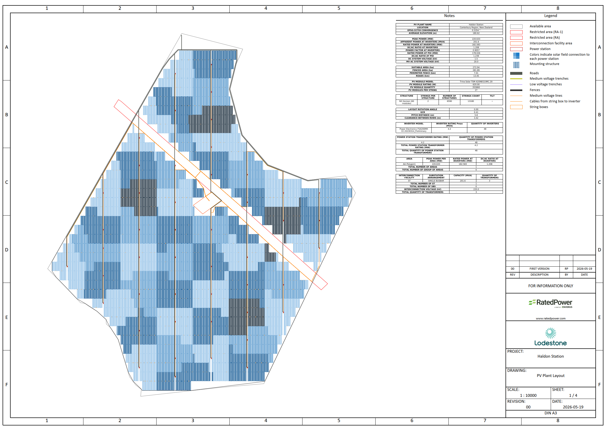
Attachment 2 – SH8 (Dog Kennel Corner) Indicative Works
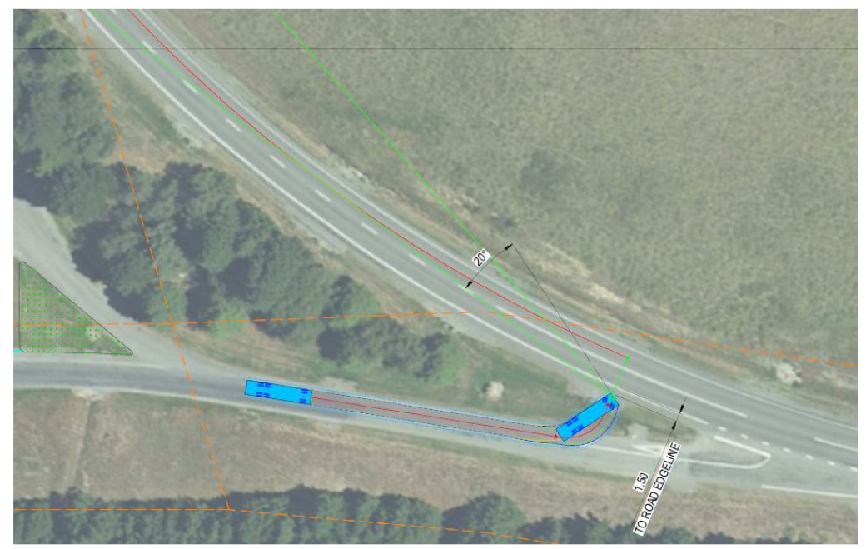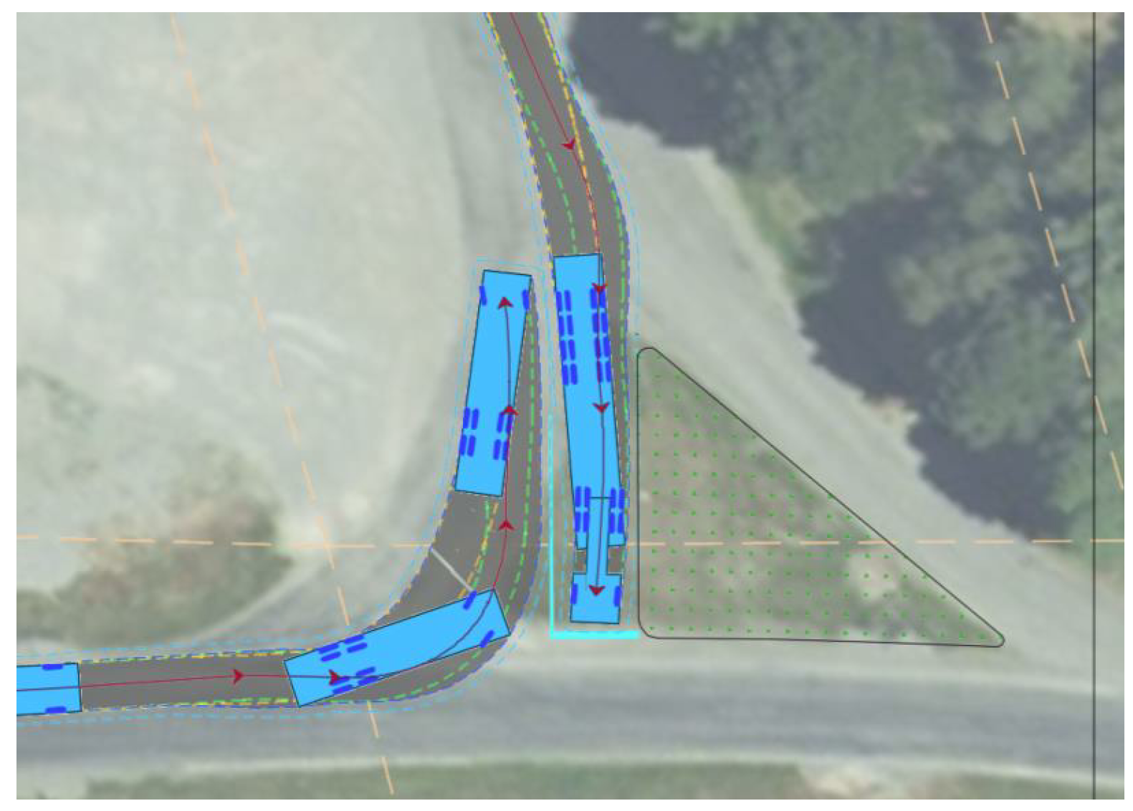

Attachment 3 – Landscape Mitigation Planting Plan (Boffa Miskell dated 26 February 2026)
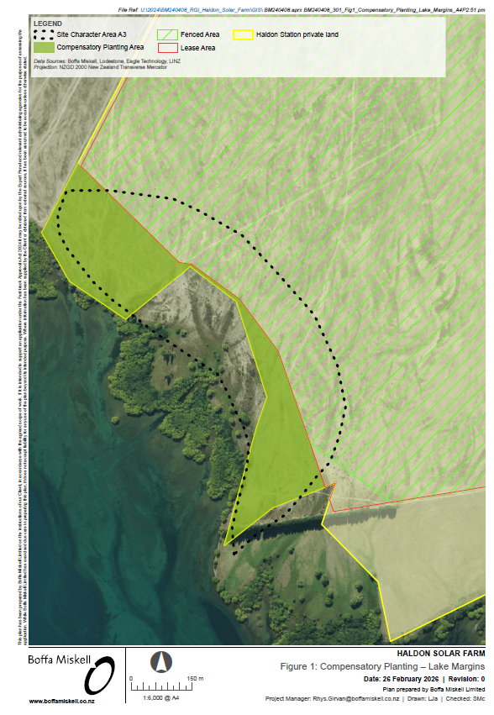

Attachment 4 – Compensation Area
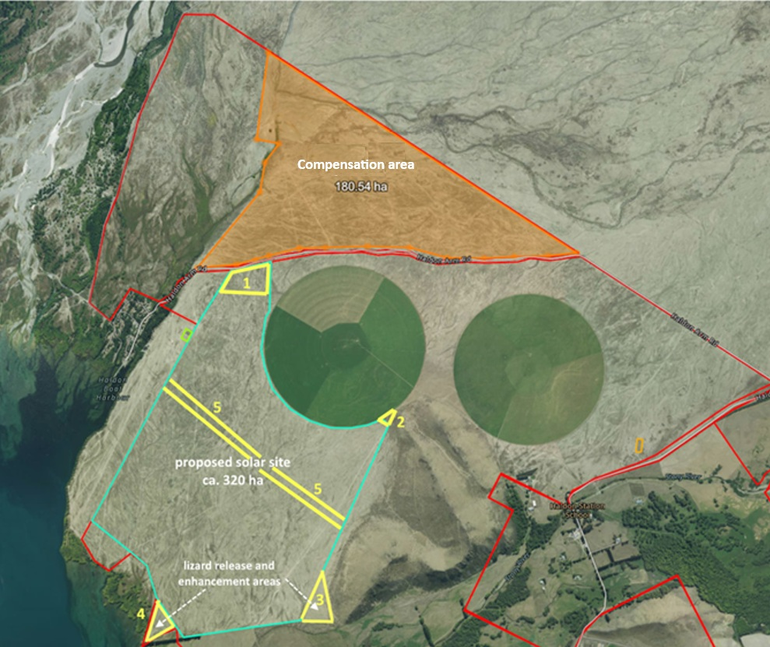

Attachment 5 - Landscape Planting for Conservation Area 1
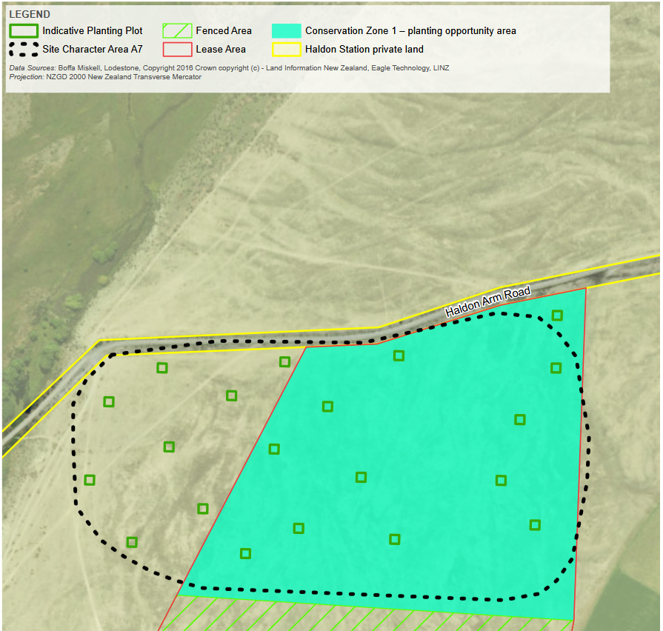
Attachment 6 – List of application documents

