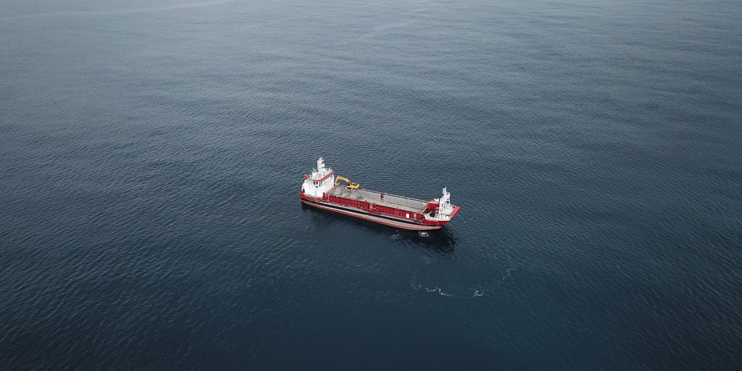


ATTACHMENT TWENTY-SEVEN
Sand Extraction Operation Plan (“SEOP”)
Version 3 (Clean) - Updated 2/07/2026





Te Ākau Bream Bay Sand Extraction Project

Sand Extraction Operation Plan (SEOP)

July 2026

Revision history

Title: Te Ākau Bream Bay Sand Extraction Project – Sand Extraction Operation Plan (SEOP)
Date | Version | Description | Prepared by | Date certified
15/07/2025 | 1 | Final draft for consultation | L.Davis  N.McCallum
11/11/2025 | 2 | Included internal procedure for closing cells | L.Davis
2/07/2026 | 3 | Updates to Section 2.3, 2.6.3, and new Section 2.6.4 | L.Davis

Glossary of Terms

ACERT | Advance Combustion Emission Reduction Technology
ASEA | Approved Sand Extraction Area
EMMP | Environmental Monitoring Management Plan
EPA | Environmental Protection Authority
IMO | International Maritime Organisation
ISPS Code | International Ship and Port Facility Security Code
MOSS | MNZ Maritime Operator Safety System
MTOP | Marine Transport Operator Plan
MARPOL | International Convention for the Prevention of Pollution from Ships
MBL | McCallum Bros Limited
MMMP | Marine Mammal Management Plan
MNZ | Maritime New Zealand
PSEAR | Pre-Sand Extraction Monitoring Report
RAM | Restricted in Ability to Manoeuvre
SEOP | Sand Extraction Operation Plan
TSHD | Trailing Suction Hopper Dredge

Limitations
The report has been prepared to a specific scope of work. The report cannot be relied upon by a third party for any use without written consent of MBL (the disclosing party). This report may not be reproduced or copies in any form without the permission of the disclosing party. This document must always be displayed onboard the William Fraser at all times.

Table of Contents

1.0 Introduction 1
1.1 Purpose 1
1.2 Scope 1
1.3 Objectives 1
2.0 Sand Extraction Operation Methodology 3
2.1 The Vessel 3
2.2 Operating Limits 4
2.3 Operating Hours 4
2.4 Method of Extraction 4
2.5 Extraction Management 8
2.5.1 Extraction Cells 8
2.5.2 Sand Extraction Rotation Methodology 9
2.6 Extraction Volume Reporting 12
2.6.1 Sand Extraction Volume and Location 13
2.6.2 Monitoring Extraction 14
2.6.3 Internal steps for closing cells 15
2.6.4 Internal steps to reopen a closed cell 17
3.0 Overview of Operational Procedure 19
4.0 General Compliance Protocols 20
4.1 Compliance with the Maritime Transport Act 1994 20
4.2 Compliance with the Maritime Security Act 2004 20
4.3 Compliance with the Ship Registration Act 1992 20
4.4 Compliance with the Port of Auckland Hauraki Gulf Transit Protocol 20
4.5 Protocols to Minimise the Risk of Vessel Collisions and Incidents 21
4.6 Protocols to Minimise Underwater Noise 21
4.7 Crew Training Protocol 22
5.0 Lighting Management Plan 22
5.1 Introduction 22
5.2 Lighting Methodology 23
5.2.1 Flood Lights 23
5.2.2 Navigational Lights 24
5.3 Lighting Management 26
5.3.1 Reducing Light-induced Effects to Seabirds 27
5.3.2 Desired Outcome 1: Minimise the seabird vessel strike due to light-induced disorientation and attraction to vessels. 27
5.3.3 Desired Outcome 2: Maximise the chance of survival for vessel-struck seabirds 28
6.0 Management plan review 29
Appendix 1: Hauraki Gulf Transit Protocol for Commercial Shipping 30
Appendix 2: Navigational Light Arrangement Plan 32
Appendix 3: Fisheries New Zealand – Protected Species Information for Commercial Fishers 33
Appendix 4: Department of Conservation – Managing artificial lights to reduce seabird vessel strikes 35
Appendix 5: Template documentation to detail tools/equipment required to meet Mitigation Standards 1.1, 1.4, 1.5, and 1.7. 36
Appendix 6: Roles and Responsibilities of MBL Staff. 39

List of Figures
Figure 1: Map Showing Sand Extraction Area and Control Areas With Cells. Source: Bioresearches 2025. Assessment of Ecological Effects – benthic ecology. 2
Figure 2: William Fraser extracting sand at Pākiri. Source: MBL. 3
Figure 3: Map showing the accepted transit route of the William Fraser (red) and the recommended route for large commercial vessels (green). This is the trip plan to Te Ākau Bream Bay from the Port of Auckland. Source: Google Earth. 5
Figure 4: Map showing the trip route from Te Ākau Bream Bay to the Port of Tauranga. Source: Google Maps. 7
Figure 5: Map showing the trip plan from Te Ākau Bream Bay to the Port Nikau (Whangārei) Source: Google Maps. 8
Figure 6: Sketch showing the numbering and naming convention of the cells in the ASEA. 9
Figure 7: Possible Trip Plan for Te Ākau Bream Bay with the approximate first 12 trips and then what a single cell looks like for a finely scaled interval (4m for this example). Source: MBL. 11
Figure 8: An example of a GPX extraction track (blue line) at Pakiri. Source: MBL. 12
Figure 9: Cell Return Spreadsheet Record at Pakiri. Source: MBL. 13
Figure 10: Map showing the sand extraction with monitoring cells (each cell is 1000 m x 200 m). Source: Bioresearches 2025. Assessment of Ecological Effects – benthic ecology. 15
Figure 11: Example of closed cells in the ASEA. 16
Figure 12: Overview of General responsibility flow diagram (Top to Bottom). 19
Figure 13: William Fraser ‘s downward facing flood lights while the is actively extracting sand at Pākiri. Image taken from the bow. Source: MBL. 23
Figure 14: Flood lights on board the William Fraser at Pākiri between 19:00-21:00, on 26 May 2025. Source: MBL. 24
Figure 15: William Fraser's Navigation Lights from the stern of the vessel while in transit. Source: MBL. 25

List of Tables
Table 1: Vessel Details. 3
Table 2: Location, number and visibility of the lights on board William Fraser. 25
Table 3: Mitigation Standard for Outcome 1 for William Fraser. 27
Table 4: Mitigation Standard for Outcome 2 for William Fraser. 28
Table 5: Roles, responsibilities, and contact details relevant to the Extraction Management Plan. 39

Introduction
McCallum Bros Limited (MBL) has been granted resource consent (reference TBC) for sand extraction at the Te Ākau Bream Bay Sand Extraction Site (Figure 1). This consent was given effect to on (date TBC) and expires on (date TBC).

Purpose
The purposes of this SEOP is to:
- Ensure sand extraction activities are carried out safely, efficiently, and in accordance with all relevant regulatory and consent requirements.
- Minimise environmental effects of extraction, particularly on benthic habitats and marine wildlife, through controlled, well-distributed operations.
- Provide clear procedures for tracking and reporting extraction volumes and environmental performance
- Manage vessel lighting to meet maritime safety standards while minimising light-related impacts on seabirds and other sensitive species.
- Align sand extraction activities with the broader environmental monitoring and management framework, ensuring regular review and continuous improvement throughout the life of the consent.

Scope
This SEOP applies to all MBL employees and contractors involved in vessel-based sand extraction operations for the Te Ākau Bream Bay Sand Extraction Site.

Objectives
The objective of this Sand Extraction Operation Plan (SEOP) is to avoid or minimise the risk of adverse effects arising from the operation of the William Fraser (Figure 2) at the sand extraction site.
This plan outlines procedures for:
- The management of sand extraction activities, including:
- An overview of extraction operations;
- Use of extraction cells to guide and control activity;
- Monitoring, reporting, and compliance protocols; and,
- Roles, responsibilities, and training of operational staff
- Implementation of a Light Management Plan (LMP) to reduce light spill and glare, and minimise potential impacts on marine wildlife and seabirds. The objective of the LMP is to avoid or minimise the potential adverse effects on seabirds, marine mammals and marine reptiles from lighting while operating in the hours of darkness.
Figure 1: Map Showing Sand Extraction Area and Control Areas With Cells. Source: Bioresearches 2025. Assessment of Ecological Effects – benthic ecology.

Sand Extraction Operation Methodology

The Vessel
The vessel used to carry out the sand extraction activities is the trailing suction dredger William Fraser. The vessel has a crew of four, with a minimum of two crew on watch during extraction. Further vessel details are shown below in Table 1:
Table 1: Vessel Details.
VESSEL DETAILS
Vessel name: | William Fraser | IMO # | 9864605
Vessel type: | Landing Craft | Vessel length | 68m
Year of build: | 2019 | Vessel draught | 4.2m
Hull material: | Steel | Service category: | Cargo
Gross Tonnage | 1540 | Loading ramp capacity | 150 tonnes
Propulsion power: | Main make & kilowatts | Auxiliary:
Propulsion power: | 2 x Caterpillar C32 - 746 kW each | 2 x 80 kVA generators  1 x 800 kVA generator
Classification society: | Lloyds Registry

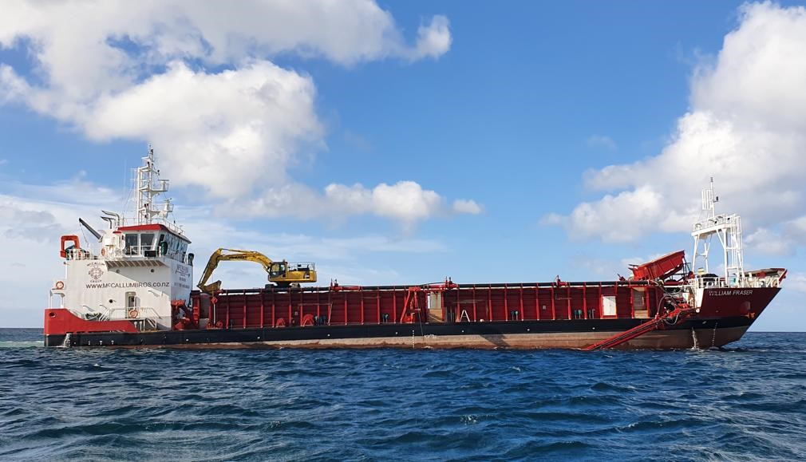
Figure 2: William Fraser extracting sand at Pākiri. Source: MBL.

Operating Limits
The following operational limits will be adopted by the William Fraser:
- The vessel has a surveyed sand carrying capacity of 923m³;
- During the first 3 years of consent (150,000m³/year) there will be 3 trips per week on average with a total of approximately 163 trips per year;
- During the remaining 32 years of consent (250,000m³/year) there will be 5 trips per week on average with a total of approximately 271 trips per year;
- During active sand extraction, the maximum allowable speed will be 2.5 knots; and,
- During transit between the extraction site and the Port of Auckland, the maximum allowable speed will be 9.5 knots.

Operating Hours
Sand extraction will be limited to the following operational windows:
- 12:00 pm to 6:00 pm during the months of April to September (inclusive).
- 12:00 pm to 8:00 pm during the months of October to March (inclusive).
Sand extraction will not exceed 3.5 hours from the time sand extraction commences to minimise time spent in the embayment. If there is a stoppage during the sand extraction, this period of time shall not be considered as part of the permitted 3.5 hours sand extraction period.
No sand extraction is to occur from the 23rd of December to the 6th of January (inclusive) or on Waitangi Day, Good Friday, Easter Monday, Anzac Day, the Sovereign’s birthday, Te Rā Aro ki a Matariki/Matariki Observance Day, and Labour Day. If Waitangi Day or Anzac Day falls on a Saturday or a Sunday then no sand extraction is to occur on the following Monday.

Method of Extraction
The following outlines the standard operational procedure for a typical sand extraction voyage by MBL to Te Ākau Bream Bay:
- The MBL Operations Manager reviews marine forecasts to determine if conditions are safe for extraction. If favourable, the Environmental Manager prepares a Trip Plan for the William Fraser.
- The William Fraser departs the Port of Auckland in the morning, travelling through Tiri Passage, past Kawau Island and Mangawhai-Pākiri to Te Ākau Bream Bay. The vessel adheres to a maximum speed of 9.5 knots. See Figure 3 below for the transit route of William Fraser.
- Upon approach to the Approved Sand Extraction Area (ASEA), the vessel operational lights are activated, and speed is reduced to 1.5–2.5 knots to commence extraction setup.
- Pre-extraction checks are undertaken to ensure the draghead and all other operational equipment in the water column are free from loose gear and entanglements.
- The Master of the William Fraser navigates the vessel to the starting coordinate of the predetermined extraction path for that trip, located on the boundary of the ASEA.
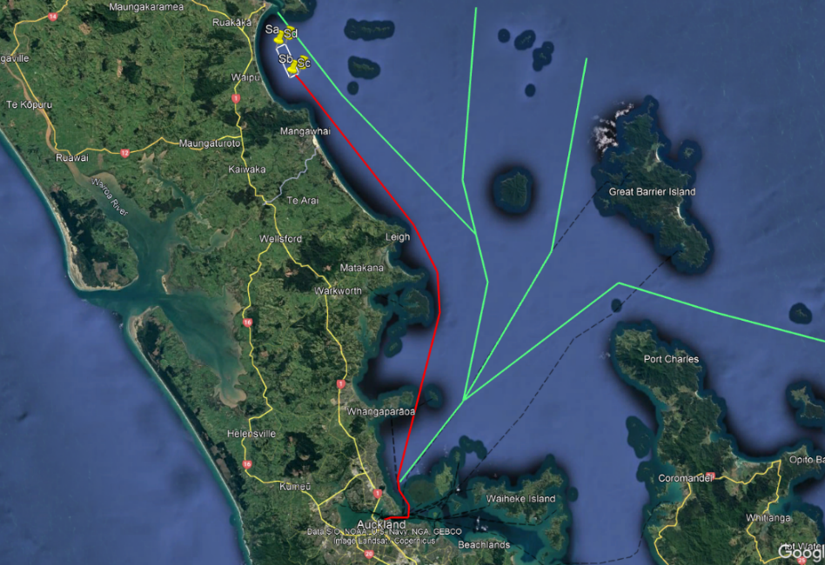
Figure 3: Map showing the accepted transit route of the William Fraser (red) and the recommended route for large commercial vessels (green). This is the trip plan to Te Ākau Bream Bay from the Port of Auckland. Source: Google Earth.
- The draghead is unsecured from the vessel, the davits extend the pump and dredge pipework over the starboard side, then they are slowly lowered within 3 m of the seafloor where suction/pumping of seawater commences to prime the pumps.
- The pumps are initially primed with water, after which the draghead is fully lowered to the seafloor to commence extraction. At this point, the vessel’s position is geolocated using the MAXSea navigational software to enable the extraction track to be recorded. Simultaneously, a switch on the swell compensator is automatically triggered, initiating an independent recording of the extraction track. Both recording systems continue logging data until extraction ceases and the draghead is lifted from the seafloor.
- As the draghead moves forward along the seafloor, the top 100 mm of seabed is fluidised and pumped onboard via the draghead and dredge system.
- This results in a 1.6 m wide x 100 mm deep extraction track being created on the sea floor. The duration of this shallow trench is temporary and dependent upon wave conditions at the time of and following extraction
- The sand slurry moves up the draghead pipe, through the pump and then onboard the vessel where it is discharged onto a double deck screening tower that utilises a 2.0 mm screen mesh to prevent larger material going into the load of the hopper.
- Oversized material passes across the top of the screen and drops via a pipe into the forward port side moon pool and exits at keel height under the vessel.
- The sand passes through the screen deck and into two pipes that run along the sides of the holding hopper and discharge into the storage hopper on board. As the slurry drops into the sand hopper the water velocity slows, and the sand settles out. The water and any finer sediment in the load then pass out of the hopper into moon pools which discharge under the vessel’s keel. There are six moon pools in total, three on each side of the hopper on the vessel.
- The barge slowly fills with sand with excess water flowing into the moon pools. As the level of sand increases in the hopper, boards are used to retain it in the hopper whilst still allowing the sediment laden water to pass out over these boards.
- The William Fraser will be operated in a consistent manner in terms of direction and speed (1.5-2.5 knots). The Master of the William Fraser and crew must remain vigilant for marine wildlife during extraction and be prepared to shutdown extraction if a large whale (killer whales and larger, including all baleen whales) is sighted within 100m from the vessel. In these circumstances, extraction will not recommence until the large whale has been resighted and has moved away from the draghead/vessel, or until there has been no further sightings for 10 minutes.
- The vessel will travel an expected distance of 13km for each trip. It is anticipated that 2 full passes of the extraction area will be needed on average to fill the hopper with 923 m³ of sand. These paths are predetermined and input into the navigation software TimeZero for the vessel to follow to ensure even extraction across the ASEA. MBL expects the time it will take to fill the hopper with sand will be between 2.5 and 3.5 hours.
- Once the vessel hopper is full or at sand volume capacity (923m³), the pump will be lifted to no greater than 3 m off the sea floor and water will be pumped through the system to ensure that all the sand has been flushed from the pipes and screen deck. Once complete, the pump will be turned off and the draghead raised and stowed back on board the vessel.
- The tracking software will turn off once the draghead is lifted from the seafloor and the Master of the William Fraser will turn off the vessel tracking on the MAXsea navigational software.
- A typical return trip from the Port of Auckland ranges from 16-20 hours, depending on weather and sea conditions.
- If the William Fraser delivers the sand to the Port of Tauranga, it will follow the route below in Figure 4, transit time to Tauranga is approximately 17 hours.
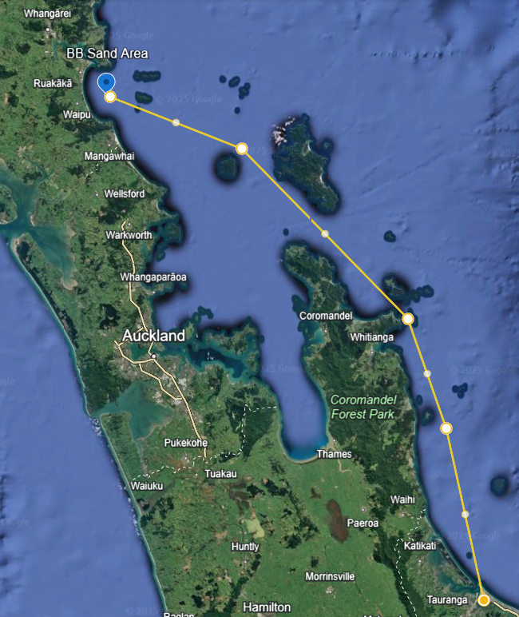
Figure 4: Map showing the trip route from Te Ākau Bream Bay to the Port of Tauranga. Source: Google Maps.
- If the William Fraser delivers the sand to Port Nikau (Whangārei Harbour) it will follow the route below in Figure 5 (below), transit time is approximately 2 hours.
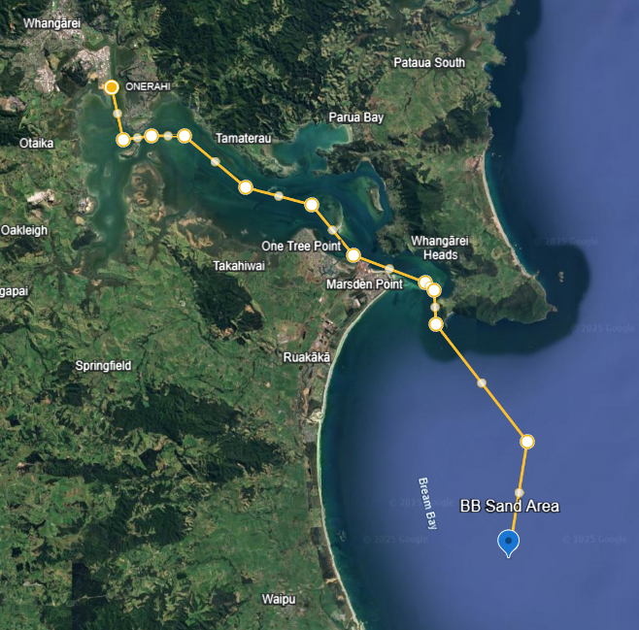
Figure 5: Map showing the trip plan from Te Ākau Bream Bay to the Port Nikau (Whangārei) Source: Google Maps.
- When the vessel returns to the Port of Auckland (or any other destination Port) the sand is unloaded using an excavator, onto a stockpiling barge or wharf to drain, after a day or so, the sand is loaded into trucks for distribution to customers or to a land-based stockpile.

Extraction Management

Extraction Cells
Sand extraction will be spatially distributed across 77 designated extraction cells, each measuring 1,000 m by 200 m. Each cell is uniquely named and numbered to support detailed trip planning and accurate reporting of individual extraction events. These cells form an integral part of the operational plan and provide a structured framework for managing extraction activities, as well as facilitating ongoing ecological and geomorphological monitoring of the site. The naming and numbering system for the extraction cells is illustrated in Figure 6 (below).
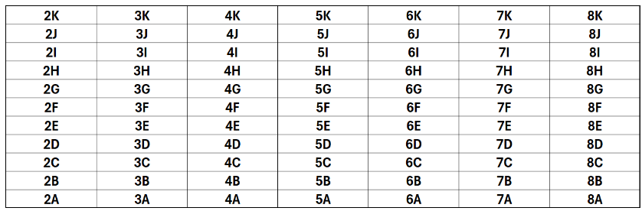
Figure 6: Sketch showing the numbering and naming convention of the cells in the ASEA.

Sand Extraction Rotation Methodology
Sand extraction is carried out along predefined lines known as tracks. During a typical extraction event, the vessel extracts sand over a distance of approximately 13 km, usually covering two rows of extraction cells. The actual length may vary slightly from trip to trip, depending on operational conditions.
A rotational methodology must be used to distribute extraction across the ASEA to avoid intentional repeat extraction of the same track for at least 12 months and prevent immediately adjacent tracks from being extracted sequentially.
The pre-planned track lines are navigation guides for achieving an even spatial distribution of extraction. The Master will follow the allocated line as closely as practicable, subject to prevailing conditions and the safe operation of the vessel. Minor lateral deviations and short sections of incidental overlap with a previously extracted track may occur. Such overlap is not to be deliberate or systematic. Following each extraction trip, the recorded extraction track will be reviewed and used in planning subsequent trips.
This approach promotes even spatial distribution of extraction across the Approved Sand Extraction Area (ASEA) and supports seabed recovery between events.

The first diagram shown in Figure 7 below illustrates the general direction and layout of extraction tracks. The final diagram shows how each extraction cell is divided into 50 parallel track lines, spaced 4 metres apart. The sand extraction is taken approximately along one of these track lines for the length of the sand extraction area (excluding any cells not covered by the ASEA).
Sequencing of adjacent extraction tracks
- For the purposes of this section, an adjacent track means the immediately neighbouring pre-planned track line, nominally spaced 4 m centre-to-centre.
- Extraction tracks must be sequenced using a rotational methodology. An adjacent pre-planned track must not be intentionally extracted on the next visit to the same row of extraction cells. So far as reasonably practicable, at least one unextracted pre-planned track must be left between tracks extracted during successive visits, and available non-adjacent tracks must be used before an immediately adjacent track is selected.
- The extraction sequence must be designed to maximise, so far as reasonably practicable, the elapsed time between extraction of adjacent tracks. This sequencing is intended to maintain an even spatial distribution of extraction and to provide the greatest practicable period for recovery of the seabed between neighbouring extraction tracks.
- The Environmental Manager must use the recorded GPX extraction tracks and the Cell Return Spreadsheet when preparing each Trip Plan. Each Trip Plan must identify the pre-planned track to be extracted and confirm that the track sequence has been applied.
- A departure from the track sequence may occur only where required for safe vessel operation, because of prevailing sea conditions, or to avoid a closed or excluded cell or part of a cell. The reason for any departure must be recorded, and subsequent Trip Plans must be adjusted to maximise the remaining interval before an adjacent track is extracted.
- This requirement applies to the intentional selection of pre-planned tracks. Minor incidental deviation from, or partial overlap with, a pre-planned track does not constitute intentional sequential extraction of adjacent tracks. However, the actual recorded extraction track must be considered when planning subsequent trips so that further extraction immediately adjacent to the affected area is avoided for as long as reasonably practicable.
With 50 track lines in each cell, this allows for a total of 550 sand extraction tracks across the ASEA. Since the vessel will cover two rows of cells during an extraction trip, this means there is a total of 275 trips before sand extraction revisits the original track line again.

The combination of the vessel-tracking software and the swell compensator effectively addresses both the vertical and horizontal components of positional accuracy. The system’s integrated horizontal-positioning capability ensures that vessel direction and movement are accurately captured and corrected in real time. Together, these systems provide the required confidence in the reliability of the William Fraser’s vessel tracks.
The requirement to report monthly sand extraction volumes for each cell and submit electronic record of the track of the William Fraser showing (i) a complete track of the William Fraser from the entry point into and departure point from the sand extraction area and (ii) a track of the William Fraser showing when the dredge head is on the seabed extracting sand and when the dredge head is above the seabed and not extracting sand allows for Council to monitor that extraction is occurring evenly across the extraction area.
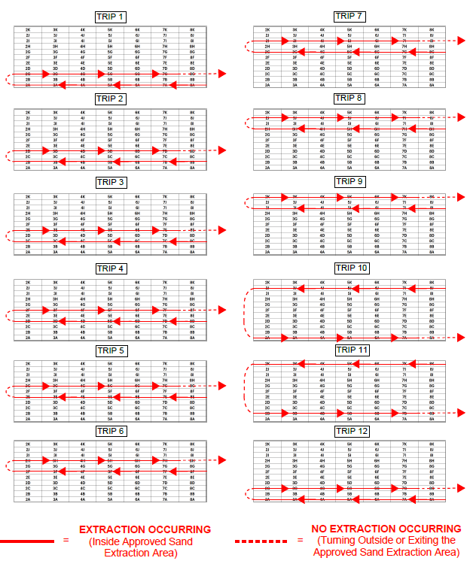
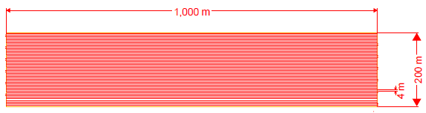
Figure 7: Possible Trip Plan for Te Ākau Bream Bay with the approximate first 12 trips and then what a single cell looks like for a finely scaled interval (4m for this example). Source: MBL.

Extraction Volume Reporting
The volume of sand extracted from each cell and location of each extraction track is recorded through the following steps:
- Upon the draghead touching the seafloor to commence extraction, MAXsea navigational software begins recording the position of the vessel as it moves along the extraction track in the form of GPX location data points.
- The GPX data (location data points) related to the position of the vessel is then automatically entered into ArcGIS, an online geographic information software.
- For each extraction trip, the GPX track (Figure 8) is analysed to determine the total distance travelled, and the proportional distance travelled within each cell is calculated. These percentages of distance travelled per cell are then applied to the total extracted volume from the corresponding trip, allowing an estimated volume to be allocated to each cell.
- The estimated volume extracted per cell is calculated using the following formula:

Volume Extracted per Cell = (Total Volume Extracted / Total Distance Travelled) x (Distance Travelled in Cell)
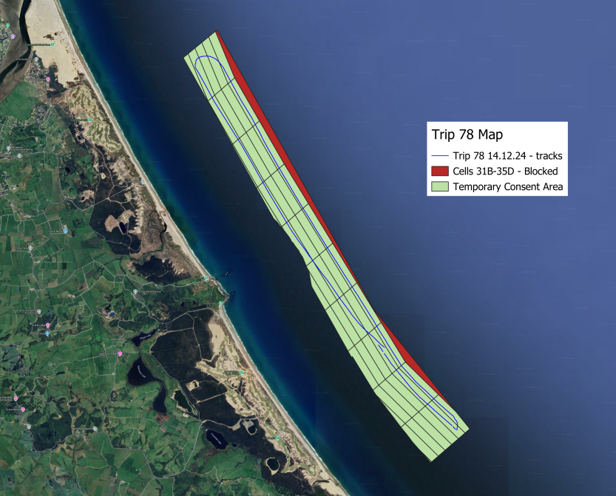
Figure 8: An example of a GPX extraction track (blue line) at Pakiri. Source: MBL.
- These volumes are then entered into the “Cell Return Spreadsheet”. This spreadsheet also calculates a heat map, displaying a percentage of the remaning volumes to be extracted from an individual cell. These live spreadsheets are shared with the William Fraser crew weekly, and assist in the planning for future extraction. An example of this spreadsheet currently used Pākiri as part of MBL’s current extraction reporting is shown in Figure 9 below.
- The sand extraction reports are then provided to Northland Regional Council on a quarterly basis.
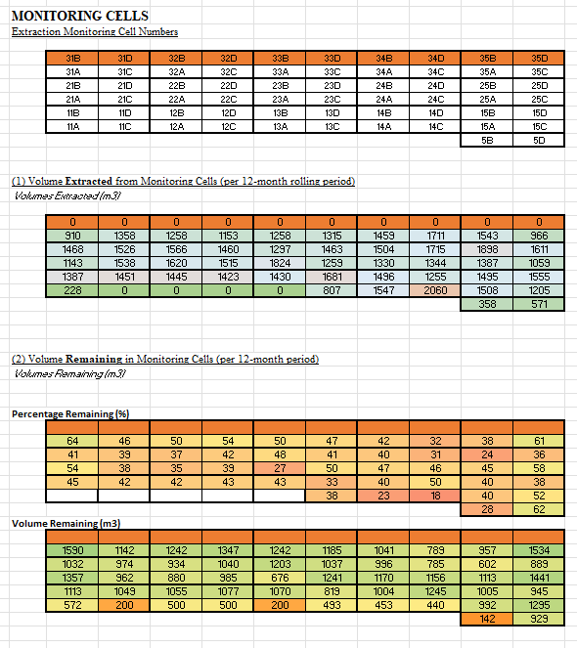
Figure 9: Cell Return Spreadsheet Record at Pakiri. Source: MBL.

2.6.1 Sand Extraction Volume and Location
As part of this process, MBL will record and report:
- The date, time and sea conditions during the period of extraction and the water depth of extraction. The volume of sand extracted from each cell where extraction has occurred.
- The total volume of sand extracted. In the event that the William Fraser is not fully loaded, MBL may report the volume of the incomplete load calculated from the onboard sensors measuring compliance with the load line marked on the vessel’s hull in accordance with Maritime NZ requirements before any unloading of sand. The record must include for each load:
  - A screenshot or other verifiable way of showing the date and time, and the reading of the sensors.
  - The volume of the load by reference to the load-line.
- An electronic record of the track of the William Fraser (using a GPX file format or equivalent) and mapped using a differential global positioning system (“DGPS”) showing:
- A complete track of the William Fraser from the entry point into and departure point from the sand extraction area.
- A track of the William Fraser showing when the dredge head is on the seabed extracting sand and when the dredge head is above the seabed and not extracting sand.

2.6.2 Monitoring Extraction
The monitoring of sand extraction and effects is comprised of:
- Recording and reporting volumes of sand removed from each cell to ensure an even spread across the whole site on a quarterly basis, along with a running record of the total volume of sand extraction for that month, year and consent period;
- Benthic ecological sampling to measure and look for potential change in biota across the site and relating this to the extraction intensity and the control cells;
- Bathymetric surveying to look for seafloor height changes;
- Topographic surveying to determine any changes in the foreshore and dune environments;
- Marine mammal and reptile monitoring to record any sightings or interactions; and,
- Sea and shorebird monitoring to record any interactions (e.g. bird strike).
A finer scale map of the extraction and monitoring cells is provided below as Figure 10, showing the sand extraction with monitoring cells (each cell is 1000 m x 200 m).

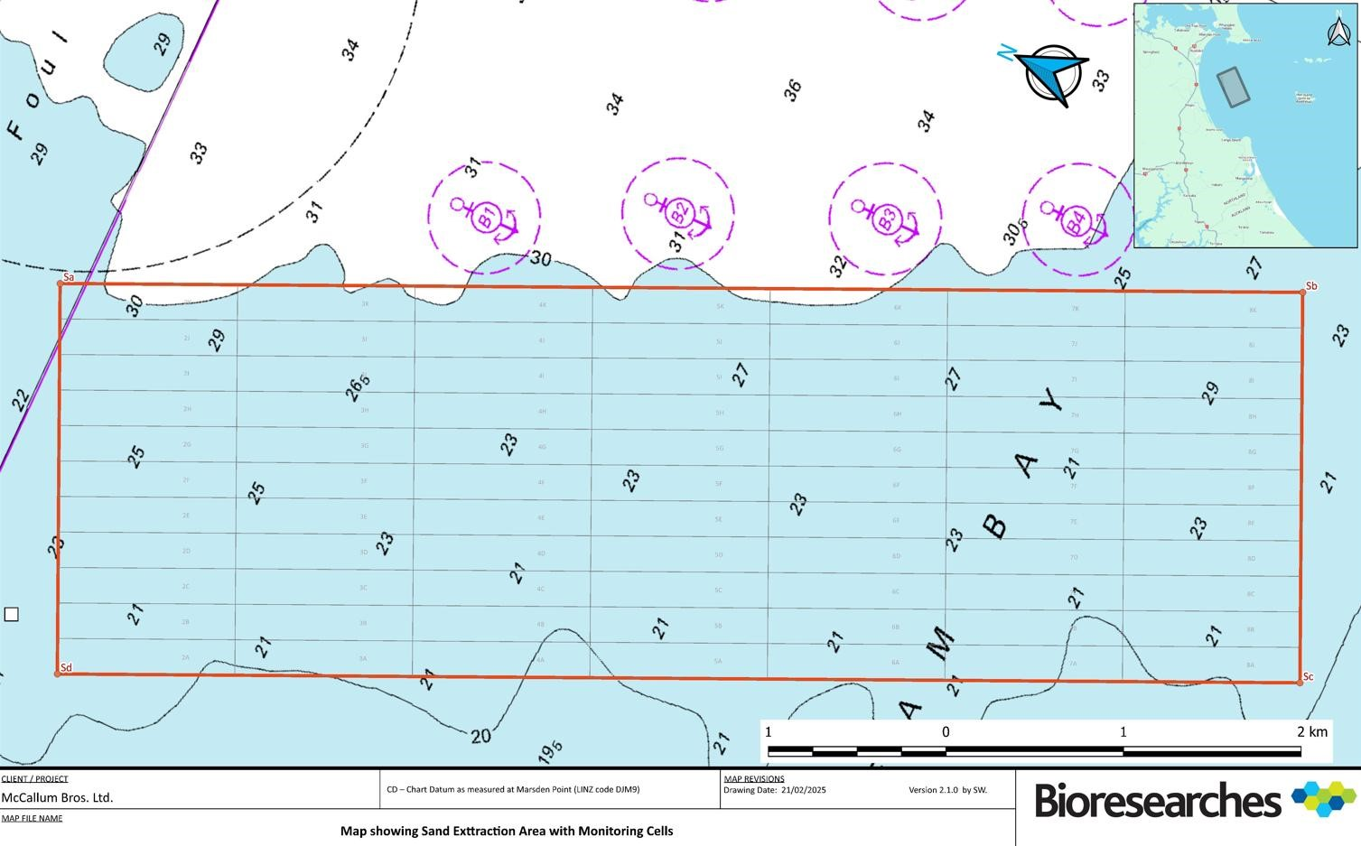
Figure 10: Map showing the sand extraction with monitoring cells (each cell is 1000 m x 200 m). Source: Bioresearches 2025. Assessment of Ecological Effects – benthic ecology.

Internal steps for closing cells
Sand extraction must be limited to the Approved Sand Extraction Area (ASEA) within the Extraction Area as identified on drawing ‘Map Showing Proposed Sand Extraction Area and Proposed Control Areas, dated 12/11/2025’ in Figure 1 or any subsequent ASEA included in any Pre-Sand Extraction Area Report (PSEAR) or Sand Extraction Monitoring Report (SEMR) certified by the Council.
An ASEA must not include areas of the seafloor which contain any of the following:
- Sediment with an average proportion of mud (grain size finer than 0.063 mm) exceeding 20% by weight; or
- Areas of immobile layers (e.g. rock) or historic facies (e.g. partly consolidated orange Pleistocene sand deposit); or
- Sensitive benthic communities (as defined by Attachment Four to Attachment 26 - Recommended Resource Consent Conditions); or
- Any absolutely protected species under the Wildlife Act 1953, excluding any species for which a Wildlife Authority is held; or
- Extraction track(s) longer than 100m with a width of less than 2m and a depth exceeding 0.4m below the typical adjacent seabed levels defined as the seabed area within 10m of each track edge.
- Cell(s) or parts of cells which have been recommended for closure from sand extraction in an SEMR on the grounds that bathymetric monitoring within the bathymetric control area shows progressive lowering of the seabed across two or more annual surveys and the average change in seabed level across the 220m width of the control area relative to the pre-extraction baseline survey (2025) exceeds 0.15 m, indicating a likely adverse effect of sand extraction that cannot be explained by natural processes and/or storm events; or
- Cell(s) or parts of cells which have been recommended for closure from sand extraction in an SEMR on the grounds that they demonstrate a trajectory of benthic change that is divergent from the trajectory of benthic change in the control site envelope having regard to the extent to which the change, or elements of the change, are likely to be attributable to sand extraction or natural variability, storm events, seasonal variation, other activities or a combination of those factors.

In the event that during extraction a discovery of one or more of those matters listed as a) to g) occurs then sand extraction within that cell is to cease immediately and not recommence until such time that sand extraction in that cell is approved though the PSEAR process as outlined in Condition 22.
The Council is to be notified within 5 working days of when sand extraction within a cell has been ceased due to a discovery of any of the matters listed in a) to g) above.
In the event that sand extraction from a cell(s) does not occur for more than a 36-month period (and sand extraction has not been ceased due to a) to f) above), a new PSEAR (for that cell(s)) must be completed under Condition 22 for certification by the Council, prior to sand extraction re-commencing in that cell(s).

MBL’s internal steps to close a cell are set out as follows:
- Discovery of one or more of those matters listed as a) to g) above.
- The Environmental Manager closes the cell(s) in the ASEA (Figure 11) and advises all MBL staff, including the Managing Director, Chief Operating Officer, Operations Manager, Compliance Manager, Compliance Officer and the Master of the William Fraser (refer to Appendix 6 in regard to the roles and responsibilities of MBL staff).
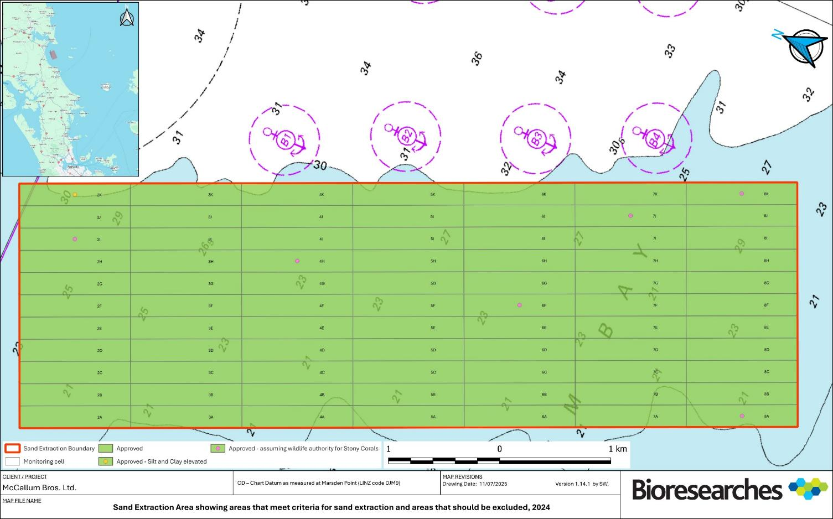
Cells not approved

Figure 11: Example of closed cells in the ASEA.
- The Compliance Officer will close the cell(s) on the Geolocated QGIS software for vessel navigation, and reporting purposes.
- The Environmental Manager will also advise the Council, Ngātiwai Trust Board, Te Pouwhenua o Tiakiriri Kukupa Trust (Te Parawhau ki Tai), and Patuharaheke Te Iwi Trust Board for their information.

Internal steps to reopen a closed cell

- A decision is made to assess whether a closed cell(s), or part of a cell(s), may be reopened for sand extraction.
- The Environmental Manager will arrange for the completion of a PSEAR in accordance with the certified Environmental Monitoring and Management Plan (EMMP), to assess whether the cell(s), or part of a cell(s), can be included within the Approved Sand Extraction Area (ASEA).
- Where the cell(s), or part of a cell(s), was previously excluded from the ASEA under Condition 20, the PSEAR must:
a. Identify the reason why the cell(s), or part of a cell(s), was excluded from the ASEA;
b. Demonstrate, Where the cell(s) or part of a cell was excluded under Condition 20 a) to e) demonstrate that the cell(s) or part of a cell no longer meets the relevant exclusion criterion or criteria; or
c. Where a cell(s), or part of a cell which has been recommended for closure under condition 20 f), include a conclusion from an SQEP that seabed levels within the bathymetric control area have stabilised having regard to natural processes, storm events and sand extraction; or
d. Where a cell(s), or part of a cell was excluded under Condition 20g), include a conclusion from an SQEP that the cell(s) has recovered to the point at which it is inside the control site envelope or exhibits a trajectory of benthic change that is not divergent from the trajectory of benthic change in the control sites having regard to the extent to which the change, or elements of the change are likely to be attributable to sand extraction or to natural variability, storm events, seasonal variation, other activities or a combination of these factors.
e. Include confirmation from a Suitably Qualified and Experienced Person (SQEP) that the cell(s), or part of a cell(s), is suitable to be reopened for sand extraction based on a0 to c) above.
- The draft PSEAR is to be provided by the Consent Holder to Te Parawhau ki Tai for their review and comments at least 20 working days before it is finalised and submitted to the Council. The final PSEAR must include and address any comments received from Te Parawhau ki Tai.

- The final PSEAR (including the proposed ASEA) must be submitted by the Consent Holder to the Council for certification prior to the sand extraction occurring in any new cell(s) in the revised ASEA.
- If the Council’s response is that it is not able to certify the PSEAR it must provide the reasons why, and any recommended changes in writing.

- Once the PSEAR has been certified by the Council, the Environmental Manager will update the Approved Sand Extraction Area (ASEA) to include the reopened cell(s), or part of a cell(s), and advise all relevant MBL staff, including the Managing Director, Chief Operating Officer, Operations Manager, Compliance Manager, Compliance Officer, and the Master of the William Fraser (refer to Appendix 6 for staff roles and responsibilities).
- The Environmental Manager or Compliance Officer will update the geolocated QGIS navigation system to reopen the certified cell(s) for operational use and compliance reporting.
- The Environmental Manager will advise the Council, Ngātiwai Trust Board, Te Pouwhenua o Tiakiriri Kukupa Trust (Te Parawhau ki Tai), and Patuharakeke Te Iwi Trust Board that the cell(s) has been reopened in accordance with the certified PSEAR and may recommence sand extraction.

3.0 Overview of Operational Procedure
(1) Operations Manager confirms weather etc suitable for voyage

(3) Master of William Fraser confirms receipt of trip plan by email
(2) MBL Environmental Manager emails William Fraser Trip Plans with comments weekly
(4) The William Fraser is navigated to the start position of extraction trip

(5) William Fraser follows extraction plan through designated extraction cells

(7) Track is recorded on Timezero as back up, with Master marking start position
(6) GPX Track begins recording when draghead lands on the seafloor

(8) William Fraser ceases extracting when average draft is 4.2m (~923m³)

(9) Master retrieves dredging gear and GPX automatically stops recording, Master marks end of extraction track

(10) Compliance Manager monthly removes storage drive from William Fraser and replaces with MT drive, full drive taken to Head Office

(11) Compliance Officer downloads extraction track and calculates trip volumes per extraction cell

(12) Compliance Officer creates heat map and Cell Return Spreadsheet

(13) Environmental Manager submits a Quarterly Report including the Cell Returns to Council with commentary

Figure 12: Overview of General responsibility flow diagram (Top to Bottom).

4.0 General Compliance Protocols

4.1 Compliance with the Maritime Transport Act 1994
The Maritime Transport Act 1994 is the primary legislation that describes the role and functions of Maritime New Zealand (MNZ) and the Director of MNZ. This legislation sets out the legal framework for maritime safety and protection of the marine environment, including:
- Licensing of ships and crew
- Investigation of maritime accidents
- Offences, response for oil spills planning and preparedness
- Other aspects of maritime law such as salvage, liability for pollution damage, limitation of liability, and compensation (Maritime New Zealand, 2025)
This act also provides for the Minister of Transport and Governor General to make maritime and marine protection rules. These rules contain the detailed standard requirements that the Maritime community are required to comply with.
A separate Oil Spill Contingency Plan has been approved by MNZ to provide guidance to the master and officers on board the ship with respect to the steps to be taken when a pollution incident has occurred or is likely to occur. As well as a separate Garbage Management Plan which has also been approved by MNZ taking into account the regulations of Annex V, Regulation 10 in the International Convention for the Prevention of Pollution from Ships (MARPOL 73/78) which indicates placards, garbage management plans, and garbage record keeping requirements.

Compliance with the Maritime Security Act 2004
This Act brought into domestic law New Zealand’s obligations under the International Maritime Organization’s International Ship and Port Facility Security Code (ISPS Code) (Maritime New Zealand, 2025). However, in this case the ISPS Code is not relevant for the purposes of this application.

Compliance with the Ship Registration Act 1992
MNZ are required to maintain the New Zealand register of ships – a list of all vessels registered as New Zealand ships. For some New Zealand ships it is compulsory to be registered. For others it is voluntary (Maritime New Zealand, 2025). All vessel under MBL’s fleet are registered with MNZ and compliant with the purposes and functions of this Act.

4.4 Compliance with the Port of Auckland Hauraki Gulf Transit Protocol
As per Section 4.3 in the Marine Mammal Management Plan (MMMP), during transit to and from the extraction area, the master of the William Fraser will ensure that the vessel is operated in compliance with the voluntary Hauraki Gulf Transit Protocol (Appendix 1). This protocol will be implemented throughout the entire transit route, i.e. not only in the Hauraki Gulf.
The requirements of the Hauraki Gulf Transit Protocol which must be followed include:
- A maximum transit speed of 10 knots (note the operational limit in Section 3.1 above restricts the Wiliam Fraser to a maximum of 9.5 knots);
- A crew member must be assigned to keep watch for whales during daylight hours;
- In the event a whale is sighted forward of the vessel beam, the vessel master should slow down and/or change course to keep as far from the whale as possible. Whenever safe to do so, no vessel should pass closer than 1,000 m from a whale; and
- All whale sightings inside the Hauraki Gulf should be reported immediately to the Ports of Auckland Harbour Control (this acts as a reporting and warning system for other vessels in the area). The reporting procedure outlined in Appendix 1 should be followed.
The abovementioned points will be implemented and addressed as part of MBL’s MMMP. The only permitted exception to the Hauraki Gulf Transit Protocol is that the William Fraser may travel inshore of the recommended transit route.

4.5 Protocols to Minimise the Risk of Vessel Collisions and Incidents
Incidents at sea can include a wide range of maritime accidents, including but not limited to collisions, fire, groundings, Man Overboard, Oil Spill etc. The McCallum bros Fleet have had no grounding or oil pollution incidents in the Mangawhai-Pākiri embayment.
All MBL vessels operate in accordance with the Maritime New Zealand Safety Management framework (MOSS) and the Relevant Harbourmaster Bylaws, regulations and COLREGS which are documented in the Company MTOP (Marine Transport Management Plan).

4.6 Protocols to Minimise Underwater Noise
As per Section 3.0 in the MMMP, underwater noise levels will be minimised during project activities as follows:
- The William Fraser and all equipment on-board, including winches, generators, engines etc., will be regularly serviced and maintained to a high standard;
- Noise suppression equipment will be used and regularly serviced and maintained to a high standard;
- Records of service and maintenance will be kept and will be available for inspection; and
- MBL will actively seek to make improvements to equipment and increase operational efficiency to:
  - reduce overall underwater noise outputs; and
  - reduce the daily dredging duration.

4.7 Crew Training Protocol
Training is a high priority for the company’s management and crew. All Crew members are trained in the use of equipment on board the vessel they are working on, including emergency procedures and drills. The company offers robust training for crew, both induction and refresher. Records are maintained in the business office. Staff meetings are held on a regular basis to discuss any ongoing training requirements.

Inductions: A Crew Induction Training Record shall be completed for all seafarers when joining the vessel, this record shall be completed, signed and dated by the seafarer and verified by the vessel’s Master.

Training: All seafarers shall complete a robust sign off specific to the role held onboard. These are broken down into Master, Mate, Engineer, Deck Crew.
No person shall maintain a solo navigational watch or sole responsibility of their role until the following training is completed to the Master’s satisfaction and the Crew Training Record is correctly verified by seafarer and Master.
All seafarers onboard in a vessel handling capacity are to complete the Vessel Handling Training Module.

MBL also run an internal Bridge Resource Management Module and Maritime NZ Approved Structured Training Program and Proficiency Plan for Pilot Exempt Masters.

Lighting Management Plan

Introduction
The purpose of this Lighting Management Plan is to outline the operational procedures and mitigation measures adopted by MBL to manage artificial lighting aboard the William Fraser during sand extraction activities at Te Ākau Bream Bay. The plan ensures that lighting is managed to maintain crew and vessel safety while minimising adverse effects on the surrounding marine environment, particularly in relation to seabird attraction and marine mammal disturbance. This plan has been developed to meet the requirements of the Sand Extraction Operation Plan (SEOP) and integrates relevant best practice guidance, including voluntary mitigation standards for reducing light-induced vessel strikes of seabirds.

The specific objectives of the Lighting Management Plan are to:
- Ensure vessel lighting meets minimum safety requirements while reducing unnecessary artificial light at sea.
- Minimise the attraction and disorientation of seabirds and other marine fauna caused by artificial lighting.
- Describe the location, configuration, and control measures of flood and navigational lighting used on the William Fraser.
- Ensure lighting configurations are consistent with maritime safety rules, particularly Maritime Rules Part 22.
- Implement and maintain operational practices that support voluntary mitigation standards for seabird protection.
- Ensure all crew are trained and aware of lighting protocols and wildlife mitigation responsibilities during extraction operations.
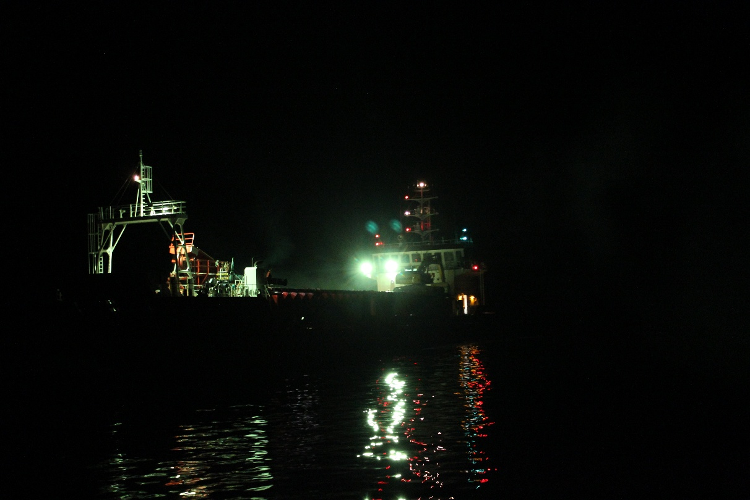
Figure 13: William Fraser ‘s downward facing flood lights while the is actively extracting sand at Pākiri. Image taken from the bow. Source: MBL.

Lighting Methodology

Flood Lights
The flood lights on board the William Fraser are subdued, downward facing, and shielded to avoid light spill over the open ocean. The yellowish-white colour of the flood lights (300-Watt LED lights) are directed over non-reflective surface of the sand within vessel hopper. The vessel uses the lowest intensity lighting appropriate to ensure crew safety with a conservative wattage of 300W. The various lighting locations onboard the vessel are shown in Figure 13 below.

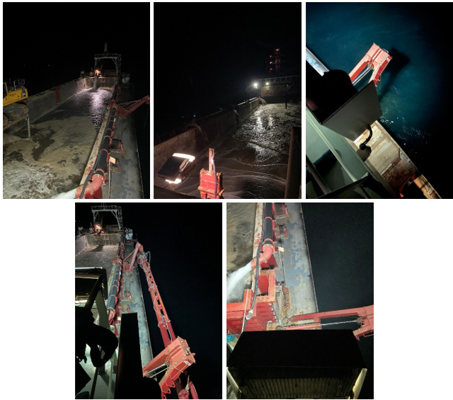
Figure 14: Flood lights on board the William Fraser at Pākiri between 19:00-21:00, on 26 May 2025. Source: MBL.

Navigational Lights
The navigational lights onboard the William Fraser are managed in line with MBL’s Navigational Light Arrangement Plan (Appendix 2), they have a predetermined intensity, defining specific visibility ranges and the spectral ranges of “white”, “red”, and “green” lights as per the Maritime Rules Part 22. During extraction operations, the lighting configuration is adjusted to minimise visibility from shore, while maintaining compliance with maritime safety regulations and ensuring the health and safety of the crew and other marine users.

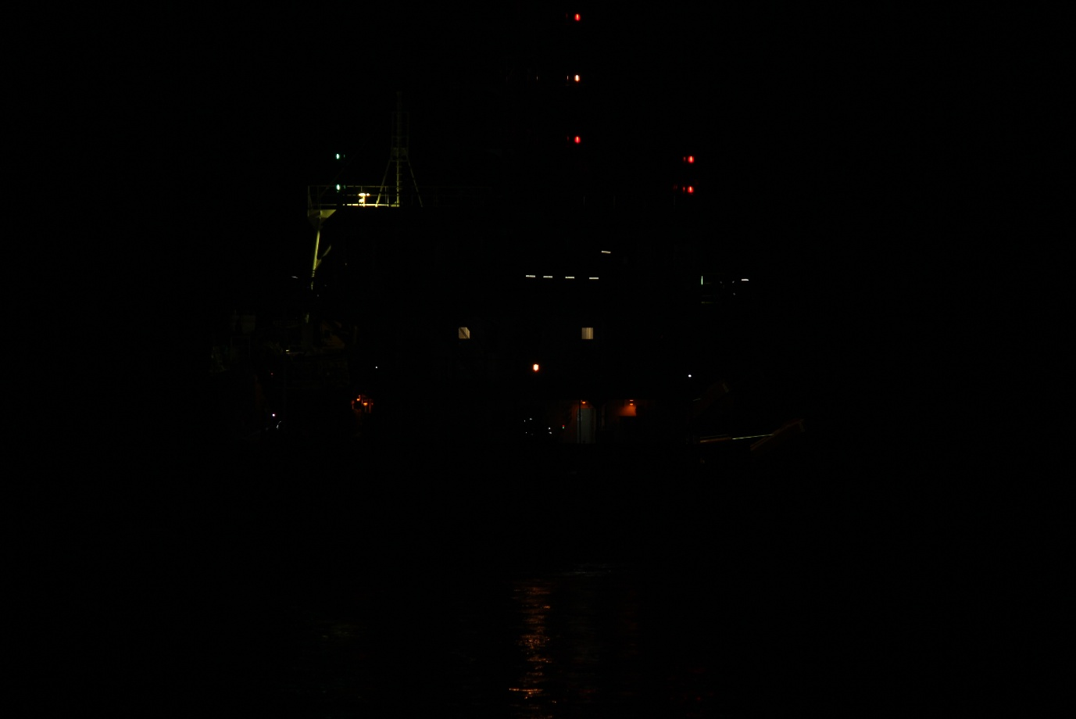
Figure 15: William Fraser's Navigation Lights from the stern of the vessel while in transit. Source: MBL.
Table 2: Location, number and visibility of the lights on board William Fraser.
William Fraser - Navigation Lights
Location | Light spectral | Number of lights | Visibility (Nm)
Anchor light | White | 2 | 3
Masthead lights | Red-White-Red (RAM Lighting on dredging side of vessel) | 3 | 6
Port and starboard lights | Red (Port) & Green (Starboard) | 2 | 3
Stern light | White | 1 | 3

Anchor light
The William Fraser will not be at anchor during any extraction event. Therefore, anchor lights are not a requirement for the purposes of this SEOP. These lights, however, are visible from 3 nautical miles away and are used when the vessel is at anchor.

Masthead lights
The William Fraser has two white masthead lights, one at the bow of the vessel and one on the mast which is above the accommodation at the stern of the vessel, which is visible across 225 degrees, 6 nautical miles, and is at least 1m above the RAM (Restricted in Ability to Manoeuvre) lights configured as Red-White-Red.

Port and starboard lights
Port and starboard lights indicate the left and right side of a boat. A red light signifies the port side and green represents the starboard. These lights are visible from 3 nautical miles away and are used when the vessel is moving.

Stern light
The William Fraser has a white light signalling the stern of a boat that shines across 135 degrees. The combined visibility of the masthead and stern lights is equal to 260 degrees. The stern light is turned on when the boat is moving and is visible from 2 nautical miles away.

Accommodation and outside lighting
Curtains will be drawn, and external doors closed at all times to prevent light spilling outside of the accommodation block. Exterior outside lights will be turned off and crew working outside will require head lamps to operate safely.

Lighting Management
During transit to the extraction area, and while extracting, the William Fraser will pass through areas that may contain protected marine species, including marine mammals and seabirds (Appendix 3). It is therefore important to use a structured approach to mitigate the risk of these species. Described and agreed daily practices include:
- Lighting is reduced to minimum requirements and intensity for operations and safety
- Non-essential activities requiring external lighting at night are avoided
- High-risk areas are avoided when using external lights
- Black-out curtains (on the cabin port holes) and amber (blue and violet-filtered) lights are used as appropriate
- Essential lights are shielded, angled, and/or positioned to only light required areas

Reducing Light-induced Effects to Seabirds
Seabirds are susceptible to disorientation from artificial lights at night, which can lead to vessel strikes. Such collisions may result in physical injury, loss of waterproofing and drowning. To mitigate these risks, MBL ensures that all crew members are trained in safe seabird handling and release techniques (refer to Appendix 4), recognising that vessel strikes can also result in direct mortality.

Whilst ensuring safe operating standards, MBL will minimise additional and unnecessary lighting so as not to attract or disorientate seabirds. As described in Mitigation Standards to Reduce Light-induced Vessel Strikes of Seabirds with New Zealand Commercial Fishing Vessels, the desired mitigation strategy outcomes are to:

Outcome 1: The number of vessel-struck seabirds due to light-induced disorientation and attraction to vessels is minimised
Outcome 2: Vessel-struck seabirds have a maximum chance of survival

Although there are currently no mandatory lighting mitigation regulations, MBL has voluntarily adopted these Mitigation Standards and integrated the necessary equipment and operational practices to support each desired outcome. These practices will be updated as new technologies or more effective operational procedures become available and are proven to meet or exceed current mitigation expectations.

Desired Outcome 1: Minimise the seabird vessel strike due to light-induced disorientation and attraction to vessels.
Mitigation Standards 1.1 to 1.7 (in order of effectiveness) shown in Table 3 below are necessary to achieve Desired Outcome 1.
Table 3: Mitigation Standard for Outcome 1 for William Fraser.
Mitigation Standard | Requirement | William Fraser
1.1 | Lights that are not essential for operations and/or vessel/crew safety are eliminated. | MBL’s vessel the William Fraser does not have any lights on board that do not serve purpose. All lighting on the vessel is essential for operations and the safety of the vessel and crew.
1.2 | Activities requiring external lighting at night are avoided whenever possible. | All activities that require external lighting are avoided where possible other than lights that are required for operations and the safety of the crew (i.e., head torches).
1.3 | High-risk areas are avoided at high-risk times when using external lighting at night. | All high-risk areas on the William Fraser, such as the hopper and loading davits, are avoided by the crew when using external lighting at night.
1.4 | All essential lights are shielded, angled, and/or positioned to only light areas required for operations and safety and minimise light spill. | As mentioned in Section 8.1 of this SEOP, the William Fraser’s lights are shielded, angled, and/or positioned to only light areas required for operations and safety such as the hopper to avoid light spill over the open ocean.
1.5 | All essential lights use the lowest intensity as appropriate for operations and vessel/crew safety. | All essential lights, such as the light to illuminate the hopper use the lowest intensity bulbs as appropriate for operations and vessel/crew safety.
1.6 | Windows are blacked out wherever and whenever practical (e.g., while at anchor). | The bridge of the William Fraser has lights that are required to be turned on for vessel operations/crew safety. The vessel does not have any other windows below the bridge, and the vessel will not be at anchor during an extraction event.
1.7 | All essential lights filter light spectra as appropriate for operations and vessel/crew safety. | Seabirds, and wildlife in general, are less attracted to warmer lights such as amber lights without blue and violet wavelengths. As mentioned in Section 8.1, the William Fraser has three yellowish-white coloured flood lights (300 Watt LED lights) (which direct light spectra over the non-reflective surface of the sand within vessel hopper (Figure 12).

Desired Outcome 2: Maximise the chance of survival for vessel-struck seabirds
Mitigation Standard 2.1 shown in Table 4 below is necessary to achieve Desired Outcome 2
Table 4: Mitigation Standard for Outcome 2 for William Fraser.
Mitigation Standard | Requirement | William Fraser
2.1: | Seabirds are handled and released in ways that maximise their chance of survival (whilst managing the risk to the crew). | MBL’s crew will follow the Department of Conservation’s Handling and Release Guide for protected species interactions (Appendix 6).

To meet Mitigation Standard 2.1, vessel operators (Master William Fraser) should:
- Instruct the deck crew in safe seabird-handling procedures and protocols and ensure these procedures and protocols are adhered to.
- Take care not to release waterlogged seabirds, instead allow them to dry and recover in a box. Do not place more than one bird in a box.

6.0 Management plan review
A review of this SEOP will be undertaken annually by a SQEP(s) from MBL. This review will assess if any changes in the sand extraction methodology can be practically implemented.

Appendix 1: Hauraki Gulf Transit Protocol for Commercial Shipping
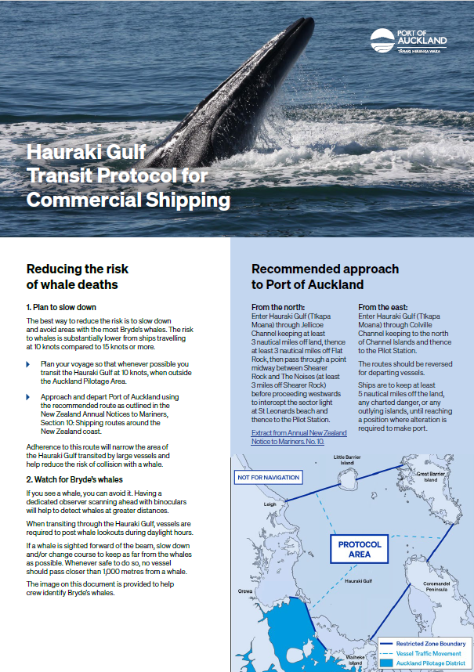

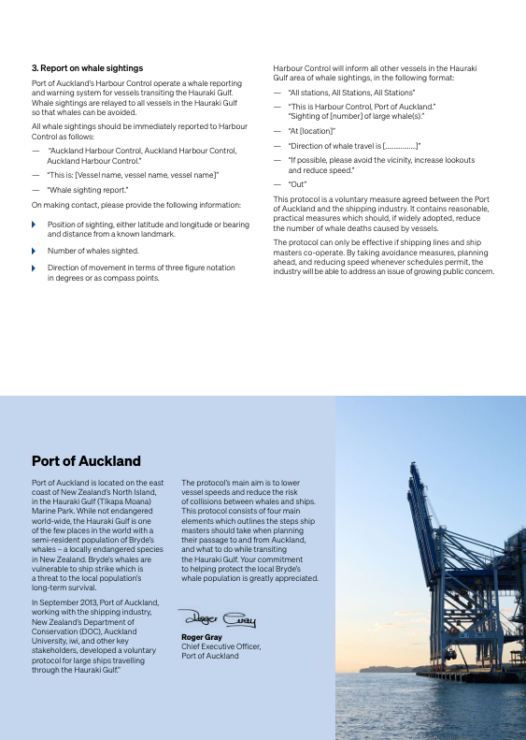

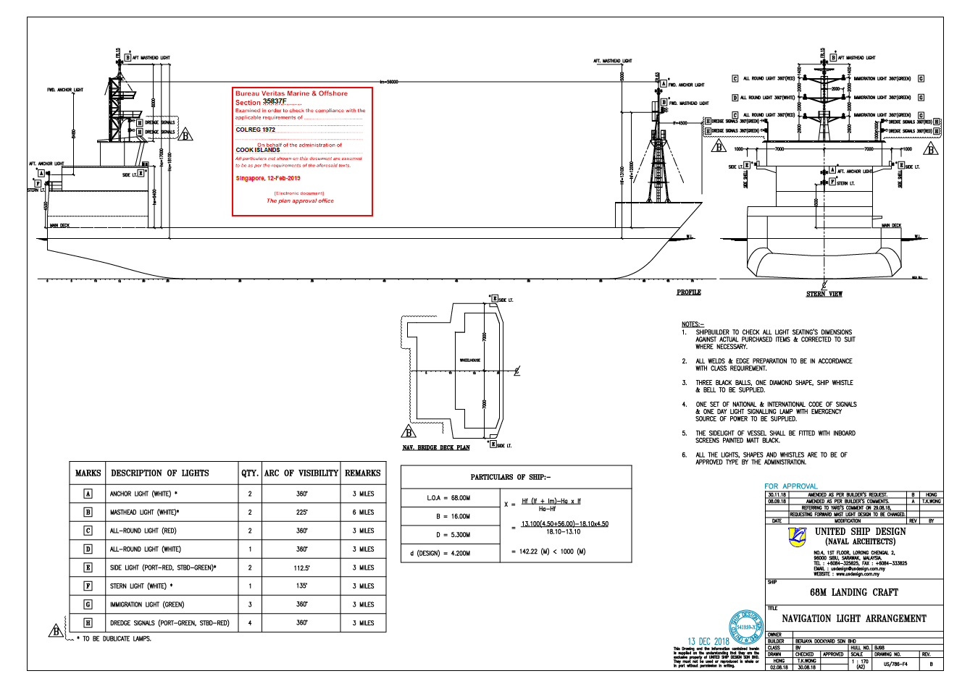
Appendix 2: Navigational Light Arrangement Plan

Appendix 3: Fisheries New Zealand – Protected Species Information for Commercial Fishers
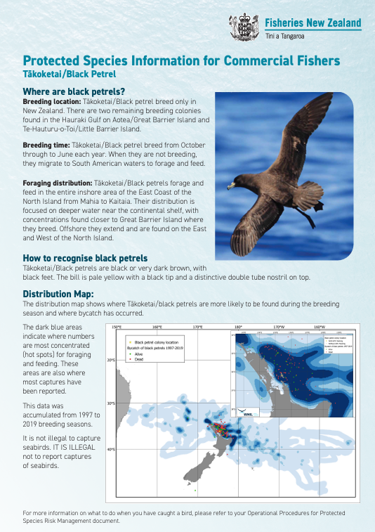
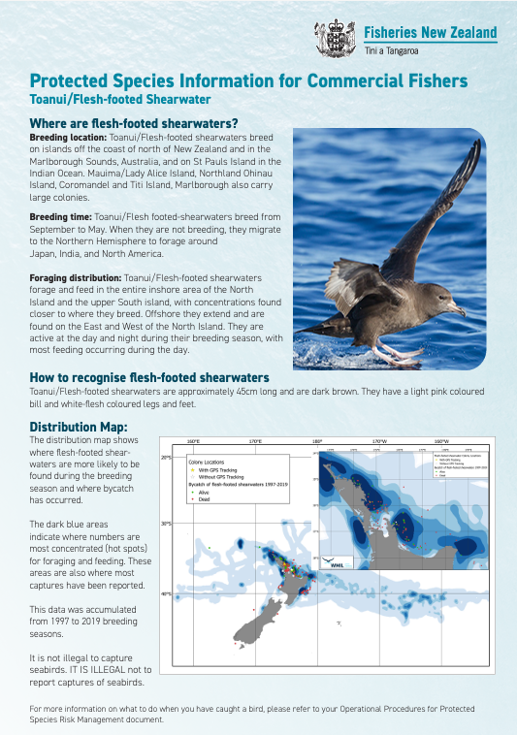

Appendix 4: Department of Conservation – Managing artificial lights to reduce seabird vessel strikes
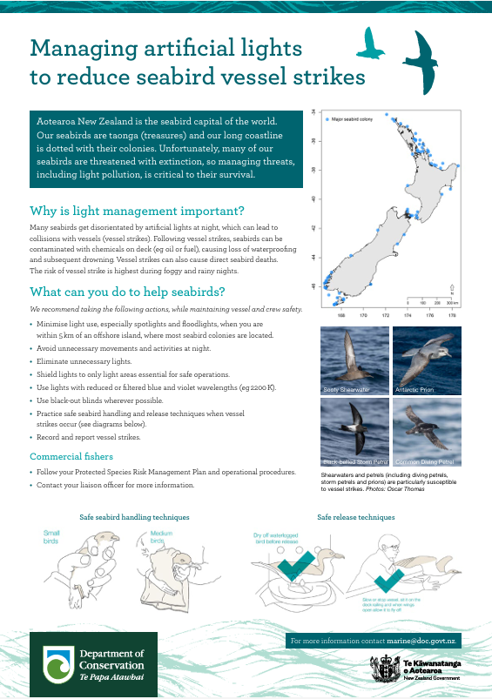

Appendix 5: Template documentation to detail tools/equipment required to meet Mitigation Standards 1.1, 1.4, 1.5, and 1.7.
1.1 Lights not essential* for fishing operations and/or vessel safety are eliminated.
*Non-essential lights refer to lights that are not essential at a given time/place for a given task. Lights can be essential for one task and non-essential for another.
This Mitigation Standard is to be met by following these steps:
Step | Action | Vessel implementation
1.1.1 | Remove completely non-essential lights (i.e., vanity lighting). | List of lights removed:
1.1.2 | Fit lights with dimmers, motion-sensors, and/or timers. | List of lights with dimmers, sensors, or timers:

1.4 All essential lights are shielded, angled, and/or positioned to only light areas required for operations and safety and eliminate light spill.
This Mitigation Standard is to be met by following these steps:
Step | Action | Vessel implementation
1.5.1 | Shield/angle/position essential lights to limit light to essential areas only. | List of shielded/angled/repositioned lights:

1.5 All essential lights use the lowest intensity as appropriate for operations and safety.
This Mitigation Standard is to be met by following these steps:
Step | Action | Vessel implementation
1.6.1 | Replace lights to lower intensity as appropriate.** | List of lights with lowered intensity:
** Before adjusting navigational lights, contact a recognized surveyor or Maritime New Zealand.

1.7 All essential lights filter light spectra as appropriate for operations and safety.
This Mitigation Standard is to be met by following these steps:
Step | Action | Vessel implementation
1.7.1 | Replace lights to adjust spectra as appropriate (e.g., filter blue/violet wavelengths, i.e., use amber lights).** | List of lights with filtered spectra:
** Before adjusting navigational lights, contact a recognized surveyor or Maritime New Zealand.

MINIMUM QUALIFICATIONS REQUIRED FOR THE VESSEL:
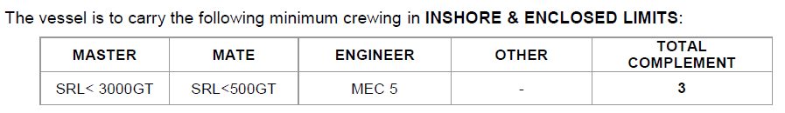

Appendix 6: Roles and Responsibilities of MBL Staff.
Table 5: Roles, responsibilities, and contact details relevant to the Extraction Management Plan.
Role | Responsibilities
Managing Director | Oversees the overall operations and strategy of the company.
Chief Operating Officer | Oversees and manages the day-to-day operations of the company, implementing the managing director’s vision and strategies to ensure efficient and effective business processes.
Operations Manager | Responsible for the coordination and management of vessel operations, including managing crew and planning transit routes.
Compliance Manager | Manager for vessel and crew health and safety, including destination port and Maritime compliance Requirements
Environmental Manager | Environmental compliance and management, including consent and environmental monitoring and reporting.
Compliance Officer | Responsible for recording and reporting obligations related to vessel analytics, extraction amounts, and extraction tracks.
Master William Fraser | Responsible for the navigation and operation of the William Fraser at berth, transit, and while extracting.

A 'seabird interaction' should be limited to birds that are injured or killed and found on deck (David Thompson, NIWA pers comms).
https://www.doc.govt.nz/globalassets/documents/conservation/marine-and-coastal/marine-conservationservices/resources/protected-species-handling-guide-20192.pdf /

