Archaeological A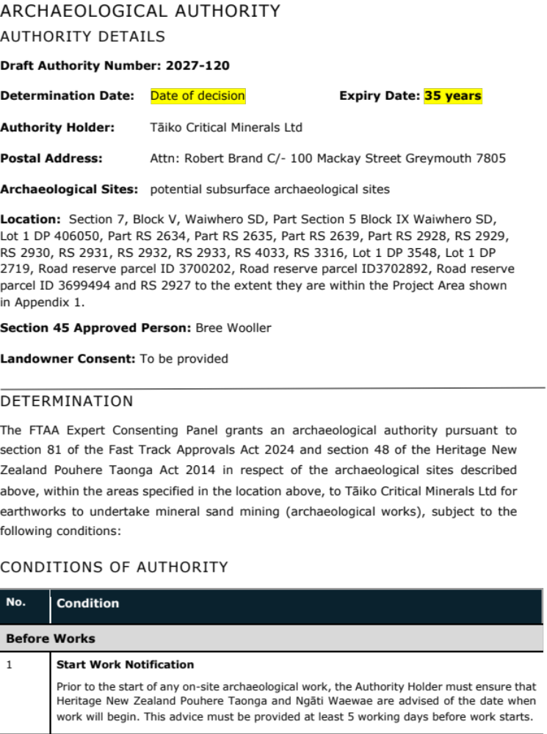uthority

AUthority details
Draft Authority Number: 2027-120
Determination Date: Date of decision Expiry Date: 35 years
Authority Holder: Tāiko Critical Minerals Ltd
Postal Address: Attn: Robert Brand C/- 100 Mackay Street Greymouth 7805
Archaeological Sites: potential subsurface archaeological sites
Location: Section 7, Block V, Waiwhero SD, Part Section 5 Block IX Waiwhero SD, Lot 1 DP 406050, Part RS 2634, Part RS 2635, Part RS 2639, Part RS 2928, RS 2929, RS 2930, RS 2931, RS 2932, RS 2933, RS 4033, RS 3316, Lot 1 DP 3548, Lot 1 DP 2719, Road reserve parcel ID 3700202, Road reserve parcel ID3702892, Road reserve parcel ID 3699494 and RS 2927 to the extent they are within the Project Area shown in Appendix 1.
Section 45 Approved Person: Bree Wooller
Landowner Consent: To be provided

Determination
The FTAA Expert Consenting Panel grants an archaeological authority pursuant to section 81 of the Fast Track Approvals Act 2024 and section 48 of the Heritage New Zealand Pouhere Taonga Act 2014 in respect of the archaeological sites described above, within the areas specified in the location above, to Tāiko Critical Minerals Ltd for earthworks to undertake mineral sand mining (archaeological works), subject to the following conditions:

CONDITIONS OF AUTHORITY
No. | Condition
Before Works
1 | Start Work Notification  Prior to the start of any on-site archaeological work, the Authority Holder must ensure that Heritage New Zealand Pouhere Taonga and Ngāti Waewae are advised of the date when work will begin. This advice must be provided at least 5 working days before work starts.
2 | Archaeological Management Plan  All works must be carried out in accordance with an Archaeological Management Plan (AMP). The AMP must specify procedures to ensure that any archaeological evidence encountered on site is treated in accordance with the conditions of this authority. The AMP must include, but is not limited to, the following:  - Areas where the s45 approved person (who may appoint a person to carry out this activity on their behalf) must be present for earthworks,  - On-site briefing by the s45 approved person (who may appoint a person to carry out the briefing on their behalf) for contractors about the archaeological work required and how to identify possible archaeological sites during works. The AMP must state who will be carrying out the briefings,  - The responsibilities of contractors with regard to notification of the discovery of archaeological evidence, and  - Emergency contact details for the s45 approved person, Heritage New Zealand Pouhere Taonga, and Ngāti Waewae.  The AMP must be submitted to Heritage New Zealand Pouhere Taonga for approval prior to the commencement of any works. No works shall commence until Heritage New Zealand Pouhere Taonga has given its written approval of the AMP. Any amendments to the AMP will require prior written approval from Heritage New Zealand Pouhere Taonga.
3 | Landowner Consent  The Authority Holder must provide Heritage New Zealand Pouhere Taonga with the written consent of all landowners of the land subject to this Authority prior to any archaeological works commencing.
4 | Site Briefing  The Authority Holder must ensure that all contractors working on the project are briefed by the s45 approved person, who may appoint a person to carry out the briefing on their behalf, prior to any works commencing on:  - The possibility of encountering archaeological evidence;  - How to identify possible archaeological sites during works;  - The archaeological work required by the conditions of this authority; and  - Contractors’ responsibilities with regard to notification of the discovery of archaeological evidence to ensure that the authority conditions are complied with.
During Works
5 | Monitoring  Any earthworks that may affect an archaeological site must be monitored by the s45-approved person, who may appoint a person to carry out the monitoring on their behalf in accordance with accepted archaeological practice and the AMP.
6 | Investigation  Any archaeological evidence encountered during the exercise of this authority must be investigated, recorded and analysed in accordance with accepted archaeological practice.
7 | Annual Report  Annually from the date of issue of this authority, the Authority Holder must submit to Heritage New Zealand Pouhere Taonga a written report containing a summary of the progress of the activity and any archaeological findings.
8 | Tikanga  - The Authority Holder must enable access for Ngāti Waewae to any archaeological site encountered in order to undertake tikanga subject to any health and safety requirements.  - If any possible taonga or Māori artefacts are encountered, Ngāti Waewae must be informed to enable appropriate tikanga to be undertaken, so long as all statutory requirements under the Heritage New Zealand Pouhere Taonga Act 2014 and the Protected Objects Act 1975 are met.  - If any archaeological site is encountered and works modifying or destroying the archaeological site are undertaken, Ngāti Waewae must be provided with a copy of any reports completed under Condition 12 and be given an opportunity to discuss it with the section 45 Approved Person if required.
9 | Kōiwi Discovery  If any kōiwi (human remains) are encountered, all works must cease within 20 metres of the discovery. Heritage New Zealand Pouhere Taonga, New Zealand Police, and Ngāti Waewae must be advised immediately. Any steps following must be undertaken in accordance with Guidelines for Kōiwi Tangata/Human Remains (AGS8 2014) and no further work in the area may take place until future actions have been agreed by all parties.
After Works
10 | Works Completion Notification  The Authority Holder must also ensure that Heritage New Zealand Pouhere Taonga and Ngāti Waewae are advised of the completion of the on-site archaeological work, within 5 working days of completion.
11 | Completion of Archaeological Siteworks  That within 20 working days of the completion of the on-site archaeological work associated with this authority, the Authority Holder shall ensure that:  - An interim report, to the satisfaction of Heritage New Zealand Pouhere Taonga, following the Archaeological Report Guideline (AGS12 2023) is submitted to Heritage New Zealand Pouhere Taonga for inclusion in the Heritage New Zealand Pouhere Taonga Archaeological Reports Digital Library.  - site record forms are updated or submitted to the NZAA Site Recording Scheme.
12 | Archaeological Records  That within 12 months of the completion of the on-site archaeological work, the Authority Holder shall ensure that a final report, completed following the Archaeological Report Guideline (AGS12 2023), is submitted to Heritage New Zealand Pouhere Taonga for inclusion in the Heritage New Zealand Pouhere Taonga Archaeological Reports Digital Library, the Grey District Museum, and the NZAA Central Filekeeper.

Appendix 1
