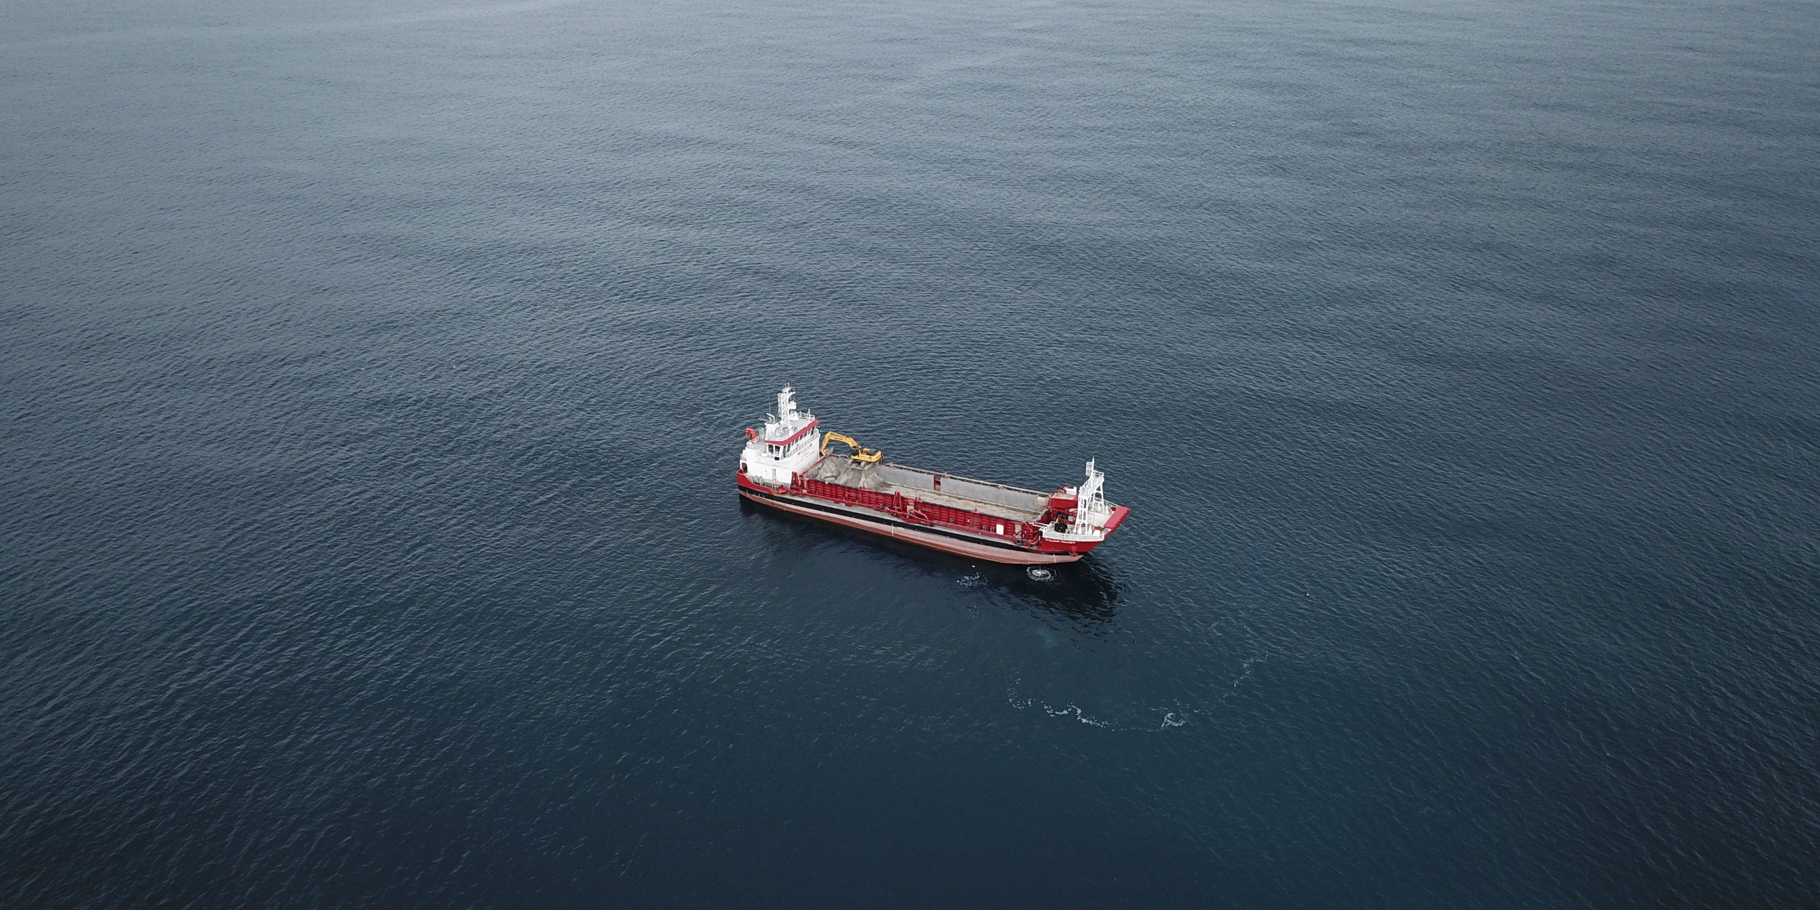

ATTACHMENT TWENTY-EIGHT

Marine Mammal Management Plan (“MMMP”)
Version 6 (Clean) - Updated 17/07/2026

Te Ākau Bream Bay Sand Extraction
Marine Mammal Management Plan
McCallum Bros Limited
PO Box 71 031
Rosebank
Auckland 1348

Prepared by:
SLR Consulting NZ
6/A Cambridge Street, Richmond, Nelson 7020, New Zealand

SLR Project No.: 840.030119.00001
17 December 2025
Revision: 5

Revision Record
Revision | Date | Prepared By | Checked By | Authorised By
01 | 31 March 2025 | HM | DG | DG
02 | 18 June 2025 | HM | MBL | HM
03 | 23 July 2025 | HM | MBL | HM
04 | 28 July 2025 | HM | MBL | HM
05 | 17 December 2025 | HM | MBL | HM
06 | 17 July 2026 | HM | MBL | HM
Certified on:

Basis of Report
This report has been prepared by SLR Consulting NZ (SLR) with all reasonable skill, care and diligence, and taking account of the timescale and resources allocated to it by agreement with McCallum Bros Limited (the Client). Information reported herein is based on the interpretation of data collected, which has been accepted in good faith as being accurate and valid.
This report is for the exclusive use of the Client. No warranties or guarantees are expressed or should be inferred by any third parties. This report may not be relied upon by other parties without written consent from SLR.
SLR disclaims any responsibility to the Client and others in respect of any matters outside the agreed scope of the work.

Table of Contents
Basis of Report i
1.0 Introduction 3
1.1 Marine Mammals in Te Ākau Bream Bay 4
1.2 Sand Extraction Operations 4
2.0 General Protocols 5
2.1 Compliance with the Marine Mammal Protection Act 1978 5
2.2 Compliance with the Marine Mammal Protection Regulations 1992 5
2.3 Compliance with Company Common Practice 5
3.0 Protocols to Minimise Underwater Noise 5
4.0 Protocols to Minimise the Risk of Ship Strike 6
4.1 Operational Limits 6
4.2 Safe Vessel Operation 6
4.3 Compliance with the Hauraki Gulf Transit Protocol 7
5.0 Protocols to Minimise Marine Debris 8
6.0 Protocols to Avoid Entanglement 8
7.0 Protocols to Minimise Artificial Lighting 9
8.0 Stranding Response 9
9.0 Recording and Reporting Requirements 9
10.0 Staff Training 10
11.0 Management Plan Review 10
12.0 Monitoring Programme 11
12.1 Soundscape Change Validation 12
13.0 References 12

Figures in Text
Figure 1 Sand ‘Extraction Area’ in Te Ākau Bream Bay 3
Figure 2 The accepted primary transit route of the William Fraser between Auckland
and Bream Bay (red) and the recommended route for large commercial
vessels (green) 8

Appendices
Appendix A Simple Rules for Boaties when Interacting with Whales and Dolphins
Appendix B Hauraki Gulf Transit Protocol, 2024
Appendix C Marine Mammal Identification Guide
Appendix D Daily Marine Mammal Record

Introduction
This Marine Mammal Management Plan (MMMP) has been prepared for McCallum Bros Limited (MBL) and relates to sand extraction operations in the designated ‘extraction area’ of Te Ākau Bream Bay (Figure 1). Sand will be dredged and collected by the trailing suction hopper dredge, the William Fraser, which will primarily travel to and from the extraction area from the Port of Auckland, with supply trips to alternative ports (Northport, Port of Tauranga, Kopu) on a less frequent basis. In addition to those dredging operations inside the extraction area, this MMMP also sets out procedures to manage impacts on marine mammals whilst the William Fraser is in transit to and from the extraction area.
The objective of this MMMP is to avoid or minimise the potential effects of sand extraction operations (including active extraction and transit) on marine mammals.

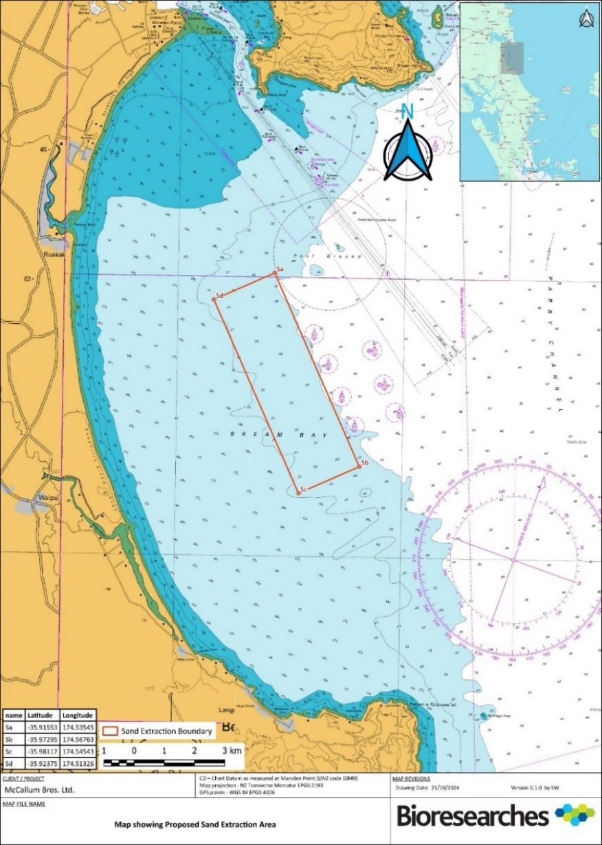
Figure 1 Sand ‘Extraction Area’ in Te Ākau Bream Bay

Marine Mammals in Te Ākau Bream Bay
While 34 marine mammal species are known from Te Ākau Bream Bay and surrounds, only seven species – bottlenose dolphins, common dolphins, Bryde’s whales, false killer whales, pilot whales, killer whales, and New Zealand fur seals – have a regular presence here.
Other species occur as occasional visitors, including leopard seals, southern right whales, humpback whales, blue whales, sei whales, sperm whales, dwarf minke whales, and Gray’s beaked whales. The presence of southern right whales and humpback whales will be seasonal over the months of winter and spring, and many of the other visiting species are primarily offshore deep-water species, e.g. blue whales, sei whales, minke whales, beaked whales, and sperm whales.

Sand Extraction Operations
Typically, the sand extraction operational cycle would begin when the William Fraser leaves the Port of Auckland on the morning of an extracting day in transit to the Te Ākau Bream Bay extraction site. The transit route passes through Tiri Passage, rounds Kawau Island, Takatu Point and Cape Rodney, before travelling along Jellicoe Channel then rounding Paepae-o-tῡ (Bream Tail) to enter Te Ākau Bream Bay. During transit, the William Fraser travels at a maximum speed of 9.5 knots. The William Fraser will transit to and from the following alternative ports on a less frequent basis: Port of Tauranga, Kopu Wharf (in Thames), and Northport (in Whangārei).
Before reaching the extraction area the William Fraser reduces its speed and begins to prepare the dredge equipment. By the time the vessel is within the extraction area it will be travelling at a speed of 1.5 – 2.5 knots which it maintains while extracting sand.
Once inside the extraction area, and following equipment checks, the draghead is lowered completely to the seabed and pumping of sand slurry (a mixture of sand and seawater) commences. Once the hopper is full, the draghead is lifted off the seabed and the equipment is flushed with seawater before it is stowed onboard, and the vessel returns to Auckland (or one of the alternative ports listed above) to unload.
Within the Te Ākau Bream Bay extraction site, a maximum daily dredge time of 3.5 hours will be implemented, and active dredging will be limited to the following operational windows:
- 12:00 pm to 6:00 pm during the months of April to September (inclusive).
- 12:00 pm to 8:00 pm during the months of October to March (inclusive).
MBL will conduct operations as follows:
- During the first three years of the proposed 35-year term, 150,000 m³ of sand will be extracted annually, representing up to 14 trips per month; and
- During the next 32 years of the proposed 35-year term, up to 250,000 m³ of sand will be extracted annually, representing up to 23 trips per month.

General Protocols
MBL will ensure that all project activities occur in accordance with this MMMP.

Compliance with the Marine Mammal Protection Act 1978
All marine mammals in New Zealand waters are fully protected under the Marine Mammals Protection Act 1978 which is administered by the Department of Conservation (DOC). It is an offence to ‘take’ a marine mammal without a permit. ‘Take’ is defined as:
- To take, catch, kill, injure, attract, poison, tranquillise, herd, harass, disturb or possess;
- To brand, tag, mark, or do any similar thing; and
- To flense, render down, or separate any part from a carcass.
MBL does not hold a permit to ‘take’ marine mammals and has no intention to do so. Any individual involved in any action in respect of marine mammals is responsible for their own actions within the framework of the Marine Mammals Protection Act 1978. Any non-compliance may result in dismissal of staff for serious misconduct and possibly render the individual and company liable to further legal sanction under the Marine Mammals Protection Act 1978. However, defences under the Marine Mammals Protection Act 1978 provide exemptions in some circumstances in relation to:
- Assisting an injured marine mammal;
- Retrieval of dead marine mammals under the direction of DOC; and
- Disposal of a dead marine mammal under the direction of DOC.

Compliance with the Marine Mammal Protection Regulations 1992
The Marine Mammal Protection Regulations 1992 outline the behaviours that must be adhered to by all persons around marine mammals. Compliance with these regulations is a legal requirement and is further discussed in Section 4.2.

Compliance with Company Common Practice
It is MBL policy for all operational staff to remain vigilant to potential threats to marine mammals and to take immediate steps to mitigate any threat identified.
Under no circumstances shall any crew member onboard the William Fraser attempt to attract a marine mammal towards the dredge vessel. For example, on no account shall a crew member offer food to a marine mammal or use any other item or bait which could be considered an attractant while the vessel is operational.

Protocols to Minimise Underwater Noise
Underwater noise levels will be minimised during project activities as follows:
- The William Fraser and all equipment on-board, including winches, generators, engines etc. will be regularly serviced and maintained to a high standard;
- Noise suppression equipment will be used and regularly serviced and maintained to a high standard;
- Records of service and maintenance will be kept and will be available for inspection upon request; and
- MBL will actively seek to make improvements to equipment and increase operational efficiency over the consent term to:
  - reduce overall underwater noise outputs; and
  - reduce the daily dredging duration.

Protocols to Minimise the Risk of Ship Strike

Operational Limits
The following operational limits will be adopted by the William Fraser:
- During active sand extraction, the average speed shall not exceed 2.5 knots; and
- During transit between the extraction site and the Port of Auckland or any of the alternative ports, the maximum allowable speed will be 10 knots.

Safe Vessel Operation
The master of the William Fraser will ensure that the vessel is operated in compliance with the Marine Mammal Protection Regulations 1992. Sections 18, 19 and 20 of the regulations outline the behaviours that must be adhered to by all persons around marine mammals. The following requirements are directly relevant to reducing collisions between marine mammals and vessels:
- Vessel operators shall endeavour not to disrupt the normal movement or behaviour of marine mammals;
- Care should be taken not to separate any individuals from, or scatter any groups of marine mammals and no vessel shall proceed through a pod of dolphins;
- No sudden or repeated change in the speed or direction of any vessel shall occur in the vicinity of marine mammals (except in emergency circumstances);
- No vessel shall cut off the path of a marine mammal;
- Vessels less than 300 m from a marine mammal shall move at a constant slow (no wake) speed. In the case of dolphins, vessels may exceed this speed in order to out-distance the dolphins but must increase speed gradually, and shall not exceed 10 knots within 300 metres of any dolphin;
- No vessel shall approach within 50 m of a whale, and if a whale approaches a vessel, the vessel shall make every attempt to keep out of the path of the whale and to maintain a minimum distance of 50 m; and
- No vessel shall approach within 200 m of a baleen whale or sperm whale with a calf.
In line with these requirements, the William Fraser shall display a laminated version of the A4 poster ‘Simple rules for boaties when interacting with whales and dolphins’ contained in Appendix A.
In terms of the last bullet point above and given the difficulty ascertaining if a whale is accompanied by a calf, the William Fraser must aim to maintain a minimum distance of 200 m from any large whale during extraction.

Compliance with the Hauraki Gulf Transit Protocol
During all transit to and from the extraction area, the master of the William Fraser will ensure that the vessel is operated in compliance with the voluntary Hauraki Gulf Transit Protocol (Appendix B). This protocol will be implemented throughout the entire transit route, i.e. not only in the Hauraki Gulf and for any potential transit scenarios associated with alternative ports.
The requirements of the Hauraki Gulf Transit Protocol which must be followed include:
- A maximum transit speed of 10 knots (noting the operational limit in Section 4.1 above restricts the Wiliam Fraser to a maximum of 9.5 knots and overrides this transit protocol requirement);
- A watch must be kept for whales during daylight hours, with the assistance of binoculars as appropriate;
- If a whale is sighted forward of the vessel beam, the vessel master will slow down and/or change course to keep as far from the whale as possible. Whenever safe to do so, no vessel should pass closer than 1,000 m from a whale; and
- All whale sightings inside the Hauraki Gulf should be reported immediately to the Ports of Auckland Harbour Control (this acts as a reporting and warning system for other vessels in the area). The reporting procedure outlined in Appendix B should be followed.
The only project specific exception to the Hauraki Gulf Transit Protocol is that the William Fraser may travel inshore of the recommended transit route when travelling between the Ports of Auckland and Bream Bay (see Figure 2). This transit route follows that presently used by the William Fraser between Auckland and their existing extraction area in the Mangawhai-Pākiri embayment. The slower than recommended transit speed, the shallow draft, and the vessel configuration will more than compensate for this deviation from the protocol recommendations.
All alternative transit routes (e.g., to Northport, Port of Tauranga and Kopu) will follow the relevant recommended route as prescribed by the Hauraki Gulf Transit Protocol (following the New Zealand Annual Notice to Mariners, Section 10: Shipping routes around the New Zealand coast).
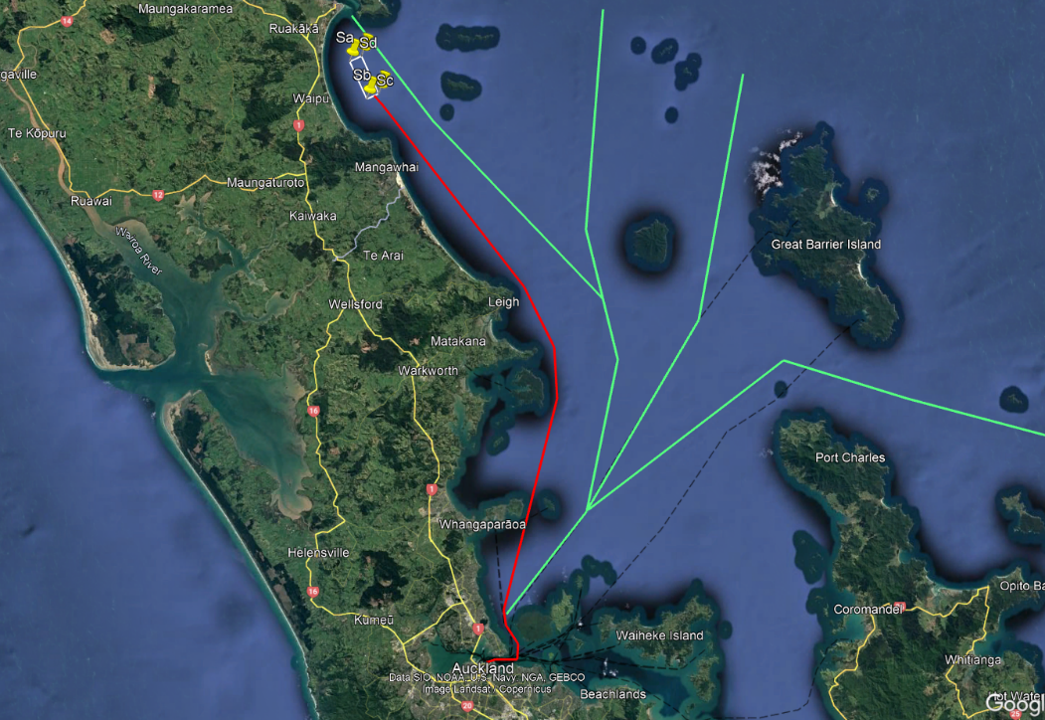
Figure 2 The accepted primary transit route of the William Fraser between Auckland and Bream Bay (red) and the recommended route for large commercial vessels (green)

Protocols to Minimise Marine Debris
To minimise any adverse effects on marine mammals from marine debris the following protocols will be implemented:
- Adoption of the following waste management strategies as contained within an MNZ approved Garbage Management Plan:
  - All cordage debris (e.g. ties, lashings, etc.), plastic strapping and other non-biodegradable waste must be collected, securely stored and disposed of at an approved solid waste facility onshore;
  - If any loose debris does enter the water, it must be promptly retrieved if safe to do so;
  - Any lost equipment should be retrieved from the seabed, water column or foreshore if it is safe and practical to do so; and
  - The William Fraser must have covered waste bins and debris retrieval nets onboard.
- Compliance with Resource Management (Marine Pollution) Regulations 1998; and
- A commitment to collect and retrieve obvious objects of marine debris during the course of dredging if it is safe and practical to do so, and to safely dispose of these onshore.

Protocols to Avoid Entanglement
As a precautionary measure and given the possible presence of Bryde’s whales in the extraction area on occasion, the following strategies are recommended to minimise the risk of entanglement:
- Ensure the draghead and all other operational equipment in the water column is free from loose lines, loops of tubing etc. which could pose an entanglement risk to marine mammals;
- Free floating or slack lines at the water surface and in the water column must be avoided;
- Ensure suction of the draghead is restricted to within 3 m of the seafloor;
- While dredging, the William Fraser must be operated in a consistent manner in terms of direction and speed;
- The dredging vessel master and crew must remain vigilant for marine mammals during active dredging, and be prepared to shutdown extraction if necessary;
- A 100 m exclusion zone for large whales (any cetacean larger than a bottlenose dolphin) should be implemented around the dredge vessel and draghead such that active dredging must cease if a large whale enters this zone; and
- Extraction should not recommence until the large whale has been resighted and has moved away from the draghead/vessel, or until there has been no further sightings for 10 minutes.
While the dredging vessel master and crew must remain vigilant for marine mammals, observations to underpin the implementation of the 100 m exclusion zone will be primarily undertaken by the master of the William Fraser who will keep a constant watch from the bridge during transit and active extraction. Watch-keeping is standard practise for safe vessel operation in terms of navigation responsibilities, compliance with the Marine Mammal Protection Regulations 1992, and compliance with the Hauraki Gulf Transit Protocol. The expansion of these watch-keeping responsibilities to monitor the 100 m exclusion zone for large whales during extraction therefore represents little additional effort and allows the deck crew to focus primarily on operations.

Protocols to Minimise Artificial Lighting
Lighting on the William Fraser must be subdued and downward facing whilst still complying with Maritime NZ lighting and safety requirements.

Stranding Response
While there is no risk of marine mammals stranding as a result of the sand extraction activities, it is recognised that whale and dolphin strandings do occur in Te Ākau Bream Bay from time to time. All stranding events are managed by DOC and because of the cultural significance of whale strandings, iwi involvement in stranding response is paramount. For animals that strand alive, refloat attempts are often made and during this process it is important that external factors that might influence the success of the refloat process be minimised. On this basis, MBL agrees not to undertake sand extraction activities on those days when they are aware that refloat attempts are to occur.
Notification of refloat attempts for live stranded marine mammals shall be received by MBL from either DOC, Te Parawhau ki Tai, or Patuharakeke Iwi Trust Board.

Recording and Reporting Requirements
A copy of the ‘Marine Mammal Identification Booklet’ (Appendix C) must be available on board the William Fraser to assist crew with reporting requirements.
On each extraction day, a ‘Daily Marine Mammal Record’ must be completed (Appendix D). This form is used to record:
- All marine mammal sightings (both inside and outside of the extraction area);
- Any marine mammal incidents (e.g. vessel strike or entanglement); and
- The absence of marine mammal sightings on any extraction day.
The paper version of the ‘Daily Marine Mammal Record’ (contained in Appendix D) may be used; however, equivalent digital records are acceptable.
On an annual basis, a summary of the data collected in the daily records will be provided to DOC, Te Parawhau ki Tai, and Patuharakeke Iwi Trust Board for informational purposes.
All vessel strike or entanglement incidents (regardless of the outcome) must be reported as soon as practicable to DOC (0800 DOC HOT), Te Parawhau ki Tai, and Patuharakeke Iwi Trust Board.

Staff Training
Training will be provided to all relevant staff during staff inductions, with training refresher sessions occurring at least twice a year during staff meetings.
MBL management staff will be ultimately responsible for ensuring training occurs and that appropriate training records are maintained. The minimum training requirements for all operational on-water staff are as follows:
- The requirement for compliance with 1) this MMMP, 2) the Marine Mammal Protection Act 1978, 3) the Marine Mammal Protection Regulations 1992, 4) all coastal permit conditions relevant to marine mammals and 4) company common practice;
- Awareness of the requirement to reduce underwater noise during on-water operations;
- Protocols to minimise the risk of ship strike, including 1) operational limits, 2) safe vessel operation (e.g. awareness of the ‘Simple Rules for Boaties when Interacting with Whales and Dolphins’), and 3) compliance with the Hauraki Gulf Transit Protocol;
- Protocols to minimise marine debris (e.g. awareness of waste management strategies);
- Protocols to avoid entanglement, including the implementation of the 100 m exclusion zone of large whales;
- Protocols to minimise artificial lighting; and
- Recording and reporting requirements.

Management Plan Review
MMMP review will follow the procedure below:
- A comprehensive review of the MMMP shall be completed –
  - after the first 12 months of operations during which the annual extraction volume is 150,000 m³;
  - in the six months prior to the planned increase in extraction volume (from 150,000 m³ to 250,000 m³);
  - after the first 12 months of operations during which the annual extraction volume is 250,000 m³; and
  - every three years thereafter for the duration of the consent.
- A comprehensive review of the MMMP shall also be completed within six months of any entanglement, vessel strike, injury or death of a marine mammal that is attributable to the sand extraction operations (including transit).
Every review of the MMMP shall by undertaken by an Independent Suitably Qualified and Experienced Expert(s), being someone with a relevant tertiary qualification and at least five years’ experience in marine mammal research or consulting. Following each review, the Independent Suitably Qualified and Experienced Expert(s) shall produce a report which summarises the outcomes of their review, and the changes they recommend (if any) to the MMMP.
This MMMP has been developed in accordance with best international practice and available information at the date of issue. During each review period, it shall be the responsibility of the reviewer to ensure that any relevant findings from ongoing international research efforts into the effects of dredging on marine mammals are adopted and that any relevant technological improvements are also assessed with regards to their potential merits for adoption by MBL in keeping with international best practice.

Monitoring Programme
Because cumulative noise effects are predicted to result in changes to the soundscape of Te Ākau Bream Bay, a monitoring programme to validate the predictions of the underwater acoustic modelling in terms of soundscape change must be undertaken. The details of this essential monitoring are outlined in Section 12.1 below.
Furthermore, and if the opportunity arises, MBL should consider providing financial support to third party research groups for marine mammal research surveys in Te Ākau Bream Bay. In terms of this, and as background, from 2022 to 2024 Patuharakeke Te Iwi Trust Board partnered with NIWA and Far Out Ocean Research Collective to conduct boat-based marine mammal surveys in Te Ākau Bream Bay and surrounds, using the following methodology:
- Vessel-based line-transect surveys (visual observations), where monitoring effort was stratified by season; and
- Photo identification for key species (e.g. Bryde’s whales, killer whales, coastal bottlenose dolphins and false killer whales).
Survey data was analysed to determine the following parameters:
- Rates of occurrence (number of sightings per km of transect);
- Species Distribution Modelling to describe distribution and habitat use in relation to environmental characteristics (including environmental and anthropogenic variables); and
- Mark recapture to calculate abundance, and critical population rates (survival etc.) for key species.
MBL recognises the value of the data that was collected through this programme and will, on a case-by-case basis, consider potential research projects and offer to contribute financially to the continuation of marine mammal surveys in Te Ākau Bream Bay.

Soundscape Change Validation
Acoustic monitoring (the ‘Acoustic Monitoring Programme’) must be undertaken to confirm that the actual levels of soundscape change that occurs inshore of the extraction area does not exceed 3 dB re 1 µPa. Specific monitoring methodology is included in the Environmental Monitoring Management Plan for this. Monitoring data will need to be collected both before the commencement of extraction activities (to establish a baseline soundscape at the monitoring location/s) and at the commencement of the consent.
The null hypothesis (H_{o}) would be that the actual measured soundscape change is equal to or lower than the modelled predictions (i.e., that soundscape increases outside the extraction area are predicted to (at most) be small, i.e. ≤ 3 dB re 1 µPa).
In terms of the baseline monitoring, measurements made over winter months will provide the most conservative baseline data (being the season when boating activity in the bay is lowest and the potential soundscape change associated with the introduction of extraction activities will be highest). For this reason, if the H_{o} is accepted against the winter baseline data, it will certainly be acceptable in the context of the other seasons.
Soundscape change validation findings should be reviewed within six months of each stage commencing, and if the H_{o} is rejected, adaptive management procedures should be actioned to reduce the noise emissions from the William Fraser into Te Ākau Bream Bay such that the operations can continue in keeping with the model predictions. Potential adaptive management procedures to achieve this could include:
- reduce the operational noise level of the William Fraser;
- reduce the frequency or duration of extraction permitted; and
- change the approach route to the extraction area.

References
Brough, T., Kereopa, H., Zaeschmar, J., Leunissen, E., Shirkey, T. 2024. Baseline surveys of marine megafauna in Te Ākau/Bream Bay to support kaitiakitanga. A collaboration between Patuharakeke, Far Out Ocean Research and that National Institute of Water and Atmospheric Research. NIWA Client Report Number 2024202HN. Dated April 2024.
SLR. 2025. Te Ākau Bay Sand Extraction: Marine mammal assessment of environmental effects. Report prepared for McCallum Bros Ltd by SLR Consulting NZ Ltd. Dated 15 July 2025.
Pine, M. 2025. Assessment of Underwater Noise Effects: proposed sand extraction Bream Bay/Te Ākau Bay. Report prepared for McCallum Bros Ltd by Styles Group Underwater Acoustics. Dated July 2025.

Simple Rules for Boaties when Interacting with Whales and Dolphins
Te Ākau Bream Bay Sand Extraction
Marine Mammal Management Plan
McCallum Bros Limited
SLR Project No.: 840.030119.00001
17 December 2025

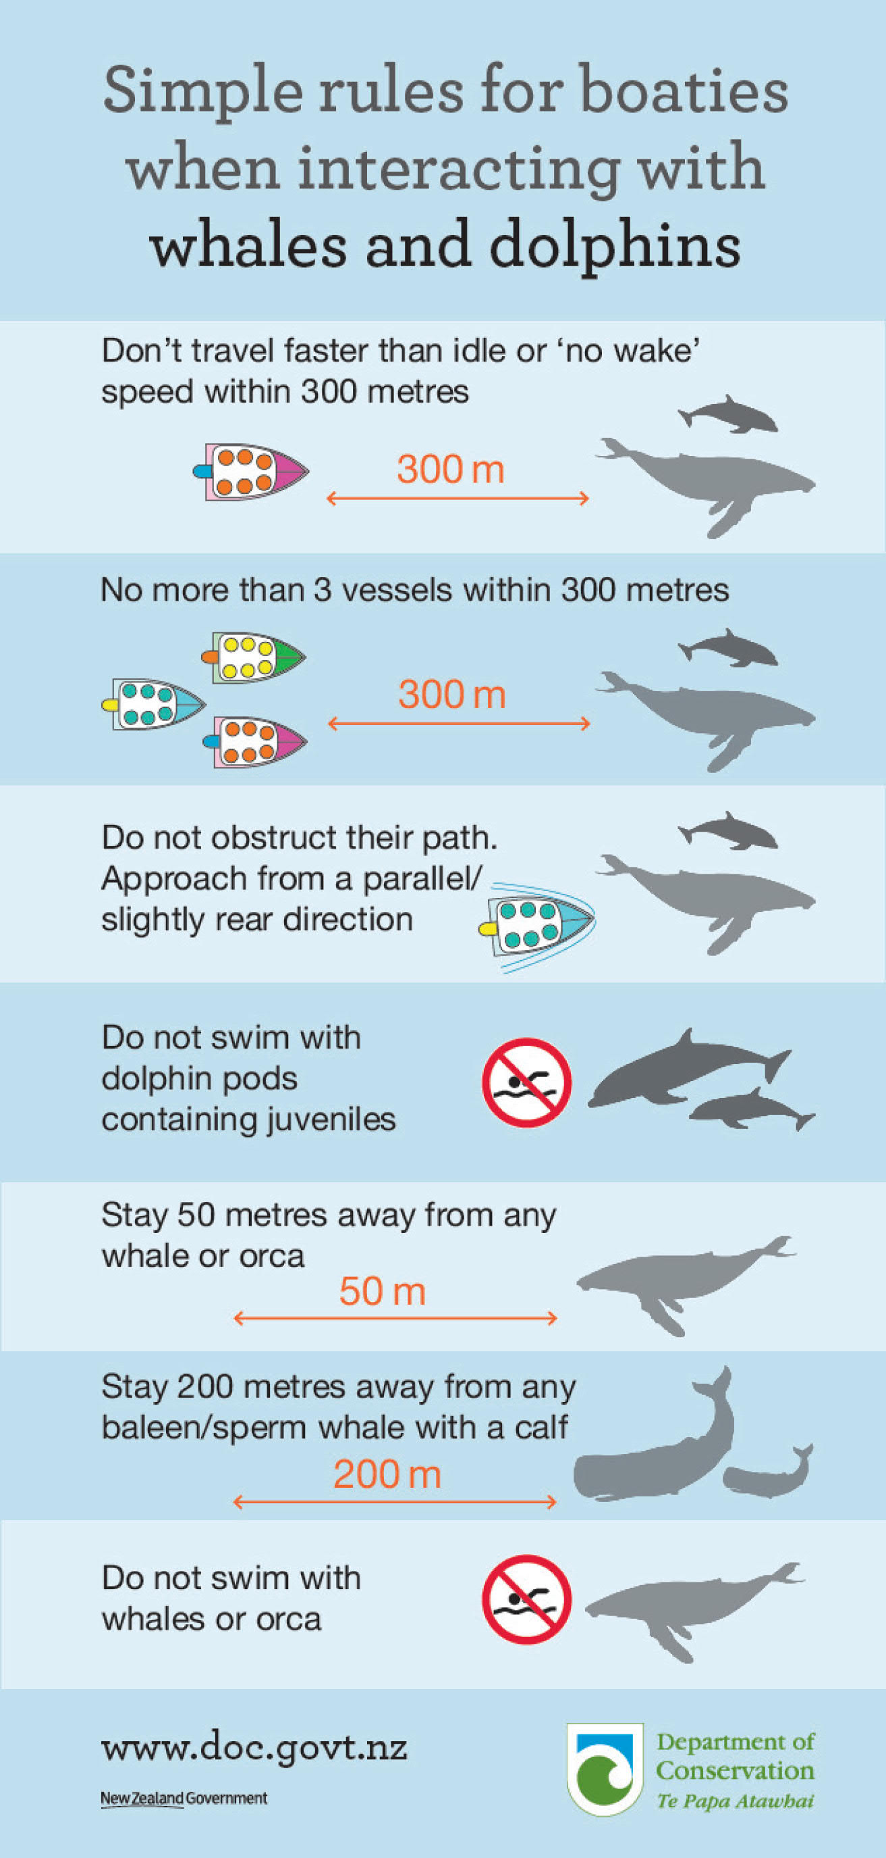

Hauraki Gulf Transit Protocol, 2024
Te Ākau Bream Bay Sand Extraction
Marine Mammal Management Plan
McCallum Bros Limited
SLR Project No.: 840.030119.00001
17 December 2025

Sourced on 17 July 2025 from:
https://www.poal.co.nz/sites/default/files/2024-09/Hauraki%20Gulf%20Transit%20Protocol%20for%20Commercial%20Shipping.pdf

Marine Mammal Identification Guide
Te Ākau Bream Bay Sand Extraction
Marine Mammal Management Plan
McCallum Bros Limited
SLR Project No.: 840.030119.00001
17 December 2025

Daily Marine
Mammal Record
Te Ākau Bream Bay Sand Extraction
Marine Mammal Management Plan
McCallum Bros Limited
SLR Project No.: 840.030119.00001
17 December 2025

Note, that this distance is greater than that required by the Marine Mammal Protection Regulations 1992, but during transit a minimum distance of 1000 m from any large whale should be maintained whenever possible.

