BENDIGO-OPHIR GOLD PROJECT
PROPOSED LAND USE CONSENT AND CONDITIONS FOR ACTIVITIES WITHIN THE JURISDICTION OF CENTRAL OTAGO DISTRICT COUNCIL
2 OCTOBER 2026

The base version of the following conditions is the clean version of the conditions dated 28 September 2026 that was provided to the EPA and Expert Panel to reflect the recommendations in Matakanui Gold Limited’s responses to RFI 12 and in response to invited parties’ closing legal submission.
Additional targeted changes have been made to these conditions to reflect Matakanui Gold Limited’s response to Minute 54 of the Expert Panel. These changes are presented in track changes with accompanying comments to briefly identify the reasons for any proposed changes.
Cross references to other conditions have been updated and are highlighted in yellow wash for ease of finding and checking the accuracy of those cross references when the conditions are finalised. In some instances, a short description of the condition being cross referenced is also provided in square brackets.

consent holder: Matakanui Gold Limited
ACTIVITY AUTHORISED: Land Use Consent to establish, operate, maintain, rehabilitate, and ultimately close an open pit and underground mining operation, referred to as the Bendigo-Ophir Gold Project (“BOGP”), including all mining operations within the Project Site identified on Plan 1 - Project Overview Plan and Plan 2 – BOGP Consent Area annexed as part of Attachment 2 – Plans in Schedule One, and all associated ancillary, monitoring, mitigation, off-setting and compensation activities and supporting infrastructure and activities within, and in the vicinity of, the Project Site as shown on Plan 2 – BOGP Consent Area annexed as part of Attachment 2 – Plans in Schedule One, subject to the following conditions.

TABLE OF Contents
Compliance with Common Conditions for Land Use Consent and Regional Consents 3
Scope of Activities 3
Lapse Period and Terms of Consent 6
Location of Mining Operations 6
Network Utilities 6
Noise, Vibration and Blasting 7
Fencing 16
Lighting (Construction and Operation) 17
Recreation 20
Hazardous Substances Management 22
Transportation 26
Archaeology and Heritage 32
Contaminated Land 33

Attachments
Attachment A: BOGP Site Layout and Nearest Noise Sensitive Receivers
Attachment B: Cushionfield Habitat
Attachment C: Potential Invertebrate Effects Area
Attachment D: Habitat boundary for Sporophyla oenospora
Attachment E: Proposed Walking Route to the Come-in-Time Battery
Attachment F: Thomson Gorge Road Widening and Ardgour Road Upgrade
Attachment G: Ardgour Rise Road Revision 5 Drawings
Attachment H: Stantec Ardgour Rise Road Safety Review

Compliance with Common Conditions for Land Use Consent and Regional Consents
No. | Condition
1 | The exercise of this consent is subject to compliance with the Common Conditions in Schedule One. Acronyms, abbreviations and defined terms set out in the Common Conditions have the same meaning for the purposes of this consent and associated conditions.

Scope of Activities
No. | Condition
2 | The activities authorised by this consent are those listed in Condition 3 below, as described in more detail in the consent documentation listed in Attachment 1 to the Common Conditions that apply to Central Otago District Council and Otago Regional Council. This documentation includes:  - The Substantive Application and Assessment of Environmental Effects prepared by Mitchell Daysh Limited dated 31 October 2025 and supporting technical documents submitted by Matakanui Gold Limited (the “Consent Holder”) to the Environment Protection Authority (“EPA”) in support of authorisations for the BOGP under the Fast-track Approvals Act 2024;  - Additional and / or amended technical documents and management plans submitted by the Consent Holder to the EPA during the post-lodgement phase of the BOGP application; and  - Various responses to further information requested by administering agencies and the Expert Panel during the post-lodgement phase of the BOGP application.  Where more recent information (of that listed above) is inconsistent with, or varies from, earlier information, the more recent information shall prevail.
3 | The activities authorised by this consent are those listed below:  - The staged establishment and operation of the RAS Open Pit and Underground Mine and SRX Open Pit, which will remain as pit lakes with adjacent benched pit walls at closure;  - The establishment of the CIT Open Pit, which will be progressively backfilled with waste rock from the RAS Open Pit and rehabilitated at the completion of mining activities;  - The establishment and operation of the SRE Open Pit, which will be progressively backfilled with waste rock before becoming an engineered landform for the adjoining SRX Open Pit;  - The establishment and use of an engineered Tailings Storage Facility (“TSF”) in the upper reach of Shepherds Valley including clean and dirty water diversion channels;  - The establishment of three engineered landforms, one in the Shepherds Valley (“Shepherds ELF”), one in the Rise and Shine Valley (“SRX ELF”) and one in a small unnamed tributary of the Rise and Shine Creek (“Western ELF”) to permanently store overburden waste rock;  - A conventional hard-rock gold processing plant in the lower reach of Shepherds Valley, along with associated processing infrastructure and ancillary activities. This includes the establishment of an all-purpose service corridor along Shepherds Valley (“Shepherds Service Corridor”) and the realignment of Shepherds Creek to form the Shepherds Creek Clean Water Diversion Channel (“Shepherds CWDC”);  - The establishment of mine offices, a laboratory, ablution blocks, carparks, workshops and equipment servicing infrastructure in the lower Shepherds Valley;  - The establishment of temporary soil, vegetation, weathered boulder and brown rock stockpiles and storage areas around the Project Site;  - Infrastructure associated with the taking of groundwater from the Bendigo Aquifer via an existing lawfully established bore and a proposed new bore for use largely in mining-related and ancillary activities. Water will be conveyed to the processing plant via a pipeline over a distance of approximately 6.5 km;  - The establishment of a water storage pond (“Shepherds Silt Pond”) at the base of the Shepherds ELF and water storage tank(s) for use at the processing plant, dust suppression and drinking water supply;  - The establishment of supporting infrastructure / activities within the Project Site, such as the upgrade of Ardgour Road and Thomson Gorge Road to provide improved access to the BOGP, internal mine access and haul roads, water pipelines and underground utilities, and electricity supply to the Project Site from Lindis Crossing and Matilda Rise;  - Fenced and secured explosive magazines and explosive emulsion mixing facilities (located outside the mining operations area on the Bendigo / Ardgour terraces);  - The establishment of supporting infrastructure associated with the BOGP on the Bendigo / Ardgour terraces, including temporary construction workers accommodation (which may include a caravan park), general security buildings, first aid and administration offices, a geology complex (including a core and sample storage area, offices and laboratory), waste management areas, contractor laydown yards and an electrical substation;  - The establishment of two aggregate pits on existing agricultural land on the Bendigo / Ardgour terraces;  - Exploration activities, including land disturbance associated with establishment of drill pads and any necessary access tracking, up to a total of no more than 3 hectares within the BOGP Consent Area beyond the Project Site / Direct Disturbance Footprint (“DDF”) (refer to Plan 2 – BOGP Consent Area in Schedule One;  - While no mining operations are proposed, nor allowed, on the public conservation land adjoining the Project Site, the following activities will be undertaken to maintain and/or improve public access and amenity:  - The realignment of Thomson Gorge Road, via Ardgour Station (“Ardgour Rise”), to provide public access between the Bendigo / Ardgour terraces and the Thomsons Saddle;  - The establishment of a replacement walking route to provide access to the historic Come-in-Time Battery (and closure of existing walking access to the Come-In-Time Battery to prevent access to the BOGP Project Site);  - An upgrade to the intersection of State Highway 8 and Ardgour Road to provide safe and suitable access to the Project Site whilst appropriately managing effects on the wider transport network;  - Crack willow management activities within the Bendigo and Clearwater Creeks; and  - All necessary activities that are ancillary to those listed above;  - Earthworks associated with the damming, diverting and reclamation of watercourses and the establishment of erosion and sediment control measures (including various clean and dirty water diversion channels);  - Salvaging and relocating notable plants, invertebrates, lizards, and habitat features (e.g. wood, weathered rock) in accordance with various management plans;  - Ecological rehabilitation and enhancement across 480 hectares within the Project Site;  - Offset and compensation measures which include ecological restoration and habitat enhancement, including establishment and management of two predator-exclusion fenced sanctuary areas (the Bendigo Sanctuary Area and the Battery Hill Sanctuary Area) across 2,219 hectares of habitat in the landscape surrounding the Project Site; and  - The undertaking of mine remediation and closure activities.  Activities not listed above may also be carried out, provided they are directly related to, and form part of, the BOGP Project as described in the documentation described in Condition 2 above and listed in Attachment 1 to the Common Conditions.

Lapse Period and Terms of Consent
No. | Condition
4 | Pursuant to Section 87(b) of the Fast-track Approvals Act 2024, this consent will lapse if not given effect to within 5 years of its date of commencement.
5 | Pursuant to Section 96 of the Fast-track Approvals Act 2024, this consent is for an unlimited term.

Location of Mining Operations
No. | Condition
6 | - Mining operations can only be undertaken within the Project Site identified on Plan 2 – BOGP Consent Area annexed as part of Attachment 2 – Plans in Schedule One.  - For the avoidance of doubt, exploration drilling can be undertaken within the Project Site and BOGP Consent Area identified on Plan 2 – BOGP Consent Area annexed as part of Attachment 2 – Plans in Schedule One. However, all exploration activities (including land disturbance associated with establishment of drill pads and any necessary access tracking) must not exceed a total of 3 hectares within the BOGP Consent Area beyond the Direct Disturbance Footprint (“DDF”) and must:  - Include the identification and physical marking of all archaeological sites and heritage features within 50 m of any proposed exploration activities and then avoid any effect on those sites and features;  - Avoid any wetlands or terrestrial ecology release sites, including the Bendigo Sanctuary Area and Battery Hill Sanctuary Area once established; and  - Not impact on any environmental outcomes that are to be achieved through the conditions of this Land Use Consent and the Common Conditions in the jurisdiction of the Central Otago District Council and the Otago Regional Council in Schedule One.

Network Utilities
No. | Condition
7 | Buildings associated with network utilities activities authorised by this consent that are located within the DDF are to:  - Have a maximum area of 20 m² and a maximum height of 4 m;  - For walls, comprise browns, greens, grey blue, greys, terracotta, tussock and dark reds provided that such colours have a Reflectivity Value (“RV”) of less than 38%;  - For exterior walls, be similar to and darker than the surrounding landscape colours; and  - For roofs, be in a low sheen in any colour that has an RV of less than 32% or comprise unpainted natural products such as timber shingles or slate and be similar to and darker than the surrounding landscape colours.  Advice Notes:  - For the avoidance of doubt, this condition does not in itself authorise buildings that are beyond the scope of the activities listed in Condition 2.  - Network utilities are defined in the Resource Management Act 1991.  - The requirements of this condition are sourced from Rule 4.7.6.D of the Central Otago District Plan. It is acknowledged that the RV may need to increase due to the use of natural timber

Noise, Vibration and Blasting
No. | Condition
Construction Noise Limits
8 | For the purposes of the following conditions:  - “Construction work” means any work in connection with the construction, erection, installation, carrying out, repair, maintenance, cleaning, painting, renewal, removal, alteration, dismantling, or demolition of:  - Any building, erection, edifice, structure, wall, fence or chimney, whether constructed wholly or partly above or below ground level;  - Any road, motorway, harbour or foreshore works, railway, cableway, tramway, canal, or aerodrome;  - Any drainage, irrigation, or river control work;  - Any electricity, water, gas, or telecommunications reticulation;  - Any bridge, viaduct, dam, reservoir, earthworks, pipeline, aqueduct, drive, shaft, tunnel, or reclamation; or  - Any scaffolding.  - Construction work includes:  - Any work in connection with any excavation, site preparation, or preparatory work, carried out for the purpose of any construction work;  - The use of any plant, tools, gear, or materials for the purpose of any construction work;  - Any construction work carried out underwater, including work on ships, wrecks, buoys, rafts, and obstructions to navigation; and  - Any inspection or other work carried out for the purpose of ascertaining whether construction work should be carried out.  - “Construction noise” means noise arising from any construction work, as defined above.  - For the avoidance of doubt, in relation to the BOGP the following activities are considered to fall within the definition of construction work:  - Site establishment activities, including the construction of all buildings and structures within the Project Site, including temporary workers accommodation;  - Construction of new access roads and road upgrades;  - Clearance of vegetation and earthworks associated with site establishment activities;  - Sourcing and processing of construction material, including aggregate pits and concrete batching;  - Installation or relocation of services or utilities;  - Construction of erosion and sediment control measures including clean and dirty water diversions channels, underdrains and silt and sediment collection ponds and associated spillways as required;  - The construction of predator-proof fences and associated structures for the Bendigo and Ardgour Sanctuaries; and  - Deconstruction works on closure of the facilities, e.g. removal of infrastructure and earthworks, and rehabilitation for future land use.  - For the avoidance of doubt, mining operations and any blasting are not included as construction works for the purpose of the following conditions.
9 | Construction noise must be managed, measured and assessed in accordance with New Zealand Standard NZS6803:1999 “Acoustics – Construction Noise” (“NZ6803”).
10 | With the exception of blasting, the noise level arising from construction activities listed in Condition 8 must comply with NZS 6803 and must comply with the noise limits set out in the following table.  Residential and dwellings in rural areas
  Day | Time Period | Long-Term Duration Noise Limits (dBA)
   |  | L_{Aeq} (dB) | L_{Amax} (dB)
  Residential Receivers
  Weekdays | 0630 – 0730  0730 – 1800  1800 – 2000  2000 – 0630 | 55  70  65  45 | 75  85  80  75
  Saturdays | 0630 – 0730  0730 – 1800  1800 – 2000  2000 – 0630 | 45  70  45  45 | 75  85  75  75
  Sundays and Public Holidays | 0630 – 0730  0730 – 1800  1800 – 2000  2000 – 0630 | 45  55  45  45 | 75  85  75  75
11 | All blasting noise and vibration during the construction phase of the BOGP must comply with the blasting limits in Conditions 17 to 21.
12 | The construction noise limits in Condition 10 do not apply to any property or site that is:  - Owned by the Consent Holder or a related company; or  - Owned by a third party which is subject to either a registered covenant or a written agreement (a copy of which is to be provided to the Central Otago District Council) whereby noise effects on the property caused by activities authorised under this consent are not to be taken into account for monitoring and compliance purposes.
Operational Noise Limits
13 | - The noise rating level from operational activities, including all mining operations but excluding blasting activities, must comply with the following noise limits at or within the notional boundary of any existing dwelling that exists at the commencement date of this consent:
  Time | Limit
  Daytime  0700 to 2200hrs | 55 dB L_{Aeq(15 min)}
  Night-time  2200 to 0700hrs | 40 dB L_{Aeq} _{(15 min)}  75 dB L_{AFmax}
13 | - “Notional boundary” means a line 20 metres from the façade of any building used for residential activity, or the legal boundary of the site on which a building containing a residential activity is located where the boundary is closer to the building than 20 metres.
Operational Noise Monitoring
14 | All noise measurements, predictions and assessments, including for any monitoring undertaken, if required to verify compliance with operational noise limits (e.g. in response to a complaint about noise levels), must be measured in accordance with the provisions of New Zealand Standard NZS6801:2008 Acoustics – Measurement of Environmental Sound (“NZS6801”) and assessed in accordance with the provisions of New Zealand Standard NZS 6802:2008 Acoustics – Environmental Noise.
15 | The operational noise limits in Condition 13 do not apply to any property or site that is:  - Owned by the Consent Holder or a related company; or  - Owned by a third party which is subject to either a registered covenant or a written agreement (a copy of which is to be provided to the Central Otago District Council) whereby noise effects on the property caused by activities authorised under this consent are not to be taken into account for monitoring and compliance purposes.
16 | The Consent Holder must implement the best practicable options to minimise noise at all times.
Blasting and Vibration Limits
17 | Surface blasting in the open pits or for construction works may only occur between 8:00 am and 7:00 pm. Underground blasting is permitted to occur at any time.
18 | To ensure public safety, the Consent Holder must ensure that the public is excluded within a 500 m of the location of any blasting events. Such exclusions must be communicated to the pubic in advance via physical onsite signage and electronic media (such as the Consent Holder’s website).  Advice Note: Compliance with this condition in relation to blasting events for construction works and in the Come-in-Time Open Pit may require the temporary exclusion of the public in the vicinity of the Come in Time Battery within the Bendigo Historic Reserve.
19 | Prior to any blasting events occurring in the Come-in-Time Open Pit, the Consent Holder must enter into an agreed protocol with the Department of Conservation regarding the procedures that will be undertaken to achieve compliance with Condition 18 to the extent it relates to the Bendigo Historic Reserve, the Ardgour Conservation Area and Bendigo Conservation Area. A copy of the agreed protocol is to be provided to the Central Otago District Council within 10 working days of it being completed and prior to any blasting events.
20 | - In relation to the nearby dwellings (shown on Attachment A – BOGP Site Layout and Nearest Noise Sensitive Receivers to this Land Use Consent), vibration from blasting activities affecting dwellings must be measured and assessed in accordance with Appendix J of Australian Standard AS 2187-2:2006 Explosives – Storage and use Part 2: Use of explosives, and the Consent Holder must ensure that:  - Blasting is managed to ensure that, in any calendar year, 95% of airblast levels do not exceed 115 dBL_{Zpeak}, with a maximum of 120 dBL_{Zpeak}, when measured and assessed at any point within the notional boundary of any rural dwelling;  - Blasting vibration must not exceed a peak particle velocity of 5 mm/s for 95% of blast events in any calendar year, with a maximum of 10 mm/s for up to 5% of blast events in any calendar year when measured and assessed at the foundation of any dwelling; and  - Blasting vibration must not exceed a peak particle velocity of 0.3 mm/s when measured and assessed at the foundation of any dwelling for underground blasting undertaken between 9 pm and 10 am.  - The limits of a peak particle velocity of 5 mm/s can only be exceeded in circumstances where the blast was designed to comply with 5 mm/s and where the exceedance was due to an unforeseeable factor such as an unusual ground propagation characteristic or some other unpredictable reason.
21 | The limits in Condition 20 do not apply to any property or site that is:  - Owned by the Consent Holder or a related company; or  - Owned by a third party which is subject to either a registered covenant or a written agreement (a copy of which will be provided to the Central Otago District Council) whereby vibration effects on the property caused by activities authorised under this consent are not to be taken into account for monitoring and compliance purposes.
Construction Noise and Vibration Management Plan
22 | All construction work must be undertaken in accordance with a Construction Noise and Vibration Management Plan (“CNVMP”), certified in accordance with Common Condition C17 (or as amended in accordance with relevant conditions of this consent), the objectives of which are to ensure:  - Construction work authorised by this consent complies with the construction noise limits set out in Condition 10; and  - The best practicable option is identified and adopted to minimise noise effects at surrounding properties.
23 | To achieve the objectives of the CNVMP in Condition 22, the plan must as a minimum, address the management measures set out in Annexure E of the NZS6803:1999 Acoustics - Construction Noise and address the following matters:  - The proposed measures to be used to control construction noise generating activities and ensure compliance with the construction noise limits in Condition 10;  - The methods and procedures to identify and require the adoption of the best practicable options for minimising noise and vibration from the major-noise and vibration generating components of construction works;  - Measures to minimise noise from construction-related vehicle movements on Ardgour Road and Thomson Gorge Road, including all practicable measures such as voluntary speed reductions on those roads and scheduling construction traffic movements during daytime hours;  - The procedure for effectively managing noise-related complaints and responses to those complaints;  - The role of the Consent Holder's staff in the management of construction noise and the nomination of specific staff member(s) responsible for overseeing the implementation and upkeep of the CNVMP;  - The methods and procedures to ensure that staff are initially and then regularly trained in noise management and noise minimisation;  - A description of all relevant records to be kept (such as for training, complaints, monitoring and actions to reduce noise and vibration); and  - Compliance reporting requirements.
Operational Noise Management Plan
24 | All mining operations must be undertaken in accordance with the Operational Noise Management Plan (“ONMP”), certified in accordance with Common Condition C17 (or as amended in accordance with relevant conditions of this consent), the objectives of which are to ensure:  - The operational noise limits set out in Condition 13 are not exceeded; and  - The best practicable option is identified and adopted to minimise noise effects at surrounding properties.
25 | To achieve the objectives of the ONMP in Condition 24, the plan must include:  - The proposed measures to be used to control operational noise generating activities and ensure compliance with the operational noise limits set out in Condition 13;  - The methods and procedures to identify and require the adoption of the best practicable options for minimising noise from the major-noise generating components of the operational mining phase;  - Methods and procedures to maintain the surfaces of roads in a smooth condition to minimise noise emissions;  - The procedures for effectively managing noise-related complaints and responses to those complaints;  - The role of the Consent Holder's staff in the management of operational noise and the nomination of specific staff member(s) responsible for overseeing the implementation and upkeep of the ONMP;  - Measures to minimise noise from vehicle movements on Ardgour Road and Thomson Gorge Road, including all practicable measures such as voluntary speed reductions on those roads and scheduling construction traffic movements during daytime hours;  - The methods and procedures to ensure that staff are initially and then regularly trained in noise management and noise minimisation;  - A description of all relevant records to be kept (such as for training, complaints, monitoring and actions to reduce noise and vibration); and  - Compliance reporting requirements.
Blasting Noise and Vibration Management Plan
26 | All blasting activities, including blasting during construction, must be undertaken in accordance with a Blasting Noise and Vibration Management Plan (“BNVMP”), certified in accordance with Common Condition C17, (or as amended in accordance with relevant conditions of this consent), the objectives of which are to ensure:  - All construction, development and production blasts are preceded by test blasts to determine attenuation constants that will be used for all subsequent blasts;  - All blasting activities comply with the requirements of Conditions 17 to 21 (Blasting and Vibration Limits); and  - Vibration and air-overpressure effects from blasting on nearby properties, residents and heritage structures are minimised.  Advice Note: For the avoidance of doubt, in relation to clause (a) tests blasts are required to ensure the applicable blasting and vibration limits can be complied with and will be required where blast propagation conditions may differ across the site (i.e. not necessarily before every blast).
27 | To achieve the objectives of the BNVMP in Condition 26, the plan must, as a minimum, include:  - Contact details for the following:  - Site Manager responsible for receiving and managing all blasting and related complaints; and  - The person responsible for blast design, monitoring and compliance;  - Provision for records of every blast event to be maintained that must include the following:  - Time and duration of blast event;  - Locations of blasts;  - Total amount of explosive used and the maximum instantaneous charge weights;  - Detonation methods and delay sequence of the blast event;  - Volume of rock blasted;  - Vibration monitoring results from all seismographs (fixed and in relation to complaints); and  - Predictions of compliance for every blast event using the scaled distance method and based on the vibration measurements from the fixed seismograph;  - Details of how blast events will be restricted to blast windows to increase the predictability for neighbours;  - Methods of advising neighbours / people living in the vicinity in advance of the intended blasting programme to be undertaken over the subsequent week, which must at a minimum include information communicated in advance via onsite signage and electronic media (such as the Consent Holder’s website);  - Methods and procedures for test blast design, firing and monitoring to provide the information necessary (including attenuation constants) for all future blast designs;  - The methods and procedures for ensuring that the vibration from all blast events is monitored and recorded from at least one permanent fixed seismograph location (for example at Ardgour Terrace) and to ensure that all results are used to inform all future / subsequent blast designs to ensure compliance with the vibration limits in Condition 20;  - A requirement to ensure that the results of all vibration measurements (including fixed and in relation to complaints) are used in the design of all subsequent blasts;  - Protocols to be followed for all blasts to ensure the objective of the BNVMP are achieved;  - Measures to avoid any effects of blasting on heritage sites and features (see Condition 32 below); and  - Procedures for ensuring that all equipment used for monitoring, equipment calibration and vibration measurement procedures comply with Australian Standard AS2187.2:2006 Explosives - Storage and Use - Use of explosives.
28 | If a complaint is received in relation to air over-pressure or vibration from blasting activities, at least one seismograph meeting the requirements of ISO 4866:2010, or sound level meter meeting the requirements of NZS6801, must be deployed to measure the air over-pressure or vibration from at least the next five blast events in locations where complaints have been made.
29 | In the event that the deployment of the seismograph required by Condition 28 shows that the vibration limits in Condition 20 are being exceeded, the Consent Holder must:  - Implement mitigation actions to ensure compliance in accordance with the certified BNVMP; and  - Submit a report to the Central Otago District Council within one month of the exceedance event which includes:  - The records for the blast event collected; and  - The mitigation actions taken to ensure future compliance.
30 | The Consent Holder must provide a Blast Summary Report to the Central Otago District Council annually as part of the Annual Monitoring and Compliance Report (required by Common Condition C12 in Schedule One). The blasting summary report must include the following:  - Confirmation of blasting actions (including all blasts for maintenance / safety purposes) taken during the previous reporting period;  - All vibration related complaints received during the current reporting period and monitoring and mitigation actions taken by the Consent Holder; and  - Any seismograph measurement results recorded during the period.
31 | - Blast event records and records of any complaints received must be kept and maintained for 12 months after completion of each blast as part of mining operations at the BOGP.  - Records must be available for perusal by to the Central Otago District Council and its representatives on request.
Blasting Vibration in relation to Heritage Sites and Features
32 | - Vibration from blasting must not exceed the limit in Line 3 of DIN 4150-3:2016 Vibrations in Buildings – Part 3: Effects on structures (“DIN 4150-3”) in relation to any heritage features located beyond the DDF unless a Suitably Qualified Expert for Central Otago District Council agrees that repair and / or non-invasive mitigation (e.g. sandbagging, plywood shoring) will provide protection to ensure no material damage to the structure so that an alternative vibration limit from AS 2187-2:2006 Explosives – Storage and use, Part 2: Use of explosives can be applied. The expert will specify the alternative vibration limit which will be either Line 1 or Line 2 of AS 2187-2:2006 Explosives – Storage and use, Part 2: Use of explosives.  - The BNVMP required by Condition 26 must include the following in relation to heritage structures beyond the DDF and within the 500 m setback of the Rise and Shine (“RAS”), Come-in-Time (“CIT”) and Srex (“SRX”) Open Pit crests (noting this setback must be increased where site-specific measurement or prediction shows the DIN 4150-3 Line 3 contour extends beyond the 500 m setback for any permitted blast):  - A protocol for identifying and classifying heritage structures and features, informed by input from a Suitably Qualified Expert;  - Structure-specific vibration limits for each identified heritage structure, established in consultation with a Suitably Qualified Expert;  - Dilapidation survey requirements to document the baseline condition of each heritage structure before blasting commences;  - The methods to demonstrate compliance with the structure-specific vibration limits; and  - Records of all vibration measurements undertaken on or near heritage structures.  - A Suitably Qualified Expert must be on-site during all pre-blasting dilapidation surveys.  - Any damage caused by blasting must be stabilised / restored.  Advice Note: Suitably Qualified Expert may be a heritage expert or structural heritage engineer or heritage stone mason as applicable to the nature of the structure.

Fencing
No. | Condition
33 | The Consent Holder must manage access to the Project Site for public safety purposes which may include, but not be necessarily limited to, the installation of security fencing, security signage and other access restriction measures.
34 | On the completion of mining activities authorised by this consent, the Consent Holder must provide a secure fence around any areas previously subjected to mining activities to the extent necessary to ensure public safety. These areas must be specified in the final Mine Closure Plan required by Condition C137 of the Common Conditions in Schedule One.

Lighting (Construction and Operation)
No. | Condition
35 | Where luminaires are visible from external locations or are high output floodlights:  - They must be installed such that their light producing faces are facing downwards and horizontal to the ground as far as reasonably practicable;  - Luminaires must be aimed away from external locations (i.e. into the Project Site); and  - They must be of luminous intensity not exceeding the limits set out in AS/NZS 4282:2023 “Control of the obtrusive effects of outdoor lighting” for the Environmental Zone A1 - Dark.
36 | The final lighting arrangement must be modelled to demonstrate compliance with AS/NZS 4282:2023 and, where practicable and safe to do so, the principles of the Dark Sky Chapter Provisions of the Central Otago District Plan, as follows:  - All fixed exterior lighting must be directed away from any adjacent roads, residential properties and lakes;  - All outdoor lighting (excluding vehicle lighting) must be fully shielded in such a manner that achieves zero upward light ratio;  - All mobile lighting must be supplied or retrofitted with zero up light, controlled luminaires with a maximum colour temperature of 3,000K (except where a higher colour temperature is necessary for operational safety in which case a maximum colour temperature of 4000K may be used);  - Only light-emitting diode (“LED”), low pressure sodium and high-pressure sodium lamps are to be used;  - The lighting design must demonstrate compliance with the obtrusive lighting limits of AS/NZS4282:2023 for the Environmental Zone A1 - Dark, except where additional illuminance is required for operational practicality or health and safety requirements; and  - All permanent exterior luminaires must have zero upward light ratio when installed.
37 | - To minimise ecological impacts, the Consent Holder must use lighting with the following characteristics:  - For fixed lighting (at the construction workers accommodation and office areas at the Ardgour Terrace Site):  - Low-output, warm-coloured LED lighting at 3,000K (or less);  - Building-mounted lighting with supplementary lighting for pathways and car parking areas away from buildings, using low pole mounted (no more than 4.5 m high) sharp cutoff and zero up-light lighting and / or zero-up-light bollard lighting, to limit horizontal and vertical light spill; and  - Automated timing controls, dimming functions, and movement sensors to reduce unnecessary luminance (except for task-specific lighting where there is a health and safety requirement for neutral daylight or high colour rendering properties and safety shower lighting).  - For fixed lighting (at the processing plant, workshops, active work areas and any other areas of the site with built structures containing permanent fixed lighting):  - Horizontal and upward lighting fixture controls to contain light spill where practicable.  - The Consent Holder must avoid direct lighting toward the high-value ecosystems (i.e. cushionfields / mixed depleted herbfield and grassland) and any occupied bird nests as shown in Attachment B to this Land Use Consent unless it is necessary to maintain health and safety.  - This condition does not apply to vehicles and mobile plant that is temporarily located at a work site and repositioned as part of normal operations but must apply to any plant or equipment that remains in a fixed location for more than seven consecutive days.
38 | - Before any lighting is installed at the Project Site, the Consent Holder must undertake photometric modelling to confirm the level of light spill at the boundary of the 1,183-hectare Potential Invertebrate Effects Area (shown in Attachment C to this Land Use Consent).  - If the photometric modelling identifies a risk of light spill exceeding 0.3 lux at or beyond the boundary of the Potential Invertebrate Effects Area, lighting specifications or placement must be adjusted to meet 0.3 lux at the boundary prior to installation.  - All photometric modelling must be documented and made available to the Central Otago District Council upon request.
39 | - Light spill must not exceed 0.3 lux at or within the habitat boundary for the two identified Sporophyla oenospora individuals (shown on Attachment D to this Land Use Consent).  - The Consent Holder must confirm compliance through:  - Photometric modelling before lighting is installed within the vicinity of the habitat boundary; and  - Biennial field measurements during night-time operations.  - This photometric modelling and field measurements must be documented and made available to the Central Otago District Council upon request.
40 | The Consent Holder must, as part of detailed design, demonstrate that the emitted flux from lighting with a colour temperature greater than 3000K is no greater than 10% of total emitted flux (including fixed lighting and mobile lighting platforms) and does not exceed 4000K, with the latter permitted only for safety reasons or in emergency responses.
41 | - Within six months of the commencement of this consent, the Consent Holder must engage a suitably qualified and experienced independent lighting engineer to model and review the lighting arrangements proposed for the construction / site establishment activities and mining operations for the BOGP and confirm that the lighting complies with Conditions 35 to 40 of this consent.  - The lighting engineer undertaking this review must not be the lighting designer responsible for preparing the lighting design for the project.  - A copy of the certification from the suitably qualified and experienced independent lighting engineer required under this condition must be held on site and provided to the Central Otago District Council.  - Where the review identifies that the lighting design does not comply with the consent conditions, the lighting design must be modified and recertified to demonstrate compliance.
Lighting Management Plan
42 | - The Consent Holder must prepare, and all mining operations undertaken in accordance with, a Lighting Management Plan, certified in accordance with Common Condition C17 (or as amended in accordance with the relevant conditions of this consent). The Lighting Management Plan must set requirements for all fixed and mobile lighting, including vehicle lighting where practicable. It must include an intent, scope, applicable legislation, roles and responsibilities, certification process and a complaints process.  - The Lighting Management Plan must set out the requirements for all fixed, mobile, and construction artificial lighting to be used as a part of the mine works, including:  - Use lighting with a maximum colour temperature of 3000K, except where a higher colour temperature is demonstrated to be necessary for operational safety in which case a maximum colour temperature of 4000K must be used;  - Reduce intensity / output of fittings to the minimum required for safety;  - Direct and tilt all lighting downward, avoiding spill onto roads, waterbodies, and residential areas;  - Apply a “start dark, add light only where needed” approach to all lighting decisions;  - Strategically locate lighting rigs to take advantage of natural landform shielding; and  - Installation of block out blinds to windows and glass doors where buildings are to be used after dark, and requirements that blinds are used.  - The Lighting Management Plan must include Lighting Audit requirements and Periodic Review.  - The Lighting Management Plan must be prepared by a suitably qualified and experienced lighting professional.
43 | Where lighting complaints are received and substantiated, the Consent Holder must implement reasonable and practicable mitigation measures.
44 | To minimise vehicle lighting causing light spill beyond the Project Site or into the sky, the Consent Holder must ensure, to the extent reasonably practicable, that:  - The outer edges of the Shepherds ELF are raised during daytime hours, and work within the inner sections is undertaken during night-time hours; and  - Haul roads are situated within cuts.

Recreation
No. | Condition
45 | The Consent Holder must provide a public viewing area of the mining operations within the Project Site from the proposed re-alignment of Thomson Gorge Road (referred to as Ardgour Rise) which is required to be constructed under Condition 67, with suitable interpretation about the BOGP, in the same style as that currently provided for at the historic Come-In-Time Battery within the Bendigo Historic Reserve.
46 | The existing walking access to the historic Come-In-Time Battery within the Bendigo Historic Reserve must be closed to restrict access to the BOGP Project Site and, prior to closing access to Thomson Gorge Road, the Consent Holder must provide and continue to maintain alternative walking access to the Come-In-Time Battery through the walking access route shown in Attachment E to this Land Use Consent.  Advice Notes:  - For the avoidance of doubt, this resource consent does not remove the requirement to obtain any separate approvals required under other legislation.  - The construction, operation and maintenance of this alternative walking access to the Come-in-Time Battery within the Bendigo Historic Reserve must be authorised by a concession granted by the Minister of Conservation or the Director-General of Conservation under the Conservation Act 1987. The Consent Holder must also comply with all conditions of this concession prior to undertaking works in the Bendigo Historic Reserve.
47 | [Condition intentionally left blank]
48 | The Consent Holder must ensure that existing public access to the Ardgour Conservation Area and the Bendigo Conservation Area is maintained throughout the operational life of the BOGP, subject to Condition 18 which places temporary public access restrictions to land within 500 m of blasting events.
48 | The Consent Holder must provide a cycling, walking and equestrian track as near as possible to the alignment of the existing Thomson Gorge Road (at the time of granting consent) which links Ardgour Terrace with Thomsons Saddle upon the completion of mining operations within the Project Site. The track must be developed to Grade 3 Standard in accordance with NZCT Guidelines and Standards New Zealand Handbook “SNZ HB 8630:2004 - Tracks and Outdoor Visitor Structures”.
50 | The Consent Holder must provide for and maintain public access on the existing formed track, where this deviates from the legal road alignment, from Thomsons Saddle across Mt Moka to the Bendigo Conservation Area. This track must be maintained by the Consent Holder to a standard suitable for walking, cycling and equestrian use.
51 | - Subject to the agreement of the Minister of Conservation, the outcomes required by Conditions 48,49 and 50 shall be secured, as necessary, by way of easements over land within the BOGP Consent Area in favour of the Minister of Conservation providing for public access by foot, horseback or bicycle (including e-bikes) to the Bendigo Conservation Area. Any such easements must include the right to carry hunting weapons and be accompanied by dogs, and confirm the Consent Holder / landowner is solely responsible for all maintenance costs.  - Within insert timeframe the Consent Holder must provide Central Otago District Council evidence to confirm that an appropriate instrument has been registered on the land titles in favour of the Minister of Conservation.

Hazardous Substances Management
No. | Condition
Overview
52 | All hazardous substances must be stored and / or contained in accordance with the following requirements where applicable:  - Hazardous Substances and New Organisms Act 1996 and associated Regulations;  - Health and Safety at Work Act 2015 and Health and Safety at Work (Hazardous Substance) Regulations 2017;  - Australian Standard AS1940 – 2009;  - Environmental Protection Authority’s Hazardous Substances (Hazardous Property Controls) Notice 2017; and  - Other legislation and standards listed in the certified Hazardous Substances Management Plan required under Condition 55.
53 | The Consent Holder must ensure that diesel is stored on-site within a containment facility that adheres to the Health and Safety at Work (Hazardous Substances) Regulations 2017, and must demonstrate that:  - An industry standard hose and filler nozzle with automatic cut-off is fitted for refuelling equipment;  - A remote stop push button and cable is accessible at the filler nozzle location to stop the pump at the bulk tank;  - Bulk fuel tanks are double skinned or bunded and located in a safely accessible location such that any spill is prevented from entering any adjacent watercourses;  - The Central Otago District Council is provided with written notice and a plan which shows the location of static fuel tanks prior to the tank being located;  - Spill kits are located at all static and mobile fuel tanks and made available to all working areas; and  - All staff receive training in the location and use of spill kits.
54 | The volumes of hazardous substances stored within the BOGP Consent Area must not exceed the following volumes:  General Project Site:  Pit Mining / Explosives and Emulsion Facilities:  Processing Plant Area:
  Substance | Maximum Volume | Storage Location
  Diesel | 300,000 L | Various double skin and / or bunded storage containers located throughout the Project Site (including the Ardgour Terrace Site and Shepherds Valley Site) in accordance with Central Otago District Council standards and WorkSafe NZ Regulations (Health and Safety at Work (Hazardous Substances) Regulations 2017).  Mobile trailers in accordance with Land Trasport Rule: Dangerous Goods 2005 and NZS 5433:2012.
  LPG | 900 kg | Cylinders connected to the service (predominantly at the processing plant area).
  Oils and greases (including waste oils) | No limit | Bulk tanks and drums within bunded areas with oil traps and signage located at workshops across the Project Site.
  Transformer oil | 20,000 L | Substation within the Ardgour Terrace Site (stored within the transformer casing).
  Flocculant poly aluminium chloride | 10,000 L | Water treatment plant.
  Sewage | 40,000 L | Underground tanks prior to treatment.
  Substance | Maximum Volume | Storage Location
  Emulsion Explosive | 50,000 kg | Emulation Facility (approved storage in accordance with NZS 4701:2001).
  Detonators | 10,000 kg | WDA Class 1 Storage Area (in one magazine).
  Detonator Boosters | 10,000 kg | WDA Class 1 Storage Area (in one magazine).
  Substance | Maximum Volume | Storage Location
  Sodium Cyanide | 44,000 kg | Tank (22 tonne isotainer)
  Leach Aid | 500 kg | Reagents Shed
  Quicklime (90% CaO avail) | 60,000 kg | Silo (30 tonne)
  Hydrated lime | 35,000 kg | Reagents Shed
  Sodium Metabisulphite | 50,000 kg | Reagents Shed
  Copper Sulphate | 25,000 kg | Reagents Shed
  Ferric Chloride | 30,000 kg | Reagents Shed
  Activated Carbon | 25,000 kg | Reagents Shed
  Sodium Hydroxide | 44,000 kg | Tank (22 tonne bulk tank)
  Hydrochloric Acid | 44,000 kg | Tank (22 tonne bulk tank)
  Flocculant | 3,000 kg | Reagents Shed
  Borax | 700 kg | Gold room
  Silica | 700 kg | Gold room
  Potassium Nitrate | 700 kg | Gold room
  Soda Ash | 700 kg | Gold room
Hazardous Substances Management Plan
55 | - The Consent Holder must prepare and implement a Hazardous Substances Management Plan (“HSMP”), certified in accordance with Common Condition C17 (or as amended in accordance with relevant conditions of this consent).  Objective  - The objective of the HSMP is to identify details of hazardous substances to be stored and used, containment methods (including to avoid contaminants entering water bodies) and procedures for the management of spills, leaks and any emergency precautions, to facilitate the safe, responsible and compliant management of hazardous substances, minimise risks to people and the environment and avoid contaminants entering water bodies.  - To achieve the objective above, the HSMP must include:  - Roles and responsibilities, including certified handler requirements;  - Procedures and roles for managing hazardous substances including:  - Process for new or changed hazardous substances used or stored;  - Management of hazardous substances register and inventory and safety data sheets;  - Transportation of hazardous substances;  - Labelling and signage requirements;  - Storage and containment requirements;  - Procedures to minimise the risk of contamination, including contingency measures to prevent any contaminants entering water bodies;  - Spill response procedure(s) which sets out a management framework (including trigger responses) for the different categories of hazardous substances to be stored and used within the Project Site;  - Certified handlers;  - Disposal of hazardous substances; and  - Storage compliance certificates required;  - Summary of inventory of substances to be stored (type, volume and location);  - Emergency response approach;  - Training; and  - Record keeping, monitoring, review and audit requirements and corrective action process.
56 | In the event of a spill of fuel or any other contaminants, the Consent Holder must clean up the spill as soon as detected and take measures to prevent a recurrence.
57 | The Consent Holder must inform the Central Otago District Council (monitoring@codc.govt.nz) within 24 hours of any spill event that occurs outside of contained areas and exceeds the relevant trigger for that hazardous substance in the Spill Response Procedure required under Condition 55 and must provide the following information:  - The date, time, location and estimated volume of the spill;  - The cause of the spill;  - The type of contaminant(s) spilled;  - Clean up procedures undertaken and disposal of contaminants and contaminated material;  - Details of the steps taken to control and remediate the effects of the spill on the receiving environment;  - An assessment of any potential effects of the spill and measures to be undertaken to prevent a recurrence; and  - A copy of any expert advice obtained by the Consent Holder in responding to the spill.
58 | To avoid exceeding the bund capacity for sodium cyanide storage at the Processing Plant Pad, the Consent Holder must ensure that the water storage tank is generally kept empty and may only be filled when a sodium cyanide delivery is imminent.
59 | As part of the establishment of the Processing Plant Pad, the Consent Holder must construct a catch fence or grizzly screen upstream of the Processing Plant to catch coarser particulate from any debris flows that may occur down the catchment to the west of the Come-in-Time Open Pit.

Transportation
No. | Condition
State Highway 8 and Ardgour Road Intersection
60 | - Prior to completion of the State Highway 8 and Ardgour Road intersection upgrade detailed below, any use of the intersection by Project traffic shall be managed in accordance with the certified Access Road Construction Traffic Management Plan (“ARCTMP”).  - The Consent Holder must, within 12 months of the commencement of this consent upgrade the intersection of State Highway 8 and Ardgour Road to:  - Include a right turn bay on State Highway 8 from the southwest into Ardgour Road. This must be designed in accordance with New Zealand Transport Agency / Waka Kotahi (“NZTA”) Traffic Control Devices Manual Part 4 (Intersections) October 2024 and Section 15 (including Figure 15.5 “Markings for right turn bays in rural areas”), and Austroads ‘Guide to Road Design Part 4: Intersections and Crossings – General’ dated May 2023;  - Extend sightlines and ensure that two-way movement of trucks turning in and out of Ardgour Road can be accommodated. The detailed design, addressing these matters, must be prepared in accordance with Austroads ‘Guide to Road Design Part 4: Intersections and Crossings – General’ dated May 2023 and the NZTA Planning Policy Manual 2007, and as determined through the detailed design process; and  - Incorporate consequential changes to roadside infrastructure including roadside barrier changes, flag lighting, and signage as determined through detailed design processes. Design of roadside barriers must be in accordance with Austroads design guidance. Design of flag lighting must be in accordance with NZTA lighting policy for flag lighting (3 lights) and the design of signage must be in accordance with NZTA Traffic Control Devices Manual and Rule for signage.  - The Consent Holder must, within 12 months of the commencement of this consent, meet the certification requirements set out in Condition 61(b) for the upgrade of the intersection of State Highway 8 and Ardgour Road.
61 | The Consent Holder must:  - Prior to commencing construction of the State Highway 8 / Ardgour Road intersection upgrade works, submit the final design drawings for the intersection upgrade to Central Otago District Council for engineering approval that the design meets the requirements of Condition 60 (a) to (c). The final design drawings must also be accompanied by the independent design safety audit required by Condition 62 below, as well as written confirmation from the NZTA that it is satisfied that the final design drawings meet NZTA and Austroads standards; and  - Upon completion of the upgrade to the State Highway 8 / Ardgour Road intersection and any agreed actions from the post construction safety audit, provide to the Central Otago District Council for certification documentary evidence that the upgrades have been completed in accordance with the design approved under Condition 61(a) and any agreed actions from the post construction safety audit required by Condition 62. This documentary evidence must also include written confirmation from the NZTA that it is satisfied the upgrade of the intersection, including any agreed actions from the post construction safety audit, have been satisfactorily completed.
62 | - The design of the proposed upgrade of the intersection of State Highway 8 and Ardgour Road must be subject to an independent design safety audit and post construction safety audit. The audits are to be carried out by safety auditors experienced in highway intersection design, appointed in consultation with the NZTA . Any changes recommended as a result of the safety audits, including design changes and post construction changes, must be agreed (“agreed actions”) with the Central Otago District Council in consultation with the NZTA.  - Any changes to the intersection that are recommended in agreed actions from the post construction safety audit shall be undertaken within two months of the completed safety audit, unless different timing is agreed with Central Otago District Council in consultation with the NZTA taking into account the level of risk associated with the safety concern and the practicable ability to implement the change within the two-month period.
63 | The Consent Holder must not establish or place any structures, buildings or stockpiles of materials sited in that triangle of land formed by the straight line between two points measured 15 m in each direction from the intersection point of the legal road boundaries.
Thomson Gorge Road Widening
64 | - The Consent Holder must, within 12 months of the commencement of this consent and at its own cost, widen Thomson Gorge Road between Ardgour Road and the proposed new intersection of Thomson Gorge Road and the proposed new site access road (approximately 1.6 km) as shown in Attachment F to this Land Use Consent to provide a minimum two-way sealed carriageway width of 6.5 m.  - The Consent Holder must:  - Prior to commencing the widening works, submit final design drawings for the widening to the Central Otago District Council for certification that they meet the requirements of this condition and relevant design standards; and  - Upon completion, and within 12 months of the commencement of this consent, provide documentary evidence that the upgrades certified under (a) have been completed.
Ardgour Road (between State Highway 8 and Thomson Gorge Road)
65 | Within 12 months of the commencement of the consents, the Consent Holder is to prepare and have certified by the Central Otago District Council a pavement management plan, including baseline condition, monitoring, and maintenance and rehabilitation requirements that are as a direct result of BOGP, including attention to measures to enable deployment of rapid edge break remediation where identified.
66 | - Within 12 months of the commencement of the consents or within 12 months of Central Otago District Council obtaining any necessary third-party landowner approval, whichever is the latter, the section of Ardgour Road (as shown in Attachment F to this Land Use Consent) is to be upgraded at the Consent Holder’s cost as follows:  - Widen to a minimum sealed width of 6.5 m, subject to the completion of a vehicle tracking assessment of all curves to determine that a 6.5 m width is sufficient;  - Provision of an edge line and curve signage delineation in accordance with NZ Traffic Control Devices Manual; and  - Management of adjacent vegetation in the road reserve to maximise forward sight lines in accordance with Austroads Guide to Road Design guidance.  - The design of the proposed upgrade of Ardgour Road must be subject to an independent design safety audit and post construction safety audit.  - The Consent Holder must:  - Prior to commencing construction of the Ardgour Road upgrade works, submit the final design drawings for the intersection upgrade to Central Otago District Council for engineering approval that the design meets the requirements of Condition 66(1)(a) and (b). The final design drawings must also be accompanied by the independent design safety audit required by Condition 66(2) above; and  - Upon completion of the Ardgour Road upgrade works, and any agreed actions from the post construction safety audit required by Condition 66(2) above, provide to the Central Otago District Council for certification documentary evidence that the upgrades have been completed in accordance with the design approved under Condition 66(3)(a) and any agreed actions from the post construction safety audit.  - The Consent Holder must, within 12 months of the commencement of this consent, or within 12 months of CODC obtaining any necessary third-party landowner approval, whichever is the latter, meet the certification requirements set out in Condition 66(3) for the Ardgour Road upgrade works.
67 | The Consent Holder is to seek approval from Central Otago District Council to implement a 60 km/h temporary speed limit during the upgrading of Ardgour Road as part of a temporary traffic management plan prepared in accordance with NZ Guide to Temporary Traffic Management.
68 | Within 12 months of the commencement of the consents, the Consent Holder must enter a Developer Agreement / Transportation Deed with Central Otago District Council relating to financial contributions toward any changes in pavement rehabilitation and widening post construction, informed by pavement monitoring during construction, currently planned funding timelines for pavement rehabilitation without the project, changes in pavement performance measures, and more detailed investigations of pavement composition where necessary.
Establishment of Ardgour Rise
69 | - Prior to the closure of Thomson Gorge Road to the public for mining operations, the Consent Holder must construct an alternative vehicle route to Thomson Gorge Road to maintain public access to the Dunstan Mountains, referred to as Ardgour Rise, in general accordance with the alignment shown on drawing set “Ardgour Rise Road Revision 5” dated 27 July 2026 prepared by Matakanui Gold Limited (provided as Attachment G to this Land Use Consent).  - The purpose of this alternative vehicle route is to ensure that there is a satisfactory alternative public access route between Ardgour Terrace and Thomsons Saddle that bypasses the Project Site when Thomson Gorge Road is closed for mining operations.  - Where the proposed road realignment passes through areas of native vegetation, the footprint of the road should be limited to minimise disturbance, with native tussock and seed recovered from within the road footprint where practicable and incorporated within batter slopes.  - Exposed fill batters must be seeded as soon as practicable following completion to encourage revegetation of an equivalent landcover with surrounding areas and assist with reducing broader visibility of exposed soil.
70 | - Prior to commencing the construction of Ardgour Rise required by Condition 69 above, the Consent Holder must submit final design drawings (including the route) to the Central Otago District Council for engineering approval that the proposed design is in general accordance with the alignment shown on drawing set “Ardgour Rise Road Revision 5” dated 27 July 2026 prepared by Matakanui Gold Limited (provided as Attachment G to this Land Use Consent) and meets the road design standards and outcomes set out in the report “Ardgour Rise Road Safety Review” dated 30 July 2026 prepared by Stantec New Zealand (provided as Attachment H to this Land Use Consent).  - The design of Ardgour Rise must be subject to an independent design safety audit and post construction safety audit.  - The Consent Holder must:  - Provide an independent design safety audit with the final design drawings as required by Condition 70(2) above; and  - Upon completion of the construction of Ardgour Rise and any agreed actions from the post construction safety audit, provide to the Central Otago District Council for certification documentary evidence that the upgrades have been completed in accordance with the design approved under Condition 70(1) and any agreed actions from the post construction safety audit required by Condition 70(2) above.
71 | - Within six months of the completion of the construction of Ardgour Rise, the Consent Holder must survey the road alignment and apply for a subdivision consent from Central Otago District Council to enable the creation of fee simple Record(s) of Title in anticipation of a process for the road (within Ardgour Station and the Ardgour Conservation Area) to be vested in the Central Otago District Council.  - Provided that the subdivision consent is granted by Central Otago District Council, and any other necessary approvals have been obtained (if any), the Consent Holder must, within the following three months, vest Ardgour Rise in Central Otago District Council.
71A | - If the vesting of Ardgour Rise in Central Otago District Council (as set out in Condition 71) has not been completed within 25 years following the commencement of the consents, the Consent Holder must provide an alternative vehicle route to Ardgour Rise within the Project Site to maintain public access across the Dunstan Mountains. This alternative vehicle route must follow the ‘upgraded / new 4WD track’ alignment that traverses through Shepherds Valley and connects to the existing Thomson Gorge Road within the Rise and Shine Valley as shown on Plan 8 – Landscape Closure Plan in Attachment 2 of Schedule One.  - The Consent Holder must submit final design drawings (including the route) to the Central Otago District Council for engineering approval that the proposed design is in general accordance with the alignment described in clause (1) above and meets the relevant design criteria in the Australian Road Research Board (“ARRB”) Unsealed Roads Best Practice Guides standards, dated October 2020. The proposed design must also include:  - Maximum gradients of 12.5%;  - Cross falls and drainage in accordance with the latest Central Otago District Council standards; and  - Windrows where there is a potential for the drop-off of vehicles.  - The design of the alternative route must be subject to an independent design safety audit and post construction safety audit.  - The Consent Holder must:  - Provide an independent design safety audit with the final design drawings as required by Condition 71A(3) above; and  - Upon completion of the construction of the alternative route and any agreed actions from the post construction safety audit, provide to the Central Otago District Council for certification documentary evidence that the upgrades have been completed in accordance with the design approved under Condition 71A(2) and any agreed actions from the post construction safety audit required by Condition 71A(3) above.
71B | - If the alternative route to Ardgour Rise is required to be constructed in accordance with Condition 71A, the Consent Holder must within six months of the completion of the construction of the alternative route, survey the road alignment and apply for a subdivision consent from Central Otago District Council to enable the creation of fee simple Record(s) of Title in anticipation of a process for the road (within the Project Site) to be vested in the Central Otago District Council.  - Provided that the subdivision consent is granted by Central Otago District Council, and any other necessary approvals have been obtained (if any), the Consent Holder must, within the following three months, vest Ardgour Rise in Central Otago District Council.  Advice Note: The requirement of the proposed covenant(s) specified in Common Condition C134 of Schedule One to protect public access (and undertake any ongoing maintenance of public access) as shown on Plan 8 – Landscape Closure Plan in Attachment 2 of Schedule One would apply to this alternative road until vesting occurs or in the event vesting does not occur.
Access Road Construction Traffic Management Plan
72 | The Consent Holder must prepare and implement the Access Road Construction Traffic Management Plan (“ARCTMP”), certified in accordance with Common Condition C17 (or as amended in accordance with Common Conditions C25-C27). The purpose of the ARCTMP is to manage traffic safety risks, mitigate adverse effects on the road network, protect road condition, and minimise effects on other road users and the surrounding community.
73 | Objectives  The objectives of the ARCTMP are to set out how the Consent Holder will manage construction and operational traffic to and from the Project Site to address the following:  - Safety: Protect the safety of workers, road users, and pedestrians by managing the risks associated with construction-related traffic;  - Minimise disruption: Reduce the impact of construction traffic on public roads, residents, and businesses by maintaining traffic flow and access;  - Manage vehicle movements: Control the entry, exit, and movement of construction vehicles to prevent congestion, delays, and conflicts with general traffic;  - Regulatory compliance: Meet Central Otago District Council and NZTA / Waka Kotahi requirements for construction activities on or near roadways;  - Promote effective communication: Provide clear information to all stakeholders, including road users, residents, and emergency services, about traffic changes and disruptions; and  - Support project efficiency: Coordinate traffic operations to support timely and cost-effective delivery of the construction project.
74 | Management Plan Requirements  To achieve these objectives, the ARCTMP must include, as a minimum:  - A traffic safety risk assessment for construction and operational phases of the BOGP;  - Forecast traffic volumes by project stage and vehicle type;  - Management of over-weight and over-dimension loads including routes, timing, piloting, and contingencies;  - The details of a heavy vehicle driver code of conduct restricting speed to 20 kph when passing school buses, students waiting for buses or walking in the road reserve, unsealed roads, interactions with stock droving / crossing on access roads, and public road users (including farm and horticultural vehicles, pedestrians, cyclists and equestrians);  - Methods and requirements for traffic and pavement monitoring, repair, and post-construction rehabilitation. This is to include traffic and pavement monitoring with quarterly reporting during peak construction activities (greater than 50 heavy vehicle movements per day) reducing to annual thereafter;  - A staff travel plan describing measures to be adopted to minimise private vehicle travel movements to work, including providing staff bus and ride share arrangements;  - The methods and approaches to coordinate with local landowners on the local road access route to determine stock moving or crossing needs and frequency on the roads, and advice for notification and disseminating information to project staff;  - Road Controlling Authority (“RCA”) Approval requirements for road improvements and works in the road reserve and expected temporary traffic management measures and plan guidance for implementation by contractors (as necessary). This must include:  - An application to the Central Otago District Council to implement a temporary 60 km/h speed limit on the access route to the Project Site from State Highway 8 (being Ardgour Road and Thomson Gorge Road) during BOGP construction activities and until such time as the Ardgour Road upgrade in Condition 64 is completed; and  - Where Project traffic uses the intersection of State Highway 8 and Ardgour Road prior to completion of its upgrade, site-specific temporary traffic management for the intersection that is prepared in accordance with the NZTA / Waka Kotahi Guide to Temporary Traffic Management. This site-specific temporary traffic management must demonstrate how safe and efficient operation of the intersection will be maintained, including any necessary traffic controls, staging, or restrictions on vehicle movements; and  - Communication, complaints procedures and community liaison requirements.
Additional Requirements
75 | Matilda Rise and Thomson Gorge Road south of the new Ardgour Rise road are to be used by BOGP mine-related traffic by exception only under the following circumstances:  - As directed by a road controlling authority or emergency personnel;  - Where the origin or destination of the trip associated with the mine site is located on Matilda Rise or Thomson Gorge Road south of the new Ardgour Rise Road; and  - Where authorised by an approved temporary traffic management plan.
76 | The Consent Holder must provide a bus service for worker transport from Cromwell, Wānaka and Alexandra during construction and mining operations in accordance with worker rosters and demand.

Archaeology and Heritage
No. | Condition
Heritage Features
77 | The Consent Holder must maintain a representative photographic record of any archaeological working (pre-1900) and any artefact of heritage value (post-1900) encountered as part of the mining activities authorised by this consent and must use its best endeavours to retrieve items from the historic sites that might be useful for displays and interpretation.
78 | Within 12 months of the completion of the on-site archaeological work, the Consent Holder must ensure that a final report, completed following the Archaeological Report Guideline (AGS12 2023), is submitted to the Heritage New Zealand Pouhere Taonga Senior Archaeologist for inclusion in the Heritage New Zealand Pouhere Taonga Archaeological Reports Digital Library, to the Cromwell Museum and the NZAA Central Filekeeper, including:  - One hard copy and one digital copy of the final report is to be sent to Heritage New Zealand Pouhere Taonga; and  - Digital copies of the final report are to be sent to the NZAA Central Filekeeper, Central Otago District Council, Cromwell Museum and takata whenua via Aukaha.
79 | - All archaeological artefacts (pre-1900) and artefacts of heritage value (post-1900) retrieved in accordance with Condition 77 should be retained and offered to the Cromwell Museum, excluding Māori artifacts which must be dealt with in accordance with the Accidental Discovery Protocol and the Protected Objects Act 1975.  - Stone from the stone huts, dam, culverts and revetments should be offered to the Department of Conservation for re-use in repurposing or repairing archaeological sites or heritage features in the surrounding landscape. Prior to their re-use, all stone should be kept in a secure storage location, with material from each site stored discretely to preserve the provenance.

Contaminated Land
No. | Condition
Soil Management Plan
80 | The Consent Holder must prepare and implement the Soil Management Plan (“SMP”) certified in accordance with Common Condition C17 (or as amended in accordance with Common Conditions C25-C27 in Schedule One), and which forms part of the consents.
81 | Objective  The objective of the SMP is to specify suitable management measures for the safe and effective management of soils at the BOGP Consent Area that have the potential to result in an adverse risk to human health and / or ecological receptors if inappropriately managed. This objective includes:  - Ensuring the effective management, preservation, and rehabilitation of soil resources taking into account preexisting soil quality, structure, and fertility;  - Managing soils in a manner that enables successful future revegetation and long-term ecosystem recovery on disturbed sites;  - Managing and monitoring soils in a way that prevents exposure to harmful contaminants, reduces dust generation, and ensures safe conditions for workers and surrounding communities; and  - Managing soils in a manner that prevents erosion, contamination, and degradation, thereby protecting surrounding ecosystems, water quality, and biodiversity and ensuring long term environmental sustainability.
82 | Management Requirements  To achieve the objective set out in Condition 81 above, the SMP must include, as a minimum:  - A summary of the known site history, identified Hazardous Activities and Industries List (“HAIL”) areas and expected contamination conditions as well as the investigation methodology for sampling to be undertaken prior to works commencing in the identified HAIL areas;  - Identification of construction and operational risks associated with key mine sources that have the potential to adversely impact human health or ecological receptors;  - The contaminated land-related soil management requirements;  - Standard soil management requirements, including those for topsoil, dust management, erosion and sediment control;  - Roles and responsibilities; and  - Monitoring, compliance and reporting requirements.
83 | Limits, Standards and Requirements  - The following specific limits, standards and requirements must be included in, and achieved through the implementation of the SMP required under Condition 81:  - The delineation of any arsenic and cadmium-bearing soils in all areas where soils have not been delineated (i.e. the north and eastern portion of the SRX Pit). These soils are to be considered arsenic-bearing and / or cadmium-bearing until:  - All arsenic concentrations at the perimeter of the investigation area are less than 70 mg/kg; and  - All cadmium concentrations at the permitter of the investigation area are less than 33 mg/kg;  - The separation of topsoil stockpile areas between high arsenic and cadmium-bearing soils and low arsenic and cadmium bearing soils by:  - Ensuring arsenic-bearing soils with arsenic concentrations greater than 70 mg/kg are sent to a high arsenic and cadmium-bearing stockpile or the Western ELF or SRX ELF; and  - Ensuring cadmium-bearing soils with cadmium concentrations greater than 33 mg/kg are sent to a high arsenic and cadmium-bearing stockpile or the Western ELF or SRX ELF;  - Ensuring arsenic and cadmium-bearing soils are not mixed with non-arsenic and cadmium bearing soils during stockpiling;  - Only using arsenic and cadmium-bearing topsoil to rehabilitate areas with naturally elevated levels of these elements;  - Establishing vegetation cover that is resistant to wind erosion on all arsenic and cadmium-bearing topsoil stockpiles to minimise dust and soil erosion; and  - Installing erosion and sediment controls for all arsenic and cadmium-bearing topsoil stockpiles to direct run-off to dedicated sediment retention ponds that are separate to the main erosion and sediment control devices used for the Project Site.  - The results of the soil testing and delineation activities undertaken in accordance with this condition are to be included as part of Annual Monitoring and Compliance Report required by Common Condition C14 in Schedule One.
84 | Any updates to the SMP must be prepared by a Suitably Qualified and Experienced Professional in accordance with Contaminated Land Management Guideline No.1: Reporting on Contaminated Sites in New Zealand, Ministry for the Environment (revised 2021).
85 | - The Consent Holder must, prior to mine closure, complete a Detailed Site Investigation (“DSI”) in the relation to the parts of the DDF that have been used for the storage and use of hazardous substances and in areas of the site where chemical spills have been reported.  - Any recommendations in the DSI must be completed as part of the mine closure. Where contamination is identified at concentrations that pose a risk to post-closure land use, remediation and validation will be undertaken and documented in a Remediation Action Plan (“RAP”) and Site Remediation and Validation Report (“SRV”).  - The DSI, and RAP and SRV (if required), must be prepared by a Suitably Qualified and Experienced Person and provided to the Central Otago District Council within 10 working days of their completion.

ATTACHMENTS TO LAND USE CONSENT

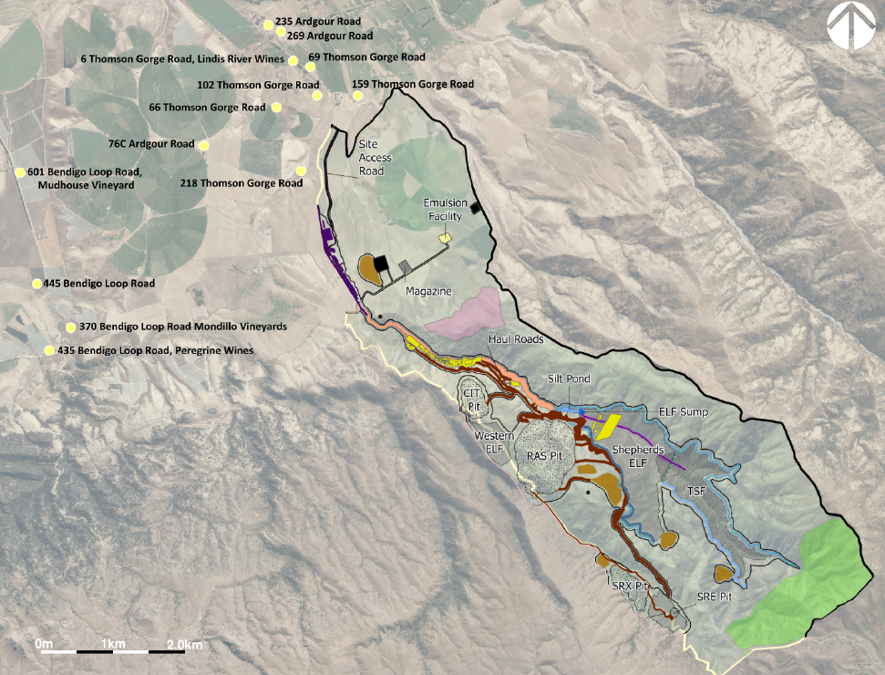
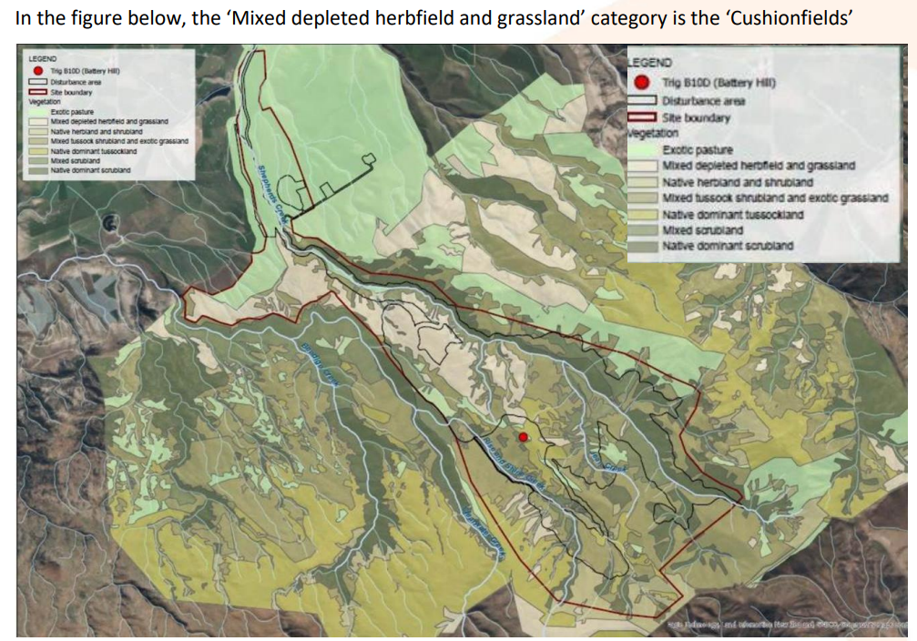
Attachment A: BOGP Site Layout and Nearest Noise Sensitive Receivers
Attachment B: Cushionfield Habitat
Note: In this attachment, ‘Mixed depleted herbfield and grassland’ category is the ‘Cushionfields’.

Attachment C: Potential Invertebrate Effects Area (Shown as Purple Shaded Area)
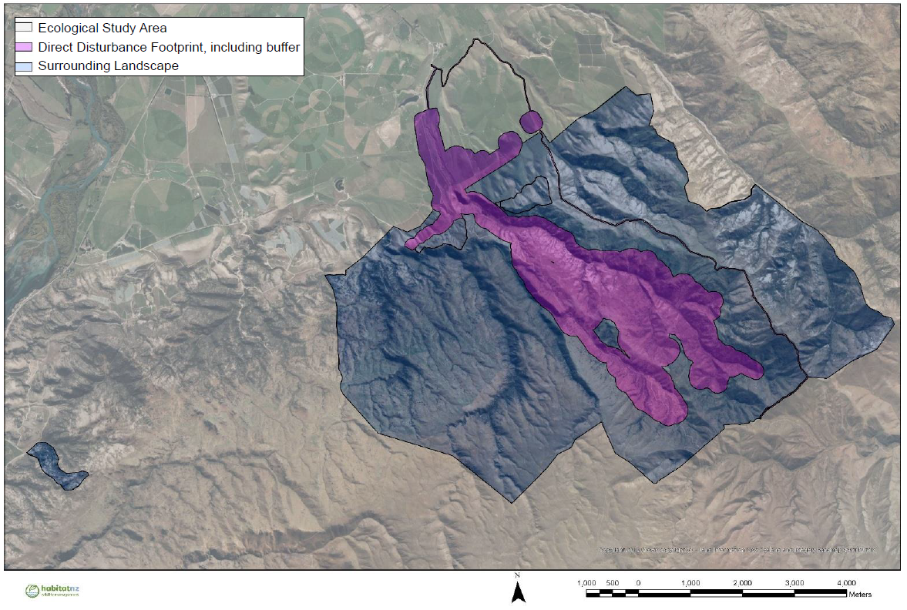

Attachment D: Habitat Boundary for Sporophyla oenospora
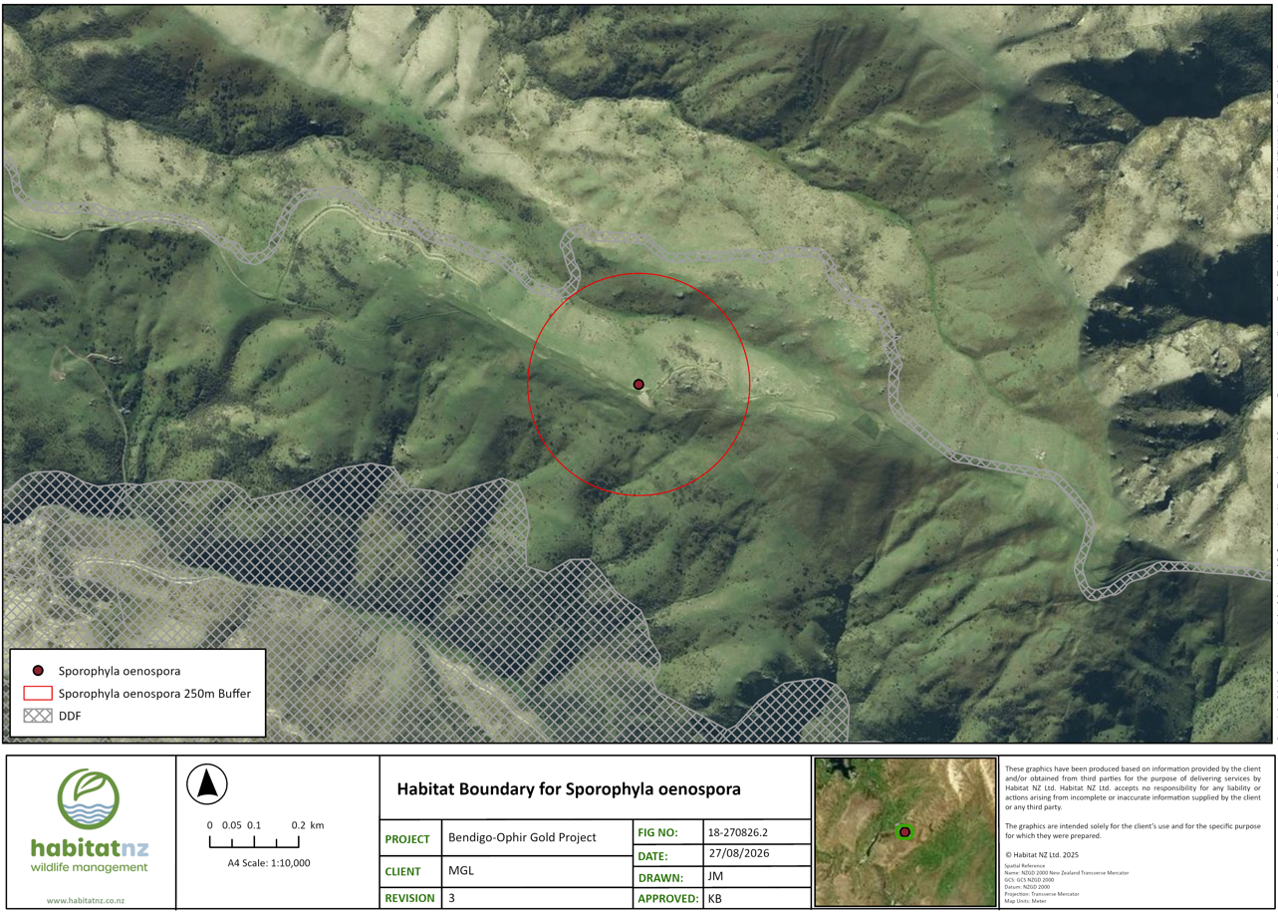

Attachment E: Proposed Walking Route to the Come-in-Time Battery
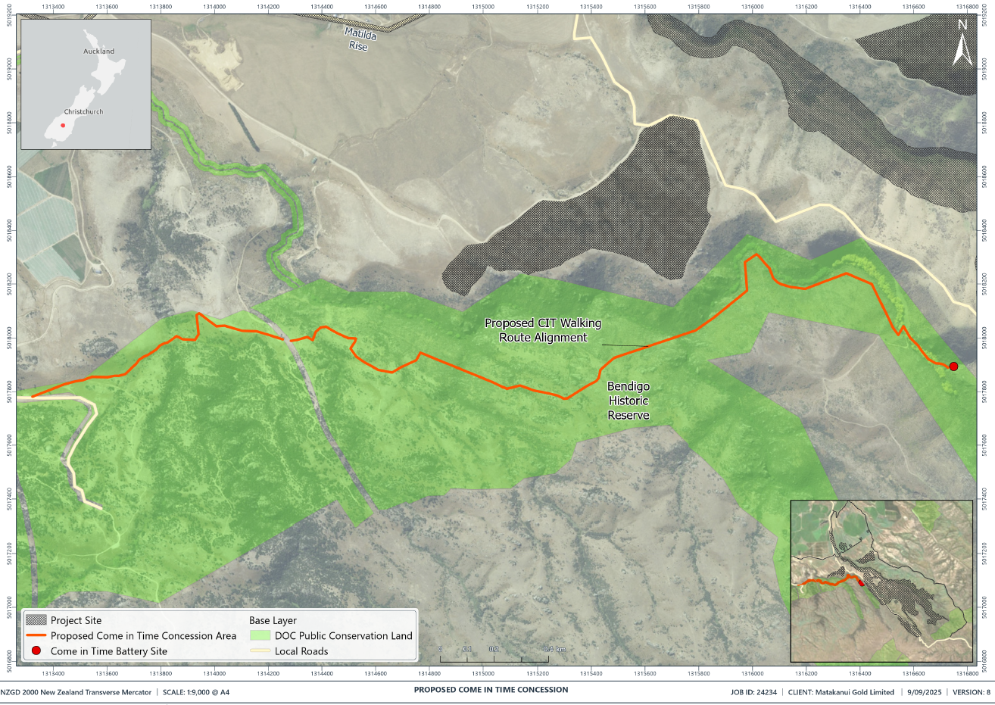

Attachment F: Thomson Gorge Road Widening (shown in Pink) and Ardgour Road Upgrades (shown in green)
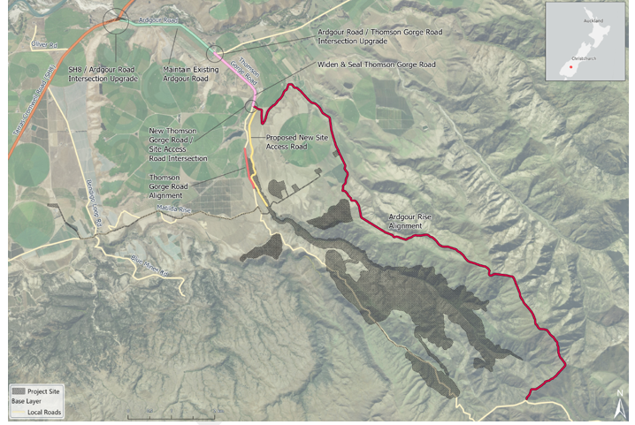

Attachment G: Ardgour Rise Road Revision 5 Drawings
Provided as separate attachment due to file size.

Attachment H: Stantec Ardgour Rise Road Safety Review
Provided as separate attachment due to file size.

