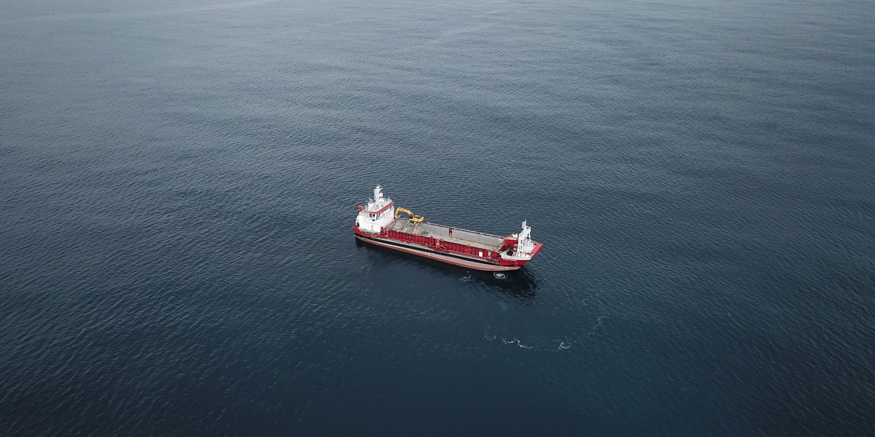

ATTACHMENT THIRTY-FIVE

Recommended Wildlife Approval Conditions
Updated 15/07/2026 – Clean Version

Dated: 15/07/2026
SCHEDULE 1:
1 | Authorised activity (including the species, any approved quantities and collection methods).  (Schedule 2, clause 2) | a) Activities authorised for a certain purpose:  i. During Monitoring – Collect dead and alive Culicia rubeola, Sphenotrochus ralphae and Kionotrochus suteri.  ii. During Monitoring – When identified on site during monitoring, return to the coastal marine area dead and alive Culicia rubeola, Sphenotrochus ralphae and Kionotrochus suteri.  iii. During Monitoring – For dead and alive Culicia rubeola, Sphenotrochus ralphae and Kionotrochus suteri not identified and returned to the coastal marine area while on site, possess in a secure location until identified and disposed of as outlined in the CCMP in Schedule Four.  iv. During Sand Extraction – Incidental collection of dead and alive Culicia rubeola, Sphenotrochus ralphae and Kionotrochus suteri and their return to the coastal marine area.  v. During Monitoring and Sand Extraction – Disturbance and incidental killing of Culicia rubeola, Sphenotrochus ralphae and Kionotrochus suteri.  b) Purpose of authorisation:  i. To authorise the disturbance, collection, incidental killing, release, disposal and possession of cup corals during monitoring associated with the sand extraction.  ii. To authorise the disturbance, incidental collection and incidental killing of live cup corals during sand extraction, and to return to the coastal marine area both live and dead cup coral during the sand extraction process.  c) Methodology:  i. In accordance with the CCMP attached as Schedule Four.
2. | The Land  (Schedule 2, clause 2) | The Sand Extraction Area and Control Sites shown on the Site Plan (Schedule Five).
3. | Personnel authorised to undertake the Authorised Activity  (Schedule 2, clause 3) | During Monitoring:  a) Simon West or a Suitably Qualified and Experienced Person (“SQEP”) replacement approved in writing by DOC.  b) Suitably qualified personnel under the direct supervision of Simon West or his replacement.  During Extraction:  c) The Master and crew for the time being of the William Fraser provided that all personnel involved in handling or returning cup corals have received training in the relevant procedures in the CCMP from the SQEP.
4. | Term  (Schedule 2, clause 4) | A 35-year period commencing from the date of approval.
5. | Approval Holder’s address for notices  (Schedule 2, clause 8) | McCallum Bros. Limited  PO Box 71-031  Rosebank  Auckland 1348  Email: luke@mccallumgroup.co.nz
6. | Department of Conservation / Director-General of Conservation address for notices | Email: askpermissions@doc.govt.nz

SCHEDULE 2: STANDARD TERMS AND CONDITIONS OF THE APPROVAL

1. Employees, Contractors, or Agents of McCallum Bros Limited (the Approval Holder)
1.1 The Approval Holder is responsible for the acts and omissions of its employees, contractors or agents. The Approval Holder is liable under this Approval for any breach of the terms of the Approval by its employees, contractors or agents as if the breach had been committed by the Approval Holder.
2. Other species
2.1 The Approval Holder must immediately notify the DOC of other coral taxa found. If requested by DOC, the Approval Holder must lodge holotype specimens and a voucher specimen of any taxa that are new to science with a recognised national collection.
3. Liabilities
3.1 The Approval Holder agrees to exercise the Approval at its own risk and releases to the full extent permitted by law the Department of Conservation / Director-General of Conservation and the Director-General of Conservation employees and agents from all claims and demands of any kind and from all liability which may arise in respect of any accident, damage or injury occurring to any person or property arising from the Approval Holder’s exercise of the Authorised Activity.
4. Compliance with Legislation and Director-Generals Notices and Directions
4.1 The Approval Holder must comply with all statutes, bylaws and regulations, and all notices, directions and requisitions of the Director-General of Conservation and any competent Authority relating to the exercise of this Approval.
5. Revocation
5.1 The Director-General of Conservation may revoke this Approval at any time (pursuant to clause 7(4) of Schedule 7 of the Fast-track Approvals Act 2024) in respect of the whole or any part of the Approval if:
(a) The Approval Holder breaches any of the conditions of this Approval; or
(b) In the Director-General of Conservation opinion, the exercise of this Approval causes any unforeseen or unacceptable effects.
5.2 If the Director-General of Conservation intends to revoke this Approval in whole or in part, the Director-General of Conservation must give the Approval Holder such prior notice as appears reasonable and necessary in the circumstances.
6. Costs
6.1 The Approval Holder must pay the standard Department of Conservation charge-out rates for any staff time and mileage required to monitor compliance with this Approval and to investigate any alleged breaches of the terms and conditions of it.
7. Variations
7.1 The Approval Holder may apply to the Director-General of Conservation for variations to this Approval in accordance with clause 7(2) of Schedule 7 of the Fast-tack Approvals Act 2024.

SCHEDULE 3: SPECIAL CONDITIONS

- Adhere to approved application

  - The Approval Holder must comply with the Cup Coral Management Plan (“CCMP”) that is annexed to this Approval (Schedule 4), or any amendment to that CCMP that has been certified in accordance with Special Conditions 3 to 6. If there is a conflict between the CCMP and the Conditions of this Approval, the Conditions shall prevail.

- Other Protected Wildlife

  - The Department of Conservation (Whangarei@doc.govt.nz and askpermissions@doc.govt.nz) is to be contacted immediately for further advice if protected wildlife other than those listed in Schedule 1 are encountered within the monitoring site (during monitoring) or area of sand extraction (during the sand extraction process) in circumstances where a separate application to disturb or kill non-authorised species may be required.

- Amendments to the CCMP

  - The Approval Holder may propose amendments to the CCMP at any time. Any proposed amendment must be prepared by a suitably qualified and experienced person and must be submitted to askpermissions@doc.govt.nz, for certification by the Director-General of Conservation in accordance with Special Condition 6. Any amendments may only be implemented once certification has been received.

- Purpose of Certification Process

  - The purpose of the certification process is to confirm that the amended CCMP gives effect to Condition 5.

- Objective of the CCMP

  - The objective of the certified CCMP is to avoid or minimise the risk of disturbance, incidental collection, and incidental killing of cup coral during both monitoring and sand extraction. The CCMP must include as a minimum:
- The methodology and processes to minimise the disturbance, incidental collection and incidental killing of cup corals during sand extraction.
- The methodology and processes to measure coral status and abundance and minimise the disturbance, collection and incidental killing of cup corals during monitoring.
- An explanation of how monitoring informs operational decisions and management responses.
- Certification

  - The certification process must confirm that the amended CCMP adequately gives effect to its objectives and contain the required information and methodologies to achieve these objectives and any relevant approval conditions.

- Cup Coral Capture and Handling

  - Cup Corals must only be handled by Authorised Personnel listed in Schedule 1 Item 3, or under the direct supervision of the Authorised Personnel.

  - All monitoring samples must be inspected for live and dead corals, and any corals discovered must be returned to the coastal marine area within the extraction cell from which they were removed, or as close to it as practicable, and as soon as practicable, unless retention is required for identification. Retention of live or dead cup corals must be limited to the minimum number and duration necessary for this purpose.

- Directions from the Director-General of Conservation

  - If required in writing by the Director-General of Conservation, the Approval Holder must make such improvements to techniques (including catching, handling, releasing, preserving and storing), and take such other steps as directed by the Director-General of Conservation.

  - The Director-General of Conservation may review the effectiveness of the conditions of this Approval if necessary to avoid, remedy or mitigate adverse effects by way of further or amended conditions. A review may be initiated within two months of receiving a Pre Sand Extraction Assessment Report (“PSEAR”) or Sand Extraction Monitoring Report (“SEMR “) and the Twelve- and Eighteen-month Pakiri Offshore Recovery Monitoring Reports.

- Cup Coral Reporting

  - A report summarising the outcomes of Cup Coral identifications during the PSEAR and SEMR must be submitted in writing to the DOC Operations Manager for Whangārei (whangarei@doc.govt.nz) and askpermissions@doc.govt.nz within:
- Four months of the completion of the monitoring of the Pre Sand Extraction Assessment Report (“PSEAR”) required under the Resource Consent for the Sand Extraction; and
- 31 October of the year a Sand Extraction Monitoring Report (“SEMR”) is required under the Resource Consent for the Sand Extraction.
Each report must include:
- The permission number;
- The species and number of any dead and alive animals collected and returned on-site during monitoring;
- The species and number of any dead and alive animals retained for identification;
- The GPS location (or a detailed map) of the collection point(s) and release point(s) of live species collected during monitoring; and
- A description of how the CCMP was implemented.

- Ownership and Possession of Absolutely Protected Wildlife

  - This Approval gives the Approval Holder the right to possess absolutely protected wildlife (Culicia rubeola, Sphenotrochus ralphae and Kionotrochus suteri) for short periods in accordance with the terms and conditions of the Approval, but the wildlife remains the property of the Crown. This includes any dead wildlife, live wildlife, any parts thereof, any eggs or progeny of the wildlife, genetic material and any replicated genetic material.

Unless expressly authorised by the Director-General of Conservation in writing, the Approval Holder must not donate, sell or otherwise transfer to any third party any wildlife, material, including any genetic material, or any material propagated or cloned from such material, collected under this Approval.

- Death of wildlife associated with activities covered by the approval

  - If, in the course of undertaking the Activities, all reasonable effort has been made to meet all of the conditions imposed in this authority; and Culicia rubeola, Sphenotrochus ralphae and Kionotrochus suteri are killed by the Approval Holder, then that will be permitted under this Approval.

- Records

  - All monitoring records must be made available for inspection at reasonable times by officers of the Director-General of Conservation.

SCHEDULE 4: CUP CORAL MANAGEMENT PLAN (“CCMP”)

SCHEDULE 5: SAND EXTRACTION AREA AND CONTROL SITES
