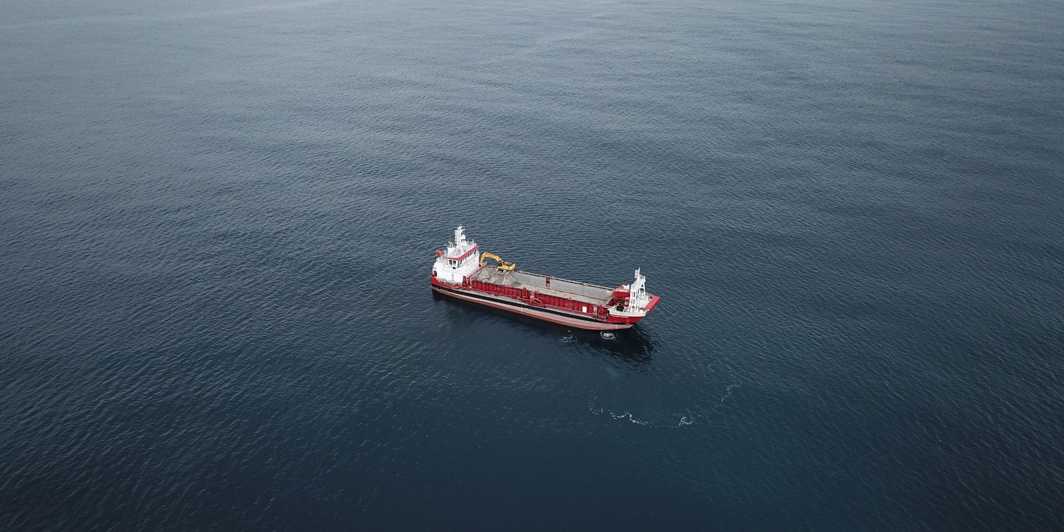

ATTACHMENT THIRTY-ONE
Biosecurity Management Plan (“BMP”)
Version 2 (Clean) - Updated 16/07/2026





Te Ākau Bream Bay Sand Extraction Project

Biosecurity Management Plan (BMP)

July 2026
Version 2

In accordance with Appendix I of MEPC Resolution MEPC.207 (62) of 2011:
‘Guidelines for the control and management of ships’ biofouling to minimize the transfer of invasive aquatic species’
Any management action undertaken should be recorded in the Biofouling Record Book
Revision history
Title: Te Ākau Bream Bay Sand Extraction Project – Biosecurity Management Plan.
Date | Version | Description | Prepared by | Date certified
15/07/2025 | 1 | Final draft for consultation | N.McCallum  L.Davis
16/07/2026 | 2 | Updates following MPI comments | L.Davis

Glossary of Terms
AC | Auckland Council
BMP | Biosecurity Management Plan
BOPRC | Bay of Plenty Regional Council
BWMP | Ballast Water Management Plan
CRMS-BIOFOUL | Craft Risk Management Standard for Biofouling on Vessels Arriving to New Zealand
IMO | International Maritime Organisation
MBL | McCallum Bros Limited
MMSI | Maritime Mobile Service Identity
MNZ | Maritime New Zealand
MPI | Ministry for Primary Industries
NRC | Northland Regional Council
NZDS | New Zealand Diving & Salvage
STD-ABTRT | Standard for the Approval of Treatments for Craft

Limitations

The report has been prepared to a specific scope of work. The report cannot be relied upon by a third party for any use without written consent of MBL (the disclosing party). This report may not be reproduced or copies in any form without the permission of the disclosing party. This document must always be displayed onboard the William Fraser at all times.

Table of Contents

1.0 Introduction 5
1.1 Purpose 5
1.2 Scope 5
1.3 Objectives 5
1.4 The Vessel 5
2.0 Ballast Water Management 7
2.1 Regulatory Context 7
2.2 Seawater Ballast 7
2.3 Freshwater Ballast 7
3.0 Biofouling Management 8
3.1 International Travel 8
3.2 Domestic Travel & Maintenance Requirements 8
3.2.1 Auckland Region Requirements 8
3.2.2 Northland Regional Council Requirements 10
3.2.3 Bay of Plenty Regional Council Requirements: 10
3.2.4 Biofouling Compliance Methodology 10
4.0 Training 11
5.0 Management Plan Review 11

List of Appendices
Appendix 1: Ballast Water Management Plan 13
Appendix 2: Anti-Foul Description and Application 14
Appendix 3: Anti-Foul Paint Specifications 15
Appendix 4: Ministry for Primary Industries - New Zealand Marine Pest ID Guide 16

List of Figures

Figure 1: Sand Extraction Vessel "William Fraser" 6
Figure 2 Hauraki Gulf Controlled Area (from Hauraki Gulf Controlled Area Notice 2020, p 3) 9

List of Tables
Table 1: William Fraser Vessel Particulars 6
Table 2: Specification Particulars / Operating Profile 6

Introduction
McCallum Bros Limited (MBL) has been granted resource consent (reference TBC) for sand extraction at the Te Ākau Bream Bay Sand Extraction Site. This consent was given effect to on (date TBC) and expires on (date TBC).

Purpose
The purpose of this Biosecurity Management Plan (BMP) is to outline the measures MBL will implement to prevent the spread of harmful aquatic organisms during sand extraction activities at the Te Ākau Bream Bay Sand Extraction Site. This plan ensures vessel operations, including ballast water use and hull maintenance, are carried out in compliance with New Zealand biosecurity regulations and best practice standards.

Scope
This plan applies to all biosecurity-related aspects of the vessel William Fraser used in the sand extraction project, including:
- Ballast water intake and discharge (seawater and freshwater)
- Hull biofouling management during domestic operations
- Compliance with relevant regional and national biosecurity controls
- Procedures for both domestic and potential international voyages
- Contingency planning for the detection and potential occurrence of Unwanted Organisms or other species of biosecurity concern.
It includes operational protocols while transiting through and working within designated Controlled Areas such as the Hauraki Gulf.

Objective
The objective of this BMP is to prevent the introduction and spread of marine pests through effective ballast water management and vessel maintenance practices.
This will be achieved by:
- Compliance with all applicable national and regional biosecurity regulations, including those of Maritime New Zealand (MNZ), Ministry for Primary Industries (MPI), Auckland Council (AC), Northland Regional Council (NRC), and the Bay of Plenty Regional Council (BOPRC).
- Minimising the risk of transporting harmful aquatic organisms between operational locations.
- Ensuring vessel hulls meet “clean hull” or “light fouling” standards through regular inspections and maintenance.
- Establishing clear procedures for identifying and reporting suspected marine pest organisms during operations.

The Vessel
The vessel used to carry out the sand extraction activities is the trailing suction dredger William Fraser.
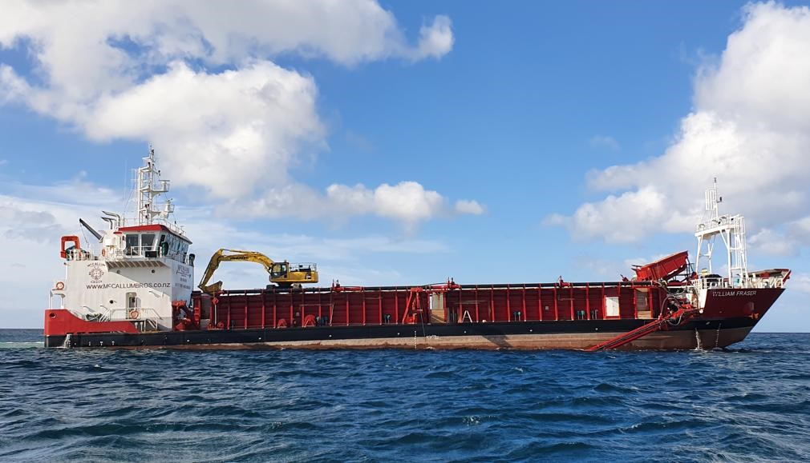
Figure 1: Sand Extraction Vessel "William Fraser"
Table 1: William Fraser Vessel Particulars
Ship Name | MV WILLIAM FRASER
Flag State | NEW ZEALAND
Port of Registry | AUCKLAND
IMO Number | 9864605
Gross Tonnage | 1540
Type (BV Classified) | DECK SHIP
Regulation Length | 68m
Beam | 14m
International Call Sign and MMSI | ZMG 3728
Current Ship Owner | McCallum Bros Ltd

Table 2: Specification Particulars / Operating Profile
Operating Speed | 9.5Kts
Period Underway / Activity (%) | 50% of the time when at full extraction rate.
Expected lay up periods  (Anchored / Moored Location) | ~2 days per week on average. Berthed at Ports of Auckland.
Typical operating region or routes | Auckland / Northland Restricted /Bay of Plenty Restricted
Planned duration between dry docking | 2½ years on average.
Expected Dry docking country | New Zealand
Dry docking and maintenance history | - Hull Cleaned by MPI Biosecurity Approved Divers - NZDS Dec 2022 and June 2023  - End of term survey, dry dock hull clean, high pressure water blasted and re-painted September/October 2024

Ballast Water Management

Regulatory Context
New Zealand is a signatory to the International Convention for the Control and Management of Ships’ Ballast Water and Sediments (2004), implemented domestically via the Maritime Transport Act 1994 and Marine Protection Rules Part 300. This convention was the international response to managing biosecurity risks from ballast water undertaking international voyages, but does not apply to vessels operating domestically.
While the William Fraser operates domestically, it is capable of international travel and complies with the relevant standards when applicable. These standards require a Ballast Water Management Plan (BWMP) which is shown in Appendix 1 of this document.

Seawater Ballast
The William Fraser does not intake or discharge seawater ballast at any point during its sand extraction operations. Instead, to maintain balance and trim in the vessel it moves freshwater ballast water held internally within the ballast tanks of the vessel depending on the vessel requirements when loading and unloading sand. This internal freshwater ballast is not discharged on the extraction site, though some may be used to water the load to flush salt water through the sand as described in section 2.3 Freshwater ballast.

Freshwater Ballast
Freshwater Ballast is taken on board the William Fraser while docked at the Ports of Auckland. This water is sourced from the reticulated metropolitan water supply managed by Watercare Services Limited and is AA-grade drinking water.
Fresh water ballast will also be taken on board the William Fraser while docked at the Port of Tauranga. This is also to an AA-grade drinking grade water standard and is supplied by the Port from Tauranga City Council.
During return voyages from the Te Ākau Bream Bay Sand Extraction Site, this freshwater is sprayed over the dredged sand in the vessel's hopper. The hopper is designed to allow free drainage, and the freshwater rinse helps flush salt from the sand. This process ensures the landed sand is suitable for use in manufacturing concrete products without requiring further freshwater treatment.
The discharge of this freshwater is minimal and occurs gradually during transit. As it is clean potable water and released in offshore marine environments, it poses no environmental risk. This practice is consistent with standard maritime operations and does not breach any current discharge or marine pollution regulations under the Maritime Transport Act 1994 or Marine Protection Rules.

Biofouling Management

International Travel
The Craft Risk Management Standard for Biofouling on Vessels Arriving to New Zealand (CRMS-BIOFOUL), issued by the Ministry for Primary Industries (MPI) under section 24G of the Biosecurity Act 1993, regulates the entry of vessels into New Zealand from international waters.
If the William Fraser undertakes international voyages, it must comply with the requirements of CRMS-BIOFOUL. The key standard is that vessels must arrive in New Zealand with a “clean hull.” To meet this requirement, vessel operators must implement one of the following approved biofouling management strategies:
- Clean prior to arrival: Undertake hull cleaning immediately before entering New Zealand territorial waters

- Out Of Water: Slip vessel at an MPI approved site & cleaned within 24hrs of arrival
- Continual maintenance: Use best-practice hull maintenance such as antifouling coatings.
- Approved treatments: Apply treatments in line with MPI’s Standard for the Approval of Treatments for Craft (STD-ABTRT).
Compliance with these standards ensures that international voyages do not introduce harmful marine organisms into New Zealand waters.

Domestic Travel & Maintenance Requirements
The William Fraser will operate in the AC, NRC, and BOPRC regions during transits and while carrying out sand extraction activities at Te Ākau Bream Bay. To ensure compliance with biosecurity regulations in these regions, MBL adheres to the requirements of the Hauraki Gulf Controlled Area Notice 2020 (issued under section 131(2) of the Biosecurity Act 1993) for Auckland waters and the Northland Regional Pest and Marine Pathway Management Plan 2017–2027, and the Bay of Plenty Regional Council’s Regional Pest Management Plan 2020-2030 for Te Akau Bream Bay sand extraction and transiting operations.

Auckland Region Requirements
Under the Hauraki Gulf Controlled Area Notice 2020, issued pursuant to section 131(2) of the Biosecurity Act 1993, AC has declared specific marine areas as controlled zones for the management of pest species. These controls form part of the Auckland Regional Pest Management Plan.
Figure 2 Hauraki Gulf Controlled Area (from Hauraki Gulf Controlled Area Notice 2020, p 3)
The William Fraser transits through these controlled areas when departing from or returning to the Ports of Auckland. Key applicable requirements under Section 5 of the Notice include:
- Hull Fouling Limits: All craft owners or persons in charge must ensure the level of hull fouling does not exceed “light fouling,” defined as no more than a slime layer and scattered barnacles.
- Water Management: Any craft entering a marine water body in the Auckland region from land must be free of all ballast water, bilge water, holding tank water, or sea water held in any container.
- Compliance for Movement: No person may move a craft into or within the Controlled Area without complying with the above requirements.
These conditions apply to all transits undertaken by the William Fraser within the Auckland marine region and are strictly adhered to by McCallum Bros Limited to ensure compliance and to reduce biosecurity risk.

Northland Regional Council Requirements
Te Ākau Bream Bay falls under the jurisdiction of the NRC, which enforces the Northland Regional Pest and Marine Pathway Management Plan 2017–2027. This plan aims to prevent and manage the spread of marine pests, such as Sabella spallanzanii (Mediterranean fanworm) and Caulerpa brachypus, through vessel biofouling management. Key requirements include:
- Hull Cleanliness: Vessels operating in Northland waters must maintain hull cleanliness to minimize the risk of spreading marine pests. The NRC conducts underwater hull surveys from October to May annually to monitor for pests, with vessel owners required to take remedial action if pests are detected.
- Marine Pest Reporting: Operators must immediately report suspected marine pests to the NRC’s Marine Biosecurity Team (contact: biosecurity@nrc.govt.nz or 0800 002 004), providing photographs or samples to aid identification.
- Controlled Area Notices: The NRC may issue Controlled Area Notices restricting activities (e.g., anchoring, dredging) in areas with identified marine pests. Operators must monitor and comply with these notices.

Bay of Plenty Regional Council Requirements:
Under the Bay of Plenty Regional Pest Management Plan, the plan contains rules that apply specifically to craft and equipment moving into or within Bay of Plenty waters to protect the region’s coast from unwanted marine pests:
When in the Bay of Plenty, MBL must ensure:
- Rule 1: The hull is sufficiently cleaned and antifouled, so that the hull has no more than a slime layer and/or barnacles.
- Rule 2: All high-risk areas on the craft are free of marine pests (this includes the anchor, chain, anchor wells and live bait tanks).
- Rule 3: All boating equipment (including fishing and diving equipment) is free of marine pests.

Biofouling Compliance Methodology
To meet NRC, AC, and BOPRC requirements, MBL implements the following measures for the William Fraser:
- Dry Dock Cleaning: Scheduled every three years at MPI-approved facilities equipped to capture runoff and debris, preventing the release of invasive species into the marine environment.
- Regular Hull Inspections: Partake in underwater hull inspections that are conducted at least annually during the NRC’s surveillance period (October–May), with additional inspections triggered by operational risks (e.g., prolonged mooring or visits to high-risk ports like Whangārei). Inspections are performed by MPI-approved contractors to ensure compliance with NRC standards.
- Antifouling Maintenance: The William Fraser maintains MPI-approved antifouling coatings, applied and inspected during triennial dry dock cleaning, to prevent biofouling accumulation. Coating condition is monitored during underwater inspections to ensure effectiveness.
- Pest Response Protocol: If suspected marine pests or organisms listed in the Auckland Regional Pest Management Plan, the Northland Regional Pest and Marine Pathway Management Plan and the Bay of Plenty Regional Council’s Regional Pest Management Plan 2020-2030 are detected during inspections, MBL will:
  - Immediately cease all cleaning and dredging activities;
  - Notify the NRC’s Marine Biosecurity Team and, if applicable, AC and BOPRC (for transits within Auckland and Bay of Plenty waters) without delay;
  - Await formal clearance from the relevant authority before resuming operations.
- Monitoring Controlled Area Notices: MBL will regularly check NRC’s website (www.nrc.govt.nz) and subscribe to biosecurity alerts to ensure compliance with any Controlled Area Notices in Bream Bay or nearby Whangārei waters. Dredging operations will be paused or adjusted as required to adhere to these notices.

Contingency plan for the detection and potential occurrence of unwanted organisms
MBL recognises that the early detection and reporting of unwanted marine organisms is an important component of New Zealand's marine biosecurity system. Although the proposed sand extraction activities are not expected to increase the risk of introducing marine pests, operational inspections provide an opportunity to identify any suspected unwanted organisms that may be present on dredging equipment or associated with extracted material.
Following the completion of sand extraction activities after each voyage, MBL will inspect the vessels draghead, screening deck and any other areas where marine organisms or debris may accumulate. Where a suspected unwanted marine organism is detected, or where an organism of concern is observed within the sand extraction area, MBL will implement the following contingency measures.

Initial Response
Upon detecting a suspected unwanted marine organism, MBL will:
- Immediately cease sand extraction activities within the affected area or extraction cell;
- Minimise any further disturbance of the area where the organism was detected;
- Retain the organism in situ where practicable and avoid handling, relocating or disposing of the organism unless directed by the relevant authority;
- Record the location (GPS coordinates where available), date and time of detection, depth, photographs, and any other relevant observations;
- Ensure all personnel are informed of the detection and the requirement to avoid actions that may spread the organism.

Notification
As soon as practicable following detection, MBL will notify:
- The Ministry for Primary Industries (MPI) Exotic Pest and Disease Hotline (0800 80 99 66);
- Northland Regional Council's Marine Biosecurity Team;
- Where relevant, Auckland Council and/or Bay of Plenty Regional Council if operations have recently occurred within, or transit through, those regions.
The notification will include:
- Photographs of the suspected organism;
- GPS coordinates of the detection;
- Description of the organism and estimated abundance;
- Operational activities occurring at the time of detection; and
- Any actions already taken to minimise further spread.
MBL will cooperate fully with MPI and any regional council investigation or response.

Operational Restrictions
Following notification:
- Sand extraction will not recommence within the affected extraction cell or area until authorised by MPI or the relevant regional authority.
- MBL will comply with any directions issued by MPI or the relevant authority regarding movement controls, additional inspections, sampling requirements or operational restrictions.
- Where directed, equipment will remain in place or be managed in accordance with MPI instructions to prevent any potential spread of the organism.

Specific Response for the Detection of Caulerpa
Should suspected exotic Caulerpa (including Caulerpa brachypus or Caulerpa parvifolia, or any other exotic Caulerpa species identified by MPI) be detected on the draghead, screening deck, or observed on the seabed during monitoring of the sand extraction and control areas, MBL will immediately implement the following additional measures:
- Immediately cease dredging operations within the affected cell or area of detection.
- Avoid any further disturbance of the seabed in the vicinity of the detection.
- Do not remove, wash, fragment or dispose of any suspected Caulerpa, recognising that even small fragments may facilitate further spread.
- If Caulerpa is present on dredging equipment, retain material on the vessel where it can be safely contained, where practicable, pending advice from MPI.
- Photograph the suspected Caulerpa and accurately record the location of detection.
- Immediately report the suspected detection to MPI via the Exotic Pest and Disease Hotline and notify Northland Regional Council.
- Follow all directions issued by MPI regarding containment, vessel movement, cleaning, disposal of material, sampling and any subsequent operational restrictions.
- Dredging within the affected area may recommence following written or verbal clearance provided by MPI or the lead biosecurity agency managing the response.

Documentation
All detections, notifications, agency communications and management actions will be recorded. Where required, incident reports will be provided to the relevant consent authority and incorporated into environmental reporting under the Sand Extraction Monitoring Report.

Training
All crew members involved in the operation of the William Fraser receive mandatory biofouling and marine biosecurity training to minimize the risk of introducing or spreading marine pests in Auckland, Northland and Bay of Plenty waters. The training program includes:
- Marine Pest Identification: Crew are trained to recognize high-risk marine pests listed in the Northland Regional Pest and Marine Pathway Management Plan (e.g., Sabella spallanzanii, Caulerpa brachypus) and the Auckland Regional Pest Management Plan, using resources such as the NRC’s “Marine Pests” guide (available at www.nrc.govt.nz) and MPI’s Marine Pest ID Guide.
- Biofouling Management Protocols: Training covers MBL’s procedures for hull maintenance, antifouling coating checks, and response to detected pests, including ceasing operations, notifying the NRC’s Marine Biosecurity Team (biosecurity@nrc.govt.nz or 0800 002 004) and AC or BOPRC (if applicable), and awaiting clearance.
- Operational Compliance: Crew are instructed on compliance with the Hauraki Gulf Controlled Area Notice 2020 (e.g., maintaining “light fouling” levels, managing ballast and bilge water) and NRC requirements for hull cleanliness and Controlled Area Notices in Bream Bay.
- Frequency and Documentation: Training is conducted annually for all crew, with additional sessions for new staff or following updates to regional biosecurity regulations. As part of this training, all crew will be familiar with the Ministry for Primary Industries – New Zealand Marine Pest ID Guide (Appendix 4). Records are maintained in the business office. Staff meetings are held regularly to discuss any ongoing training requirements.

Management Plan Review
MBL commits to regularly reviewing and updating the Biosecurity Management Plan to ensure ongoing compliance and alignment with best practices:
- Review Schedule: The plan is reviewed annually or following significant changes to biosecurity regulations, operational practices, or the identification of new marine pests in Auckland, Northland and Bay of Plenty waters.
- Stakeholder Engagement: MBL engages with the NRC’s Marine Biosecurity Team and AC prior to major reviews to incorporate updated guidance, such as changes to the Northland Regional Pest and Marine Pathway Management Plan, Hauraki Gulf Controlled Area Notice or the Bay of Plenty Regional Council’s Regional Pest Management Plan 2020-2030.
- Updates and Communication: Any updates to the plan are documented, communicated to all crew, and incorporated into training sessions. Revised plans are submitted to relevant authorities (NRC, AC, BOPRC, and MPI) for approval if required.

Appendix 1: Ballast Water Management Plan

Appendix 2: Anti-Foul Description and Application

Appendix 3: Anti-Foul Paint Specifications

Appendix 4: Ministry for Primary Industries - New Zealand Marine Pest ID Guide

