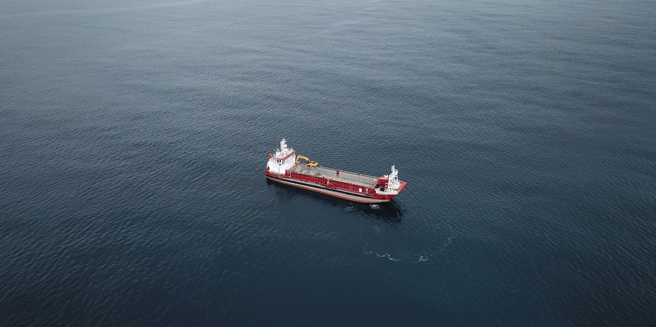

ATTACHMENT THIRTY

Cup Coral Management Plan (“CCMP”)
Version 4 (Clean) - Updated 05/08/2026



Te Ākau Bream Bay Sand Extraction Project

Cup Coral Management Plan (CCMP)

August 2026
Version 4

Revision history
Title: McCallum Bros Limited Bream Bay Sand Extraction Project Coral Management Plan
Date | Version | Description | Prepared by | Reviewed by | Date certified
14/07/2025 | 1 | Issue for Wildlife Act Approval. | L.Davis | S.West  J.Beaumont
28/10/2025 | 2 | Edits to Section 5 | L.Davis | S.West  J.Beaumont
15/07/2026 | 3 | Updates to Sections 1.0-4.0 | L.Davis | J.Beaumont
5/08/26 | 4 | Updates | S. Elstob | J.Beaumont

Glossary of Terms
MBL | McCallum Bros Limited
CCMP | Cup Coral Management Plan
NZTCS | New Zealand Threat Classification System
TSHD | Trailing Suction Hopper Dredge

Limitations
This report has been prepared by McCallum Bros Limited (MBL) in collaboration with Bioresearches and reviewed by Earth Sciences New Zealand. The report has been prepared to a specific scope of work. The report cannot be relied upon by a third party for any use without written consent of MBL (the disclosing party).
This report may not be reproduced or copies in any form without the permission of the disclosing party. This document must always be displayed onboard the William Fraser at all times

Table of Contents

1.0 Introduction 1
1.1 Purpose 1
1.2 Scope 1
1.3 Objective 2
2.0 This Plan 4
3.0 Scleractinia cup corals 5
3.1 Sphenotrochus ralphae 5
3.2 Kionotrochus suteri 6
3.3 Culicia rubeola 6
3.4 Resilience of Scleractinia cup corals 7
4.0 Management 8
4.1 MBL’s sand extraction methodology 8
4.2 Spatial management of sand extraction 9
5.0 Monitoring 10
5.1 Benthic biota monitoring methodology 10
5.1.1 Drop Camera 10
5.1.2 Grab Sampling 11
5.1.3 Epibenthic dredge 13
6.0 Communications 14
6.1 MBL’s Roles and responsibilities 14
6.2 Key Contacts 14
7.0 Management plan review 14
References 14
List of Appendices
Appendix A: Wildlife Act Authorisation 16

List of Figures

Figure 1: Map showing the proposed sand extraction area and control areas in Te Ākau Bream Bay. Source: Simon West, Bioresearches, personal communication. 3
Figure 2: Images of Sphenotrochus ralphae. photographed alongside a ruler for scale with each black line 1 mm apart. Left: top view; Right: side view. Source: Simon West, Bioresearches, personal communication. 5
Figure 3: Images of Kionotrochus suteri. Source: Simon West, Bioresearches, personal communication. 6
Figure 4: Two specimens of Culicia rubeola from a sample collected at Pākiri. Image of NIC specimen 183334 taken by Diana Macpherson (Earth Sciences NZ) with a ruler as a scale bar. The left hand specimen has layers of mollusc shell underneath showing that this was previously attached to a shell (Beaumont et al, 2026). 6
Figure 5: Scleractinia cup corals retained on a 2 mm screen as per the William Frasers'. Source: Simon West, Bioresearches, personal communication. 9
Figure 6: Map Showing the cells within the proposed Sand Extraction Area and proposed Control Areas. The red symbols indicate the location of live cup corals observed during previous monitoring. Source: Simon West, Bioresearches, personal communication. 10
Figure 7: MBL’s drop camera frame. Source: Shayne Elstob, MBL, personal communication. 11
Figure 8: Modified standard ponar grab. Left: collecting a sediment sample on the seabed. Right: Sediment sample being emptied into a bucket. Source: Simon West, Bioresearches, personal communication. 11
Figure 9: Scleractinia cup corals retained on a 3 mm sieve as part of Bioresearches monitoring methodology. Source: Simon West, Bioresearches, personal communication. 12
Figure 10: Epibenthic dredge being deployed. Source: Simon West, Bioresearches, personal communication. 13

List of Tables

Table 1: Roles, responsibilities, and contact details relevant to the Extraction Management Plan. Source: McCallum Bros Limited 14
Table 2: Key contacts. 14

1.0 Introduction
McCallum Bros Limited (MBL) has been granted resource consent (reference TBC) for sand extraction at the Te Ākau Bream Bay Sand Extraction Site. This consent was given effect to on (date TBC) and expires on (date TBC). This consent allows for sand extraction of:

1) 150,000 m³ of sand annually for the first three years.
2) After the first three years, the volume of extraction may increase up to 250,000m³ annually over 32 years.

Sand extraction occurs using a trailing suction hopper dredge (TSHD) vessel, the “William Fraser”. During the extraction process, sand is fluidised into a slurry at the draghead via suction pulling sand and water through the draghead at the seabed. The sand slurry then moves up the draghead pipe, through a pump and onto the vessel where it is discharged onto a screen deck that utilises a dual screen layer system with a 20 mm screen above a 2.0 mm screen mesh to prevent larger material going into the load of the hopper. The larger 20 mm screen is likely to prevent larger, heavier, material from damaging smaller biota (including scleractinian corals) as they pass across the 2.0 mm screen. The oversized material (> 2.0 mm), including scleractinian corals, passes across the top of the screen and drops, via a pipe, into the forward port side moon pool where it drops through the vessel and exits, at keel height, under the vessel to return immediately to the seabed.

In March 2024, monitoring confirmed the presence of populations of solitary scleractinian cup corals (Kionotrochus suteri and Sphenotrochus ralphae) within the sand extraction and control areas at Te Ākau Bream Bay. On 8 May 2026, a third species of scleractinian coral was confirmed within the sand extraction area at Bream Bay. This additional species (Culicia rubeola) differs from the two other corals in that it is classified within a different family and is a colonial form rather that a solitary cup coral. All specimens of Culicia rubeola were dead when collected.

1.1 Purpose
The purpose of this draft Coral Management Plan (CMP) is to identify how the marine sand extraction process and monitoring will address, avoid, and manage the potential effects on populations of scleractinian corals known to be present within the proposed extraction area (Kionotrochus suteri, Sphenotrochus ralphae and Culicia rubeola). The report includes measures to reduce disturbance and the risk of incidental killing of these corals during the sand extraction at Te Ākau Bream Bay.

1.2 Scope
This CMP applies to all MBL employees, including sub-contractors.

1.3 Objective

The objective of the certified CCMP is to avoid or minimise the risk of disturbance, possession and incidental killing of scleractinian corals during both monitoring and sand extraction. The CMP must include as a minimum
- The methodology and processes to minimise the disturbance, possession and incidental killing of corals during sand extraction,
- The methodology and processes to minimise the disturbance, possession and incidental killing of corals during monitoring.

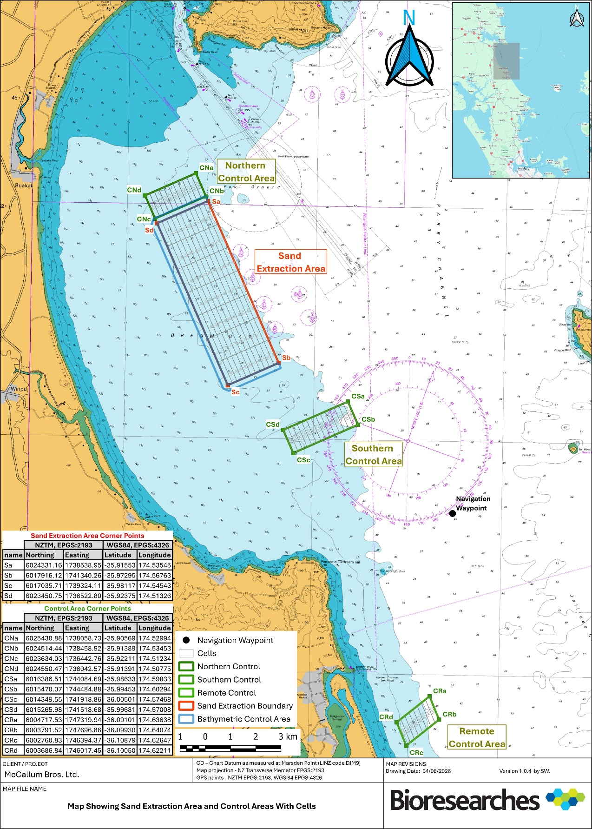
Figure 1: Map showing the proposed sand extraction area and control areas in Te Ākau Bream Bay. Source: Simon West, Bioresearches, personal communication.

2.0 This Plan
The key elements of this plan include:

- Section 1.0 – Introduces the purpose, scope and objectives of the plan.
- Section 3.0 – Provides an overview of the Scleractinian corals present within MBL’s proposed extraction area.
- Section 4.0 – Sets out MBL’s management processes to reduce disturbance and the risk of incidental killing of scleractinian corals.
- Section 5.0 – Sets out the benthic biota monitoring plan.
- Section 6.0 – Provides information about communication.
- Section 7.0 – Sets out the management plan review frequency.

3.0 Scleractinian corals
Sphenotrochus ralphae and Kionotrochus suteri are both members of the family Turbinoliidae (Cnidaria, Scleractinia). Turbinoliidae are small (usually less than 10 mm) cup corals that occur mostly in moderately deep water in temperate and tropical seas (Beaumont et al. 2025 and references within). These corals have a hard calcium carbonate skeleton forming a cup-like structure that houses the polyp. Their small size and apparent interstitial habit within sandy substrates at lower shelf to upper slope depths (110-150m) have resulted in the collection of relatively few turbinoliidae specimens, and little is known about their modes of life and life history traits (Cairns 1997).

Culicia rubeola (Quoy and Gaimard 1833) is a species of ahermatypic (non-reef-building) scleractinian coral in the family Rhizangiidae. This species lives attached to hard substrates such as rocky reefs and bivalve shells with a depth range of 0–82 m (Brook 1982, Cairns 1995). There are no rocky reefs, present within the extraction area at Bream Bay ( Assessment of Effects on Benthic Ecology, Bioresearches 2024) To date, only dead specimens have been found attached to shells within the extraction area. These specimens may have lived on shells within the proposed extraction area or on reefs outside of the extraction area, with the possibility that dead skeletons have been brought in through the movement of currents and/or storm conditions.

3.1 Sphenotrochus ralphae
Sphenotrochus ralphae (Squires 1964) is endemic to Aotearoa New Zealand. This species has a small triangular corallum with flat faces and rounded edges. The corallum is white or sometimes porcellanous and measures up to 9 mm in height (Figure 2).

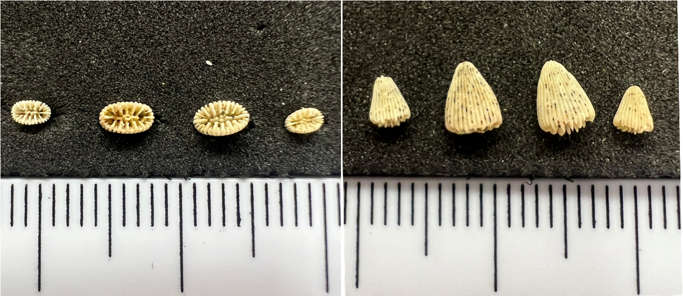
Figure 2: Images of Sphenotrochus ralphae. photographed alongside a ruler for scale with each black line 1 mm apart. Left: top view; Right: side view. Source: Simon West, Bioresearches, personal communication.

3.2 Kionotrochus suteri
Kionotrochus suteri is also endemic to Aotearoa New Zealand. This species is up to 6.8 mm in CD and 6.5 mm in height (Figure 3). The corallum is white and often attached to a bivalve shell. Mature specimens have a conical corallum with a rounded base.
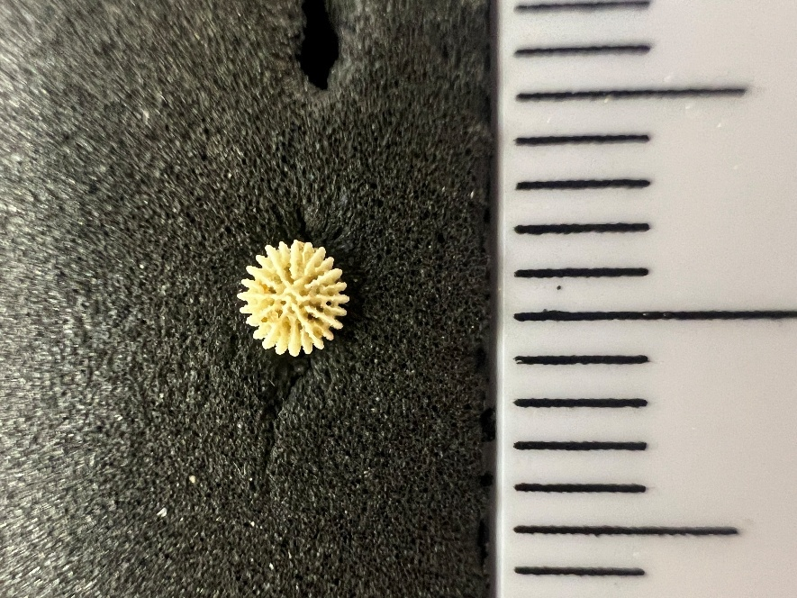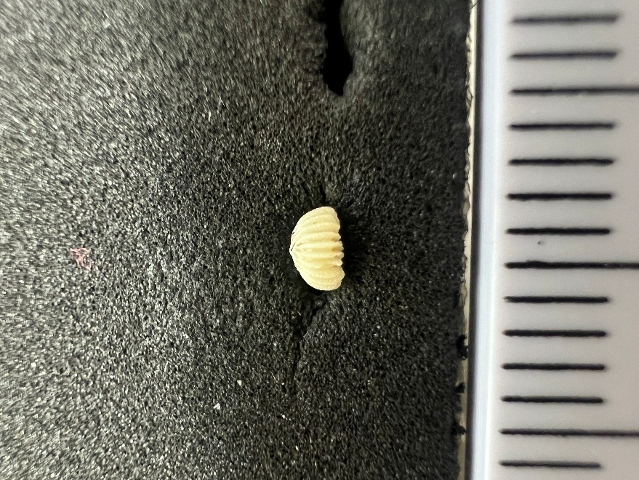
Figure 3: Images of Kionotrochus suteri. Source: Simon West, Bioresearches.

3.3 Culicia rubeola
Although Cairns (1995) concluded Culicia rubeola (Figure 4) was probably endemic to Aotearoa New Zealand, this coral species has since been recorded in India (Viswambharan and Sreenath 2024) and Hong Kong (Lam et al. 2008) and the Ocean Biodiversity Information System (OBIS) database includes records from the Central and south-west and eastern Pacific, in the littoral zone (to 55 m). This species lives attached to hard substrates, they are circular and mostly 3.5-4.5 mm in diameter (Cairns 1995), but can be up to 6.0 mm in sheltered environments (Brook 1982). Culicia rubeola is not included in the New Zealand Threat Classification System (NZTCS) as being at risk or threatened (No search results found).
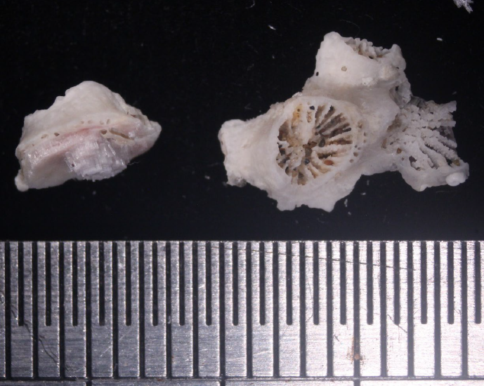
Figure 4: Two specimens of Culicia rubeola from a sample collected at Pākiri. Image of NIC specimen 183334 taken by Diana Macpherson (Earth Sciences NZ) with a ruler as a scale bar. The left hand specimen has layers of mollusc shell underneath showing that this was previously attached to a shell (Beaumont et al, 2026).

3.4 Resilience of Scleractinia cup corals

While there is little available information on the behaviour or life histories of Sphenotrochus ralphae or Kionotrochus suteri, evidence in the literature suggests that members of the Turbinoliidae family of cup corals are well adapted to infaunal life and the challenges faced with living in mobile sediments (see Beaumont et al. 2025). For example, corals can move vertically through sediments to escape burial (at least up to 1 cm), can burrow into sediments (perhaps as a predator avoidance strategy) and can return to an upright position after being overturned. In addition, many species of solitary cup coral, including those within the Turbinoliidae family, can regenerate both soft and skeletal tissues following fragmentation. This is true even of relatively small fragments (approximately 10% of original coral). See Beaumont et al. (2025) for further details.

MBL’s sand extraction process has the potential to cause mortality and/or damage to benthic faunal species as they pass through the draghead and screening deck. However, previous survivorship studies showed that many benthic faunal species, particularly those smaller than approximately 20 mm, did survive this process at MBL’s extraction site in the Mangawhai-Pākiri embayment, at least as far as being returned to the seafloor. Cup corals were not included in survivability studies as no live corals were observed within the samples. However, the presence of live Sphenotrochus corals within the sand extraction area at MBL’s Pākiri site suggests that cup corals may have some ability to survive the proposed disturbance at Te Ākau Bream Bay. This is perhaps not surprising given the ability of corals to move within sediments and regenerate tissues if damaged.

It should be noted, however, that fragmented parts of cup corals would be unlikely to have the ability to escape sediment burial and may also be prone to predation on the seabed. As such, some mortality of fragments would be expected but the extent of such mortality is unknown. Sentoku et al. (2017) noted that fragmented cup corals were able to burrow into sediments 188 days (a little over 6 months) following fragmentation. Survival of coral fragments following sand extraction would, therefore, be increased by returning damaged corals and/or fragments to an area that will remain undisturbed by active sand extraction for at least 7 months. It is, however, considered likely that repeated disturbance could reduce the resilience or survivability of cup corals following damage or fragmentation.

There is also little available information on the behaviour or life history of Culicia rubeola (see Beaumont et al. 2026). In a study in the Indian region, Viswambharan and Sreenath (2024) concluded that Culicia is resilient to high turbidity (suspended sediments). However, their study was on Culicia stellata rather than Culicia rubeola. No further information was found on the resilience of Culicia rubeola to disturbance. However, as discussed in Beaumont et al. (2025) with respect to Sphenotrochus ralphae and Kionotrochus suteri, many coral species are known to have some regenerative potential following physical disturbance.

It is considered likely that Culicia rubeola has the ability to regenerate following physical damage or fragmentation. However, it is considered unlikely that these corals have the ability to burrow or move through sediments and so any corals that become buried by sediments would likely suffer mortality. However, at this stage there have been no live Culicia rubeola found within the proposed sand extraction area at Te Ākau Bream Bay. It is not known whether Culicia rubeola live within the proposed sand extraction area attached to bivalve shells (there are no known rocky reefs within this area) or whether the dead skeletons originated from nearby reefs and have been moved into the area once dead.

4.0 Management

4.1 MBL’s sand extraction methodology
The following technology is used on the William Fraser which assist to reduce disturbance and incidental killing of scleractinian corals:

- A Dutch-designed screening deck, rather than flume pipes, which reduces damage to live animals passing through the draghead and increases the screening efficiency.
- Moon pools to immediately deliver the over-size material and sediment discharge below the water line to minimise turbidity.
- The moon pool system also reduces the aeration of the sediment and/or biota, which decreases their settling time, and therefore the time they may be vulnerable to predation, compared to the flume pipe and discharge over the side of the boat method.

During extraction, the sand slurry is discharged onto a double deck screening tower that utilises a 20mm screen and a 2.0mm screen mesh (Figure 5) to prevent larger material (which would include Scleractinia) going into the load of the hopper. The 20mm screen (not pictured) is likely to prevent larger heavier material from damaging smaller biota such as the scleractinian corals.

Oversized material (<2.0mm) passes across the top of the screens and drops via a pipe into the forward port side moon pool and exits at keel height under the vessel. Having the oversize material pass through the moonpool and enter the sea at keel height reduces the aeration of the sediment (compared to pumping over the side of the vessel) which accelerates the descent of the suspended sediment in the water column, therefore reducing the effects on water quality.

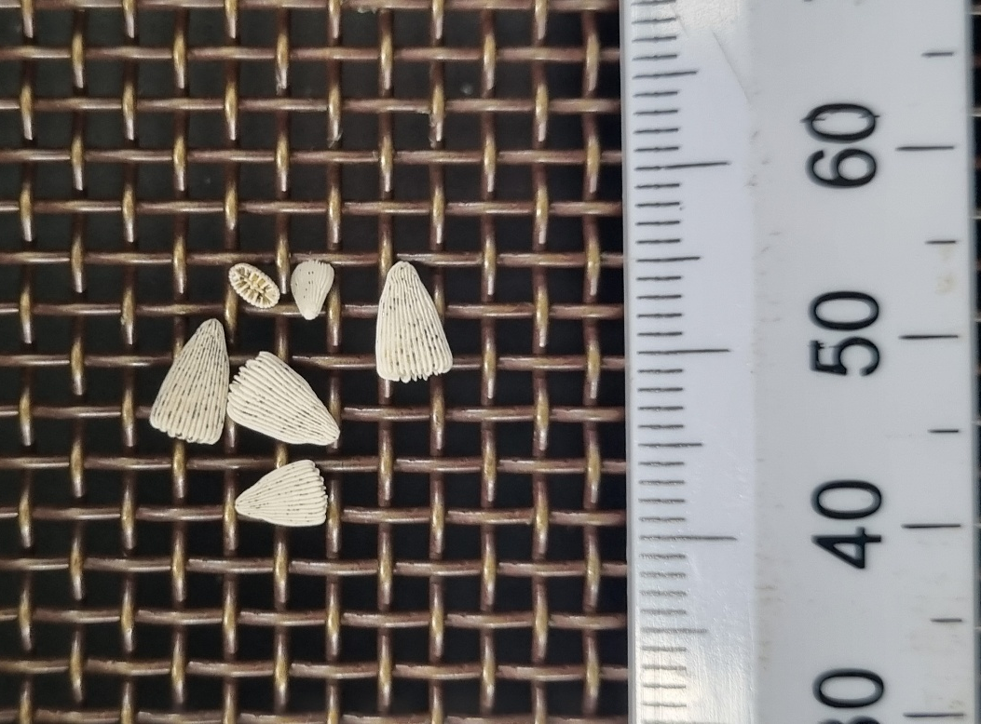

Figure 5: Scleractinia cup corals retained on a 2 mm screen as per the William Frasers'. Source: Simon West, Bioresearches, personal communication.
The screened sand passes through the screen deck and into two pipes that run along the sides of the hopper. As the sand slurry drops into the hopper, the water velocity slows, and the sand settles out. The water and any finer suspended micro-sediments (<2.0mm, including any remaining scleractinian corals) will pass out of the hopper and into one of the six moon pools (three on each side of the hopper) which discharges any oversized or suspended sediments under the vessel’s keel. It is expected all scleractinian corals will be retained on the sieve and returned to the seafloor via the moonpool.

4.2 Spatial management of sand extraction
The sand extraction rotation methodology, as outlined in Attachment 27 - Sand Extraction Operation Plan (SEOP), will result in the same extraction tracks not being reused for up to 1 year. This would maximise the time available for damaged/fragmented corals to regenerate between disturbance events, giving them the ability to move through sediments to escape burial (Beaumont et al, 2025).

5.0 Monitoring

5.1 Benthic biota monitoring methodology
Due to the small size and difficulty in locating and collecting scleractinian corals within the sand extraction area, salvaging and relocating these corals is not considered feasible. Therefore, alternative management measures are required to monitor and understand their presence and condition.

A benthic monitoring program will be implemented to assess the presence of benthic biota including scleractinian corals within and around the sand extraction area. Monitoring will be conducted annually for the first seven years following the commencement of extraction activities, and then at a reduced frequency of no greater than 3 years for the duration of the consent, to provide data on ecological changes and coral presence.

The sand extraction area and three control areas as shown in Figure 6 have been divided into monitoring cells 1000m long and 200m wide.
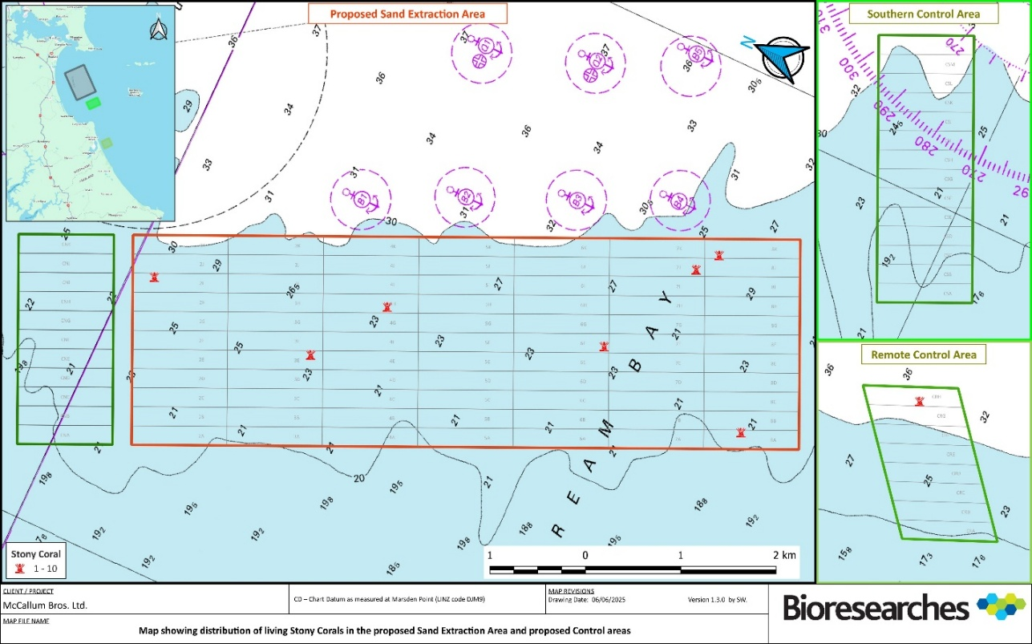
Figure 6: Map Showing the cells within the proposed Sand Extraction Area and proposed Control Areas. The red symbols indicate the location of live cup corals observed during previous monitoring. Source: Simon West, Bioresearches, personal communication.

5.1.1 Drop Camera
A drop camera will be used to quantify benthic species and communities within the proposed sand extraction and control areas within Te Ākau Bream Bay. At each sampling period, at least three camera drops will be made within each of 77 extraction cells and five drops per cell in the 33 cells within the control area (a total of at least 396 deployments). The frame of the drop camera rests on the seafloor during the camera survey. The camera frame is 1 m² with a large void in the centre to image the sediments (Figure 7). An area of approximately 0.05 m² makes contact with the seabed at each deployment, or approximately 19.8 m² in total for each sampling period.

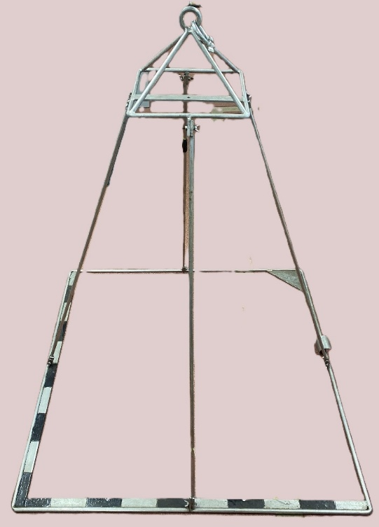
Figure 7: MBL’s drop camera frame. Source: Shayne Elstob, MBL, personal communication.

5.1.2 Grab Sampling
At three stratified random locations within each cell of the sand extraction area, and at five locations in each control area cell, benthic grab samples will be collected using a modified standard ponar grab sampler (sample area 0.071 m², bite depth ~100 mm). At each sampling period, at least three grab samples will be collected from each of 77 extraction cells within the sand extraction area together with at least five grab samples from each of 33 cells within the control areas.

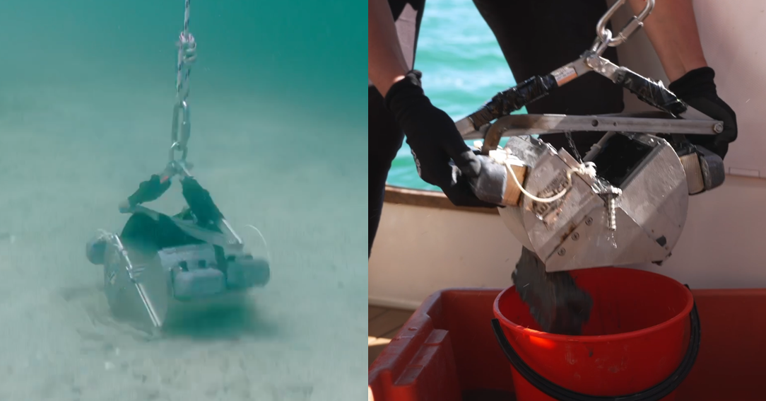
Figure 8: Modified standard ponar grab. Left: collecting a sediment sample on the seabed. Right: Sediment sample being emptied into a bucket. Source: Simon West, Bioresearches, personal communication.
Upon arriving at the surface, collected sediment samples are deposited into a clean fish bin. The sample is then homogenised by mixing and two 100 ml subsamples taken for analysis of sediment properties. Samples with volumes less than 2L will be discarded and recollected to ensure sufficient sample size.
Each of the 396 samples will be puddle sieved, washing each whole sample through 3 mm and 1 mm mesh sieves in buckets of seawater, immediately after collection to separate biota from sediment.

Biota retained on the 3 mm sieve (Figure 9) will be visually inspected by a SEQP for the presence of cup corals or notable macrofauna. If detected, they will be photographed, enumerated, and returned to the seafloor. Exposure of fauna (e.g., live corals) to air will be minimised where possible.

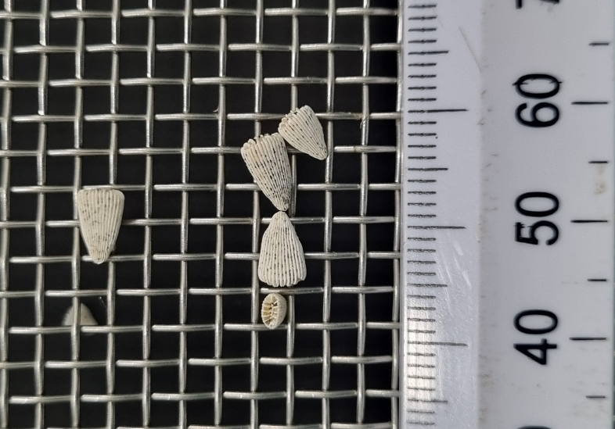
Figure 9: Scleractinia cup corals retained on a 3 mm sieve as part of Bioresearches monitoring methodology. Source: Simon West, Bioresearches, personal communication.
The remaining material retained on the 3 and 1 mm sieves will then be transferred to a polyethylene ‘zip lock’-type bag with a pre-printed waterproof label (identifying site, sample date and testing required), and preserved in a solution of 5% glyoxal, 70% ethanol sea water solution, sealed and placed in a second polyethylene ‘zip lock’-type bag and packed into a labelled plastic container, for transportation to the laboratory.

Prior to sorting, the samples will be rinsed on a 1 mm sieve with freshwater and placed in a white sorting tray. All organisms will be picked out of the samples and placed in labelled vials of 70% ethanol solution prior to taxonomic identification (to the lowest taxonomic group possible) and counting.

Only animals with intact heads and/or coral will be identified and counted, by an SQEP benthic taxonomist. Both living and dead corals will be identified and counted, with the living and dead specimens counted separately.

All samples will be store in a secure restricted access room. Abundance, location, identification, life status of all scleractinian corals will be reported to DOC as required by the Wildlife Act (1953) and specimens sent to Earth Sciences NZ who are authorised to hold them.

5.1.3 Epibenthic dredge
At each sampling period, macrofauna will be sampled using a single dredge tow spread across every two cells (adjoining along the seaward side) of the proposed extraction area and three control areas, resulting in 55 tows in the sand extraction area and 16 in the control areas combined. The dredge (Figure 10) is 600 mm wide and will be towed at low speed (~<1kt) for approximately 200 m (approximately 120 m² per tow, or 6,600 m² in the sand extraction area and 1,920 m² in the control areas).

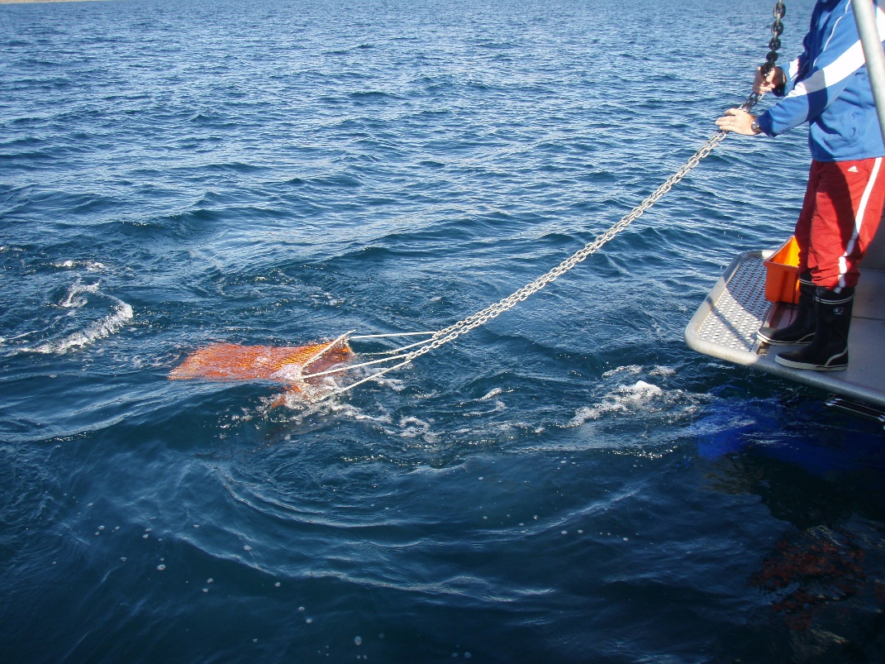
Figure 10: Epibenthic dredge being deployed. Source: Simon West, Bioresearches, personal communication.
The dredge is fitted with a 35 mm mesh bag which should allow any cup corals that enter the dredge to return to the seabed unless attached to substrates such as shells. Culicia rubeola may also be retained if specimens are sufficiently large. All material retained on the dredge is sorted onboard, identified and returned to the seabed. Exposure to air is minimised where possible.

6.0 Communications

6.1 MBL’s Roles and responsibilities
Role | Responsibilities
Managing Director | Oversees the overall operations and strategy of the company.
Chief Operating Officer | Oversees and manages the day-to-day operations of the company, implementing the managing director’s vision and strategies to ensure efficient and effective business processes.
Operations Manager | Responsible for the coordination and management of vessel operations, including managing crew and planning transit routes.
Compliance Manager | Manager for vessel and crew health and safety, including destination port and maritime compliance obligations.
Environmental Manager | Environmental compliance and management, including consent and environmental monitoring and reporting.
Compliance Officer | Responsible for recording and reporting obligations related to vessel analytics, extraction amounts, and extraction tracks.
Master William Fraser | Responsible for the navigation and operation of the William Fraser at berth, transit, and while extracting.
Table 1: Roles, responsibilities, and contact details relevant to the Extraction Management Plan. Source: McCallum Bros Limited

6.2 Key Contacts
The key contacts for matters set out in this CCMP are set out in Table 2.
Party | Person | Phone | Email
MBL’s Environmental Manager | Luke Davis | +64 27 260 8850 | luke@mccallumgroup.co.nz
Earth Sciences NZ | Jennifer Beaumont | +64 4 386 0392 | jennifer.beaumont@earthsciences.nz
Bioresearches | Simon West | +64 21 285 4331 | simon.west@bioresearches.co.nz
DOC approved cup coral expert | TBC |  | corals@doc.govt.nz
Northland Regional Council | TBC
Table 2: Key contacts.

7.0 Management plan review
A review of this CMP will be undertaken annually by a SQEP(s). This review will assess if any changes in the sand extraction or monitoring methodology can be practically implemented to reduce the risk of disturbance and incidental killing of scleractinian corals.

References
Beaumont, J., Anderson, O., Mills, S. (2025). Scleractinian cup corals at Te Ākau Bream Bay Literature review and distribution of cup corals identified within the proposed sand extraction area. National Institute of Water & Atmospheric Research Ltd.

Beaumont, J., Anderson, O. (2026). The scleractinian coral Culicia rubeola at Te Ākau Bream Bay
Literature review and distribution of Culicia rubeola identified within the proposed sand extraction area. New Zealand Institute for Earth Science Limited.

Bioresearches. (2024). Te Ākau Bream Bay Sand Area, 2024 Initial Sand Extraction Assessment, February - March 2024. Report for McCallum Bros Limited. pp 200

Bongaerts, P., Hoeksema, B.W., Hay, K.B., Hoegh-Guldberg, O. (2012) Mushroom corals overcome live burial through pulsed inflation. Coral Reefs, 31: 339. doi 10.1007/s00338-011-0862-z

Brook, F.J. (1982) The scleractian coral fauna of Rakitu Island, north-eastern New Zealand. Tane, 28: 163–173.

Cairns, S.D. (1995) The marine fauna of New Zealand: Scleractinia (Cnidaria: Anthozoa). New Zealand Oceanographic Memoir, 103: 139. https://docs.niwa.co.nz/library/public/Memoir%20103_Scletactinia_of_New_Zealand%20-%201995.pdf

Cairns, S.D. (1997). A Generic Revision and Phylogenetic Analysis of the Turbinoliidae (Cnidaria: Scleractinia). Smithsonian Contributions to Zoology, 591: 1-55.

Quoy, J.R.C., Gaimard, J.P. (1833) Voyage de la corvette l'Astrolabe: exécuté par ordre du roi, pendant les années 1826-1827-1828-1829, sous le commandement de M. J. Dumont d'Urville. Zoologie, 2(2): 321–686.

Riegl, B. (1995) Effects of sand deposition on scleractinian and aclyonacean corals. Marine Biology, 121: 517–526.

Sentoku, A., Tokuda, Y., Ezaki, Y., Webb, G.E. (2017). Modes of regeneration and adaptaion to soft-botom subsrates of the free-living solitary scleractinian Deltocyathoides orientalis. Lethaia, 51: 102-111. 10.1111/let.12228

Sheridan, C., Grosjean, P., Leblud, J., Palmer, C.V., Kushmaro, A., Eeckhaut, I. (2014) Sedimentation rapidly induces an immune response and depletes energy stores in a hard coral. Coral Reefs, 33: 1067–1076.

Squires, D.F. (1964). Flabellum rubrum (Quoy and Gaimard). New Zealand Oceanographic Institude Memoir No. 20: 40.

Viswambharan, D., Sreenath, K.D. (2024) Morphological traits and spatial distribution of azooxanthellate corals of Rhizangiidae in the Laccadive Sea. Journal of the Marine Biological Association of the United Kingdom, 104(124): 1–7. https://doi.org/10.1017/S0025315424001103

Appendix A: Wildlife Act Authorisation

To be appended once granted by Department of Conservation.

