**Draft Conditions - Panel Version** – Dated 4 August 2025 (Clean)

|  |  |  |
| --- | --- | --- |
| **C** | Land Use (s9) | Demolish Shearing Shed and Chimney |

**Resource Consent: ………**

**Grants to**: CCKV Maitai Dev Co Limited Partnership

**Commencement date: ………**

**Lapse Date:** 2 years after consent commencement date

**Expiry date:** No expiry

**Location:** 7 Ralphine Way, Maitai Valley, Nelson

**The activity:**

Land use consent (Section 9 RMA) to demolish the existing shearing shed and chimney

Note: To be read in conjunction with (………)

*Subject to the following conditions:*

**General condition**

1. The activity of demolishing the shearing shed and chimneyshall be carried out in accordance with the application for resource consent, including any further information provided by the Consent Holder, and in accordance with the following conditions of consent. Where there is any apparent conflict between the application and consent conditions, the consent conditions shall prevail.

**Specific Conditions of Consent**

2. Prior to the “shearing shed” and “chimney” being demolished, the Consent Holder shall record the existing shearing shed and chimney by digital 3D scanning inside and outside and a 3D model produced.

3. At least 5 working days prior to any demolition works proceed on the “shearing shed” and “chimney”, the Consent Holder shall provide a copy of the 3D record to the Nelson City Council’s Monitoring Officer.

4. Prior to the “shearing shed” being demolished, the Consent Holder shall salvage the:

a) shearers’ graffiti on the rusticated weatherboard clad walls and sliding doors to Woolshed Part A1 and Part B (refer Miller 2022) for adaptive reuse and presentation; and

b) shearing equipment and the ground floor windows to Part A1 (refer Miller 2022), including any timber and building materials that are recoverable and reusable.

The shearers’ graffiti within Parts A1 and B of the shearing shed are shown in Photos 26 and 27 attached, being photos contained in the Miller 2022 investigation.

The shearing equipment and ground floor windows in Part A1 are shown in Photos 22-24 attached, being photos contained in the Miller 2022 investigation.

Note: Miller 2022 relates to the ‘*Investigations into selected heritage structures – timber woolshed/barn, concrete chimney, and concrete/stone wall remnants*’ (Updated 6 April 2022, prepared by Robin Miller from Origin Consultants Limited)

5. Photographs of the salvaged items, along with information as to their storage and planned adaptive reuse, and/or presentation within the application site shall be provided to the Council’s Monitoring Officer within 15 working days of the demolition works being completed.

**Advice Notes**:

1. Where a condition requires notification to, or review/approval by, Nelson City Council, all relevant documents, plans, and communications shall be submitted to the Council’s Monitoring Officer in the first instance.

The Monitoring Officer will coordinate any review/approval with the appropriate Nelson City Council staff, as follows (examples only):

• Team Leader Environmental Compliance – for documents such as Dust and Erosion and Sediment Control Plans (DESCPs), earthworks methodologies, and potentially noise and vibration plans.

• Team Leader Transport Operations – for transport and roading-related documentation, such as Construction Traffic Management Plans (CTMPs).

• Team Leader Integrated Catchments – for ecological restoration plans, lizard management plans, and related matters.

• Team Leader Water & Air – for wetland and stream restoration plans.

Where no Council review/approval is required by a condition but an action or document is to be provided (e.g. notice of commencement of works, geotechnical or SQEP engagement letters), these should also be sent directly to the Monitoring Officer.

1. “Shearing shed” and “chimney” in this condition set relates to the specific structures identified within the Origin Consultants Limited Memo updated 6 April 2022 and entitled “Investigations into selected heritage structures – timber woolshed/barn, concrete chimney, and concrete/stone wall remnants” and presented within PPC28. Furthermore, in relation to the shearing shed, it is only part A1 of the building that is captured by this rule.
2. The Consent Holder is also advised that the works covered by this consent are also the subject of Archaeological Authority 2024/332.
3. The Consent Holder has confirmed it will apply for an Archaeological Authority under the NZHPT Act 2014 for the wider site. This shall be applied for prior to earthworks commencing on-site.
4. The Consent Holder is also advised that part of the site is also a HAIL site, and so appropriate care and consideration must be given to the National Environment Standard for Assessing and Managing Contaminants on Soil to Protect Human Health (NES-CS), along with the consent conditions in set ‘M’ Remediation of Contaminated Land.

**Photo 26** (Source: Miller 2022)

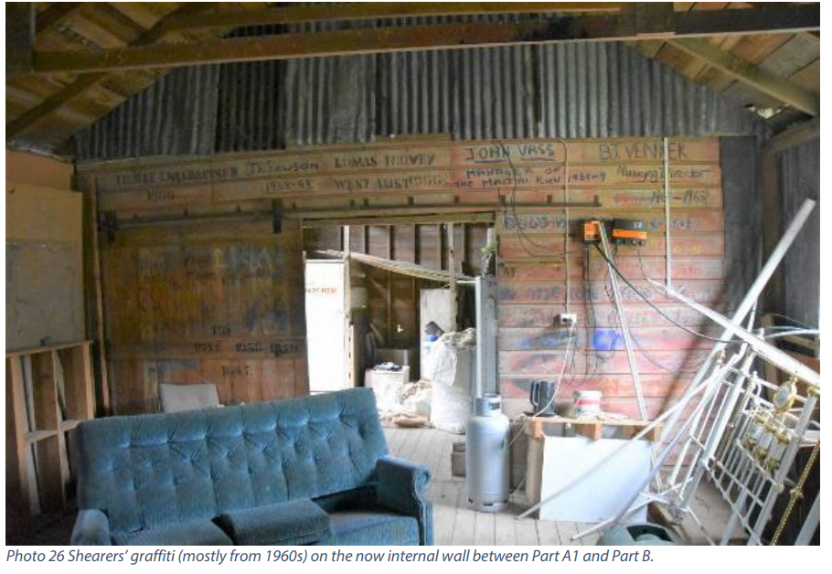

**Photo 27** (Source: Miller 2022)

**Photo 28** (Source: Miller 2022)

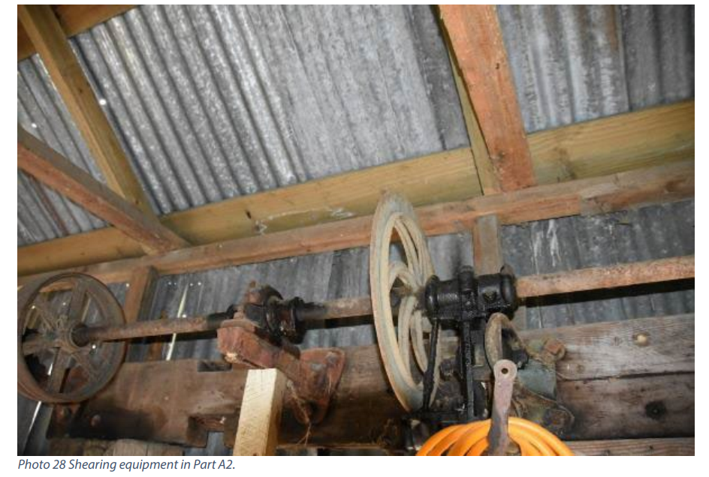

**Photo 22** (Source: Miller 2022)

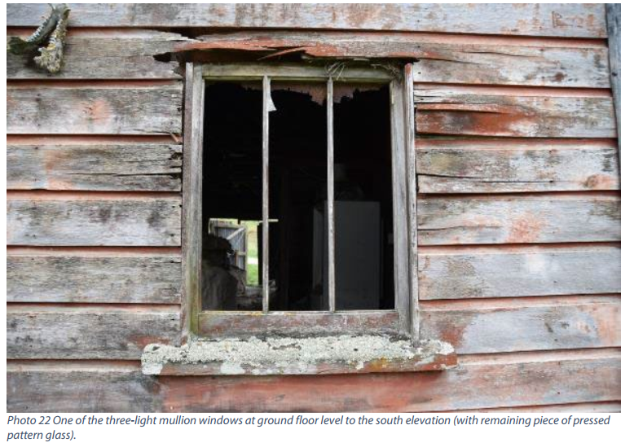

**Photo 23** (Source: Miller 2022)

**Photo 24** (Source: Miller 2022)

