Draft Conditions - Panel Version – Dated 4 August 2025 (Clean)
L | Discharge Permit (s15) | Discharge of construction phase stormwater

Resource Consent: ……..
Grants to: CCKV Maitai Dev Co Limited Partnership
Commencement date: ……..
Lapse Date: 10 years after commencement date
Expiry date: 11 years after commencement date
Location: 7 Ralphine Way, Maitai Valley, Nelson
The activity:
Discharge Permit (Section 15 RMA) for the discharge of construction phase stormwater (including dewatering, sediment, and flocculant) to land and surface water. This includes consent under the NES-FW for any construction phase discharge within 100m of a natural inland wetland.
Note: To be read in conjunction with (…….)

Subject to the following conditions:
General conditions
- The activity, being the discharge of construction phase stormwater (including dewatering, sediment, and flocculant) to land and surface water shall be carried out in accordance with the application for resource consent, including any further information provided by the Consent Holder, and in accordance with the following conditions of consent. Where there is any apparent conflict between the application and consent conditions, the consent conditions shall prevail.

Specific Conditions of Consent
- The Consent Holder shall advise the Nelson City Council (Council) Monitoring Officer in writing, at least 15 working days prior to works commencing on site, so that monitoring of the conditions of this consent can be undertaken. Please email regulatory@ncc.govt.nz and advise the consent number, RM…….
- At least 5 working days before the commencement of earthworks on site, the Consent Holder shall hold a pre-construction meeting with the Council’s Monitoring Officer, the relevant supervising experts, lead contractor(s), and iwi. At this pre-construction meeting, the Consent Holder shall provide an explanation as to the works programme, monitoring and reporting requirements.

Erosion and Sediment Control Report
- All construction phase discharge of stormwater shall be carried out in general accordance with the Southern Skies Environmental Erosion and Sediment Control Assessment Report dated 31 January 2025 including the table below:
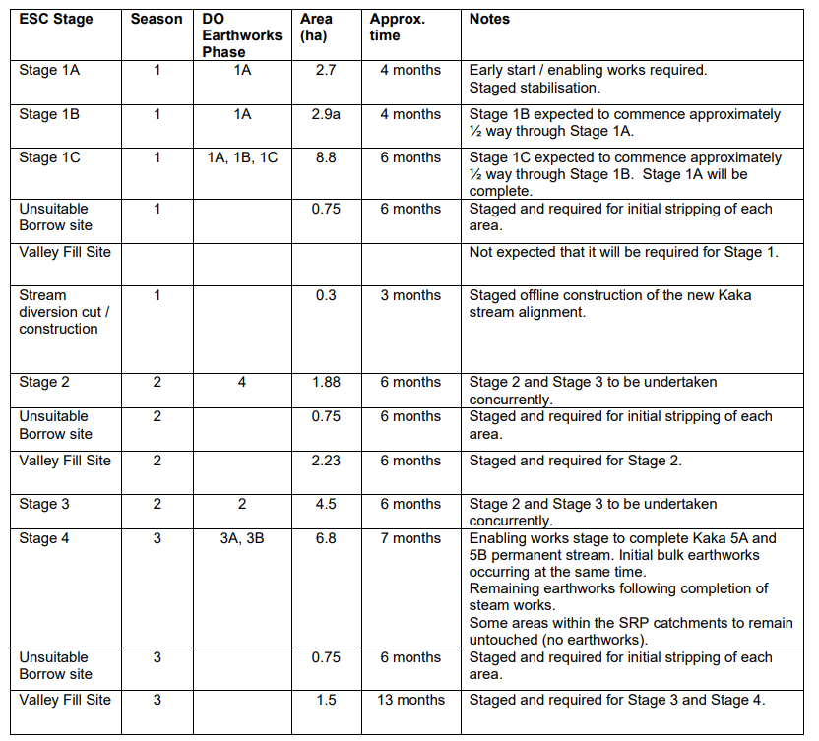
- The Consent Holder shall ensure that any clean water diversion drains subject to condition 6 shall be constructed in accordance with the Nelson Tasman Land Development Manual (NTLDM) and discharged to Kākā Stream (or any other watercourse within the site).
- All clean water diversion drains or bunds shall be constructed after the installation of the sediment retention ponds and before any other earthworks occur.
- Any outfall structure shall be constructed to ensure no localised erosion of the water course occurs. The direction of the discharge shall be aligned with the natural downstream flow as much as practicable so as to prevent erosion and scouring of the opposite stream bank. Any outfall structure shall be protected against erosion and scouring in accordance with the requirements of the NTLDM.
- No obstructions shall be placed in the cut off or diversion drains that will impede the natural flow.
- The Consent Holder shall provide a plan of any discharge points clearly identifying the location (including coordinates) of the outfall structure to the Monitoring Officer prior to the commencement of the discharge.

Water Quality
- Notwithstanding any other condition of this consent, the Consent Holder shall not cause any of the following effects in Kākā Stream (or any other watercourse) in the opinion of the Monitoring Officer:
  - The production of any conspicuous oil or grease films, scums or foams, or floatable or suspended materials;
  - The discharge of potentially contaminated soil from the HAIL site;
  - The discharge of sediment to a level where it may adversely impact on the ecological function and aquatic habits in the Maitai River;
  - After reasonable mixing, any conspicuous change in colour or visual clarity that is not typical of ambient background levels at the time; or
  - Any emission of objectionable odour.

Erosion and Sediment Control Monitoring Plan
- All construction phase stormwater discharges (including dewatering, sediment and flocculant) shall be supervised and monitored by SQEPs in accordance with the Erosion and Sediment Control Monitoring Plan (ESCMP) provided in Appendix B of the Southern Skies Environmental Erosion and Sediment Control Assessment Report including the specific requirements set out in Conditions 12-14.

- Water quality shall be monitored for clarity and pH during rainfall events of greater than 25mm within a 24 hour period. If one or more of the targets listed in Section 4.2 of the ESCMP are breached, then the management actions identified within Section 5.3 of the ESCMP shall be implemented.

- Following a rainfall trigger event (>25mm in a 24hr period), a summary report of the performance of sediment retention ponds, decanting earth bunds, and overall erosion and sediment control system observed during the rainfall event report will be provided to NCC. The report will include:
- A summary of the rainfall (total and intensity)
- A summary of the manual monitoring undertaken and comparison of manual monitoring results to previously recorded results
- A summary of the site performance against the performance targets.
- A record of any other matters which may have compromised the overall ESC performance during the rain event and the identified mitigation, maintenance, and management response.
- A summary of the water sample analysis.
- The Rainfall Trigger Event Report will be provided to NCC within 10 working days of the rainfall trigger event.

Chemical Treatment Management Plan (CTMP)
- All chemical treatment and dosing of earthworked areas on site shall be designed, maintained, supervised and monitored by suitably qualified and experienced professionals in accordance with the Chemical Treatment Management Plan provided in Appendix A – Chemical Treatment Management Plan in the Southern Skies Environmental Erosion and Sediment Control Assessment Report.

Monitoring of Erosion and Sediment Control Measures
- In the event of failure of any erosion and sediment control measures and/or an event resulting in erosion and sedimentation, the Consent Holder shall notify Council’s Monitoring Officer of the incident no later than 24 hours following the incident. The notification shall include, but not be limited to the following:
i. Time and date of the incident
ii. Details of the nature of the incident, including the cause, scale of the incident and any effects that the incident has imposed on the receiving environment.
iii. Any measures taken to prevent further effects.

Dewatering from contaminated land
- Prior to any discharge to either surface water or land, any dewatering of groundwater or stormwater (following excavation) required from the area of contamination in the location of the sheep dip shall be treated in accordance with Envirolink’s 2025 Remediation Action Plan (RAP) v4, or any subsequent certified version, as well as any other requirements of Consent …….. (Remediation).

Māori Cultural Values
- The Consent Holder shall work in partnership with Ngāti Koata Trust and other relevant iwi Pou Taiao to define appropriate indicators, monitoring locations, and reporting formats to integrate mātauranga Māori indicators of cultural health into the stream monitoring methods.
The purpose of the induction is to ensure that all personnel are aware of and understand the tikanga (customs), kawa (protocols), and culturally significant matters relevant to the area and the scope of the works.
A record of induction attendance shall be maintained by the Consent Holder and made available to the Council’s Monitoring Officer and Te Tauihu Iwi representatives upon request.
- The Consent Holder shall engage a suitably qualified cultural practitioner to carry out Cultural Health Index monitoring at 6 months, 12 months and 24 months from the first application of flocculant. Should any cultural effects arise from this monitoring that can be directly attributed to the discharge of flocculants, the applicant shall resolve and remediate the issues with the appropriate iwi authority.
- All iwi engagement, monitoring, and remediation works shall be carried out at the Consent Holder’s expense.

Monitoring & Review
- For the purposes of, and pursuant to Section 128 of the Resource Management Act 1991, the Council reserves the right to review the conditions of this and related consents annually commencing 12 months from the date this consent is granted, for any of the following purposes:
(a) To modify existing conditions of consent relating to the effects of the activity on the environment.
(b) To require the Consent Holder to adopt the best practicable option to reduce, remediate or remove any adverse effect upon the environment, arising from the generated effects of the activity.
(c) If the Council deems that it is necessary to do so in order to deal with any adverse effect on the environment which may arise from the exercise of this consent, and which is appropriate to deal with at a later date.

Advice notes:
- Where a condition requires notification to, or review/approval by, Nelson City Council, all relevant documents, plans, and communications shall be submitted to the Council’s Monitoring Officer in the first instance.

The Monitoring Officer will coordinate any review/approval with the appropriate Nelson City Council staff, as follows (examples only):

• Team Leader Environmental Compliance – for documents such as Dust and Erosion and Sediment Control Plans (DESCPs), earthworks methodologies, and potentially noise and vibration plans.
• Team Leader Transport Operations – for transport and roading-related documentation, such as Construction Traffic Management Plans (CTMPs).
• Team Leader Integrated Catchments – for ecological restoration plans, lizard management plans, and related matters.
• Team Leader Water & Air – for wetland and stream restoration plans.

Where no Council review/approval is required by a condition but an action or document is to be provided (e.g. notice of commencement of works, geotechnical or SQEP engagement letters), these should also be sent directly to the Monitoring Officer.
- Rainfall will be recorded on site at the existing weather station located near the southern extent of the Kākā Stream.
- Council Officers, at their discretion and at the Consent Holders expense, may seek (where not available inhouse) independent advice from suitably qualified professionals to support and provide advice as part of any review and/or approval.

