BENDIGO-OPHIR GOLD PROJECT
PROPOSED CONSENTS AND CONDITIONS FOR RESOURCE CONSENTS WITHIN THE JURISDICTION OF THE OTAGO REGIONAL COUNCIL
28 SEPTEMBER 2026

The base version of the following conditions is the clean version of the conditions dated 14 September 2026 that was provided to the EPA and Expert Panel in response to invited parties’ submissions on Matakanui Gold Limited’s responses to RFI 11 (including comments on conditions).
Additional targeted changes have been made to these conditions to reflect the recommendations in Matakanui Gold Limited’s responses to RFI 12 and in response to invited parties’ closing legal submissions. These changes are presented in track changes.
Comments are included for some conditions to briefly identify the reasons why amendments to conditions or new conditions are proposed.
Cross references to other conditions have been updated and are highlighted in yellow wash for ease of finding and checking the accuracy of those cross references when the conditions are finalised. In some instances, a short description of the condition being cross referenced is also provided in square brackets.

Notes:
All of the following consents are subject to compliance with:
- The Common Conditions between the Central Otago District Council and the Otago Regional Council in Schedule One; and
- The General Conditions in Schedule Two which apply to all Otago Regional Council consents.
Particular controls, limits, management of effects and monitoring required associated with the activities that are the subject of the consents below are controlled by way of the conditions in Schedules One and Two noted above. On that basis, and to avoid unnecessary repetition, most of the following consents have relatively few individual conditions.

tABLE OF Contents
Section 9 Permits 3
Section 13 Permits 6
Section 14 Permits 10
Section 15 Permits 15

Attachments
Section 13 Permits
Attachment 1: Location of Culverts in the Rise and Shine Creek
Section 15 Permits
Attachment 1: Flow Augmentation Sites

Section 9 Permits
CONSENT TYPE AND ACTIVITY AUTHORISED | RMA S9 | A Land Use Consent to undertake earthworks, soil disturbance and vegetation clearance activities within:  - The Project Site shown on Plan 2 - BOGP Consent Area annexed as part of Attachment 2 – Plans to the Common Conditions (Schedule One) for the purpose of mining development, mining operations, maintenance and ancillary activities; and  - Within the BOGP Consent Area beyond the Direct Disturbance Footprint / Project Site shown on Plan 2 – BOGP Consent Area annexed as part of Attachment 2 – Plans to the Common Conditions (Schedule One) up to a maximum of 3 hectares for the purposes of exploration drilling,  including locations within, or within a 10 m or 100 m setback from, natural inland wetlands within the catchments of Shepherds Creek, Rise and Shine Creek and an unnamed tributary of Clearwater Creek that result in, or will likely result in, the complete or partial drainage of all or part of a wetland.
CONSENT NUMBER | RMFT25.007.01
TERM | 35 years
LAPSE PERIOD | 5 years

No. | Condition
Schedule One – Common Conditions Which Apply to All Otago Regional Council and Central Otago District Council Consents
1 | The Consent Holder must comply with the Common Conditions in Schedule One (which apply to all of the consents for the BOGP within the jurisdiction of the Central Otago District Council and the Otago Regional Council) to the extent relevant to the management of activities authorised by this consent.
Schedule Two – General Conditions Which Apply to All Otago Regional Council Consents
2 | The Consent Holder must comply with the General Conditions in Schedule Two (which apply to all of the consents for the BOGP within the jurisdiction of the Otago Regional Council) to the extent relevant to the activities authorised by this consent.

CONSENT TYPE AND ACTIVITY AUTHORISED | RMA S9 | A Land Use Consent to drill bores and holes associated with mineral exploration, geotechnical investigations, establishment of underground mine declines and drives to access and mine an ore body, blasting and dewatering activities and for the establishment of groundwater production and monitoring bores / piezometers within the area shown on Plan 2 – BOGP Consent Area annexed as part of Attachment 2 – Plans to the Common Conditions (Schedule One).
CONSENT NUMBER | RMFT25.007.02
TERM | 35 years
LAPSE PERIOD | 10 years

No. | Condition
Schedule One – Common Conditions Which Apply to All Otago Regional Council and Central Otago District Council Consents
1 | The Consent Holder must comply with the Common Conditions in Schedule One (which apply to all of the consents for the BOGP within the jurisdiction of the Central Otago District Council and the Otago Regional Council) to the extent relevant to the management of activities authorised by this consent.
Schedule Two – General Conditions Which Apply to All Otago Regional Council Consents
2 | The Consent Holder must comply with the General Conditions in Schedule Two (which apply to all of the consents for the BOGP within the jurisdiction of the Otago Regional Council) to the extent relevant to the activities authorised by this consent.
General Requirements – Bendigo Aquifer Borefield
Advice Note: The following conditions apply to bores associated with the taking of groundwater from the Bendigo Aquifer. They do not apply to holes drilled for blasting, geotechnical dewatering and mineral exploration purposes.
3 | The Otago Regional Council must be notified in writing at least 10 working days in advance of the installation of each bore, piezometer and groundwater monitoring bore.
4 | The bore must be constructed and maintained so that it will not cause cross contamination between hydraulic units (aquifers) in any water (including groundwater).
5 | All openings to the bore must be sealed or screened to prevent the entry of foreign matter or contaminants. The ground immediately surrounding the top of the bore casing must be sealed and graded to drain surface water away from the bore.
6 | Upon completion of the bore, any wastes introduced to the bore during drilling and construction must be removed.
7 | If artesian conditions are encountered, a conductor casing must be grout sealed to ensure control of potential flowing artesian groundwater and to prevent instability of the ground at the bore head. Bore head completion must be such that groundwater leakage under flowing artesian pressures is prevented.
8 | Discharge of wastewater from bore installation into or onto the ground is permitted provided that only non-hazardous and non-toxic drilling fluids and/or foams are used as approved by Otago Regional Council. Drilling must be undertaken in such a manner that there is no discharge of grease or oil, and wastewater does not directly enter surface water.
9 | Bores that are no longer operational must be decommissioned to prevent contamination, by grouting and capping.
10 | The Consent Holder must submit to the Otago Regional Council, as part of the Annual Monitoring and Compliance Report required under Condition C14 in Schedule One, a report which contains:  - A log for each bore drilled during that calendar year. Each log must show:  - The location of the bore; in NZTM2000 coordinates;  - Date of completion;  - Duration of drilling;  - Depth and diameter of the bore;  - The method of drilling;  - Full construction details;  - The subsurface geology;  - Development information; and  - Installed instrumentation (pumps, loggers, flow meters etc.).  - A list of any decommissioned bores, including their logs.

Section 13 Permits
CONSENT TYPE AND ACTIVITY AUTHORISED | RMA S13 | A Land Use Consent to place, use, maintain, upgrade and remove structures in the beds of watercourses and in natural inland wetlands within the catchments of Shepherds Creek, Rise and Shine Creek and an unnamed tributary of Clearwater Creek associated with mine development, operation, maintenance and closure activities within the Project Site and adjacent land shown on Plan 2 - BOGP Consent Area annexed as part of Attachment 2 – Plans to the Common Conditions (Schedule One).
CONSENT NUMBER | RMFT25.007.03
TERM | 35 years
LAPSE PERIOD | 10 years

No. | Condition
Schedule One – Common Conditions Which Apply to All Otago Regional Council and Central Otago District Council Consents
1 | The Consent Holder must comply with the Common Conditions in Schedule One (which apply to all of the consents for the BOGP within the jurisdiction of the Central Otago District Council and the Otago Regional Council) to the extent relevant to the management of activities authorised by this consent.
Schedule Two – General Conditions Which Apply to All Otago Regional Council Consents
2 | The Consent Holder must comply with the General Conditions in Schedule Two (which apply to all of the consents for the BOGP within the jurisdiction of the Otago Regional Council) to the extent relevant to the activities authorised by this consent.
Design and Performance Requirements – All Instream Structures
3 | No less than 15 days prior to the commencement of works for the installation of any instream structure, the Consent Holder must advise Otago Regional Council of the intended works commencement date.
4 | The culverts in the Rise and Shine Creek must be located in general accordance with the Plan in Attachment 1 to this consent and be constructed and operated to convey the runoff resulting from at least a 5% Annual Exceedance Probability (“AEP”), 24-hour duration, design storm for all durations.
5 | The Consent Holder must ensure that the area of disturbance during placement / construction of all instream structures is kept to a practical minimum and is undertaken in accordance with a Site-Specific Erosion and Sediment Control Plan (“SSESCP”) as required by Condition 2 of the Schedule 2 General Conditions which apply to all of the resource consents within the jurisdiction of the Otago Regional Council.
6 | - The Consent Holder must undertake routine monitoring and maintenance of the culverts (once placed), as detailed below:  - The Consent Holder must visually inspect each culvert within five days of any event that may cause damage that could affect the culvert’s stability, the ability of the culvert to provide for fish passage, ability to convey the design flows, or cause erosion or scour; and  - If any of the visual inspections in clause (a) identify that the culvert is damaged, engage a Suitably Qualified and Experienced Person to assess the damage and provide recommendations to remedy the damage. The Consent Holder must then undertake the recommended repair and / or maintenance works as soon as practicable to remedy the issues identified.  - Following any maintenance works undertaken in accordance with clause (b) of this condition, provide to the Consent Holder an updated version of the information relating to the structure as set out in Condition 5 of this consent.  Advice Note: For the avoidance of doubt, the various technical assessments prepared as part of the Substantive Application demonstrated that the water bodies within the Project Site do not contain any fish species.
7 | Consent Holder must provide the Otago Regional Council with the information required under Regulations 62(3) and 63(3) of the Resource Management (National Environmental Standards for Freshwater) Regulations 2020 (“NES Freshwater”) no more than 20 working days following completion of the installation of the culverts within Rise and Shine Creek.

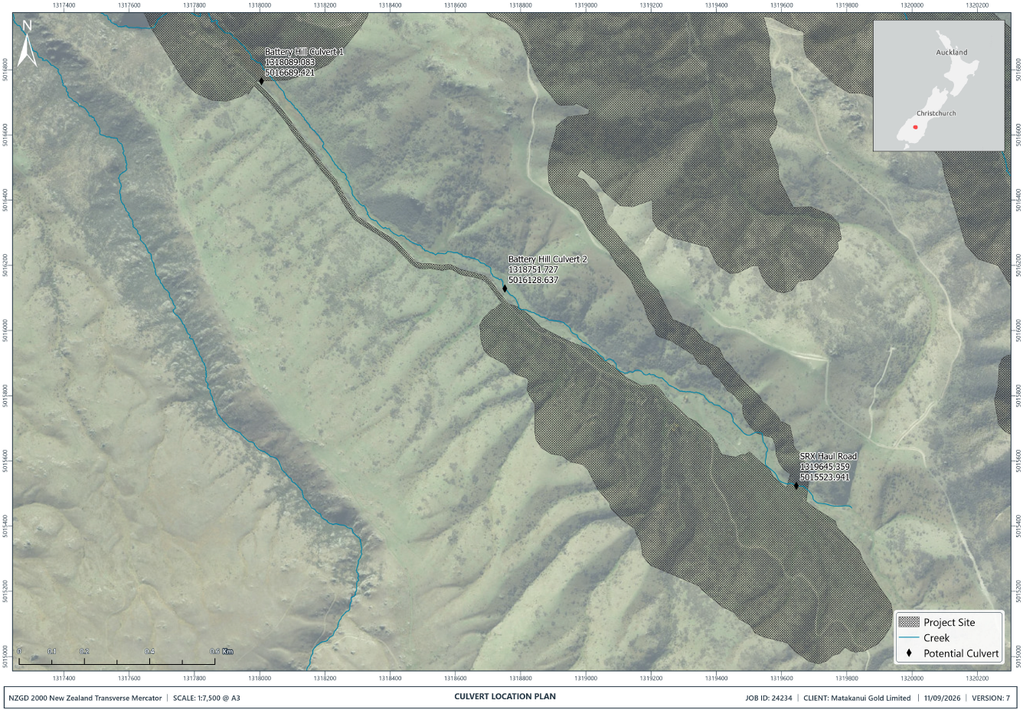

Attachment 1 – Location of Culverts in the Rise and Shine Creek

CONSENT TYPE AND ACTIVITY AUTHORISED | RMA S13 | A Land Use Consent to alter, disturb and reclaim the beds of the Shepherds Creek, Rise and Shine Creek, Jean Creek and an unnamed tributary of Clearwater Creek, including associated tributaries and connected natural inland wetlands within the Project Site shown on Plan 2 - BOGP Consent Area annexed as part of Attachment 2 – Plans to the Common Conditions (Schedule One).
CONSENT NUMBER | RMFT25.007.04
TERM | 35 years
LAPSE PERIOD | 10 years

No. | Condition
Schedule One – Common Conditions Which Apply to All Otago Regional Council and Central Otago District Council Consents
1 | The Consent Holder must comply with the Common Conditions in Schedule One (which apply to all of the consents for the BOGP within the jurisdiction of the Central Otago District Council and the Otago Regional Council) to the extent relevant to the management of activities authorised by this consent.
Schedule Two – General Conditions Which Apply to All Otago Regional Council Consents
2 | The Consent Holder must comply with the General Conditions in Schedule Two (which apply to all of the consents for the BOGP within the jurisdiction of the Otago Regional Council) to the extent relevant to the activities authorised by this consent.

Section 14 Permits
CONSENT TYPE AND ACTIVITY AUTHORISED | RMA S14 | A Water Permit to:  - Take and use groundwater from the Bendigo Aquifer for the purposes of supplying water to support all mining construction, operation, maintenance and ancillary activities (including ecological rehabilitation and enhancement) and for augmenting flows within Shepherds Creek, Rise and Shine Creek and natural inland wetlands; and  - Take groundwater for dewatering purposes associated with open pit and underground mining operations;  within the Project Site shown on Plan 1 - Project Overview Plan and the BOGP Consent Area shown on Plan 2 – BOGP Consent Area annexed as part of Attachment 2 – Plans to the Common Conditions (Schedule One).
CONSENT NUMBER | RMFT25.007.05
TERM | 35 years
LAPSE PERIOD | 10 years

No. | Condition
Schedule One – Common Conditions Which Apply to All Otago Regional Council and Central Otago District Council Consents
1 | The Consent Holder must comply with the Common Conditions in Schedule One (which apply to all of the consents for the BOGP within the jurisdiction of the Central Otago District Council and the Otago Regional Council) to the extent relevant to the management of activities authorised by this consent.
Schedule Two – General Conditions Which Apply to All Otago Regional Council Consents
2 | The Consent Holder must comply with the General Conditions in Schedule Two (which apply to all of the consents for the BOGP within the jurisdiction of the Otago Regional Council) to the extent relevant to the activities authorised by this consent.
Water Take from the Bendigo Aquifer
3 | The maximum instantaneous rate of take from the production bores (CB13/0215 and CB13/0216) must not exceed 97 litres per second.
4 | The Consent Holder must install a system to measure on a continuous basis the volume taken via the bore. The system must have a reliable calibration and must be maintained to an accuracy of +/- 5 percent.
5 | Within one month of installation of the system required by Condition 4, the Consent Holder must provide Otago Regional Council:  - A copy of any relevant manufacturer calibration certificate; and  - Evidence from a suitably qualified person showing that the system required by Condition 4 is verified as accurate to +/- 5 percent.
6 | - The Consent Holder must engage a suitably qualified person to undertake additional verification of the accuracy of the system required by Condition 4:  - At the written request of Otago Regional Council; and  - At a frequency of no less than five yearly from the date of the first verification required by Condition 4; and  - To the satisfaction of Otago Regional Council.  - Evidence documenting each additional verification must be forwarded to Otago Regional Council within one month of the verification being completed.
7 | The Consent Holder must telemeter – via a telemetry system developed after liaison with Otago Regional Council to ensure that the telemetry system is compatible with Otago Regional Council telemetry system standards and data protocols - continuous 15-minute values of take volume (in units of cubic metres). The data must be reported once daily to Otago Regional Council via the telemetry system and there must be 96 values per parameter per daily report. When no groundwater is being taken the data must specify the take volume as zero.
8 | - The Consent Holder must ensure the full operation of the water measuring system and telemetry unit at all times during the exercise of this consent. All malfunctions of the water measuring or telemetry unit during the exercise of this consent must be reported to the Otago Regional Council within 5 working days of observation. Appropriate repairs must be performed within 30 working days of observation of the malfunction or within a timeframe agreed with the Otago Regional Council.  - Once the malfunction has been remedied, a copy of the calibration record, Water Measuring Device Verification Form (Form RS1) with photographic evidence and any non-transferred data must be submitted to the Otago Regional Council within 5 working days of the completion of repairs.  - Photographs must be in colour and be no smaller than 200 x 150 millimetres in size and be in JPEG form.  Advice Note: The water meter, data logger and telemetry unit should be safely accessible by the Otago Regional Council and its contractors at all times. The Water Measuring Device Verification Form and Calibration Form are available on the Otago Regional Council’s website.
9 | - Within 30 working days following the commencement of this consent, the Consent Holder must notify the owners of groundwater bores within 1 km radius of the Bendigo Aquifer bore CB13/0215 (the subject of this consent) of the anticipated commencement date for which groundwater will be first taken, and invite those surrounding bore owners to provide the following information in relation to their existing lawfully established bores / water takes:  - Location and depth of the bore;  - Standing depth to water;  - Consented rate and volume of water take (including any seasonal variations);  - A description of the physical infrastructure associated with the take (e.g. submersible pump, surface pump, any water conveyance infrastructure etc.); and  - A copy of any resource consents (where applicable).  - All surrounding bore owners who provide the information above within 30 working days of the date of the request will be eligible to benefit from the regime set out in Condition 10 below.
10 | If any surrounding bore owner that has provided the information set out in accordance with the requirements set out in Condition 9 advises the Consent Holder that they cannot access their full consented or permitted allocation of groundwater, the Consent Holder must then undertake the following sequential steps:  - The Consent Holder must commission an independent hydrogeological assessment to verify the alleged issues with accessing their full groundwater allocation and likely causes to determine whether this reduction is caused by the Consent Holders take at the Bendigo Aquifer authorised by this consent. This assessment must be prepared by a Suitably Qualified and Experienced Person and provided to the Otago Regional Council and the affected bore owner within 20 working days.  - If the assessment required in clause (a) concludes that the reported issues with accessing their full allocation are a result of the Consent Holders take at the Bendigo Aquifer authorised by this consent, the Consent holder must provide an alternative water supply equivalent to the confirmed shortfall until the following steps have been completed:  - Undertake investigations which may include (but are not limited to):  - Detailed measurements of the affected bore(s);  - Reference to bore log, bore construction and drilling records;  - Pulling the pump unit and making essential measurements; and  - Measuring the internal decline in bore water level during pumping of the subject bore (specific capacity or step rate testing).  - Investigate and implement the most practicable and effective remedial option to ensure that the bore owner can continue to access and abstract water at the rate and volume that that they were abstracting prior to notification of the reported drawdown, taking into account any preferences of the bore owner about the solution to be implemented. These solutions may include, but are not limited to, the following:  - Lowering of the pump unit within the original bore (where feasible);  - Re-drilling of the bore and setting a deeper, larger diameter screen to allow lower setting of the pump unit and higher screen loss efficiency; or  - Provision of a replacement, high reliability water supply of equal or better water quality in the case of elevated risk of bore water supply interruption that cannot be remedied by any other means.  Advice Note: If the affected bore owner is abstracting water in accordance with a permitted activity rule that has a fixed limit, the Consent Holder must ensure that the full volume allowed for by that permitted activity rule is accessible by the affected bore owner.
11 | - No more than three months following the commissioning of the Active Water Treatment Plant, the Consent Holder must undertake a review of the rate and volume of water required for the continued operation, active-closure, and rehabilitation of the mine in accordance with consent conditions, and produce a Water Take Review Report detailing the findings.  - The purpose of this review is to determine whether there is an ongoing need for water to be introduced to the Project Site from the Bendigo Aquifer, and to quantity this requirement.  - The Consent Holder must provide a copy of the Water Take Review Report to Otago Regional Council within 20 working days following the completion of the report.  - If the findings of the Water Take Review Report is that the Consent Holder requires less than 97 L/s from the Bendigo Aquifer bore, either seasonally or permanently, then the Consent Holder must, within three months following completion of the report:  - Submit an application under section 127 of the RMA to change or cancel a consent condition to adjust the abstraction rate and / or volume from the Bendigo Aquifer Bore; or  - Surrender this water permit, in whole or in part.

CONSENT TYPE AND ACTIVITY AUTHORISED | RMA S14 | A Water Permit to dam, divert, take and use surface water from the Shepherds Creek, Rise and Shine Creek, Jean Creek and associated tributaries and an unnamed tributary of Clearwater Creek, and from the RAS, CIT, SRX and SRE Open Pits, for the purposes of mining construction, operation, maintenance and ancillary activities including locations within, or within a 10m or 100m setback from, natural inland wetlands that results in, or is likely to result in, the complete or partial drainage of all or part of the wetland(s) within the Project Site shown on Plan 2 - BOGP Consent Area annexed as part of Attachment 2 – Plans to the Common Conditions (Schedule One).
CONSENT NUMBER | RMFT25.007.06
TERM | 35 years
LAPSE PERIOD | 10 years

No. | Condition
Schedule One – Common Conditions Which Apply to All Otago Regional Council and Central Otago District Council Consents
1 | The Consent Holder must comply with the Common Conditions in Schedule One (which apply to all of the consents for the BOGP within the jurisdiction of the Central Otago District Council and the Otago Regional Council) to the extent relevant to the management of activities authorised by this consent.
Schedule Two – General Conditions Which Apply to All Otago Regional Council Consents
2 | The Consent Holder must comply with the General Conditions in Schedule Two (which apply to all of the consents for the BOGP within the jurisdiction of the Otago Regional Council) to the extent relevant to the activities authorised by this consent.

Section 15 Permits
CONSENT TYPE AND ACTIVITY AUTHORISED | RMA S15 | A Discharge Permit to discharge water and associated contaminants to water associated with:  - The discharge of water (taken from the Bendigo Aquifer) into Shepherds Creek and Rise and Shine Creek for the purpose of augmenting flows;  - The discharge of water and associated contaminants from the SRX Open Pit, SRX ELF and portions of the Western ELF and RAS Open Pit into Rise and Shine Creek;  - The discharge of water and associated contaminants from the Western ELF into an unnamed tributary of Clearwater Creek;  - The discharge of water and associated contaminants from the Shepherds Silt Pond to Shepherds Creek (in the form of the Shepherds Stream Diversion);  - The discharge of water and contaminants from erosion and sediment control structures in accordance with certified Site-Specific Erosion and Sediment Control Plans; and  - The discharge of treated mine water from the Active Water Treatment Plant (or Passive Water Treatment System) and associated contaminants to Shepherds Creek;  within the Project Site shown on Plan 2 - BOGP Consent Area annexed as part of Attachment 2 – Plans to the Common Conditions (Schedule One).
CONSENT NUMBER | RMFT25.007.07
TERM | 35 years
LAPSE PERIOD | 10 years

No. | Condition
Schedule One – Common Conditions Which Apply to All Otago Regional Council and Central Otago District Council Consents
1 | The Consent Holder must comply with the Common Conditions in Schedule One (which apply to all of the consents for the BOGP within the jurisdiction of the Central Otago District Council and the Otago Regional Council) to the extent relevant to the management of activities authorised by this consent.
Schedule Two – General Conditions Which Apply to All Otago Regional Council Consents
2 | The Consent Holder must comply with the General Conditions in Schedule Two (which apply to all of the consents for the BOGP within the jurisdiction of the Otago Regional Council) to the extent relevant to the activities authorised by this consent.
Augmentation of Flows in the Shepherds Creek and Rise and Shine Creek
3 | Maintenance of Flows  - Prior to any land disturbance activities that may result in the depletion of flows in Rise and Shine Creek and Shepherds Creek, the Consent Holder must commence stream augmentation to maintain the mean monthly surface water flow rates at Rise and Shine Creek and Shepherds Creek.  - The flows in Rise and Shine Creek and Shepherds Creek must be maintained at the estimated pre-mining influenced mean monthly surface flow rates detailed below by, if necessary, augmenting flows in Shepherds Creek and Rise and Shine Creek using water taken from the Bendigo Aquifer under Water Permit [insert consent number].  Note: all values are litres per second.  Advice Note: For the purposes of this condition, land disturbance activities that may result in stream depletion include open pit development, stream reclamations and damming and diversion activities.
  Month | SC01 | RS03
  January | 10.8 | 8.1
  February | 7.0 | 5.3
  March | 6.6 | 5.0
  April | 7.6 | 5.7
  May | 12.8 | 9.7
  June | 21.9 | 16.5
  July | 32.1 | 24.2
  August | 39.7 | 29.9
  September | 31.8 | 24.0
  October | 21.7 | 16.4
  November | 24.4 | 18.4
  December | 14.3 | 10.8
4 | Augmentation of Flows  Subject to adjustments as described in Condition 5 below, the Consent Holder must undertake, as a minimum, surface water augmentation of the Rise and Shine Creek and Shepherds Creek at the flow augmentation sites (shown in Attachment 1 to this consent) to maintain the flows rates in Condition 3 above.
5 | Augmentation Flow Rate Increase  Subject to adjustments as described in Condition 6(c) below, the Consent Holder must increase augmentation flow rates upon the commencement of the identified mine components below:  - For Shepherds Creek (SC01):  - 10.0 litres per second for all months once the RAS Underground commences; and  - 1.7 litres per second for all months once the CIT Open Pit commences.  - For Clearwater / Rise and Shine Creek (RS03):  - 15.3 L/s for all months once the SRX Open Pit commences.
6 | Monitoring and Reporting  The Consent Holder must implement the following performance monitoring methods to ensure the rate of augmentation is appropriate to ensure surface creek flows are maintained at the estimated pre-mining influenced mean monthly surface flow rates identified in Condition 3 above:  - Record volumes and flow rates of water discharged for flow augmentation;  - Install automated creek flow gauging sites at:  - RS03 on Clearwater Creek to monitor flow changes in Clearwater Creek and Rise and Shine Creek;  - An additional site on Clearwater Creek upstream of the confluence with Rise and Shine Creek to distinguish natural flow variability from mine influence; and  - SC01 to monitor flow changes in Shepherds Creek;  - If monitoring data at the automated creek flow gauging sites shows augmentation flow rates are too high, or too low, relative to the minimum mean monthly flow rates specified in Condition 3 above, the Consent Holder must adjust the augmentation flow rates accordingly in order to maintain the mean monthly surface flow rates at Rise and Shine Creek and Shepherds Creek as set out in Condition 3 above; and  - This condition does not apply in the post-closure phase once performance monitoring demonstrates creek flows exceed pre-mining flows without any augmentation.
Active Water Treatment Plant
7 | Water Treatment Studies  - Within one year of tailings being produced, the Consent Holder must commission water treatment studies which utilise representative mine impacted waters to inform the detailed design of the Active Water Treatment Plant. The water treatment studies must include, at a minimum:  - A review of literature to validate preferred treatment processes;  - Bench testing - simulation of each step in the treatment train;  - Scaled-up testing / pilot trials as necessary to ensure the process works at the required scale;  - Assessment of mine impacted water sludge or processing residues to inform the appropriate management requirements once treatment commences; and  - The water treatment studies must be informed by:  - The results of the cover system trials required by Condition 82 of the Schedule 2 General Conditions (which apply to all of the resource consents within the jurisdiction of the Otago Regional Council); and  - The Water Load and Balance Modelling required by Conditions 29-33 of the Schedule 2 General Conditions (which apply to all of the resource consents within the jurisdiction of the Otago Regional Council) to ensure that the Active Water Treatment Plant is designed with adequate capacity.  - For each year that the water treatment studies are undertaken, the Consent Holder must include the results (and any associated analysis or interpretation) of all testing that is carried out in accordance with this condition in the Annual Monitoring and Compliance Report required by Common Condition C14, and details on work proposed for the next 12 months within the Annual Work Programme required by Common Condition C13 in Schedule One which apply to all of the resource consents within the jurisdiction of the Central Otago District Council and Otago Regional Council.
8 | No later than four years after tailings are first produced, the Consent Holder must submit to Otago Regional Council for certification the detailed design for the Active Water Treatment Plant. The detailed design must be prepared by a Suitably Qualified and Experienced Person and must be informed by the results of the water treatment studies required under Condition 7.
9 | The Active Water Treatment Plant must be designed to achieve the following standards and requirements:  - All discharges from the plant will achieve the surface water quality compliance limits set out in Attachment 5 of Schedule Two at the discharge point;  - The plant must be located outside of the 1% AEP flood level;  - The plant must be designed to include safeguards to minimise the risk of physical failure of the plant and to avoid or minimise adverse effects on the receiving environment in the event of a failure; and  - The plant must be designed to include safeguards to minimise the risk of treatment process failure and to avoid or minimise adverse effects on the receiving environment in the event of a failure.
10 | - The Consent Holder must instigate the construction and subsequent commissioning of the Active Water Treatment Plant upon the earliest occurrence of any of the following triggers:  - Measured sulfate concentrations at groundwater performance monitoring sites GW02A, GW02B and GW02C (shown as GW02 on Attachment 3 – Groundwater Monitoring Locations and listed in Attachment 4A – Groundwater Compliance and Performance Monitoring Location Details in the General Conditions in Schedule Two (that apply to all of the resource consents within the jurisdiction of the Otago Regional Council) when the rolling average of the three most recent monitoring results exceeds 50% of sulfate compliance limit, including at least one exceedance of the limit, (unless it is demonstrated not to be attributable to activities on the Project Site); or  - The results of the Water Load Balance Model (which is to be maintained and updated annually as set out in Conditions 36-39 of the General Conditions in Schedule Two (which apply to all of the resource consents within the jurisdiction of the Otago Regional Council)) predicts that:  - The Project Site will be in water surplus condition that cannot be managed by engineering controls in 24 months’ time; and  - Discharge of mine-circuit water would lead to an exceedance of 50% of the surface water quality compliance limits for any parameter set out in Attachment 5 of the General Conditions in Schedule Two (which apply to all of the resource consents within the jurisdiction of the Otago Regional Council); or  - Permanent cessation of mining where ongoing water management is required.  - Following confirmation that a trigger has been reached, the Consent Holder must:  - Notify the Otago Regional Council within 20 working days; and  - Subject to Condition 7, construct and commission the Active Water Treatment Plant as soon as reasonably practicable, and no later than 12 months after the trigger has been reached, unless otherwise agreed between the Consent Holder and Otago Regional Council.
11 | The water discharged from the Active Water Treatment Plant must at all times comply with the surface water compliance limits shown in Attachment 5 of the General Conditions which apply to all of the resource consents within the jurisdiction of the Otago Regional Council.
Monitoring and Reporting
12 | - The Consent Holder must undertake the following sampling during the operational phase of the Active Water Treatment Plant:  - Online (Realtime) continuous monitoring of pH, turbidity, dissolved oxygen and electrical conductivity of treated water which must be calibrated daily by the water treatment plant operations staff; and  - Monthly water quality analysis of all surface water quality compliance parameters shown in Attachment 5 of the General Conditions in Schedule Two (which apply to all of the resource consents within the jurisdiction of the Otago Regional Council) by an IANZ accredited laboratory at the discharge point from the Active Water Treatment Plant polishing pond.  - The Consent Holder must provide a summary of the monthly water quality results (and any associated analysis or interpretation) carried out in accordance with clause (b) in the Annual Monitoring and Compliance Report required by Common Condition C14 in Schedule One.
13 | The Consent Holder must develop an Operations and Maintenance Manual for the Active Water Treatment Plant prior to the operation of the plant. This must include, as a minimum, the following:  - Alarms response procedures;  - Maintenance Schedules;  - Sampling Requirements;  - Calibration;  - Performance testing requirements;  - Manufacturers data and manuals;  - Material Safety Data Sheet information;  - Change management;  - Hazardous Substances and New Organisms Act 1996 (“HSNO”) Requirements;  - Processes for the removal and disposal of water sludge or processing residues, including frequencies and triggers; and  - Contingency measures in the event of engineering or process failure at the plant.
Passive Water Treatment System
14 | Passive Water Treatment Studies  - The Consent Holder must undertake studies to confirm that the Passive Water Treatment System will meet the water quality limits set out in Attachment 5 of the General Conditions in Schedule Two. Specifically:  - For passive treatment in Shepherds Creek, the studies are required to commence at least 5 years before passive treatment is required and within 5 years of active treatment commencing; and  - For passive treatment in Rise and Shine Creek, the studies are required to commence at least 5 years before passive treatment is required.  - The passive water treatment studies must include, at a minimum:  - A review of literature to validate preferred treatment processes;  - Bench testing - simulation of each step in the passive treatment train;  - Scaled-up testing / pilot trials as necessary to ensure the passive treatment process works at the required scale; and  - Assessment of mine impacted water sludge to inform the appropriate management requirements once treatment commences.  - The passive water treatment studies must be informed by:  - The results of the cover system trials required by Condition 82 of the Schedule 2 General Conditions (which apply to all of the resource consents within the jurisdiction of the Otago Regional Council); and  - The Water Load and Balance Modelling required by Conditions 29-33 of the Schedule 2 General Conditions (which apply to all of the resource consents within the jurisdiction of the Otago Regional Council) to ensure that the Active Water Treatment Plant is designed with adequate capacity.
15 | For each year that the passive water treatment studies are undertaken, the Consent Holder must include the results (and any associated analysis or interpretation) of all passive water treatment studies undertaken in accordance with Condition 14 in the Annual Monitoring and Compliance Report required under Common Condition C14 in Schedule One, and details on work proposed for the next 12 months within the Annual Work Programme required by Common Condition C13 in Schedule One, which apply to all of the resource consents within the jurisdiction of the Central Otago District Council and Otago Regional Council in Schedule One.
16 | - No less than three months prior to commencing construction of the Passive Water Treatment System, the Consent Holder must submit the detailed design for the Passive Water Treatment System to Otago Regional Council for certification (including being reviewed by the Peer Review Panel as detailed in Condition C15 of the Common Conditions in Schedule One).  - The detailed design must be prepared by a Suitably Qualified and Experienced Person and must be informed by the results of the water treatment studies required under Condition 14.  Advice Note: Criteria must be prepared by a Suitably Qualified and Experienced Person and must be informed by outcomes of the testing condition in Condition NEW 6.
17 | The Passive Water Treatment System must be designed to achieve the following standards and requirements:  - All discharges from the system will achieve the surface water quality compliance limits set out in Attachment 5 of the General Conditions in Schedule Two at the discharge point;  - The system must be located outside of the 1 in 100-year Annual Reoccurrence Interval (“ARI”) event;  - The system must be resilient to extreme weather events (taking into account the expected effects of climate change);  - The system must be designed to include safeguards to minimise the risk of physical failure and to avoid or minimise adverse effects on the receiving environment in the event of a failure; and  - The system must be designed to include safeguards to minimise the risk of treatment process failure and to avoid or minimise adverse effects on the receiving environment in the event of a failure.
18 | The water discharged from the Passive Water Treatment System must at all times comply with the surface water compliance limits shown in Attachment 5 of the General Conditions in Schedule Two (which apply to all of the resource consents within the jurisdiction of the Otago Regional Council).
19 | Following the construction of the Passive Water Treatment System that is certified in accordance with Condition 16, the Consent Holder must retain the Active Water Treatment Plant in a working and well-maintained state for a minimum of two years prior to the Active Water Treatment Plant being decommissioned.  Advice Note: The Passive Water Treatment Studies required in Condition 14 will confirm the efficiency of the Passive Water Treatment System and when it can successfully treat contaminant loads.
Monitoring and Reporting
20 | - The Consent Holder must undertake the following sampling during the operational phase of the passive water treatment system:  - Online (Realtime) continuous monitoring of pH, dissolved oxygen, and electrical conductivity of treated water; and  - Monthly water quality analysis of all the surface water quality compliance parameters shown in Attachment 5 of the General Conditions in Schedule Two (which apply to all of the resource consents within the jurisdiction of the Otago Regional Council) by an IANZ accredited laboratory at the discharge point of the Passive Water Treatment System.  - The Consent Holder must provide a summary of the monthly water quality results (and any associated analysis or interpretation) carried out in accordance with clause (b) in the Annual Monitoring and Compliance Report required by Common Condition C14 in Schedule One.
21 | The Consent Holder must develop an Operations and Maintenance Manual for the passive water treatment system prior to the operation of the system. This must include, as a minimum, the following:  - Maintenance Schedule;  - Monitoring requirements and processes;  - Data management;  - Change management;  - Health and safety requirements;  - Processes for the removal and disposal of water sludge or processing residues, including frequencies and triggers; and  - Contingency measures in the event of engineering or process failure of the system.

Attachment 1 – Flow augmentation sites
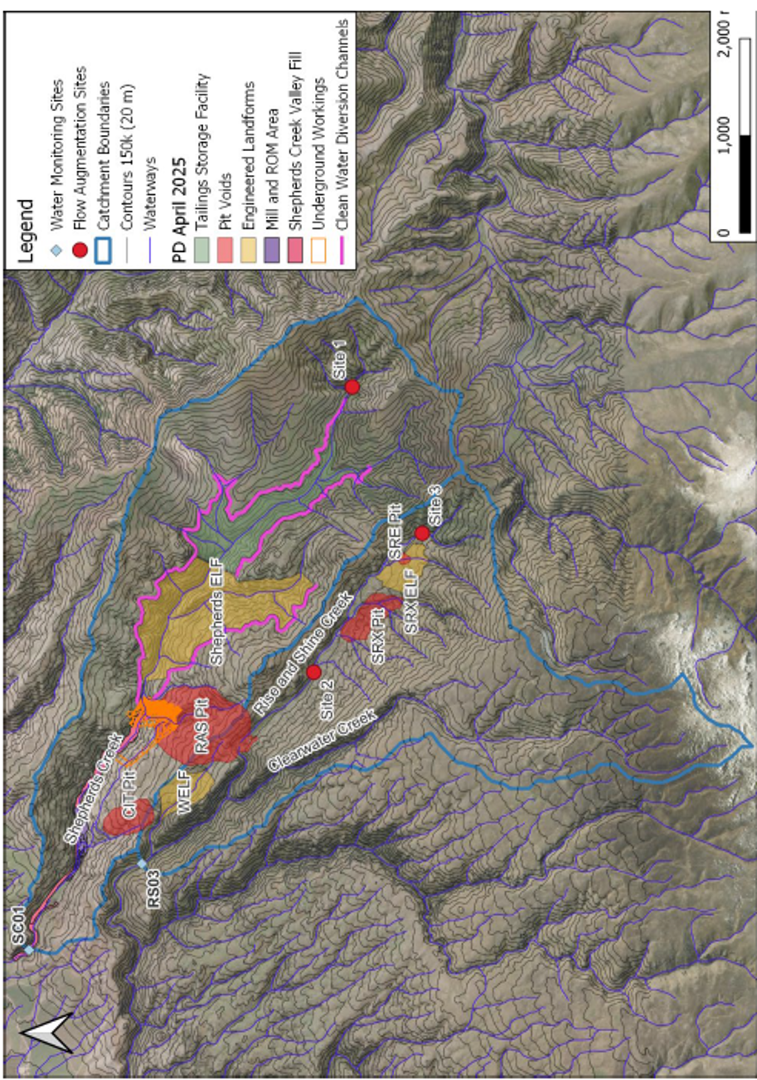
CONSENT TYPE AND ACTIVITY AUTHORISED | RMA S15 | A Discharge Permit to discharge water and contaminants to land, including circumstances where contaminants may enter water, associated with:  - The discharge of soil and rock material to create the various topsoil and brown rock stockpiles, the TSF, various ELFs, the Shepherds Service Corridor, haul roads, erosion and sediment control structures and treatment devices, two aggregate pits, and to support the construction of any ancillary mining development, operation and maintenance activities;  - The discharge of water and contaminants, via seepage or surface runoff, from topsoil and brown rock stockpiles, the TSF, various ELFs, the Shepherds Service Corridor, haul roads, erosion and sediment control structures and treatment devices, two aggregate pits and other ancillary mining development, operation and maintenance activities;  - The discharge of water and contaminants from erosion and sediment control structures in accordance with certified Site-Specific Erosion and Sediment Control Plans;  - The discharge of water and contaminants within a 100 m setback from natural inland wetlands, including where the discharge may enter a wetland and change its water level range or hydrological function; and  - The discharge of water for dust suppression purposes;  within the Project Site shown on Plan 2 - BOGP Consent Area annexed as part of Attachment 2 – Plans to the Common Conditions (Schedule One).
CONSENT NUMBER | RMFT25.007.08
TERM | 35 years
LAPSE PERIOD | 10 years

No. | Condition
Schedule One – Common Conditions Which Apply to All Otago Regional Council and Central Otago District Council Consents
1 | The Consent Holder must comply with the Common Conditions in Schedule One (which apply to all of the consents for the BOGP within the jurisdiction of the Central Otago District Council and the Otago Regional Council) to the extent relevant to the management of activities authorised by this consent.
Schedule Two – General Conditions Which Apply to All Otago Regional Council Consents
2 | The Consent Holder must comply with the General Conditions in Schedule Two (which apply to all of the consents for the BOGP within the jurisdiction of the Otago Regional Council) to the extent relevant to the activities authorised by this consent.
General
3 | All roofs and impervious car parking areas within the Project Site associated with offices and administration buildings and vehicle servicing and repair areas shall be connected to a reticulated stormwater system.

CONSENT TYPE AND ACTIVITY AUTHORISED | RMA S15 | A Discharge Permit to discharge contaminants into or onto land, including in circumstances where it may enter water, associated with the discharge of tailings into the TSF within the Project Site shown on Plan 2 - BOGP Consent Area annexed as part of Attachment 2 – Plans to the Common Conditions (Schedule One).
CONSENT NUMBER | RMFT25.007.09
TERM | 35 years
LAPSE PERIOD | 10 years

No. | Condition
Schedule One – Common Conditions Which Apply to All Otago Regional Council and Central Otago District Council Consents
1 | The Consent Holder must comply with the Common Conditions in Schedule One (which apply to all of the consents for the BOGP within the jurisdiction of the Central Otago District Council and the Otago Regional Council) to the extent relevant to the management of activities authorised by this consent.
Schedule Two – General Conditions Which Apply to All Otago Regional Council Consents
2 | The Consent Holder must comply with the General Conditions in Schedule Two (which apply to all of the consents for the BOGP within the jurisdiction of the Otago Regional Council) to the extent relevant to the activities authorised by this consent.

CONSENT TYPE AND ACTIVITY AUTHORISED | RMA S15 | A Discharge Permit to discharge contaminants to air from the crushing and screening of aggregates, and mining operations (including mineral extraction and processing activities) associated with the BOGP within the Project Site shown on Plan 2 - BOGP Consent Area annexed as part of Attachment 2 – Plans to the Common Conditions (Schedule One).
CONSENT NUMBER | RMFT25.007.10
TERM | 35 years
LAPSE PERIOD | 10 years

No. | Condition
Schedule One – Common Conditions Which Apply to All Otago Regional Council and Central Otago District Council Consents
1 | The Consent Holder must comply with the Common Conditions in Schedule One (which apply to all of the consents for the BOGP within the jurisdiction of the Central Otago District Council and the Otago Regional Council) to the extent relevant to the management of activities authorised by this consent.
Schedule Two – General Conditions Which Apply to All Otago Regional Council Consents
2 | The Consent Holder must comply with the General Conditions in Schedule Two (which apply to all of the consents for the BOGP within the jurisdiction of the Otago Regional Council) to the extent relevant to the activities authorised by this consent.

SCHEDULE ONE
BENDIGO-OPHIR GOLD PROJECT - COMMON CONDITIONS WHICH APPLY TO ALL OF THE RESOURCE CONSENTS WITHIN THE JURISDICTION OF THE CENTRAL OTAGO DISTRICT COUNCIL AND OTAGO REGIONAL COUNCIL

SCHEDULE TWO
BENDIGO-OPHIR GOLD PROJECT - GENERAL CONDITIONS WHICH APPLY TO ALL OF THE RESOURCE CONSENTS WITHIN THE JURISDICTION OF THE OTAGO REGIONAL COUNCIL

